Supplementary tables and figures

- eFig1: Consort figure
- eTable1: Comparison of risk cohorts
- eTable2: Description of outcome NDD codes by data source
- Exposure algorithm
- eFig2: The association between maternal exposure to mental illness or infection and autism/ASD, ADHD, cerebral palsy, intellectual disability and epilepsy for boys and girls
- etable3: Sensitivity analyses

eFig1: Consort figure

eTable1: Characteristics of cohorts
 |  | Pregnancy  (N=410,461) | 1 year before  (N= 351,614) | 2 years before  (N=301,779)
Common mental illness N (%) | Exposed | 20,579 (5.0) | 34,438 (9.8) | 27,840 (9.2)
Infection N (%) | Exposed | 90,482(22.0) | 82,062 (23.3) | 70,011 (23.2)
Maternal age at start | Median [IQR] | 30 [26-34] | 29 [25-33] | 28 [24-32]
Maternal BMI | Median [IQR] | 24.1 [21.5-28.0] | 23.7 [21.2-27.3] | 23.6 [21.1-27.1]
 | Missing N (%) | 172,121 (41.9%) | 144,243 (41.0%) | 128,967 (42.7%)
Charlson comorbidity index N (%) | 0 | 8,773(2.1) | 7,584 (2.2) | 5,892 (2.0)
 | 1 | 348,321 (84.9) | 299,433 (85.2) | 259,175 (85.9)
 | 2 | 50,289(12.3) | 42,034 (12.0) | 34,741 (11.5)
 | 3 or more | 3,078 (0.8) | 2,563 (0.7) | 1,971 (0.7)
Smoking status N (%) | Never smoked | 199,973 (48.7) | 171,132 (48.7) | 143,229 (47.5)
 | Ex-smoker | 33,223 (8.1) | 26,056 (7.4) | 20,060 (6.7)
 | Current smoker | 116,295 (28.3) | 100,431 (28.6) | 82,942 (27.5)
 | Not known | 60,970 (14.9) | 53,995 (15.4) | 55,548 (18.4)
Mother NDD N (%) | Any | 11,464 (2.8) | 9,758 (2.8) | 8,449 (2.8)
Child gender N (%) | Female | 199,758 (48.7) | 171,200 (48.7) | 146,908 (48.7)
Ethnicity N (%) | Asian/British Asian | 18,686 (4.6) | 14,356 (4.1) | 11,260 (3.7)
 | Black/ black British | 8,687 (2.1) | 6,733 (1.9) | 5,229 (1.7)
 | Mixed | 11,196 (2.7) | 9,260 (2.6) | 7,766 (2.6)
 | Other | 5,452 (1.3) | 4,104 (1.2) | 3,170 (1.1)
 | White | 311,388 (75.9) | 270,748 (77.0) | 235,480 (78.0)
 | Unknown | 55,052 (13.4) | 46,413 (13.2) | 38,874 (12.9)
IMD N (%) | 1 | 67,043(16.3) | 56,338 (16.0) | 46,942 (15.6)
 | 2 | 73,769 (18.0) | 62,795 (17.9) | 53,338 (17.7)
 | 3 | 77,943 (19.0) | 66,462 (18.9) | 56,754 (18.8)
 | 4 | 86,517 (21.1) | 74,341 (21.1) | 64,145 (21.3)
 | 5 | 105,189 (25.6) | 91,678 (26.1) | 80,600 (26.7)
Child NDD N (%) | Any | 11,165 (2.7) | 9,637 (2.7) | 8,426 (2.8)
Gestational age | Median [IQR] | 40 [38.7-40] | 40 [38.7-40] | 40 [38.6-40]
 | Missing N (%) | 41,055 (10.0%) | 35,298 (10.0) | 30,022 (9.95)
Birthweight N (%) | <2000g | 4,887 (1.2) | 4,234 (1.2) | 3,684 (1.2)
 | Missing N (%) | 104,858 (25.6) | 90,203 (25.7) | 76,849 (25.5)

eTable2: Description of outcome NDD codes by data source
 | Data source
Outcome | CPRD prescriptions | HES diagnosis at Outpatient visit | HES ICD10 diagnosis at hospital admission
ADHD | BNF chapter 4, section 4, paragraph 0 (excluding caffeine) | F84 | F84
ASD | NA | F90 | F90
ID | NA | F70-F79 | F70-F79
Cerebral Palsy | NA | G40 | G40
Epilepsy | NA | G80-G83 | G80-G83
The CPRD read codes for ADHD, ASD, ID, CP and epilepsy are available at github.

Mental illness exposure algorithm
The algorithm considers common mental illness to be episodic, and takes account of the reality that a diagnosis of depression or anxiety will only be entered once into a person’s primary care record. Therefore mental illness within a given period (in pregnancy, 1 year or 2 years before pregnancy) was calculated using the following rules:
- Record of a diagnosis of anxiety or depression in the period.
- Record of a prescription to treat anxiety or depression in the period, where there was a historic diagnosis of anxiety or depression.
- Record of a symptom of anxiety or depression in the period, where there was a historic diagnosis of anxiety or depression.
- Record of a symptom of anxiety or depression within 3 months of a prescription for anxiety or depression in the period.
See github for list of exposure prescriptions, symptoms, and diagnoses.
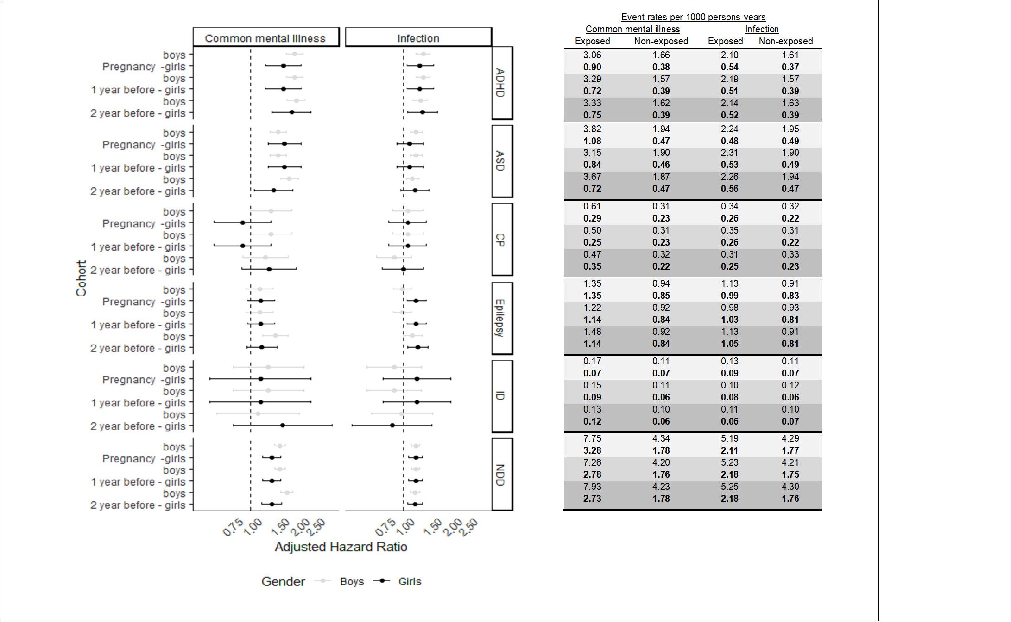
eFig2: The association between maternal exposure to mental illness or infection and autism/ASD, ADHD, Cerebral palsy, Intellectual disability and Epilepsy for boys and girls. Model adjusted for; maternal; age, smoking status, alcohol or substance misuse, BMI; comorbidities, maternal history of NDD (yes/no), child; gender, ethnicity, birth year and order and area; region, and index of multiple deprivation, maternal mental illness adjusted for maternal infection and maternal infection adjusted for maternal mental illness.

- etable3: Sensitivity analyses
 | Maternal mental illness in pregnancy |  |  | Infection in pregnancy
Cohort | Rate (per 1000 person years) | HR | Adjusted HR | Rate (per 1000 person years) | HR | Adjusted HR
Restricted to women in all three cohorts N=(301,779)
Pregnancy | 5.56 versus 3.10 | 1.83 (1.66 to 2.01) | 1.58 (1.43 to 1.73) | 3.57 versus 2.99 | 1.23 (1.16 to 1.30) | 1.17 (1.11 to 1.24)
1-year before | 5.12 versus 3.03 | 1.72 (1.60 to 1.84) | 1.50 (1.40 to 1.62) | 3.78 versus 3.03 | 1.25 (1.19 to 1.32) | 1.21 (1.14 to 1.27)
Restricted to children with known gestational age
Pregnancy (N= 369,406) | 5.87 versus 3.26 | 1.87 (1.71 to 2.04) | 1.62 (1.49 to 1.78) | 3.80 versus 3.14 | 1.26 (1.19 to 1.33) | 1.21 (1.14 to 1.28)
1-year before (N= 316,316) | 5.17 versus 3.18 | 1.66 (1.36 to 1.79) | 1.47 (1.36 to 1.58) | 3.98 versus 3.17 | 1.26 (1.20 to 1.33) | 1.21 (1.14 to 1.28)
2-year before (N=271,757) | 5.50 versus 3.19 | 1.77 (1.64 to 1.90) | 1.61 (1.49 to 1.74) | 3.91 versus 3.23 | 1.22 (1.15 to 1.30) | 1.17 (1.10 to 1.24)
Model adjusted for; maternal; age, smoking status, comorbidities, BMI, history of NDD; child; gender, ethnicity, birth year; and area; region and level of deprivation.

