SM 1. Quality assessment of included studies
In five studies, participants were not blind to treatment allocation (Brinkworth et al., 2016; Dolatkhah et al., 2023; Faulconbridge et al., 2018; Faulconbridge et al., 2012; Geliebter et al., 1997). In 12 of the studies, it was unclear whether those delivering treatment were blind to treatment assignment (Brinkworth et al., 2009; Faulconbridge et al., 2012; Foster et al., 1992; Fuller et al., 2017; Halyburton et al., 2007; Payne et al., 2018; Rodriguez-Lozada et al., 2019; Snel et al., 2012; Tan et al., 2016; Thomson et al., 2010; Wadden et al., 1985; Wadden et al., 1988) and in ten studies it was unclear whether outcome assessors were blind to treatment assignment (Brinkworth et al., 2009; Foster et al., 1992; Fuller et al., 2017; Halyburton et al., 2007; Payne et al., 2018; Rodriguez-Lozada et al., 2019; Snel et al., 2012; Thomson et al., 2010; Wadden et al., 1985; Wadden et al., 1988). One study reported not blinding those delivering treatments, or outcome assessors, to treatment assignment (Dolatkhah et al., 2023). Notably, the blinding of the participants and research staff is nearby impossible in lifestyle modification trials, thus the blinding of study participants and research staff were not considered when assessing the overall quality of studies.
Five of 25 studies were classified as interventional studies, which were also categorised as low risk of bias. All five studies had no control group (Buffenstein et al., 2000; LaPorte, 1990; Pearl et al., 2018; Stefanska et al., 2016; Wadden et al., 1986). However, all studies measured depression pre and post-test, using reliable measurement tools. The one study included in the systematic review was categorised as high quality and of a low risk of bias (Elder et al., 2012).

Table S1. Quality assessment of studies included in the meta-analysis (n=25) using the Joanna Briggs Institute Checklist for Randomized Controlled Trials and Checklist for Quasi-Experimental Studies
Checklist for Randomized Controlled Trials
Reference | Q1: Was true randomization used for assignment of participants to treatment groups? | Q2: Was allocation to treatment groups concealed? | Q3: Were treatment groups similar at the baseline? |  | Q4: Were participants blind to treatment assignment? |  |  | Q5: Were those delivering treatment blind to treatment assignment? | Q6: Were outcomes assessors blind to treatment assignment? |  |  | Q7: Were treatment groups treated identically other than the intervention of interest? |  |  | Q8: Was follow up complete and if not, were differences between groups in terms of their follow up adequately described and analyzed? |  |  | Q9: Were participants analyzed in the groups to which they were randomized? | Q10: Were outcomes measured in the same way for treatment groups? |  | Q11: Were outcomes measured in a reliable way? | Q12: Was appropriate statistical analysis used? |  | Q13: Was the trial design appropriate, and any deviations from the standard RCT design (individual randomization, parallel groups) accounted for in the conduct and analysis of the trial?
Brinkworth, 2009 | Y | Y | Y |  | Y |  |  | U | U |  |  | Y |  |  | Y |  |  | Y | Y |  | Y | Y |  | Y
Brinkworth et al., 2016 | Y | Y | Y |  | N |  |  | N | Y |  |  | Y |  |  | Y |  |  | Y | Y |  | Y | Y |  | Y
Dolatkhah et al., 2023 | Y | Y | Y |  | N |  |  | N | N |  |  | Y |  |  | Y |  |  | Y | Y |  | Y | Y |  | Y
Faulconbridge et al., 2012 | Y | U | U |  | N |  |  | U | Y |  |  | Y |  |  | Y |  |  | Y | Y |  | Y | Y |  | Y
Faulconbridge et al., 2018 | U | U | Y |  | N |  |  | N | Y |  |  | Y |  |  | Y |  |  | Y | Y |  | Y | Y |  | Y
Foster et al., 1992 | Y | Y | Y |  | Y |  |  | U | U |  |  | Y |  |  | Y |  |  | Y | Y |  | Y | Y |  | Y
Fuller et al., 2017 | Y | Y | Y |  | Y |  |  | U | U |  |  | Y |  |  | Y |  |  | N | Y |  | Y | Y |  | Y
Geliebter et al., 1997 | Y | Y | Y |  | N |  |  | Y | Y |  |  | Y |  |  | Y |  |  | Y | Y |  | Y | Y |  | Y
Halyburton et al., 2007 | Y | Y | Y |  | U |  |  | U | U |  |  | Y |  |  | Y |  |  | Y | Y |  | Y | Y |  | Y
Imayama, 2011 | Y | Y | Y |  | Y |  |  | Y | Y |  |  | Y |  |  | Y |  |  | Y | Y |  | Y | Y |  | Y
Kakoschke et al., 2021 | Y | Y | Y |  | Y |  |  | Y | Y |  |  | Y |  |  | Y |  |  | Y | Y |  | Y | Y |  | Y
Ma et al., 2019 | Y | Y | Y |  | Y |  |  | Y | Y |  |  | Y |  |  | Y |  |  | Y | Y |  | Y | Y |  | Y
Payne et al., 2018 | Y | Y | Y |  | U |  |  | U | U |  |  | Y |  |  | Y |  |  | Y | Y |  | Y | Y |  | Y
Rodriguez-Lozada et al., 2019 | Y | U | Y |  | U |  |  | U | U |  |  | Y |  |  | Y |  |  | Y | Y |  | Y | Y |  | Y
Sanchez et al., 2017 | Y | Y | Y |  | Y |  |  | Y | Y |  |  | Y |  |  | Y |  |  | Y | Y |  | Y | Y |  | Y
Snel et al., 2012 | Y | Y | Y |  | Y |  |  | U | U |  |  | Y |  |  | Y |  |  | Y | Y |  | Y | Y |  | Y
Tan et al., 2016 | Y | Y | Y |  | Y |  |  | U | Y |  |  | Y |  |  | Y |  |  | Y | Y |  | Y | Y |  | Y
Thompson et al., 2010 | Y | Y | Y |  | Y |  |  | U | U |  |  | Y |  |  | Y |  |  | Y | Y |  | Y | Y |  | Y
Wadden et al., 1985 | Y | U | Y |  | U |  |  | U | U |  |  | Y |  |  | Y |  |  | Y | Y |  | Y | Y |  | Y
Wadden, Stunkard and Liebschutz, 1988 | Y | Y | Y |  | U |  |  | U | U |  |  | Y |  |  | Y |  |  | Y | Y |  | Y | Y |  | Y
Checklist for Quasi-Experimental Studies
Reference | Q1:Is it clear in the study what is the “cause”and what is the “effect”(i.e. there is no confusion about which variable comes first)? |  | Q2: Were the participants included in any comparisons similar? |  |  | Q3: Were the participants included in any comparisons receiving similar treatment/care, other than the exposure or intervention of interest? |  |  |  | Q4: Was there a control group? |  |  | Q5: Were there multiple measurements of the outcome both pre and post the intervention/exposure? |  |  | Q6: Was follow up complete and if not, were differences between groups in  terms of their follow up adequately described and analyzed? |  |  |  | Q7: Were the outcomes of participants included in any comparisons  measured in the same way? |  |  | Q8: Were outcomes measured in a reliable way? |  | Q9: Was appropriate statistical analysis used?
Buffenstein, Karklin & Driver, 2000 | Y |  |  | N |  |  | N |  |  |  | N |  |  | Y |  |  | Y |  |  | Y |  |  | Y |  | Y
LaPorte et al., 1990 | Y |  |  | Y |  |  | Y |  |  |  | N |  |  | Y |  |  | Y |  |  | Y |  |  | Y |  | Y
Pearl et al., 2018 | Y |  |  | Y |  |  | N |  |  |  | N |  |  | Y |  |  | Y |  |  | Y |  |  | Y |  | Y
Stefańska et al. 2016 | Y |  |  | N |  |  | N |  |  |  | N |  |  | Y |  |  | Y |  |  | Y |  |  | Y |  | Y
Wadden, Stunkard, & Smoller, 1986 | Y |  |  | N |  |  | N |  |  |  | N |  |  | Y |  |  | Y |  |  | Y |  |  | Y |  | Y
Notes. N = no; U = unclear; Y = yes.
Table S2. Quality assessment of studies included in the systematic review using the Joanna Briggs Institute Checklist for Analytical Cross-Sectional Studies
Reference | Were the criteria for inclusion in the sample clearly defined? | Were the study subjects and the setting described in detail? | Was the exposure measured in a valid and reliable way? | Were objective, standard criteria used for measurement of the condition? | Were confounding factors identified? | Were strategies to deal with confounding factors stated? | Were the outcomes measured in a valid and reliable way? | Was appropriate statistical analysis used?
Elder et al., 2012 | Y | Y | Y | Y | Y | Y | Y | Y
Notes. N = no; U = unclear; Y = yes.

SM 2. Funnel plots

Figure S1. Funnel plot for the cross-sectional meta-analysis of n=4 studies comparing depressive symptoms in individuals treated with a calorie-restricted diet with individuals following their usual diet.

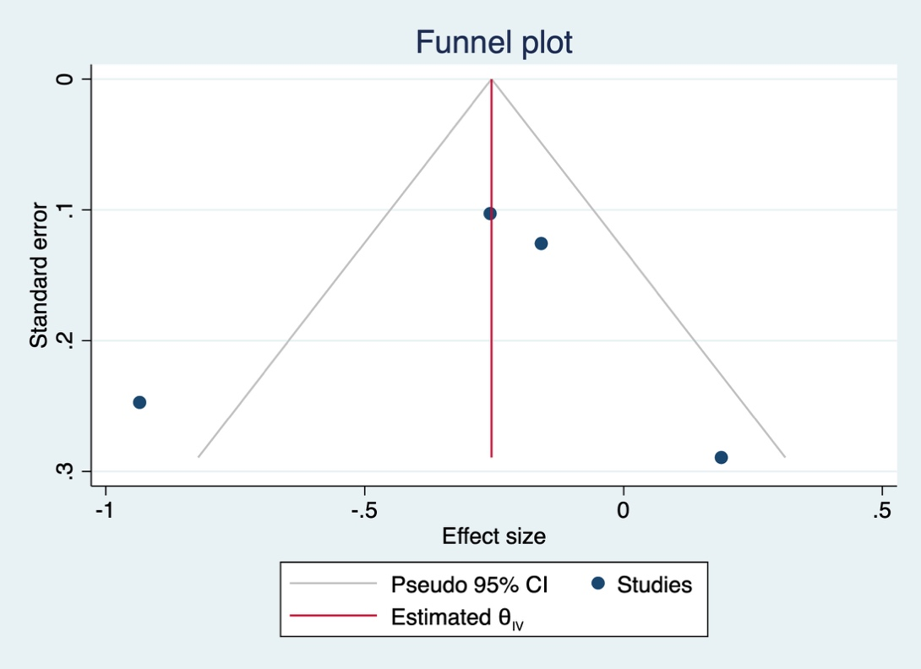

Figure S2. Funnel plot for the pre-post meta-analysis of n=25 studies comparing depressive symptoms in individuals before and after adhering to a calorie-restricted diet.

