# Supplementary material

## Overview

Our overall analysis strategy is outlined schematically in Figure 1. Specifically, a data-driven group independent component analysis (GICA) method was utilized to decompose resting-state fMRI data into 50 intrinsic connectivity networks (ICNs) ([Calhoun, Adali, Pearlson, & Pekar, 2001](#_ENREF_3" \o "Calhoun, 2001 #1296)), representing *N* = 50 regions of interest within the large-scale brain networks. Using a deterministic streamline tractography, we generated the large-scale structural network connectivity (SNC) matrices among all ICNs from diffusion-weighted imaging (DWI) data. Subsequently, we turned it into a fully connected communicability matrix ([Crofts & Higham, 2009](#_ENREF_7" \o "Crofts, 2009 #1109)). Meanwhile, dynamic functional network connectivity (FNC) matrices were generated using a sliding window technique and subsequently clustered into two distinct configuration states using a k-means clustering analysis ([Allen et al., 2014](#_ENREF_1" \o "Allen, 2014 #474)). Once the SNC and dynamic FNC were created, the state-specific SC-FC coupling for each individual was estimated at three network levels. Global calculations were performed for the overall connections of large-scale brain networks; meso-level calculations were conducted on the connections of anatomical rich-club organization; and local calculations were made on individual brain regions. We further computed and correlated the temporal and topological features of dynamic FNC with SC-FC coupling. The overall SC-FC coupling for each state was correlated with the temporal properties of dynamic FC states; the meso-level correlation focused on the relationships between SC-FC coupling of the rich-club organization and dynamic functional network efficiency; and local level correlation explored the relationships between spatial variability of regional SC-FC coupling and the hierarchy of functional specialization (i.e., participation coefficient) and integration (i.e., degree centrality).

## Participants

A total of 778 participants (137 first-episode treatment-naïve SZ patients, 186 treatment-naïve MDD patients, 201 BD patients, and 254 unaffected controls) were studied from October 2014 to June 2018. For these participants, 74 of them (21 MDD patients, 19 BD patients, 13 SZ patients, and 21 UCs) were excluded due to incomplete scans, and 47 of them (12 MDD patients, 13 BD patients, 11 SZ patients, and 11 UCs) were excluded due to excessive head movement. The dynamic SC-FC coupling analyses were carried out in the remaining 657 participants, comprising 166 drug-naïve patients with MDD, 168 patients with BD, 118 patients with first-episode drug-naïve SZ, and 205 UCs.

In terms of age and gender, there were no significant differences between control and patient groups, nor across patient groups (all tests *P* > .05); however, the years of education of each patient group were considerably lower than that of the control group (*P* < .001, two-sample *t*-test). The duration of untreated psychosis did not differ between patient groups (*P* >.05). However, there were apparent disparities in clinical symptoms. Notably, patients with BD had lower HAMD scores than patients with MDD (*P* < .001, two-sample *t*-test) and lower PANSS scores than patients with SZ (all *P* < .001, two-sample *t*-test). Detailed demographic and clinical characteristics of the included participants are shown in **Table S1**.

**MRI acquisition**

High-resolution 3D T1-weighted structural images were acquired with a magnetization-prepared rapid gradient-echo sequence (repetition time: 8.1 ms, echo time: 3.7 ms, flip angle: 7º, slice thickness: 1 mm, acquisition matrix: 256×256, the field of view: 256 mm, voxel size: 1 × 1 × 1 mm3, and 188 slices). DTI scans were obtained by an echo-planer image sequence with 2 diffusion gradient directions (b-values: 0 and 1000 s/mm2, repetition time: 10407 ms, echo time: 92 ms, flip angle: 90º, slice thickness: 2 mm, the field of view: 256 mm, reconstructed voxel size: 2 × 2 × 2 mm3, and 75 slices). Resting-state fMRI images were obtained with an echo-planar imaging sequence (repetition time: 2000 ms, echo time: 30 ms, flip angle: 90º, slice thickness: 4 mm, reconstructed voxel size: 3.75 × 3.75 × 4 mm3, the field of view: 240 mm, 38 slices, resulting in 240 volumes per participant).

## DWI preprocessing

Each participant’s DWI images were preprocessed by the Pipeline for Analyzing Brain Diffusion Images (PANDA) ([Cui, Zhong, Xu, He, & Gong, 2013](#_ENREF_9" \o "Cui, 2013 #1049)). The primary preprocessing involved the following four steps: First, the brain mask was estimated by removing the skull from the b0 image. Second, non-brain space was removed from the raw images to reduce the memory requirements and accelerate the processing of subsequent steps. The acquired brain mask was used to determine the brain's three-dimensional borders. Thirdly, head motion and eddy-current induced distortion of diffusion-weighted images were corrected by registering the DWI images to the b0 image using an affine transformation. The diffusion tensor metrics were then calculated, including fractional anisotropy (FA), mean diffusivity, axial diffusivity, and radial diffusivity maps.

## Resting-state fMRI preprocessing

Resting-state functional images were preprocessed using the DPARSF ([Yan & Zang, 2010](#_ENREF_33" \o "Yan, 2010 #1048)) based on SPM 12 (http://www.fil.ion.ucl.ac.uk/spm). The primary preprocessing consisted of the following four steps: First, the initial five volumes were discarded in order to stabilize the signal and compensate for the inherent scanner noise. Second, the remaining images were corrected by calibrating slice timing and realigning head motion. In particular, they were realigned to the first volume for the purpose of correcting inter-scan head motion after first correcting differences in within-scan acquisition time between slices. The images were then resampled to a resolution of 3 × 3 × 3 mm3 after being spatially normalized to a standard three-dimensional space using the Montreal Neurological Institute (MNI) template. Here, a rigid-body transformation was utilized to co-register high resolution structural images of the individuals with the mean functional images, and all co-registered images were segmented into gray matter, white matter, and cerebrospinal fluid in MNI space. The images were then spatial smoothed with a 6 mm full width at half maximum Gaussian kernel. In addition, to account for the artifact of head motion, any data affected by head motion (maximal motion between volumes in each direction is greater than 1.5 mm, and rotation in each axis is greater than 1.5°) were discarded. On the basis of realignment parameters, we also calculated the mean frame-wise displacement (FD) of each participant; those with an FD greater than 0.2 mm were excluded ([Power, Schlaggar, Lessov-Schlaggar, & Petersen, 2013](#_ENREF_22" \o "Power, 2013 #52)). No significant group differences in FD were observed between the remaining participants. In the subsequent statistical comparisons, head motion was also corrected by including mean FD as a covariate.

## Group independent component analysis

In line with previous research on dynamic functional network connectivity ([Kim et al., 2017](#_ENREF_12" \o "Kim, 2017 #473); [Tu et al., 2019](#_ENREF_27" \o "Tu, 2019 #801)), we used a standard spatial GICA pipeline to decompose preprocessed fMRI data into multiple independent components (ICs). We utilized GICA to determine network nodes because it is superior at capturing individual differences in the brain’s real functional boundaries ([Calhoun et al., 2001](#_ENREF_3" \o "Calhoun, 2001 #1296)). Notably, we carried out global signal regression (GSR) using the GICA framework and the GIFT toolbox. In particular, the global mean signal per time point was eliminated as a standard principal component analysis (PCA) processing step prior to ICA, in accordance with previous dynamic FC studies ([Allen et al., 2014](#_ENREF_1" \o "Allen, 2014 #474); [Tu et al., 2020](#_ENREF_26" \o "Tu, 2020 #1129)). The PCA was then utilized to reduce subject-specific data into 120 principal components. Using an infomax algorithm, the subject-reduced data of all subjects across time were then concatenated and reduced to 100 ICs ([Bell & Sejnowski, 1995](#_ENREF_2" \o "Bell, 1995 #909)). To ensure the reliability and stability of the decomposition, the infomax ICA algorithm was executed 20 times within ICASSO (http://research.ics.tkk.fi/ica/icasso/). After determining the group spatial maps, a group information-guided ICA method was utilized to determine the subject-specific spatial maps and the associated time courses. Using the following criteria, the intrinsic connectivity networks (ICNs) among the 100 ICs were identified. Initially, peak activation coordinates were primarily located in gray matter. Secondly, there is minimal spatial overlap with known vascular, ventricular, motion, and susceptibility artifacts. Thirdly, low-frequency fluctuations predominated time courses ([Allen et al., 2014](#_ENREF_1" \o "Allen, 2014 #474); [Fiorenzato et al., 2019](#_ENREF_10" \o "Fiorenzato, 2019 #800)). Based on the spatial correlation values between ICs and the template, we identified 50 ICNs among 100 ICs, which were grouped into seven resting-state networks (RSNs) ([Allen et al., 2014](#_ENREF_1" \o "Allen, 2014 #474); [Shirer, Ryali, Rykhlevskaia, Menon, & Greicius, 2012](#_ENREF_24" \o "Shirer, 2012 #1099)). As illustrated in **Fig. S1-S7**, these RSNs were organized into sub-cortical (SUC; 2 ICNs), auditory (AUD; 3 ICNs), visual (VIS; 12 ICNs), somatomotor (SM; 13 ICNs), cognitive control (CC; 9 ICNs), default mode (DM; 8 ICNs), and cerebellar (CB; 3 ICNs) networks. **Table S2** presents the activation information spatial maps for 50 ICNs. In addition, post-processing was performed on the time courses of the identified ICNs to eliminate any residual noise sources. This included detrending linear, quadratic, and cubic trends; conducting regressions of the 6 realignment parameters and their temporal derivatives; despiking detected outliers; and low-pass filtering with a cutoff frequency of 0.15 Hz.

## Structural network construction

We tracked the white matter fibers between pairs of ICNs to construct structural brain networks. The ICNs in the MNI space were transformed into each participant’ native DWI space. First, the individual FA image in the native space was co-registered with its b0 image using a linear transformation. The transformed b0 image was then registered non-linearly to the ICBM152 template. On the basis of the transformations resulting from these two steps, an inverse warping transformation from the MNI space to the native DWI space was obtained. Using the fiber assessment by continuous tracking (FACT) algorithm, we subsequently performed deterministic tractography in the native space of each participant ([Mori, Crain, Chacko, & Van Zijl, 1999](#_ENREF_19" \o "Mori, 1999 #1094)). Here, fiber tracking was terminated if the angle between two consecutive orientations was greater than 45° or if the FA value was less than 0.2. Given that the outcome of tractography is dependent on the initial position of the seed points within the voxel ([Cheng et al., 2012](#_ENREF_4" \o "Cheng, 2012 #1092)), 100 seeds were selected at random within each voxel to eliminate biases resulting from initial seed positioning. Resulting whole-brain tracts supplied the structural connectome with its edges. Notably, we used deterministic tractography as a measure of SC since it has also been frequently used to assess the structural brain networks in major psychiatric disorders, making our findings of SC-FC coupling comparable to those of earlier investigations. In accordance with previous studies ([Crossley et al., 2017](#_ENREF_8" \o "Crossley, 2017 #949); [van den Heuvel, Scholtens, de Reus, & Kahn, 2016](#_ENREF_29" \o "van den Heuvel, 2016 #1015); [van den Heuvel et al., 2013](#_ENREF_31" \o "van den Heuvel, 2013 #952)), SC weight was evaluated using streamline density (SD) between each pair of ICNs, which was calculated by dividing the FN by the average cortical volume and fiber length of the connected regions. Other definitions of SC weight, such as the number of deterministic fiber streamlines (FN) and the production of average fractional anisotropy (FA) and FN (FA × FN), yielded comparable results (FN: *P* = .013, FDR-corrected, η2 =.017; FA × FN: *P* = .007, FDR-corrected, η2 =.019; **Fig. S8**). The post hoc analyses revealed that compared to controls and patients with MDD, SZ patients exhibited a significant decrease in overall SC strength in both FN (communicability, SZ < NC, *P* = .009, FDR-corrected, Cohen's d = .313; SZ < MDD, *P* = .002, FDR-corrected, Cohen's d = .401) and FA × FN (communicability, SZ < NC, *P* = .007, FDR-corrected, Cohen's d = .337; SZ < MDD, *P* = .006, FDR-corrected, Cohen's d = .353). Because deterministic tractography produced a relatively sparse SC matrix, the original SC matrix was converted into a fully-connected matrix by computing the communicability, where edge weights reflect the weighted sum of both direct and indirect pathways between regions, and shorter paths with stronger connections are weighted more heavily ([Crofts & Higham, 2009](#_ENREF_7" \o "Crofts, 2009 #1109)). The communicability transformation has been demonstrated to be an effective method of evaluating SC-FC coupling ([Zamani Esfahlani, Faskowitz, Slack, Misic, & Betzel, 2022](#_ENREF_35" \o "Zamani Esfahlani, 2022 #1321)).

## Dynamic functional network construction

Following prior research([Allen et al., 2014](#_ENREF_1" \o "Allen, 2014 #474); [Kim et al., 2017](#_ENREF_12" \o "Kim, 2017 #473); [Tu et al., 2020](#_ENREF_26" \o "Tu, 2020 #1129)), we estimated the dynamic FNC of each participant using a sliding window approach. Specifically, a tapered window with a length of 44 s was used to divide the time courses of ICNs across the entire scan into 209 windows with a 2 s increment-step. The window length of 44 s was chosen because prior research revealed a good balance between the estimation quality of the correlation matrix and the capacity to detect functional changes ([Allen et al., 2014](#_ENREF_1" \o "Allen, 2014 #474)). We calculated the covariance matrix among ICNs within each window and concatenated all windowed matrices to generate a *N* × *N* × *T* array for each participant (where *N* denotes the number of ICNs and *T* denotes the number of windows), representing the dynamic changes of functional brain networks over time ([Smith et al., 2011](#_ENREF_25" \o "Smith, 2011 #1064)). The dynamic FC matrices of all participants were then subjected to a k-means clustering analysis to estimate recurrent dynamic FNC states, which show the transient patterns of FC throughout time. The matrices were classified into two separate clusters based on the similarity of the L1 distance between the matrices and cluster centroids. The gap statistic (defined as the standardized pooled within-cluster sum of squares in within-cluster dispersion expected under a null reference distribution) and silhouette statistic (defined as the ratio of the similarity between windows in the same cluster relative to similarity with windows in a different cluster) were used to estimate the optimal number of clusters. To ensure that the results remained true across various sliding window sizes, we also performed the dynamic FNC analyses in other window sizes (36-52 s). We investigated the temporal properties of dynamic FC states by determining the occurrence rate and mean dwell time in each state and the number of transitions and transition likelihood from one state to another ([Fiorenzato et al., 2019](#_ENREF_10" \o "Fiorenzato, 2019 #800); [Tu et al., 2019](#_ENREF_27" \o "Tu, 2019 #801)). The occurrence rate is defined as the proportion of time spent in each state; the mean dwell time is defined as the number of consecutive windows belonging to one state before switching to another; the number of transitions is defined as the transitioning times between states; and the transition likelihood is defined as the proportion of probability of switching between states.

## Graph-theoretical metrics

**Anatomical rich-club organization**. Within each dynamic FNC state, we evaluated SC-FC coupling across various network levels (global, meso-, regional). Significantly, at the meso-network level, we focused on the rich-club organization - a pivotal structural framework underpinning global brain communication ([van den Heuvel & Sporns, 2011](#_ENREF_30" \o "van den Heuvel, 2011 #1179)). Rich-club organization, characterized by key anatomical hub regions, is instrumental in guiding functional control and information flow ([van den Heuvel, Kahn, Goni, & Sporns, 2012](#_ENREF_28" \o "van den Heuvel, 2012 #1175)). The rich-club disorganization of structural brain networks has been repeatedly reported in previous psychiatric disorder studies ([Collin, Scholtens, Kahn, Hillegers, & van den Heuvel, 2017](#_ENREF_5" \o "Collin, 2017 #1085); [Liu et al., 2021](#_ENREF_16" \o "Liu, 2021 #1177); [van den Heuvel et al., 2013](#_ENREF_31" \o "van den Heuvel, 2013 #952)). In line with this, we identified the anatomical rich-club organization and subsequently identified its functional counterpart in state-specific brain networks. In particular, we evaluated weighted anatomical rich-club coefficient *Φw*(*k*) ([Opsahl, Colizza, Panzarasa, & Ramasco, 2008](#_ENREF_20" \o "Opsahl, 2008 #610)). First, all network connections were ranked by their weight, yielding the vector *Wranked*. Second, sub-networks containing nodes with a degree greater than *k* (where *k* is the number of binary connections linked to each node) were chosen for values of *k* between 5 and 40. Third, the number of edges and the sum of their weights (*W>k*)were determined within the chosen sub-network (*E>k*). Fourth, the weights of the top *E>k* edges in the ranked weights *Wranked* were added to determine the network’s strongest *E>k* edges. Finally, the weighted rich-club parameter *Φw*(*k*) was calculated as the ratio of *W>k* to the total number of the strongest links *E>k* in the whole-brain network:

$$ϕ^{w}\left(k\right)=\frac{W_{>k}}{\sum_{l=1}^{E_{>k}}{w_{l}^{ranked}}}$$

The weighted rich-club parameter *Φw*(*k*) was normalized by comparing it to 1,000 random networks in order to determine the extent to which the observed connection strength between rich-club nodes exceeds that predicted by the random null model driven solely by node degree. Normalized rich-club coefficient *Φnorm*(*k*) is the ratio of *Φw*(*k*) in the network to the mean of *Φrandom*(*k*) across random networks:

$$ϕ_{norm}\left(k\right)=\frac{ϕ(k)}{ϕ_{random}(k)}$$

with a normalized rich-club coefficient *Φnorm*(*k*) > 1 expressing the presence of a rich-club organization in the network. Random networks were generated by shuffling the structural network’s edges, while preserving the (binary) degree distribution and connection weights ([Maslov & Sneppen, 2002](#_ENREF_17" \o "Maslov, 2002 #22)). The rich-club coefficient was calculated until there were fewer than three nodes in the examined set. rich-club nodes and local nodes were identified for each participant based on the  for a given *k*, and the edges associated with these nodes were further classified as rich-club, feeder, and local edges, representing the connections between rich-club nodes, rich-club nodes and non-rich-club nodes, and non-rich-club nodes, respectively. Notably, rich-club nodes were determined using the group-averaged structural network, which was computed by selecting the connections shared by at least 75% of all participants. In addition, we found a node set that was comparable to that based on all participants when we constructed the rich-club nodes using only the unaffected controls (keeping the degree threshold > 13 and concentrating on the top 15% consistent nodes). Graph metrics and null models were calculated using the Brain Connectivity Toolbox for MATLAB ([Rubinov & Sporns, 2010](#_ENREF_23" \o "Rubinov, 2010 #148)).

**Connectivity strength***.* Connectivity strength (*S*) was calculated as the weighted average of all network connections:

$$S= \overline{W}$$

where *W* represents the connectivity weights of the edges of the reconstructed network.

**Network density**. Network density (*D*) was calculated by dividing the number of connections that existed in the network by the number of connections in the fully-connected network as follows:

$$D= \frac{E}{n(n−1)/2}$$

where *E* represents the number of connections and *n* represents the number of nodes.

**Global efficiency**. Global efficiency (*EWglob*) was defined as the efficiency of the whole network exchanges information:





where *Ei* represents node *i*’s weighted efficiency and *dijw* represents the shortest weighted path length between nodes *i* and *j*. *dijw*was defined as:





where *auv* is the connection status; *aij* = 1 as a link (*i*, *j*) existed (i.e., node i and j are neighbors); otherwise *aij* = 0 (*aii* = 0 for all *i*). *wuv* stand for the connection weights between nodes *u* and *v*. *f* is a map (e.g., an inverse) from weight to length and *gi ↔ jw* is the shortest weighted path between node *i* and *j*. *N* represents the set of all nodes, and the number of nodes in the given network is denoted by the letter *n*. This metric was computed using weighted networks, as denoted by the superscript “*w*”. All metrics utilized in this study were weighted, so the superscript “*w*” was omitted from other sections.

**Local efficiency**. Local efficiency was defined as the mean efficiency of the local sub-networks ([Latora & Marchiori, 2001](#_ENREF_14" \o "Latora, 2001 #1698)) and computed as:





where *Eloc,iw* represents the weighted local efficiency of node *i*. *wij* denotes the connection weights between nodes *i* and *j*, and *djhw(Ni)* denotes the weighted length of the shortest path between *j* and *h*, composed only of the neighbors of *i*.

**Path length.** Characteristic path length was equivalent to the inverse of *Eglob* and computed as:





where *Liw* represents the mean weighted distance between node *i* and the remaining nodes. *dijw* is the shortest weighted length of path between *i* and *j*.

**Clustering coefficient**. Clustering coefficient was defined as the proportion of a node’s neighbors who are also its neighbors ([Watts & Strogatz, 1998](#_ENREF_32" \o "Watts, 1998 #1699)). It was chosen to reflect local efficiency because it conveys similar information as *Eloc*; it can be described as follows:





where *Ciw* is the weighted clustering coefficient of node *i* (*Ciw* = 0 if *ki* < 2), *ki* is the degree of node *i*, and *ti*w is the geometric mean of triangles in the neighborhood of *i*, which was computed as follows:





where *wij* represents the connection weights between *i* and *j*.

**Degree centrality**. Weighted degree centrality of a certain node ([Rubinov & Sporns, 2010](#_ENREF_23" \o "Rubinov, 2010 #148)). The equations were computed as:



${{(L}_{i}^{W})}^{−1}=\frac{n−1}{\sum_{j∈N, j≠i}{d_{ij}^{w}}}$

where *dijw* represents the shortest weighted path length between nodes *i* and *j*.

**Participation coefficient**. Weighted participation coefficient of a certain node *i* was defined as follows ([Guimerà & Amaral, 2005](#_ENREF_11" \o "Guimerà, 2005 #1380)):

where *M* is the set of modules, and *ki (m)* is the number of links between *i* and all nodes in module *m*.

Note that all the above graph metrics were calculated at a sparsity threshold *S* (the ratio of actual edges to the maximum possible number of edges in a network), where the sparsity threshold range was defined as 0.1 to 0.35 in 0.01 increments ([Tu et al., 2019](#_ENREF_27" \o "Tu, 2019 #801); [Yu et al., 2015](#_ENREF_34" \o "Yu, 2015 #463)). In order to avoid the specific selection of a threshold, we utilized the area under the curve (AUC) method, which is commonly used in graph theory-based network studies. The AUC was calculated for each topological metric within the threshold range.

## Global topological properties of structural networks

On global topological metrics, such as global efficiency, local efficiency, path length and clustering coefficient, there were no significant difference between patient and control groups, as well as between patient groups, indicating a globally intact topology of structural networks in patients with major psychiatric disorders (**Fig. S9**).

## Dynamic SC-FC coupling with different sliding window sizes

To test the consistency of our results across sliding window sizes, we estimated the dynamic functional network connectivity in other window sizes with 18 TRs and 26 TRs. We applied the k-means clustering analysis to cluster all windowed FC matrices into 2 different dynamic states. As shown in **Fig. S10a** and **Fig. S11a**, the cluster centroids of these states were similar to the dynamic patterns in the manuscript. We then explored the group difference in the temporal properties of dynamic states and found that the patients with SZ exhibited a higher switching probability from State 2 to State 1 compared to controls (18 TRs: *P* = 0.021, 26 TRs: *P* = 0.013, permutation test, FDR-corrected) and patients with BD (18 TRs: *P* = 0.012, 26 TRs: *P* = 0.011, permutation test, FDR-corrected; see **Fig. S10b** and **Fig. S11b**), consistent with the results obtained by 22 TRs. We further calculated the SC-FC coupling between all connections of structural and functional networks for every dynamic state and discovered that the overall SC-FC coupling was similar across patients and controls (**Fig. S10c** and **Fig. S11c**). Taken all these results together, our findings revealing the transition likelihood and overall SC-FC coupling in MDD, BD, and SZ were consistent using different lengths of sliding window.

## Short- and long-range SC-FC coupling

Distinction between short- and long-range connections is indeed pivotal in elucidating the topological nuances of dynamic SC-FC coupling. Therefore, we categorized overall structural connections into two segments: short-range (below the first quartile, < 33.267 mm) and long-range (exceeding the fourth quartile, > 80.050 mm), using the distribution of tract lengths from the unaffected control cohort ([Kulik et al., 2022](#_ENREF_13" \o "Kulik, 2022 #1310); [Meijer, Steenwijk, Douw, Schoonheim, & Geurts, 2020](#_ENREF_18" \o "Meijer, 2020 #1545)). Functional connections, with a direct structural counterpart, were then demarcated into their respective short- and long-range categories. The level of SC-FC coupling for individual participants was measured using Spearman rank correlation between the short- or long-range connections of the SC matrix and the corresponding state-specific FC matrix. As shown in **Fig. S12**, no significant differences were found across groups in both the short- and long-range domains of SC-FC coupling for each state. This suggests a consistent pattern of dynamic SC-FC coupling, irrespective of connection distance in our cohort. Moreover, given the paucity of connections, we refrained from computing the short- and long-range SC-FC couplings at meso- and regional network levels.

## Dynamic SC-FC coupling with Yeo' 7-network atlas

To investigate the transdiagnostic relevance of the attention network, we conducted dynamic SC-FC analyses utilizing the 7-network functional atlas proposed by Yeo et al. (2011). As illustrated in **Fig. S13**, these further analyses revealed patterns in SC-FC coupling consistent with our primary findings. While no overall SC-FC coupling differences were observed between controls and patients, rich-club edges exhibited decreased SC-FC coupling across patient groups for each state. Furthermore, significant group differences in the regional SC-FC coupling were also identified for each state (see **Table S3**). Notably, regions manifesting pronounced differences converged predominantly in the ventral attention network (VEN) and default mode network (DMN). Disruptions in the VEN have been postulated to play a role in the attentional deficits seen in schizophrenia. Moreover, altered connectivity between the VAN and other networks, such as the DMN, may contribute to the characteristic symptoms of the disorder, like hallucinations. Alterations in the VEN, especially in its connectivity with the DMN and the dorsal attention network, have been reported in MDD. These alterations may be related to ruminative tendencies and the difficulty in shifting attention away from negative, self-focused thoughts. Both DMN and VEN have been frequently associated with connectivity aberrations across a spectrum of psychiatric disorders. In a transdiagnostic context, the disruptions in the VEN and DMN can result in shared symptoms across multiple disorders. To sum up, by integrating results derived from the Yeo' atlas with our data-driven outcomes, we have broadened the scope of our investigation, potentially capturing transdiagnostic deviations from various angles.

## Machine learning-based classification

We first wished to determine whether the patient groups could be distinguished from the unaffected controls using machine learning (ML) techniques based on the dynamic SC-FC coupling of each participant. We performed a classification of unaffected controls (UCs) versus the combined patient group and then a classification of UCs versus each patient group. To this end, state-specific SC-FC coupling at three different network levels was projected into a single column, which was then fed into the classification pipeline. A widely-used, high-performing supervised learning model (linear support vector machine, SVM) classifier was utilized ([Cortes & Vapnik, 1995](#_ENREF_6" \o "Cortes, 1995 #318); [Pereira, Mitchell, & Botvinick, 2009](#_ENREF_21" \o "Pereira, 2009 #282)). Second, we wished to determine whether the clinical symptom of a patient can be predicted using ML techniques based on the dynamic SC-FC coupling of each participant. A commonly used regression model (linear support vector regression, SVR) was applied ([Li et al., 2022](#_ENREF_15" \o "Li, 2022 #1337)). In addition, 5-fold cross-validation was conducted to provide an unbiased estimation of performance. Model performance was evaluated using balanced accuracy, while model significance was examined using non-parametric testing, operationalized through the random allocation of group labels to features 5,000 times.

A fitted model was able to classify patients (combined patient group) from UCs in both State 1 (mean balanced accuracy = 0.641, 95% CI, 0.598-0.690, *P* = .001) and State 2 (mean balanced accuracy = 0.643, 95% CI, 0.610-0.667, *P* = .001). Moreover, fitted models distinguished diagnosis for all separate disease groups compared with UC in both State 1 (UC vs. MDD: mean balanced accuracy = 0.576, 95% CI, 0.456-0.647, *P* = .001; UC vs. BD: mean balanced accuracy = 0.512, 95% CI, 0.485-0.567, *P* = .001; UC vs. SZ: mean balanced accuracy = 0.653, 95% CI, 0.576-0.741, *P* = .001) and State 2 (UC vs. MDD: mean balanced accuracy = 0.539, 95% CI, 0.467-0.601, *P* = .001; UC vs. BD: mean balanced accuracy = 0.509, 95% CI, 0.478-0.622, *P* = .001; UC vs. SZ: mean balanced accuracy = 0.634, 95% CI, 0.564-0.700, *P* = .001).

The prediction model for HAMD scores of MDD patients and for YMRS scores of BD patients failed to produce significant findings in both states. However, the predicted PANSS total scores of SZ patients were highly correlated with their actual scores when using SC-FC coupling features in both State 1 (*r* = .32, *P* < .001) and State 2 (*r* = .30, *P* = .003).

## Inherent within-disorder heterogeneity

The presence of substantial within-disorder heterogeneity in psychiatric disorders is indeed a crucial consideration when interpreting group differences. For example, we found a significant difference in overall SC strength between control and SZ groups (*P* =.002, FDR-corrected, Cohen's d =.401; **Fig. S8a**). Here, the calculated effect size, Cohen's d = 0.401, indicates a modest standardized mean difference between the control and SZ groups. This effect size, while being statistically significant, further underscores the notion that there is a considerable overlap between the groups. This overlap can be partially attributed to the inherent heterogeneity within each group. Psychiatric disorders are not monolithic entities. They manifest with a spectrum of symptoms, severities, and co-morbidities. The observed heterogeneity within the patient group can be reflective of different illness durations, symptom profiles, treatment histories, or even genetic predispositions. Such heterogeneity can lead to considerable overlap in neuroimaging measures even when average group differences are significant. Thus, while our results provide important insights into the differences between control and patient groups, they should be interpreted in the broader context of individual variability and the diverse symptomatology of psychiatric disorders. Emphasizing group averages can offer insights, but individual profiles might vary considerably from the mean, warranting a more person-centered approach in future research and clinical practice.

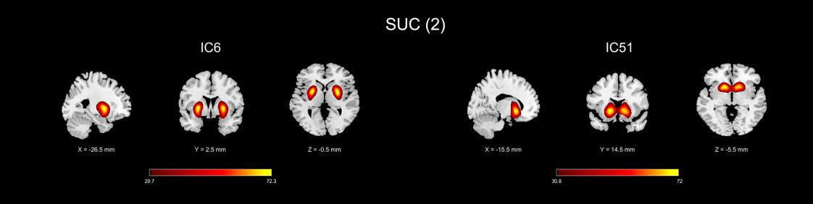

## Fig. S1. Spatial maps of intrinsic connectivity networks in subcortical domain. Intrinsic connectivity networks are divided into the 7 domains shown in Fig. 2 and are thresholded at |t|>10, where one-sample t-statistics have been computed across the single-subject SMs. Sagittal, coronal, and axial slices are shown at the maximal t-statistic for clusters larger than 3 cm3.

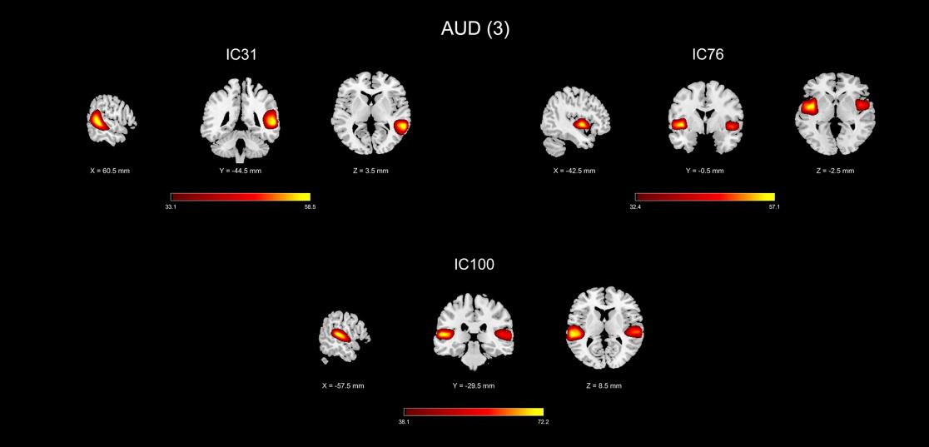

## Fig. S2. Spatial maps of intrinsic connectivity networks in auditory domain. Intrinsic connectivity networks are divided into the 7 domains shown in Fig. 2 and are thresholded at |t|>10, where one-sample t-statistics have been computed across the single-subject SMs. Sagittal, coronal, and axial slices are shown at the maximal t-statistic for clusters larger than 3 cm3.

## 4

## Fig. S3. Spatial maps of intrinsic connectivity networks in visual domain. Intrinsic connectivity networks are divided into the 7 domains shown in Figure 2 and are thresholded at |t|>10, where one-sample t-statistics have been computed across the single-subject SMs. Sagittal, coronal, and axial slices are shown at the maximal t-statistic for clusters larger than 3 cm3.

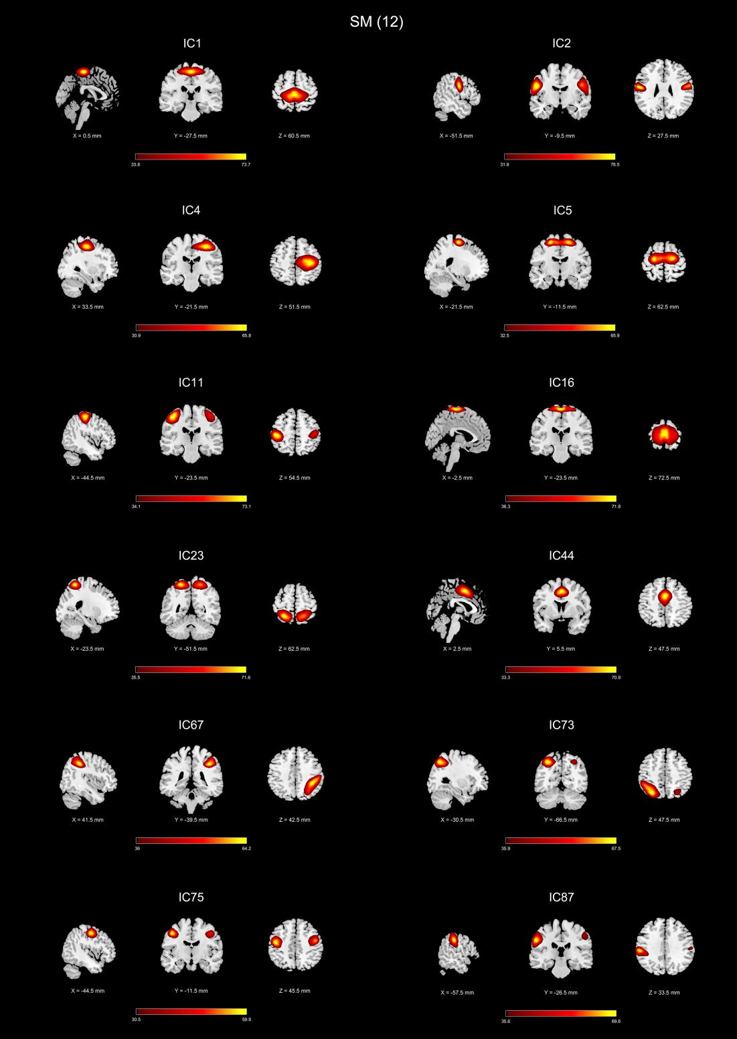

## Fig. S4. Spatial maps of intrinsic connectivity networks in sensorimotor domain. Intrinsic connectivity networks are divided into the 7 domains shown in Fig. 2 and are thresholded at |t|>10, where one-sample t-statistics have been computed across the single-subject SMs. Sagittal, coronal, and axial slices are shown at the maximal t-statistic for clusters larger than 3 cm3.

## 5

## Fig. S5. Spatial maps of intrinsic connectivity networks in cognitive control domain. Intrinsic connectivity networks are divided into the 7 domains shown in Fig. 2 and are thresholded at |t|>10, where one-sample t-statistics have been computed across the single-subject SMs. Sagittal, coronal, and axial slices are shown at the maximal t-statistic for clusters larger than 3 cm3.

## 6

## Fig. S6. Spatial maps of intrinsic connectivity networks in default mode domain. Intrinsic connectivity networks are divided into the 7 domains shown in Fig. 2 and are thresholded at |t|>10, where one-sample t-statistics have been computed across the single-subject SMs. Sagittal, coronal, and axial slices are shown at the maximal t-statistic for clusters larger than 3 cm3.

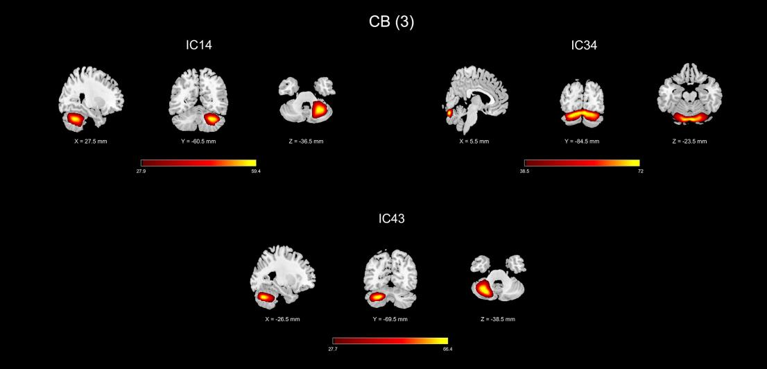

## Fig. S7. Spatial maps of intrinsic connectivity networks in cerebellum domain. Intrinsic connectivity networks are divided into the 7 domains shown in Figure 2 and are thresholded at |t|>10, where one-sample t-statistics have been computed across the single-subject SMs. Sagittal, coronal, and axial slices are shown at the maximal t-statistic for clusters larger than 3 cm3.

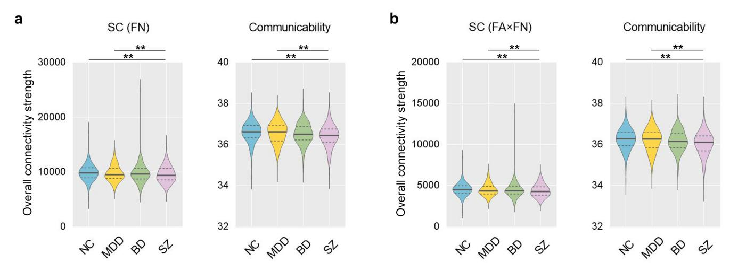

**Fig. S8.** Group differences in overall SC strength with different definition of SC weight. Violin plots showing mean (SD) level values of overall SC strength per participant group with (a) the number of deterministic fiber streamlines (FN) and (b) the production of average FA and FN (FA×FN). \*\**P*<0.01, FDR-corrected.

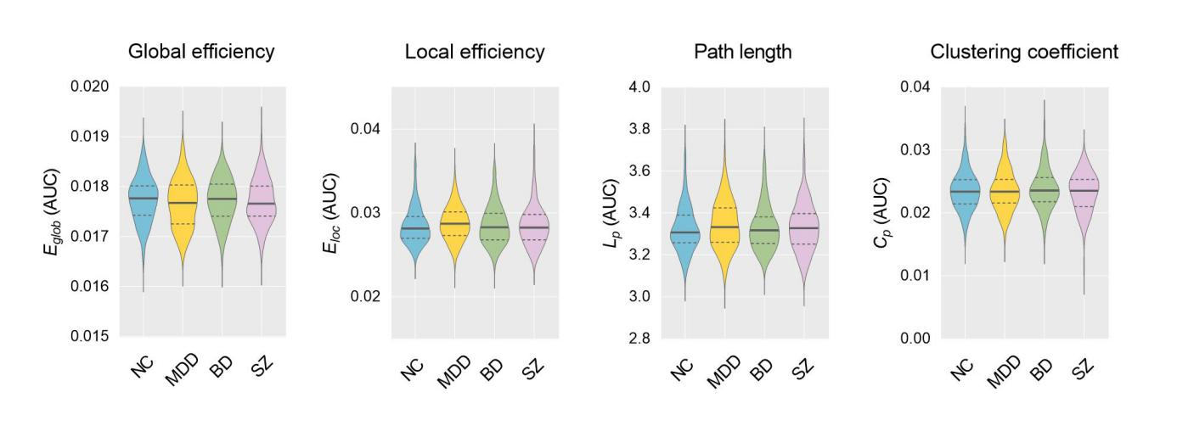

**Fig. S9.** Global topological properties of structural networks for each group. Violin plots showing mean (SD) level values of area under the curve (AUC) per participant group for global topological metrics, such as global efficiency, local efficiency, path length and clustering coefficient.

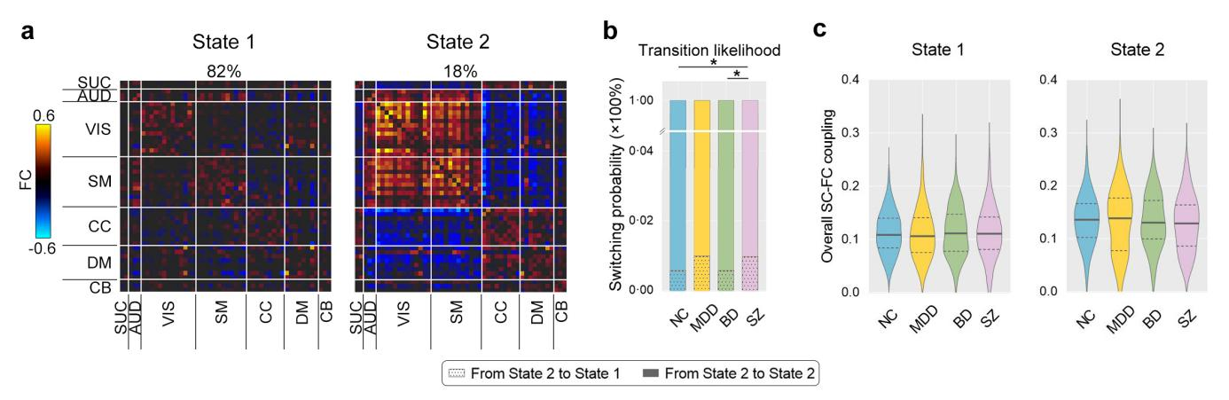

**Fig. S10.** Dynamic functional network connectivity patterns with 18 TRs. (a) Two discrete dynamic connectivity patterns across all groups. The percentage of occurrences is listed above each cluster centroid. The color bar represents z-value of FC. (b) Group differences in transition likelihood (TL). Bar plots showing mean level values of switching probability per participant group. (c) Violin plots showing mean level values of overall SC-FC coupling per participant group for each state. \**P*<0.05, FDR-corrected.

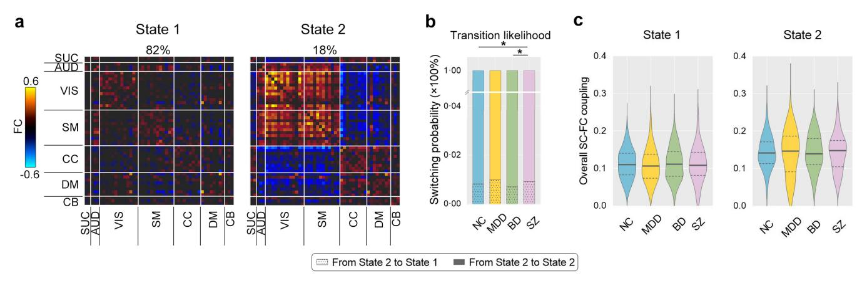

**Fig. S11.** Dynamic functional network connectivity patterns with 26 TRs. (a) Two discrete dynamic connectivity patterns across all groups. The percentage of occurrences is listed above each cluster centroid. The color bar represents z-value of FC. (b) Group differences in transition likelihood (TL). Bar plots showing mean level values of switching probability per participant group. (c) Violin plots showing mean level values of overall SC-FC coupling per participant group for each state. \**P*<0.05, FDR-corrected.

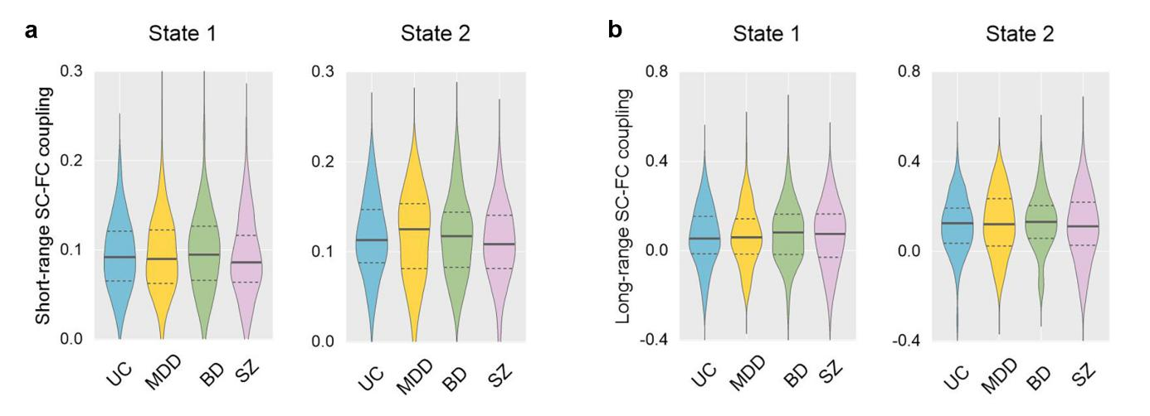**Fig. S12. Short- and long-range SC-FC coupling of overall connections.** (a) Violin plots depict the mean SC-FC coupling intensities for short-range connections, stratified by participant groups and states. (b) Corresponding representations for long-range connections, highlighting group-specific mean SC-FC coupling magnitudes for each state.

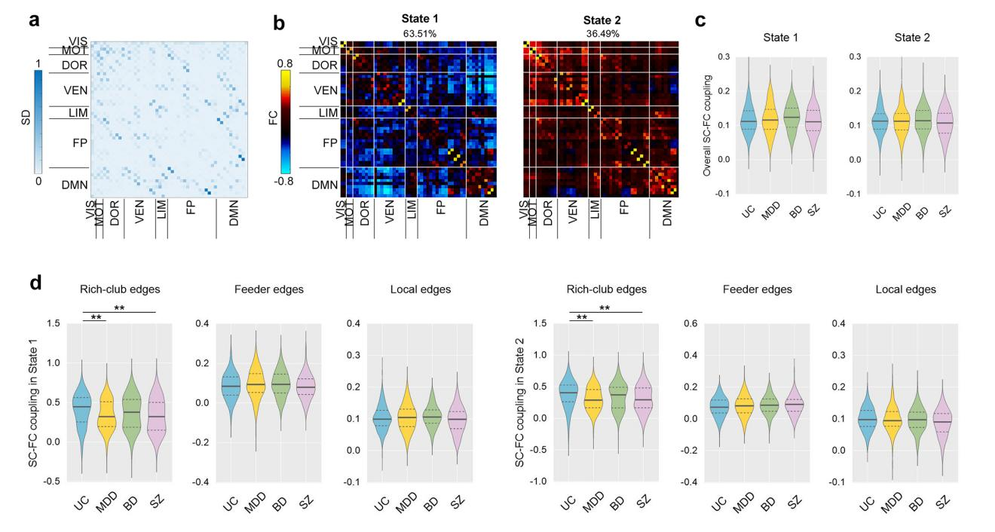

**Fig. S13.** **Dynamic SC-FC coupling patterns with Yeo' 7-network atlas.** (a) Averaged structural network connectivity matrix across all participants. (b) Two discrete connectivity patterns (states) across all groups. The percentage of occurrences is listed above each cluster centroid. The color bar represents the z-value of FC. (c) Violin plots showing mean level values of overall SC-FC coupling per participant group for each state. (d) Violin plots showing mean level values of SC-FC coupling of rich-club, feeder, and local edges per participant group for each state. VIS, visual network. MOT, somatomotor network. DOR, dorsal attention network. VEN, ventral attention network. LIM, limbic network. FP, frontal-parietal control network. DMN, default mode network. * *P* <.05, ** *P* <.01, *** *P* <.001, FDR-corrected.

# 

## Table S1. Demographic and clinical characteristics of all participants

|  |  |  |  |  |  |  |  |  |  |  |
| --- | --- | --- | --- | --- | --- | --- | --- | --- | --- | --- |
|  | **MDD**  **(n=166)** | **BD**  **(n=168)** | **SZ**  **(n=118)** | **UC**  **(n=205)** | **UC .vs MDD** | **UC .vs BD** | **UC .vs SZ** | **BD .vs MDD** | **BD .vs SZ** | **SZ .vs MDD** |
| Age (years) | 28.55 ± 9.03 | 27.81 ± 9.92 | 26.67 ± 8.38 | 26.79 ± 7.93 | *P* = .079a | *P* = .819a | *P* = .435a | *P* = .209a | *P* = .380a | *P* = .076a |
| Gender (males/females) | 60/106 | 78/90 | 63/55 | 90/115 | *P* = .056b | *P* = .014b | *P* = .130b | *P* = .246b | *P* = .626b | *P* = .010b |
| Handedness (right/left) | 166/0 | 168/0 | 118/0 | 205/0 | \ | \ | \ | \ | \ | \ |
| Education (years) | 13.70 ± 3.19 | 13.90 ± 3.00 | 12.27 ± 3.21 | 15.09 ± 3.27 | *P* < .001a | *P* < .001a | *P* < .001a | *P* = .653a | *P* < .001a | *P* < .001a |
| Illness duration (months) | 6.68 ± 5.93 | 7.10± 8.16 | 6.65 ± 6.99 | \ | \ | \ | \ | *P* = .263a | *P* = .269a | *P* = .913a |
| Medication situations (yes/no) | 0/166 | 120/48 | 0/118 | \ | \ | \ | \ | \ | \ | \ |
| HAMD scores | 21.13 ± 5.35 | 9.96 ± 7.18 | \ | \ | \ | \ | \ | *P* < .001a | \ | \ |
| YMRS scores | \ | 7.75 ± 9.10 | \ | \ | \ | \ | \ | \ | \ | \ |
| PANSS score |  |  |  |  |  |  |  |  |  |  |
| Total scores | \ | 48.32 ± 22.29 | 88.44 ± 21.28 | \ | \ | \ | \ | \ | *P* < .001a | \ |
| Positive symptoms | \ | 10.81 ± 6.65 | 22.77 ± 6.52 | \ | \ | \ | \ | \ | *P* < .001a | \ |
| Negative symptoms | \ | 10.60 ± 6.51 | 23.07 ± 8.31 | \ | \ | \ | \ | \ | *P* < .001a | \ |
| General symptoms | \ | 27.14 ± 12.14 | 42.61 ± 11.18 | \ | \ | \ | \ | \ | *P* < .001a | \ |
| Mean FD | 0.15 ± 0.06 | 0.15 ± 0.06 | 0.16 ± 0.07 | 0.14 ± 0.05 | *P* = .468a | *P* = .210a | *P* = .051a | *P* = .641a | *P* = .238a | *P* = .110a |

Note: a two-sample t-test, b chi-square t test; Values are mean ± SD.

Abbreviations: MDD, major depressive disorder; BD, bipolar disorder; SZ, schizophrenia; UC, unaffected control; HAMD, Hamilton rating scale for depression; YMRS, young mania rating scale; PANSS, positive and negative syndrome scale; FD, frame-wise displacement.

## Table S2. Peak activation information of the 50 ICNs

|  |  |  |  |  |  |  |  |  |
| --- | --- | --- | --- | --- | --- | --- | --- | --- |
| **ICNs** | **Anatomical regions** | **AAL** | **BA** | **MNI coordinates\*** | | | **Cluster size** | ***T*-value** |
| X | Y | Z |
| **SUC (2)** |  |  |  |  |  |  |  |  |
| IC6 | L putame | Putamen_L | - | -27 | 3 | 0 | 475 | 72.8721 |
|  | R putame | Putamen_R | - | 27 | 0 | 0 | 549 | 72.3142 |
| IC51 | B caudate | Caudate_L & _R | - | -15 | 15 | 6 | 1046 | 72.6876 |
| **AUD (3)** |  |  |  |  |  |  |  |  |
| IC31 | R superior temporal gyrus | Temporal_Sup_R | 22 | 60 | -45 | 3 | 918 | 58.9069 |
| IC76 | L superior temporal gyrus | Temporal_Sup_L | 22 | -42 | 0 | -3 | 544 | 57.8443 |
|  | R superior temporal gyrus | Temporal_Sup_R | 22 | 51 | 3 | -6 | 318 | 51.637 |
| IC100 | L superior temporal gyrus | Temporal_Sup_L | 22 | -57 | -30 | 9 | 635 | 72.9894 |
|  | R superior temporal gyrus | Temporal_Sup_R | 22 | 63 | -21 | 3 | 578 | 67.6655 |
| **VIS (13)** |  |  |  |  |  |  |  |  |
| IC8 | R middle occipital gyrus | Occipital_Mid_R | 18 | 24 | -72 | -6 | 1208 | 62.6373 |
| IC10 | L fusiform gyrus | Fusiform_L | 37 | -30 | -45 | -15 | 521 | 69.4835 |
|  | R fusiform gyrus | Fusiform_R | 37 | 30 | -45 | -15 | 482 | 63.4848 |
| IC17 | L lingual gyrus | Lingual_L | 18 | -27 | -72 | -12 | 1123 | 74.8584 |
| IC18 | B calcarine | Calcarine_L & _R | 18 | 0 | -90 | 3 | 1115 | 81.8455 |
| IC26 | B middle occipital gyrus | Occipital_Mid_L& _R | 18 | -21 | -99 | -3 | 1189 | 81.3029 |
| IC48 | B calcarine | Calcarine_L & _R | 30 | -12 | -60 | 9 | 1115 | 82.8608 |
| IC58 | L middle temporal gyrus | Temporal_Mid_L | 39 | -54 | -57 | 9 | 835 | 62.8346 |
| IC61 | B cuneus | Cuneus_L & _R | 18 | 0 | -84 | 21 | 1116 | 75.2879 |
| IC62 | L middle occipital gyrus | Occipital_Mid_L | 19 | -36 | -84 | 24 | 378 | 62.1592 |
|  | R middle occipital gyrus | Occipital_Mid_R | 19 | 42 | -81 | 27 | 451 | 62.3454 |
| IC66 | B cuneus | Cuneus_L & _R | 7 | -9 | -75 | 33 | 934 | 87.3546 |
| IC85 | L middle temporal gyrus | Temporal_Mid_L | 21 | -54 | -33 | -6 | 729 | 71.9404 |
|  | R middle temporal gyrus | Temporal_Mid_R | 21 | 54 | -30 | -9 | 171 | 48.8646 |
| IC97 | L middle occipital gyrus | Occipital_Mid_L | 19 | -36 | -87 | 6 | 513 | 62.0491 |
|  | R middle occipital gyrus | Occipital_Mid_R | 19 | 39 | -87 | 6 | 255 | 57.5417 |
| IC98 | L inferior temporal gyrus | Temporal_Inf_L | 37 | -48 | -57 | -12 | 665 | 58.901 |
|  | R inferior temporal gyrus | Temporal_Inf_R | 37 | 51 | -54 | -18 | 288 | 44.7758 |
| **SM (12)** |  |  |  |  |  |  |  |  |
| IC1 | B paracentral lobule | Paracentral_Lobule_L & _R | 6 | 0 | -27 | 60 | 1150 | 74.1385 |
| IC2 | L postcentral gyrus | Postcentral_L | 6 | -51 | -9 | 27 | 563 | 77.3989 |
|  | R postcentral gyrus | Postcentral_R | 6 | 60 | -3 | 24 | 480 | 70.4509 |
| IC4 | R precentral gyrus | Precentral_R | 6 | 33 | -21 | 51 | 1134 | 65.9543 |
| IC5 | L precentral gyrus | Precentral_L | 6 | -21 | -12 | 63 | 1042 | 67.0999 |
| IC11 | L postcentral gyrus | Postcentral_L | 3 | -45 | -24 | 54 | 774 | 73.7758 |
|  | R postcentral gyrus | Postcentral_R | 3 | 45 | -24 | 60 | 381 | 54.9344 |
| IC16 | B paracentral lobule | Paracentral_Lobule_L & _R | 6 | -3 | -24 | 72 | 1174 | 72.469 |
| IC23 | L superior parietal lobule | Parietal_Sup_L | 7 | -24 | -51 | 63 | 589 | 72.6097 |
|  | R superior parietal lobule | Parietal_Sup_R | 7 | 24 | -51 | 60 | 581 | 64.2688 |
| IC44 | B supplementary motor area | Supp_Motor_Area_L & _R | 24 | 3 | 6 | 48 | 878 | 71.2888 |
| IC67 | R supramarginal gyrus | SupraMarginal_R | 40 | 42 | -39 | 42 | 884 | 65.0924 |
| IC73 | L superior parietal lobule | Parietal_Sup_L | 40 | -30 | -66 | 48 | 820 | 67.8275 |
| IC75 | L precentral gyrus | Precentral_L | 6 | -45 | -12 | 45 | 421 | 60.5028 |
|  | R precentral gyrus | Precentral_R | 6 | 48 | -3 | 45 | 338 | 54.8149 |
| IC87 | L supramarginal gyrus | SupraMarginal_L | 40 | -57 | -27 | 33 | 656 | 70.7578 |
|  | R supramarginal gyrus | SupraMarginal_R | 40 | 57 | -24 | 45 | 151 | 43.6271 |
| **CC (9)** |  |  |  |  |  |  |  |  |
| IC20 | L superior frontal gyrus | Frontal_Sup_L | 9 | 0 | 33 | 36 | 1145 | 59.2537 |
| IC39 | L middle frontal gyrus | Frontal_Mid_L | 10 | -30 | 54 | 0 | 500 | 69.2805 |
|  | R middle frontal gyrus | Frontal_Mid_R | 10 | 33 | 57 | 0 | 336 | 64.5297 |
| IC41 | L middle frontal gyrus | Frontal_Inf_Oper_L | 9 | -42 | 12 | 27 | 571 | 64.5679 |
|  | R middle frontal gyrus | Frontal_Inf_Oper_R | 9 | 45 | 15 | 30 | 251 | 51.5105 |
| IC69 | B supplementary motor area | Supp_Motor_Area_L & _R | 6 | -3 | 12 | 63 | 570 | 70.9771 |
| IC77 | R middle frontal gyrus | Frontal_Mid_R | 10 | 27 | 48 | 24 | 972 | 59.5788 |
| IC86 | L inferior frontal gyrus | Frontal_Inf_Tri_L | 46 | -48 | 33 | 6 | 849 | 61.7941 |
| IC89 | L inferior parietal lobule | Parietal_Inf_L | 40 | -57 | -51 | 39 | 506 | 67.4521 |
|  | R inferior parietal lobule | Parietal_Inf_R | 40 | 57 | -48 | 39 | 362 | 58.4803 |
| IC90 | L insula | Insula_L | 47 | -36 | 18 | -12 | 385 | 63.2478 |
|  | R insula | Insula_R | 47 | 36 | 24 | -12 | 483 | 69.3451 |
| IC96 | R inferior frontal gyrus | Frontal_Inf_Oper_R | 46 | 48 | 12 | 21 | 881 | 62.7148 |
| **DM (8)** |  |  |  |  |  |  |  |  |
| IC45 | B medial frontal gyrus | Frontal_Sup_Medial_L & _R | 9 | 0 | 54 | 24 | 857 | 70.2881 |
| IC50 | B precuneus | Precuneus_L & _R | 7 | 0 | -60 | 51 | 957 | 81.7218 |
| IC52 | L anterior cingulate cortex | Cingulum_Ant_L & _R | 32 | 6 | 27 | 18 | 999 | 65.9704 |
| IC53 | R angular gyrus | Angular_R | 39 | 48 | -66 | 39 | 392 | 67.942 |
| IC72 | B posterior cingulate cortex | Cingulum_Post_L & _R | 31 | -3 | -33 | 27 | 1082 | 74.1042 |
| IC82 | B medial frontal gyrus | Frontal_Med_Orb_L & _R | 11 | -15 | 36 | -9 | 1032 | 68.1849 |
| IC83 | B precuneus | Precuneus_L & _R | 31 | -3 | -63 | 27 | 433 | 72.0676 |
| IC93 | L anterior cingulate cortex | Cingulum_Ant_L & _R | 32 | -3 | 48 | -3 | 943 | 80.7231 |
| **CB (3)** |  |  |  |  |  |  |  |  |
| IC14 | R cerebellum | Cerebelum_6 _R | - | 27 | -60 | -36 | 996 | 59.9837 |
| IC34 | B cerebellum | Cerebelum_Crus1_L & _R | - | 6 | -84 | -24 | 1245 | 73.0976 |
| IC43 | B cerebellum | Cerebelum_Crus2_L | - | -27 | -69 | -39 | 830 | 66.9409 |

*The coordinates are peak voxel coordinates of the one-sample t-test results for each component spatial maps of all participants. A color-coded legend of each IC number matches to the overlaid colors of the spatial maps in Figure S2. Abbreviations: ICNs, intrinsic connectivity networks; IC, independent component; BA, Brodmann area; L, left; R, right; B, bilateral.

## Table S3. Group differences in regional SC-FC coupling with Yeo' 7-network atlas

|  |  |  |  |  |
| --- | --- | --- | --- | --- |
|  | **State 1** | | **State 2** | |
| *Brain regions* | *P-value* | *Brain regions* | *P-value* |
| BD > UC | R_DMN_medial prefrontal cortex | < .001 |  |  |
| SZ > UC | R_DOR_precentral ventral | = .002 | L_VEN_medial | < .001 |
| R_VEN_medial | < .001 | L_DMN posterior cingulate cortex | < .001 |
| R_DMN_temporal | < .001 |  |  |
| SZ > BD | L_VEN_medial | = .001 | R_DMN_temporal | < .001 |
| SZ > MDD | L_VEN_parietal operculum | < .001 |  |  |
| L_VEN_medial | < .001 |  |  |
| R_DMN_temporal | < .001 |  |  |

Note. L, left. R, right.

# Supplementary References

Allen, E. A., Damaraju, E., Plis, S. M., Erhardt, E. B., Eichele, T., & Calhoun, V. D. (2014). Tracking Whole-Brain Connectivity Dynamics in the Resting State. *Cereb Cortex, 24*(3), 663-676. https://doi.org/10.1093/cercor/bhs352.

Bell, A. J., & Sejnowski, T. J. (1995). An information-maximization approach to blind separation and blind deconvolution. *Neural Computing, 7*(6), 1129–1159. https://doi.org/10.1162/neco.1995.7.6.1129.

Calhoun, V. D., Adali, T., Pearlson, G. D., & Pekar, J. J. (2001). A method for making group inferences from functional MRI data using independent component analysis. *Hum Brain Mapp, 14*(3), 140-151. https://doi.org/10.1002/hbm.1048.

Cheng, H., Wang, Y., Sheng, J., Sporns, O., Kronenberger, W. G., Mathews, V. P., . . . Saykin, A. J. (2012). Optimization of seed density in DTI tractography for structural networks. *J Neurosci Methods, 203*(1), 264-272. https://doi.org/10.1016/j.jneumeth.2011.09.021.

Collin, G., Scholtens, L. H., Kahn, R. S., Hillegers, M. H. J., & van den Heuvel, M. P. (2017). Affected Anatomical Rich Club and Structural-Functional Coupling in Young Offspring of Schizophrenia and Bipolar Disorder Patients. *Biol Psychiatry, 82*(10), 746-755. https://doi.org/10.1016/j.biopsych.2017.06.013.

Cortes, C., & Vapnik, V. (1995). Support-vector networks. *Machine Learning, 20*(3), 273-297.

Crofts, J. J., & Higham, D. J. (2009). A weighted communicability measure applied to complex brain networks. *Journal of the Royal Society Interface, 6*(33), 411-414. https://doi.org/10.1098/rsif.2008.0484.

Crossley, N. A., Marques, T. R., Taylor, H., Chaddock, C., Dell'Acqua, F., Reinders, A. A., . . . Dazzan, P. (2017). Connectomic correlates of response to treatment in first-episode psychosis. *Brain, 140*(2), 487-496. https://doi.org/10.1093/brain/aww297.

Cui, Z., Zhong, S., Xu, P., He, Y., & Gong, G. (2013). PANDA: a pipeline toolbox for analyzing brain diffusion images. *Front Hum Neurosci, 7*, 42. https://doi.org/10.3389/fnhum.2013.00042.

Fiorenzato, E., Strafella, A. P., Kim, J., Schifano, R., Weis, L., Antonini, A., & Biundo, R. (2019). Dynamic functional connectivity changes associated with dementia in Parkinson's disease. *Brain, 142*(9), 2860-2872. https://doi.org/10.1093/brain/awz192.

Guimerà, R., & Amaral, L. A. N. (2005). Cartography of complex networks: modules and universal roles. *Journal of Statistical Mechanics: Theory and Experiment, 2005*(02). https://doi.org/10.1088/1742-5468/2005/02/p02001.

Kim, J., Criaud, M., Cho, S. S., Díez-Cirarda, M., Mihaescu, A., Coakeley, S., . . . Strafella, A. P. (2017). Abnormal intrinsic brain functional network dynamics in Parkinson's disease. *Brain, 140*, 2955-2967. https://doi.org/10.1093/brain/awx233.

Kulik, S. D., Nauta, I. M., Tewarie, P., Koubiyr, I., Van Dellen, E., Ruet, A., . . . Schoonheim, M. M. (2022). Structure-function coupling as a correlate and potential biomarker of cognitive impairment in multiple sclerosis. *Network Neuroscience, 6*(2), 339-356. https://doi.org/10.1162/netn_a_00226.

Latora, V., & Marchiori, M. (2001). Efficient Behavior of Small-World Networks. *Physical Review Letters, 87*(19), 198701. https://doi.org/10.1103/PhysRevLett.87.198701.

Li, Z., Zhao, L., Ji, J., Ma, B., Zhao, Z., Wu, M., . . . Zhang, Z. (2022). Temporal Grading Index of Functional Network Topology Predicts Pain Perception of Patients With Chronic Back Pain. *Front Neurol, 13*. https://doi.org/10.3389/fneur.2022.899254.

Liu, X. Y., He, C. C., Fan, D. D., Zang, F. F., Zhu, Y., Zhang, H. S., . . . Xie, C. M. (2021). Alterations of core structural network connectome associated with suicidal ideation in major depressive disorder patients. *Transl Psychiatry, 11*, 243. https://doi.org/10.1038/s41398-021-01353-3.

Maslov, S., & Sneppen, K. (2002). Specificity and stability in topology of protein networks. *Science, 296*(5569), 910-913. https://doi.org/10.1126/science.1065103.

Meijer, K. A., Steenwijk, M. D., Douw, L., Schoonheim, M. M., & Geurts, J. J. G. (2020). Long-range connections are more severely damaged and relevant for cognition in multiple sclerosis. *Brain, 143*(1), 150-160. https://doi.org/10.1093/brain/awz355.

Mori, S., Crain, B. J., Chacko, V. P., & Van Zijl, P. C. (1999). Three-dimensional tracking of axonal projections in the brain by magnetic resonance imaging. *Ann Neurol, 45*, 265–269. https://doi.org/10.1002/1531-8249(199902)45:2<265::AID-ANA21>3.0.CO;2-3.

Opsahl, T., Colizza, V., Panzarasa, P., & Ramasco, J. J. (2008). Prominence and control: the weighted rich-club effect. *Phys Rev Lett, 101*(16), 168702. https://doi.org/10.1103/PhysRevLett.101.168702.

Pereira, F., Mitchell, T., & Botvinick, M. (2009). Machine learning classifiers and fMRI: a tutorial overview. *Neuroimage, 45*(1 Suppl), S199-209. https://doi.org/10.1016/j.neuroimage.2008.11.007.

Power, J. D., Schlaggar, B. L., Lessov-Schlaggar, C. N., & Petersen, S. E. (2013). Evidence for hubs in human functional brain networks. *Neuron, 79*(4), 798-813.https://doi.org/10.1016/j.neuron.2013.07.035.

Rubinov, M., & Sporns, O. (2010). Complex network measures of brain connectivity: uses and interpretations. *Neuroimage, 52*(3), 1059-1069. https://doi.org/10.1016/j.neuroimage.2009.10.003.

Shirer, W. R., Ryali, S., Rykhlevskaia, E., Menon, V., & Greicius, M. D. (2012). Decoding subject-driven cognitive states with whole-brain connectivity patterns. *Cereb Cortex, 22*(1), 158-165. https://doi.org/10.1093/cercor/bhr099.

Smith, S. M., Miller, K. L., Salimi-Khorshidi, G., Webster, M., Beckmann, C. F., Nichols, T. E., . . . Woolrich, M. W. (2011). Network modelling methods for FMRI. *Neuroimage, 54*(2), 875-891. https://doi.org/10.1016/j.neuroimage.2010.08.063.

Tu, Y., Fu, Z., Mao, C., Falahpour, M., Gollub, R. L., Park, J., . . . Kong, J. (2020). Distinct thalamocortical network dynamics are associated with the pathophysiology of chronic low back pain. *Nat Commun, 11*(1), 3948. https://doi.org/10.1038/s41467-020-17788-z.

Tu, Y., Fu, Z., Zeng, F., Maleki, N., Lan, L., Li, Z., . . . Kong, J. (2019). Abnormal thalamocortical network dynamics in migraine. *Neurology, 92*(23), e2706-e2716. https://doi.org/10.1212/WNL.0000000000007607.

van den Heuvel, M. P., Kahn, R. S., Goni, J., & Sporns, O. (2012). High-cost, high-capacity backbone for global brain communication. *Proceedings of the National Academy of Sciences, 109*(28), 11372-11377. https://doi.org/10.1073/pnas.1203593109.

van den Heuvel, M. P., Scholtens, L. H., de Reus, M. A., & Kahn, R. S. (2016). Associated Microscale Spine Density and Macroscale Connectivity Disruptions in Schizophrenia. *Biol Psychiatry, 80*(4), 293-301. https://doi.org/10.1016/j.biopsych.2015.10.005.

van den Heuvel, M. P., & Sporns, O. (2011). Rich-club organization of the human connectome. *J Neurosci, 31*(44), 15775-15786. https://doi.org/10.1523/JNEUROSCI.3539-11.2011.

van den Heuvel, M. P., Sporns, O., Collin, G., Scheewe, T., Mandl, R. C., Cahn, W., . . . Kahn, R. S. (2013). Abnormal rich club organization and functional brain dynamics in schizophrenia. *JAMA Psychiatry, 70*(8), 783-792. https://doi.org/10.1001/jamapsychiatry.2013.1328.

Watts, D. J., & Strogatz, S. H. (1998). Collective dynamics of ‘small-world’networks. *Nature, 393*(6684), 440.

Yan, C., & Zang, Y. (2010). DPARSF: A MATLAB Toolbox for "Pipeline" Data Analysis of Resting-State fMRI. *Front Syst Neurosci, 4*, 13. https://doi.org/10.3389/fnsys.2010.00013.

Yu, Q., Erhardt, E. B., Sui, J., Du, Y., He, H., Hjelm, D., . . . Calhoun, V. D. (2015). Assessing dynamic brain graphs of time-varying connectivity in fMRI data: application to healthy controls and patients with schizophrenia. *Neuroimage, 107*, 345-355. https://doi.org/10.1016/j.neuroimage.2014.12.020.

Zamani Esfahlani, F., Faskowitz, J., Slack, J., Misic, B., & Betzel, R. F. (2022). Local structure-function relationships in human brain networks across the lifespan. *Nat Commun, 13*, 2053. https://doi.org/10.1038/s41467-022-29770-y.