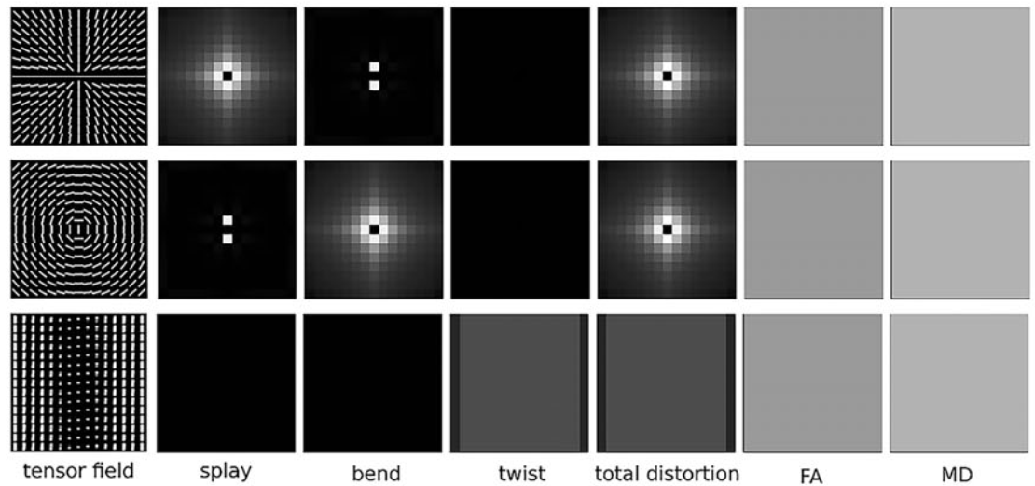
Figure S1. Three synthetic tensor fields with splay, bend, and twist geometric patterns, and their six different index maps (splay, bend, twist, total distortion, FA, and MD). All tensors in these three tensor fields share the same shape but with different orientations, resulting in constant FA and MD maps. Notably, DFA indices (i.e., Splay, bend and twist) could effectively distinguish these three tensor fields, where each tensor field has only one non-zero index map if disregarding the influence of singular points at the center. The figure is adapted from(Zhao, Cheng, Liu et al. 2021)

Figure S2. WM tracts associated with significant changes in bend, splay and twist in patients with OCD. Compared with HCs, patients with OCD showed decreased bend in the majority of the whole callosum, the left posterior corona radiata and the right anterior corona radiata, increased splay in the genu and the body of the callosum and decreased splay in left posterior corona radiata, and decreased twist in the genu and the body of the callosum. These results were corrected for multiple comparisons using TFCE.

Reference
Zhao H, Cheng J, Liu T, Jiang J, Koch F, Sachdev PS, Basser PJ, et al. (2021) Orientational changes of white matter fibers in Alzheimer's disease and amnestic mild cognitive impairment. 42(16), 5397-5408.

