Methods: Family Study
Participants
Participants of our family study were recruited at two research sites: London (UK) and Belmont (MA, USA). The study was approved by the local ethics committee at both research sites. All participants provided written informed consent before assessments. Both research sites recruited patients with psychosis and controls, while the London sample also recruited the unaffected relatives of patients. Patients and their relatives were recruited by clinical teams at mental health services in London and at McLean Hospital (Belmont, MA, USA), while controls were recruited in local communities via advertisements. Patients were defined as those who received a diagnosis of psychotic disorders (schizophrenia, bipolar I disorder, schizoaffective disorder, schizophreniform disorder, delusional disorder, brief psychotic episode or other psychotic disorder not otherwise specified) based on the Diagnostic and Statistical Manual of Mental Disorders, fourth edition (DSM-IV) (American Psychiatric Association, 1994). The diagnoses were validated by the Structured Clinical Interview for DSM Disorders (SCID) (Spitzer et al., 1992; Williams et al., 1992) or the Schedule for Affective Disorders and Schizophrenia (SADS) (Endicott & Spitzer, 1978). In addition, patients completed the Positive and Negative Syndrome Scale (PANSS) for schizophrenia (Kay et al., 1987). Controls in the study did not have any personal or family histories of psychosis. Unaffected relatives recruited in London were the first-degree relatives of the patients without personal histories of psychosis.
EEG Recording and Processing
London. Participants’ EEG was recorded during an auditory oddball paradigm. Stimuli in the paradigm were 400 binaural 80 dB tones of 20 ms duration. They included 20% 1500 Hz target tones randomly embedded in 80% 1000 Hz standard tones with an interstimulus interval of 2 s. Participants were instructed to press a button only when they detected a target tone. EEG was continuously recorded by the Neuroscan system (Scan 4.0; Compumedics, Victoria, Australia) at a digitization rate of 500 Hz, with a bandpass of 0.03 to 120 Hz, and from 17 scalp sites referenced to the left earlobe.
EEG data were processed using the EEGLAB toolbox (Delorme & Makeig, 2004) in MATLAB R2021b (MathWorks, Natick, MA, USA). Signals were bandpass filtered between 0.1 and 30 Hz. EEG data were segmented into epochs by stimulus marker (−200 to 800 ms) and baseline corrected (−200 to 0 ms pre-stimulus). Eye blinks were removed using independent component analysis, where raw data were separately filtered using a high-pass filter of 1 Hz and then decomposed into independent components (Delorme & Makeig, 2004). Components were labelled using an automated algorithm and those labelled as eye artefacts with a probability > 80% were removed (Pion-Tonachini et al., 2019). We also performed an additional visual inspection and removed artefacts that were not detected by the algorithm. Epochs at individual channels were rejected if the amplitude exceeded ±100 μV or the voltage change exceeded 100 μV in a 200 ms window.
Belmont. Participants’ EEG was recorded during an auditory oddball paradigm. Stimuli in the paradigm were 400 binaural 80 dB tones of 50 ms duration. They included 15% 1500 Hz target tones randomly embedded in 85% 1000 Hz standard tones with an interstimulus interval of 1.8 to 2.2 s. Participants were instructed to press a button when they detected a target tone. EEG was continuously recorded by the BioSemi Active Two system (BioSemi Inc., Amsterdam, Netherlands) at a digitization rate of 512 Hz, with a bandpass of DC–104 Hz, and a Common Mode Sense (CMS) as the reference (PO2 site) using either an 18- or 64-channel electrode cap.
EEG data were processed using BrainVision Analyzer 2 (Brain Products GmbH, Munich, Germany). Signals were re-referenced to an average of the mastoids and bandpass filtered between 0.01 and 20 Hz. EEG data were segmented into epochs by stimulus marker (−100 to 1000 ms) and baseline corrected (−100 to 0 ms pre-stimulus). Eye blinks were removed using a regression-based method (Gratton et al., 1983). Epochs at individual channels were rejected if the amplitude exceeded ±100 μV, the voltage gradient exceeded 50 μV/ms, or the signal was flat (< 0.5 μV for >100 ms).
N100 amplitudes and latencies to the standard stimuli were measured at the Cz electrode at both research sites. N100 amplitudes were measured as the most negative peak amplitude between a window from 50 to 200 ms post-stimulus. N100 latencies were measured as the interval between the N100 peak and stimulus onset.
Results: Meta-Analysis
Primary Meta-Analysis with Uncorrected Outlier Data
As one outlier study had unusually small SDs for the N100 latency (15), we calculated new corrected SDs using the original SDs as SEs and used the corrected SDs for the meta-analysis. We also performed separate analyses using the uncorrected data and sensitivity analyses excluding this outlier study, and the results of those analyses are presented below.
For the primary meta-analysis comparing patients with psychosis and controls in family studies, we found very strong evidence that patients had reduced N100 amplitudes compared to controls with a medium effect size (SMD: −0.48; 95% CI: −0.59 to −0.36; p < 0.001; I² = 31%; Figure S1A). Similarly, we found evidence that patients with psychosis had longer N100 latencies than controls (SMD: 0.87; 95% CI: 0.20 to 1.53; p = 0.010; Figure S1B), but with very high heterogeneity across included studies due to the inclusion of the outlier study (I² = 95%). This result remained significant after excluding the outlier study (SMD: 0.20; 95% CI: 0.02 to 0.39; p = 0.029; I² = 31%; Figure S1C).
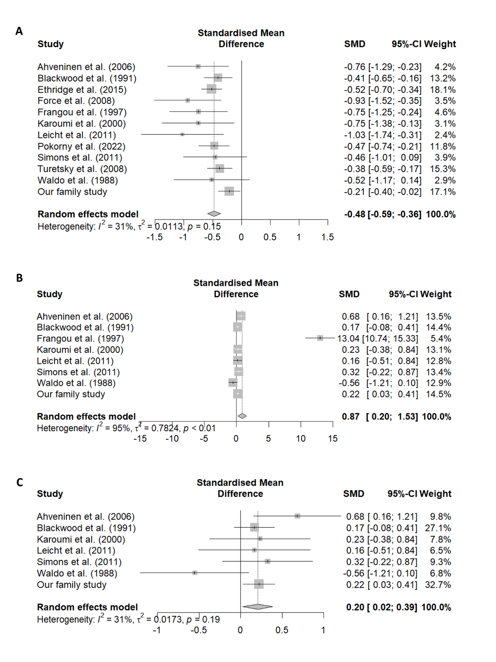
Figure S1. Forest plots comparing N100 amplitude between 999 patients and 1,216 controls (A), N100 latency between 466 patients and 585 controls (B), and N100 latency between 433 patients and 553 controls after excluding one outlier study (C). SMD, standardised mean difference.
For the N100 amplitude, we found evidence that relatives had significantly smaller N100 amplitudes than controls with a small effect size (SMD: −0.20; 95% CI: −0.35 to −0.05; p = 0.011; I² = 60%; Figure S2A). The meta-analysis also revealed that relatives had significantly longer N100 latencies than controls (SMD: 0.76; 95% CI: 0.21 to 1.30; p = 0.006; Figure S2B), but with very high heterogeneity across included studies due to the inclusion of the outlier study (I² = 92%; Figure S2B). The effect remained significant after excluding the outlier study (SMD: 0.33; 95% CI: 0.14 to 0.52; p < 0.001; Figure S2C), with lower heterogeneity among remaining studies (I² = 31%; Figure S2C).
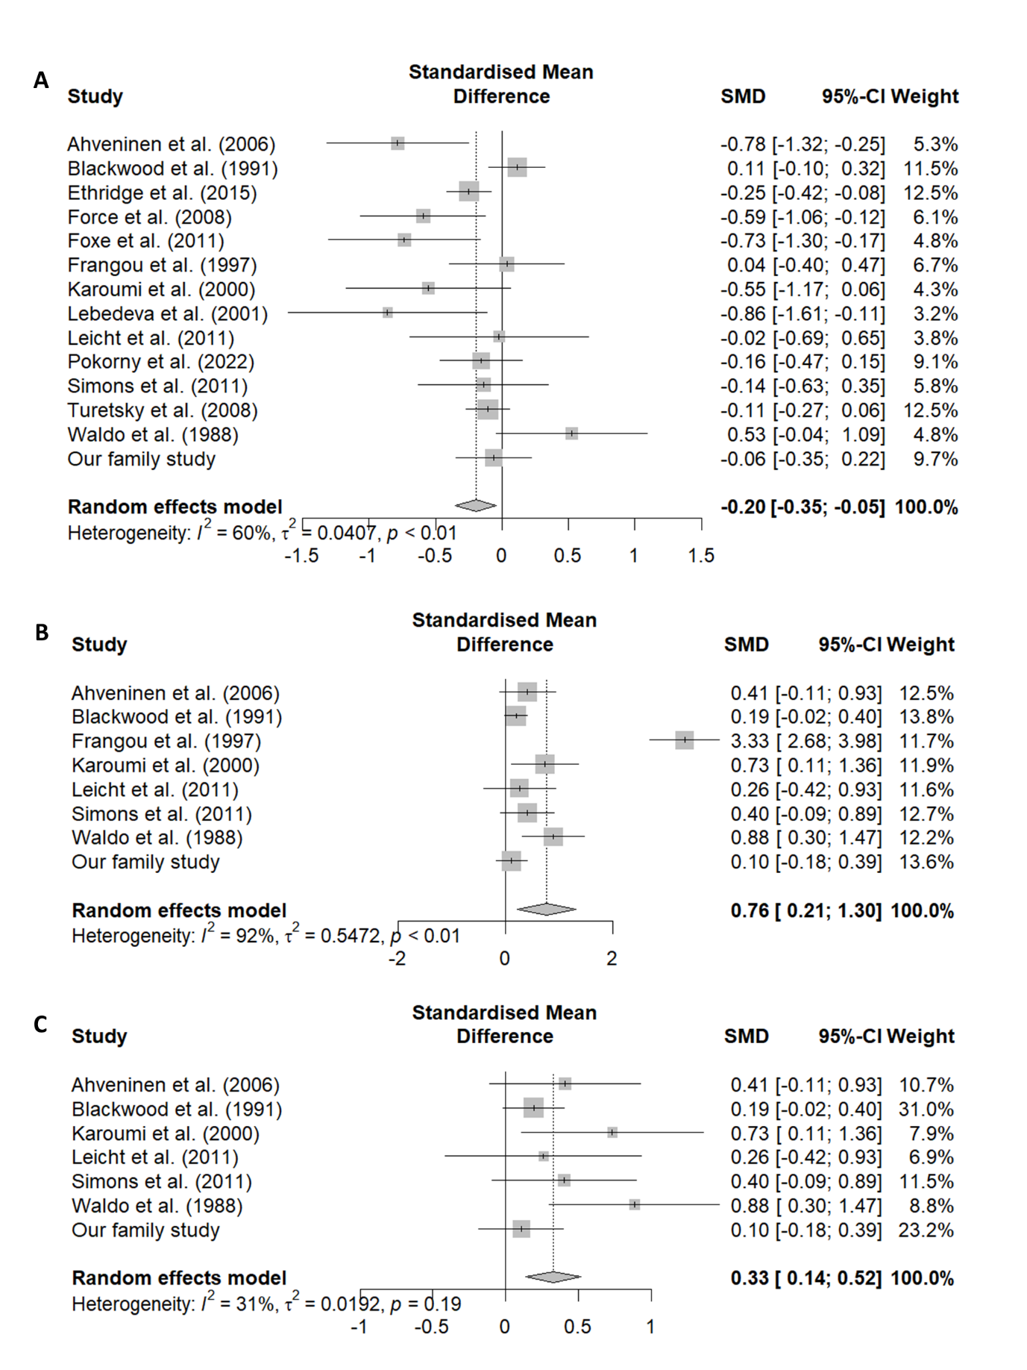
Figure S2. Forest plots comparing N100 amplitude between 1,192 relatives and 1,253 controls (A), N100 latency between 402 relatives and 585 controls (B), and N100 latency between N100 latency between 382 relatives and 553 controls after excluding one outlier study (C). SMD, standardised mean difference.

Forest Plots of Sensitivity Analysis of Meta-Analysis
Figure S3 shows the forest plot of sensitivity analysis of the primary meta-analysis comparing patients and controls after excluding participants with broad clinical status. It yielded consistent results with the primary meta-analysis (SMD: −0.48; 95% CI: −0.60 to −0.36; p < 0.001; I² = 30%). No sensitivity analyses were conducted for N100 latency between patients and controls, as no studies involved participants with broad clinical status or affected relatives.
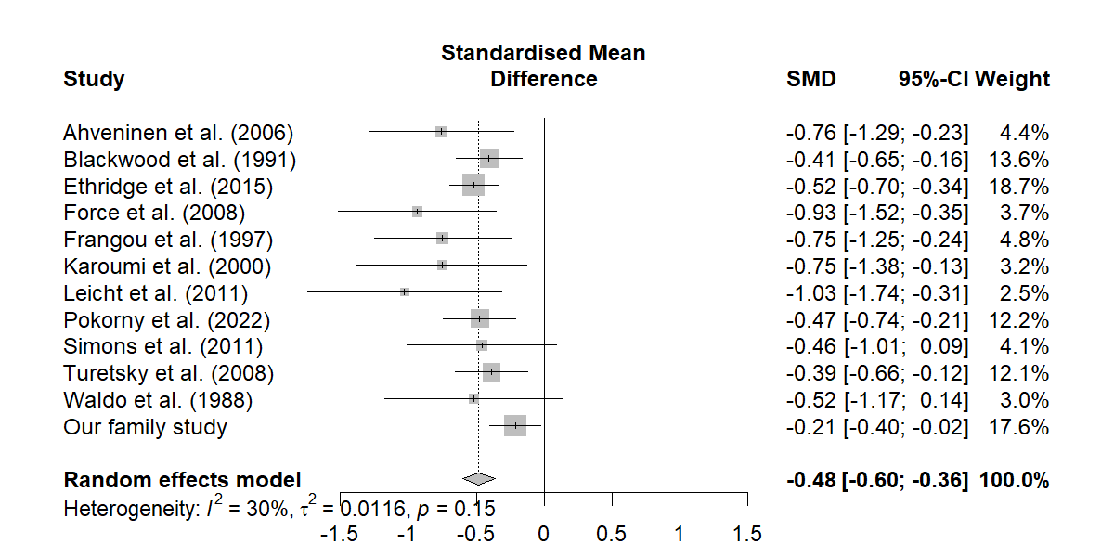
Figure S3. Forest plot of sensitivity analysis of the primary meta-analysis comparing the N100 amplitude between 941 patients and 1,148 controls after excluding samples with broad clinical status. SMD, standardised mean difference.

For sensitivity analyses of the primary meta-analysis comparing relatives and control, after excluding samples with affected relatives and with broad clinical status, the difference between patients with controls on N100 amplitude became no longer significant (SMD: −0.27; 95% CI: −0.62 to 0.08; p = 0.129; I² = 74%; Figure S4A). By contrast, after excluding samples with affected relatives, the sensitivity analysis on N100 latency between relatives and controls showed consistent results with the primary meta-analysis (SMD: 0.40; 95% CI: 0.19 to 0.61; p < 0.001; I² = 23%; Figure S4B).
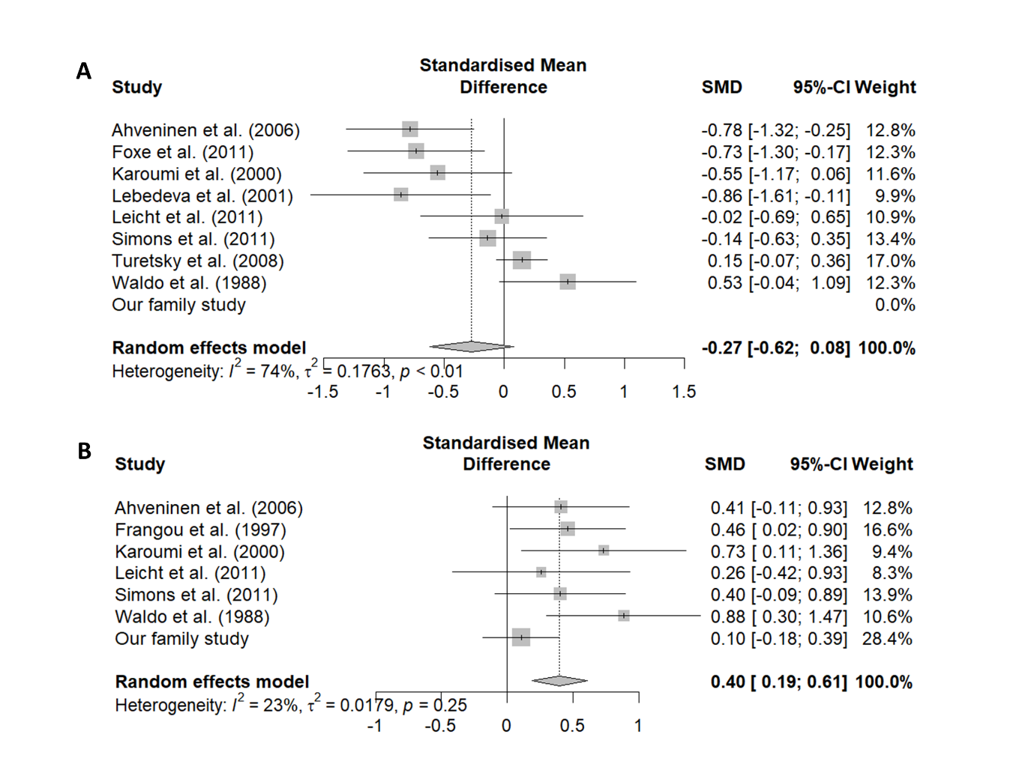
Figure S4. Forest plots of sensitivity analysis of primary meta-analysis comparing the N100 amplitude between 435 relatives and 532 controls after excluding samples with affected relatives and broad clinical status (A) and the N100 latency between 252 unaffected relatives and 374 controls after excluding samples with affected relatives (B). SMD, standardised mean difference.

Because the reduction in N100 amplitude was no longer significant after excluding affected relatives and participants with broad clinical status, one might postulate that only the N100 latency was associated with the genetic risk for psychosis, while the N100 amplitude was more associated with the state of psychosis and/or medication effect. Alternatively, the primary meta-analysis as well as its corresponding sensitivity analysis might have been biased due to the inclusion of Waldo et al. (1988) (Waldo et al., 1988), whose sample was distinct from other included studies as it was intentionally selected to represent two subgroups: those with and without P50 gating deficits. We combined the results of those two subgroups together and included the study in the primary meta-analysis, but the larger amplitudes of relatives in this study might have biased the results, especially in the sensitivity analysis that had reduced statistical power. This could also explain why the subgroup analysis focusing on the oddball paradigm remained significant in the sensitivity analysis, as it was not affected by this particular study.

Subgroup Analysis
For the comparison between patients and controls, the subgroup analysis including only studies that used the oddball paradigm and its variants yielded consistent results with the primary analysis for N100 amplitude (SMD: −0.51; 95% CI: −0.66 to −0.37; p < 0.001; I² = 42%; Figure S5A) and N100 latency (SMD: 0.55; 95% CI: 0.14 to 0.95; p = 0.008; I² = 86%; Figure S5B).
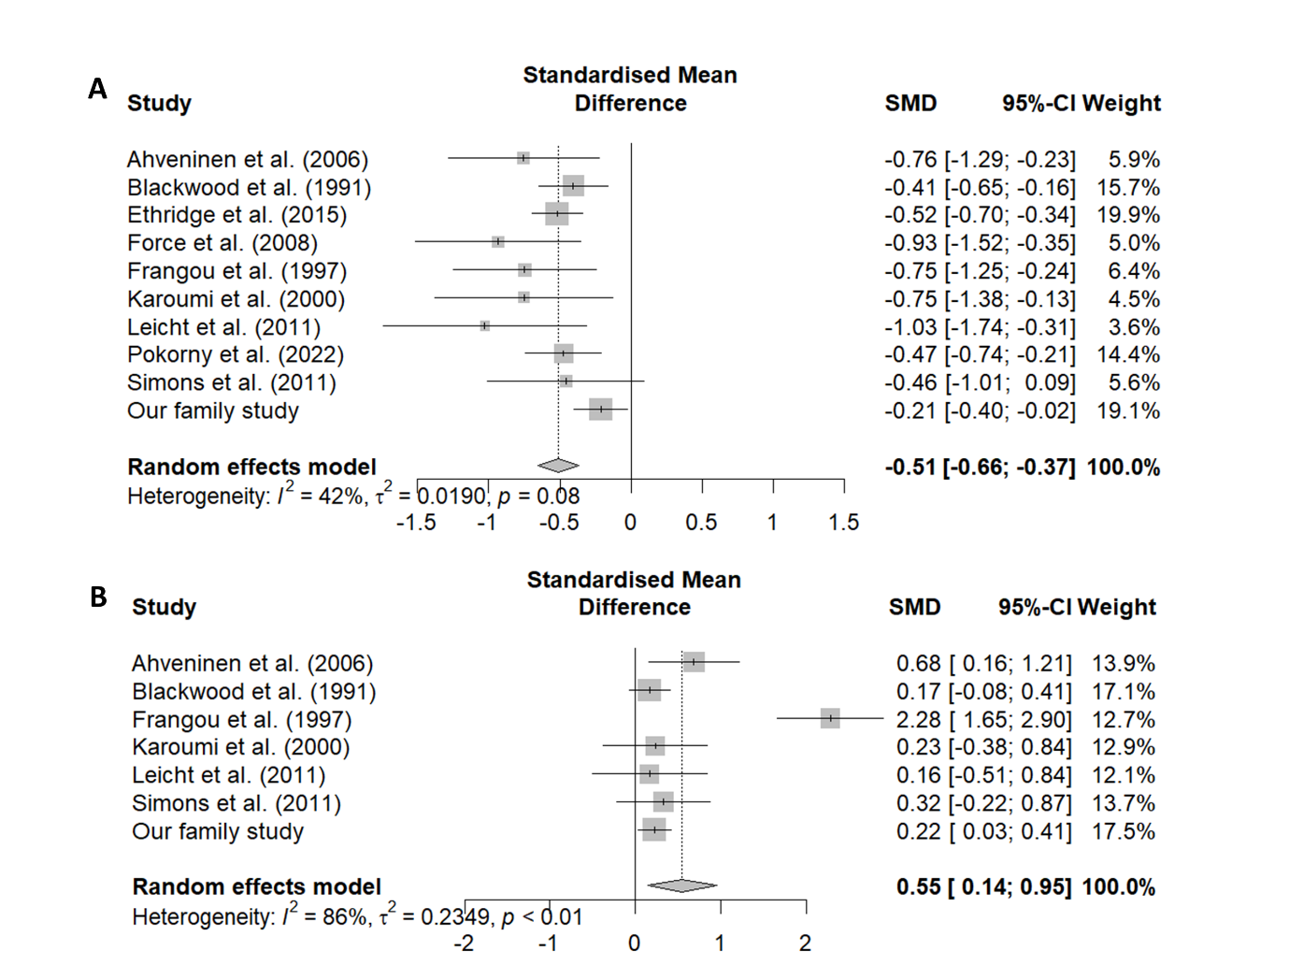
Figure S5. Forest plots of the subgroup analysis including only studies using the oddball paradigm or its variants comparing the N100 amplitude between 844 patients and 963 controls (A) and the N100 latency between 453 patients and 553 controls (B). SMD, standardised mean difference.

For the comparison between relatives and controls, the subgroup analysis showed consistent results with the primary analysis for N100 amplitude (SMD: −0.26; 95% CI: −0.43 to −0.09; p = 0.003; I² = 58%; Figure S6A) and N100 latency (SMD: 0.26; 95% CI: 0.12 to 0.40; p < 0.001; I² = 0%; Figure S6B).
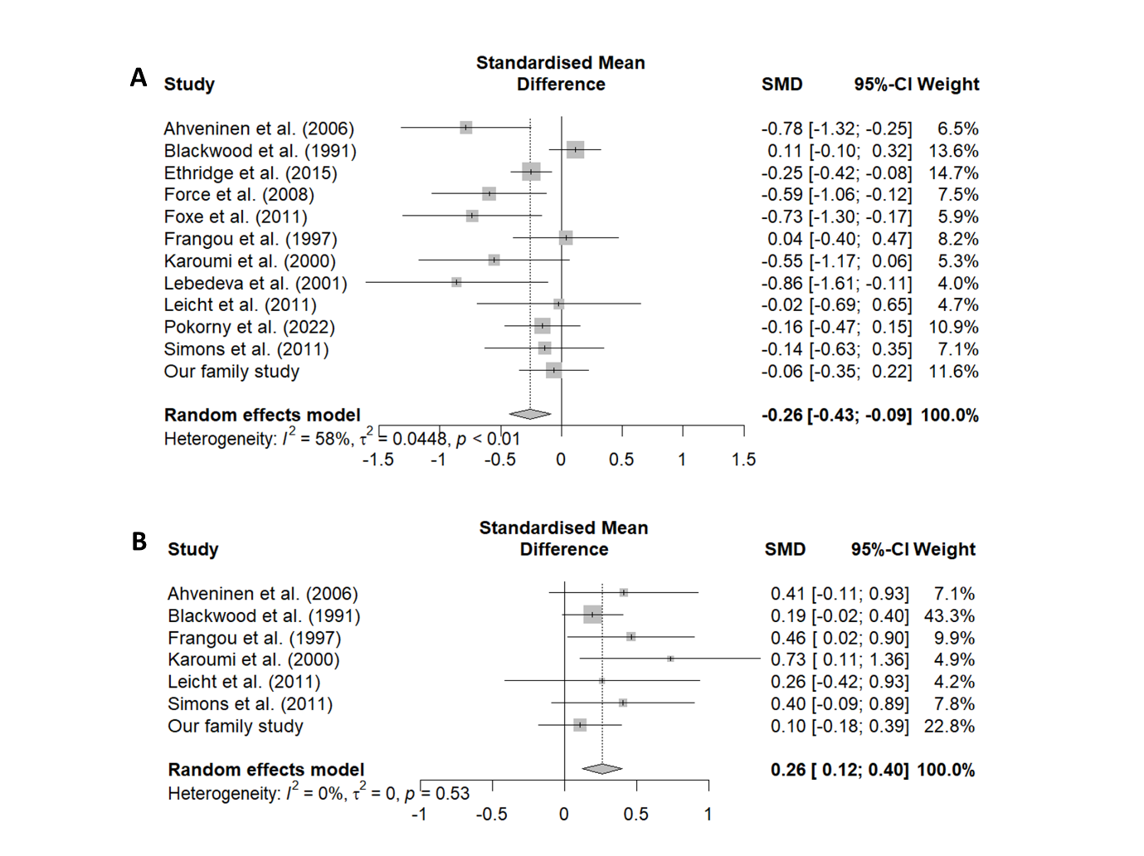
Figure S6. Forest plots of subgroup analysis including only studies using the oddball paradigm or its variants comparing N100 amplitude between 799 relatives and 1,000 controls (A) and N100 latency between 382 relatives and 553 controls (B). SMD, standardised mean difference.

Publication Bias
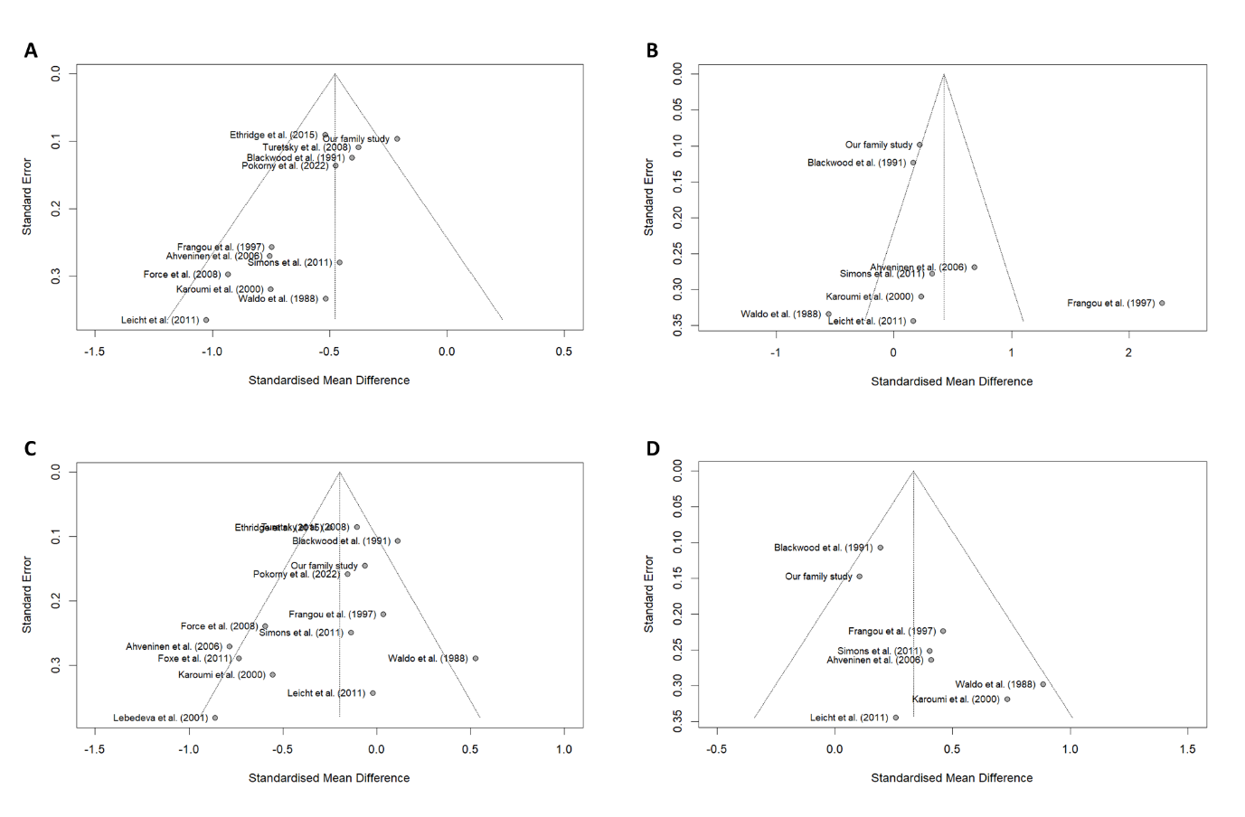
Figure S7. Funnel plots assessing publication bias for the primary meta-analysis comparing patients and controls on the N100 amplitude (A) and latency (B) and comparing relatives and controls on the N100 amplitude (C) and latency (D).

