Reward anticipation-related neural activation following cued reinforcement in adults with psychotic psychopathology and biological relatives

Caroline Demro^{1,2}, Elijah Lahud¹, Philip C. Burton³, John R. Purcell⁴, Joe J. Simon⁵, Scott R. Sponheim^{4,1,2}
Supplementary Materials:
Participant procedures. Participants were recruited from the community, via local care services and research studies at collaborating institutions. Participants completed written informed consent and were compensated with both an hourly rate and bonus (up to $60) based on task performance. Inclusion criteria. English proficiency, visual acuity. Exclusion criteria. Learning disability, estimated IQ<70, central nervous system disease, significant head injury, electroconvulsive therapy, alcohol/substance abuse in the past month or dependence in the past 6 months. Sample. PwP included 75 people with schizophrenia, 34 with psychotic bipolar disorder, and 14 with schizoaffective disorder. Relatives consisted of first-degree biological full siblings (58.0%), parents (32.1%), and children (6.2%). Relatives were related to a family member with schizophrenia (61.7%), bipolar disorder with psychotic features (28.4%), or schizoaffective disorder (9.9%). Of the 81 relatives, 51.9% had a mental health diagnosis (most commonly depression). Excluded participants. Only one participant (a relative) did not complete task fMRI due to failure to meet performance threshold during task practice. 275 participants completed the CRRT during fMRI scanning but 4 participants had unusable task data (2 Ctrl, 1 REL, 1 SZ), 3 were excluded for anatomical pathology (1 REL, 2 SZ), and 6 were excluded for eligibility issues (e.g., did not meet diagnostic criteria; 1 REL, 5 PwP). Thus, 262 participants provided usable tfMRI data. Of these, 9 participants (1 Ctrl, 5 SZ, 2 SZA, 1 BPp) were excluded due to excessive motion, yielding a final sample of 253 participants. Two participants completed fewer scans in the second session (n=865; n=600 volumes) than others due to technical errors.

Data acquisition details. Assessment: General cognitive ability was estimated from performance on the Similarities and Matrix Reasoning subtests of the Wechsler Adult Intelligence Scale - fourth edition (WAIS-IV; Wechsler, 2008). CRRT: CRRT task involves responding to an odd-one-out target stimulus (three circles in a horizontal row) after seeing one of six anticipation cues (green circles or red squares indicating high/low gain, high/low loss, or neutral stimuli indicating null-outcome trials). Participants were instructed to respond quickly and accurately, and informed that they would be paid the amount of money earned in the task, up to $60. Two 80-trial blocks were administered, taking approximately 27 minutes. fMRI data acquisition: The task was displayed using a projector and acrylic screen located behind the magnet bore. Participants viewed the task using a mirror affixed to the head coil and made responses using a fiber-optic button-box. The task was programmed in Presentation software (Neurobehavioral Systems, Berkeley, CA). fMRI data processing. The Euclidean norm (i.e., square root of the sum of squares of the derivatives of the six rotation and translation motion parameters) was calculated for every subject. Volumes with displacement greater than 0.5 mm by this metric were excluded from the analysis (Jones et al., 2010; Caballero-Gaudes & Reynolds, 2017). The following AFNI tools were used at each step of analysis: slice timing correction (3dTshift), distortion correction (3dQWarp), alignment of base EPI volume to which all other volumes will be aligned during motion correction to T1 (align_epi_anat.py), warping to MNI152 space (@auto_tlrc), motion correction (3dvolreg), smoothing with 3mm FWHM kernel (3dmerge -1blur 3.0), scaling so that each voxel has a mean of 100 and betas are all on the same scale, (i.e., % change from the mean) (3dTstat and 3dcalc). Of these components, distortion correction, motion correction, alignment parameters, and MNI transformation were computed and all of these transformations were applied in one step. The GLM was conducted with censor volumes with Euclidean norm (enorm_ > 0.5 mm) and detrended baseline with constant plus 5 degrees of Legandre polynomials (i.e., linear, quadratic, etc.; which are regressors of no interest in the GLM). Demeaned motion parameters were also regressors of no interest. Whole-brain fMRI analyses: First-level analyses were conducted within the framework of a general linear model (GLM) with 20 event-related regressors: six motion regressors (three rotations and three translations), two gain anticipation regressors (AnticipateHighGain, AnticipateLowGain), two loss anticipation regressors (AnticipateHighLoss, AnticipateLowLoss), two neutral anticipation regressors (NullAnticipationGain, NullAnticipationLoss), two gain outcome regressors (HighGainOutcome, LowGainOutcome), two loss outcome regressors (HighLossOutcome, LowLossOutcome), regressors for null outcomes (NullGainOutcome and NullLossOutcome), and regressors of no interest for odd-one-out target stimuli and errors. Additionally, first- through seventh-order Legendre polynomials were included as regressors for each run to account for baseline drift. Functional connectivity analyses: The beta-series correlation method yields one beta estimate per trial per condition. Thus, each trial is entered as a regressor and a beta coefficient is computed. These coefficients are then concatenated to create a beta series for each condition.

ROI analyses with covariates. All ROI results remain consistent and with similar effect size when controlling for antipsychotic medication and tobacco use. Specifically, the effect of group in bilateral caudate for both anticipation of reward (F(2,247)=10.49, p<.001, η²=0.08) and anticipation of loss (F(2,247)=5.87, p=.003, η²=0.05) remains. Post-hoc analyses remain significant for both conditions such that PwP had lower caudal activation than controls (reward: p<.001; loss: p=.002) and relatives (reward: p=.013; loss: p=.009) and relatives had lower caudal activation than controls during reward anticipation (p=.016). During anticipation of reward all psychotic disorder subgroups still demonstrated lower bilateral caudate activation compared to controls (SZ p<.001, SZA p=.005, BPp p<.001) and SZ differed from Relatives (p=.020). Diagnostic comparisons during loss anticipation continue to show lower caudal activation, as compared to Ctrl, for SZ (p=.006) and now also SZA (p=.024) and BP (p=.016) when controlling for medication and tobacco. The effects of group in putamen (F(2,247)=7.22, p<.001, η²=0.06), NAcc (F(2,247)=3.80, p=.024, η²=0.03), and AI (F(2,247)=5.87, p=.003, η²=0.05) activation during anticipation of reward remain with these covariates in place. Specifically, PwP had lower activation of NAcc (p=.029), putamen (p<.001), and AI (p=.001) compared to Ctrl and lower activation of putamen (p=.039) and AI (p=.014) compared to Relatives, whereas Relatives had lower NAcc (p=.008) and putamen (p=.044) activation than controls during anticipation of reward when controlling for medication and tobacco. Diagnostic comparisons indicate that diagnostic subgroups had lower activation than controls in putamen (SZ p=.001, SZA p=.021, BPp p=.002), NAcc (SZ p=.089, BPp p=.033), and AI (SZ p=.007, BPp p=.004) during reward anticipation with these covariates in place. Thus, transdiagnostic hypoactivation in these regions was present regardless of antipsychotic medication and tobacco exposure.

Table S1. Sample Demographics and Characteristics by Diagnosis
 | Ctrl  (n=49) | SZ  (n=75) | SZA  (n=14) | BPp  (n=34) | Comparison | Tukey post-hoc
Mean Age (SD) | 39.0  (13.1) | 39.81 (12.06) | 37.07 (12.46) | 34.06 (11.67) | F(3,168)=1.82,  p=.146 | SZ vs. Ctrl: p=.984  SZA vs. Ctrl: p=.955  BPp vs. Ctrl: p=.279
Female Sex | 51%  (25) | 29.3% (22) | 50%  (7) | 70.6% (24) | χ²(3,N=172)=17.26, p<.001
Race  AI/A/AA/HL/Mult/W | 0/1/3/1/1/43 | 0/3/14//4/3/51 | 0/1/1/1/1/10 | 1/1/4/0/1/27 | χ²(15,N=172)=14.35, p=.499 | -
WAIS-IV IQ | 106.8  (11.2) | 94.69 (10.96) | 97.71 (10.28) | 103.88 (9.72) | F(3,168)=14.19,  p<.001 | SZ vs. Ctrl: p=.000  SZA vs. Ctrl: p=.032  BPp vs. Ctrl: p=.631
Years of education | 16.08  (2.52) | 13.56 (2.02) | 13.71 (2.20) | 15.35 (1.81) | F(3,168)=15.76,  p<.001 | SZ vs. Ctrl: p=.000  SZA vs. Ctrl: p=.002  BPp vs. Ctrl: p=.429
Mean SAPS (SD) | - | 6.64 (4.38) | 5.29 (3.10) | 2.03 (2.48) | F(2,120)=17.08,  p<.001 | SZ vs. BPp: p<.001  SZA vs. BPp: p=.022
Mean SANS (SD) | - | 7.03 (3.44) | 6.00 (1.96) | 3.56 (3.69) | F(2,120)=12.27,  p<.001 | SZ vs. BPp: p<.001
Antipsychotic Type (%): first gen./second gen./none | - | 72/12/16 | 71.4/14.3/14.3 | 64.7/2.9/32.4 | χ2(4,N=122)=6.91, p=.141 | -
Mean CPZ equivalent (SD) | - | 423 (535) | 513 (400) | 133 (198) | F(2,119)=5.73, p=.004 | SZ vs. BPp: p=.007  SZA vs. BPp: p=.030
Cued Reinforcement Reaction Time Task Performance
Total task winnings | $29.59 (5.92) | $24.80 (7.07) | $24.23 (7.03) | $25.74 (5.53) | F(3,168)=6.14  p<.001 | SZ vs. Ctrl: p<.001  SZA vs. Ctrl: p=.035  BPp vs. Ctrl: p=.042
Total task errors | 12.70  (7.78) | 19.44 (11.91) | 23.57 (11.93) | 17.41 (10.16) | F(3,168)=5.80  p<.001 | SZ vs. Ctrl: p=.003  SZA vs. Ctrl: p=.005  BPp vs. Ctrl: p=.190
Reward speeding  (+$2 vs. +$0) | -.047  (.053) | -.029 (.055) | -.041 (.55) | -.039 (.040) | χ²(3,N=172)=5.44, p=.142 | -
Reward speeding (+$2 vs. +$0.40) | -.015  (.037) | -.012  (.040) | -.019  (.036) | -.010  (.028) | χ²(3,N=172)=1.00, p=.801 | -
Loss avoidance speeding  (-$1 vs.  -$0) | -.0426 (0.049) | -0.033 (0.048) | -0.018 (0.072) | -0.025 (0.047) | χ²(3,N=172)=4.13, p=.248 | -
Loss avoidance speeding  (-$1 vs. -$0.20) | -.011  (.035) | -.00007  (.037) | -.001  (.036) | .004  (.037) | χ²(3,N=172)=3.80, p=.284 | -
Note: SZ=schizophrenia; SZA=schizoaffective disorder; BPp=bipolar disorder with psychosis; AI=American Indian; A=Asian; AA=African American; HL=Hispanic/Latino; Mult=Multiracial; W=White; SAPS/SANS=Scales for the Assessment of Positive/Negative Symptoms; CPZ=oral chlorpromazine equivalents were used to compare different antipsychotic medications across participants and were calculated based on the Defined Daily Dose method (Leucht, Samara, Heres, & Davis, 2016).

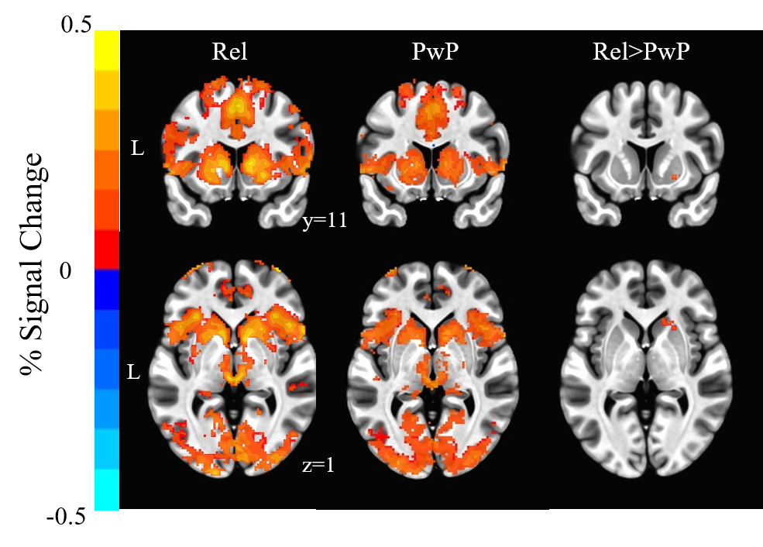
Figure S1. Whole-brain within-group and between-group activation maps during reward anticipation (+$2 vs. neutral). PwP had lower activation than Relatives in the right lentiform nucleus/putamen/caudate, confirming that the dorsal striatum is a primary region implicated in psychosis in task-related brain activation. No significant differences emerged between Relatives and Ctrl.

Table S2. Whole brain results
Region(s) of Activation and Brodmann Area | Hemi | # Voxels | Peak  x | Peak  y | Peak  z | p-value
Ctrl vs. PwP (anticipation of reward)
Caudate (some NAcc/Putamen) | B | 736 | -8 | 4 | 8 | <.01
Precuneus (BA7) | L | 485 | 0 | -74 | 50 | <.01
Occipital/Precuneus (BA19) | R | 245 | 12 | -82 | 42 | <.01
Precentral Gyrus (BA4) | L | 152 | -42 | -18 | 52 | <.01
Precuneus (BA7) | R | 145 | 4 | -74 | 46 | <.01
Supramarginal Gyrus (BA40) | L | 107 | -38 | -42 | 38 | <.01
Cuneus (BA19) | B | 91 | 0 | -84 | 34 | <.01
Middle Temporal Gyrus (BA21) | R | 86 | 52 | -26 | -8 | <.01
Crus II | L | 64 | -38 | -68 | -42 | <.01
Medial Frontal Gyrus (BA6) | B | 64 | 0 | 4 | 54 | <.01
Superior Parietal Lobule (BA7) | R | 61 | 18 | -58 | 64 | <.01
Middle Frontal Gyrus (BA6) | R | 57 | 52 | 8 | 50 | <.01
Superior Parietal Lobule (BA7) | R | 53 | 30 | -64 | 48 | <.01
Middle Frontal Gyrus (BA6) | R | 49 | 26 | -2 | 52 | <.02
Superior Frontal Gyrus (BA6) | R | 46 | 20 | 8 | 58 | <.02
Anterior Insula/Triangular Inferior Frontal Gyrus (BA45/13) | R | 45 | 36 | 28 | 2 | <.02
Cingulate Gyrus (BA8) | R | 45 | 2 | 26 | 38 | <.02
Anterior Prefrontal Cortex (BA10) | R | 38 | 36 | 56 | 24 | <.03
Anterior Prefrontal Cortex (BA10) | L | 35 | -36 | 42 | 20 | <.03
Middle Frontal Gyrus (BA6) | L | 35 | -46 | 2 | 42 | <.03
Lingual Gyrus (BA19) | R | 34 | 24 | -76 | -16 | <.03
Cuneus (BA17) | R | 34 | 12 | -74 | 12 | <.03
Precentral Gyrus (BA6) | L | 34 | -28 | -10 | 52 | <.03
Lobule VI | L | 32 | -28 | -72 | -22 | <.04
Paracentral Lobule (BA5) | R | 32 | 4 | -32 | 54 | <.04
Medial Frontal Gyrus (BA6) | R | 29 | 6 | 10 | 48 | <.05
Lingual Gyrus (BA19) | R | 28 | 16 | -48 | -6 | <.05
Pars Orbitalis (47) | L | 27 | -22 | 46 | -10 | <.05
REL vs. PwP (anticipation of reward)
Putamen | R | 90 | 22 | 16 | -2 | <.01
Precuneus (BA7) | L | 29 | -26 | -54 | 50 | <.04
Ctrl vs. PwP (anticipation of loss)
None
REL vs. PwP (anticipation of loss)
None
Ctrl vs. REL (anticipation of reward and loss)
None
Ctrl vs. SZ (anticipation of reward)
Caudate/Putamen | R | 251 | 8 | 4 | 6 | <.01
Caudate/Putamen | L | 220 | -8 | 4 | 8 | <.01
Parieto-Occipital (BA7) | L | 193 | -26 | -70 | 30 | <.01
Parieto-Occipital (BA7) | R | 141 | 4 | -78 | 38 | <.01
Precentral Gyrus (BA6) | L | 89 | -48 | -4 | 54 | <.01
Superior Parietal Lobule (BA7) | L | 85 | -24 | -70 | 58 | <.01
Supramarginal Gyrus (BA40) | L | 68 | -38 | -42 | 38 | <.01
Cuneus (BA19) | R | 58 | 28 | -84 | 40 | <.01
Superior Parietal Lobule (BA7) | R | 57 | 32 | -68 | 52 | <.01
Precuneus (BA7) | R | 55 | 8 | -72 | 60 | <.01
Medial Frontal Gyrus (BA6) | L | 52 | -8 | 8 | 52 | <.01
Anterior Insula (BA13) | R | 42 | 32 | 22 | 2 | <.02
Angular Gyrus (BA39) | R | 40 | 36 | -70 | 38 | <.02
Superior Frontal Gyrus (BA6) | R | 39 | 24 | -2 | 50 | <.02
Middle Temporal Gyrus (BA21) | R | 32 | 52 | -26 | -8 | <.03
Anterior Prefrontal Cortex (BA10) | L | 32 | -34 | 48 | 18 | <.03
Caudate | R | 31 | 10 | -2 | 16 | <.03
Anterior Prefrontal Cortex (BA10) | R | 31 | 34 | 60 | 22 | <.03
Premotor (BA6) | R | 30 | 52 | 6 | 48 | <.03
Precuneus (BA7) | R | 28 | 4 | -74 | 46 | <.04
Fusiform Gyrus (BA37) | R | 27 | 26 | -62 | -14 | <.04
Superior Temporal Gyrus (BA22) | R | 26 | 62 | -44 | 8 | <.04
Thalamus | L | 26 | -6 | -18 | 10 | <.04
Precuneus (BA7) | L | 26 | -6 | -76 | 54 | <.04
Occipital (BA19) | L | 24 | -38 | -78 | -4 | <.05
Ctrl vs. SZ (anticipation of loss)
None
Ctrl vs. SZA (anticipation of reward & loss)
None
Ctrl vs. BPp (anticipation of reward & loss)
None

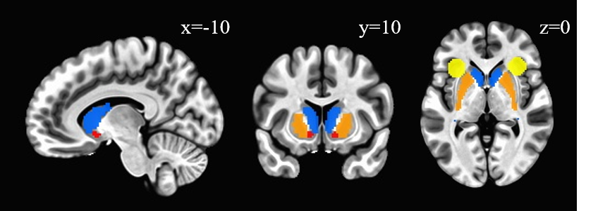
Figure S2. The bilateral Regions of Interest were structurally defined. Blue=caudate, orange=putamen, red=nucleus accumbens, yellow=anterior insula. Striatal ROIs were anatomically defined with the MNI_avg152 atlas and AI ROI was defined using peak coordinates from reward-anticipation literature. Visual inspection of the coordinates ensured that the ROIs did not contain overlapping voxels.

Figure S3. Caudate seed mask for beta-series connectivity analysis.

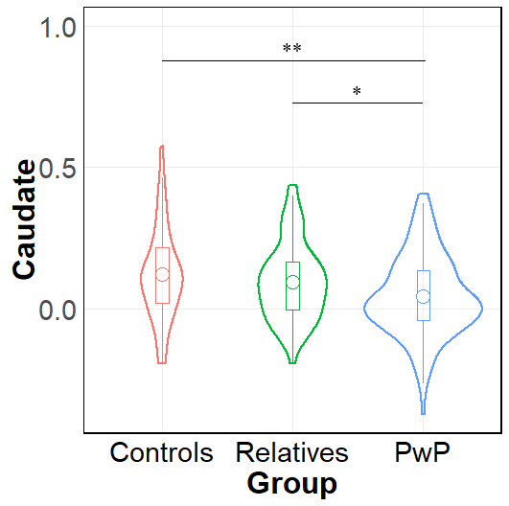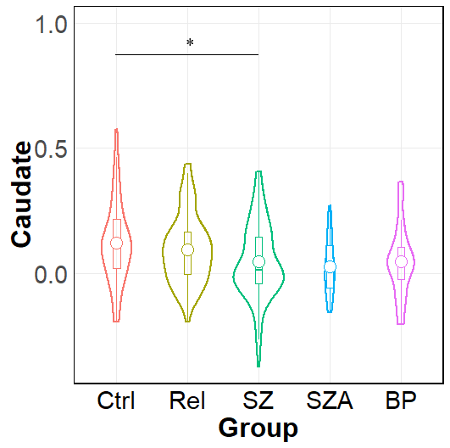
Figure S4. Density plots showing group differences in caudal activation during anticipation of loss (-$1 vs. $0). Participants with psychotic psychopathology had lower activation in the bilateral caudate compared to controls and Relatives during the anticipation phase of the loss condition (-$1 relative to neutral). BP=Bipolar disorder with psychosis.

Table S3. Symptom correlations with bilateral caudate during reward anticipation cueing among people with psychosis
Negative Symptom Domain/Dimension | Correlation  (PwP group) | Correlation  (by Diagnostic Category)
SANS Diminished Expressivity | r=-.23, p=.011* | SZ: r=-.24, p=.037+  SZA: r=-.38, p=.185  BPp: r=-.07, p=.697
SANS Blunted Affect | r=-.25, p=.005* | SZ: r=-.25, p=.030+  SZA: r=-.36, p=.205  BPp: r=-.14, p=.448
SANS Alogia | r=-.10, p=.266 | SZ: r=-.13, p=.270  SZA: r=-.19, p=.507  BPp: r=.06, p=.729
SANS Motivation and Pleasure | r=-.14, p=.115 | SZ: r=-.11, p=.343  SZA: r=.08, p=.775  BPp: r=-.17, p=.332
SANS Anhedonia | r=.07, p=.452 | SZ: r=.06, p=.598  SZA: r=.27, p=.346  BPp: r=-.04, p=.838
SANS Asociality | r=-.17, p=.055 | SZ: r=-.14, p=.231  SZA: r=-.07, p=.811  BPp: r=-.20, p=.255
SANS Avolition | r=-.11, p=.242 | SZ: r=-.08, p=.499  SZA: r=.16, p=.588  BPp: r=-.13, p=.463
* survives FDR correction; + does not survive FDR correction

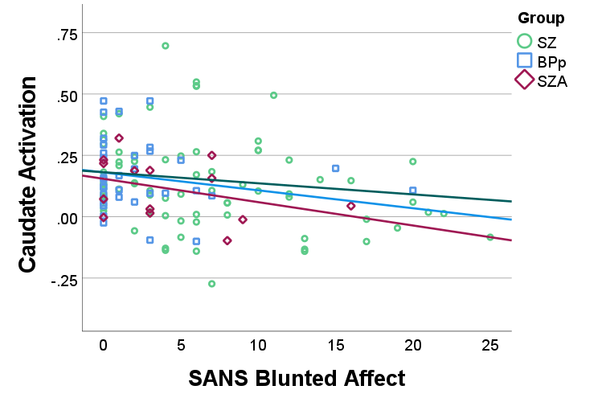
Figure S5. Pearson Correlation between negative symptom severity and brain activation in bilateral caudate during reward anticipation cueing ($2 vs. $0) among persons with psychotic psychopathology by diagnostic group.

Table S4. Functional connectivity results showing association with bilateral caudate during reward anticipation
Region(s) of Activation | Hemi | # Voxels | Peak  x | Peak  y | Peak  z | p-value
PwP vs. Ctrl during anticipation of reward ($2 vs. $0)
Medial Frontal Gyrus (BA6) | B | 194 | 4 | 14 | 54 | <.001
Anterior Insula/Pars Opercularis (BA44) | R | 63 | 34 | 16 | 10 | <.001
Middle Frontal Gyrus (BA6) | L | 48 | -30 | -2 | 52 | <.001
Cingulate Gyrus (BA8) | B | 41 | 6 | 26 | 36 | <.01
Putamen | R | 40 | -20 | 8 | 0 | <.01
Medial Occipitotemporal Gyrus (BA 19) | L | 29 | -28 | -64 | -14 | <.01
Dorsal Anterior Cingulate (BA32) | L | 27 | -8 | 32 | 24 | <.01
Angular Gyrus (BA39) | L | 26 | -26 | -74 | 28 | <.01
Caudate | R | 22 | 18 | 18 | 4 | <.01
Putamen | R | 20 | 24 | 10 | 0 | <.02
Superior Frontal Gyrus (BA6) | L | 18 | -12 | -2 | 66 | <.02
Anterior Prefrontal Cortex (BA10) | L | 17 | -34 | 54 | 12 | <.03
Premotor (BA6) | R | 16 | 50 | 6 | 34 | <.03
Lobule VI | L | 15 | -28 | -50 | -20 | <.04
Putamen | L | 15 | -20 | 2 | 6 | <.04
Anterior Prefrontal Cortex (BA10) | L | 15 | -36 | 40 | 24 | <.04
Superior Parietal Lobule/Precuneus (BA7) | R | 15 | 18 | -70 | 40 | <.04
Middle Frontal Gyrus (BA6) | L | 14 | -44 | -8 | 58 | <.05
SZ vs. Ctrl during anticipation of reward ($2 vs. $0)
Lingual Gyrus (BA18) /Occipital Lobe/Crus VI | L | 901 | -8 | -96 | -4 | <.001
Superior Medial Frontal (BA6) /Anterior Cingulate | L | 724 | -6 | 10 | 54 | <.001
Anterior Insula (BA13)/ Caudate/ Putamen/Thalamus | R | 579 | 38 | 12 | 10 | <.001
Precuneus (BA7) | R | 382 | 10 | -68 | 46 | <.001
Lobule V/VI/Declive | B | 252 | -8 | -72 | -22 | <.001
Angular Gyrus (BA39) | L | 236 | -26 | -74 | 28 | <.001
Dorsal Anterior Cingulate Cortex (BA32) | B | 227 | 0 | 26 | 34 | <.001
Cuneus (BA17) | R | 214 | 16 | -90 | 6 | <.001
Putamen/Caudate | L | 180 | -20 | 8 | 0 | <.001
Anterior Prefrontal (BA10) | L | 180 | -32 | 56 | 16 | <.001
Middle frontal (BA6) | L | 154 | -44 | -2 | 44 | <.001
Lobule VI/Crus I/II Culmen | R | 141 | 36 | -52 | -22 | <.001
Fusiform Gyrus (BA37) | R | 115 | 32 | -54 | -12 | <.001
Precuneus (BA19) | R | 95 | 30 | -72 | 30 | <.001
Lingual gyrus (BA19) | R | 77 | 26 | -70 | -8 | <.01
Premotor/Inferior Frontal Gyrus (BA6/44) | R | 75 | 48 | 10 | 30 | <.01
Superior Frontal/Supplementary Motor (BA6) | R | 74 | 26 | 0 | 72 | <.01
Occipital (BA18) | R | 68 | 38 | -84 | 0 | <.01
Lobule IX/Tonsil | L | 61 | -14 | -54 | -46 | <.01
Lobule VIIIa/Inferior Semi-Lunar Lobule | R | 61 | 8 | -66 | -48 | <.01
Superior Temporal Gyrus Supramarginal Gyrus (BA 22/40) | R | 61 | 60 | -38 | 20 | <.01
Middle Frontal Gyrus (BA6) | L | 61 | -30 | -2 | 52 | <.01
Precuneus (BA7) | L | 59 | -8 | -66 | 46 | <.01
Cuneus (BA19) | R | 58 | 16 | -96 | 20 | <.01
Angular Gyrus (BA39) | R | 58 | 62 | -50 | 32 | <.01
Thalamus | L | 55 | -4 | -16 | 10 | <.01
Anterior Insula (BA13) | L | 54 | -30 | 24 | 8 | <.01
Anterior Prefrontal/Middle Frontal Gyrus (BA10) | R | 53 | 42 | 46 | 16 | <.01
Superior Parietal Lobule (BA7) | L | 53 | -26 | -66 | 50 | <.01
Occipital (BA17) | R | 52 | 4 | -92 | -2 | <.01
Angular Gyrus (BA39) | R | 51 | 46 | -58 | 16 | <.01
Anterior Prefrontal Cortex (BA10) | R | 48 | 22 | 54 | 24 | <.01
Cuneus (BA18) | L | 47 | -20 | -94 | 22 | <.01
Angular Gyrus (39) | R | 45 | 50 | -46 | 16 | <.01
Dorsal Posterior Cingulate (BA31) | L | 41 | -12 | -24 | 42 | <.01
Occipital (BA19) | R | 40 | 44 | -64 | 2 | <.01
Fusiform Gyrus (BA37) | R | 38 | 50 | -64 | 4 | <.02
Middle Frontal Gyrus (BA8) | R | 38 | 42 | 16 | 34 | <.02
Lingual Gyrus (BA18) | L | 37 | -10 | -58 | 2 | <.02
Angular Gyrus (BA39) | R | 37 | 60 | -54 | 18 | <.02
Superior Parietal Lobule (BA7) | L | 37 | -10 | -66 | 62 | <.02
Premotor Cortex (BA6) | L | 37 | -28 | -0 | 66 | <.02
Angular Gyrus (BA39) | L | 36 | -50 | -56 | 4 | <.02
Crus I/Culmen | L | 35 | -46 | -50 | -38 | <.02
Pars Triangularis/Anterior Insula (BA45) | L | 35 | -46 | 20 | 4 | <.02
Precuneus (BA7) | L | 35 | -14 | -78 | 52 | <.02
Anterior Prefrontal Cortex (BA10) | R | 34 | 26 | 60 | 0 | <.02
Lobule V/Culmen | R | 33 | 24 | -48 | -20 | <.02
Cuneus (BA18) | L | 33 | -12 | -98 | 6 | <.02
Angular Gyrus (BA39) | L | 33 | -60 | -52 | 10 | <.02
Precentral Gyrus (BA4) | L | 33 | -40 | -16 | 50 | <.02
Supplementary Motor (BA6) | L | 32 | -22 | -12 | 68 | <.02
Dorsolateral Prefrontal Cortex (BA9) | L | 31 | -40 | 34 | 36 | <.02
Anterior Prefrontal Cortex (BA10) | L | 30 | -30 | 48 | 24 | <.03
Supramarginal Gyrus (BA40) | L | 30 | -32 | -40 | 42 | <.03
Lobule VI/Declive | R | 28 | 10 | -74 | -16 | <.03
Angular Gyrus (39) | L | 28 | -44 | -66 | 14 | <.03
Lobule X/Tonsil | L | 27 | -14 | -44 | -42 | <.04
Lobule VI/Culmen | R | 27 | 32 | -40 | -34 | <.04
Middle Temporal Gyrus (BA21) | R | 27 | 54 | -32 | -16 | <.04
Dorsal Anterior Cingulate (BA32) | L | 27 | -8 | 38 | 16 | <.04
Dorsolateral Prefrontal Cortex (BA9) | L | 27 | -28 | 40 | 34 | <.04
Angular Gyrus (BA39) | L | 26 | -60 | -48 | 30 | <.04
Ventral Posterior Cingulate (BA23) | L | 26 | -2 | -22 | 30 | <.04
Thalamus | R | 25 | 8 | -24 | -4 | <.04
Insula (BA13) | L | 25 | -38 | 2 | 10 | <.04
Supplementary Motor Area (BA6) | R | 25 | 12 | -2 | 64 | <.04
Vermis Crus II/Pyramis | L | 24 | -2 | -74 | -34 | <.05
Brainstem | L | 24 | -4 | -32 | -12 | <.05
BP vs. Ctrl during anticipation of reward ($2 vs. $0)
Dorsal Anterior Cingulate (BA32) | L | 28 | -2 | 8 | 44 | <.001
Anterior Insula (BA13) | R | 24 | 36 | 22 | 4 | <.01
Dorsal Anterior Cingulate (BA32) | L | 21 | -8 | 32 | 26 | <.01
Putamen/Nu | L | 14 | -20 | 12 | -8 | <.01
Dorsal Anterior Cingulate (BA32) | R | 13 | 6 | 6 | 48 | <.02
Putamen | L | 11 | -24 | 0 | 10 | <.03
SZA vs. Ctrl during anticipation of reward ($2 vs. $0)
Premotor/Ventral Anterior Cingulate (BA6/BA24) | L | 58 | -6 | 8 | 46 | <.01
Putamen | R | 34 | 22 | 12 | 2 | <.03
Precuneus (BA19) | R | 31 | 16 | -72 | 36 | <.03
REL vs. Ctrl during anticipation of reward ($2 vs. $0)
Angular Gyrus (BA39) | R | 100 | 42 | -60 | 52 | <.001
Vermis VIIIa/Nodule | B | 40 | 2 | -60 | -32 | <.02
Fusiform Gyrus (BA37) | R | 31 | 52 | -48 | -10 | <.04
Note: There were no significant group differences in connectivity between any brain region and the bilateral caudate during anticipation of loss (-$1) for PwP or SZ compared to Ctrl.

