Associations between gambling disorder and work disability: a longitudinal nationwide case cohort study in Sweden

Supplementary material

Table of Contents
Appendix Table 1. Variable description and data preparation 1
Appendix Table 2. Fit statistics for correlational structures in GEE-models. 3
Appendix Table 3. The diagnostic metric of Group-Based Trajectory Models. 3
Appendix Table 4. GEE model 6. Covariate’s contribution to long-term work disability. 3
Appendix Table 5. GEE models 7 and 8. 4
Appendix Table 6 4
Appendix Table 7. Net days of work disability (aggregated SA+DP) relative to GD diagnosis among the matched cohort. 4
Appendix Figure 1. Trajectory groups of work disability among individuals with GD. 5
Appendix Table 8. Crude model of trajectory assignment 6
Information on Swedish social insurance system 7
Supplementary Figure 2. Patients with GD, of working age, in the National Patient registry between 2005-2018 7

Supplementary Table 1. Variable description and data preparation
Variable | Codes and data | Register | Timepoints, description and data preparation
Age | Range 19–62 | LISA | Measured the year before registered Gambling Disorder (GD).
Sex | 0 = Women  1 = Men | LISA | Measured the year before regsitrered GD.
Migration |  | LISA | During the study period
Highest education | Years of education, baseline year,  -1: Missing information,  1: 0-9 years,  2: 10-12 years,  3: >12 years | LISA | Year before incident GD.  Missing information (-1) was recoded into 1: 0-9 years for analysis.  There were missing data for 154 individuals (0.44%), these were recoded as belonging to category 0 – 9 years. Status of gainful employment was analyzed in two categories (yes/no), collapsing those without gainful employment but with income statements from an employer (7.77% of full sample) with those without gainful employment and no income statements (14.51% of full sample).
Family | -1: Missing information,  1: Married or cohabitant without children  2: Married or cohabitant with children  3: Single without children  4: Single with children | LISA | Family status, baseline year
Country of birth | Europe  Other  Sweden | LISA | Country of birth, 3 categories
Dispensed psychotropic medication | The Anatomical Therapeutic Chemical (ATC )codes:  N03,  N05A,  N05BA,  N05BB and  N05BC, N05C,  N06A,N06B, N07B, N04. | PDR | Measured at time of incident GD and three years before.
Somatic diagnoses | International Statistical Classification of Diseases(ICD) except F00-F99 and childbirth: O80-O84)  Possible values between 0 - 5 | NPR | Divided on these categories: Cancer (C00-C97, D00-D48), Diabetes (E10-E14, O24, R73), Cardiovascular (I05-I15, I20-I28, I30-I52, I60-I89, I95-I99), Injuries (S00-T98) and  Other (all other excluding. childbirth; O80-O84)
Psychiatric diagnoses | ICD-10: F00-F99 | NPR | Psychiatric diagnoses received during hospitalizations or in specialized open care.  Measured at time of incident GD and three years before for GEE models. GEE = Generalized Estimating Equations
Number of psychiatric disorders | Possible values between 0 and 9  Anxiety disorders, i.e. neurotic. stress-related and somatoform disorders (F40-F48)  Mood Disorders (F30-F39)  Alcohol use disorder, i.e. mental and behavioural disorders due to use of alcohol (F10)  Drug use disorders, i.e. psychoactive substance use (except nicotine) (F11-F16,F18,F19)  Personality disorders, i.e. disorders of adult personality and behaviour (F60-F69. not F63.0)  ADHD, i.e. hyperkinetic disorders (F900)  Psychotic disorders, i.e. schizophrenia. schizotypal and delusional disorders (F20-F29)  Eating Disorders (F50)  Other (F00-F09, F51-F59, F70-F79, F80-89, F99) | NPR | Before and after GD (-3, -2, -1, +1, +2, +3)
Health care unit | Treatment units:  901 = Psychiatric outpatient treatment  945 = Alcohol treatment  954 = Treatment for drug use disorders  944 = Specialized psychiatric care (incl. addiction centers) | NPR | Treatment unit where the GD was first diagnosed. Specialized psychiatric care (addiction center) often located in major cities.
Work disability categories | 0  1-90  91-180  181-365 | MiDAS | Outcome in GEE models
Work disability | Sickness absence + disability pension | MiDAS | Net days of sickness absence (SA) and disability pension (DP) during one year. Measured at GD (-3, -2, -1, +1, +2, +3)
Long term sickleave | Sickness absence + disability pension  0 = 0-90 days  1 > 90 days | MiDAS | Period of sick leave >90 days in one year  Measured at GD (-3, -2, -1, +1, +2, +3)
Gainful employment | Sysstat  1 =Had gainful employment  0 = No gainful employment | LISA | Measured at six timepoints during the study period: GD (-3, -2, -1, +1, +2, +3)
Disposable income |  | LISA | The individuals` part of total income received, including allowances, minus taxes paid.
Death - cause of death | National Cause of Death Register | CoD | During the study period
Degree of urbanisation of area of residence (DEGURBA) | 1: Cities  2: Towns and suburbs  3: Rural areas | LISA | Measured the year before incident GD.
LISA = The longitudinal integrated database for health insurance and labor market studies, , NPR = The National Patient Register, MiDas = Micro-data for analyses of the social insurance, PDR = Swedish Prescribed Drug Register

Supplementary Table 2. Fit statistics for correlational structures in GEE-models.

Correlation structures | QIC | QICu | Quasi Lik | CIC | params | QICC
Autoregressive | 117066.80 | 117066.13 | -58527.07 | 6.33 | 6.00 | 117066.80
Exchangeable | 117067.28 | 117062.74 | -58525.37 | 8.27 | 6.00 | 117067.28
Unstructured | 117063.89 | 117063.17 | -58525.59 | 6.36 | 6.00 | 117063.90
Independent | 117071.80 | 117062.69 | -58525.35 | 10.55 | 6.00 | 117071.80

Supplementary Table 3. The diagnostic metric of Group-Based Trajectory Models.

N of clusters | AIC | BIC | APPA.mean | APPA.min | MSE | Relative Entropy
1 | 780589 | 780630 | 1.00000 | 1.00000 | 37673.49
2 | 387187 | 387265 | 0.99943 | 0.99908 | 11929.05 | 0.99829
3 | 319101 | 319214 | 0.99829 | 0.99689 | 9290.45 | 0.99321
4 | 282689 | 282838 | 0.99437 | 0.98993 | 8526.92 | 0.98450
5 | 261829 | 262013 | 0.99310 | 0.98966 | 7631.49 | 0.97955
6 | 247573 | 247793 | 0.98763 | 0.98232 | 7232.10 | 0.96906
7 | 235231 | 235487 | 0.98548 | 0.97383 | 7153.35 | 0.96626
8 | 225377 | 225668 | 0.97025 | 0.88129 | 11421.30 | 0.90699
4 (cubic, qudratic) | 279610 | 279782 | 0.99541 | 0.99368 | 8377.43 | 0.98653
5 (quartic, qudratic) | 278031 | 278227 | 0.99650 | 0.99245 | 8039.88 | 0.98613

Sensitivity analyses

Supplementary Table 4. GEE model 6. Covariate’s contribution to long-term work disability.

Variable | AOR | p.value | Lower 95 % CI | Upper 95 % CI
Female sex | 1.73 | 0.00 | 1.60 | 1.88
Age | 1.05 | 0.00 | 1.04 | 1.05
Birthcountry (ref: Sweden) | 1.00
Europe (not Sweden) | 1.22 | 0.00 | 1.09 | 1.37
Outside of Europe | 0.98 | 0.76 | 0.88 | 1.10
Education (ref: >12 years) | 1.00
10-12 years | 2.11 | 0.00 | 1.88 | 2.37
0-9 years | 4.48 | 0.00 | 3.97 | 5.06
Degree of urbanisation of living area (ref: cities) | 1.00
Towns and suburbs | 1.10 | 0.02 | 1.02 | 1.18
Rural areas | 1.18 | 0.00 | 1.07 | 1.31
Family (ref: married or cohabiting with children) | 1.00
Single with children | 1.34 | 0.00 | 1.15 | 1.57
Married or cohabitant without children | 1.31 | 0.00 | 1.14 | 1.50
Single without children | 2.16 | 0.00 | 1.99 | 2.35
Prior diagnoses
Drug use disorders (except nicotine) | 1.04 | 0.64 | 0.88 | 1.22
Alcohol use disorder | 0.99 | 0.91 | 0.84 | 1.17
Anxiety disorders | 1.55 | 0.00 | 1.38 | 1.73
ADHD | 1.82 | 0.00 | 1.40 | 2.37
Mood disorders | 1.59 | 0.00 | 1.41 | 1.79
Number of somatic diagnoses | 1.65 | 0.00 | 1.55 | 1.76
Prior psychotropic medication
Drugs used in addictive disorders (N07B) | 0.90 | 0.23 | 0.75 | 1.07
Psychostimulants (N06B) | 1.17 | 0.27 | 0.88 | 1.56
Anxiolytics (N05B) | 1.46 | 0.00 | 1.32 | 1.62
Hypnotics (N05C) | 1.67 | 0.00 | 1.52 | 1.85
Antidepressants (N06A) | 2.27 | 0.00 | 2.05 | 2.51

Supplementary Table 5. GEE models 7 and 8.
Model 7: adjusted for model 3 + number of psychiatric disorders + prior psychotropic medication. Model 8: adjusted for model 3 + number of psychiatric disorders (v3) + prior psychotropic medication.

 | Model 7 | Model 8
Timepoint | AOR (95 % CI) | AOR (95 % CI)
GD - 3 | 1.58 (1.41-1.78) | 1.16 (1.02-1.31)
GD - 2 | 1.59 (1.41-1.78) | 1.17 (1.03-1.32)
GD - 1 | 2.15 (1.92-2.40) | 1.62 (1.44-1.82)
GD +1 | 3.03 (2.71-3.39) | 2.35 (2.09-2.65)
GD + 2 | 2.34 (2.09-2.61) | 1.78 (1.58-2.00)
GD +3 | 2.18 (1.95-2.44) | 1.65 (1.47-1.86)
Note. AOR =adjusted Odds Ratios.. Model 3 = adjusted for age and gender + education, status of gainful employment, degree of urbanization of living area, family, country of birth + number of somatic diagnoses categories.

Appendix Table 6. Net days of work disability

Net days of work disability (i.e., aggregated days of sickness absence and disability pension) for each of the three years before and three years after the incident gambling disorder (GD) diagnosis among individuals with GD (N=2830).
Net days WD | GD - 3 | GD - 2 | GD - 1 | GD +1 | GD +2 | GD+3
 | % | % | % | % | % | %
0 | 70.95% | 68.48% | 56.71% | 53.32% | 60.99% | 61.45%
1-90 | 8.16% | 9.51% | 15.97% | 13.07% | 10.07% | 10.28%
91-180 | 3.53% | 3.75% | 6.04% | 6.78% | 4.59% | 4.10%
181-365 | 17.35% | 18.27% | 21.27% | 26.82% | 24.35% | 24.17%

Appendix Table 7. Net days of work disability (aggregated SA+DP) relative to GD diagnosis among the matched cohort.

Net days WD | GD - 3 | GD - 2 | GD - 1 | GD +1 | GD +2 | GD+3
 | % | % | % | % | % | %
0 | 86.44 | 86.08 | 85.65 | 85.44 | 85.21 | 84.82
1-90 | 5.37 | 5.45 | 5.71 | 5.92 | 6.13 | 6.37
91-180 | 1.81 | 1.61 | 1.77 | 1.82 | 1.75 | 1.83
181-365 | 6.39 | 6.87 | 6.87 | 6.82 | 6.91 | 6.98

Supplementary Figure 1. Trajectory groups of work disability among individuals with GD.
From average, count model and probability of certain zero model.

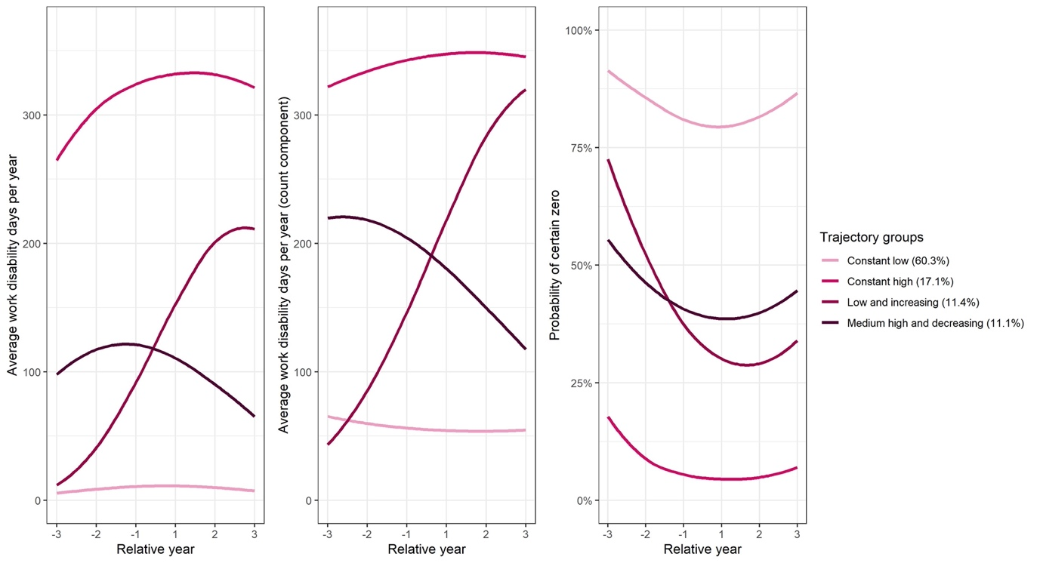

Supplementary Table 8. Crude model of trajectory assignment in multinomial regression analysis. Bold indicate significant at p <.05.

 | Crude
 | Medium high and decreasing |  | Low and increasing |  | Constant high
Attributes | OR (95% CI) | p-value | OR (95% CI) | p-value | OR (95% CI) | p-value
Female sex | 2.66 (2.03 - 3.48) | 0.000 | 2.17 (1.65 - 2.85) | 0.000 | 3.24 (2.59 - 4.06) | 0.000
Country of birth
Sweden (reference) | - | - | - | - | - | -
Europe | 1.18 (0.79 - 1.78) | 0.416 | 1.40 (0.95 - 2.07) | 0.089 | 1.41 (1.01 - 1.96) | 0.041
Other | 0.59 (0.38 - 0.92) | 0.020 | 1.17 (0.82 - 1.66) | 0.380 | 0.94 (0.69 - 1.29) | 0.702
Family
Married or cohabitant with children(reference) | - | - | - | - | - | -
Married or cohabitant without children | 1.45 (0.79 - 2.65) | 0.230 | 0.98 (0.52 - 1.86) | 0.951 | 4.94 (2.90 - 8.43) | 0.000
Single without children | 0.98 (0.73 - 1.32) | 0.906 | 0.82 (0.62 - 1.09) | 0.170 | 3.13 (2.22 - 4.41) | 0.000
Single with children | 1.59 (0.93 - 2.71) | 0.091 | 1.32 (0.78 - 2.24) | 0.299 | 4.31 (2.58 - 7.19) | 0.000
Education
>12 years (reference) | - | - | - | - | - | -
10-12 years | 1.05 (0.72 - 1.54) | 0.790 | 1.94 (1.32 - 2.85) | 0.001 | 2.71 (1.92 - 3.83) | 0.000
0-9 years | 1.13 (0.82 - 1.57) | 0.445 | 1.45 (1.01 - 2.06) | 0.042 | 1.83 (1.32 - 2.53) | 0.000
 | - | - | - | - | - | -
Prior psychotropic medication | 3.17 (2.41 - 4.17) | 0.000 | 3.23 (2.46 - 4.23) | 0.000 | 5.65 (4.35 - 7.34) | 0.000
Age | 1.03 (1.02 - 1.05) | 0.000 | 1.03 (1.01 - 1.04) | 0.000 | 1.06 (1.05 - 1.07) | 0.000
N of prior psychiatric diagnoses | 1.81 (1.64 - 2.00) | 0.000 | 1.84 (1.67 - 2.03) | 0.000 | 2.47 (2.27 - 2.70) | 0.000
N of prior somatic diagnoses by category(0-5) | 2.07 (1.62 - 2.63) | 0.000 | 1.83 (1.44 - 2.33) | 0.000 | 2.92 (2.37 - 3.60) | 0.000

Information on the Swedish social insurance system

Sweden has a publicly funded social insurance system providing financial security at different stages of life, e.g., compensation during sick leave or childbirth. All insured citizens above 16 years with an income from work or parental benefits are eligible for sickness benefits of up to 80% of their income. To be granted a disability pension, the work capacity must be permanently reduced based on a medical assessment. In 2008, the lower age limit for receiving a disability pension was set to 30 years, but individuals aged 19-30 years can receive a temporary disability pension.

Supplementary Figure 2. Patients with GD, of working age, in the National Patient registry between 2005-2018. Above each bar, the number of individuals for that year is displayed.

