Childhood trauma moderates schizotypy-related brain morphology: Analyses of 1,182 healthy individuals from the ENIGMA Schizotypy working group

– Supplementary Material –

*Corresponding author
Dr Yann Quidé, NeuroRecovery Research Hub, School of Psychology, Biological Sciences (Biolink) Building, UNSW Sydney, NSW, 2052, Australia.
Phone: +61 2 9065 1883
E-mail: y.quide@unsw.edu.au; yannquide@gmail.com

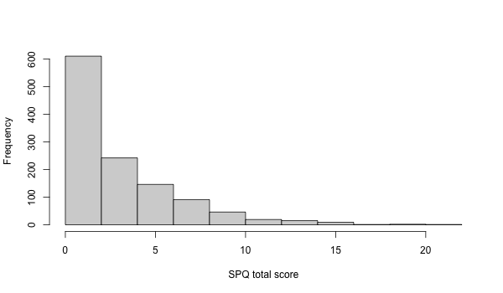
Supplementary Figure 1. Distribution of the SPQ total score (maximum possible range 0-22). SPQ: schizotypal personality questionnaire

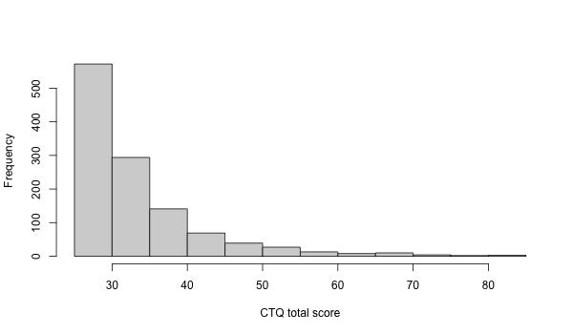
Supplementary Figure 2. Distribution of the CTQ total score (maximum possible range 25-125). CTQ: Childhood trauma questionnaire

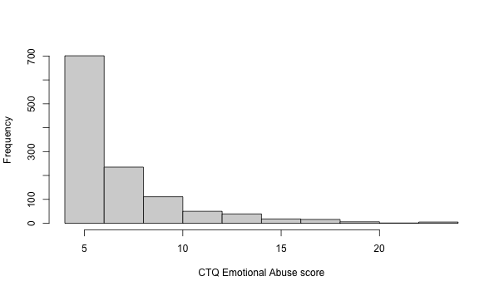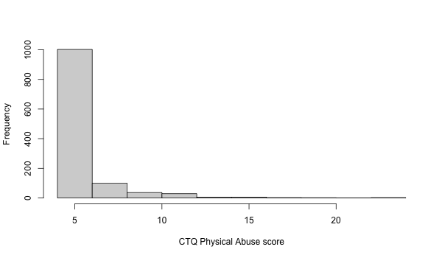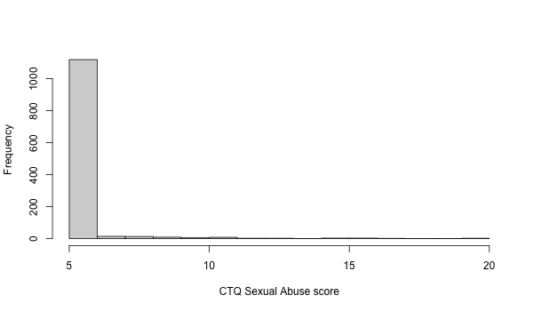
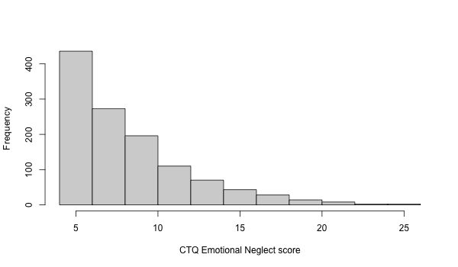
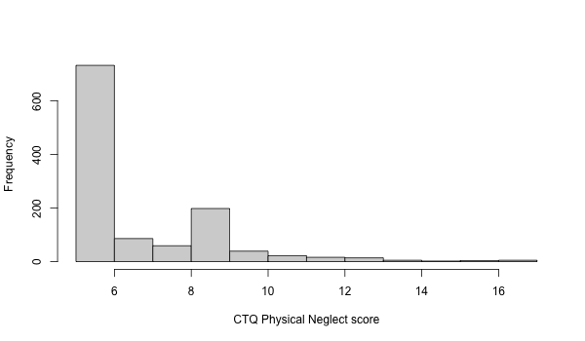
Supplementary Figure 3. Distribution of scores for each CTQ subscale. CTQ: Childhood trauma questionnaire; CTQEA: Emotional abuse subscale of the CTQ; CTQPA: Physical abuse subscale of the CTQ; CTQSA: Sexual abuse subscale of the CTQ; CTQEN: Emotional neglect subscale of the CTQ; CTQPN: Physical neglect subscale of the CTQ.

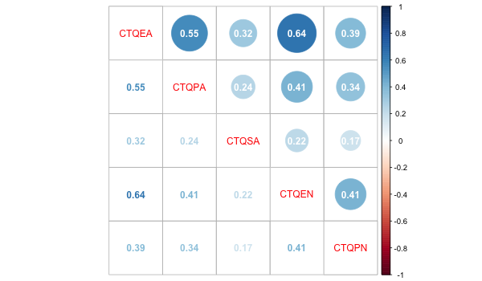

Supplementary Figure 4. Correlation matrix (Pearson’s r) between all CTQ subscales. CTQ: Childhood trauma questionnaire; CTQEA: Emotional abuse subscale of the CTQ; CTQPA: Physical abuse subscale of the CTQ; CTQSA: Sexual abuse subscale of the CTQ; CTQEN: Emotional neglect subscale of the CTQ; CTQPN: Physical neglect subscale of the CTQ. Strength of the correlation is represented by disc size and colour.

Supplementary Table 1. Sample sizes of the contributing sites
Sites | Sample size (N)
FOR2107 – Marburg | 408
FOR2107 – Muenster | 224
Muenster Neuroimaging Cohort (MNC) | 169
New York – Hillside | 165
Zurich | 59
IGP | 52
London | 45
Paris | 40
Roehampton | 20

Supplementary Table 2. Scanner details for each site
Cohorts | Scanner type | Magnet strength | Acquisition sequence | Sequence parameters | FreeSurfer version
FOR2107 – Marburg | Siemens Magnetom TiroTim syngo | 3T | 3D-MPRAGE | TR 1900ms, TE 2.26ms, TI 900ms, FA 9°, voxel size 1.0x1.0x1.0mm³, Acquisition Direction Sagittal, 176 slices, slice gap 0.5mm. | 5.3
FOR2107 – Muenster | Siemens Prisma | 3T | 3D-MPRAGE | TR 2130ms, TE 2.28ms, TI 900ms, FA 8°, voxel size 1.0x1.0x1.0mm³, Acquisition Direction Sagittal, 192 slices, no slice gap. | 5.3
Muenster Neuroimaging Cohort (MNC) | Philips Gyroscan Intera | 3T | 3D-fast gradient echo sequence (turbo field echo) | TR 7.4ms, TE 3.4ms, FA 9°, two signal averages, inversion prepulse every 814.5 ms, acquired over a FOV of 256 (feet-head [FH]) × 204 (anterior-posterior [AP]) × 160 (right-left [RL]) mm, phase encoding in AP and RL direction, reconstructed to cubic voxels of .5 × .5 × .5 mm³ | 5.3
New York – Hillside | GE | 3T | 3D-SPGR | TR 7.5 ms, TE 3 ms, matrix 256x256, FOV 240 mm, 216 contiguous images, thickness 1mm, interleaved | 6.0
IGP | Philips Achieva TX | 3T | 3D-MPRAGE | TR 8.9ms, TE 4.1ms, FOV 240mm, matrix 268 x 268, 200 sagittal slices, slice thickness 0.9mm (no gap) | 5.3
Zurich | Philips Achieva | 3T | 3D-MPRAGE | TR 8.2ms; TE 3.8ms; FA 8°; voxel size, 1×1×1 mm³; FOV 160 × 240 mm², 160 slices | 6.0
London1b | Philips Intera | 3T | 3D fast-field echo (FFE) sequence | TR 25 ms, TE 4.6 ms, FOV 260 mm, matrix 256x256, 160 contiguous axial slices of 1-mm thickness, voxel size 1x1x1 mm³ | 6.0
Paris | Siemens Tim Trio | 3T | 3D-MPRAGE | TR 2300 ms, TE 2.98 ms, 160 slices ;  voxel size, 1.0 × 1.0 × 1.1 | 5.3
Roehampton | Siemens | 3T | 3D-MPRAGE | TR 2000ms, TE 2.07ms, FA 11°; voxel size, 1×1×1 mm³; slice thickness 1mm; matrix 256x256, 176 slices256 | 6.0
TR: repetition time, TE= echo time, FA: flip angle; FOV: field of view

Supplementary Table 3. Results of the analyses with all CTQ subscales for ROIs showing a significant main effect of trauma (CTQ total score)
ROI | Effect |  | Adjusted R² | F | df | p-value | b | se | LLCI | ULCI | t-value | p-value
LThal | Model |  | 0.468 | 69.74 | 15,1157 | <2.2e⁻¹⁶
 | Main Effects | SPQTOT |  |  |  |  | -3.89 | 6.47 | -17.22 | 9.45 | -0.601 | 0.548
 |  | CTQEA |  |  |  |  | 12.97 | 10.42 | -7.01 | 32.94 | 0.569 | 0.571
 |  | CTQPA |  |  |  |  | -24.91 | 13.74 | -46.19 | 3.62 | -1.813 | 0.070
 |  | CTQSA |  |  |  |  | -32.97 | 17.17 | -62.75 | -3.19 | -1.920 | 0.055
 |  | CTQEN |  |  |  |  | -1.74 | 7.55 | -15.95 | 12.47 | -0.230 | 0.818
 |  | CTQPN |  |  |  |  | -12.40 | 10.14 | -32.45 | 7.65 | -1.223 | 0.222
 | Interactions | SPQTOT x CTQEA |  |  |  |  | -0.57 | 2.56 | -6.06 | 4.92 | -0.225 | 0.822
 |  | SPQTOT x CTQPA |  |  |  |  | -1.20 | 3.43 | -7.05 | 4.65 | -0.349 | 0.727
 |  | SPQTOT x CTQSA |  |  |  |  | 5.95 | 3.64 | -2.35 | 14.25 | 1.634 | 0.103
 |  | SPQTOT x CTQEN |  |  |  |  | 0.63 | 2.12 | -3.67 | 4.94 | 0.299 | 0.765
 |  | SPQTOT x CTQPN |  |  |  |  | -1.20 | 2.74 | -6.97 | 4.57 | -0.439 | 0.661
RCaud | Model |  | 0.406 | 54.47 | 15,1161 | <2.2e⁻¹⁶
 | Main Effects | SPQTOT |  |  |  |  | 4.00 | 3.70 | -3.55 | 1.16 | 1.082 | 0.279
 |  | CTQEA |  |  |  |  | -5.68 | 5.90 | -17.45 | 6.08 | -0.962 | 0.336
 |  | CTQPA |  |  |  |  | 0.96 | 7.83 | -15.06 | 16.98 | 0.123 | 0.902
 |  | CTQSA |  |  |  |  | -6.91 | 9.79 | -26.25 | 12.43 | -0.706 | 0.480
 |  | CTQEN |  |  |  |  | -3.47 | 4.30 | -11.59 | 4.65 | -0.808 | 0.419
 |  | CTQPN |  |  |  |  | 1.91 | 5.77 | -9.15 | 12.97 | 0.331 | 0.741
 | Interactions | SPQTOT x CTQEA |  |  |  |  | -0.21 | 1.46 | -3.27 | 2.84 | -0.145 | 0.885
 |  | SPQTOT x CTQPA |  |  |  |  | -0.15 | 1.95 | -4.26 | 3.96 | -0.077 | 0.938
 |  | SPQTOT x CTQSA |  |  |  |  | -0.22 | 2.08 | -4.09 | 3.65 | -0.105 | 0.916
 |  | SPQTOT x CTQEN |  |  |  |  | -1.15 | 1.20 | -3.72 | 1.42 | -0.956 | 0.339
 |  | SPQTOT x CTQPN |  |  |  |  | 3.74 | 1.56 | -2.74 | 3.48 | 0.240 | 0.811
L_fusiform | Model |  | 0.480 | 72.98 | 15,1155 | <2.2e⁻¹⁶
 | Main Effects | SPQTOT |  |  |  |  | -2.34e-4 | 9.30e-4 | -2.13e-3 | 3.72e-3 | -0.251 | 0.802
 |  | CTQEA |  |  |  |  | 7.34e-4 | 1.50e-3 | -2.25e-3 | 3.72e-3 | 0.490 | 0.624
 |  | CTQPA |  |  |  |  | -4.90e-3 | 1.98e-3 | -8.53e-3 | -1.27e-3 | -2.475 | 0.014
 |  | CTQSA |  |  |  |  | -9.31e-4 | 2.48e-3 | -5.40e-3 | 3.53e-3 | -0.376 | 0.707
 |  | CTQEN |  |  |  |  | -1.18e-3 | 1.09e-3 | -3.52e-3 | 1.16e-3 | -1.089 | 0.276
 |  | CTQPN |  |  |  |  | -5.51e-5 | 1.47e-5 | -3.44e-3 | 3.33e-3 | -0.038 | 0.970
 | Interactions | SPQTOT x CTQEA |  |  |  |  | -4.72e-4 | 3.67e-4 | -1.39e-3 | 4.48e-3 | -1.285 | 0.199
 |  | SPQTOT x CTQPA |  |  |  |  | 3.81e-4 | 4.91e-4 | -1.20e-3 | 1.96e-3 | 0.776 | 0.438
 |  | SPQTOT x CTQSA |  |  |  |  | -3.15e-4 | 5.23e-4 | -1.70e-3 | 1.07e-3 | -0.603 | 0.547
 |  | SPQTOT x CTQEN |  |  |  |  | 3.68e-4 | 3.03e-3 | -3.25e-4 | 1.06e-3 | 1.213 | 0.225
 |  | SPQTOT x CTQPN |  |  |  |  | 1.84e-4 | 3.93e-4 | -1.12e-3 | 1.57e-3 | 0.469 | 0.639
L_postcentral | Model |  | 0.503 | 78.70 | 15,1136 | <2.2e⁻¹⁶
 | Main Effects | SPQTOT |  |  |  |  | 6.12e-4 | 8.37e-4 | -1.18e-3 | 2.41e-3 | 0.732 | 0.465
 |  | CTQEA |  |  |  |  | -4.47e-4 | 1.32e-4 | -2.87e-3 | 1.97e-3 | -0.338 | 0.735
 |  | CTQPA |  |  |  |  | 1.25e-4 | 1.74e-4 | -3.09e-3 | 3.34e-3 | 0.072 | 0.943
 |  | CTQSA |  |  |  |  | 3.35e-3 | 2.17e-3 | -3.72e-4 | 7.07e-3 | 1.543 | 0.123
 |  | CTQEN |  |  |  |  | -1.28e-3 | 9.59e-4 | -3.18e-3 | 6.33e-4 | -1.331 | 0.184
 |  | CTQPN |  |  |  |  | -1.67e-3 | 1.29e-3 | -4.14e-3 | 7.96e-4 | -1.298 | 0.194
 | Interactions | SPQTOT x CTQEA |  |  |  |  | 2.09e-4 | 3.26e-4 | -3.95e-4 | 8.15e-4 | 0.641 | 0.521
 |  | SPQTOT x CTQPA |  |  |  |  | -4.48e-4 | 4.33e-4 | -1.30e-3 | 4.06e-4 | -1.034 | 0.302
 |  | SPQTOT x CTQSA |  |  |  |  | 4.76e-4 | 4.59e-4 | -9.46e-5 | 1.05e-3 | 1.036 | 0.300
 |  | SPQTOT x CTQEN |  |  |  |  | -4.32e-4 | 2.72e-4 | -1.01e-3 | 1.44e-4 | -1.586 | 0.113
 |  | SPQTOT x CTQPN |  |  |  |  | 2.73e-4 | 3.46e-4 | -4.10e-4 | 9.55e-4 | 0.788 | 0.430
L_superiorparietal | Model |  | 0.600 | 117.90 | 15,1153 | <2.2e⁻¹⁶
 | Main Effects | SPQTOT |  |  |  |  | -6.45e-5 | 7.12e-4 | -1.47e-3 | 1.34e-3 | -0.091 | 0.928
 |  | CTQEA |  |  |  |  | 4.43e-4 | 1.13e-3 | -1.78e-3 | 2.67e-3 | 0.394 | 0.694
 |  | CTQPA |  |  |  |  | -5.46e-4 | 1.49e-3 | -3.36e-3 | 2.27e-3 | -0.368 | 0.713
 |  | CTQSA |  |  |  |  | -1.26e-4 | 1.85e-3 | -3.66e-3 | 3.41e-3 | -0.068 | 0.946
 |  | CTQEN |  |  |  |  | -1.52e-3 | 8.16e-4 | -3.18e-3 | 1.47e-4 | -1.861 | 0.063
 |  | CTQPN |  |  |  |  | -3.38e-4 | 1.09e-3 | -2.35e-3 | 1.67e-3 | -0.309 | 0.757
 | Interactions | SPQTOT x CTQEA |  |  |  |  | 2.09e-5 | 2.77e-4 | -5.38e-4 | 5.80e-4 | 0.076 | 0.940
 |  | SPQTOT x CTQPA |  |  |  |  | 2.82e-4 | 3.70e-4 | -4.10e-4 | 9.74e-4 | 0.763 | 0.446
 |  | SPQTOT x CTQSA |  |  |  |  | -7.42e-5 | 3.92e-4 | -7.74e-4 | 6.26e-4 | -0.189 | 0.850
 |  | SPQTOT x CTQEN |  |  |  |  | -1.10e-4 | 2.28e-4 | -5.59e-4 | 3.39e-4 | -0.482 | 0.630
 |  | SPQTOT x CTQPN |  |  |  |  | 4.86e-5 | 2.95e-4 | -4.98e-4 | 5.95e-4 | 0.165 | 0.869
ROI: region of interest; SPQ: schizotypal personality questionnaire; CTQ: childhood trauma questionnaire; CTQ: Childhood trauma questionnaire; CTQEA: Emotional abuse subscale of the CTQ; CTQPA: Physical abuse subscale of the CTQ; CTQSA: Sexual abuse subscale of the CTQ; CTQEN: Emotional neglect subscale of the CTQ; CTQPN: Physical neglect subscale of the CTQ; LThal: left thalamus; RCaud: right caudate; Adj R²: adjusted coefficient of determination; se: standard error; LLCI: bootstrapped 95% lower levels confidence interval; ULCI: bootstrapped 95% upper levels confidence interval
Statistically significant associations (p<0.05 within each model) are in bold and highlighted in grey

Supplementary Table 4. Results of the analyses with all CTQ subscales for ROIs showing a significant schizotypy-by-trauma interaction (CTQ total score)
ROI | Effect |  | Adjusted R² | F | df | p-value | b | se | LLCI | ULCI | t-value | p-value
L_caudalanteriorcing. | Model |  | 0.168 | 16.63 | 15,1148 | <2.2e⁻¹⁶
 | Main Effects | SPQTOT |  |  |  |  | 4.51e-4 | 1.98e-3 | -3.49e-3 | 4.39e-3 | 0.228 | 0.820
 |  | CTQEA |  |  |  |  | -3.03e-3 | 3.17e-3 | -9.66e-3 | 3.59e-3 | -0.957 | 0.339
 |  | CTQPA |  |  |  |  | 1.63e-3 | 4.19e-3 | -6.65e-3 | 9.90e-3 | 0.388 | 0.698
 |  | CTQSA |  |  |  |  | 8.63e-3 | 5.24e-3 | -3.10e-3 | 2.04e-2 | 1.648 | 0.100
 |  | CTQEN |  |  |  |  | 1.67e-3 | 2.31e-3 | -2.77e-3 | 6.12e-3 | 0.726 | 0.468
 |  | CTQPN |  |  |  |  | -1.63e-3 | 3.10e-3 | -7.72e-3 | 4.47e-3 | -0.525 | 0.600
 | Interactions | SPQTOT x CTQEA |  |  |  |  | 2.29e-3 | 7.77e-3 | 4.87e-4 | 4.09e-3 | 2.943 | 0.003
 |  |  |  |  | Low CTQEA score |  | -6.54e-3 | 3.51e-3 | -1.34e-2 | 3.51e-4 | -1.863 | 0.063
 |  |  |  |  | Average CTQEA score |  | 4.68e-4 | 2.00e-3 | -3.46e-3 | 4.40e-3 | 0.233 | 0.815
 |  |  |  |  | High CTQEA score |  | 7.48e-3 | 3.39e-3 | 8.24e-4 | 1.41e-2 | 2.205 | 0.028
 |  | SPQTOT x CTQPA |  |  |  |  | -6.51e-4 | 1.04e-3 | -2.55e-3 | 1.24e-3 | -0.626 | 0.532
 |  | SPQTOT x CTQSA |  |  |  |  | -1.80e-3 | 1.11e-3 | -3.83e-3 | 2.34e-4 | -1.621 | 0.105
 |  | SPQTOT x CTQEN |  |  |  |  | -1.00e-4 | 6.44e-3 | -1.35e-3 | 1.15e-3 | -0.156 | 0.876
 |  | SPQTOT x CTQPN |  |  |  |  | 3.23e-6 | 8.34e-4 | -1.68e-3 | 1.69e-3 | 0.004 | 0.997
L_caudalmiddlefrontal | Model |  | 0.532 | 89.82 | 15,1156 | <2.2e⁻¹⁶
 | Main Effects | SPQTOT |  |  |  |  | -1.02e-3 | 9.56e-4 | -2.82e-3 | 7.82e-4 | -1.064 | 0.288
 |  | CTQEA |  |  |  |  | 2.14e-3 | 1.53e-3 | 1.81e-3 | 4.30e-3 | 0.813 | 0.416
 |  | CTQPA |  |  |  |  | 4.99e-3 | 2.03e-3 | 1.27e-3 | 8.71e-3 | 2.458 | 0.014
 |  | CTQSA |  |  |  |  | -6.20e-3 | 2.54e-3 | -1.14e-3 | -9.55e-3 | -2.440 | 0.015
 |  | CTQEN |  |  |  |  | 5.71e-4 | 1.11e-3 | -1.81e-3 | 2.95e-3 | 0.512 | 0.608
 |  | CTQPN |  |  |  |  | -3.27e-4 | 1.50e-3 | -3.45e-3 | 2.80e-3 | -0.218 | 0.828
 | Interactions | SPQTOT x CTQEA |  |  |  |  | -1.77e-4 | 3.77e-4 | -9.51e-4 | 5.97e-4 | -0.470 | 0.639
 |  | SPQTOT x CTQPA |  |  |  |  | -4.07e-4 | 5.04e-4 | -1.36e-3 | 5.43e-4 | -0.807 | 0.420
 |  | SPQTOT x CTQSA |  |  |  |  | -6.70e-4 | 5.38e-4 | -1.84e-3 | 4.97e-4 | -1.245 | 0.213
 |  | SPQTOT x CTQEN |  |  |  |  | -1.82e-4 | 3.12e-4 | -8.24e-4 | 4.61e-4 | -0.582 | 0.560
 |  | SPQTOT x CTQPN |  |  |  |  | 2.62e-4 | 4.04e-4 | -5.90e-4 | 1.11e-3 | 0.649 | 0.516
R_caudalmiddlefrontal | Model |  | 0.490 | 76.40 | 15,1160 | <2.2e⁻¹⁶
 | Main Effects | SPQTOT |  |  |  |  | 1.95e-5 | 1.00e-3 | -1.94e-3 | 1.98e-3 | 0.019 | 0.984
 |  | CTQEA |  |  |  |  | 3.07e-3 | 1.60e-3 | -5.73e-5 | 6.20e-3 | 1.913 | 0.056
 |  | CTQPA |  |  |  |  | -7.54e-4 | 2.13e-3 | -4.53e-3 | 3.027e-3 | -0.354 | 0.723
 |  | CTQSA |  |  |  |  | -6.98e-3 | 2.61e-3 | -1.28e-2 | -1.15e-3 | -2.624 | 0.009
 |  | CTQEN |  |  |  |  | 1.74e-4 | 1.17e-3 | -2.15e-3 | 2.50e-3 | 0.149 | 0.882
 |  | CTQPN |  |  |  |  | -4.76 e-4 | 1.58e-3 | -3.56e-3 | 2.60e-3 | -0.302 | 0.762
 | Interactions | SPQTOT x CTQEA |  |  |  |  | -7.45e-4 | 4.11e-4 | -1.56e-3 | 6.90e-5 | -1.814 | 0.070
 |  | SPQTOT x CTQPA |  |  |  |  | 7.26e-4 | 5.38e-4 | -1.92e-4 | 1.64e-3 | 1.350 | 0.177
 |  | SPQTOT x CTQSA |  |  |  |  | 3.68e-4 | 5.64e-4 | -8.84e-4 | 1.62e-3 | 0.652 | 0.514
 |  | SPQTOT x CTQEN |  |  |  |  | -4.62e-5 | 3.35e-4 | -6.84e-4 | 5.91e-4 | -0.138 | 0.890
 |  | SPQTOT x CTQPN |  |  |  |  | -4.60e-4 | 4.34e-4 | -1.20e-3 | 2.85e-4 | -1.062 | 0.289
R_inferiorparietal | Model |  | 0.650 | 144.60 | 15,1147 | <2.2e⁻¹⁶
 | Main Effects | SPQTOT |  |  |  |  | 9.79e-5 | 6.99e-4 | -1.23e-3 | 1.43e-3 | 0.140 | 0.889
 |  | CTQEA |  |  |  |  | 6.99e-4 | 1.13e-3 | -1.53e-3 | 2.93e-3 | 0.621 | 0.535
 |  | CTQPA |  |  |  |  | 6.81e-4 | 1.51e-3 | -2.09e-3 | 3.45e-3 | 0.450 | 0.653
 |  | CTQSA |  |  |  |  | 1.85e-4 | 1.93e-3 | -3.50e-3 | 3.87e-3 | 0.096 | 0.924
 |  | CTQEN |  |  |  |  | -1.08e-3 | 8.18e-4 | -2.73e-3 | 5.72e-4 | -1.318 | 0.188
 |  | CTQPN |  |  |  |  | 2.66e-4 | 1.10e-3 | -2.07e-3 | 2.61e-3 | 0.241 | 0.810
 | Interactions | SPQTOT x CTQEA |  |  |  |  | 1.94e-4 | 2.76e-4 | -3.48e-4 | 7.37e-4 | 0.704 | 0.482
 |  | SPQTOT x CTQPA |  |  |  |  | -6.06e-4 | 3.70e-4 | -1.33e-3 | 1.14e-4 | -1.638 | 0.102
 |  | SPQTOT x CTQSA |  |  |  |  | 7.60e-4 | 3.98e-4 | -4.73e-4 | 1.99e-3 | 1.908 | 0.057
 |  | SPQTOT x CTQEN |  |  |  |  | 3.34e-7 | 2.28e-4 | -4.77e-4 | 4.78e-4 | 0.001 | 0.999
 |  | SPQTOT x CTQPN |  |  |  |  | 5.27e-4 | 2.96e-4 | -9.10e-5 | 1.14e-3 | 1.781 | 0.075
R_middletemporal | Model |  | 0.526 | 86.65 | 15,1145 | <2.2e⁻¹⁶
 | Main Effects | SPQTOT |  |  |  |  | 9.23e-4 | 9.85e-4 | -1.17e-3 | 3.02e-3 | 0.937 | 0.349
 |  | CTQEA |  |  |  |  | -2.00e-5 | 1.58e-3 | -3.18e-3 | 3.14e-3 | -0.013 | 0.990
 |  | CTQPA |  |  |  |  | -4.94e-5 | 2.09e-3 | -4.28e-3 | 4.18e-3 | -0.024 | 0.981
 |  | CTQSA |  |  |  |  | -1.05e-3 | 2.63e-3 | -6.08e-3 | 3.98e-3 | -0.400 | 0.689
 |  | CTQEN |  |  |  |  | 4.30e-4 | 1.16e-3 | -1.67e-3 | 2.53e-3 | 0.372 | 0.710
 |  | CTQPN |  |  |  |  | -2.97e-3 | 1.55e-3 | -6.18e-3 | 2.44e-4 | -1.911 | 0.056
 | Interactions | SPQTOT x CTQEA |  |  |  |  | -2.97e-4 | 3.87e-4 | -1.08e-3 | 4.83e-4 | -0.768 | 0.443
 |  | SPQTOT x CTQPA |  |  |  |  | 1.32e-3 | 5.18e-4 | 4.30e-4 | 2.21e-3 | 2.553 | 0.011
 |  |  |  |  | Low CTQPA score |  | -1.51e-3 | 1.45e-3 | -4.35e-3 | 1.34e-3 | -1.039 | 0.299
 |  |  |  |  | Average CTQPA score |  | 8.98e-4 | 1.07e-3 | -1.20e-3 | 2.99e-3 | 0.842 | 0.400
 |  |  |  |  | High CTQPA score |  | 3.30e-3 | 1.24e-3 | 8.65e-4 | 5.74e-3 | 2.658 | 0.008
 |  | SPQTOT x CTQSA |  |  |  |  | 7.77e-4 | 7.40e-4 | -8.52e-4 | 2.41e-3 | 1.050 | 0.294
 |  | SPQTOT x CTQEN |  |  |  |  | 5.98e-6 | 3.24e-4 | -5.95e-4 | 6.07e-4 | 0.018 | 0.985
 |  | SPQTOT x CTQPN |  |  |  |  | 1.73e-5 | 4.21e-4 | -8.11e-4 | 8.46e-4 | 0.041 | 0.967
R_parahippocampal | Model |  | 0.117 | 11.45 | 15,1165 | <2.2e⁻¹⁶
 | Main Effects | SPQTOT |  |  |  |  | -5.97e-5 | 2.24e-3 | -4.6e-3 | 4.24e-3 | -0.027 | 0.979
 |  | CTQEA |  |  |  |  | -2.29e-3 | 3.61e-3 | -9.25e-3 | 4.67e-3 | -0.635 | 0.526
 |  | CTQPA |  |  |  |  | -5.25e-3 | 4.77e-3 | -1.49e-3 | 4.42e-3 | -1.101 | 0.271
 |  | CTQSA |  |  |  |  | 3.92e-3 | 5.97e-3 | -8.82e-3 | 1.67e-2 | 0.657 | 0.511
 |  | CTQEN |  |  |  |  | -1.39e-3 | 2.62e-3 | -6.65e-3 | 3.87e-3 | -0.532 | 0.595
 |  | CTQPN |  |  |  |  | 1.61e-3 | 3.52e-3 | -5.04e-3 | 8.26e-3 | 0.458 | 0.647
 | Interactions | SPQTOT x CTQEA |  |  |  |  | 1.27e-3 | 8.85e-4 | -1.28e-4 | 2.67e-3 | 1.435 | 0.152
 |  | SPQTOT x CTQPA |  |  |  |  | -6.35e-4 | 1.19e-3 | -3.08e-3 | 1.81e-3 | -0.535 | 0.592
 |  | SPQTOT x CTQSA |  |  |  |  | -1.26e-3 | 1.26e-3 | -4.25e-3 | 1.17e-3 | -0.997 | 0.319
 |  | SPQTOT x CTQEN |  |  |  |  | 8.52e-4 | 7.32e-4 | -4.52e-4 | 2.16e-3 | 1.164 | 0.245
 |  | SPQTOT x CTQPN |  |  |  |  | 1.19e-4 | 9.49e-4 | -1.60e-3 | 1.83e-3 | 0.126 | 0.900
R_insula | Model |  | 0.417 | 54.41 | 15,1104 | <2.2e⁻¹⁶
 | Main Effects | SPQTOT |  |  |  |  | 2.18e-3 | 1.26e-2 | -3.30e-4 | 4.69e-3 | 1.727 | 0.084
 |  | CTQEA |  |  |  |  | -1.89e-3 | 2.00e-3 | -5.75e-3 | 1.97e-3 | -0.945 | 0.345
 |  | CTQPA |  |  |  |  | -1.90e-3 | 2.65e-3 | -6.97e-3 | 3.18e-3 | -0.717 | 0.473
 |  | CTQSA |  |  |  |  | 1.84e-3 | 3.27e-3 | -4.80e-3 | 8.47e-3 | 0.561 | 0.575
 |  | CTQEN |  |  |  |  | -8.11e-4 | 1.46e-3 | -3.70e-3 | 2.08e-3 | -0.555 | 0.579
 |  | CTQPN |  |  |  |  | 6.53e-4 | 1.97e-3 | -3.06e-3 | 4.36e-3 | 0.332 | 0.740
 | Interactions | SPQTOT x CTQEA |  |  |  |  | 1.07e-3 | 4.91e-3 | 1.05e-4 | 2.04e-3 | 2.181 | 0.029
 |  |  |  |  | Low CTQEA score |  | -1.11e-3 | 2.25e-3 | -5.52e-3 | 3.30e-3 | -0.494 | 0.621
 |  |  |  |  | Average CTQEA score |  | 2.19e-3 | 1.28e-3 | -3.07e-4 | 4.70e-3 | 7.721 | 0.086
 |  |  |  |  | High CTQEA score |  | 5.50e-3 | 1.68e-3 | 2.20e-3 | 8.8e-3 | 3.273 | 0.001
 |  | SPQTOT x CTQPA |  |  |  |  | -1.14e-3 | 6.58e-4 | -2.27e-3 | -1.45e-3 | -1.738 | 0.085
 |  | SPQTOT x CTQSA |  |  |  |  | -2.40e-4 | 6.93e-4 | -1.31e-3 | 8.25e-4 | -0.346 | 0.729
 |  | SPQTOT x CTQEN |  |  |  |  | 9.27e-5 | 4.08e-4 | -7.34e-4 | 9.19e-4 | 0.227 | 0.820
 |  | SPQTOT x CTQPN |  |  |  |  | 5.76e-4 | 5.32e-4 | -3.56e-4 | 1.51e-3 | 1.084 | 0.279
ROI: region of interest; SPQ: schizotypal personality questionnaire; CTQ: childhood trauma questionnaire; CTQ: Childhood trauma questionnaire; CTQEA: Emotional abuse subscale of the CTQ; CTQPA: Physical abuse subscale of the CTQ; CTQSA: Sexual abuse subscale of the CTQ; CTQEN: Emotional neglect subscale of the CTQ; CTQPN: Physical neglect subscale of the CTQ; Adj R²: adjusted coefficient of determination; se: standard error; LLCI: bootstrapped 95% lower levels confidence interval; ULCI: bootstrapped 95% upper levels confidence interval
Statistically significant associations (p<0.05 within each model) are in bold and highlighted in grey

