Supplement

Table S1. Linear regression results on affect instability based on CT severity.
Affect | Any CTª |  |  |  |  | Mild CTª |  |  |  |  | Severe CTª
 | Beta^{b} | SE | p | pFDR^{c} | d | Beta^{b} | SE | p | pFDR^{c} | d | Beta^{b} | SE | p | pFDR^{c} | d
 | Model 1 – adjustment for age, sex, and education
PA instability^{d} | 0.120 | 0.039 | 0.002 | 0.004 | 0.336 | 0.100 | 0.045 | 0.028 | 0.056 | 0.278 | 0.147 | 0.051 | 0.004 | 0.008 | 0.412
NA instability | 0.109 | 0.027 | <0.001 | <0.001 | 0.435 | 0.085 | 0.032 | 0.009 | 0.034 | 0.335 | 0.144 | 0.036 | <0.001 | <0.001 | 0.580
 | Model 2 – additional adjustment for mean levels of affect
PA instability^{d} | 0.047 | 0.038 | 0.222 | 0.296 | 0.130 | 0.040 | 0.044 | 0.370 | 0.493 | 0.110 | 0.057 | 0.050 | 0.249 | 0.332 | 0.157
NA instability | 0.013 | 0.020 | 0.513 | 0.513 | 0.051 | 0.005 | 0.024 | 0.829 | 0.829 | 0.020 | 0.026 | 0.027 | 0.340 | 0.340 | 0.101
Note. CT (n = 159), mild CT (n = 90), severe CT (n = 69), no CT (n = 187).
ª Reference group: no CT; ^{b} Unstandardized beta; ^{c} multiple testing (FDR p-value < 0.05) adjustment for 4 tests; ^{d} Log_{e}-transformed (ln).
Boldface indicates statistical significance (p < .05). CT, childhood trauma; PA, positive affect; NA, negative affect, SE, standard error.

Table S2. Pearson correlations (r) between sociodemographic and main study variables (n = 346).
 | CT, yes | Mean PA | Variability  PAª | Autocorrelation  PA | Mean NAª | Variability  NAª | Autocorrelation  NA^{b}
Age (years) | 0.123* | 0.086 | -0.158** | -0.033 | -0.077 | -0.089 | -0.021
Sex, male | -0.091 | -0.007 | -0.167** | -0.037 | 0.077 | -0.041 | 0.028
Education (years) | -0.152** | 0.073 | -0.011 | -0.003 | -0.107* | -0.063 | -0.070
Note: Categorical variables: point-biserial correlation. ***p < 0.001, ** p < 0.01, * p <0.05, ª – log_{e}-transformed (ln), ^{b} data missing for 1 participant. CT, childhood trauma; PA, positive affect; NA, negative affect.

Table S3. Moderation findings by psychiatric status (lifetime vs. no lifetime disorder) in linear regression analyses.
Affect | CTª × lifetime disorder
 | Beta^{b} | SE | p | pFDR^{c}
 | Adjustment for age, sex, education, and psychiatric status
Mean PA | 0.176 | 0.272 | 0.519 | 0.934
Mean NA | 0.006 | 0.117 | 0.963 | 0.963
PA variability^{d} | 0.080 | 0.252 | 0.750 | 0.934
PA autocorrelation | -0.035 | 0.064 | 0.592 | 0.934
NA variability^{d} | 0.017 | 0.062 | 0.779 | 0.934
NA autocorrelation* | -0.063 | 0.068 | 0.355 | 0.934
 | Additional adjustment for mean levels of affect
PA variability^{d} | 0.133 | 0.239 | 0.579 | 0.736
PA autocorrelation | -0.029 | 0.064 | 0.645 | 0.736
NA variability^{d} | 0.016 | 0.046 | 0.736 | 0.736
NA autocorrelation* | -0.064 | 0.064 | 0.312 | 0.736
Note. CT (n = 159), no CT (n = 187).
ª Reference group: no CT; ^{b} Unstandardized beta; ^{c} multiple testing (FDR p-value < 0.05) adjustment; ^{d} Log_{e}-transformed (ln); * Data missing for 1 participant. Boldface indicates statistical significance (p < 0.05). CT, childhood trauma; PA, positive affect; NA, negative affect, SE, standard error.

Table S4. Linear regression results on affect fluctuations (lifetime disorder).
Affect | Any CTª
 | Beta^{b} | SE | p | pFDR^{c} | d
 | Adjustment for age, sex, and education
Mean PA | -0.285 | 0.099 | 0.004 | 0.018 | -0.362
Mean NA | 0.120 | 0.043 | 0.006 | 0.018 | 0.344
PA variability^{d} | 0.125 | 0.088 | 0.155 | 0.311 | 0.174
PA autocorrelation | -0.016 | 0.022 | 0.458 | 0.513 | -0.091
NA variability^{d} | 0.023 | 0.023 | 0.318 | 0.476 | 0.122
NA autocorrelation | 0.015 | 0.023 | 0.513 | 0.513 | 0.081
 | Additional adjustment for mean levels of affect
PA variability^{d} | 0.049 | 0.085 | 0.568 | 0.727 | 0.068
PA autocorrelation | -0.025 | 0.022 | 0.265 | 0.530 | -0.142
NA variability^{d} | -0.020 | 0.018 | 0.255 | 0.530 | -0.106
NA autocorrelation | -0.008 | 0.022 | 0.727 | 0.727 | -0.043

Note. CT (n = 149), no CT (n = 123). ª Reference group: no CT; ^{b} Unstandardized beta; ^{c} multiple testing (FDR p-value < 0.05) adjustment; ^{d} Log_{e}-transformed (ln); Boldface indicates statistical significance (p < 0.05). CT, childhood trauma; PA, positive affect; NA, negative affect, SE, standard error.

Table S5. Linear regression results on affect fluctuations (no lifetime disorder).
Affect | Any CTª
 | Beta^{b} | SE | p | pFDR^{c} | d
 | Adjustment for age, sex, and education
Mean PA | -0.503 | 0.202 | 0.015 | 0.092 | -0.862
Mean NA | 0.097 | 0.071 | 0.179 | 0.536 | 0.479
PA variability^{d} | 0.009 | 0.236 | 0.969 | 0.969 | 0.013
PA autocorrelation | 0.011 | 0.064 | 0.862 | 0.969 | 0.061
NA variability^{d} | -0.002 | 0.030 | 0.944 | 0.969 | -0.023
NA autocorrelation* | 0.060 | 0.070 | 0.394 | 0.787 | 0.304
 | Additional adjustment for mean levels of affect
PA variability^{d} | -0.263 | 0.220 | 0.236 | 0.471 | -0.389
PA autocorrelation | -0.003 | 0.067 | 0.969 | 0.969 | 0.017
NA variability^{d} | -0.032 | 0.021 | 0.129 | 0.471 | -0.378
NA autocorrelation* | 0.026 | 0.066 | 0.699 | 0.932 | 0.131

Note. CT (n = 10), no CT (n = 64). ª Reference group: no CT; ^{b} Unstandardized beta; ^{c} multiple testing (FDR p-value < 0.05) adjustment; ^{d} Log_{e}-transformed (ln); * Data missing for 1 participant. Boldface indicates statistical significance (p < 0.05). CT, childhood trauma; PA, positive affect; NA, negative affect, SE, standard error.

Table S6. Linear regression results on affect fluctuations based on CT types.
Affect | Emotional neglectª |  |  |  |  |  | Emotional abuseª |  |  |  |  |  | Physical abuseª |  |  |  |  | Sexual abuseª
 | Beta^{b} | SE | p | FDR^{c} | d | Beta^{b} |  | SE | p | FDR^{c} | d | Beta^{b} |  | SE | p | FDR^{c} | d | Beta^{b} | SE | p | FDR^{c} | d
 | Model 1 – adjustment for age, sex, and education
PA variability^{d} | 0.268 | 0.084 | 0.002 | 0.003 | 0.367 | 0.275 |  | 0.099 | 0.006 | 0.012 | 0.372 | 0.189 |  | 0.137 | 0.169 | 0.225 | 0.246 | 0.152 | 0.120 | 0.207 | 0.370 | 0.198
PA autocorrelation | 0.006 | 0.021 | 0.785 | 0.785 | 0.034 | 0.006 |  | 0.024 | 0.795 | 0.795 | 0.034 | -0.019 |  | 0.033 | 0.570 | 0.570 | -0.103 | -0.0002 | 0.028 | 0.995 | 0.995 | -0.001
NA variability^{d} | 0.079 | 0.021 | <0.001 | 0.001 | 0.429 | 0.076 |  | 0.024 | 0.002 | 0.007 | 0.425 | 0.091 |  | 0.033 | 0.006 | 0.024 | 0.494 | 0.031 | 0.028 | 0.277 | 0.370 | 0.175
NA autocorrelation* | 0.068 | 0.023 | 0.004 | 0.005 | 0.346 | 0.069 |  | 0.027 | 0.011 | 0.014 | 0.349 | 0.071 |  | 0.036 | 0.052 | 0.103 | 0.350 | 0.060 | 0.032 | 0.064 | 0.257 | 0.299
 | Model 2 – additional adjustment for mean levels of affect
PA variability^{d} | 0.078 | 0.082 | 0.343 | 0.740 | 0.105 | 0.040 |  | 0.095 | 0.678 | 0.678 | 0.053 | -0.049 |  | 0.128 | 0.699 | 0.905 | -0.063 | 0.002 | 0.113 | 0.984 | 0.984 | 0.003
PA autocorrelation | -0.013 | 0.022 | 0.565 | 0.740 | -0.073 | -0.013 |  | 0.025 | 0.611 | 0.678 | -0.073 | -0.039 |  | 0.034 | 0.252 | 0.905 | -0.212 | -0.012 | 0.029 | 0.678 | 0.904 | -0.068
NA variability^{d} | -0.005 | 0.016 | 0.740 | 0.740 | -0.027 | -0.013 |  | 0.018 | 0.469 | 0.678 | -0.071 | -0.012 |  | 0.022 | 0.598 | 0.905 | -0.064 | -0.024 | 0.019 | 0.195 | 0.779 | -0.136
NA autocorrelation* | 0.016 | 0.022 | 0.459 | 0.740 | 0.080 | 0.012 |  | 0.025 | 0.633 | 0.678 | 0.060 | 0.004 |  | 0.034 | 0.905 | 0.905 | 0.020 | 0.021 | 0.029 | 0.455 | 0.904 | 0.104
Note. Emotional neglect (n = 130), emotional abuse (n = 84), physical abuse (n = 39), sexual abuse (n = 57), no CT (n = 187).
ª Analyzed in separate models with no CT as reference group; ^{b} Unstandardized beta; ^{c} multiple testing (FDR p-value < 0.05) adjustment for 4 tests per model; ^{d} Log_{e}-transformed (ln); * Data missing for 1 participant. Boldface indicates statistical significance (p < 0.05). CT, childhood trauma; PA, positive affect; NA, negative affect, SE, standard error.

Table S7. Moderation findings by mean levels of affect in linear regression analyses.
Affect | Any CTª × mean PA |  |  |  | Any CTª × mean NA
 | Beta^{b} | SE | p | pFDR^{c} | Beta^{b} | SE | p | pFDR^{c}
 | Adjustment for age, sex, education, and mean levels of affect
PA variability^{d} | 0.304 | 0.090 | 0.001 | 0.001 | - | - | - | -
PA autocorrelation | 0.005 | 0.024 | 0.853 | 0.853 | - | - | - | -
NA variability^{d} | - | - | - | - | -0.151 | 0.041 | <0.001 | <0.001
NA autocorrelation* | - | - | - | - | -0.228 | 0.056 | <0.001 | <0.001
Note. CT (n = 159), no CT (n = 187).
ª Reference group: no CT; ^{b} Unstandardized beta; ^{c} multiple testing (FDR) adjustment for 4 tests; ^{d} Log_{e}-transformed (ln); * Data missing for 1 participant. Boldface indicates statistical significance (p < 0.05). CT, childhood trauma; PA, positive affect; NA, negative affect, SE, standard error.

Table S8. Moderation findings by mean levels of affect in linear regression analyses (current or remitted disorder only).
Affect | Any CTª × mean PA |  |  |  | Any CTª × mean NA
 | Beta^{b} | SE | p | pFDR^{c} | Beta^{b} | SE | p | pFDR^{c}
 | Adjustment for age, sex, education, and mean levels of affect
PA variability^{d} | 0.252 | 0.107 | 0.020 | 0.029 | - | - | - | -
PA autocorrelation | -0.011 | 0.028 | 0.709 | 0.709 | - | - | - | -
NA variability^{d} | - | - | - | - | -0.148 | 0.050 | 0.003 | 0.013
NA autocorrelation* | - | - | - | - | -0.145 | 0.063 | 0.022 | 0.029
Note. CT (n = 149), no CT (n = 123).
ª Reference group: no CT; ^{b} Unstandardized beta; ^{c} multiple testing (FDR) adjustment for 4 tests; ^{d} Log_{e}-transformed (ln); * Data missing for 1 participant. Boldface indicates statistical significance (p < 0.05). CT, childhood trauma; PA, positive affect; NA, negative affect, SE, standard error.

Table S9. Pearson correlations (r) between antidepressant use and main study variables (n = 346).
 | CT, yes | Mean PA | Variability  PAª | Autocorrelation  PA | Mean NAª | Variability  NAª | Autocorrelation  NA^{b}
Antidepressant use, yes | 0.149** | -0.329*** | 0.209*** | 0.126* | 0.304*** | 0.307*** | 0.218***
Note: Point-biserial correlation. ***p < 0.001, ** p < 0.01, * p < 0.05, ª – log_{e}-transformed (ln), ^{b} data missing for 1 participant. CT, childhood trauma; PA, positive affect; NA, negative affect

Psychiatric status adjustment
2 linear regressions:
Mean PA~CT (yes/no) + lifetime disorder (yes/no)
Mean NA~CT (yes/no) + lifetime disorder (yes/no)
Main analysis
Model 1
Covariates: age, sex, education
Model 2
Covariates: age, sex, education, mean levels of affect
CT
6 linear regressions:
Mean PA~CT (yes/no)
Mean NA~CT (yes/no)
PA variability~CT (yes/no)
PA autocorrelation~CT (yes/no)
NA variability~CT (yes/no)
NA autocorrelation~CT (yes/no)

CT severity
4 linear regressions:
PA variability~CT (mild/no; severe/no)
PA autocorrelation~CT (mild/no; severe/no)
NA variability~CT (mild/no; severe/no)
NA autocorrelation~CT (mild/no; severe/no)
CT types
16 linear regressions:
PA variability~EN (yes/no)
PA autocorrelation~EN (yes/no)
NA variability~EN (yes/no)
NA autocorrelation~EN (yes/no)

PA variability~EA (yes/no)
PA autocorrelation~EA (yes/no)
NA variability~EA (yes/no)
NA autocorrelation~EA (yes/no)

PA variability~PA (yes/no)
PA autocorrelation~PA (yes/no)
NA variability~PA (yes/no)
NA autocorrelation~PA (yes/no)

PA variability~SA (yes/no)
PA autocorrelation~SA (yes/no)
NA variability~SA (yes/no)
NA autocorrelation~SA (yes/no)

Moderation by psychiatric status
4 linear regressions:
PA variability~CT (yes/no) + lifetime disorder (yes/no) + CT×lifetime disorder
PA autocorrelation~CT (yes/no) + lifetime disorder (yes/no) + CT×lifetime disorder
NA variability~CT (yes/no) + lifetime disorder (yes/no) + CT×lifetime disorder
NA autocorrelation~CT (yes/no) + lifetime disorder (yes/no) + CT×lifetime disorder

CT
4 linear regressions:
PA variability~CT (yes/no)
PA autocorrelation~CT (yes/no)
NA variability~CT (yes/no)
NA autocorrelation~CT (yes/no)

CT severity
4 linear regressions:
PA variability~CT (mild/no; severe/no)
PA autocorrelation~CT (mild/no; severe/no)
NA variability~CT (mild/no; severe/no)
NA autocorrelation~CT (mild/no; severe/no)
CT types
16 linear regressions:
PA variability~EN (yes/no)
PA autocorrelation~EN (yes/no)
NA variability~EN (yes/no)
NA autocorrelation~EN (yes/no)

PA variability~EA (yes/no)
PA autocorrelation~EA (yes/no)
NA variability~EA (yes/no)
NA autocorrelation~EA (yes/no)

PA variability~PA (yes/no)
PA autocorrelation~PA (yes/no)
NA variability~PA (yes/no)
NA autocorrelation~PA (yes/no)

PA variability~SA (yes/no)
PA autocorrelation~SA (yes/no)
NA variability~SA (yes/no)
NA autocorrelation~SA (yes/no)

Moderation by psychiatric status
4 linear regressions:
PA variability~CT (yes/no) + lifetime disorder (yes/no) + CT×lifetime disorder
PA autocorrelation~CT (yes/no) + lifetime disorder (yes/no) + CT×lifetime disorder
NA variability~CT (yes/no) + lifetime disorder (yes/no) + CT×lifetime disorder
NA autocorrelation~CT (yes/no) + lifetime disorder (yes/no) + CT×lifetime disorder

Moderation by mean level of affect
4 linear regressions:
PA variability~CT (yes/no) + mean PA +
CT×mean PA
PA autocorrelation~CT (yes/no) + mean PA + CT×mean PA
NA variability~CT (yes/no) + mean NA + CT×mean NA
NA autocorrelation~CT (yes/no) + mean NA + CT×mean NA

Psychiatric status adjustment
4 linear regressions:
PA variability~CT (yes/no) + mean PA + CT×mean PA + lifetime disorder (yes/no)
PA autocorrelation~CT (yes/no) + mean PA + CT×mean PA + lifetime disorder (yes/no)
NA variability~CT (yes/no) + mean NA + CT×mean NA + lifetime disorder (yes/no)
NA autocorrelation~CT (yes/no) + mean NA + CT×mean NA + lifetime disorder (yes/no)

Figure S1. Analytical steps of the main analysis.
Note. PA, positive affect; NA, negative affect; CT, childhood trauma; EN, emotional neglect; EA, emotional abuse; PA, physical abuse; SA, sexual abuse.

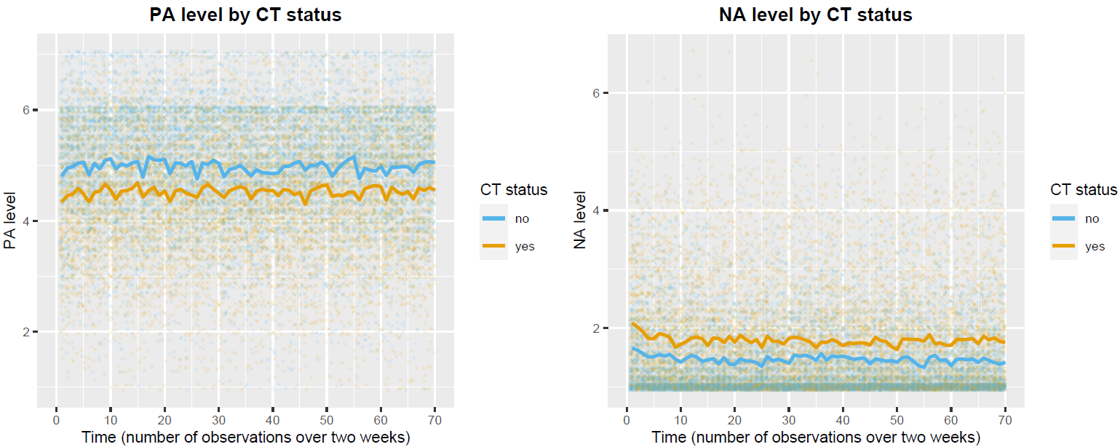

Figure S2. Visualization of the average PA and NA scores calculated for each timepoint over the two-week observations by CT status.
Note. Crosses represent raw mean affect participant scores at each time point.
CT (n = 159), no CT (n = 187). PA, positive affect; NA, negative affect; CT, childhood trauma

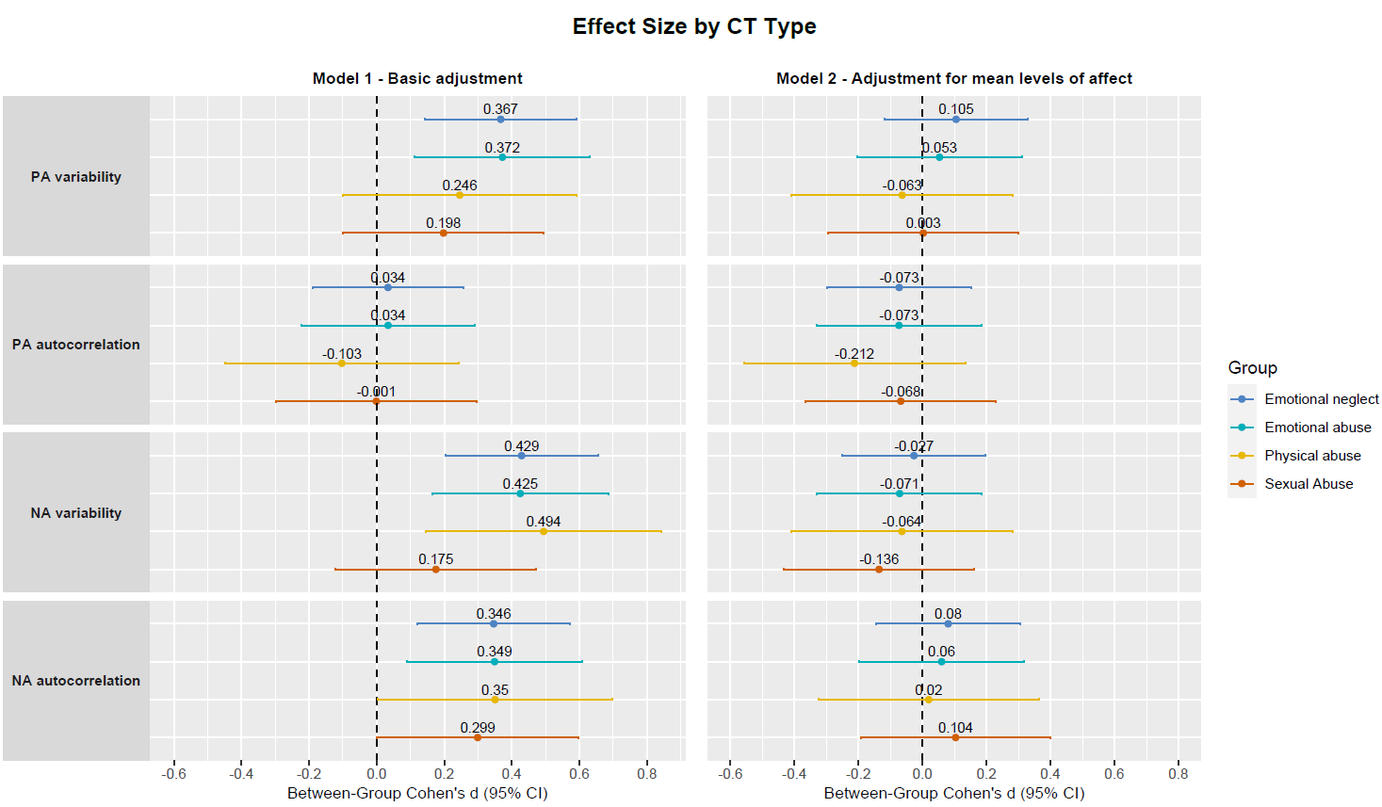

Figure S3. Forest plot of between group effect sizes with corresponding 95% confidence intervals (based on unstandardized regression coefficients) of affect fluctuations by CT type (referenced to no CT group).
Note. Basic adjustment: age, sex, and education. CT types analyzed in separate models with no CT as reference group.
Emotional neglect (n = 130), emotional abuse (n = 84), physical abuse (n = 39), sexual abuse (n = 57), no CT (n = 187).
CT, childhood trauma; PA, positive affect; NA, negative affect

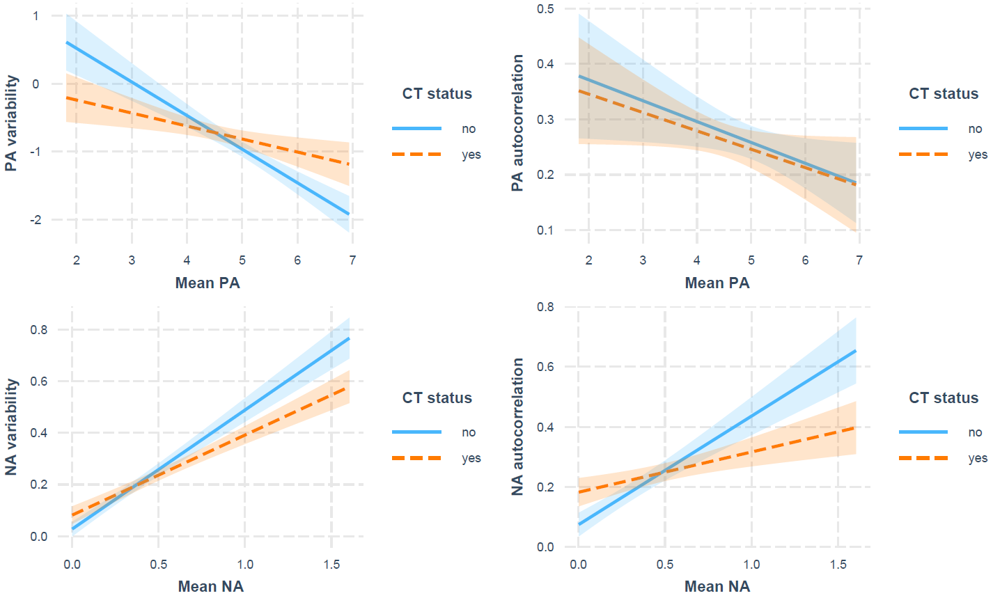

Figure S4. Association between dynamic affect fluctuations and mean affect levels with 95% confidence intervals according to CT status.
Note. Adjusted for age, sex, education. CT, childhood trauma; PA, positive affect; NA, negative affect. Log_{e}-transformed (ln): PA variability, NA variability, mean NA level.

