Supplemental tables and figures accelerated brain aging as a biomarker for staging in bipolar disorder
Supplemental Figure 1. Staging flowcharts
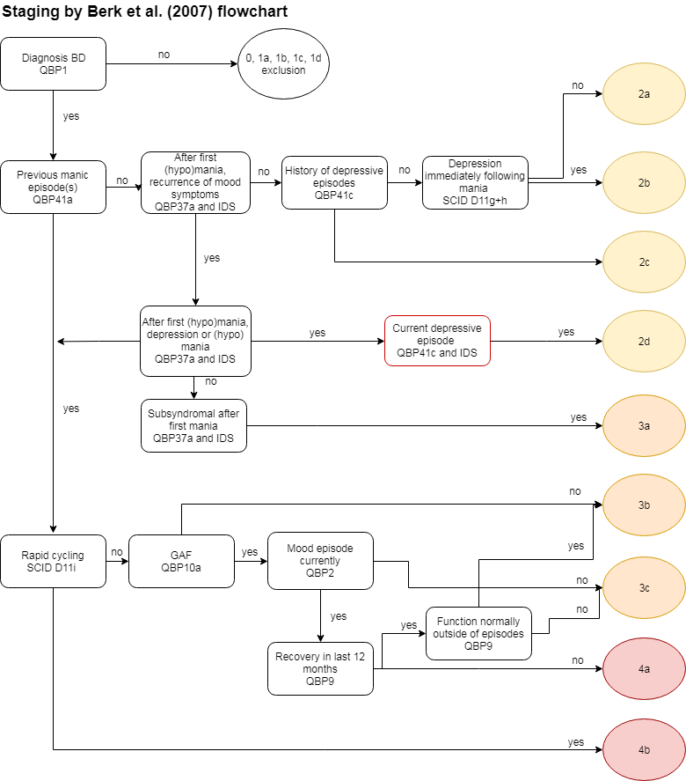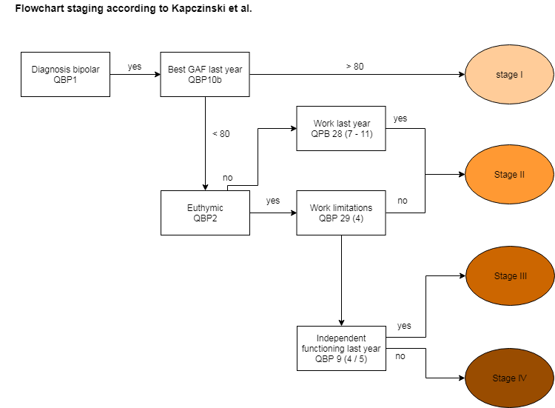
Supplemental Figure 2. Bar charts of the brain-PAD per stage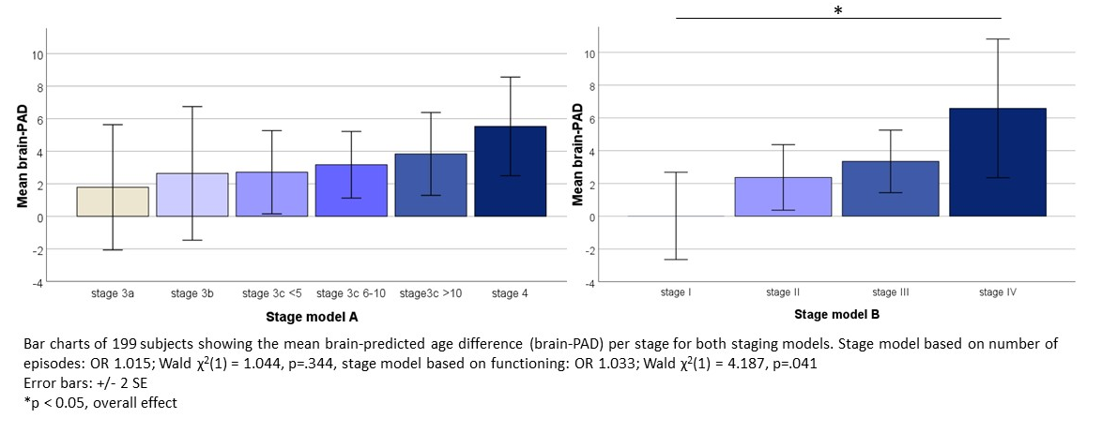

Supplemental Table 1. Patient characteristics per stage
 | Model based on the number of episodes |  |  |  |  |  |  | ANOVA / X² , (df, N), p-value | Model based on inter-episodic functioning |  |  |  |  | ANOVA / X2 , (df, N), p-value
 | Stage 3a | Stage 3b | Stage 3c <5 | Stage 3c 6-10 | Stage 3c >10 | Stage 4 |  |  | Stage I | Stage II | Stage III | Stage IV
N | 6 | 12 | 33 | 79 | 60 | 9 |  |  | 21 | 65 | 98 | 15
Age at MRI scan, mean years (SD) | 34.5 (12.5) | 41.3 (13.6) | 42.5 (11.4) | 44.4 (10.3) | 48.7 (7.8) | 35.4 (9.0) | F(5,193)=5.30, p<0.001 |  | 40.3 (12.0) | 44.3 (8.9) | 45.9 (10.5) | 45.7 (12.7) | F(3,195)=1.78, p=0.153
Sex, m/f (%m) | 3/3  (50) | 8/4 (66.7) | 18/15 (54.5) | 34/45 (43.0) | 28/32 (46.7) | 4/5 (44.4) | X²(5,199)=3.12, p=0.682 |  | 13/9 (57.1) | 32/33 (49.2) | 48/50 (49.0) | 7/8 (46.7) | X2(3,199)=.55, p=0.910
Handedness, R/L/B (%right) | 4/0/2 (66.7) | 8/4/0 (66.7) | 29/2/1 (90.6) | 65/11/2 (83.3) | 56/4/0 (93.3) | 9/0/0 (100) | X²(10,197)=35.73, p<0.001 |  | 17/2/2 (81.0) | 57/7/0 (89.1) | 85/9/3 (87.6) | 12/2/1 (80.0) | X²(6,197)=5.97, p=0.427
Premorbid IQ, mean (SD) | 106.5 (8.4) | 105.8 (10.1) | 107.1 (5.6) | 106.5  (9.9) | 107.4  (9.4) | 104.8  (11.3) | F(5,194)=0.18, p=0.970 |  | 108.2 (7.9) | 108.8 (7.9) | 105.6 (10.4) | 105.2 (9.2) | F(3,195)=1.83, p=0.142
Current IQ, mean (SD) | 106.5 (14.7) | 103.7 (11.0) | 99.7 (13.6) | 99.6 (15.1) | 98.8 (11.8) | 99.0 (7.2) | F(5,170)=0.55, p=0.742 |  | 109.5 (13.4) | 98.4 (12.7) | 99.9 (12.9) | 98.6 (15.8) | F(3,176)=3.95, p=0.009*
Age at onset (years)  Manic symptoms  Depressive symptoms | 29.8 (10.5)  19.0  (0.0) | 30.7 (10.6)  27.7 (11.4) | 31.6 (12.0)  26.8  (8.5) | 26.9  (9.8)  22.6 (10.1) | 24.7  (9.3)  20.4  (9.1) | 23.9  (6.9)  22.0  (8.6) | F(5,189)=2.50, p=0.032  F(5,176)=2.28, p=0.049 |  | 28.4  (9.6)  24.5  (8.5) | 26.4  (9.4)  21.9  (8.0) | 27.9 (10.6)  22.7 (10.3) | 24.1 (11.7)  21.8 (12.5) | F(3,190)=0.79, p=0.499  F(3,177)=0.39, p=0.759
Number of depressive episodes | 0.0 | 1.1  (1.2) | 2.2  (1.6) | 5.8  (7.9) | 10.5 (7.8) | 1.5  (0.7) | F(5,144)=6.21, p=<0.001 |  | 3.4  (4.6) | 4.2  (5.2) | 7.4  (9.1) | 5.7  (4.4) | F(3,145)=2.60, p=0.055
Number of hypomanic / manic episodes | 1.8  (2.0) | 1.3  (0.5) | 2.1  (1.3) | 5.2 (11.8) | 7.4  (6.8) | 1.5  (0.8) | F(5,177)=2.45, p=0.035 |  | 3.2  (4.7) | 5.2 (13.2) | 4.6  (4.7) | 7.6  (9.0) | F(3,178)=0.71, p=0.548
Current lithium use N (%) | 4  (66.7) | 6  (50.0) | 24 (72.7) | 51 (64.4) | 34 (56.7) | 8  (88.9) | X²(5,199)=5.95, p=0.312 |  | 17  (81.0) | 48  (73.8) | 60  (61.2) | 7  (46.7) | X²(3,199)=7.40, p=0.060
Brain age | 36.3 (12.0) | 43.9 (12.6) | 45.2 (14.4) | 47.6 (13.9) | 52.6 (12.0) | 41.0 (12.0) | F(5,193)=3.41, p=0.006 |  | 40.4 (11.4) | 46.6 (12.2) | 49.3 (14.2) | 52.3 (13.6) | F(3,195)=3.34, p=0.021
Brain-PAD | 1.8 (4.7) | 2.6 (7.1) | 2.7 (7.3) | 3.1 (9.1) | 3.8 (9.9) | 5.5 (4.5) | F(5,193)=0.24, p=0.942 |  | <0.1 (6.1) | 2.4 (8.1) | 3.3 (9.4) | 6.6 (8.2) | F(3,195)=1.86, p=0.137
Brain-PAD for li+ subjects | 0.3 (3.2) | -2.1 (5.5) | 2.6 (7.9) | 1.1 (8.4) | 1.4 (9.4) | 6.3 (4.1) | F(5,121)=0.90, p=0.486 |  | -0.7 (6.5) | 0.7 (7.5) | 1.6 (8.8) | 7.5 (8.9) | F(3,128)=1.81, p=0.147
Brain-PAD for li- subjects | 4.8 (7.4) | 7.3 (5.3) | 3.1 (5.9) | 6.9 (9.3) | 7.0 (9.7) | 0.9 (-) | F(5,66)=0.45, p=0.812 |  | 3.0 (2.4) | 7.1 (7.8) | 6.1 (9.9) | 5.8 (8.1) | F(3,63)=0.24, p=0.867
Significant results on anova and chi-square in bold and italic
Pairwise comparison using the Games-Howell test for ANOVA and adjusted residual for chi-square showed the following significant pairwise comparisons:
Age at MRI scan: episodes model: stage3c>10 > stage4
Handedness, R/L/B: episodes model stage3a B>L/R, stage3b L/R>B
Current IQ: functioning model stage I > stage II; stage I > stage III
Onset depressive symptoms: episodes model stage3a < stage 3c<5; 3a < 3c6-10; stage 3c<5 > stage 3c>10
Number of hypomanic / manic episodes: episodes model stage3a < stage3c>10; stage 3b < stage3c>10; stage3c<5 < stage 3c>10; stage3c>10 > stage 4
Brain age: episodes model: functioning model stage I < stage III; stage I < stage IV

Supplemental Table 2. Characteristics of the study sample including subjects >60 years
 | Bipolar patiënts  (N = 256) | Controls  (N = 166) | t-test / X² (df), p-value
Sociodemographic characteristics
Age at MRI scan, mean years (SD) | 47.8 (12.3) | 44.7 (14.6) | T(309)=2.24, p=0.026
Sex, m/f (%m) | 125/131 (48.8%) | 84/82 (49.4%) | X²⁽1)=0.01, p=0.909
Handedness, R/L/B (%right) | 218/24/9 (86.9%) | 136/20/6 (84.0%) | X²(2)=0.82, p=0.665
Premorbid IQ, mean (SD) | 106.5 (10.1) | 107.9 (9.27) | T(409)=1.35, p=0.179
Current IQ, mean (SD) | 99.8 (13.7) | 108.1 (16.8) | T(300)=5.17, p<0.001
Psychiatric characteristics of the patients with BD
Age at onset (years)  Manic symptoms  Depressive symptoms | 29.1 (13.5)  26.7 (17.7) | n/a  n/a
Number of depressive episodes | 20.1 (34.1) | n/a
Number of hypomanic / manic episodes | 11.3 (25.4) | n/a
Lithium use N (%)¹ | 169 (40.3) | n/a
Comorbid anxiety disorders y/n (%yes) | 46/205 (18%) | n/a
Comorbid substance use disorders  Alcohol, units/week (SD)  Substance abuse, y/n (%yes)  Substance dependence, y/n (%yes) | 26.4 (49.6)  15/200 (7.0%)  18/196 (8.4%) | 26.1 (41.8)  7/74 (8.6)  5/66 (7.0%) | T(222)=-0.39, p=0.969  X²(1)=0.24, p=0.626  X²(1)=0.14, p=0.714
Brain age
Brain age, mean years (SD) | 50.7 (14.7) | 44.7 (16.5) | T(420)=3.90, p=<0.001
Brain-PAD, mean years (SD) | 2.9 (8.61) | 0.0 (7.58) | T(383)=3.65, p=<0.001
Significant results in bold and italic
¹ at the time of the scan

Supplemental Table 3. Associations between cortical ROI volumes and illness progression for both models, corrected for intracranial volume, age and sex.
 | Model based on the number of episodes |  |  |  | Model based on inter-episodic functioning
volume | Odds ratio | Range | Wald | p-value | Odds ratio | Range | Wald | p-value
Banks of superior temporal sulcus | 0.836 | 0.399 - 1.753 | 0.224 | 0.636 | 0.893 | 0.407 - 1.955 | 0.081 | 0.776
Caudal anterior cingulate cortex | 1.133 | 0.596 - 2.152 | 0.145 | 0.703 | 1.019 | 0.524 - 1.982 | 0.003 | 0.955
Caudal middle frontal gyrus | 1.089 | 0.832 - 1.424 | 0.383 | 0.536 | 0.724 | 0.543 - 0.967 | 4.776 | 0.029
Cuneus | 0.689 | 0.357 - 1.328 | 1.238 | 0.266 | 0.422 | 0.212 - 0.839 | 6.051 | 0.014
Entorhinal cortex | 0.723 | 0.292 - 1.790 | 0.490 | 0.484 | 1.106 | 0.439 - 2.784 | 0.046 | 0.831
Fusiform cortex | 0.921 | 0.734 - 1.157 | 0.497 | 0.481 | 0.967 | 0.765 - 1.223 | 0.078 | 0.781
Inferior parietal lobule | 0.912 | 0.774 - 1.075 | 1.205 | 0.272 | 0.874 | 0.736 - 1.036 | 2.401 | 0.121
Inferior temporal gyrus | 0.912 | 0.740 - 1.123 | 0.756 | 0.385 | 0.833 | 0.667 - 1.041 | 2.574 | 0.109
Isthmus cingulate cortex | 0.785 | 0.390 - 1.582 | 0.457 | 0.499 | 0.659 | 0.319 - 1.359 | 1.276 | 0.259
Lateral occipital gyrus | 0.832 | 0.682 - 1.016 | 3.265 | 0.071 | 0.906 | 0.739 - 1.110 | 0.905 | 0.341
Lateral orbitofrontal cortex | 0.855 | 0.592 - 1.236 | 0.693 | 0.405 | 0.784 | 0.533 - 1.152 | 1.538 | 0.215
Lingual cortex | 0.976 | 0.727 - 1.311 | 0.025 | 0.874 | 0.685 | 0.503 - 0.933 | 5.760 | 0.016
Medial orbitofrontal cortex | 0.632 | 0.368 - 1.085 | 2.765 | 0.096 | 0.563 | 0.319 - 0.994 | 3.923 | 0.048
Middle temporal gyrus | 1.115 | 0.879 - 1.415 | 0.802 | 0.371 | 0.920 | 0.717 - 1.180 | 0.430 | 0.512
Parahippocampal cortex | 0.715 | 0.301 - 1.698 | 0.577 | 0.447 | 0.526 | 0.217 - 1.277 | 2.015 | 0.156
Paracentral cortex | 0.931 | 0.551 - 1.575 | 0.070 | 0.791 | 0.679 | 0.391 - 1.179 | 1.891 | 0.169
Pars opercularis | 0.783 | 0.474 - 1.293 | 0.915 | 0.339 | 0.977 | 0.579- 1.648 | 0.008 | 0.929
Pars orbitalis | 0.581 | 0.216 - 1.565 | 1.154 | 0.283 | 0.899 | 0.321 - 2.516 | 0.041 | 0.840
Pars triangularis | 0.555 | 0.328 - 0.939 | 4.818 | 0.028 | 1.014 | 0.588 - 1.749 | 0.002 | 0.961
Pericalcarine cortex | 0.785 | 0.373 - 1.649 | 0.410 | 0.522 | 0.371 | 0.170 - 0.808 | 6.232 | 0.013
Postcentral cortex | 1.216 | 0.946 - 1.563 | 2.334 | 0.127 | 0.856 | 0.660 - 1.110 | 1.376 | 0.241
Posterior cingulate cortex | 0.829 | 0.459 - 1.497 | 0.387 | 0.534 | 0.669 | 0.361 - 1.240 | 1.628 | 0.202
Precentral cortex | 0.952 | 0.781 - 1.160 | 0.238 | 0.625 | 0.814 | 0.661 - 1.003 | 3.732 | 0.053
Precuneus | 0.822 | 0.636 - 1.063 | 2.233 | 0.135 | 0.854 | 0.655 - 1.112 | 1.374 | 0.241
Rostral anterior cingulate cortex | 1.201 | 0.593 - 2.435 | 0.259 | 0.611 | 0.867 | 0.412 - 1.823 | 0.142 | 0.707
Rostral middle frontal gyrus | 0.952 | 0.815 - 1.113 | 0.376 | 0.540 | 0.918 | 0.779 - 1.081 | 1.050 | 0.305
Superior frontal gyrus | 0.988 | 0.871 - 1.120 | 0.037 | 0.847 | 0.866 | 0.756 - 0.992 | 4.333 | 0.037
Superior parietal lobule | 0.957 | 0.791 - 1.159 | 0.200 | 0.654 | 1.013 | 0.835 - 1.229 | 0.018 | 0.894
Superior temporal gyrus | 0.974 | 0.790 - 1.200 | 0.062 | 0.804 | 0.861 | 0.688 - 1.077 | 1.709 | 0.191
Supramarginal gyrus | 0.928 | 0.746 - 1.156 | 0.443 | 0.506 | 0.853 | 0.679 - 1.072 | 1.869 | 0.172
Frontal pole | 1.887 | 0.181 - 19.703 | 0.282 | 0.596 | 0.450 | 0.042 - 4.825 | 0.436 | 0.509
Temporal pole | 1.111 | 0.383 - 3.222 | 0.037 | 0.847 | 0.856 | 0.279 - 2.621 | 0.074 | 0.785
Transverse temporal cortex | 1.258 | 0.324 - 4.876 | 0.110 | 0.740 | 0.236 | 0.058 - 0.953 | 4.109 | 0.043
Insula | 1.046 | 0.712 - 1.537 | 0.053 | 0.817 | 0.878 | 0.590 - 1.306 | 0.414 | 0.520
p < 0.05 in italic

Supplemental Table 4. Associations between global and subcortical brain measures and brain-PAD and illness progression for both models, with global and subcortical brain measures corrected for lithium (yes/no), intracranial volume [except cortical thickness and cortical surface measures], age and sex and brain-PAD corrected for lithium (yes/no), age and age².
 | Model based on the number of episodes |  |  |  | Model based on inter-episodic functioning
 | Odds ratio | Range | Wald | p-value | Odds ratio | Range | Wald | p-value
Global measures
Intracranial volume | 1.002 | 1.001 - 1.004 | 6.966 | 0.008 | 1.001 | 0.999 - 1.002 | 0.648 | 0.421
Cortical gray matter volume | 0.997 | 0.990 - 1.005 | 0.501 | 0.479 | 0.995 | 0.986 - 1.003 | 1.729 | 0.189
Cortical white matter volume | 0.995 | 0.989 - 1.001 | 2.295 | 0.130 | 0.999 | 0.992 - 1.005 | 0.227 | 0.634
Cerebellum volume | 0.978 | 0.957 - 0.999 | 4.252 | 0.039 | 0.992 | 0.970 - 1.014 | 0.548 | 0.459
Lateral ventricle volume | 1.043 | 1.010 - 1.077 | 6.569 | 0.010 | 1.036 | 1.002 - 1.072 | 4.234 | 0.040
Third ventricle volume | 2.151 | 1.108 - 4.174 | 5.123 | 0.024 | 1.104 | 0.558 - 2.187 | 0.081 | 0.776
Mean cortical thickness | 0.545 | 0.120 - 2.470 | 0.619 | 0.432 | 0.339 | 0.066 - 1.756 | 1.660 | 0.198
Mean surface area | 1.001 | 0.999 - 1.003 | 0.577 | 0.448 | 1.000 | 0.998 - 1.002 | 0.081 | 0.776
Subcortical volumes
Thalamus | 0.987 | 0.659 - 1.480 | 0.004 | 0.950 | 1.101 | 0.729 - 1.664 | 0.209 | 0.648
Caudate nucleus | 0.833 | 0.435 - 1.595 | 0.305 | 0.581 | 1.040 | 0.530 - 2.041 | 0.013 | 0.909
Putamen | 0.737 | 0.468 - 1.158 | 1.753 | 0.186 | 0.658 | 0.414- 1.046 | 3.126 | 0.077
Pallidum | 0.537 | 0.123 - 2.348 | 0.682 | 0.409 | 0.389 | 0.087 - 1.742 | 1.525 | 0.217
Hippocampus | 0.491 | 0.259 - 0933 | 4.716 | 0.030 | 0.535 | 0.275 - 1.042 | 3.379 | 0.066
Amygdala | 0.374 | 0.118 - 1.189 | 2.778 | 0.096 | 0.250 | 0.073 - 0.850 | 4.928 | 0.026
Nucleus accumbens | 0.511 | 0.129 - 2.019 | 0.917 | 0.338 | 0.456 | 0.108 - 1.927 | 1.141 | 0.286
Brain-PAD
Brain-PAD* | 1.014 | 0.984 - 1.045 | 0.817 | 0.366 | 1.023 | 0.991 - 1.056 | 1.911 | 0.167
p < 0.05 in italic
*Lithium as regression coefficient for Model based on inter-episodic functioning OR 1.962 range 1.085 - 3.550, p 0.026

Supplemental Table 5. Associations between global and subcortical brain measures and brain-PAD and illness progression for both models, with global and subcortical brain measures corrected for current IQ, intracranial volume [except cortical thickness and cortical surface measures], age, sex and brain-PAD corrected for current IQ. age and age².
 | Model based on the number of episodes |  |  |  | Model based on inter-episodic functioning
Var | Odds ratio | Range | Wald | p-value | Odds ratio | Range | Wald | p-value
Global measures | .
Intracranial volume | 1.002 | 1.001 - 1.004 | 7.310 | 0.007 | 1.001 | 0.999 - 1.002 | 0.360 | 0.549
Cortical gray matter volume | 0.998 | 0.991 - 1.006 | 0.186 | 0.666 | 0.992 | 0.984 - 1.000 | 3.479 | 0.062
Cortical white matter volume | 0.995 | 0.989 - 1.001 | 2.350 | 0.125 | 0.997 | 0.991 - 1.004 | 0.672 | 0.412
Cerebellum volume | 0.978 | 0.957 - 1.000 | 3.925 | 0.048 | 0.992 | 0.971 - 1.015 | 0.440 | 0.507
Lateral ventricle volume | 1.040 | 1.007 - 1.073 | 5.847 | 0.016 | 1.042 | 1.008 - 1.077 | 5.989 | 0.014
Third ventricle volume | 2.047 | 1.067 - 3.929 | 4.644 | 0.031 | 1.414 | 0.724 - 2.759 | 1.029 | 0.310
Mean cortical thickness | 0.722 | 0.155 - 3.356 | 0.172 | 0.678 | 0.248 | 0.047 - 1.297 | 2.729 | 0.099
Mean surface Area | 1.001 | 0.999 - 1.003 | 0.641 | 0.423 | 0.999 | 0.997 - 1.001 | 0.606 | 0.436
Subcortical volumes
Thalamus | 1.000 | 0.670 - 1.491 | 0.000 | 0.999 | 0.973 | 0.650 - 1.455 | 0.018 | 0.892
Caudate nucleus | 0.789 | 0.405 - 1.539 | 0.483 | 0.487 | 0.899 | 0.451 - 1.796 | 0.090 | 0.764
Putamen | 0.771 | 0.491 - 1.211 | 1.273 | 0.259 | 0.596 | 0.375 - 0.946 | 4.812 | 0.028
Pallidum | 0.571 | 0.128 - 2.559 | 0.536 | 0.464 | 0.331 | 0.073 - 1.496 | 2.062 | 0.151
Hippocampus | 0.552 | 0.293 - 1.043 | 3.344 | 0.067 | 0.422 | 0.218 - 0.819 | 6.505 | 0.011
Amygdala | 0.382 | 0.122 - 1.201 | 2.710 | 0.100 | 0.200 | 0.060 - 0.672 | 6.780 | 0.009
Nucleus accumbens | 0.565 | 0.150 - 2.137 | 0.706 | 0.401 | 0.326 | 0.080 - 1.320 | 2.469 | 0.116
Brain-PAD⁺
Brain-PAD | 1.011 | 0.981 - 1.041 | 0.493 | 0.482 | 1.031 | 0.999 - 1.063 | 3.662 | 0.056
⁺ Corrected for age and age²
p < 0.05 in italic

Supplemental Table 6. Associations between global and subcortical brain measures and brain-PAD and illness progression for both models in the sample including subjects >60 years, with global and subcortical brain measures corrected for intracranial volume [except cortical thickness and cortical surface measures], age and sex and brain-PAD corrected for age and age².
 | Model based on the number of episodes |  |  |  | Model based on inter-episodic functioning
 | Odds ratio | Range | Wald | p-value | Odds ratio | Range | Wald | p-value
Global measures
Intracranial volume | 1.002 | 1.000 - 1.003 | 6.072 | 0.014 | 1.000 | 0.999 - 1.002 | 0.087 | 0.768
Cortical gray matter volume | 0.998 | 0.990 - 1.005 | 0.449 | 0.503 | 0.993 | 0.985 - 1.000 | 3.383 | 0.066
Cortical white matter volume | 0.996 | 0.991 - 1.002 | 1.818 | 0.178 | 0.999 | 0.993 - 1.004 | 0.271 | 0.603
Cerebellum volume | 0.980 | 0.960 - 1.000 | 3.811 | 0.051 | 0.988 | 0.967 - 1.009 | 1.305 | 0.253
Lateral ventricle volume | 1.031 | 1.003 - 1.060 | 4.855 | 0.028 | 1.020 | 0.991 - 1.049 | 1.759 | 0.185
Third ventricle volume | 1.911 | 1.063 - 3.435 | 4.688 | 0.030 | 1.032 | 0.573 - 1.858 | 0.011 | 0.917
Mean cortical thickness | 0.674 | 0.164 - 2.766 | 0.300 | 0.584 | 0.202 | 0.044 - 0.930 | 4.217 | 0.040
Mean surface Area | 1.001 | 0.999 - 1.003 | 0.435 | 0.510 | 0.999 | 0.998 - 1.001 | 0.276 | 0.599
Subcortical volumes
Thalamus | 0.893 | 0.617 - 1.290 | 0.365 | 0.546 | 0.851 | 0.587 - 1.233 | 0.730 | 0.393
Caudate nucleus | 0.912 | 0.506 - 1.641 | 0.095 | 0.758 | 0.903 | 0.491 - 1.661 | 0.108 | 0.743
Putamen | 0.735 | 0.482 - 1.121 | 2.048 | 0.152 | 0.585 | 0.381 - 0.899 | 5.999 | 0.014
Pallidum | 0.596 | 0.146 - 2.435 | 0.518 | 0.472 | 0.298 | 0.077 - 1.154 | 3.071 | 0.080
Hippocampus | 0.584 | 0.323 - 1.055 | 3.173 | 0.075 | 0.512 | 0.277 - 0.946 | 4.571 | 0.033
Amygdala | 0.563 | 0.190 - 1.667 | 1.075 | 0.300 | 0.271 | 0.086 - 0.856 | 4.954 | 0.026
Nucleus accumbens | 0.571 | 0.170 - 1.917 | 0.822 | 0.365 | 0.386 | 0.109 - 1.370 | 2.171 | 0.141
Brain-PAD⁺ | 1.016 | 0.989 - 1.044 | 1.310 | 0.252 | 1.028 | 0.999 - 1.057 | 3.617 | 0.057
⁺ Corrected for age and age2
p < 0.05 in italic

Supplemental Table 7. Dispersion of subjects over the stages of the staging models
 |  | Model based on the number of episodes |  |  |  |  |  |  | Model based on inter-episodic functioning
 |  | Stage 3a | Stage 3b | Stage 3c<5 | Stage3c 5-10 | Stage 3c >10 | Stage 4 | Total | stage I | stage II | stage III | stage IV | Total
Original sample of subjects <60 |  | 6 | 12 | 33 | 79 | 60 | 9 | 199 | 21 | 65 | 98 | 15 | 199
Lithium use | yes | 4 | 6 | 24 | 51 | 34 | 8 | 127 | 17 | 48 | 60 | 7 | 132
 | no | 2 | 6 | 9 | 28 | 26 | 1 | 72 | 4 | 17 | 38 | 8 | 67
Anxiety disorders | yes | 1 | 0 | 3 | 13 | 17 | 0 | 34 | 1 | 7 | 21 | 5 | 34
 | no | 5 | 12 | 30 | 65 | 42 | 9 | 163 | 20 | 57 | 76 | 10 | 163
Substance abuse or dependence | yes | 0 | 0 | 4 | 11 | 3 | 2 | 20 | 0 | 8 | 10 | 2 | 20
 | no | 6 | 12 | 24 | 51 | 48 | 6 | 147 | 18 | 45 | 73 | 11 | 147

Supplemental Table 8. Associations between global and subcortical brain measures and brain-PAD and illness progression for both models, with global and subcortical brain measures corrected for anxiety disorders (yes/no), intracranial volume [except cortical thickness and cortical surface measures], age and sex and brain-PAD corrected for anxiety disorders (yes/no),, age and age².
 | Model based on the number of episodes |  |  |  | Model based on inter-episodic functioning
 | Odds ratio | Range | Wald | p-value | Odds ratio | Range | Wald | p-value
Global measures
Intracranial volume | 1.002 | 1.000 – 1.004 | 5.127 | 0.024 | 1.000 | 0.998 - 1.002 | 0.004 | 0.947
Cortical gray matter volume | 0.998 | 0.990 – 1.005 | 0.413 | 0.520 | 0.995 | 0.986 - 1.003 | 1.746 | 0.186
Cortical white matter volume | 0.996 | 0.990 – 1.005 | 1.827 | 0.176 | 0.998 | 0.992 - 1.004 | 0.461 | 0.497
Cerebellum volume | 0.978 | 0.957 - 0.999 | 4.264 | 0.039 | 0.991 | 0.969 - 1.013 | 0.652 | 0.419
Lateral ventricle volume | 1.039 | 1.006 – 1.073 | 5.398 | 0.020 | 1.036 | 1.002 - 1.072 | 4.308 | 0.038
Third ventricle volume | 2.040 | 1.060 – 3.926 | 4.551 | 0.033 | 1.221 | 0.622 - 2.396 | 0.336 | 0.562
Mean cortical thickness | 0.538 | 0.119 – 2.427 | 0.650 | 0.420 | 0.306 | 0.059 - 1.582 | 1.997 | 0.158
Mean surface area | 1.001 | 0.999 – 1.003 | 0.396 | 0.529 | 0.999 | 0.997 - 1.001 | 0.344 | 0.557
Subcortical volumes
Thalamus | 1.016 | 0.685 – 1.506 | 0.006 | 0.939 | 0.962 | 0.644 - 1.438 | 0.035 | 0.852
Caudate nucleus | 0.903 | 0.471 – 1.731 | 0.094 | 0.759 | 1.058 | 0.535 - 2.092 | 0.027 | 0.870
Putamen | 0.715 | 0.456 – 1.731 | 2.126 | 0.145 | 0.577 | 0.363 - 0.917 | 5.419 | 0.020
Pallidum | 0.551 | 0.126 – 2.405 | 0.628 | 0.428 | 0.323 | 0.073 - 1.435 | 2.207 | 0.137
Hippocampus | 0.499 | 0.265 - 0.937 | 4.670 | 0.031 | 0.478 | 0.248 - 0.922 | 4.857 | 0.028
Amygdala | 0.400 | 0.128 – 1.254 | 2.470 | 0.116 | 0.210 | 0.062 - 0.708 | 6.335 | 0.012
Nucleus accumbens | 0.594 | 0.155 - 2.268 | 0.582 | 0.446 | 0.438 | 0.106 - 1.812 | 1.298 | 0.255
Brain-PAD⁺
Brain-PAD | 1.012 | 0.982 - 1.042 | 0.566 | 0.452 | 1.025 | 0.993 - 1.058 | 2.370 | 0.124
⁺ Corrected for age and age²
p < 0.05 in italic

Supplemental Table 9. Associations between global and subcortical brain measures and brain-PAD and illness progression for both models, with global and subcortical brain measures corrected for substance use disorders (yes/no), intracranial volume [except cortical thickness and cortical surface measures], age and sex and brain-PAD corrected for substance use disorders (yes/no), age and age².
 | Model based on the number of episodes |  |  |  | Model based on inter-episodic functioning
 | Odds ratio | Range | Wald | p-value | Odds ratio | Range | Wald | p-value
Global measures
Intracranial volume | 1.002 | 1.000 - 1.004 | 2.994 | 0.084 | 1.001 | 0.999 - 1.003 | 0.744 | 0.388
Cortical gray matter volume | 0.995 | 0.987 - 1.003 | 1.257 | 0.262 | 0.991 | 0.983 - 1.000 | 3.738 | 0.053
Cortical white matter volume | 0.994 | 0.988 - 1.001 | 2.856 | 0.091 | 0.996 | 0.989 - 1.002 | 1.584 | 0.208
Cerebellum volume | 0.974 | 0.952 - 0.996 | 5.314 | 0.021 | 0.980 | 0.957 - 1.003 | 3.022 | 0.082
Lateral ventricle volume | 1.054 | 1.018 - 1.090 | 8.876 | 0.003 | 1.051 | 1.014 - 1.090 | 7.338 | 0.007
Third ventricle volume | 2.585 | 1.285 - 5.198 | 7.095 | 0.008 | 1.441 | 0.706 - 2.941 | 1.006 | 0.316
Mean cortical thickness | 0.400 | 0.079 - 2.020 | 1.231 | 0.267 | 0.163 | 0.027 - 0.972 | 3.964 | 0.046
Mean surface Area | 1.000 | 0.998- 1.002 | 0.012 | 0.914 | 0.999 | 0.997 - 1.002 | 0.293 | 0.589
Subcortical volumes
Thalamus | 0.955 | 0.626 - 1.457 | 0.012 | 0.914 | 0.829 | 0.539 - 1.277 | 0.722 | 0.395
Caudate nucleus | 0.821 | 0.400 - 1.686 | 0.046 | 0.830 | 0.623 | 0.293 - 1.325 | 1.511 | 0.219
Putamen | 0.781 | 0.479 - 1.274 | 0.289 | 0.591 | 0.451 | 0.269 - 0.756 | 9.141 | 0.002
Pallidum | 0.589 | 0.121 - 2.855 | 0.981 | 0.322 | 0.158 | 0.031 - 0.802 | 4.958 | 0.026
Hippocampus | 0.486 | 0.243 - 0.975 | 0.433 | 0.511 | 0.410 | 0.199 - 0.847 | 5.811 | 0.016
Amygdala | 0.353 | 0.105 - 1.182 | 4.126 | 0.042 | 0.169 | 0.046 - 0.618 | 7.226 | 0.007
Nucleus accumbens | 0.532 | 0.123 - 2.299 | 2.850 | 0.091 | 0.186 | 0.039 - 0.894 | 4.409 | 0.036
Brain-PAD⁺
Brain-PAD | 1.014 | 0.983 -1.046 | 0.757 | 0.384 | 1.046 | 1.012 - 1.081 | 7.072 | 0.008
⁺ Corrected for age and age²
p < 0.05 in italic

