**Supplemental Online Content**

**This supplement includes 4 eTables and 7 eFigures.**

**eTable 1.** Content of Cognitively Stimulating Activities Related Questions Assessed at Different Age levels

**eTable 2.** Correlation Coefficient Table of Items on Cognitively Stimulating Activities at Age 6, 12, 18 (Early Life Period)

**eTable 3.** Exploratory Factor Analysis (EFA)Factor Loadings of Early-life Activity Items Simultaneously Fitted across Age 6, 12, 18 (Factor Number = 3, Items with Factor Loading >=0.4 were Highlighted for Each Factor)

**eTable 4.** Odds Ratios a (OR) and 95% Confidence Intervals (CI) for Late-life Depression and Anxiety per 1 Point Increase in Early-Life Cognitively Stimulating Activity Sub-Scale Scores from Exploratory Factor Analysis (EFA)

**eFigure 1.** Pearson Correlation Among Age 6, 12, 18, 40 and Early Life Activity Scores

**eFigure 2.** Distributions of Age 6, 12, 18, 40 and Early Life Activity Scores

**eFigure 3.** Epidemiology Confounding Structure as Presented in a Directed Acyclic Graph (DAG)

**eFigure 4.** Early Life Cognitively Stimulating Activity Score – Response Curves using Log Odds of Outcome Risk and Probability of Outcome Risk as Y-axis

**eFigure 5.** Pearson Correlation Matrix Plot of Items on Cognitively Stimulating Activities at Age 6, 12, 18 (Early Life Period)

**eFigure 6**. Exploratory Factor Analysis (EFA) Scree Plots of Age-specific Cognitively Stimulating Activities Separately Fitted at Age 6, 12, 18

**eFigure 7.** Exploratory Factor Analysis (EFA) Scree Plot of Age-specific Cognitively Stimulating Activities Simultaneously Fitted across Age 6, 12, 18

**eTable 1. Content of Cognitively Stimulating Activities Related Questions Assessed at Different Age levels**

|  |  |
| --- | --- |
| **Age** | **Activities** |
| When you were 6… | a How often did you play games like tic-tac-toe, checkers, or other board games, cards, or word games?  a How often did someone in your home read to you?  a How often did someone in your home tell you stories? |
| When you were 12… | b About how much time did you spend reading each day?  a How often did you visit a library?  a How often did you read a newspaper?  a How often did you read magazines?  a How often did you read books?  a How often did you write letters?  a How often did you play games like checkers or other board games, cards, puzzles, word games, mind teasers, or any other similar games?  b How much time did you spend on homework each day? |
| When you were 18… | c How many times had you visited a museum?  c How many times had you attended a concert, play, or musical?  b About how much time did you spend reading each day?  a How often did you visit a library?  a How often did you read newspapers?  a How often did you read magazines?  a How often did you read books?  a How often did you write letters?  a How often did you play games like checkers or other board games, etc.? |
| When you were 40… | b About how much time did you spend reading each day?  a How often did you read newspapers?  a How often did you read magazines?  a How often did you read books?  a How often did you write letters?  a How often did you play games like checkers or other board games, cards, puzzles, etc.?  c (From age 30 to 40) How many times did you visit a museum?  c (From age 30 to 40) How many times did you attend a concert, play, or musical?  a (From age 30 to 40) How often did you visit a library? |

a Responses were coded as: Once a year or less (1), Several times a year (2), Several times a month (3), Several times a week (4), Every day/almost every day (5); b Responses were coded as: None (1), Less than one hour (2), One to less than two hours (3), Two to less than three hours (4), Three or more hours (5); c Responses were coded as: Never (1), 1-2 times (2), 3-9 times (3), 10-19 times (4), More than 20 times (5).

**eTable 2. Correlation Coefficient Table of Items on Cognitively Stimulating Activities at Age 6, 12, 18 (Early Life Period)**

|  |  |  |  |  |  |  |  |  |  |  |  |  |  |  |  |  |  |  |  |  |
| --- | --- | --- | --- | --- | --- | --- | --- | --- | --- | --- | --- | --- | --- | --- | --- | --- | --- | --- | --- | --- |
|  | **read to 6** | **storytelling 6** | **games 6** | **read 12** | **library 12** | **newspaper 12** | **magazine 12** | **book 12** | **letter 12** | **games 12** | **homework 12** | **museum 18** | **music 18** | **read 18** | **library 18** | **newspaper 18** | **magazine 18** | **book 18** | **letter 18** | **games 18** |
| **read to 6** | **1.00** | 0.66 | 0.42 | 0.28 | 0.37 | 0.23 | 0.32 | 0.43 | 0.36 | 0.37 | 0.17 | 0.32 | 0.31 | 0.26 | 0.29 | 0.23 | 0.37 | 0.28 | 0.32 | 0.25 |
| **storytelling 6** | 0.66 | **1.00** | 0.43 | 0.21 | 0.30 | 0.22 | 0.30 | 0.31 | 0.35 | 0.39 | 0.13 | 0.26 | 0.25 | 0.24 | 0.27 | 0.22 | 0.28 | 0.29 | 0.31 | 0.29 |
| **games 6** | 0.42 | 0.43 | **1.00** | 0.23 | 0.33 | 0.19 | 0.29 | 0.35 | 0.31 | 0.70 | 0.13 | 0.24 | 0.22 | 0.20 | 0.23 | 0.19 | 0.29 | 0.25 | 0.26 | 0.40 |
| **read 12** | 0.28 | 0.21 | 0.23 | **1.00** | 0.44 | 0.30 | 0.33 | 0.64 | 0.32 | 0.26 | 0.33 | 0.29 | 0.27 | 0.61 | 0.29 | 0.26 | 0.52 | 0.30 | 0.28 | 0.13 |
| **library 12** | 0.37 | 0.30 | 0.33 | 0.44 | **1.00** | 0.28 | 0.36 | 0.56 | 0.40 | 0.36 | 0.20 | 0.31 | 0.29 | 0.31 | 0.43 | 0.25 | 0.43 | 0.32 | 0.31 | 0.22 |
| **newspaper 12** | 0.23 | 0.22 | 0.19 | 0.30 | 0.28 | **1.00** | 0.65 | 0.36 | 0.22 | 0.22 | 0.12 | 0.29 | 0.25 | 0.27 | 0.30 | 0.70 | 0.33 | 0.51 | 0.20 | 0.21 |
| **magazine 12** | 0.32 | 0.30 | 0.29 | 0.33 | 0.36 | 0.65 | **1.00** | 0.40 | 0.35 | 0.30 | 0.16 | 0.36 | 0.31 | 0.28 | 0.33 | 0.54 | 0.36 | 0.67 | 0.27 | 0.24 |
| **book 12** | 0.43 | 0.31 | 0.35 | 0.64 | 0.56 | 0.36 | 0.40 | **1.00** | 0.42 | 0.37 | 0.21 | 0.39 | 0.33 | 0.48 | 0.39 | 0.31 | 0.74 | 0.37 | 0.35 | 0.22 |
| **letter 12** | 0.36 | 0.35 | 0.31 | 0.32 | 0.40 | 0.22 | 0.35 | 0.42 | **1.00** | 0.32 | 0.18 | 0.29 | 0.28 | 0.27 | 0.35 | 0.23 | 0.38 | 0.34 | 0.66 | 0.26 |
| **games 12** | 0.37 | 0.39 | 0.70 | 0.26 | 0.36 | 0.22 | 0.30 | 0.37 | 0.32 | **1.00** | 0.16 | 0.26 | 0.23 | 0.25 | 0.27 | 0.23 | 0.34 | 0.30 | 0.29 | 0.52 |
| **homework 12** | 0.17 | 0.13 | 0.13 | 0.33 | 0.20 | 0.12 | 0.16 | 0.21 | 0.18 | 0.16 | **1.00** | 0.12 | 0.10 | 0.35 | 0.18 | 0.09 | 0.19 | 0.13 | 0.17 | 0.08 |
| **museum 18** | 0.32 | 0.26 | 0.24 | 0.29 | 0.31 | 0.29 | 0.36 | 0.39 | 0.29 | 0.26 | 0.12 | **1.00** | 0.67 | 0.32 | 0.36 | 0.33 | 0.40 | 0.34 | 0.27 | 0.20 |
| **music 18** | 0.31 | 0.25 | 0.22 | 0.27 | 0.29 | 0.25 | 0.31 | 0.33 | 0.28 | 0.23 | 0.10 | 0.67 | **1.00** | 0.29 | 0.32 | 0.27 | 0.33 | 0.25 | 0.27 | 0.18 |
| **read 18** | 0.26 | 0.24 | 0.20 | 0.61 | 0.31 | 0.27 | 0.28 | 0.48 | 0.27 | 0.25 | 0.35 | 0.32 | 0.29 | **1.00** | 0.49 | 0.28 | 0.62 | 0.29 | 0.33 | 0.19 |
| **library 18** | 0.29 | 0.27 | 0.23 | 0.29 | 0.43 | 0.30 | 0.33 | 0.39 | 0.35 | 0.27 | 0.18 | 0.36 | 0.32 | 0.49 | **1.00** | 0.31 | 0.57 | 0.33 | 0.40 | 0.23 |
| **newspaper 18** | 0.23 | 0.22 | 0.19 | 0.26 | 0.25 | 0.70 | 0.54 | 0.31 | 0.23 | 0.23 | 0.09 | 0.33 | 0.27 | 0.28 | 0.31 | **1.00** | 0.36 | 0.68 | 0.25 | 0.25 |
| **magazine 18** | 0.37 | 0.28 | 0.29 | 0.52 | 0.43 | 0.33 | 0.36 | 0.74 | 0.38 | 0.34 | 0.19 | 0.40 | 0.33 | 0.62 | 0.57 | 0.36 | **1.00** | 0.42 | 0.44 | 0.29 |
| **book 18** | 0.28 | 0.29 | 0.25 | 0.30 | 0.32 | 0.51 | 0.67 | 0.37 | 0.34 | 0.30 | 0.13 | 0.34 | 0.25 | 0.29 | 0.33 | 0.68 | 0.42 | **1.00** | 0.31 | 0.31 |
| **letter 18** | 0.32 | 0.31 | 0.26 | 0.28 | 0.31 | 0.20 | 0.27 | 0.35 | 0.66 | 0.29 | 0.17 | 0.27 | 0.27 | 0.33 | 0.40 | 0.25 | 0.44 | 0.31 | **1.00** | 0.30 |
| **games 18** | 0.25 | 0.29 | 0.40 | 0.13 | 0.22 | 0.21 | 0.24 | 0.22 | 0.26 | 0.52 | 0.08 | 0.20 | 0.18 | 0.19 | 0.23 | 0.25 | 0.29 | 0.31 | 0.30 | **1.00** |

**eTable 3. Exploratory Factor Analysis (EFA) Factor Loadings of Early-life Activity Items Simultaneously Fitted across Age 6, 12, 18 (Factor Number = 3, Items with Factor Loading >=0.4 were Highlighted for Each Factor)**

|  |  |  |  |
| --- | --- | --- | --- |
|  | **3 FACTORS** | | |
| **Item** | **Factor 1** | **Factor 2** | **Factor 3** |
| **read to 6** | 0.25 | 0.04 | 0.42 |
| **storytelling 6** | 0.1 | 0.07 | 0.49 |
| **games 6** | -0.03 | -0.03 | 0.83 |
| **read 12** | 0.75 | -0.02 | -0.07 |
| **library 12** | 0.48 | 0.03 | 0.2 |
| **newspaper 12** | 0.01 | 0.79 | -0.05 |
| **magazine 12** | 0.05 | 0.69 | 0.1 |
| **book 12** | 0.79 | -0.01 | 0.07 |
| **letter 12** | 0.35 | 0.06 | 0.26 |
| **games 12** | 0.01 | 0.01 | 0.8 |
| **homework 12** | 0.32 | -0.04 | 0.03 |
| **museum 18** | 0.34 | 0.21 | 0.1 |
| **music 18** | 0.32 | 0.14 | 0.11 |
| **read 18** | 0.75 | -0.02 | -0.09 |
| **library 18** | 0.52 | 0.11 | 0.05 |
| **newspaper 18** | -0.05 | 0.88 | -0.05 |
| **magazine 18** | 0.83 | 0.02 | -0.02 |
| **book 18** | 0.04 | 0.74 | 0.06 |
| **letter 18** | 0.38 | 0.04 | 0.2 |
| **games 18** | -0.03 | 0.14 | 0.51 |

**eTable 4. Odds Ratiosa (OR) and 95% Confidence Intervals (CI) for Late-life Depression and Anxiety per 1 Point Increase in Early-Life Cognitively Stimulating Activity Sub-scale Scores from Exploratory Factor Analysis (EFA)**

|  |  |  |
| --- | --- | --- |
|  | **Depression** | **Anxiety** |
| **Activities type** | **OR (95% CI)** | **OR (95% CI)** |
| Factor 1 | 0.75 (0.57-0.99) | 0.87 (0.62-1.22) |
| Factor 2 | 0.71 (0.57-0.89) | 1.12 (0.86-1.46) |
| Factor 3 | 0.67 (0.50-0.89) | 0.91 (0.64-1.28) |

*a Adjusted for age, sex, race, parental education, childhood family structure, childhood socioeconomic status.*

**eFigure 1. Pearson Correlation Among Age 6, 12, 18, 40 and Early Life Activity Scores.**

**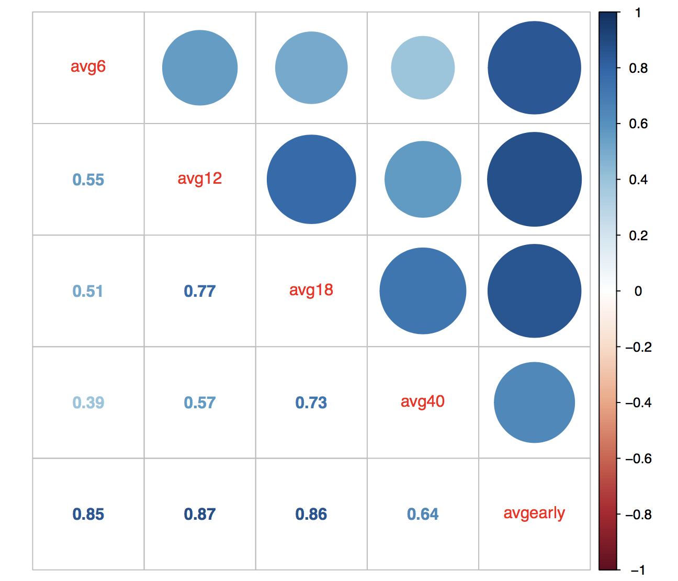**

avg6 is the average age 6 score, avg12 is the average age 12 score, avg18 is the average age 18 score, avg40 is the average age 40 score and avgearly is the average early life score.

**eFigure 2. Distributions of Age 6, 12, 18, 40 and Early Life Activity Scores**

**/Volumes/Saint_Louis_Baby_Teeth_Study/Individuals/Xinye/all_age_dist_10212022.pdf**

**eFigure 3. Epidemiology Confounding Structure as Presented in a Directed Acyclic Graph (DAG)**

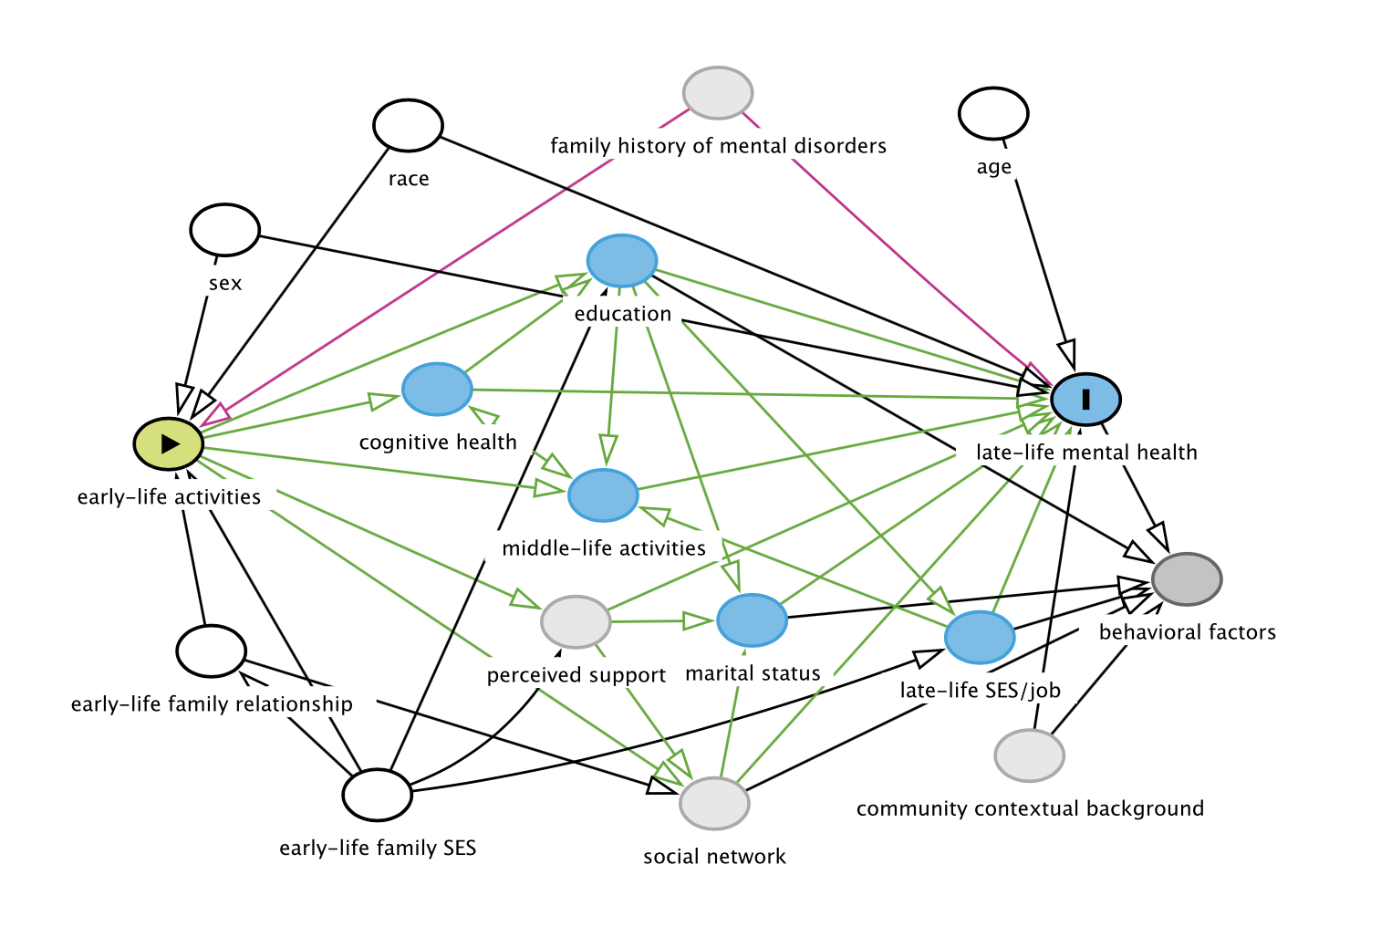 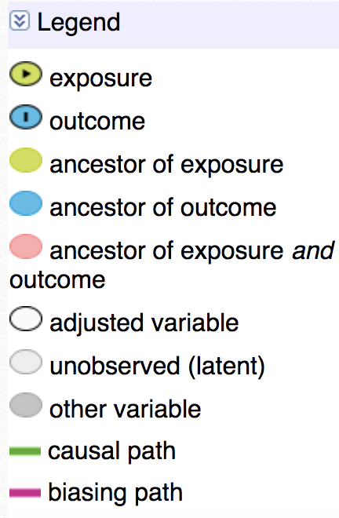

**eFigure 4. Early Life Cognitively Stimulating Activity Score – Response Curves using Log Odds of Outcome Risk and Probability of Outcome Risk as Y-axis**

**Plots_add/both_curves_logit_1107_2022.pdf**

**Plots_add/both_curves_prob_1130_2022.pdf**

**eFigure 5. Pearson Correlation Matrix Plot of Items on Cognitively Stimulating Activities at Age 6, 12, 18 (Early Life Period)**

**eFigure 6. Exploratory Factor Analysis (EFA) Scree Plots of Age-specific Cognitively Stimulating Activities Separately Fitted at Age 6, 12, 18**

**Age 6. Age 12.**

**Age 18.**

**eFigure 7. Exploratory Factor Analysis (EFA) Scree Plot of Age-specific Cognitively Stimulating Activities Simultaneously Fitted across Age 6, 12, 18**

