Supplementary Material
Supplementary Method 1: Data acquisition and magnetic resonance imaging parameters
Supplementary Method 2: ECT-associated changes in suicidality and delusion
Supplementary Result 1: 3x3 ANOVA on HDRS and BDI scores
Supplementary Result 2: Associations between short-term and long-term grey matter volume change in the ECT group
Supplementary Result 3: ECT-associated changes in suicidality and delusion
Supplementary Table 1: Details on psychopharmacological treatment in patient groups
Supplementary Table 2: Characteristics of electroconvulsive therapy
Supplementary Table 3: Extracted clusters for association analyses
Supplementary Table 4: Detailed information on percentages of brain areas in significant clusters from the 3x3 ANOVA
Supplementary Table 5: Whole-brain cross-sectional differences between groups in grey matter volume (p_{unc}<.001)
Supplementary Table 6: Results of the group x time interaction (controlling for depression severity)
Supplementary Table 7: Associations of grey matter volume changes with clinical outcome measures (controlling for covariates)
Supplementary Table 8: Associations of grey matter volume changes with suicidality and delusion
Supplementary Figure 1: Flow diagram visualizing the participant dropout process
Supplementary Figure 2: Distribution of additional ECT treatments in the ECT group
Supplementary Figure 3: Grey matter volume changes associated with clinical outcome
References

Supplementary Method 1: Data acquisition and magnetic resonance imaging parameters
T1-weighted high resolution anatomical images were acquired before the first ECT session (M=11.06 days, SD=18.58 days before ECT onset) and within a few days after the last ECT session (M=3.63 days, SD=4.32 days after ECT cessation) as well as two years later (M=795 days, SD=98.42 days) employing a 3D fast gradient echo sequence ('Turbo Field Echo', TFE), TR=7.4 ms, TE=3.4 ms, FA=9°, 2 signal averages, inversion prepulse every 814.5ms, acquired over a field of view of 256(FH)x204(AP)x160(RL) mm, phase encoding in AP and RL direction, reconstructed to cubic voxels of 0.5x0.5x0.5 mm.
Supplementary Method 2: ECT-associated changes in suicidality and delusion
Drawing from the work by Lattuada and colleagues (Lattuada, Serretti, Cusin, Gasperini, & Smeraldi, 1999), we employed three specific items (items 2, 15 and 20) from the HDRS (Hamilton, 1960) to form a subscale for measuring delusion. Additionally, item 3 of the HDRS (Hamilton, 1960) was utilized to evaluate suicidality, following previously established practices in the literature (Kellner et al., 2005). First, paired t-tests were conducted to investigate changes in suicidality and delusion within the ECT group from t₀ to t₁ and from t₁ to t₂. Second, score changes were calculated reflecting immediate (t₀ vs. t₁), delayed (t₀ vs. t₂) and long-term (t₁ vs. t₂) changes in delusion and suicidality. Higher change scores were indicative of an increase in either delusion or suicidality, respectively. Spearman's correlation coefficient was used to examine associations of short-term ∆GMV_{post-baseline} changes with immediate or delayed changes in suicidality and delusion, and of long-term ∆GMV_{follow-up-post} changes with long-term changes in suicidality and delusion.
Supplementary Result 1: 3x3 ANOVA on HDRS and BDI scores
A significant group x time interaction on HDRS scores was found (F_{(4, 136)}=16.999, p<.001, η_{p}²=.333) resulting from a significant decrease of HDRS scores from t₀ to t₁ (M_{Diff-ECT}=14.118, M_{Diff-TAU}=10.879; both p<.001) and t₀ to t₂ (M_{Diff-ECT}=13.118, M_{Diff-TAU}=12.636; both p<.001) in both MDD groups. No significant changes in HDRS scores from t₀ to t₁ (M_{Diff-HC}=-.143; p>.99) and to t₂ (M_{Diff-HC} = -.476; p=.702) were found in the HC group. No significant differences were found between t₁ and t₂ in any group (all p≥.416). There was a significant main effect of group (p<.001, η_{p}²=.682) with both MDD groups showing significantly higher HDRS scores than the HC group at all time points (all p<.001), while the ECT and TAU group did not differ significantly from each other at all time points (all p≥.135).
A significant group x time interaction on BDI scores was found (F_{(4, 114)}=7.174, p<.001, η_{p}²=.201) resulting from a significant decrease of BDI scores from t₀ to t₁ (M_{Diff-ECT}=11.933, M_{Diff-TAU}=11.630; both p<.001) and t₀ to t₂ (M_{Diff-ECT}=11.267, M_{Diff-TAU}=14.111; both p<.001) in both MDD groups. No significant changes in BDI scores from t₀ to t₁ (M_{Diff-HC}=1.833; p>.99) and to t₂ (M_{Diff-HC} =.722; p>.99) were found in the HC group. No significant differences were found between t₁ and t₂ in any group (all p≥.374). There was a significant main effect of group (p<.001, η_{p}²=.592) with both MDD groups showing significantly higher BDI scores than the HC group at all time points (all p<.001), while the ECT and TAU group did not differ significantly from each other at all time points (all p≥.072).
Supplementary Result 2: Associations between short-term and long-term grey matter volume change in the ECT group
Using Spearman's correlation, GMV changes between t₀ and t₁ were associated with GMV changes between t₁ and t₂ in four clusters of the significant interaction. Analyses revealed significant negative associations between short-term GMV change and long-term GMV change in the ECT group (Cluster 1: r=-.598, p=.011; Cluster 2: r=-.522, p=.031; Cluster 3: r=-.596, p=.012; Cluster 4: r=-.809, p<.001). This indicates that those with the largest GMV increase following ECT had the strongest GMV decline in the long-term.
Supplementary Result 3: ECT-associated changes in suicidality and delusion
Paired t-tests showed a significant decrease of suicidality (M_{baseline}=1.471, SD_{baseline}=.875; M_{post}=.529, SD_{post}=.717) and delusion (M_{baseline}=1.020, SD_{baseline}=.416; M_{post}=.412, SD_{post}=.479) within the ECT group from t₀ to t₁ (suicidality: T₍₁₆₎=5.191, p<.001; delusion: T₍₁₆₎=4.510, p<.001). There was no significant change in suicidality (M_{post}=.529, SD_{post}=.717; M_{follow-up}=.529, SD_{follow-up}=.800) or delusion (M_{post}=.412, SD_{post}=.479; M_{follow-up}=.392, SD_{follow-up}=.517) within the ECT group from t₁ to t₂ (suicidality: T₍₁₆₎=.000, p>.999; delusion: T₍₁₆₎=.223, p=.826).
There were no significant associations of short-term GMV_{post-baseline} change or long-term GMV_{follow-up-post} change with immediate (all p≥.080), delayed (all p≥.143) or long-term (all p≥.104) changes in suicidality and delusion (Supplementary Table 8).
Supplementary Table 1: Details on psychopharmacological treatment in patient groups
Supplementary Table 1. Details on psychopharmacological treatment in patient groups
 | ECT group  n=17 |  | TAU group  n=33
 | Mean (SD) |  | Mean (SD) |  | p-valueª
No. of patients under psychopharmacological medication at t₀ (yes/no)^{b} | 17/0 |  | 32/1 |  | .468
No. of patients under psychopharmacological medication at t₁ (yes/no)^{b} | 16/1 |  | 33/0 |  | .159
No. of patients under psychopharmacological medication at t₂ (yes/no)^{b} | 17/0 |  | 23/10 |  | .011
Medication load index at t₀ | 4.06 (1.78) |  | 2.12 (.96) |  | <.001
Medication (no/yes), No. of patients at t₀
Antidepressants
NaSSA | 10/7 |  | 29/4 |  | -
Tricyclics | 14/3 |  | 31/2 |  | -
NDRI | 17/0 |  | 33/0 |  | -
SSRI | 16/1 |  | 23/10 |  | -
SSNRI | 6/11 |  | 18/15 |  | -
MAO-Inhibitors | 17/0 |  | 33/0 |  | -
Other | 16/1 |  | 26/7 |  | -
Antipsychotics | 6/11 |  | 19/14 |  | -
Mood stabilizer | 12/5 |  | 33/0 |  | -
Medication load index at t₁ | 4.41 (2.06) |  | 2.70 (1.36) |  | .001
Medication (no/yes), No. of patients at t₁
Antidepressants
NaSSA | 8/9 |  | 26/7 |  | -
Tricyclics | 14/3 |  | 31/2 |  | -
NDRI | 16/1 |  | 32/1 |  | -
SSRI | 16/1 |  | 26/7 |  | -
SSNRI | 5/12 |  | 14/19 |  | -
MAO-Inhibitors | 17/0 |  | 33/0 |  | -
Other | 16/1 |  | 26/7 |  | -
Antipsychotics | 8/9 |  | 19/14 |  | -
Mood stabilizer | 13/4 |  | 31/2 |  | -
Medication load index at t₂ | 4.88 (2.60) |  | 1.39 (1.44) |  | <.001
Medication (no/yes), No. of patients at t₂
Antidepressants
NaSSA | 9/8 |  | 31/2 |  | -
Tricyclics | 16/1 |  | 33/0 |  | -
NDRI | 15/2 |  | 31/2 |  | -
SSRI | 16/1 |  | 28/5 |  | -
SSNRI | 7/10 |  | 18/15 |  | -
MAO-Inhibitors | 16/1 |  | 32/1 |  | -
Other | 15/2 |  | 30/3 |  | -
Antipsychotics | 5/12 |  | 28/5 |  | -
Mood stabilizer | 9/8 |  | 30/3 |  | -
Δ Medication load index t₀ – t₁^{b} | -.35 (2.18) |  | -.58 (1.17) |  | ECT: .514  TAU: .008
Δ Medication load index t₀ – t₂^{b} | -.82 (2.72) |  | .73 (1.96) |  | ECT: .230  TAU: .041
Δ Medication load index t₁ – t₂^{b} | -.47 (2.98) |  | 1.30 (2.13) |  | ECT: .524  TAU: .001
ECT, electroconvulsive therapy; TAU, treatment as usual; NaSSA, noradrenergic and specific serotonergic antidepressant; NDRI, norepinephrine and dopamine reuptake inhibitors; SSRI, selective serotonin reuptake inhibitors; SSNRI, selective serotonin and norepinephrine uptake inhibitors; MAO-Inhibitors, monoamine oxidase inhibitors.
ª Comparing patients from the ECT and the TAU group by using the unpaired two-tailed t-test except where noted.
^{b} p-values were obtained using repeated measures t-tests within each group.

Supplementary Table 2: Characteristics of electroconvulsive therapy

Supplementary Table 2. Characteristics of electroconvulsive therapy
Variable | Mean (SD) | Range
ECT series between t₀ and t₁ª
Number of ECT sessions | 12.71 (5.86) | 5 - 30
Number of days between first and last ECT session | 35.5 (18.05) | 14 - 91
Stimulus intensity (%) | 47.91 (21.36) | -
Pulse frequency (Hz) | 37.51 (12.15) | -
Seizure duration EEG (sec) | 40.42 (10.81) | -
Seizure duration EMG (sec) | 20.47 (7.61) | -
Postictal suppression index (%) | 82.70 (19.26) | -
ECT sessions between t₁ and t₂^{b}
Number of additional ECT sessions | 5.43 (3.74) | 1 - 12
ECT, electroconvulsive therapy.
ª Information regarding characteristics of electroconvulsive therapy was missing for n=1 patient in the ECT group. Two patients in the ECT group had received an ECT series before study participation (2.3 and 6 years respectively).
^{b} N=7 patients in the ECT group underwent additional ECT sessions between t₁ and t₂.

Supplementary Table 3: Extracted clusters showing significant GMV increase from _{t0} to t₁ in the rmANOVA in the ECT group
Supplementary Table 3. Extracted clusters showing significant GMV increase from t₀ to t₁ in the rmANOVA in the ECT group.
Cluster | Anatomical regions | Side | Cluster sizeª | Peak voxel coordinates |  |  | T-value^{b} | P_{FWE}-value | η_{p}²
 |  |  |  | x | y | z
Cluster 1 | Hippocampus/ parahippocampal gyrus (g.)/ amygdala/ laterale geniculate nucleus/ pars reticula/ pallidum | R | 1614 | 34 | -18 | -12 | 11.72 | <.001 | .842
Cluster 2 | Insula/ rolandic operculum/ putamen/ inferior frontal g. | R | 1121 | 38 | 0 | 20 | 9.81 | <.001 | .728
Cluster 3 | Middle temporal pole/ superior temporal pole/ parahippocampal g./ inferior temporal g./ posterior orbitofrontal cortex/ fusiform g. | R | 908 | 30 | 18 | -30 | 7.52 | <.001 | .771
Cluster 4 | Insula/ rolandic operculum/ inferior frontal g./ putamen/ precentral g. | L | 583 | -34 | -4 | 20 | 7.92 | <.001 | .583
Cluster 5 | Hippocampus/ posterior cingulate cortex/ medial pulvinar nucleus/ precuneus/ lateral pulvinar nucleus | R | 234 | 9 | -20 | 21 | 5.57 | .001 | .639
Cluster 6 | Hippocampus/ laterale geniculate nucleus | L | 272 | -34 | -26 | -4 | 5.53 | .001 | .449
ª Only significant clusters (p_{FWE}<.001) with cluster size k≥100 are reported.
^{b} df=44.

Supplementary Table 4: Detailed information on percentages of brain areas in significant clusters from the 3x3 ANOVA

Supplementary Table 4. Detailed information on percentages of brain areas in significant clusters from the 3x3 ANOVA
Peak voxel coordinates  (x/y/z) | Cluster sizeª | Anatomical region | % Cluster^{b} | % Label^{c}
Group x time interaction effect
18/-9/-9 | 1303 | Hippocampus | 39.06 | 22.70
 |  | Amygdala | 2.61 | 5.78
 |  | Lateral geniculate nucleus | 1.92 | 21.97
 |  | Pallidum | 1.92 | 3.77
 |  | Parahippocampal gyrus | 1.30 | 0.63
 |  | Pars reticula | 0.31 | 2.81
30/-2/16 | 883 | Putamen | 21.40 | 7.51
 |  | Insula | 19.03 | 4.00
 |  | Rolandic Operculum | 8.83 | 2.47
 |  | Inferior frontal gyrus | 1.13 | 0.30
-34/-8/20 | 330 | Insula | 37.58 | 2.82
 |  | Putamen | 9.70 | 1.35
 |  | Rolandic Operculum | 8.79 | 1.24
 |  | Inferior frontal gyrus | 0.61 | 0.08
-30/-22/-6 | 251 | Hippocampus | 11.55 | 1.31
 |  | Lateral geniculate nucleus | 4.38 | 10.79
Post-hoc tests
ECT group: Baseline < Post
18/-9/-9 | 2066 | Hippocampus | 39.30 | 36.21
 |  | Parahippocampal gyrus | 6.58 | 5.07
 |  | Amygdala | 3.29 | 11.57
 |  | Pallidum | 1.79 | 5.57
 |  | Lateral geniculate nucleus | 1.40 | 25.49
 |  | Pars reticula | 0.19 | 2.81
30/-2/16 | 1708 | Putamen | 22.48 | 15.25
 |  | Insula | 19.32 | 7.87
 |  | Rolandic Operculum | 15.34 | 8.30
 |  | Inferior frontal gyrus | 2.87 | 1.48
 |  | Supramarginal gyrus | 0.88 | 0.32
-28/0/16 | 820 | Insula | 35.61 | 6.63
 |  | Rolandic operculum | 21.22 | 7.43
 |  | Putamen | 8.17 | 2.83
 |  | Inferior frontal gyrus | 5.24 | 1.75
 |  | Precentral gyrus | 0.49 | 0.05
9/-22/20 | 379 | Hippocampus | 11.61 | 1.96
 |  | Medial pulvinar nucleus | 4.22 | 3.79
 |  | Posterior cingulate cortex | 1.58 | 0.76
 |  | Precuneus | 0.79 | 0.04
 |  | Lateral pulvinar nucleus | 0.26 | 1.56
 |  | Anterior pulvinar nucleus | 0.26 | 1.24
-28/-20/-9 | 648 | Hippocampus | 40.90 | 12.00
 |  | Lateral geniculate nucleus | 3.24 | 20.60
 |  | Amygdala | 0.77 | 0.96
 |  | Pallidum | 0.15 | 0.14
30/18/-30 | 864 | Superior temporal pole | 51.85 | 14.13
 |  | Middle temporal pole | 34.38 | 10.56
 |  | Parahippocampal gyrus | 3.24 | 1.04
 |  | Orbitofrontal cortex | 1.85 | 1.20
12/0/24 | 165 | Caudate nucleus | 10.30 | 0.83
ECT group: Post > Follow-up
20/-10/-8 | 1293 | Hippocampus | 29.31 | 16.90
 |  | Parahippocampal gyrus | 11.37 | 5.48
 |  | Amygdala | 3.71 | 8.17
Supplementary Table 4. Detailed information on percentages of brain areas in significant clusters from the 3x3 ANOVA
Peak voxel coordinates  (x/y/z) | Cluster sizeª | Anatomical region | % Cluster^{b} | % Label^{c}
 |  | Pallidum | 2.40 | 4.67
 |  | Lateral geniculate nucleus | 1.24 | 14.06
 |  | Superior temporal pole | 0.77 | 0.32
 |  | Pars reticula | 0.31 | 2.81
30/-2/16 | 911 | Putamen | 36.33 | 13.15
 |  | Insula | 15.48 | 3.36
 |  | Rolandic operculum | 3.73 | 1.08
 |  | Inferior frontal gyrus | 1.43 | 0.39
-28/-4/16 | 1039 | Putamen | 23.58 | 10.35
 |  | Insula | 12.42 | 2.93
 |  | Hippocampus | 7.60 | 3.58
 |  | Pallidum | 1.92 | 2.88
 |  | Laterale geniculate nucleus | 1.35 | 13.74
 |  | Rolandic operculum | 1.35 | 0.60
 |  | Amygdala | 0.10 | 0.19
10/2/21 | 263 | Caudate nucleus | 38.02 | 4.90
ECT, electroconvulsive therapy.
ª Only significant clusters (p_{FWE}<.050) with cluster size k≥100 are reported.
^{b} Percentage of the cluster occupied by the named brain area. The missing percentages are due to missing labels according to the AAL-atlas (Tzourio-Mazoyer et al., 2002).
^{c} Percentage of the brain area lying within the cluster.

Supplementary Table 5: Group differences in grey matter volume (p_{unc}<.001)

Supplementary Table 5. Group differences in grey matter volume (p_{unc}<.001)
Anatomical region |  | Side | Cluster sizeª | Peak voxel coordinates |  |  | Test statistics
 |  |  |  | x | y | z
Main effect of group^{b} |  |  |  |  |  |  | F-value | P_{unc}-  value | η_{p}²
Postcentral gyrus/ supramarginal gyrus/ precentral gyrus |  | R | 345 | 48 | -18 | 33 | 18.37 | <.001 | .227
Inferior parietal gyrus/ supramarginal gyrus/ postcentral gyrus/ superior parietal gyrus |  | R | 399 | 32 | -39 | 45 | 18.11 | <.001 | .215
Inferior parietal gyrus/ postcentral gyrus/ supramarginal gyrus |  | L | 539 | -51 | -30 | 36 | 12.61 | <.001 | .140
Post-hoc tests at baseline^{c} |  |  |  |  |  |  | T-value | P_{unc}-  value | η_{p}²
ECT group > HC group |  | - | - | - | - | - | - | n.s. | -
ECT group < HC group
 | Inferior parietal gyrus/ postcentral gyrus/ supramarginal gyrus/ superior parietal gyrus | R | 575 | 32 | -39 | 45 | 5.35 | <.001 | .089
 | Superior frontal gyrus/ anterior cingulate cortex/ middle cingulate cortex | L/R | 678 | 10 | 51 | 18 | 4.98 | <.001 | .096
 | Fusiform gyrus/ inferior temporal gyrus/ cerebellum | L | 679 | -38 | -36 | -21 | 4.61 | <.001 | .020
 | Inferior parietal gyrus/ postcentral gyrus/ supramarginal gyrus | L | 519 | -52 | -28 | 34 | 3.99 | <.001 | .055
ECT group > TAU group |  | - | - | - | - | - | - | n.s. | -
ECT group < TAU group
 | Calcarine gyrus/ cuneus/ lingual gyrus | L/R | 634 | -2 | -80 | 20 | 4.18 | <.001 | .011
TAU group > HC group |  | - | - | - | - | - | - | n.s. | -
TAU group < HC group
 | Postcentral gyrus/ supramarginal gyrus/ precentral gyrus | R | 866 | 48 | -16 | 33 | 5.84 | <.001 | .128
 | Inferior parietal gyrus/ postcentral gyrus/ supramarginal gyrus | L | 1204 | -33 | -39 | 46 | 5.55 | <.001 | .094
 | Postcentral gyrus/ supramarginal gyrus/ inferior parietal gyrus/ superior parietal gyrus | R | 357 | 32 | -39 | 44 | 5.10 | <.001 | .088
 | Middle frontal gyrus/ inferior frontal gyrus/ superior frontal gyrus | R | 372 | 36 | 39 | 8 | 4.29 | <.001 | .055
 | Superior frontal gyrus/ supplementary motor area | L | 410 | -15 | 18 | 60 | 4.27 | <.001 | .065
 | Lingual gyrus/ cerebellum/ fusiform gyrus | R | 338 | 15 | -52 | -8 | 4.05 | <.001 | .090
 | Gyrus rectus/ orbitofrontal cortex/ orbitofrontal gyrus/ olfactory sulcus/ ventral striatum/ middle frontal gyrus | L/R | 594 | -10 | 15 | -15 | 3.94 | <.001 | .064
Post-hoc tests at post^{c} |  |  |  |  |  |  | T-value | P_{unc}-  value | η_{p}²
ECT group > HC group
 | Hippocampus | R | 322 | 34 | -24 | -6 | 4.16 | <.001 | .642
ECT group < HC group
 | Supplementary motor area/ superior frontal gyrus | L | 380 | -10 | 12 | 62 | 5.28 | <.001 | .117
 | Inferior parietal gyrus/ supramarginal gyrus/ postcentral gyrus/ superior parietal gyrus/ | R | 605 | 32 | -39 | 45 | 5.17 | <.001 | .136
 | Superior frontal gyrus/ anterior cingulate cortex/ middle cingulate cortex | R | 476 | 9 | 51 | 18 | 4.40 | <.001 | .039
ECT group > TAU group |  | - | - | - | - | - | - | n.s. | -
ECT group < TAU group
 | Calcarine gyrus/ lingual gyrus/ cuneus | L/R | 1163 | 0 | -84 | 3 | 4.22 | <.001 | .131
TAU group > HC group
 | Calcarine gyrus/ precuneus/ lingual gyrus | L | 367 | -22 | -54 | 8 | 4.46 | <.001 | .136
TAU group < HC group
 | Postcentral gyrus/ supramarginal gyrus/ precentral gyrus | R | 662 | 48 | -18 | 33 | 5.56 | <.001 | .057
 | Inferior parietal gyrus/ postcentral gyrus/ supramarginal gyrus | L | 1064 | -33 | -39 | 46 | 5.19 | <.001 | .054
 | Postcentral gyrus/ supramarginal gyrus/ inferior parietal gyrus/ superior parietal gyrus | R | 344 | 32 | -39 | 44 | 5.08 | <.001 | .067
Supplementary Table 5. Whole-brain cross-sectional differences in grey matter volume (p_{unc}<.001) (continued)
Anatomical region |  | Side | Cluster Sizeª | Peak voxel coordinates |  |  | Test statistics
 |  |  |  | x | y | z
 | Superior frontal gyrus/ supplementary motor area | L | 407 | -14 | 18 | 60 | 4.57 | <.001 | .079
 | Middle frontal gyrus/ inferior frontal gyrus/ superior frontal gyrus | R | 408 | 38 | 39 | 8 | 4.53 | <.001 | .058
Post-hoc tests at follow-up^{c} |  |  |  |  |  |  | T-value | P_{unc}-  value | η_{p}²
ECT group > HC group |  | - | - | - | - | - | - | n.s. | -
ECT group < HC group
 | Inferior parietal gyrus/ supramarginal gyrus/ postcentral gyrus/ superior parietal gyrus | R | 458 | 32 | -39 | 45 | 5.00 | <.001 | .531
 | Anterior cingulate cortex/ superior frontal gyrus/ middle cingulate cortex | L/R | 566 | 8 | 50 | 15 | 4.65 | <.001 | .481
ECT group > TAU group |  | - | - | - | - | - | - | n.s. | -
ECT group < TAU group |  | - | - | - | - | - | - | n.s. | -
TAU group > HC group
 | Calcarine gyrus/ precuneus/ lingual gyrus | L | 356 | -22 | -54 | 9 | 4.35 | <.001 | .160
TAU group < HC group
 | Postcentral gyrus/ supramarginal gyrus/ inferior parietal gyrus/ precentral gyrus/ superior parietal gyrus | R | 1218 | 48 | -16 | 33 | 6.16 | <.001 | .070
 | Inferior parietal gyrus/ postcentral gyrus/ supramarginal gyrus | L | 1246 | -32 | -39 | 45 | 5.37 | <.001 | .076
 | Superior frontal gyrus/ supplementary motor area | L | 770 | -14 | 18 | 60 | 4.84 | <.001 | .073
 | Middle frontal gyrus/ inferior frontal gyrus/ superior frontal gyrus | R | 387 | 33 | 42 | 9 | 4.38 | <.001 | .039
 | Anterior cingulate cortex/ superior frontal gyrus | L | 307 | -6 | 42 | 8 | 3.96 | <.001 | .071
 | Gyrus rectus/ orbitofrontal gyrus/ olfactory gyrus/ orbitofrontal cortex/ anterior cingulate cortex | L/R | 596 | 4 | 36 | -14 | 3.66 | <.001 | .051
ECT, electroconvulsive therapy; TAU, treatment as usual; HC, healthy controls.
ª Only significant clusters (p_{unc}<.001) with cluster size k≥300 are reported.
^{b} df₁=2; df₂=200.
^{c} df=200.

Supplementary Table 6: Results of the group x time interaction (controlling for depression severity)

Table 2. Results of the group x time interaction (controlling for depression severity)
Anatomical region | Side | Cluster sizeª | Peak voxel coordinates |  |  | Test statistics
 |  |  | x | y | z
Group x time interaction effect^{b} |  |  |  |  |  | F-value | p_{FWE}-  value
Hippocampus/ lateral geniculate nucleus/ amygdala/ pallidum/ parahippocampal gyrus/ pars reticula | R | 1201 | 20 | -10 | -8 | 36.53 | <.001
Putamen/ insula/ rolandic operculum/ inferior frontal gyrus | R | 812 | 30 | -2 | 16 | 33.35 | <.001
Insula/ putamen/ rolandic operculum/ inferior frontal gyrus/ precentral gyrus | L | 390 | -28 | 0 | 16 | 19.08 | <.001
Hippocampus/ lateral geniculate nucleus | L | 279 | -30 | -22 | -6 | 14.23 | <.001
Post-hoc tests^{c} from baseline to post |  |  |  |  |  | T-value | p_{FWE}-  value
ECT group: Baseline < Post
Hippocampus/ lateral geniculate nucleus/ amygdala/ pallidum/ parahippocampal gyrus/ pars reticula | R | 1279 | 28 | -20 | -8 | 10.33 | <.001
Putamen/ Insula/ rolandic operculum/ inferior frontal gyrus/ supramarginal gyrus | R | 1075 | 30 | -2 | 16 | 10.16 | <.001
Insula/ rolandic operculum/ putamen/ inferior frontal gyrus/ precentral gyrus | L | 676 | -28 | 0 | 16 | 8.56 | <.001
Hippocampus/ medial pulvinar nucleus/ lateral pulvinar nucleus/ precuneus/ posterior cingulate cortex/ anterior pulvinar nucleus | R | 338 | 10 | -21 | 21 | 7.30 | <.001
Hippocampus/ lateral geniculate nucleus/ amygdala | L | 458 | -28 | -20 | -9 | 6.35 | <.001
TAU group: Baseline < Post | - | - | - | - | - | - | n.s.
HC group: Baseline > Post | - | - | - | - | - | - | n.s.
Post-hoc tests^{c} from post to follow-up |  |  |  |  |  | T-value | p_{FWE}-  value
ECT group: Post > Follow-up
Hippocampus/ parahippocampal gyrus/ amygdala/ pallidum/ lateral geniculate nucleus/ superior temporal pole/ pars reticula | R | 907 | 30 | -2 | 16 | 9.84 | <.001
Putamen/ insula/ rolandic operculum/ inferior frontal gyrus | R | 1287 | 20 | -10 | -8 | 9.84 | <.001
Putamen/ insula/ hippocampus/ pallidum/ laterale geniculate nucleus/ rolandic operculum/ amygdala | L | 1063 | -28 | -4 | 16 | 7.93 | <.001
Caudate nucleus | R | 259 | 10 | 2 | 21 | 6.46 | <.001
TAU group: Post > Follow-up | - | - | - | - | - | - | n.s.
HC group: Post > Follow-up | - | - | - | - | - | - | n.s.
Post-hoc tests^{c} from baseline to follow-up |  |  |  |  |  | T-value | p_{FWE}-  value
ECT group: Baseline < Follow-up | - | - | - | - | - | - | n.s.
TAU group: Baseline > Follow-up | - | - | - | - | - | - | n.s.
HC group: Baseline > Follow-up | - | - | - | - | - | - | n.s.
ECT, electroconvulsive therapy; TAU, treatment as usual; HC, healthy controls.
ª Only significant clusters (p_{FWE}<.050) with cluster size k≥100 are reported.
^{b} df₁= 4; df₂=199.
^{c} df=199.

Supplementary Table 7: Associations of grey matter volume changes with clinical outcome measures (controlling for covariates)
Supplementary Table 7. Associationsª of grey matter volume changes with clinical outcome measures (controlling for covariates)
∆ GMV changes |  | ∆ HDRS score change |  | ∆ BDI score change^{b} |  | Number of depressive episodes
 |  | r | p | r | p | r | p
Short-term grey matter volume change and immediate clinical outcome variables^{c}
t₀ vs t₁ |  | t₀ vs t₁ |  | t₀ vs t₁ |  | -
Cluster 1 |  | .486 | .056 | .433 | .466 | - | -
Cluster 2 |  | .593 | .015e | .057 | .841 | - | -
Cluster 3 |  | .156 | .564 | -.106 | .708 | - | -
Cluster 4 |  | .564 | .023 | .296 | .283 | - | -
Cluster 5 |  | .105 | .698 | -.300 | .278 | - | -
Cluster 6 |  | .287 | .281 | .492 | .062 | - | -
Short-term grey matter volume change and delayed clinical outcome variables^{c}
t₀ vs t₁ | t₀ vs t₂ |  |  | t₀ vs t₂ |  | t₀ vs t₂
Cluster 1 |  | .406 | .118 | .175 | .532 | .423 | .102
Cluster 2 |  | .638 | .008e | .330 | .229 | .476 | .063
Cluster 3 |  | .019 | .944 | .108 | .701 | -.249 | .353
Cluster 4 |  | .512 | .043 | .530 | .042 | .500 | .048
Cluster 5 |  | .172 | .523 | -.060 | .832 | .254 | .342
Cluster 6 |  | .258 | .336 | .611 | .016 | .474 | .420
Long-term grey matter volume change and long-term clinical outcome variables^{d}
t₁ vs t₂ |  | t₁ vs t₂ |  | t₁ vs t₂ |  | t₁ vs t₂
Cluster 1 |  | -.114 | .673 | -.721 | .004e | -.275 | .302
Cluster 2 |  | -.228 | .396 | -.752 | .002e | -.383 | .143
Cluster 3 |  | -.243 | .363 | -.530 | .051 | .008 | .976
Cluster 4 |  | -.165 | .542 | -.476 | .085 | -.194 | .472
Cluster 5 |  | .019 | .945 | -.546 | .043 | -.371 | .157
Cluster 6 |  | -.328 | .215 | -.304 | .290 | -.368 | .160
GMV, grey matter volume; HDRS, Hamilton depression rating scale; BDI, Beck depression inventory.
ª Correlation analyses using Spearman’s correlation coefficient.
^{b} Information regarding BDI score change was missing for n=1 patient in the ECT group.
^{c} Correlation analyses were controlled for the number of ECT sessions.
^{d} Correlation analyses were controlled for the GMV change between baseline and post.
^{e} No correction for multiple comparisons was made. With a Bonferroni-adjusted p-value of .016, only these correlation results remain significant.

Supplementary Table 8: Associations of grey matter volume changes with suicidality and delusion
Supplementary Table 8. Associationsª of grey matter volume changes with suicidality and delusion
∆ GMV changes |  | ∆ change in suicidality^{b} |  | ∆ change in delusion^{b}
 |  | r | p | r | p
t₀ vs t₁ |  | t₀ vs t₁ |  | t₀ vs t₁
Cluster 1 |  | .140 | .592 | .220 | .395
Cluster 2 |  | .219 | .398 | .436 | .080
Cluster 3 |  | .358 | .158 | .417 | .096
Cluster 4 |  | .383 | .129 | .411 | .101
Cluster 5 |  | .203 | .433 | .279 | .279
Cluster 6 |  | .166 | .523 | -.082 | .754
t₀ vs t₁ | t₀ vs t₂ |  |  | t₀ vs t₂
Cluster 1 |  | .014 | .956 | .074 | .778
Cluster 2 |  | .279 | .278 | .164 | .529
Cluster 3 |  | .370 | .143 | .371 | .143
Cluster 4 |  | .227 | .381 | .338 | .185
Cluster 5 |  | .214 | .410 | .119 | .649
Cluster 6 |  | -.130 | .618 | -.001 | .996
t₁ vs t₂ |  | t₁ vs t₂ |  | t₁ vs t₂
Cluster 1 |  | -.149 | .569 | .212 | .413
Cluster 2 |  | -.173 | .506 | .408 | .104
Cluster 3 |  | -.248 | .338 | -.082 | .755
Cluster 4 |  | -.124 | .636 | .146 | .577
Cluster 5 |  | -.149 | .569 | .321 | .209
Cluster 6 |  | -.173 | .506 | -.045 | .865
GMV, grey matter volume; HDRS, Hamilton depression rating scale; BDI, Beck depression inventory.
ª Correlation analyses using Spearman’s correlation coefficient.
^{b} Changes in suicidality and delusion were assessed via specific items from the HDRS (Hamilton, 1960).

Supplementary Figure 1: Flow diagram visualizing the participant dropout process
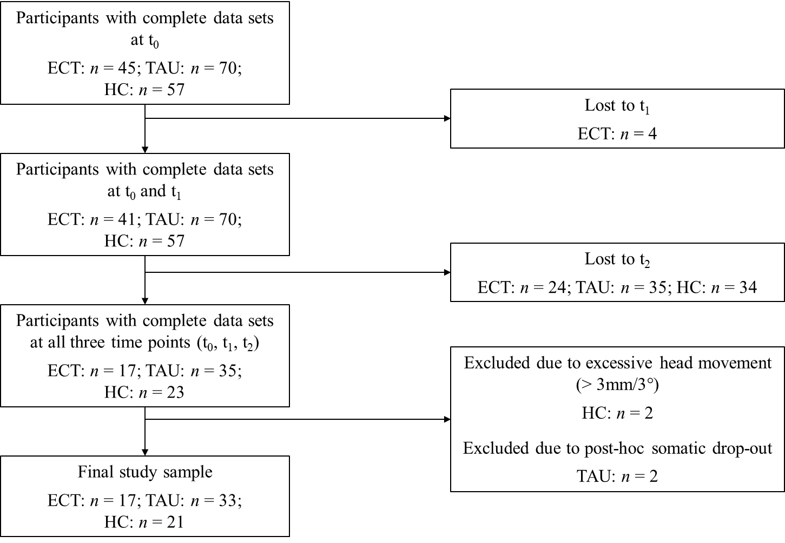
Supplementary Figure 1. Flow diagram visualizing the participant dropout process. ECT = Electroconvulsive therapy, TAU = Treatment as usual, HC = Healthy controls, t₀ = Baseline assessment, t₁ = Post assessment, t₂ = Follow-up assessment.

Supplementary Figure 2: Distribution of additional ECT treatments in the ECT group

Supplementary Figure 2. Distribution of additional ECT treatments in the ECT group. The distribution of additional ECT treatments between t₁ and t₂ in responder and non-responder and the varying disease progression between t₁ and t₂ in the respective groups. There was no significant difference in rates of additional ECT treatment between response groups (χ²₍₁₎=2.837, p=.092). ª Information on additional ECT treatment between t₁ and t₂ was missing for n=1 patient in the ECT group. ^{b} according to DSM-IV (Wittchen, Wunderlich, Gruschwitz, & Zaudig, 1997). ECT = Electroconvulsive therapy, t₀ = Baseline assessment, t₁ = Post assessment, t₂ = Follow-up assessment.

Supplementary Figure 3: Grey matter volume changes associated with clinical outcome
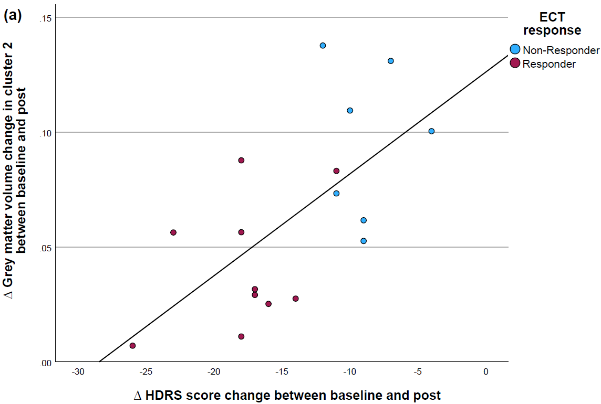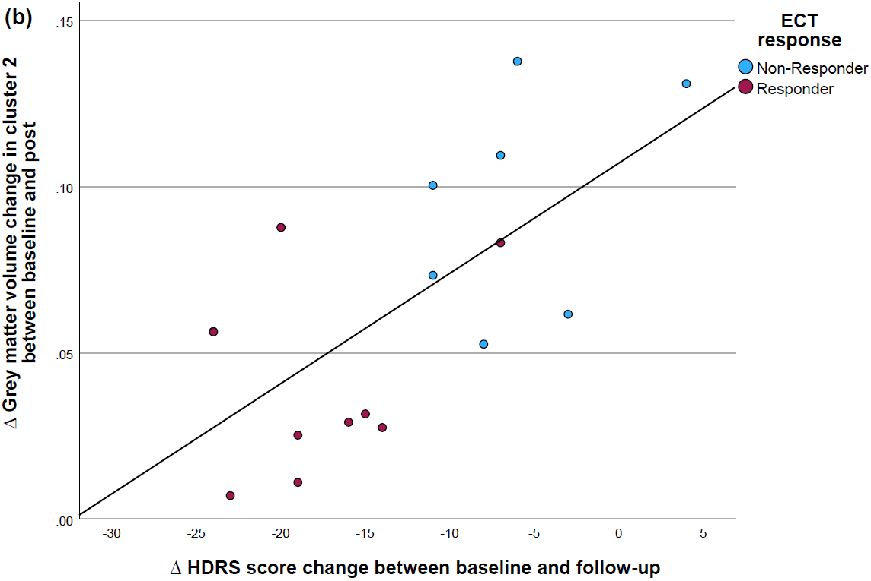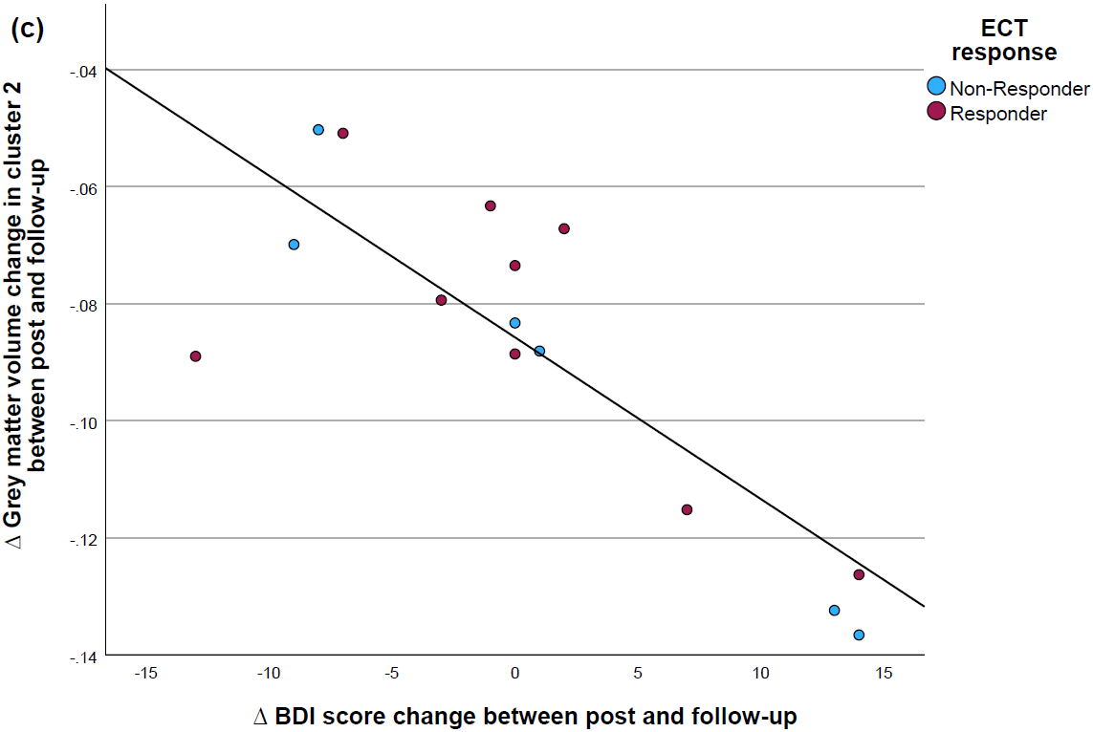
Supplementary Figure 3. Grey matter volume changes associated with clinical outcome. Scatterplots of the association between (a) short-term ∆ GMV change (computed as GMV post – GMV baseline) and immediate HDRS score change (computed as post – HDRS baseline), (b) short-term ∆ GMV change (computed as GMV post – GMV baseline) and delayed HDRS score change (computed as HDRS follow-up – HDRS baseline) and (c) long-term ∆ GMV change (computed as GMV follow-up – GMV post) and long-term HDRS score change (computed as BDI follow-up – BDI post) in cluster 2 (see Table 3). Colours indicate ECT response group. Continuous line: regression line.

References
Hamilton, M. (1960). A scale for depression. Journal of Neurology, Neurosurgery and Psychiatry, 23(1), 56–62.
Kellner, C. H., Fink, M., Knapp, R., Petrides, G., Husain, M., Rummans, T., … Malur, C. (2005). Relief of expressed suicidal intent by ECT: A consortium for research in ECT study. American Journal of Psychiatry, 162(5), 977–982. https://doi.org/10.1176/appi.ajp.162.5.977
Lattuada, E., Serretti, A., Cusin, C., Gasperini, M., & Smeraldi, E. (1999). Symptomatologic analysis of psychotic and non-psychotic depression. Journal of Affective Disorders, 54(1–2), 183–187. https://doi.org/10.1016/S0165-0327(98)00141-4
Tzourio-Mazoyer, N., Landeau, B., Papathanassiou, D., Crivello, F., Etard, O., Delcroix, N., … Joliot, M. (2002). Automated anatomical labeling of activations in SPM using a macroscopic anatomical parcellation of the MNI MRI single-subject brain. NeuroImage, 15(1), 273–289. https://doi.org/10.1006/nimg.2001.0978
Wittchen, H.-U., Wunderlich, U., Gruschwitz, S., & Zaudig, M. (1997). Strukturiertes Klinisches Interview für DSM-IV: SKID. Achse I: Psychische Störungen. Interviewheft und Beurteilungsheft. Eine deutschsprachige, erweiterte Bearbeitung der amerikanischen Originalversion des SKID-I. Göttingen: Hogrefe.

