Neuroadaptive Changes Following Mindfulness Training Enhance Fear Extinction Learning
Supplementary Figures

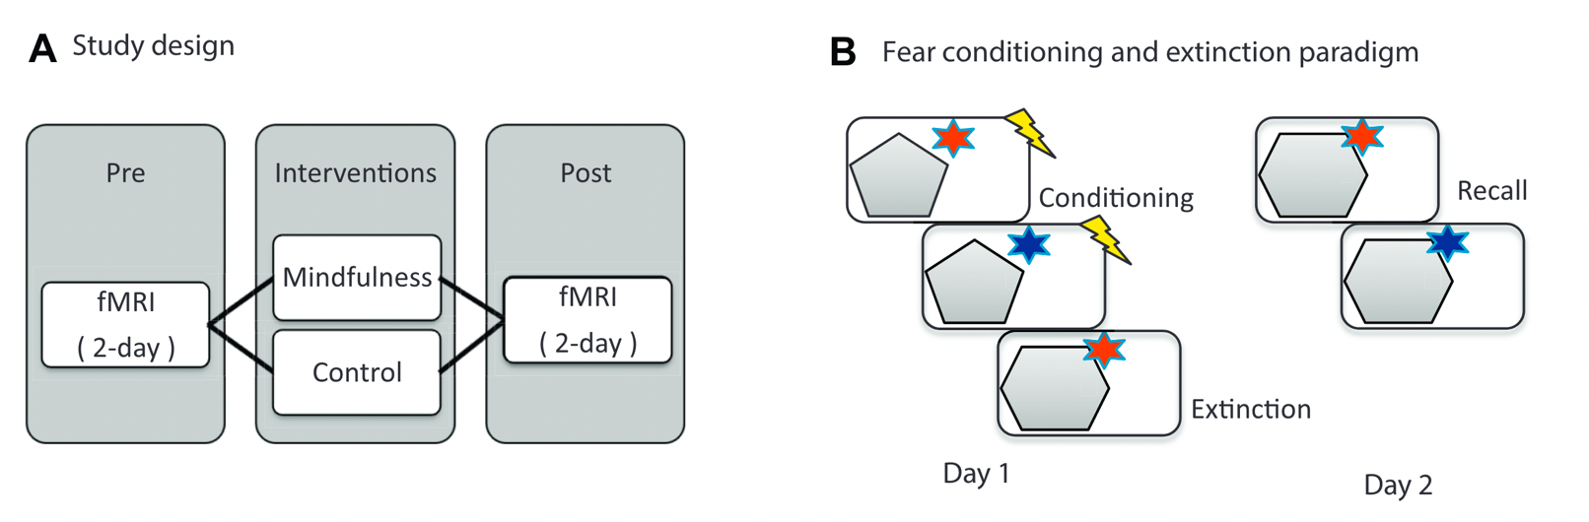
Sup. Fig. 1. A. Study design. B. Fear conditioning and extinction paradigm (adapted from Sevinc et al., 2019).

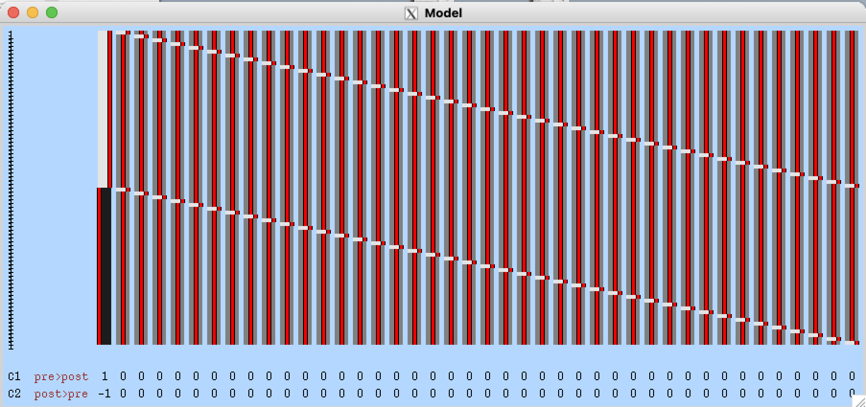
Sup. Fig. 2. Design Matrix- Extracted from FSL. Depicts the Post> Pre-contrast for CS+ BOLD response. Second level analysis - within group difference.

