Supplementary Material - Figures
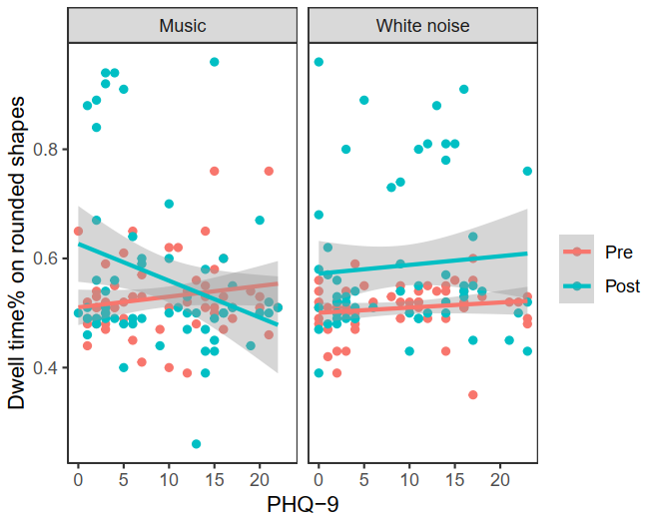
Figure S1. Dwell time percent (DT%) on rounded shapes by PHQ-9 scores at pre- and post- training – Music (left panel); White noise (right panel). Shaded area represents 95% confidence intervals. PHQ-9 = Patient Health Questionnaire 9.

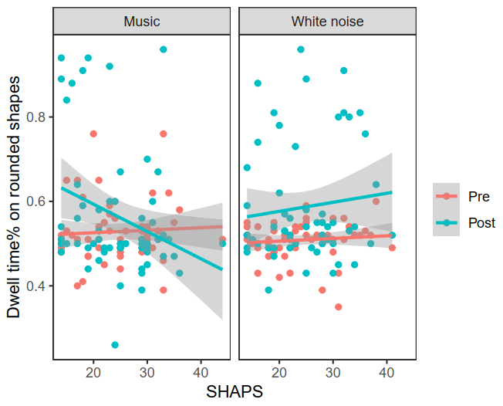
Figure S2. Dwell time percent (DT%) on rounded shapes by SHAPS scores at pre- and post-training – Music (left panel); White noise (right panel). Shaded area represents 95% confidence intervals. SHAPS = Snaith-Hamilton Pleasure Scale.

