Table S1.
Age of participants at each wave
Age | Wave 1 | Wave 2 | Wave 3 | Wave 4 | Wave 5 | Wave 6
Min | 13.14 | 14.06 | 14.59 | 15.33 | 16.02 | 19.05
Max | 15.63 | 16.39 | 17.34 | 17.98 | 19.85 | 23.68
Mean | 14.38 | 15.14 | 15.84 | 16.59 | 17.49 | 20.85
SD | 0.62 | 0.63 | 0.62 | 0.62 | 0.67 | 0.88
N | 393 | 387 | 377 | 372 | 382 | 386

Table S2.
Mean and Standard Deviation for each risk marker from wave 1 to wave 5 by onset group at wave 6.
 |  | Wave 1 |  |  |  | Wave 2 |  |  |  | Wave 3 |  |  |  | Wave 4 |  |  |  | Wave 5
 |  | N | Mean | SD |  | N | Mean | SD |  | N | Mean | SD |  | N | Mean | SD |  | N | Mean | SD
Depression and Anxiety Symptoms
1. General Depression | Onset | 77 | 1.75 | 0.61 |  | 73 | 1.92 | 0.64 |  | 72 | 1.70 | 0.51 |  | 70 | 1.80 | 0.59 |  | 74 | 1.71 | 0.53
 | No onset | 314 | 1.52 | 0.50 |  | 304 | 1.53 | 0.53 |  | 304 | 1.46 | 0.47 |  | 294 | 1.46 | 0.46 |  | 303 | 1.39 | 0.40
2. Ill Temper | Onset | 77 | 1.65 | 0.78 |  | 73 | 1.70 | 0.76 |  | 72 | 1.43 | 0.58 |  | 69 | 1.42 | 0.57 |  | 74 | 1.42 | 0.54
 | No onset | 315 | 1.38 | 0.61 |  | 305 | 1.41 | 0.65 |  | 304 | 1.29 | 0.55 |  | 297 | 1.30 | 0.57 |  | 304 | 1.22 | 0.43
3. Social Anxiety | Onset | 78 | 1.88 | 0.91 |  | 73 | 1.92 | 0.85 |  | 72 | 1.74 | 0.76 |  | 69 | 1.73 | 0.85 |  | 74 | 1.54 | 0.72
 | No onset | 312 | 1.65 | 0.78 |  | 304 | 1.58 | 0.70 |  | 304 | 1.49 | 0.67 |  | 295 | 1.44 | 0.65 |  | 303 | 1.28 | 0.47
4. Panic | Onset | 77 | 1.42 | 0.59 |  | 73 | 1.47 | 0.52 |  | 72 | 1.29 | 0.35 |  | 70 | 1.36 | 0.56 |  | 74 | 1.30 | 0.43
 | No onset | 315 | 1.25 | 0.42 |  | 304 | 1.27 | 0.49 |  | 304 | 1.21 | 0.44 |  | 297 | 1.19 | 0.38 |  | 304 | 1.15 | 0.35
5. Traumatic Intrusions | Onset | 78 | 1.46 | 0.73 |  | 73 | 1.43 | 0.59 |  | 72 | 1.23 | 0.39 |  | 71 | 1.24 | 0.47 |  | 74 | 1.29 | 0.53
 | No onset | 314 | 1.30 | 0.56 |  | 305 | 1.26 | 0.55 |  | 304 | 1.21 | 0.43 |  | 295 | 1.20 | 0.44 |  | 304 | 1.18 | 0.47
6. Traumatic Avoidance | Onset | 76 | 1.89 | 1.03 |  | 71 | 1.71 | 0.88 |  | 72 | 1.55 | 0.74 |  | 70 | 1.43 | 0.64 |  | 72 | 1.41 | 0.66
 | No onset | 310 | 1.73 | 0.89 |  | 299 | 1.59 | 0.83 |  | 303 | 1.46 | 0.75 |  | 293 | 1.40 | 0.72 |  | 302 | 1.33 | 0.68
7. Mania | Onset | 77 | 1.83 | 0.92 |  | 73 | 1.66 | 0.74 |  | 72 | 1.55 | 0.73 |  | 70 | 1.61 | 0.78 |  | 74 | 1.46 | 0.68
 | No onset | 315 | 1.55 | 0.71 |  | 303 | 1.51 | 0.74 |  | 304 | 1.43 | 0.67 |  | 294 | 1.37 | 0.66 |  | 304 | 1.29 | 0.51
Personality Traits
8. Neuroticism | Onset | 78 | 2.92 | 0.76 |  | 77 | 3.12 | 0.73 |  | 71 | 3.03 | 0.79 |  | 73 | 3.11 | 0.73 |  | 74 | 3.01 | 0.79
 | No onset | 313 | 2.60 | 0.75 |  | 310 | 2.73 | 0.78 |  | 301 | 2.61 | 0.77 |  | 298 | 2.72 | 0.78 |  | 305 | 2.64 | 0.77
9. Conscientiousness | Onset | 78 | 3.48 | 0.63 |  | 77 | 3.39 | 0.69 |  | 72 | 3.42 | 0.71 |  | 73 | 3.39 | 0.70 |  | 74 | 3.51 | 0.66
 | No onset | 315 | 3.78 | 0.64 |  | 310 | 3.75 | 0.68 |  | 302 | 3.81 | 0.66 |  | 298 | 3.79 | 0.62 |  | 305 | 3.82 | 0.62
10. Extraversion | Onset | 78 | 3.59 | 0.84 |  | 77 | 3.53 | 0.89 |  | 72 | 3.44 | 0.93 |  | 73 | 3.39 | 0.86 |  | 74 | 3.43 | 0.88
 | No onset | 315 | 3.84 | 0.77 |  | 312 | 3.79 | 0.82 |  | 303 | 3.79 | 0.82 |  | 298 | 3.77 | 0.84 |  | 305 | 3.79 | 0.84
Depressogenic cognitive/personality styles
11. Rumination | Onset | 75 | 1.86 | 0.64 |  | 73 | 1.88 | 0.67 |  | 71 | 1.81 | 0.62 |  | 70 | 1.87 | 0.63 |  | 73 | 1.89 | 0.65
 | No onset | 307 | 1.51 | 0.51 |  | 298 | 1.50 | 0.54 |  | 301 | 1.45 | 0.51 |  | 290 | 1.49 | 0.56 |  | 302 | 1.45 | 0.55
12. Self-criticism | Onset | 76 | 2.31 | 0.92 |  | 73 | 2.48 | 0.95 |  | 71 | 2.34 | 0.85 |  | 70 | 2.43 | 0.90 |  | 73 | 2.36 | 0.84
 | No onset | 308 | 1.90 | 0.77 |  | 299 | 1.92 | 0.82 |  | 303 | 1.81 | 0.73 |  | 292 | 1.83 | 0.79 |  | 304 | 1.80 | 0.73
13. Dependency | Onset | 76 | 2.36 | 0.64 |  | 73 | 2.42 | 0.67 |  | 71 | 2.17 | 0.70 |  | 69 | 2.36 | 0.65 |  | 73 | 2.27 | 0.68
 | No onset | 307 | 2.20 | 0.68 |  | 292 | 2.16 | 0.69 |  | 299 | 2.07 | 0.66 |  | 290 | 2.09 | 0.67 |  | 301 | 2.07 | 0.70
Social Risk Factors
14. Social Support | Onset | 77 | 5.83 | 0.95 |  | 73 | 5.55 | 1.23 |  | 72 | 5.57 | 0.92 |  | 73 | 5.65 | 1.02 |  | 74 | 5.73 | 0.81
 | No onset | 314 | 5.91 | 1.01 |  | 308 | 5.92 | 1.06 |  | 303 | 5.90 | 0.94 |  | 297 | 5.97 | 1.04 |  | 305 | 5.96 | 1.04
15. School Engagement | Onset | 77 | 15.56 | 3.28 |  | 73 | 15.23 | 3.22 |  | 72 | 15.08 | 2.91 |  | 73 | 15.24 | 3.15 |  | 71 | 15.93 | 2.76
 | No onset | 313 | 16.66 | 3.17 |  | 307 | 16.38 | 3.19 |  | 302 | 16.43 | 3.03 |  | 296 | 16.64 | 2.87 |  | 303 | 16.86 | 3.00
16. Bullying | Onset | 77 | 4.25 | 1.37 |  | 73 | 4.25 | 1.27 |  | 72 | 3.93 | 0.94 |  | 72 | 3.74 | 0.86 |  | 74 | 3.60 | 0.66
 | No onset | 312 | 4.00 | 1.17 |  | 306 | 4.04 | 1.22 |  | 301 | 3.68 | 0.93 |  | 295 | 3.75 | 1.15 |  | 304 | 3.59 | 0.89
17. Parental Criticism | Onset | 72 | 1.68 | 0.74 |  | 62 | 1.74 | 0.81 |  | 68 | 1.78 | 0.86 |  | 67 | 1.71 | 0.78 |  | 69 | 1.84 | 0.74
 | No onset | 298 | 1.59 | 0.73 |  | 271 | 1.62 | 0.67 |  | 283 | 1.60 | 0.68 |  | 280 | 1.65 | 0.70 |  | 290 | 1.66 | 0.67
Note. Raw scores were presented. Onset = First DD onset at wave 6. No onset = No onset to date.

Table S3.
Mean and variance of measurement model of each risk marker with intercept set at wave 1 and wave 5 respectively.
 |  | Mean |  |  |  |  |  |  |  | Variance
 |  | Intercept |  |  |  | Slope |  |  |  | Intercept |  |  |  | Slope
 |  | Estimate | S.E. | p |  | Estimate | S.E. | p |  | Estimate | S.E. | p |  | Estimate | S.E. | p
Depression and Anxiety Symptoms
1. General Depression | Wave 5 | -0.12** | 0.04 | 0.01 |  | -0.06** | 0.01 | 0.00 |  | 0.53** | 0.07 | 0.00 |  | 0.02** | 0.01 | 0.01
 | Wave 1 | 0.11* | 0.05 | 0.03 |  | -0.06** | 0.01 | 0.00 |  | 0.62** | 0.07 | 0.00 |  | 0.02** | 0.01 | 0.01
2. Ill Temper | Wave 5 | -0.16** | 0.04 | 0.00 |  | -0.08** | 0.01 | 0.00 |  | 0.37** | 0.10 | 0.00 |  | 0.02** | 0.01 | 0.00
 | Wave 1 | 0.16** | 0.05 | 0.00 |  | -0.08** | 0.01 | 0.00 |  | 0.69** | 0.11 | 0.00 |  | 0.02** | 0.01 | 0.00
3. Social Anxiety | Wave 5 | -0.27** | 0.04 | 0.00 |  | -0.13** | 0.02 | 0.00 |  | 0.37** | 0.07 | 0.00 |  | 0.03** | 0.01 | 0.00
 | Wave 1 | 0.25** | 0.05 | 0.00 |  | -0.13** | 0.02 | 0.00 |  | 0.76** | 0.10 | 0.00 |  | 0.03** | 0.01 | 0.00
4. Panic | Wave 5 | -0.13** | 0.04 | 0.00 |  | -0.07** | 0.01 | 0.00 |  | 0.44** | 0.12 | 0.00 |  | 0.01 | 0.01 | 0.56
 | Wave 1 | 0.13** | 0.05 | 0.01 |  | -0.07** | 0.01 | 0.00 |  | 0.45** | 0.10 | 0.00 |  | 0.01 | 0.01 | 0.56
5. Traumatic Intrusions | Wave 5 | -0.14** | 0.04 | 0.00 |  | -0.07** | 0.01 | 0.00 |  | 0.32** | 0.11 | 0.00 |  | 0.01 | 0.01 | 0.33
 | Wave 1 | 0.12** | 0.05 | 0.01 |  | -0.07** | 0.01 | 0.00 |  | 0.36** | 0.10 | 0.00 |  | 0.01 | 0.01 | 0.33
6. Traumatic Avoidance | Wave 5 | -0.25** | 0.04 | 0.00 |  | -0.12** | 0.01 | 0.00 |  | 0.32** | 0.07 | 0.00 |  | 0.02** | 0.01 | 0.01
 | Wave 1 | 0.25** | 0.05 | 0.00 |  | -0.12** | 0.01 | 0.00 |  | 0.61** | 0.10 | 0.00 |  | 0.02** | 0.01 | 0.01
7. Mania | Wave 5 | -0.21** | 0.04 | 0.00 |  | -0.10** | 0.01 | 0.00 |  | 0.52** | 0.10 | 0.00 |  | 0.03** | 0.01 | 0.00
 | Wave 1 | 0.20** | 0.05 | 0.00 |  | -0.10** | 0.01 | 0.00 |  | 0.65** | 0.11 | 0.00 |  | 0.03** | 0.01 | 0.00
Personality Traits
8. Neuroticism | Wave 5 | 0.03 | 0.05 | 0.61 |  | 0.01 | 0.01 | 0.44 |  | 0.83** | 0.07 | 0.00 |  | 0.03** | 0.01 | 0.00
 | Wave 1 | -0.01 | 0.05 | 0.80 |  | 0.01 | 0.01 | 0.44 |  | 0.68** | 0.06 | 0.00 |  | 0.03** | 0.01 | 0.00
9. Conscientiousness | Wave 5 | 0.03 | 0.05 | 0.54 |  | 0.02 | 0.01 | 0.12 |  | 0.82** | 0.06 | 0.00 |  | 0.02** | 0.00 | 0.00
 | Wave 1 | -0.04 | 0.05 | 0.48 |  | 0.02 | 0.01 | 0.12 |  | 0.80** | 0.07 | 0.00 |  | 0.02** | 0.00 | 0.00
10. Extraversion | Wave 5 | -0.03 | 0.05 | 0.52 |  | -0.02 | 0.01 | 0.07 |  | 0.94** | 0.07 | 0.00 |  | 0.02** | 0.00 | 0.00
 | Wave 1 | 0.04 | 0.05 | 0.38 |  | -0.02 | 0.01 | 0.07 |  | 0.73** | 0.06 | 0.00 |  | 0.02** | 0.00 | 0.00
Depressogenic cognitive/personality styles
11. Rumination | Wave 5 | -0.04 | 0.05 | 0.37 |  | -0.02 | 0.01 | 0.12 |  | 0.72** | 0.08 | 0.00 |  | 0.02** | 0.01 | 0.00
 | Wave 1 | 0.03 | 0.05 | 0.48 |  | -0.02 | 0.01 | 0.12 |  | 0.55** | 0.07 | 0.00 |  | 0.02** | 0.01 | 0.00
12. Self-criticism | Wave 5 | -0.06 | 0.05 | 0.19 |  | -0.03* | 0.01 | 0.02 |  | 0.72** | 0.06 | 0.00 |  | 0.03** | 0.01 | 0.00
 | Wave 1 | 0.06 | 0.05 | 0.24 |  | -0.03* | 0.01 | 0.02 |  | 0.73** | 0.07 | 0.00 |  | 0.03** | 0.01 | 0.00
13. Dependency | Wave 5 | -0.08 | 0.05 | 0.09 |  | -0.04** | 0.01 | 0.00 |  | 0.74** | 0.07 | 0.00 |  | 0.03** | 0.01 | 0.00
 | Wave 1 | 0.09 | 0.05 | 0.05 |  | -0.04** | 0.01 | 0.00 |  | 0.59** | 0.07 | 0.00 |  | 0.03** | 0.01 | 0.00
Social Risk Factors
14. Social Support | Wave 5 | 0.02 | 0.05 | 0.65 |  | 0.01 | 0.01 | 0.50 |  | 0.53** | 0.06 | 0.00 |  | 0.03** | 0.01 | 0.00
 | Wave 1 | -0.02 | 0.05 | 0.72 |  | 0.01 | 0.01 | 0.50 |  | 0.55** | 0.07 | 0.00 |  | 0.03** | 0.01 | 0.00
15. School Engagement | Wave 5 | 0.05 | 0.05 | 0.35 |  | 0.02 | 0.02 | 0.14 |  | 0.55** | 0.07 | 0.00 |  | 0.02** | 0.01 | 0.00
 | Wave 1 | -0.04 | 0.05 | 0.41 |  | 0.02 | 0.02 | 0.14 |  | 0.63** | 0.09 | 0.00 |  | 0.02** | 0.01 | 0.00
16. Bullying | Wave 5 | -0.24** | 0.04 | 0.00 |  | -0.11** | 0.01 | 0.00 |  | 0.34** | 0.07 | 0.00 |  | 0.03** | 0.01 | 0.00
 | Wave 1 | 0.21** | 0.05 | 0.00 |  | -0.11** | 0.01 | 0.00 |  | 0.68** | 0.13 | 0.00 |  | 0.03** | 0.01 | 0.00
17. Parental Criticism | Wave 5 | 0.08 | 0.05 | 0.13 |  | 0.03* | 0.01 | 0.02 |  | 0.74** | 0.09 | 0.00 |  | 0.03** | 0.01 | 0.00
 | Wave 1 | -0.04 | 0.05 | 0.40 |  | 0.03* | 0.01 | 0.02 |  | 0.73** | 0.08 | 0.00 |  | 0.03** | 0.01 | 0.00
Note. Unstandardized mean and variance of measurement model were presented. Wave 1 = intercept set at Wave 1, Wave 5 = intercept set at Wave 5. Two-sided statistical tests were performed at a level of significance of 5%. Red indicates significant and positive result; green indicates significant and negative result. Lighter color indicates significance test coefficients lower than .05, whereas darker color indicates significance test coefficients lower than .01.
* p < .05. ** p < .01.

Table S4.
Fit indices of structural equation model predicting first DD onset at wave 6 using latent intercept and slope estimated using standardized scores of each risk marker from wave 1 to wave 5.
 | Loglikelihood | AIC | BIC
Depression and Anxiety Symptoms
1. General Depression | -2503.35 | 5032.70 | 5084.36
2. Ill Temper | -2573.72 | 5173.43 | 5225.09
3. Social Anxiety | -2521.18 | 5068.36 | 5120.02
4. Panic | -2601.98 | 5229.97 | 5281.63
5. Traumatic Intrusions | -2693.78 | 5413.55 | 5465.21
6. Traumatic Avoidance | -2605.14 | 5236.28 | 5287.93
7. Mania | -2498.46 | 5022.91 | 5074.57
Personality Traits
8. Neuroticism | -2323.20 | 4672.39 | 4724.05
9. Conscientiousness | -2140.40 | 4306.81 | 4358.47
10. Extraversion | -2061.85 | 4149.71 | 4201.37
Depressogenic cognitive/personality styles
11. Rumination | -2424.60 | 4875.20 | 4926.86
12. Self-criticism | -2350.73 | 4727.46 | 4779.12
13. Dependency | -2453.73 | 4933.46 | 4985.12
Social Risk Factors
14. Social Support | -2638.08 | 5302.16 | 5353.82
15. School Engagement | -2556.18 | 5138.36 | 5190.02
16. Bullying | -2589.14 | 5204.27 | 5255.93
17. Parental Criticism | -2265.48 | 4556.96 | 4608.62
Note. Model fit of structural model with intercept set at wave 5 for each risk marker is presented. Model fit of structural model with intercept set at wave 1 for each risk marker is generally the same. AIC = Akaike Information Criteria. BIC = Bayesian Information Criteria.

Table S4.
Developmental trends of onset vs. no onset groups from wave 1 to wave 5.
 |  | Mean |  |  |  |  |  |  |  | Variance
 |  | Intercept |  |  |  | Slope |  |  |  | Intercept |  |  |  | Slope
 |  | Estimate | S.E. | p |  | Estimate | S.E. | p |  | Estimate | S.E. | p |  | Estimate | S.E. | p
Depression and Anxiety Symptoms
1. General Depression | No Onset | -0.24** | 0.05 | 0.00 |  | -0.06** | 0.01 | 0.00 |  | 0.45** | 0.08 | 0.00 |  | 0.02** | 0.01 | 0.01
 | Onset | 0.36** | 0.11 | 0.00 |  | -0.04** | 0.04 | 0.30 |  | 0.59** | 0.13 | 0.00 |  | 0.02 | 0.02 | 0.22
2. Ill Temper | No Onset | -0.22** | 0.04 | 0.00 |  | -0.08** | 0.01 | 0.00 |  | 0.37** | 0.12 | 0.00 |  | 0.02* | 0.01 | 0.03
 | Onset | 0.05 | 0.09 | 0.63 |  | -0.11** | 0.04 | 0.01 |  | 0.27 | 0.15 | 0.06 |  | 0.04* | 0.02 | 0.05
3. Social Anxiety | No Onset | -0.34** | 0.04 | 0.00 |  | -0.13** | 0.02 | 0.00 |  | 0.30** | 0.08 | 0.00 |  | 0.03** | 0.01 | 0.00
 | Onset | 0.02 | 0.12 | 0.86 |  | -0.12** | 0.04 | 0.00 |  | 0.54** | 0.17 | 0.00 |  | 0.05* | 0.02 | 0.02
4. Panic | No Onset | -0.20** | 0.05 | 0.00 |  | -0.06** | 0.01 | 0.00 |  | 0.44** | 0.13 | 0.00 |  | 0.02 | 0.01 | 0.18
 | Onset | 0.09 | 0.09 | 0.33 |  | -0.07* | 0.03 | 0.01 |  | 0.31** | 0.09 | 0.00 |  | 0.00
5. Traumatic Intrusions | No Onset | -0.16** | 0.05 | 0.00 |  | -0.06** | 0.02 | 0.00 |  | 0.39** | 0.13 | 0.00 |  | 0.02 | 0.01 | 0.19
 | Onset | -0.07 | 0.08 | 0.39 |  | -0.09** | 0.03 | 0.00 |  | 0.19** | 0.07 | 0.01 |  | 0.00
6. Traumatic Avoidance | No Onset | -0.25** | 0.05 | 0.00 |  | -0.12** | 0.02 | 0.00 |  | 0.37** | 0.09 | 0.00 |  | 0.02* | 0.01 | 0.03
 | Onset | -0.22** | 0.08 | 0.00 |  | -0.15** | 0.03 | 0.00 |  | 0.12 | 0.07 | 0.08 |  | 0.02 | 0.02 | 0.19
Personality Traits
7. Neuroticism | No Onset | -0.07 | 0.06 | 0.20 |  | 0.01 | 0.01 | 0.52 |  | 0.80** | 0.07 | 0.00 |  | 0.03** | 0.01 | 0.00
 | Onset | 0.42** | 0.11 | 0.00 |  | 0.01 | 0.03 | 0.68 |  | 0.77** | 0.14 | 0.00 |  | 0.03* | 0.01 | 0.02
8. Conscientiousness | No Onset | 0.14** | 0.05 | 0.01 |  | 0.02 | 0.01 | 0.11 |  | 0.75** | 0.06 | 0.00 |  | 0.02** | 0.00 | 0.00
 | Onset | -0.42** | 0.12 | 0.00 |  | 0.00 | 0.02 | 0.96 |  | 0.86** | 0.14 | 0.00 |  | 0.02* | 0.01 | 0.02
9. Extraversion | No Onset | 0.06 | 0.06 | 0.32 |  | -0.01 | 0.01 | 0.32 |  | 0.89** | 0.08 | 0.00 |  | 0.02** | 0.00 | 0.00
 | Onset | -0.39** | 0.12 | 0.00 |  | -0.05* | 0.02 | 0.04 |  | 0.95** | 0.16 | 0.00 |  | 0.02* | 0.01 | 0.04
Depressogenic cognitive/personality styles
10. Rumination | No Onset | -0.18** | 0.05 | 0.00 |  | -0.03 | 0.01 | 0.07 |  | 0.65** | 0.10 | 0.00 |  | 0.03** | 0.01 | 0.00
 | Onset | 0.51** | 0.11 | 0.00 |  | 0.01 | 0.03 | 0.86 |  | 0.65** | 0.11 | 0.00 |  | 0.00
11. Self-criticism | No Onset | -0.20** | 0.05 | 0.00 |  | -0.04** | 0.01 | 0.00 |  | 0.59** | 0.06 | 0.00 |  | 0.03** | 0.01 | 0.00
 | Onset | 0.50** | 0.12 | 0.00 |  | 0.01 | 0.03 | 0.84 |  | 0.85** | 0.14 | 0.00 |  | 0.04** | 0.02 | 0.01
12. Dependency | No Onset | -0.14* | 0.06 | 0.01 |  | -0.04** | 0.01 | 0.00 |  | 0.72** | 0.08 | 0.00 |  | 0.02** | 0.01 | 0.00
 | Onset | 0.15 | 0.11 | 0.17 |  | -0.04 | 0.03 | 0.25 |  | 0.78** | 0.14 | 0.00 |  | 0.06** | 0.02 | 0.00
Social Risk Factors
13. Social Support | No Onset | 0.08 | 0.05 | 0.11 |  | 0.02 | 0.02 | 0.26 |  | 0.51** | 0.07 | 0.00 |  | 0.03** | 0.01 | 0.00
 | Onset | -0.19* | 0.09 | 0.05 |  | -0.01 | 0.03 | 0.84 |  | 0.48** | 0.11 | 0.00 |  | 0.02 | 0.01 | 0.05
14. School Engagement | No Onset | 0.12* | 0.05 | 0.02 |  | 0.02 | 0.02 | 0.16 |  | 0.53** | 0.08 | 0.00 |  | 0.02** | 0.01 | 0.01
 | Onset | -0.26* | 0.11 | 0.02 |  | 0.02 | 0.03 | 0.52 |  | 0.52** | 0.16 | 0.00 |  | 0.03* | 0.01 | 0.04
15. Bullying | No Onset | -0.24** | 0.04 | 0.00 |  | -0.10** | 0.02 | 0.00 |  | 0.38** | 0.09 | 0.00 |  | 0.03* | 0.01 | 0.01
 | Onset | -0.23** | 0.07 | 0.00 |  | -0.16** | 0.03 | 0.00 |  | 0.21** | 0.07 | 0.00 |  | 0.03 | 0.02 | 0.07
16. Parental Criticism | No Onset | 0.02 | 0.05 | 0.66 |  | 0.02 | 0.01 | 0.15 |  | 0.67** | 0.08 | 0.00 |  | 0.03** | 0.01 | 0.00
 | Onset | 0.30* | 0.13 | 0.02 |  | 0.07* | 0.03 | 0.02 |  | 1.01** | 0.28 | 0.00 |  | 0.03* | 0.02 | 0.05
Note. Growth curve modelling was performed for onset and no onset groups, respectively, with intercept set at wave 5. Due to convergence problems, slope variances of Panic, Traumatic Intrusions and Rumination were fixed to 0. The pattern of results did not change with intercept set at wave 1. Two-sided statistical tests were performed at a level of significance of 5%. Red indicates significant and positive result; green indicates significant and negative result. Lighter color indicates significance test coefficients lower than .05, whereas darker color indicates significance test coefficients lower than .01.
* p < .05. ** p < .01.

Figure S1
Standardized scores of each risk marker from wave 1 to wave 5 by onset group.
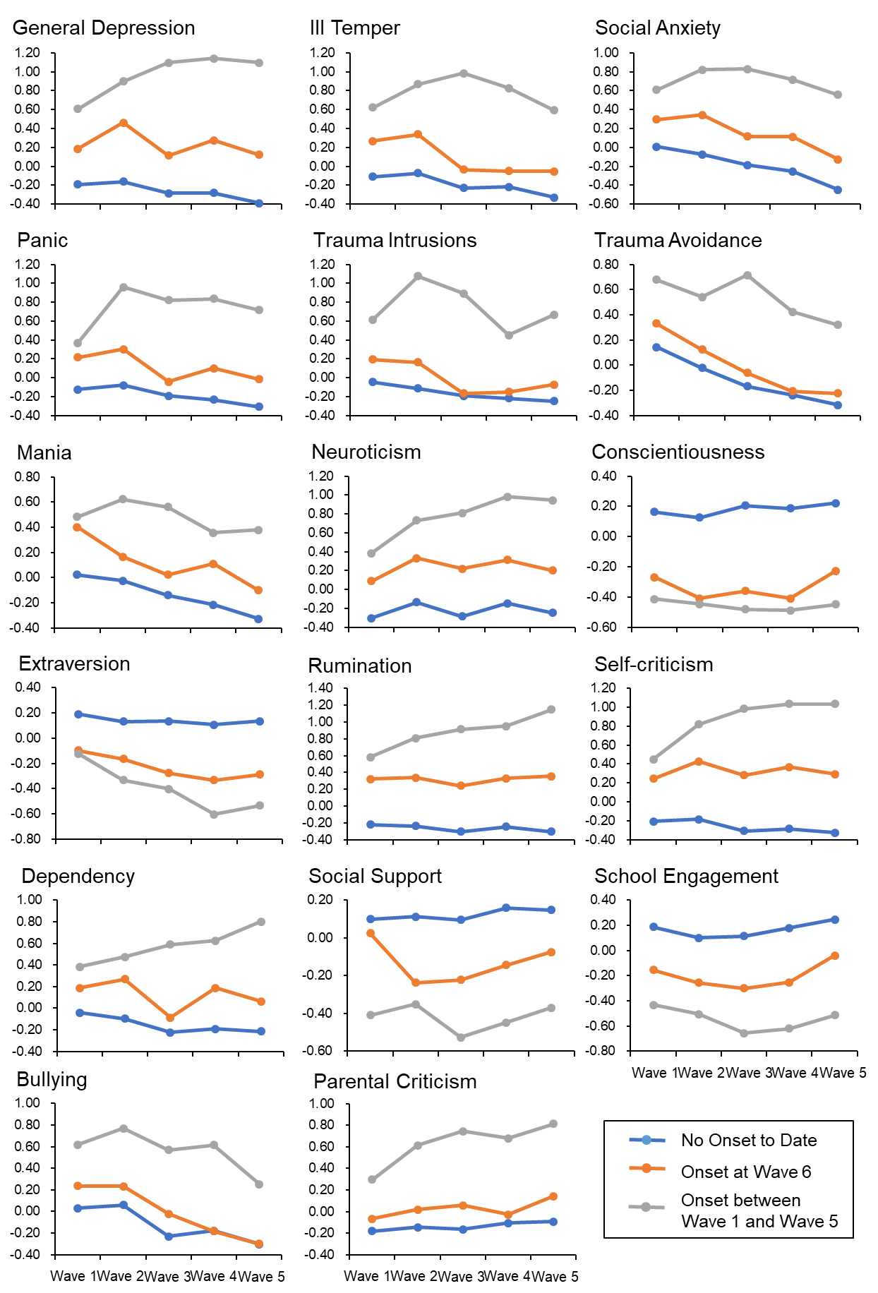
Note. No onset to date = participants never developed MDD or dysthymic disorder across all 6 waves, n = 315; Onset between wave 1 and wave 5 = participants had MDD or dysthymic disorder between wave 1 and wave 5, n = 72; Onset at wave 6 = participants had first onset of MDD or dysthymic disorder between wave 5 and wave 6, n = 78. It should be noted that we observed worsening of risk markers in the onset group between wave 1 and wave 5, which likely reflects the consequences of DD.
Figure S2
Spaghetti plot of each participant’s risk trajectory from wave 1 to wave 5 in a random subsample of 10% of the current sample.
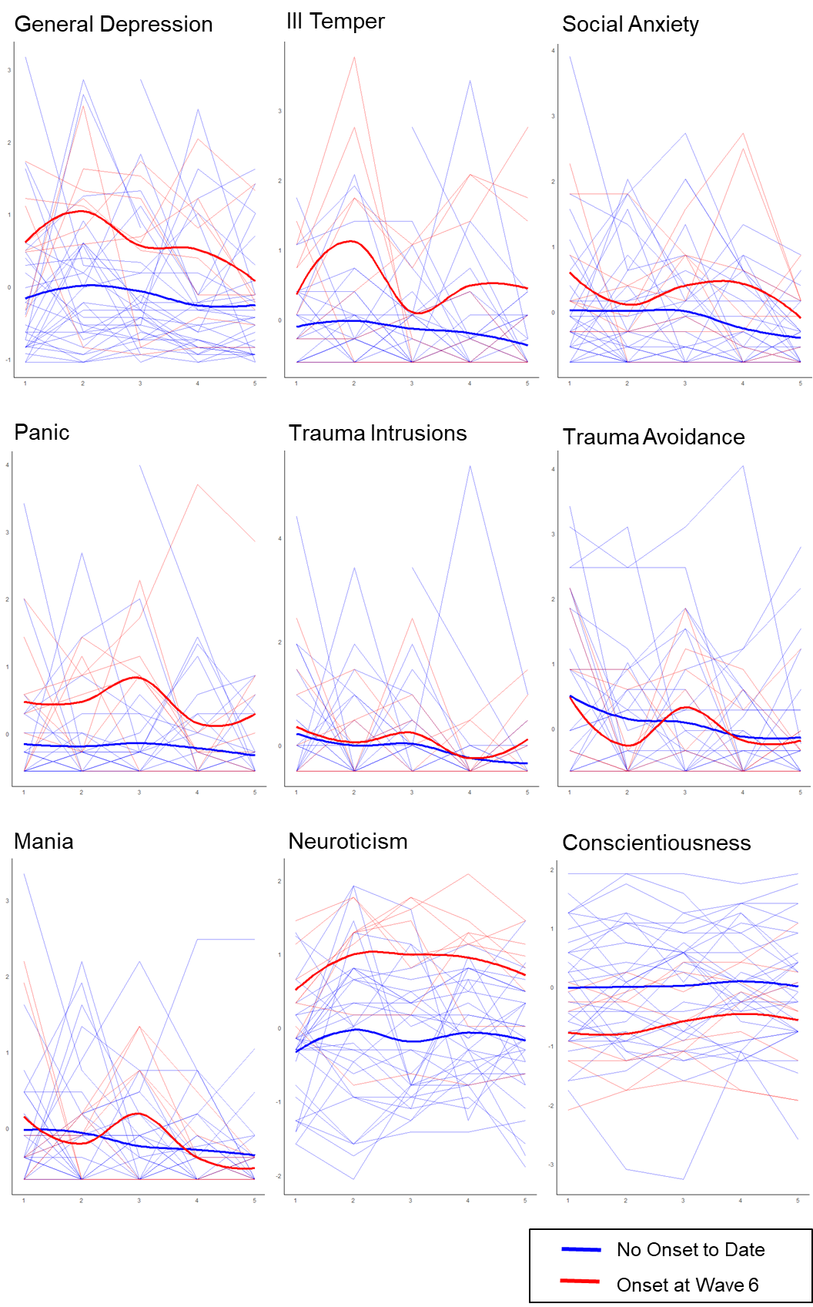
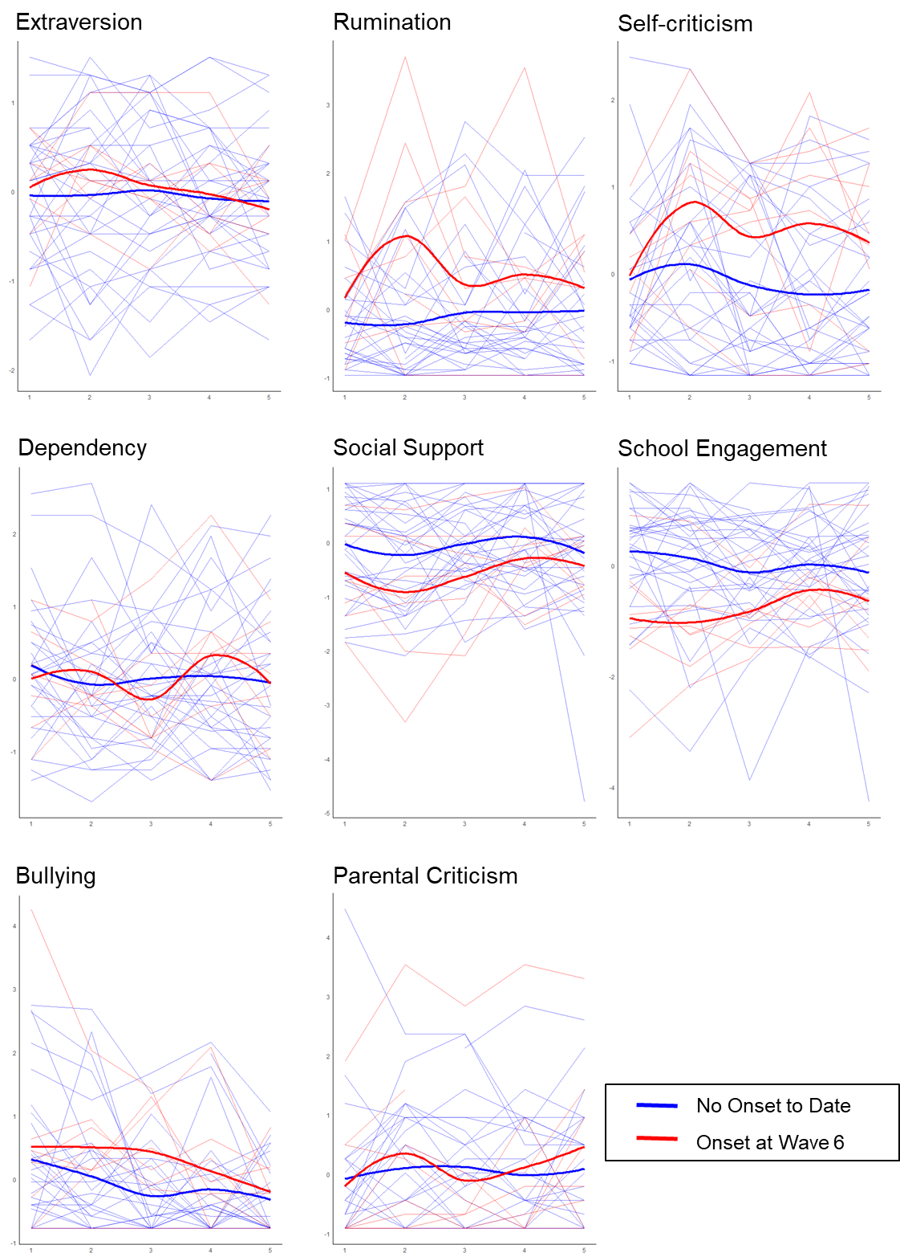
Note. Standardized scores for each risk marker were used.

