Supplementary Materials

Abbreviations used in the Supplementary Materials 3
Search Strategy 4
Summary of scales included in the systematic review and/or meta-analysis measuring specific types of Emotion Regulation strategies 6
Control Group: Major Depressive Disorder (MDD) 8
Summary Table - Characteristics of the comparisons to people with MDD included in the Systematic Review and Meta-analysis 8
Additional results – Results of the sensitivity analysis comparing euthymic samples diagnosed with between Bipolar Disorder and Major Depressive Disorder 17
Additional results – Results of the sensitivity analysis comparing Bipolar Disorder and Major Depressive Disorder using a more conservative level of significance. 19
Cognitive Emotion Regulation Questionnaire, CERQ (main, subgroup, cumulative, and sensitivity analyses) 21
Difficulties in Emotion Regulation Scale, DERS (main, subgroup, cumulative, and sensitivity analyses) 44
Response to Positive Affect, RPA (main, cumulative, and sensitivity analyses) 72
Ruminative Response Scale, RRS (main, cumulative, and sensitivity analyses) 78
Response Style Questionnaire, RSQ (main analysis) 83
Emotion Regulation Questionnaire, ERQ (main analysis) 86
Control Group: Borderline Personality Disorder (BPD) 88
Summary Table - Characteristics of the comparisons to people with BPD included in the Systematic Review and Meta-analysis 88
Additional results – Results of the sensitivity analysis comparing Bipolar Disorder and Borderline Personality Disorder using a more conservative level of significance. 92
Cognitive Emotion Regulation Questionnaire, CERQ (main analysis) 94
Difficulties in Emotion Regulation Scale, DERS (main, cumulative, and sensitivity analyses) 103
Control Group: Schizophrenia 122
Summary Table - Characteristics of the comparisons to people with schizophrenia included in the Systematic Review 122
Control Group: Attention Deficit Hyperactivity Disorder (ADHD) 123
Summary Table - Characteristics of the comparisons to people with ADHD included in the Systematic Review 123
Control Group: Anxiety Disorders 125
Summary Table - Characteristics of the comparisons to people with anxiety disorders included in the Systematic Review 125
Control Group: Post-Traumatic Stress Disorder 126
Summary Table - Characteristics of the comparisons to people with post-traumatic stress disorder included in the Systematic Review 126
Quality appraisal of studies included in the Systematic Review and Meta-analysis 127
Excluded studies, with reason 129
PRISMA 2020 Checklist 133
MOOSE Guidelines 136

Abbreviations used in the Supplementary Materials

AAQ-II - Acceptance and Action Questionnaire, II; ACS - Affective Control Scale; ADHD - Attention Deficit-Hyperactivity disorder; BD - Bipolar Disorder; BPD - Borderline Personality Disorder; CERQ - Cognitive Emotion Regulation Questionnaire; DERS - Difficulties in Emotion Regulation Scale; DIGS - Diagnostic Interview for Genetic Studies; DSM - Diagnostic and Statistical Manual of Mental Disorders; ERQ - Emotion Regulation Questionnaire; HC - Healthy Controls; ICD - International Classification of Diseases; LESS - Leahy Emotional Schema Scale; MADRS - Montgomery-Asberg Depression Rating Scale; MDD - Major Depressive Disorder; MINI - The Mini-International Neuropsychiatric Interview; MRI - Magnetic resonance imaging; NOS - Newcastle-Ottawa Scale; PTSD - Post-traumatic Stress Disorder; RIPoSt-40 - Reactivity, Intensity, Polarity and Stability questionnaire; RIPoSt-Y - Reactivity, Intensity, Polarity and Stability questionnaire, Youth version; RPA - Response to Positive Affect; RRS - Ruminative Response Scale; RSQ - Response Styles Questionnaire; SADS - Schedule for Affective Disorders and Schizophrenia; SCID - Structured Clinical Interview for DSM Disorders; YMRS - Young Mania Rating Scale.

Search Strategy

Pubmed/MEDLINE (from inception up to 28/04/22, 691 records retrieved)
("bipolar disorder"[MeSH Terms] OR "bipolar disorder"[Title/Abstract] OR "mania"[Title/Abstract] OR "hypomania"[Title/Abstract] OR "manic"[Title/Abstract] OR "hypomanic"[Title/Abstract] OR "bipolar depression"[Title/Abstract])

AND

("emotional regulation"[MeSH Terms] OR "emotional regulation"[Title/Abstract] OR "emotional dysregulation"[Title/Abstract] OR "emotion dysregulation"[Title/Abstract] OR "emotion regulation"[Title/Abstract] OR "asq"[Title/Abstract] OR "ders"[Title/Abstract] OR "cerq"[Title/Abstract] OR "eros"[Title/Abstract] OR "erq"[Title/Abstract] OR "ripost40"[Title/Abstract] OR "mood lability"[Title/Abstract] OR "mood instability"[Title/Abstract])

EMBASE (from inception up to 28/04/22, 561 records retrieved)

('bipolar disorder':ab,ti OR 'bipolar depression':ab,ti OR 'bipolar mania':ab,ti OR hypomania:ab,ti)

AND

('emotion dysregulation':ab,ti OR 'emotion regulation':ab,ti OR 'emotional dysregulation':ab,ti OR 'difficulties in emotion regulation scale':ab,ti OR 'affective style questionnaire':ab,ti OR ('cognitive emotion regulation questionnaire':ab,ti AND cerq:ab,ti) OR ('emotion regulation questionnaire':ab,ti AND erq:ab,ti) OR 'ripost 40':ab,ti OR ('emotion regulation of others':ab,ti AND self:ab,ti) OR 'mental instability':ab,ti)

SCOPUS (from inception up to 28/04/22, 1133 records retrieved)

(TITLE-ABS("bipolar disorder") OR TITLE-ABS("bipolar depression") OR TITLE-ABS("mania") OR TITLE-ABS("hypomania") OR TITLE-ABS("manic") OR TITLE-ABS("hypomanic"))

AND

(TITLE-ABS("emotion regulation") OR TITLE-ABS("emotional regulation") OR TITLE-ABS("emotion dysregulation") OR TITLE-ABS("emotional dysregulation") OR TITLE-ABS("ASQ") OR TITLE-ABS("CERQ") OR TITLE-ABS("EROS") OR TITLE-ABS("ERQ") OR TITLE-ABS("DERS") OR TITLE-ABS("RIPOST-40") OR TITLE-ABS("mood lability") OR TITLE-ABS("mood instability"))

PsycINFO (from inception up to 28/04/22, 829 records retrieved)

(TI bipolar disorder OR AB bipolar disorder OR TI bipolar depression OR AB bipolar depression OR TI mania OR AB mania OR TI manic episode OR AB manic episode OR TI hypomania OR AB hypomania OR TI hypomanic episode OR AB hypomanic episode)

AND

(TI ( emotion dysregulation or regulation of emotion or emotional regulation ) OR AB ( emotion dysregulation or regulation of emotion or emotional regulation ) OR TI ( emotional dysregulation or emotional regulation ) OR AB ( emotional dysregulation or emotional regulation ) OR AB ( ders or difficulties in emotional regulation scale ) OR AB erq OR AB asq OR AB eros OR AB cerq OR AB RIPOST-40 OR AB mood instability

Summary of scales included in the systematic review and/or meta-analysis measuring specific types of Emotion Regulation strategies

Supplementary Table n.1 – Summary of scales included in the systematic review and/or meta-analysis measuring specific types of Emotion Regulation strategies

General Category of Emotion Regulation Strategy | Type of Emotion Regulation Strategy | Validated Scale | Subscale
Maladaptive Emotion Regulation Strategies | Negative Rumination | CERQ | Rumination
 |  | RRS | Reflective pondering
 |  | RRS | Brooming
 |  | RSQ | Rumination
 | Positive Rumination | RPA | Emotion-focus
 |  | RPA | Self-focus
 |  | RIPOST-40 | Positive emotionality
 |  | RISPOST-Y | Positive emotionality
 | Negative Focus | ACS | Anger
 |  | ACS | Depression
 |  | ACS | Anxiety
 |  | CERQ | Self-blame
 |  | CERQ | Blaming the others
 |  | CERQ | Catastrophizing
 |  | RIPOST-40 | Negative emotionality
 | Risk-taking Behavior | DERS | Impulse
 |  | RIPOST-40 | Emotional impulsivity
 |  | RSQ | Risk-taking
 | Suppression | ERQ | Suppression
 | Dampening | ACS | Positive affect
 |  | RPA | Dampening
Adaptive Emotion Regulation Strategies | Cognitive Reframing | CERQ | Putting into perspective
 |  | CERQ | Positive refocusing
 |  | CERQ | Positive reappraisal
 |  | CERQ | Focus on replanning
 |  | ERQ | Reappraisal
 | Adaptive Coping | DERS | Goals (reverse)
 |  | DERS | Strategies (reverse)
 |  | LESS | Adaptive emotional schemas
 |  | RSQ | Adaptive
 | Acceptance | AAQ-II | Total score
 |  | CERQ | Acceptance
 |  | DERS | Non-acceptance (reverse)
 |  | DERS | Awareness (reverse)
 |  | DERS | Clarity (reverse)

Control Group: Major Depressive Disorder (MDD)

Summary Table - Characteristics of the comparisons to people with MDD included in the Systematic Review and Meta-analysis

Supplementary Table n.2 - Characteristics of the comparisons to people with MDD included in the Systematic Review and Meta-analysis
Author, year, country | Study design | Description of the study and population characteristics | Diagnostic criteria | Outcome BD vs. MDD, mean±SD | Quality of the study (NOS)
AAQ-II - Acceptance and Action Questionnaire, II
Weinstock L.M. et al., 2018, USA | Cross-sectional | 30 outpatients (mean age=42.4±12.2; %females=63) recruited through community advertisements or local clinician referral and diagnosed with BD-I, and 30 patients (mean age=39.7±11.7; %females=60) diagnosed with MDD were evaluated to explore the differences in emotion regulation processes. Patients were currently depressed. People with current psychotic symptoms, alcohol or substance abuse, or major neurological disease, were excluded. In the present study, HCs were also included | DSM-IV (SCID-I) | Total score: 38.3±6.5 vs. 34.7±8.7 | 5 / FAIR
CERQ (short version when indicated) - Cognitive Emotion Regulation Questionnaire
Ariana Kia E. et al., 2014, Iran | Cross-sectional | 25 patients (mean age=35.3±7.8; %females=44) diagnosed with BD and 25 patients (mean age=34.1±7; %females=52) diagnosed with MDD were evaluated to determine the role of cognitive emotion regulation strategies, anxiety, and impulsivity in developing and maintaining the affective symptomatology. Cognitive emotion regulation was measured with CERQ-short version. In the present study, HCs were also included | DSM-IV (SCID-I) | Self-blame subscale: 5.47±2.07 vs. 5.44±2.07;  Blaming others subscale: 4.67±2.11 vs. 4.82±2.63;  Rumination subscale: 5.36±1.95 vs. 7.2±1.75;  Catastrophizing subscale: 6±2.32 vs. 5.47±2.57;  Putting into perspective subscale: 4.74±2.23 vs. 4.16±1.74;  Positive refocusing subscale: 4.92±2.07 vs. 3.36±1.5;  Positive reappraisal subscale: 3.82±2.03 vs. 3.82±1.99;  Acceptance subscale: 6.24±2.37 vs. 5.7±2.91;  Refocus on planning subscale: 4.32±1.98 vs. 3.92±2.04 | 4 / POOR
Fletcher K. et al., 2013, Australia | Cross-sectional | 193 patients recruited via advertisements on the Black Dog Institute (BDI) Website, the Volunteer Research Register and flyers located within the BDI Depression Clinic and diagnosed with BD-I (86) or BD-II (107), and 93 patients diagnosed with MDD were evaluated to explore the different coping styles in clinical and non-clinical populations. In present study, HCs were also included | DSM-IV (MINI) | Self-blame subscale: 13.34±4.02 vs. 13.6±4.2;  Blaming others subscale: 8.2±3.17 vs. 8.6±3.5;  Rumination subscale: 13.42±3.37 vs. 14.5±3.4;  Catastrophizing subscale: 10.7±3.93 vs. 10.4±3.5;  Putting into perspective subscale: 10.25±4.04 vs. 9.6±3.5;  Positive refocusing subscale: 6.72±2.89 vs. 7±2.7;  Positive reappraisal subscale: 9.42±4.09 vs. 9.4±3.4;  Acceptance subscale: 12.88±4.5 vs. 12.8±3.2;  Refocus on planning subscale: 10.13±3.84 vs. 10.4±35 | 4 / POOR
Kjaerstad H.L. et al., 2016, Denmark | Cross-sectional | 20 outpatients (mean age=32.1±9.8; %females=60) recruited at an outpatient clinic for affective disorder for a validation study on new screening instruments for cognitive dysfunction in affective disorder and diagnosed with BD-I (9) or BD-II (11), and 20 outpatients (mean age=41±11.6; %females=75) diagnosed with MDD were evaluated to explore the ability of patients to down-regulate emotional responses with no specific instructions or in a setting involving social-relevant scenarios. Patients were all in remission. People with substance use were excluded. | ICD-10 | Self-blame subscale: 10.94±4.67 vs. 9.89±3.46;  Blaming others subscale: 5.56±1.41 vs. 7±3.06;  Rumination subscale: 13.44±3.33 vs. 12.47±3.15;  Catastrophizing subscale: 9±3.76 vs. 7.79±3.16;  Putting into perspective subscale: 13±4.32 vs. 10.32±3.99;  Positive refocusing subscale: 9.44±3.46 vs. 8.63±3.02;  Positive reappraisal subscale: 13.56±2.5 vs. 11.79±3.82;  Acceptance subscale: 12.31±2.5 vs. 12±3.15;  Refocus on planning subscale: 16.06±2.98 vs. 13.63±3.15 | 3 / POOR
Lois G. et al., 2017, Germany | Cross-sectional | 21 patients (mean age=39.6±9.4; %females=52) recruited at the Central Institute of Mental Health  (Mannheim, Germany) and through local psychotherapists, psychiatrists, and patient support groups, and diagnosed with BD-I, and 21 patients (mean age=44.4±9.9; %females=67) diagnosed with MDD were asked to perform emotional tasks during fMRI scanning to explore and compare the patterns of functional connectivity during distraction and reappraisal in specific regions of interest. BD patients were euthymic, and patients with MDD were in remission. Patients with current or lifetime substance use, head trauma history, or with large tattoos with metal-containing color, were excluded. In the present study, HCs were also included | DSM-IV (SCID) | Rumination subscale: 12.4±3.7 vs. 10.7±3.4 | 7 / GOOD
Van Meter A.R. et al., 2016, USA | Cross-sectional | 23 outpatients (mean age=26±5.5; %females=48) recruited through the university psychiatry  department and diagnosed with BD-I (11), BD-II (5), or BD NOS (7), and 21 patients (mean age=31.6±7.8; %females=76) diagnosed with MDD were exposed to emotional stimuli and their emotional response was evaluated. People with BD were mostly euthymic and on medications at the time of the assessment; people with MDD were in remission and mostly on medications | DSM-IV (MINI) | Maladaptive composite scale (self-blame subscale, blaming others subscale, rumination subscale, catastrophizing subscale, and acceptance subscale): 52.52±9.23 vs. 48.62±7.19;  Adaptive composite scale (putting into perspective subscale, positive refocusing subscale, positive reappraisal subscale, and Refocus on planning subscale): 47.62±14.44 vs. 46.9±13.83 | 6 / FAIR
Wolkenstein L. et al., 2013, Germany | Cross-sectional | 42 outpatients (mean age=40.9±12.8; %females=62) recruited through an outpatient clinic or through advertisements posted on the internet and within the community and diagnosed with BD-I (26) or BD-II (16), and 43 people (mean age=36.9±13.4; %females=72) diagnosed with MDD were evaluated to compare the habitual use of emotion regulation strategies among these populations. People with BD were euthymic and most of them were on medications at the time of the assessment; people with MDD were in remission and less than half of them were taking medications. Patients with insufficient knowledge of the german language, with lifetime psychotic symptoms, with current substance use, or with a comorbid diagnosis of personality disorders (A or B) or anorexia nervosa, were excluded. In the present study, HCs were also included | DSM-IV (SCID-I) | Self-blame subscale: 10.81±3.71 vs. 10.93±4.03;  Blaming others subscale: 7.33±2.93 vs. 7.19±2.4;  Rumination subscale: 11.36±3.79 vs. 12.16±3.55;  Catastrophizing subscale: 8.14±3.59 vs. 7.63±3.01;  Putting into perspective subscale: 10.36±3.31 vs. 11.14±3.1;  Positive refocusing subscale: 8.64±3.6 vs. 9.19±3.47;  Positive reappraisal subscale: 11.36±3.8 vs. 11.77±4.17;  Acceptance subscale: 11.74±12.21 vs. 12.21±3.11;  Refocus on planning subscale: 10.57±3.58 vs. 11.21±2.87 | 4 / POOR
DERS - Difficulties in Emotion Regulation Scale
Ambrosi E. et al., 2017, USA | Cross-sectional | 36 inpatients (mean age=31±11.3; %females=56) recruited from the Menninger Clinic and diagnosed with BD, and 40 patients (mean age=30±11.7; %females=47) with MDD were evaluated with fMRI to investigate the functional connectivity between insula and amygdala, and to explore their contribution to the functional networks involved in emotion regulation. Both groups were depressed and mostly on medication at the time of assessment. Substance use was diagnosed both in patients with BD (55.5%) and MDD (52.5%). In the present study, HCs were also included | DSM-IV (SCID-I) | Total score: 114.9±21.4 vs. 108.5±26.8 | 7 / GOOD
Becerra R. et al., 2013, Australia | Cross-sectional | 48 patients (mean age=44.9±11.6) recruited from a private psychiatrist, clinical psychologist, or as part of an ongoing study and diagnosed with BD, and 50 patients (mean age=44±11.7) with MDD were evaluated to explore the differences in emotion regulation difficulties. People with BD were euthymic (34) or mildly depressed (14). In the present study, HCs and people diagnosed with anxiety disorders were also included | ICD-10 | Total score: 93.42±22.59 vs. 108.24±22.58;  Non-acceptance subscale: 15.08±5.71 vs. 18.28±6.35;  Goals subscale: 16.71±4.73 vs. 17.59±3.97;  Impulse subscale: 13.75±4.8 vs. 15.67±4.95;  Awareness subscale: 15.46±4.97 vs. 18.78±4.9;  Strategies subscale: 19.15±6.51 vs. 21.46±6.17;  Clarity subscale: 13.27±4.84 vs. 16.86±4.17 | 4 / POOR
Becerra R. et al., 2016, Australia | Cross-sectional | 24 patients (mean age=40.4±9.8; %females=33) diagnosed with BD-I and 38 patients (mean age=42.8±12.5; %females=26) diagnosed with MDD were evaluated to explore the differences in emotion regulation difficulties. People with BD were euthymic for at least three months; people with MDD were in remission for at least three months. People who were pregnant, with a score on the Spielberger State/Trait Anxiety Inventory of more than 50, with a score on the MADRS of more than 5, and a score on the YMRS of more than 4, were excluded. In the present study, HCs were also included | DSM-IV (MINI) | Total score: 69.46±16.79 vs. 79.16±17.83;  Non-acceptance subscale: 11.33±3.14 vs. 13.8±6.04;  Goals subscale: 12.88±4.73 vs. 15.13±4.54;  Impulse subscale: 9.7±3.67 vs. 10.87±3.99;  Awareness subscale: 11.71±3.74 vs. 13.55±3.7;  Strategies subscale: 15.54±6.03 vs. 16.76±5.23;  Clarity subscale: 8.29±2.68 vs. 9.05±2.74 | 5 / FAIR
Musket C.W. et al., 2021, USA | Cross-sectional | 51 outpatients (mean age=31.8±10.6; %females=78) recruited using internet advertisement and diagnosed with BD-I and 32 patients (mean age=31.2±11.4; %females=65) diagnosed with MDD were evaluated to explore the differences in difficulties in emotion regulation. Patients with BD were euthymic (32) or manic (19), people with MDD were in remission. People with a lifetime history of neurological disease, severe head trauma, stroke, autoimmune disorder, severe medical illness, and alcohol or substance abuse in the past six months were excluded. In the present study, HCs were also included | DSM-IV (SCID-I) | Total score: 89.67±37.7 vs. 83.5±42.42;  Non-acceptance subscale: 13.78±6.14 vs. 13.09±4.9;  Goals subscale: 15.84±4.87 vs. 15.53±4.47;  Impulse subscale: 14.27±5.81 vs. 12.03±4.3;  Awareness subscale: 15±4.99 vs. 13.66±4.04;  Strategies subscale: 19.36±7.81 vs. 16.56±6.94;  Clarity subscale: 11.36±5.99 vs. 11.09±2.99 | 6 / GOOD
Oymak Yenilmez D. et al., 2021, Turkey | Cross-sectional | 85 outpatients (mean age=36.6±11.6; %females=54) recruited from several facilities and diagnosed with BD-I (64) and BD-II (21), and 81 patients (mean age=36.3±9.4; %females=66) diagnosed with MDD were evaluated to determine the role of emotion dysregulation and childhood adversities on automatic thoughts and meta-cognition. Patients were in remission for at least six months. People who had any central nervous system disease, intellectual disability, alcohol or any other substance use disorder, history of major traumas and head injuries, or hospitalized in the last six months, were excluded. In the present study, HCs were also included | DSM-IV (SCID-I) | Total score: 102.78±25.31 vs. 95.21±18.4;  Non-acceptance subscale: 16.92±5.96 vs. 15.15±4.22;  Goals subscale: 17.2±4.44 vs. 14.39±2.75;  Impulse subscale: 18.13±5.79 vs. 16.24±4.49;  Strategies subscale: 24.69±7.7 vs. 21.66±5.16;  Clarity subscale: 13.12±3.99 vs. 13.34±3.12 | 5 / FAIR
Weintraub M.J. et al., 2017, USA | Cross-sectional | 57 patients recruited from mood disorder clinic and diagnosed with BD and 78 patients with MDD were evaluated to explore their self-harm behaviors, and if it could relate to personality traits. People diagnosed with schizophrenia or intellectual disability, were excluded | DSM-IV (DIGS) | Total score: 92.01±26.37 vs. 100.12±25.58;  Non-acceptance subscale: 15.3±6.69 vs. 16.9±6.62;  Goals subscale: 16.77±4.56 vs. 16.83±4.77;  Impulse subscale: 13.79±5.86 vs. 14.1±5.48;  Awareness subscale: 13.85±4.5 vs. 15.99±5.11;  Strategies subscale: 21.46±7.79 vs. 22.97±7.49;  Clarity subscale: 10.84±3.99 vs. 13.33±4.53 | 6 / GOOD
ERQ - Emotion Regulation Questionnaire
Aslan I.H. et al., 2021, United Kingdom | Cross-sectional | 50 patients (mean age=37.3±14.3; %females=72) diagnosed with BD and 50 patients (mean age=31.9±11.4; %females=68) diagnosed with MDD were evaluated to explore the differences between groups in terms of rumination, emotion regulation and cognitive functions. Patients were currently depressed. People with current psychotic symptoms, alcohol or substance abuse, or major neurological disease, were excluded. In the present study, HCs were also included | DSM-5 (SCID-5) | Reappraisal subscale: 25.1±8.1 vs. 23±9;  Suppression subscale: 16.8±5.8 vs. 15.3±5.3 | 5 / FAIR
Kim K. et al., 2021, Republic of Korea | Cross-sectional | 19 patients diagnosed with BD-I (3) or BD-II (16) recruited at the psychiatric department of an university medical center  from February 2020 to March 2021, and 71 patients diagnosed with MDD were asked to complete a clinical assessment to validate the ERQ, Korean version. People diagnosed with schizophrenia spectrum disorders, mood disorders with psychotic features, intellectual disability, or neurocognitive disorders were excluded. In the present study, people diagnosed with PTSD or ADHD were also included | DSM-5 (SCID-5) | Reappraisal subscale: 19.32±7.7 vs. 19.06±6.21;  Suppression subscale: 14.32±6.28 vs. 17.59±4.81 | 4 / POOR
LESS - Leahy Emotional Schema Scale
Batmaz S. et al., 2014, Turkey | Cross-sectional | 140 outpatients (mean age=37.9±11.9; %females=57) who presented to the psychiatry clinics of  Ankara Oncology Training and Research Hospital, Ataturk Training and Research Hospital, and Mersin State Hospital  between August 2009 and April 2013 and diagnosed with BD-I and 166 outpatients (mean age=37.6±12.3; %females=60) diagnosed with MDD were evaluated to distinguish unipolar and bipolar depression in terms of metacognitions and emotional schemas. Patients were all depressed. People with a comorbid axis-I psychiatric condition, uncontrolled medical condition, with substance use, history of head-trauma, pregnant, or taking psychiatric treatment in the last 12 weeks, were excluded. In the present study, HCs were also included | DSM-IV | Adaptive emotional schemas: 93.65±12.75 vs. 89.3±8.18;  Rigid emotional schemas: 82.49 ±15.26 vs. 86.66±11.44;  Negative beliefs about emotions: 172. 5±22.76 vs. 179.36±14.25 | 4 / POOR
RPA - Response to Positive Affect
Fletcher K. et al., 2013, Australia | Cross-sectional | 193 patients recruited via advertisements on the Black Dog Institute (BDI) Website, the Volunteer Research Register and flyers located within the BDI Depression Clinic and diagnosed with BD-I (86) or BD-II (107), and 93 patients diagnosed with MDD were evaluated to explore the different coping styles in clinical and non-clinical populations. In present study, HCs were also included | DSM-IV (MINI) | Dampening subscale: 16.91±5.75 vs. 16.4±5;  Emotion focus subscale: 13.76±3.74 vs. 12.3±3.3;  Self-focus subscale: 9.35±2.99 vs. 8.4±2.5 | 4 / POOR
Gilbert K.E. et al., 2013, USA | Prospective cohort | 31 patients (mean age=30.9±9.8; %females=64) recruited through internet advertisement and flyers and diagnosed with BD-I and 31 patients (mean age=31.7±11.2; %females=68) diagnosed with MDD were evaluated to explore the relationships between rumination and dampening with emotional responding. Moreover, the patients were followed-up for six months to observe the prospective relationships between self-reported amplification and dampening, and symptom severity. Patients were in remission. People who had any central nervous system disease, alcohol or any other substance use disorder, history of major traumas and head injuries, autoimmune disorders, or cardiovascular diseases or arrhythmia, were excluded | DSM-IV (SCID-I) | Dampening subscale: 15.48±5.51 vs. 13.16±3.6;  Emotion focus subscale: 14.26±3.66 vs. 13.29±3.57;  Self-focus subscale: 10.29±3.39 vs. 9.16±3.06 | 4 / POOR
Shapero B.G. et al., 2015, USA | Cross-sectional | 31 young patients (mean age=18.6±1.5; %females=71) recruited from a larger sample from the greater area of the Philadelphia region diagnosed with BD and 122 young patients (mean age=18.4±1.4; %females=65) diagnosed with MDD, were evaluated to identify, and differentiate the cognitive styles among different groups. Patients were all euthymic. People with lifetime history of any psychotic disorder or not fluent in English were excluded. In the present study, HCs were also included | DSM-IV (SADS-L) | Dampening subscale: 15.84±5.2 vs. 15.13±5.59;  Emotion focus subscale: 16.13±1.61 vs. 14.44±3.09;  Self-focus subscale: 11.39±2.6 vs. 10.49±3.01 | 6 / GOOD
Weinstock L.M. et al., 2018, USA | Cross-sectional | 30 outpatients (mean age=42.4±12.2; %females=63) recruited through community advertisements or local clinician referral and diagnosed with BD-I, and 30 patients (mean age=39.7±11.7; %females=60) diagnosed with MDD were evaluated to explore the differences in emotion regulation processes. Patients were currently depressed. People with current psychotic symptoms, alcohol or substance abuse, or major neurological disease, were excluded. In the present study, HCs were also included | DSM-IV (SCID-I) | Dampening subscale: 20.1±5.3 vs. 19.8±5.2;  Emotion focus subscale: 12±3.2 vs. 12.2±3.3;  Self-focus subscale: 9.5±2.8 vs. 8.4±2.7 | 5 / FAIR
RRS - Ruminative Response Scale
Aslan I.H. et al., 2021, United Kingdom | Cross-sectional | 50 patients (mean age=37.3±14.3; %females=72) diagnosed with BD and 50 patients (mean age=31.9±11.4; %females=68) diagnosed with MDD were evaluated to explore the differences between groups in terms of rumination, emotion regulation and cognitive functions. Patients were currently depressed. People with current psychotic symptoms, alcohol or substance abuse, or major neurological disease, were excluded. In the present study, HCs were also included | DSM-5 (SCID-5) | Total score: 27±6.6 vs. 30.1±7;  Brooding subscale: 13.7±3.6 vs. 15.4±3.6;  Reflective pondering subscale: 13.2±3.4 vs. 14.7±3.8 | 5 / FAIR
Kim S. et al., 2012, Republic of Korea | Cross-sectional | 157 in- and outpatients recruited from November 2007 to August 2010 and diagnosed with BD-I (68), BD-II (52), or BD-NOS (37), and 227 in- and outpatients with MDD were evaluated to investigate the extension of rumination and its differences among the groups. Patients with mood disorders and comorbid anxiety disorders, as well as patients with anxiety disorders and comorbid mood disorders, were excluded. In the present study, people with panic disorder or other anxiety disorders were also included | DSM-IV (SCID) | Total score: 54.17±19.1 vs. 53.65±14.17;  Brooding subscale: 12.65±3.6 vs. 13±2.98;  Reflective pondering subscale: 11.35±3.74 vs. 10±2.98 | 6 / GOOD
Shapero B.G. et al., 2015, USA | Cross-sectional | 31 young patients (mean age=18.6±1.5; %females=71) recruited from a larger sample from the greater area of the Philadelphia region diagnosed with BD and 122 young patients (mean age=18.4±1.4; %females=65) diagnosed with MDD, were evaluated to identify, and differentiate the cognitive styles among different groups. Patients were all euthymic. People with lifetime history of any psychotic disorder or not fluent in English were excluded. In the present study, HCs were also included | DSM-IV (SADS-L) | Brooding subscale: 13.1±3.13 vs. 12.31±3.64;  Reflective pondering subscale: 13.5±3.7 vs. 12.66±3.26 | 6 / GOOD
RSQ - Response Styles Questionnaire
Fletcher K. et al., 2013, Australia | Cross-sectional | 193 patients recruited via advertisements on the Black Dog Institute (BDI) Website, the Volunteer Research Register and flyers located within the BDI Depression Clinic and diagnosed with BD-I (86) or BD-II (107), and 93 patients diagnosed with MDD were evaluated to explore the different coping styles in clinical and non-clinical populations. In present study, HCs were also included | DSM-IV (MINI) | Rumination subscale: 64.91±13.06 vs. 63.4±11.3;  Adaptive subscale: 27.58±6.67 vs. 27.7±6.3;  Risk-taking subscale: 12.63±3.96 vs. 11.1±2; | 4 / POOR
Perich T. et al., 2011, Australia | Cross-sectional | 90 patients selected from the participants to a trial comparing mindfulness to treatment as usual, recruited via advertisements on the Black Dog Institute (BDI) research register and diagnosed with BD, and 39 patients diagnosed with MDD were evaluated to explore the relationship between mindfulness and psychiatric symptomatology among clinical groups. Patients with BD were mostly euthymic, patients with MDD were in remission. People with a diagnosis of schizophrenia or schizoaffective disorder, substance abuse disorder, organic brain syndrome, antisocial or borderline personality disorder, or a concurrent significant medical condition impeding their ability to participate, were excluded. In present study, HCs were also included. The 48-items version of the RSQ was adopted | DSM-IV (SCID) | Rumination subscale: 38.57±11.46 vs. 28.42±12.49;  Adaptive subscale: 14.61±7.56 vs. 18.64±7.42;  Risk-taking subscale: 4.12±4.28 vs. 1.72±1.89 | 6 / FAIR
Weinstock L.M. et al., 2018, USA | Cross-sectional | 30 outpatients (mean age=42.4±12.2; %females=63) recruited through community advertisements or local clinician referral and diagnosed with BD-I, and 30 patients (mean age=39.7±11.7; %females=60) diagnosed with MDD were evaluated to explore the differences in emotion regulation processes. Patients were currently depressed. People with current psychotic symptoms, alcohol or substance abuse, or major neurological disease, were excluded. In the present study, HCs were also included | DSM-IV (SCID-I) | Brooding subscale: 11.1±3.1 vs. 10±3 | 5 / FAIR

Additional results – Results of the sensitivity analysis comparing euthymic samples diagnosed with between Bipolar Disorder and Major Depressive Disorder

Supplementary Table n.3 – Results of the sensitivity analysis comparing euthymic samples diagnosed with Bipolar Disorder and Major Depressive Disorder

Scale adopted | Subscale | Studies, n | BD patients, n | Control, diagnosis | Control, n | SMD | 95% CI | p-value |  | 95% PI | I² (%) | tau² | Q-test p-value
Euthymic samples only
Overall measures of Emotion Dysregulation
DERS | Total score | 2 | 109 | MDD | 119 | -0.08 | -0.95, 0.79 | 0.85 |  | -1.52, 1.37 | 88 | 0.35 | <0.01
Maladaptive Emotion Regulation Strategies
Negative Rumination
CERQ | Rumination | 3 | 83 | MDD | 84 | 0.13 | -0.31, 0.57 | 0.55 |  | -0.56, 0.82 | 48.4 | 0.07 | 0.15
Positive Rumination
RPA | Emotion-focus | 2 | 62 | MDD | 153 | 0.46 | 0.15, 0.77 | 0.003 |  | 0.15, 0.77 | 0 | 0 | 0.32
RPA | Self-focus | 2 | 62 | MDD | 153 | 0.32 | 0.01, 0.63 | 0.046 |  | 0.01, 0.63 | 0 | 0 | 0.93
Negative Focus
CERQ | Self-blame | 2 | 62 | MDD | 63 | 0.06 | -0.29, 0.41 | 0.74 |  | -0.29, 0.41 | 0 | 0 | 0.46
CERQ | Blaming others | 2 | 62 | MDD | 63 | -0.23 | -0.85, 0.4 | 0.49 |  | -1.17, 0.72 | 63.5 | 0.13 | 0.1
CERQ | Catastrophizing | 2 | 62 | MDD | 63 | 0.21 | -0.14, 0.56 | 0.24 |  | -0.14, 0.56 | 0 | 0 | 0.62
Risk-taking Behavior
DERS | Impulse | 2 | 109 | MDD | 119 | -0.07 | -0.71, 0.58 | 0.84 |  | -0.97, 1.1 | 78.6 | 0.17 | 0.03
Dampening
RPA | Dampening | 2 | 62 | MDD | 153 | 0.27 | -0.08, 0.62 | 0.14 |  | -0.14, 0.69 | 19.3 | 0.01 | 0.27
Adaptive Emotion Regulation Strategies
Cognitive Reframing
CERQ | Putting into perspective | 2 | 62 | MDD | 63 | 0.16 | -0.69, 1.02 | 0.71 |  | -1.22, 1.54 | 80 | 0.3 | 0.03
CERQ | Positive refocusing | 2 | 62 | MDD | 63 | -0.02 | -0.39, 0.35 | 0.91 |  | -0.42, 0.37 | 6.9 | 0.01 | 0.3
CERQ | Positive reappraisal | 2 | 62 | MDD | 63 | 0.17 | -0.45, 0.79 | 0.58 |  | -0.76, 1.11 | 63.1 | 0.13 | 0.1
CERQ | Refocus on planning | 2 | 62 | MDD | 63 | 0.26 | -0.69, 1.21 | 0.59 |  | -1.29, 1.82 | 83.6 | 0.4 | 0.01
Adaptive Coping
DERS | Goals (reverse) | 2 | 109 | MDD | 119 | -0.15 | -1.36, 1.06 | 0.8 | -2.21, 1.9 |  | 93.7 | 0.71 | <0.01
DERS | Strategies (reverse) | 2 | 109 | MDD | 119 | -0.15 | -0.81, 0.51 | 0.65 | -1.21, 0.91 |  | 79.6 | 0.18 | 0.03
Acceptance
CERQ | Acceptance | 2 | 62 | MDD | 63 | -0.06 | -0.41, 0.29 | 0.73 |  | -0.41, 0.29 | 0 | 0 | 0.52
DERS | Non-acceptance (reverse) | 2 | 109 | MDD | 119 | 0.04 | -0.76, 0.84 | 0.92 |  | -1.28, 1.35 | 85.8 | 0.29 | <0.01
DERS | Clarity (reverse) | 2 | 109 | MDD | 119 | 0.12 | -0.14, 0.38 | 0.38 |  | -0.14, 0.38 | 0 | 0 | 0.48

Additional results – Results of the sensitivity analysis comparing Bipolar Disorder and Major Depressive Disorder using a more conservative level of significance.

Supplementary Table n.4 – Results of the sensitivity analysis comparing Bipolar Disorder and Major Depressive Disorder using a more conservative level of significance

Scale adopted | Subscale | Studies, n | BD patients, n | Control, diagnosis | Control, n | SMD | 95% CI | p-value | 95% PI | I² (%) | tau² | Q-test p-value
Overall measures of Emotion Dysregulation
DERS | Total score | 6 | 301 | MDD | 319 | -0.12 | -0.46, 0.23 | 1 | -0.93, 0.70 | 77.6 | 0.14 | 0.01
Maladaptive Emotion Regulation Strategies
Negative Rumination
CERQ | Rumination | 5 | 301 | MDD | 205 | -0.17 | -0.63, 0-29 | 1 | -1.17, 0.83 | 79.3 | 0.21 | 0.01
RRS | Brooding | 3 | 238 | MDD | 399 | -0.11 | -0.46, 0.24 | 1 | -0.72, 0.51 | 70.7 | 0.07 | 0.05
RRS | Reflective pondering | 3 | 238 | MDD | 399 | 0.10 | -0.39, 0.59 | 1 | -0.82, 1.01 | 85 | 0.16 | 0.01
RSQ | Rumination | 2 | 283 | MDD | 132 | 0.47 | -0.25, 1.19 | 1 | -0.73, 1.68 | 89.4 | 0.24 | 0.01
Positive Rumination
RPA | Emotion-focus | 4 | 285 | MDD | 279 | 0.46 | 0.27, 0.64 | 3.57e-5 | 0.27, 0.64 | 0 | 0 | 0.60
RPA | Self-focus | 4 | 285 | MDD | 279 | 0.34 | 0.15, 0.52 | 0.01134 | 0.15, 0.52 | 0 | 0 | 0.99
Negative Focus
CERQ | Self-blame | 4 | 280 | MDD | 184 | -0.02 | -0.21, 0.17 | 1 | -0.21, 0.17 | 0 | 0 | 0.83
CERQ | Blaming others | 4 | 280 | MDD | 184 | -0.12 | -0.31, 0.07 | 1 | -0.31, 0.07 | 0 | 0 | 0.42
CERQ | Catastrophizing | 4 | 280 | MDD | 184 | 0.13 | -0.06, 0.32 | 1 | -0.06, 0.32 | 0 | 0 | 0.87
Risk-taking Behavior
DERS | Impulse | 5 | 265 | MDD | 279 | 0.02 | -0.30, 0.34 | 1 | -0.66, 0.70 | 70.3 | 0.09 | 0.01
RSQ | Risk-taking | 2 | 283 | MDD | 132 | 0.48 | 0.27, 0.69 | 3.41e-4 | 0.27, 0.69 | 0 | 0 | 0.36
Suppression
ERQ | Suppression | 2 | 69 | MDD | 121 | -0.17 | -1.04, 0.71 | 1 | -1.62, 1.29 | 86.5 | 0.35 | 0.01
Dampening
RPA | Dampening | 4 | 285 | MDD | 279 | 0.15 | -0.03, 0.33 | 1 | -0.03, 0.33 | 0 | 0 | 0.55
Adaptive Emotion Regulation Strategies
Cognitive Reframing
CERQ | Putting into perspective | 4 | 280 | MDD | 184 | 0.16 | -0.14, 0.46 | 1 | -0.35, 0.66 | 47.2 | 0.04 | 0.13
CERQ | Positive refocusing | 4 | 280 | MDD | 184 | 0.16 | -0.27, 0.59 | 1 | -0.68, 1.01 | 73.9 | 0.14 | 0.02
CERQ | Positive reappraisal | 4 | 280 | MDD | 184 | 0.03 | -0.16, 0.22 | 1 | -0.16, 0.22 | 0 | 0 | 0.41
CERQ | Refocus on planning | 4 | 280 | MDD | 184 | 0.10 | -0.26, 0.46 | 1 | -0.56, 0.77 | 62.9 | 0.08 | 0.07
ERQ | Reappraisal | 2 | 69 | MDD | 121 | 0.17 | -0.14, 0.48 | 1 | -0.14, 0.48 | 0 | 0 | 0.53
Adaptive Coping
DERS | Goals (reverse) | 5 | 265 | MDD | 279 | -0.05 | -0.46, 0.36 | 1 | -0.97, 0.87 | 81.6 | 0.18 | 0.01
DERS | Strategies (reverse) | 5 | 265 | MDD | 279 | -0.02 | -0.36, 0.32 | 1 | -0.75, 0.70 | 73.2 | 0.11 | 0.01
RSQ | Adaptive | 2 | 283 | MDD | 132 | -0.25 | -0.75, 0.25 | 1 | -1.06, 0.55 | 78.9 | 0.1 | 0.03
Acceptance
CERQ | Acceptance | 4 | 280 | MDD | 184 | 0.02 | -0.17, 0.21 | 1 | -0.17, 0.21 | 0 | 0 | 0.79
DERS | Non-acceptance (reverse) | 5 | 265 | MDD | 279 | 0.14 | -0.20, 0.48 | 1 | -0.59, 0.86 | 73.1 | 0.11 | 0.01
DERS | Awareness (reverse) | 4 | 180 | MDD | 198 | 0.33 | -0.08, 0.74 | 1 | -0.47, 1.14 | 73.1 | 0.13 | 0.01
DERS | Clarity (reverse)* | 5 | 265 | MDD | 279 | 0.33 | 0.02, 0.64 | 1 | -0.32, 0.98 | 68 | 0.08 | 0.01

*significance changed after using a more conservative p-value.
The more conservative significance level was calculated by dividing the original significance level (0.05) by the number of total comparisons (42)

Cognitive Emotion Regulation Questionnaire, CERQ (main, subgroup, cumulative, and sensitivity analyses)

Supplementary Figure n.1 - CERQ “self-blame” subscale (main analysis)
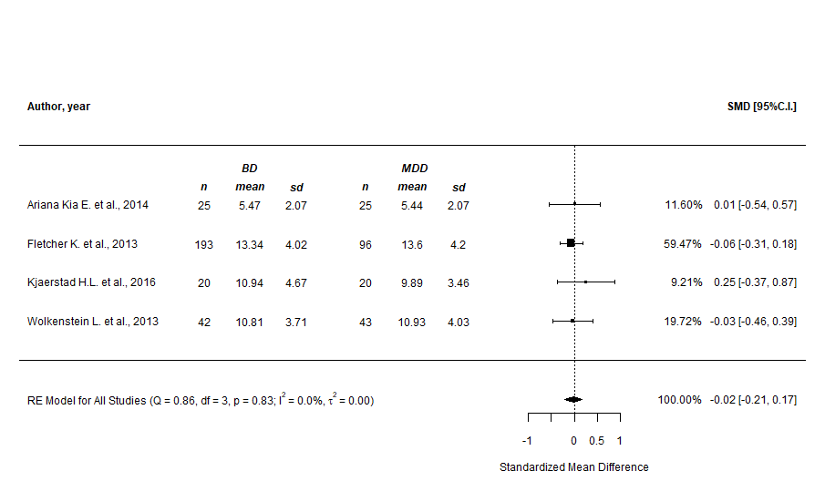
Supplementary Figure n.2 - CERQ “self-blame” subscale (prediction intervals)
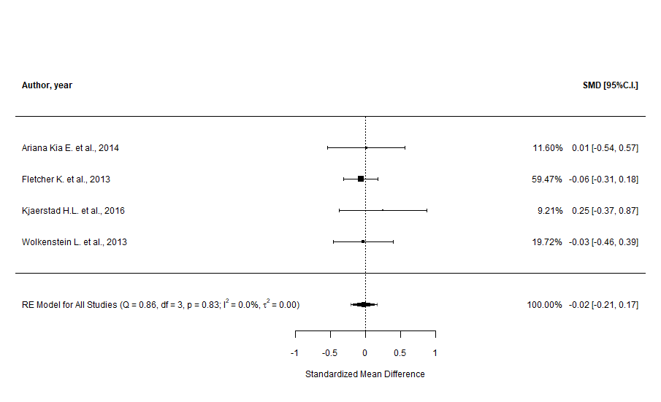
Supplementary Figure n.3 - CERQ “self-blame” subscale (cumulative analysis)
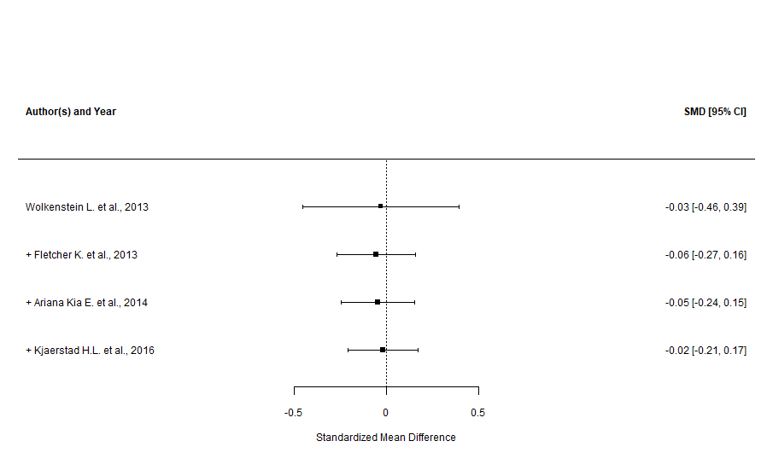

Supplementary Figure n.4 - CERQ “self-blame” subscale (leave-one-out sensitivity analysis)

Supplementary Figure n.5 - CERQ “blaming others” subscale (main analysis)
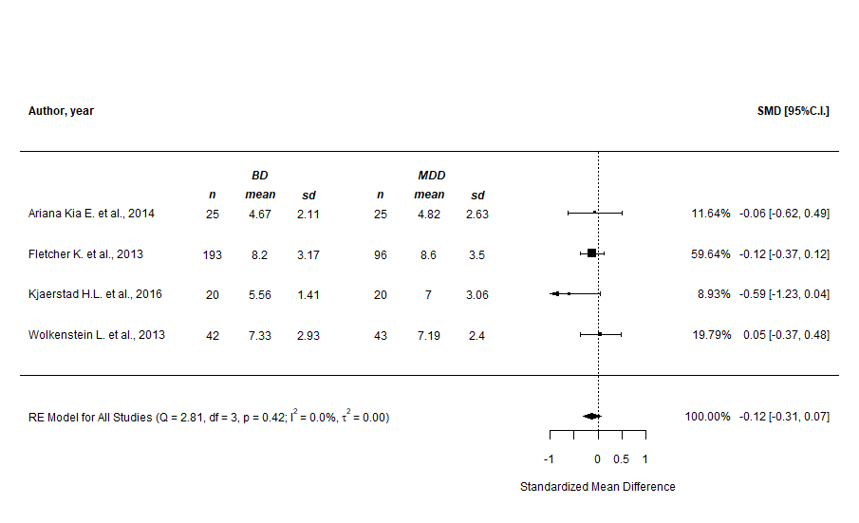

Supplementary Figure n.6 - CERQ “blaming others” subscale (prediction intervals)

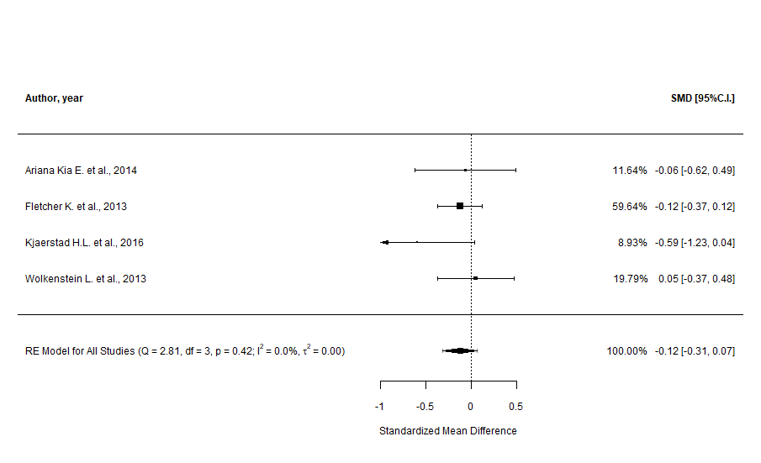
Supplementary Figure n.7 - CERQ “blaming others” subscale (cumulative analysis)
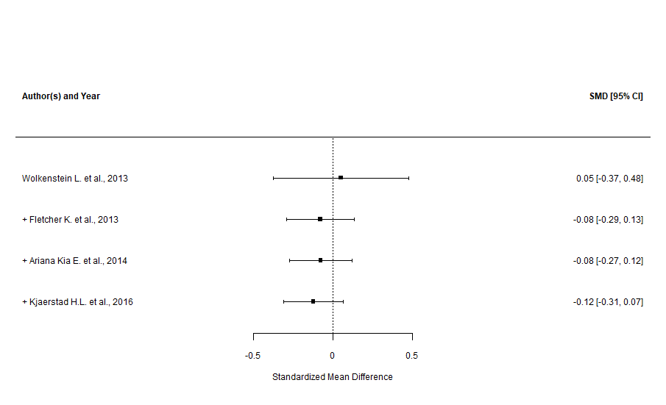

Supplementary Figure n.8 - CERQ “blaming others” subscale (leave-one-out sensitivity analysis)

Supplementary Figure n.9 - CERQ “rumination” subscale (main and subgroup analyses)
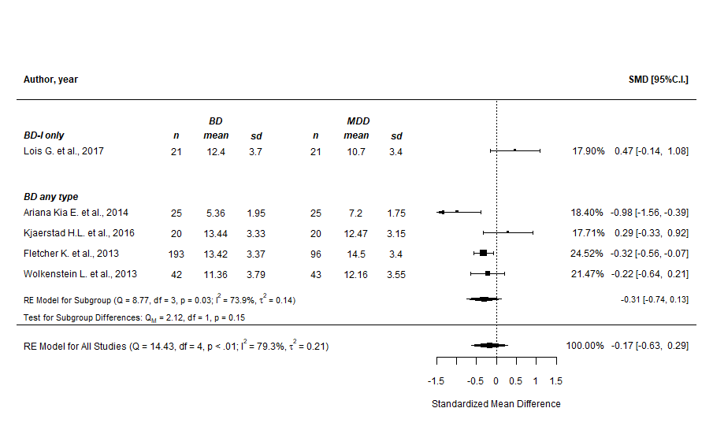
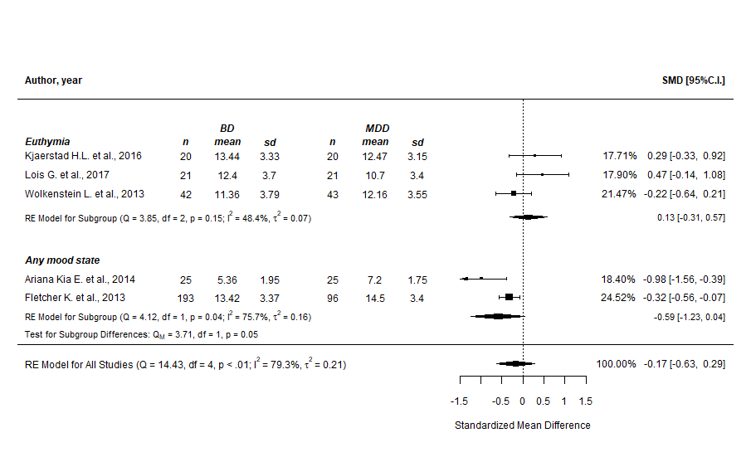

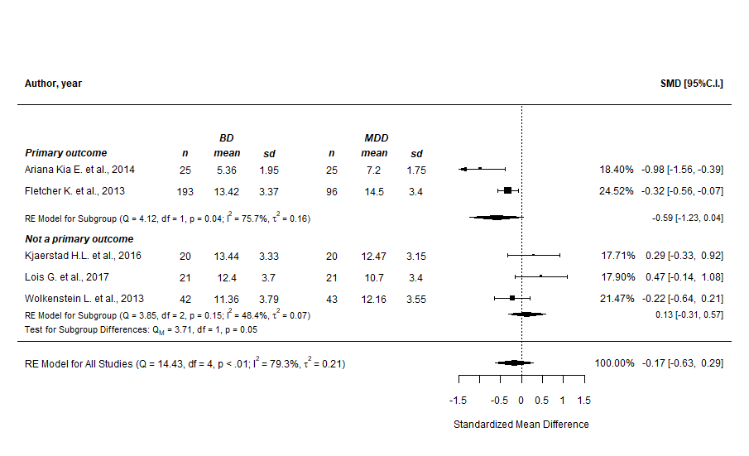

Supplementary Figure n.10 - CERQ “rumination” subscale (prediction intervals)

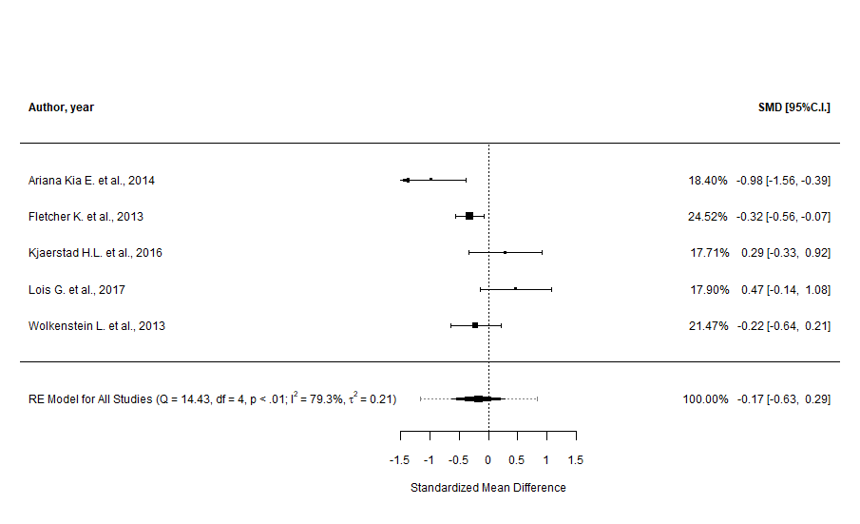

Supplementary Figure n.11 - CERQ “rumination” subscale (cumulative analysis)
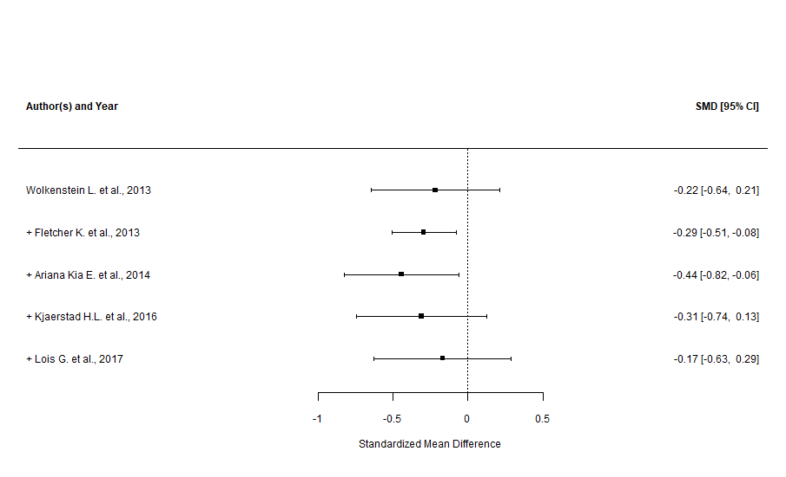

Supplementary Figure n.12 - CERQ “rumination” subscale (leave-one-out sensitivity analysis)

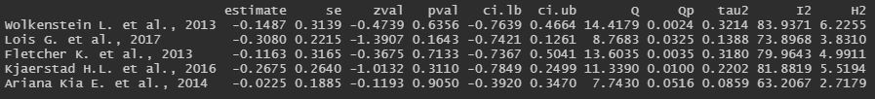

Supplementary Figure n.13 - CERQ “rumination” subscale (GOSH plots, overall and with “Lois G. et al., 2017” highlighted)

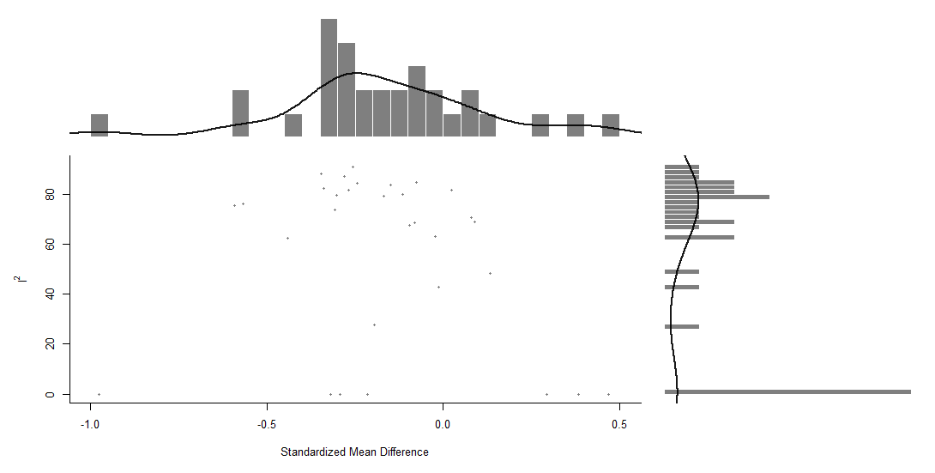

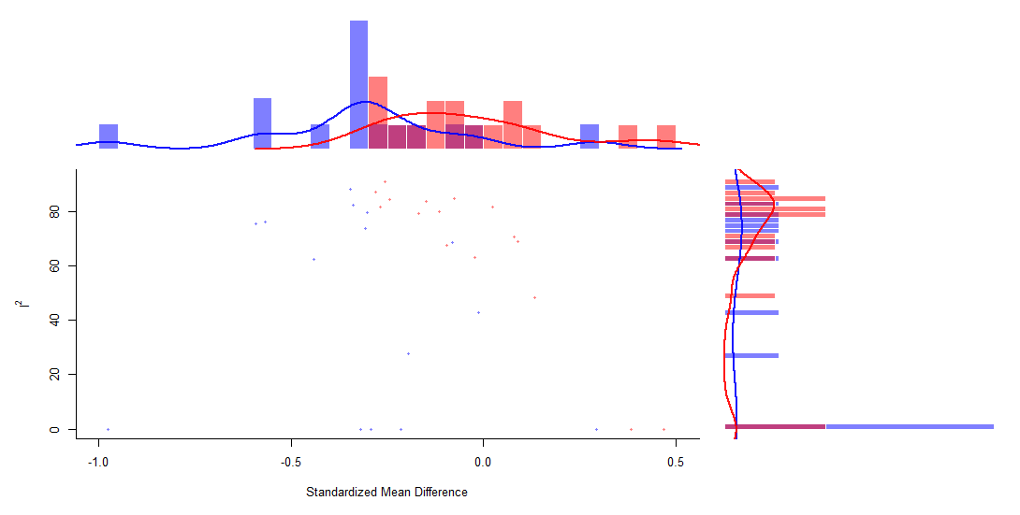

Supplementary Figure n.14 - CERQ “catastrophizing” subscale (main analysis)
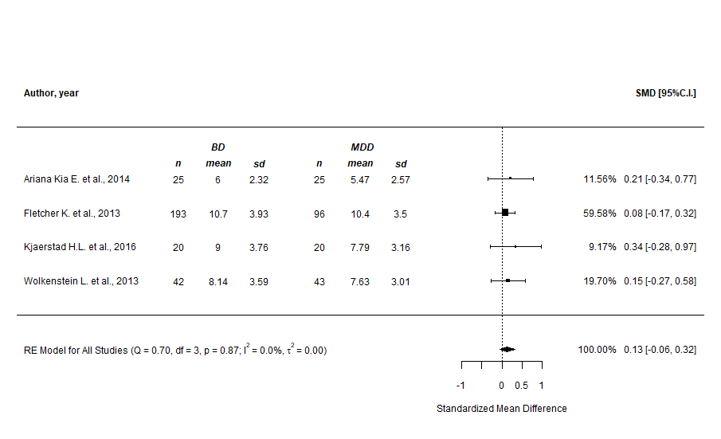

Supplementary Figure n.15 - CERQ “catastrophizing” subscale (prediction intervals)

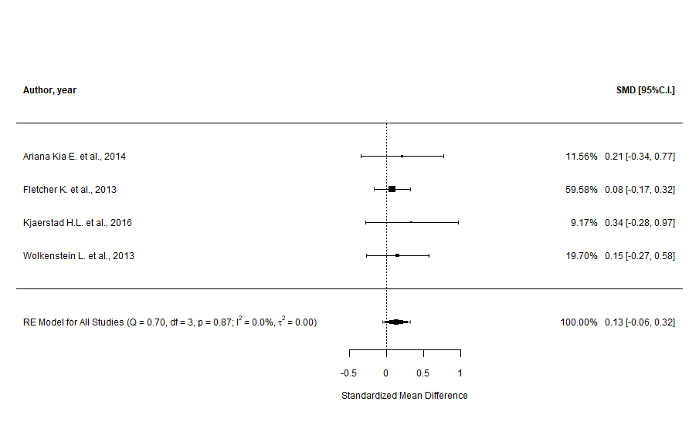
Supplementary Figure n.16 - CERQ “catastrophizing” subscale (cumulative analysis)
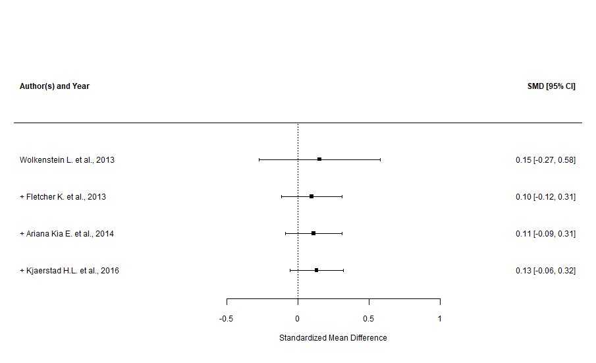

Supplementary Figure n.17 - CERQ “catastrophizing” subscale (leave-one-out sensitivity analysis)

Supplementary Figure n.18 - CERQ “putting into perspective” subscale (main analysis)
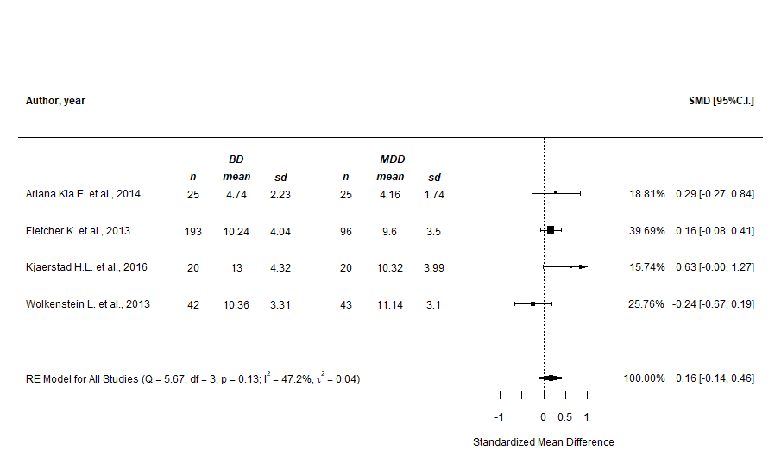

Supplementary Figure n.19 - CERQ “putting into perspective” subscale (prediction intervals)

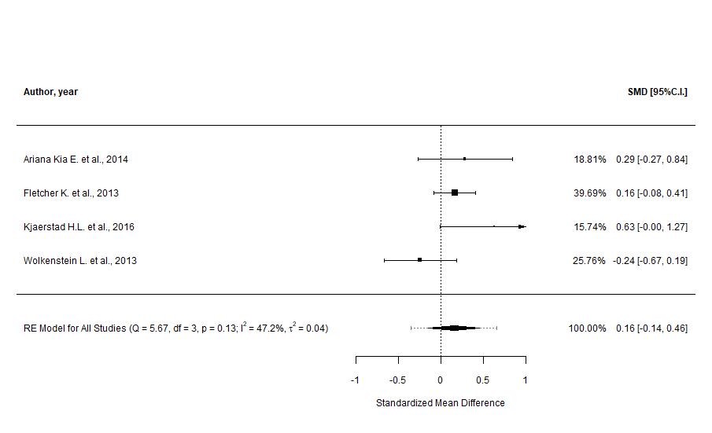
Supplementary Figure n.20 - CERQ “putting into perspective” subscale (cumulative analysis)
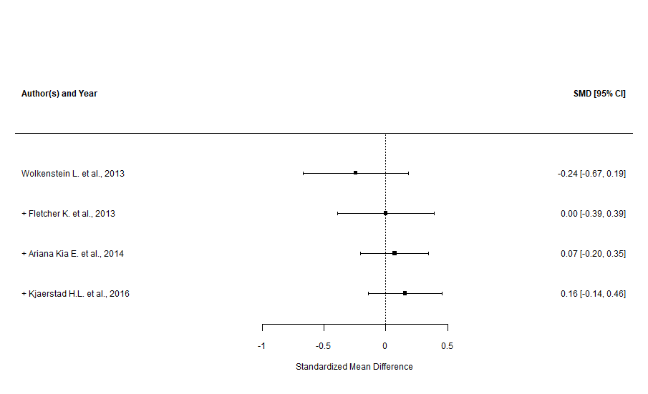

Supplementary Figure n.21 - CERQ “putting into perspective” subscale (leave-one-out sensitivity analysis)

Supplementary Figure n.22 - CERQ “putting into perspective” subscale (GOSH plots, overall and with “Wolkenstein L. et al., 2013” highlighted)
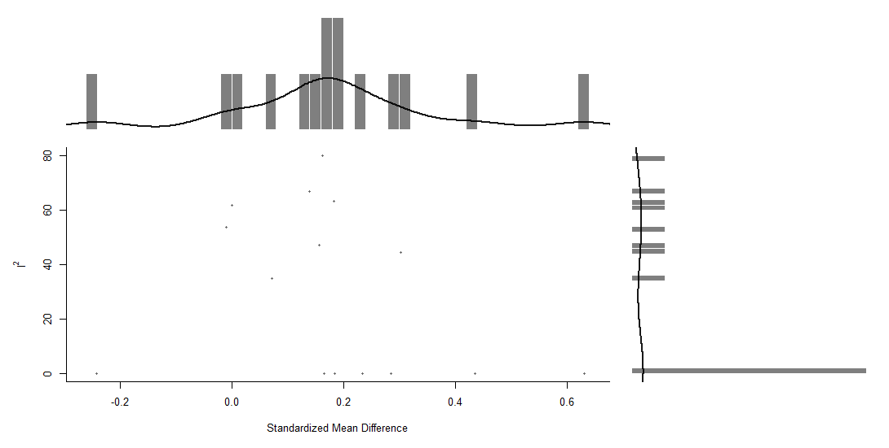

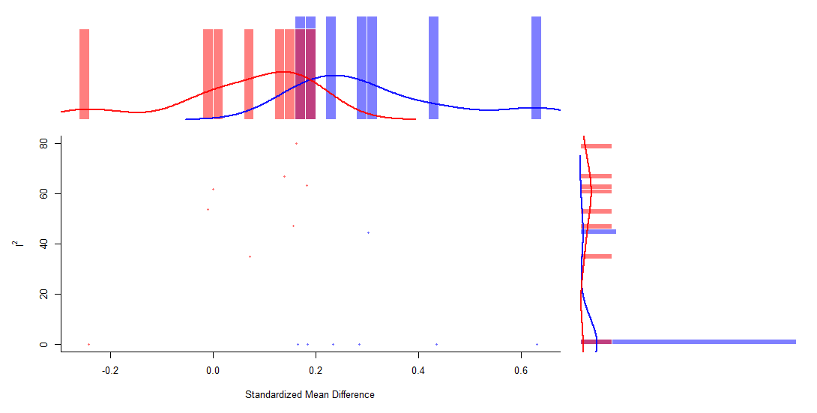

Supplementary Figure n.23 - CERQ “positive refocusing” subscale (main and subgroup analyses)
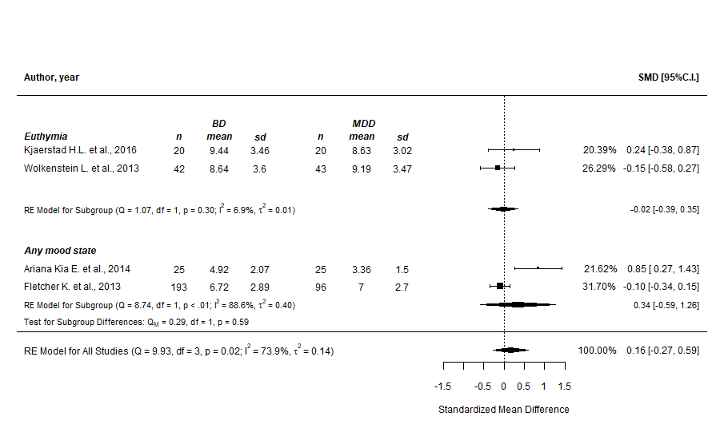
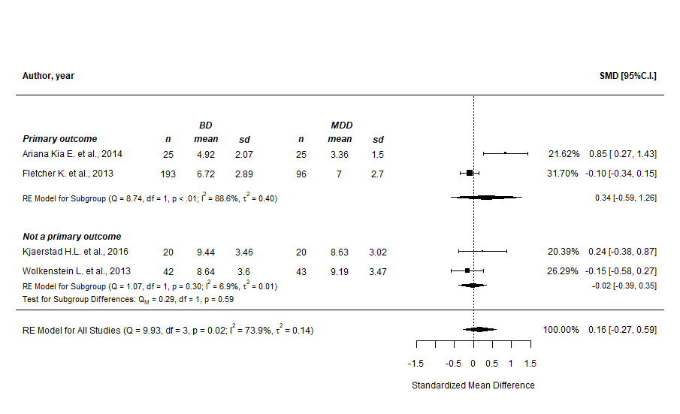

Supplementary Figure n.24 - CERQ “positive refocusing” subscale (prediction intervals)
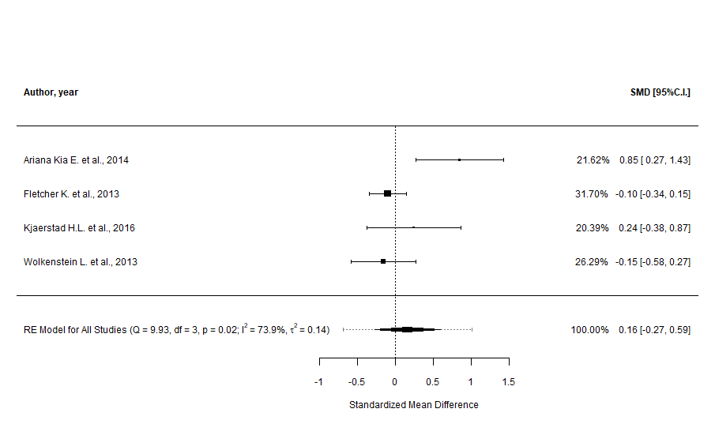

Supplementary Figure n.25 - CERQ “positive refocusing” subscale (cumulative analysis)
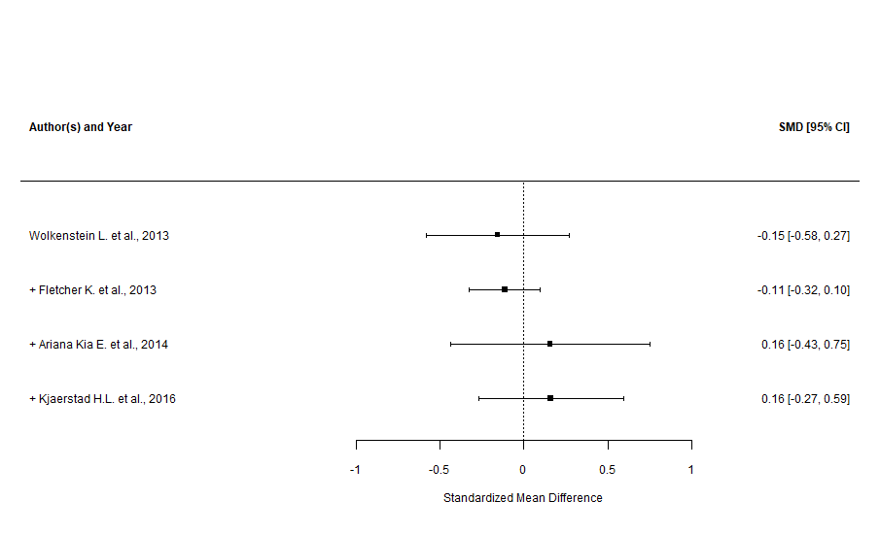

Supplementary Figure n.26 - CERQ “positive refocusing” subscale (leave-one-out sensitivity analysis)
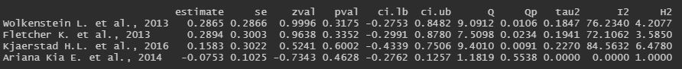

Supplementary Figure n.27 - CERQ “positive refocusing” subscale (GOSH plots, overall and with “Ariana Kia E. et al., 2014” highlighted)

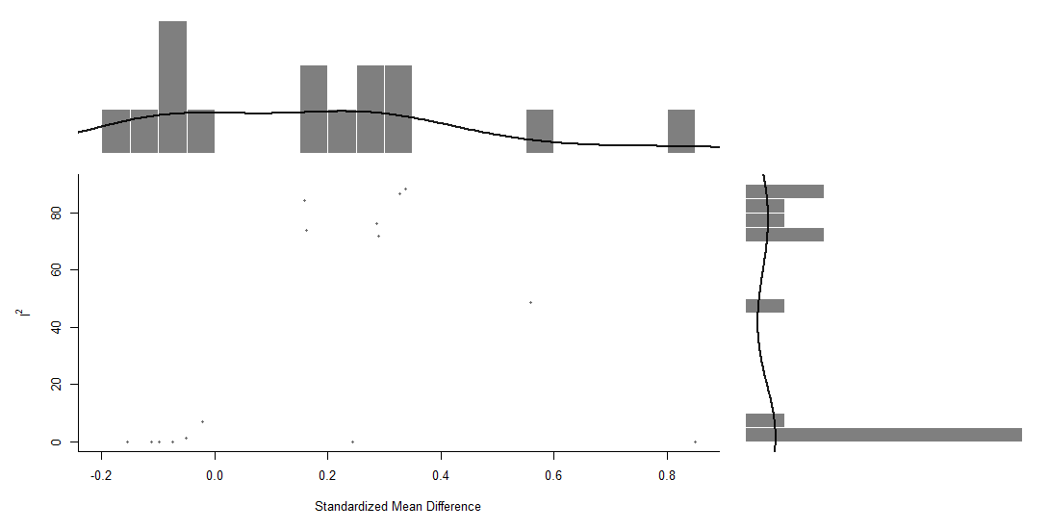
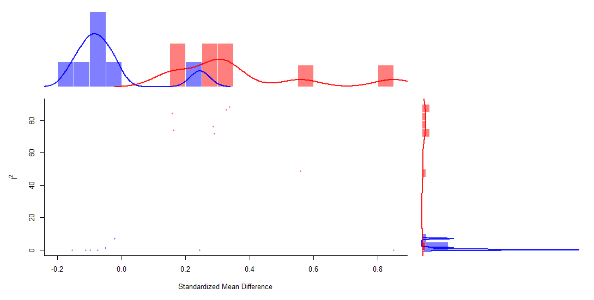

Supplementary Figure n.28 - CERQ “positive reappraisal” subscale (main analysis)
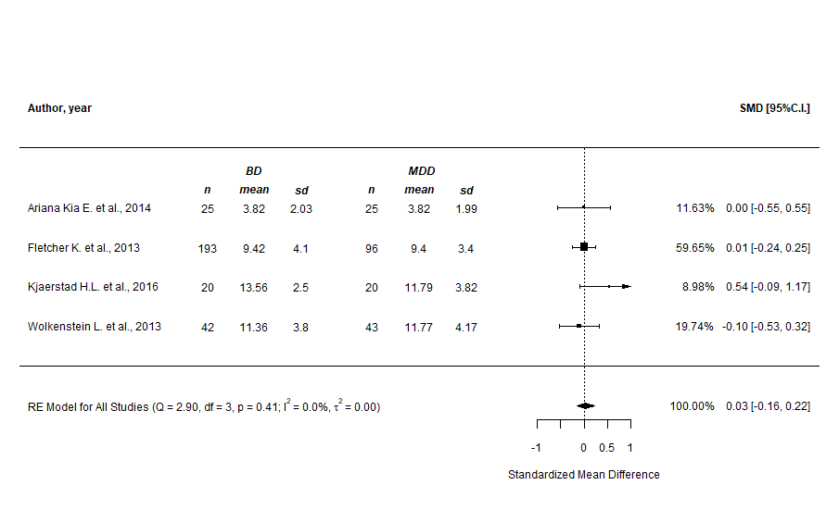

Supplementary Figure n.29 - CERQ “positive reappraisal” subscale (prediction intervals)
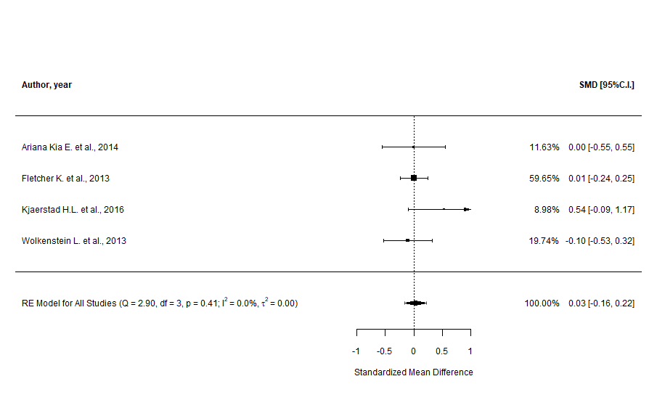

Supplementary Figure n.30 - CERQ “positive reappraisal” subscale (cumulative analysis)
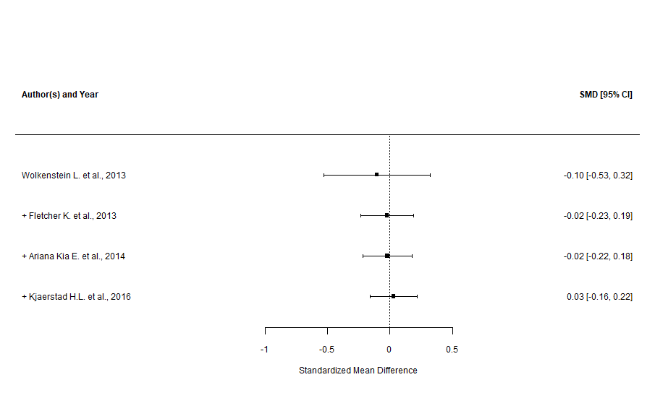

Supplementary Figure n.31 - CERQ “positive reappraisal” subscale (leave-one-out sensitivity analysis)

Supplementary Figure n.32 - CERQ “acceptance” subscale (main analysis)
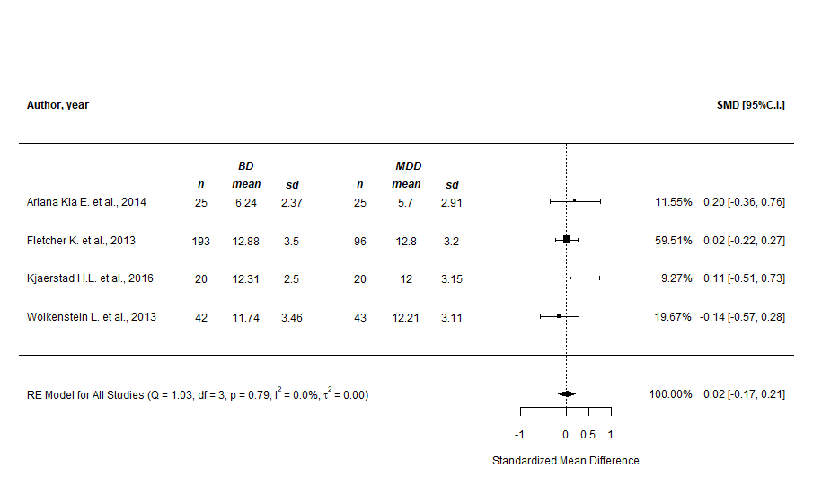

Supplementary Figure n.33 - CERQ “acceptance” subscale (prediction intervals)

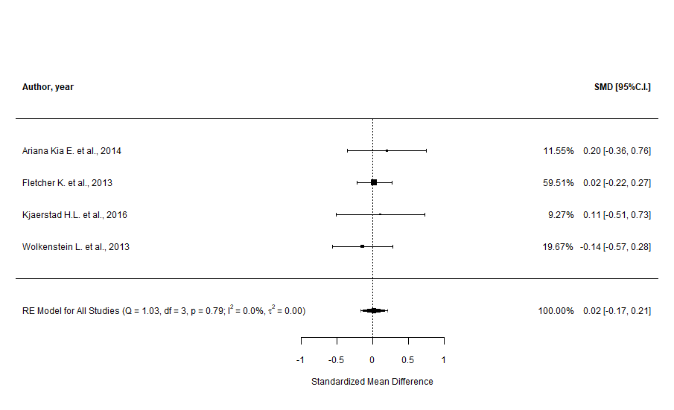
Supplementary Figure n.34 - CERQ “acceptance” subscale (cumulative analysis)
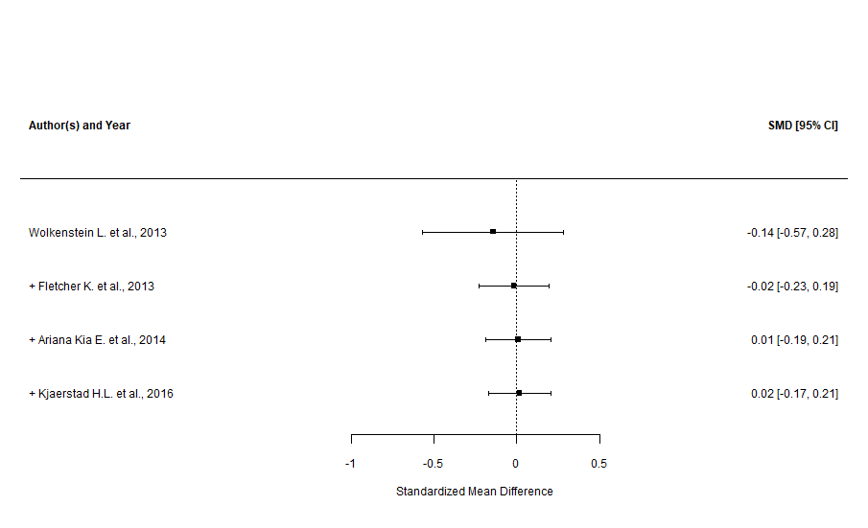

Supplementary Figure n.35 - CERQ “acceptance” subscale (leave-one-out sensitivity analysis)

Supplementary Figure n.36 - CERQ “refocus on planning” subscale (main analysis)
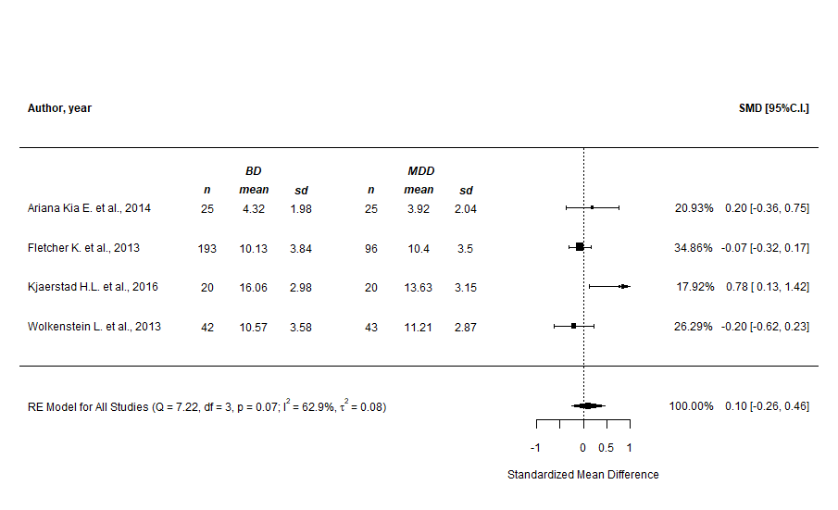

Supplementary Figure n.37 - CERQ “refocus on planning” subscale (prediction intervals)
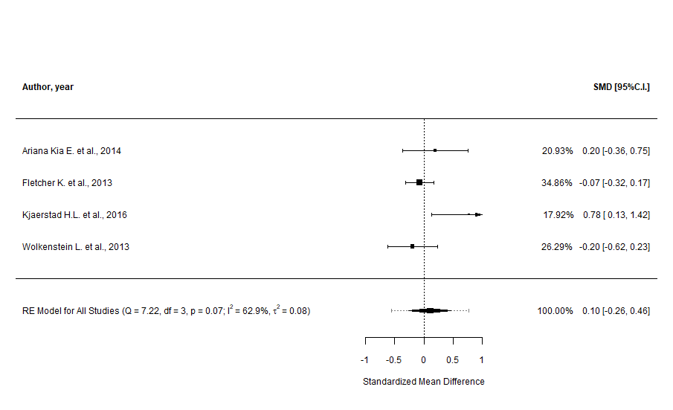

Supplementary Figure n.38 - CERQ “refocus on planning” subscale (cumulative analysis)
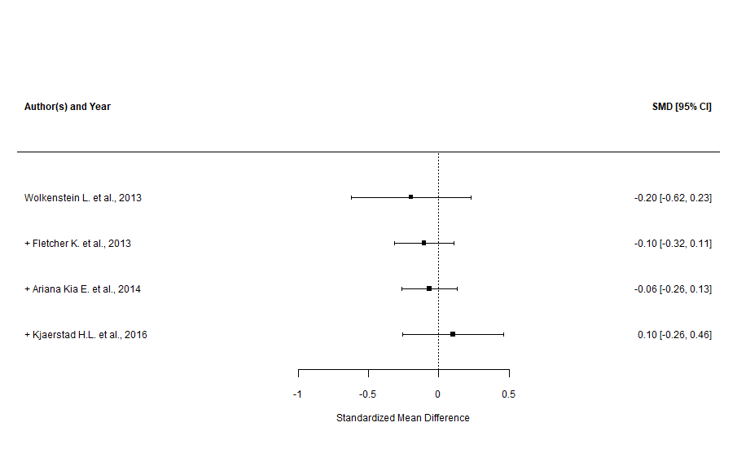

Supplementary Figure n.39 - CERQ “refocus on planning” subscale (leave-one-out sensitivity analysis)

Supplementary Figure n.40 - CERQ “refocus on planning” subscale (GOSH plots, overall and with “Kjaerstad H.L. et al., 2016” highlighted)

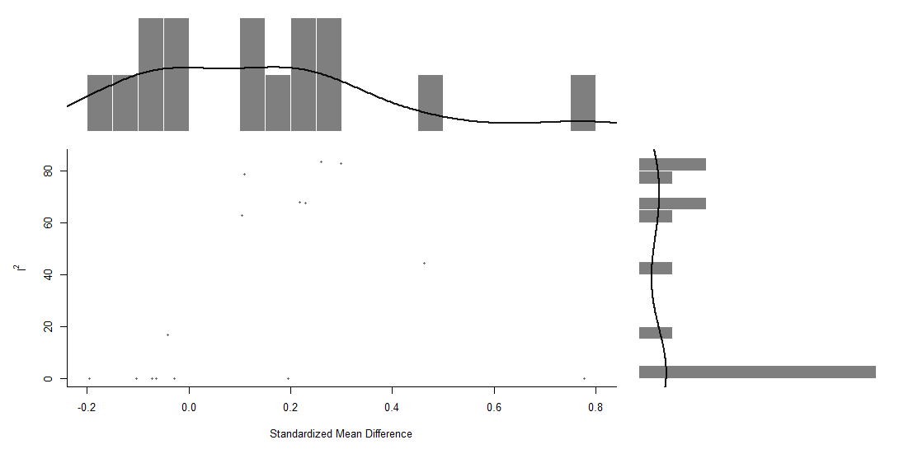
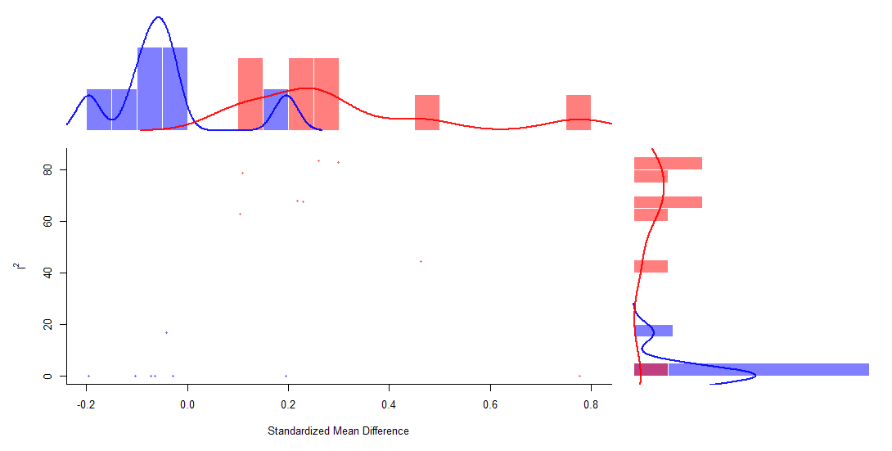

Difficulties in Emotion Regulation Scale, DERS (main, subgroup, cumulative, and sensitivity analyses)

Supplementary Figure n.41 - DERS “total” score (main and subgroup analyses)
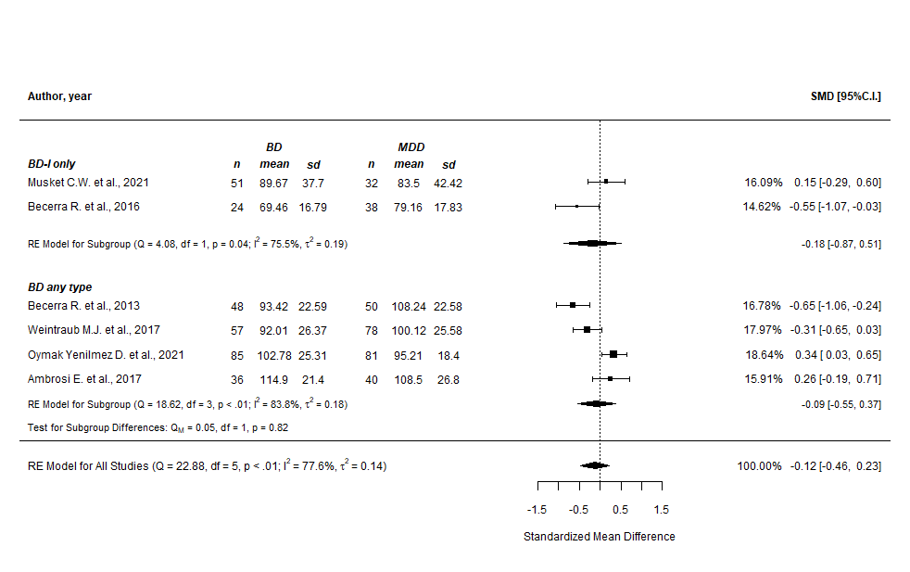
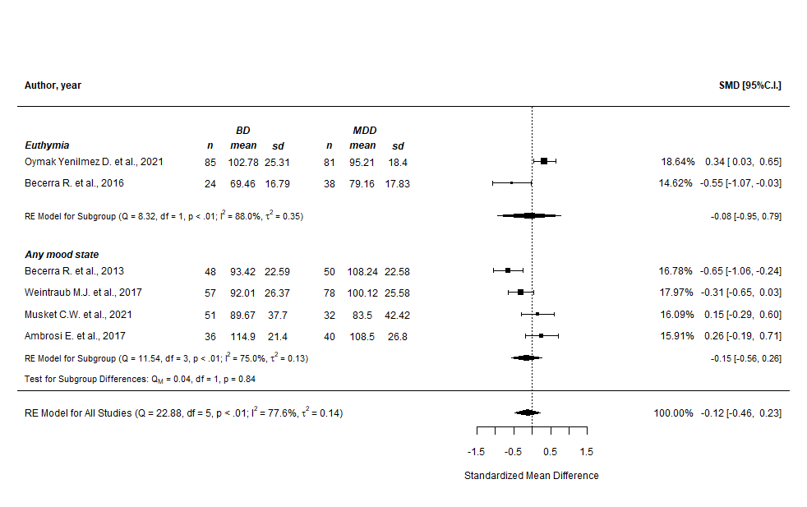
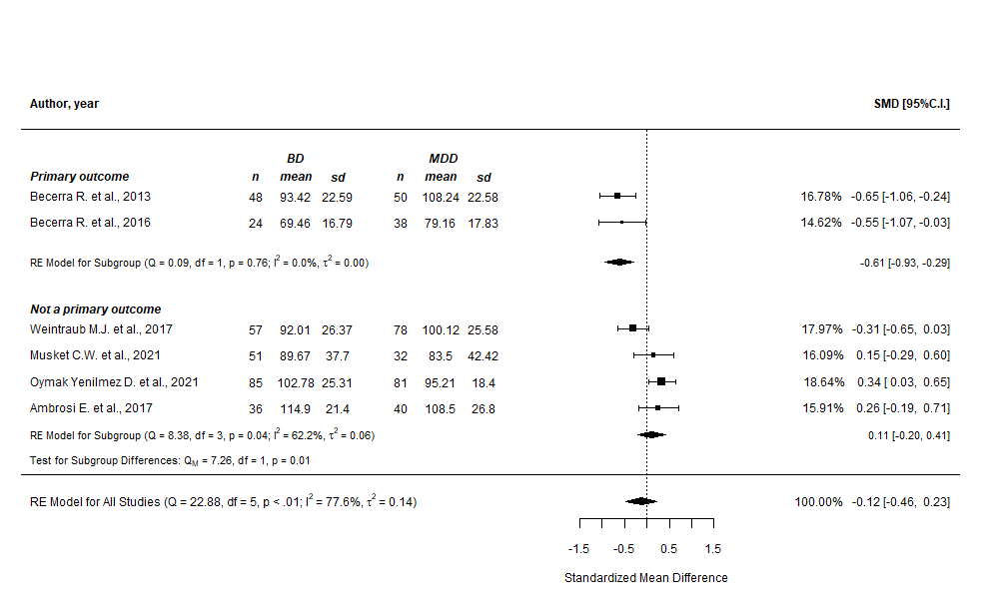

Supplementary Figure n.42 - DERS “total” score (prediction intervals)
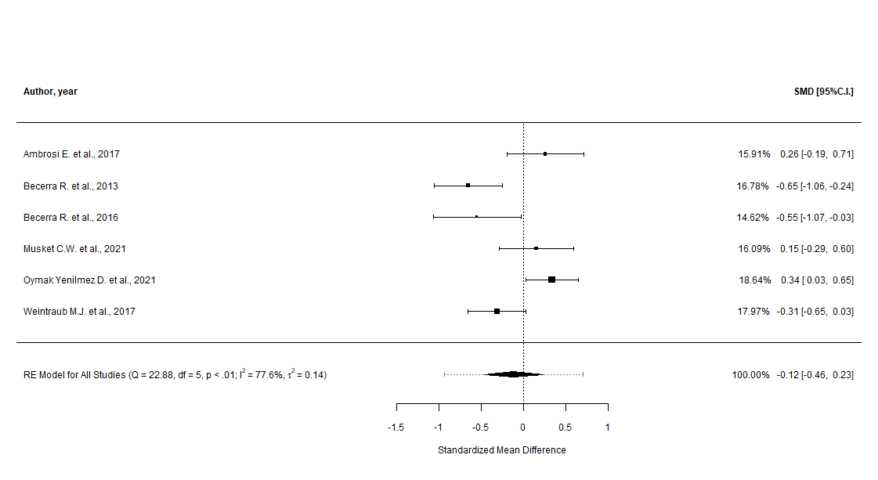

Supplementary Figure n.43 - DERS “total” score (cumulative analysis)
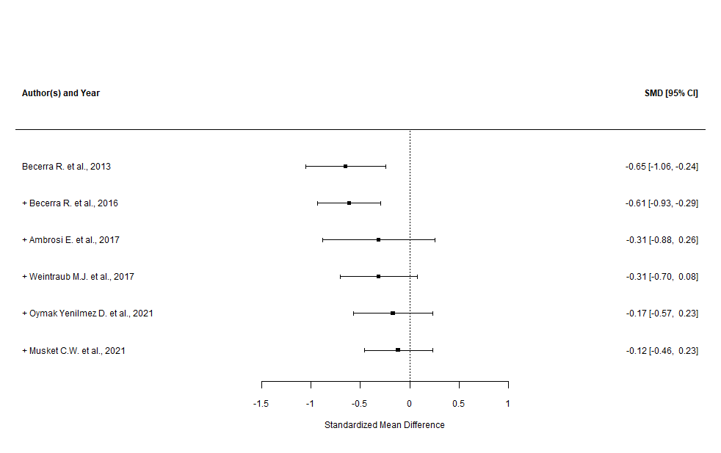
Supplementary Figure n.44 - DERS “total” score (leave-one-out and good quality only sensitivity analysis)

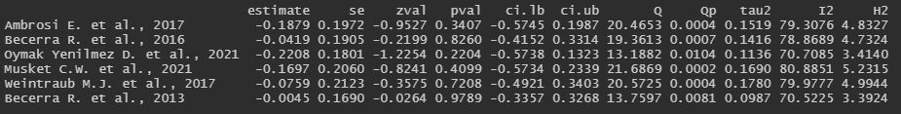

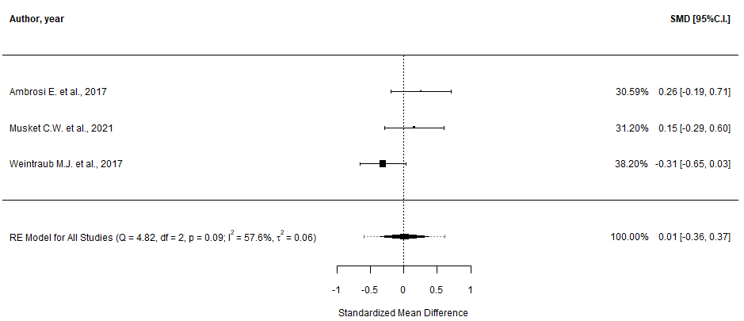
Supplementary Figure n.45 - DERS “total” score (GOSH plot)

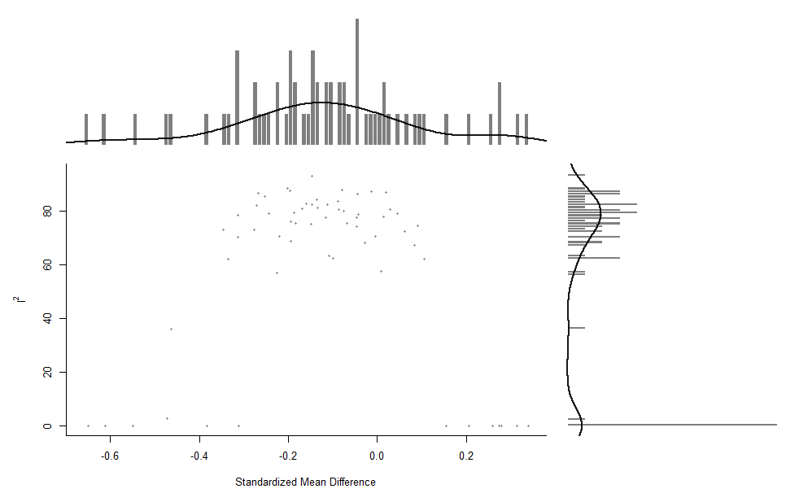

Supplementary Figure n.46 - DERS “non acceptance” subscale (main and subgroup analyses)
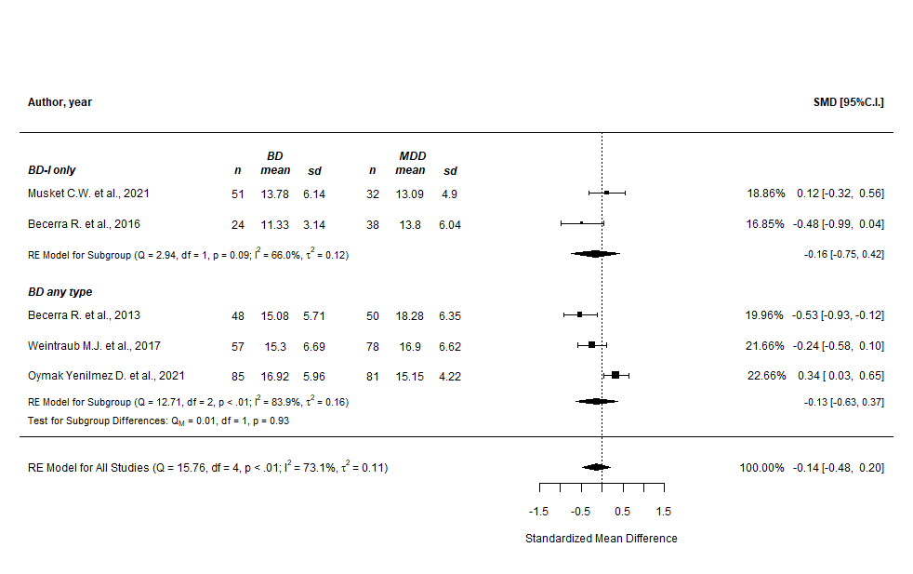
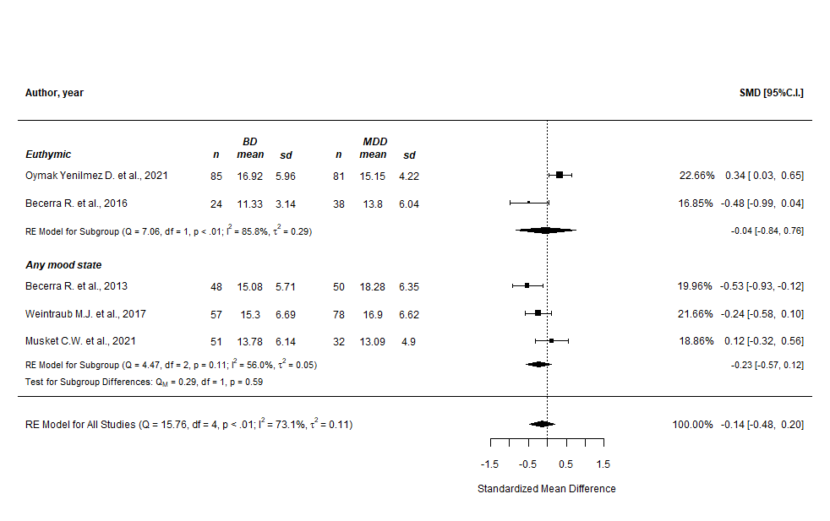
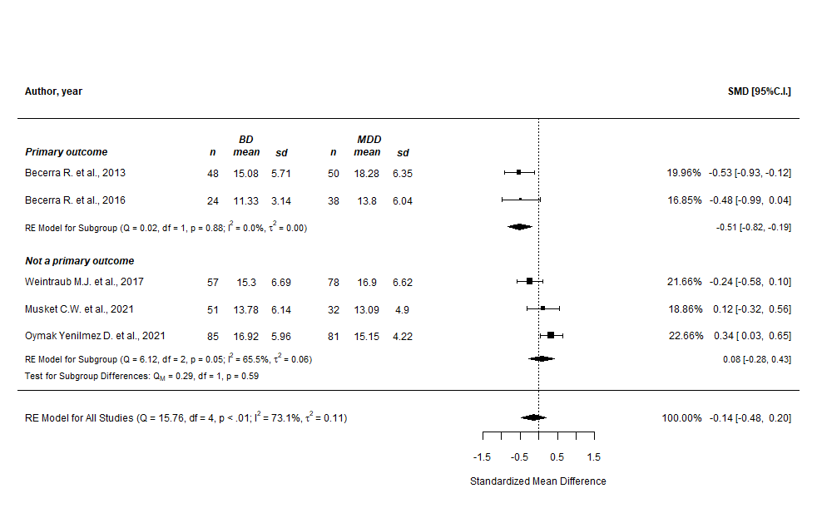

Supplementary Figure n.47 - DERS “non acceptance” subscale (prediction intervals)
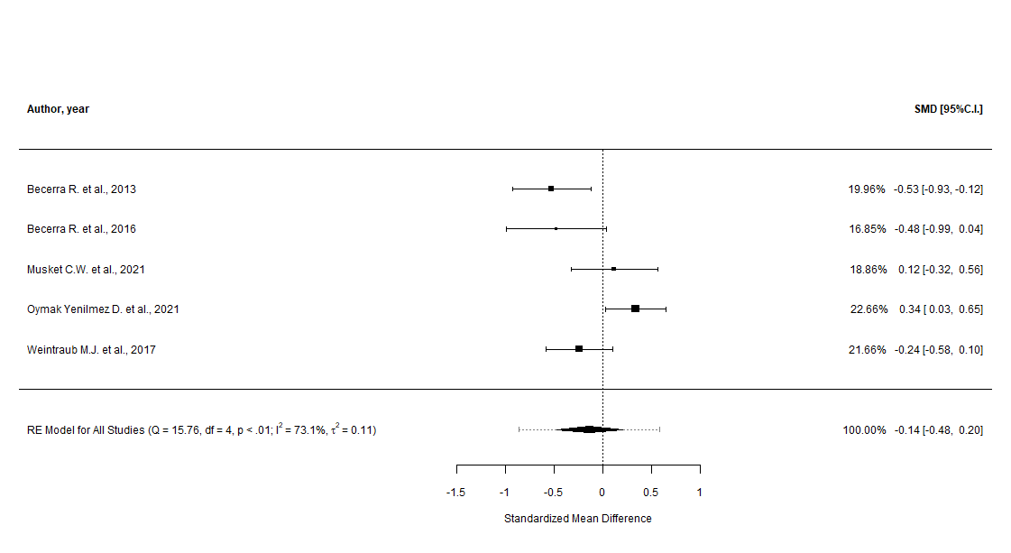

Supplementary Figure n.48 - DERS “non acceptance” subscale (cumulative analysis)
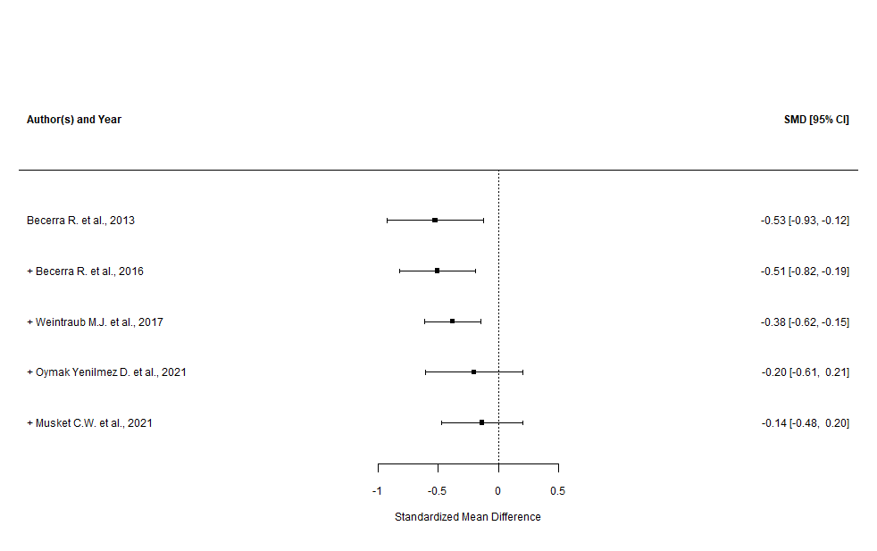

Supplementary Figure n.49 - DERS “non acceptance” subscale (leave-one-out and good quality only sensitivity analysis)
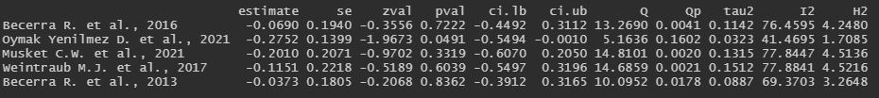

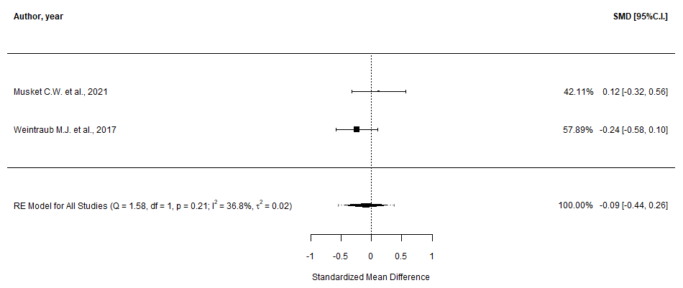

Supplementary Figure n.50 - DERS “non acceptance” subscale (GOSH plots, overall and with “Oymak Y.D. et al., 2021” highlighted)
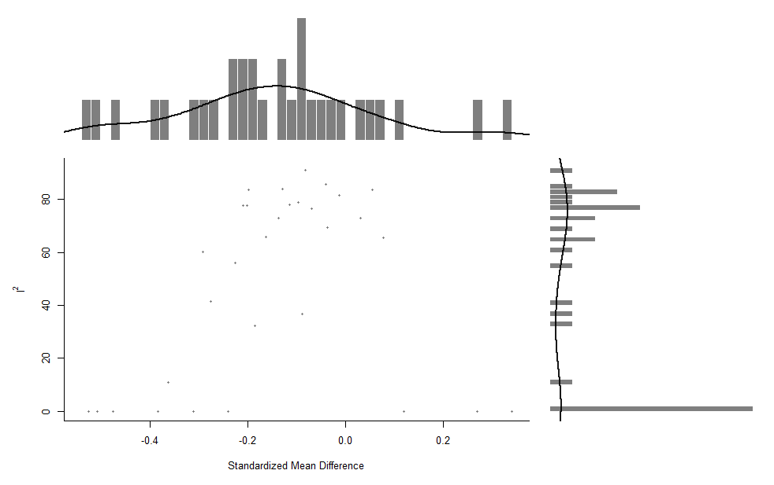
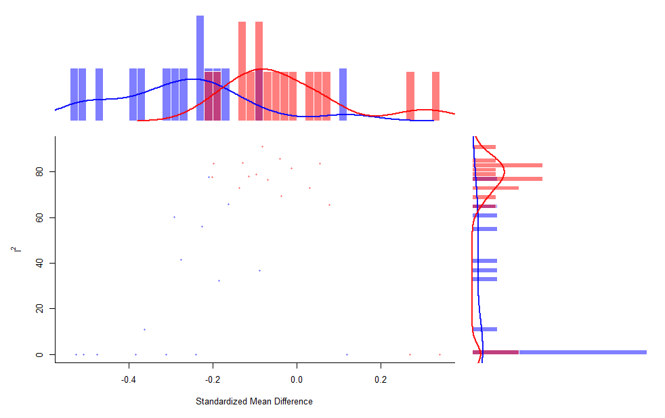
Supplementary Figure n.51 - DERS “goals” subscale (main and subgroup analyses)
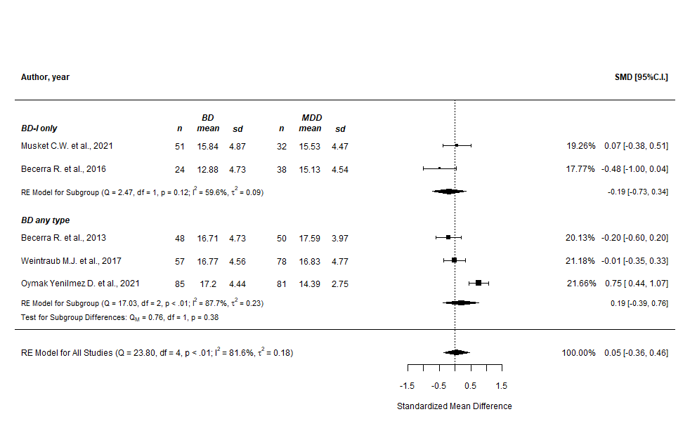
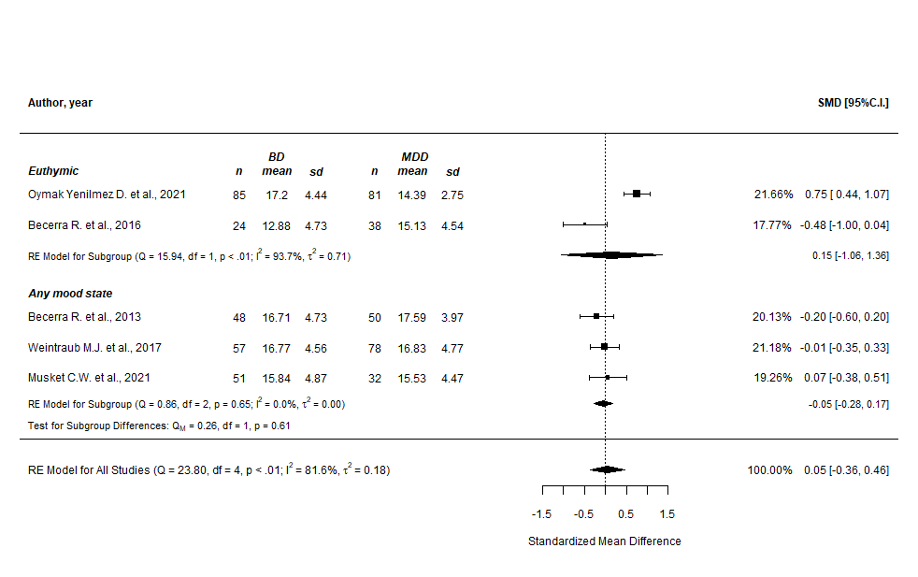

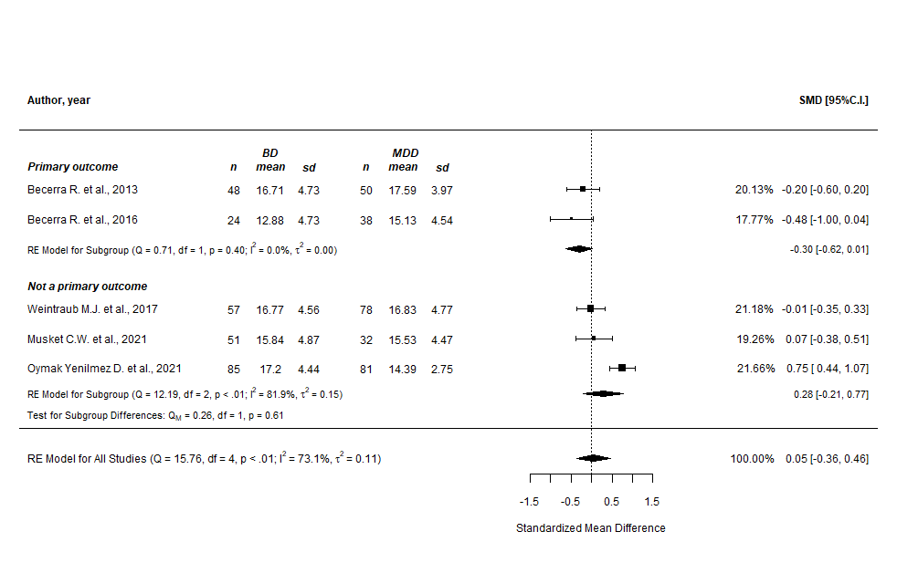

Supplementary Figure n.52 - DERS “goals” subscale (prediction intervals)
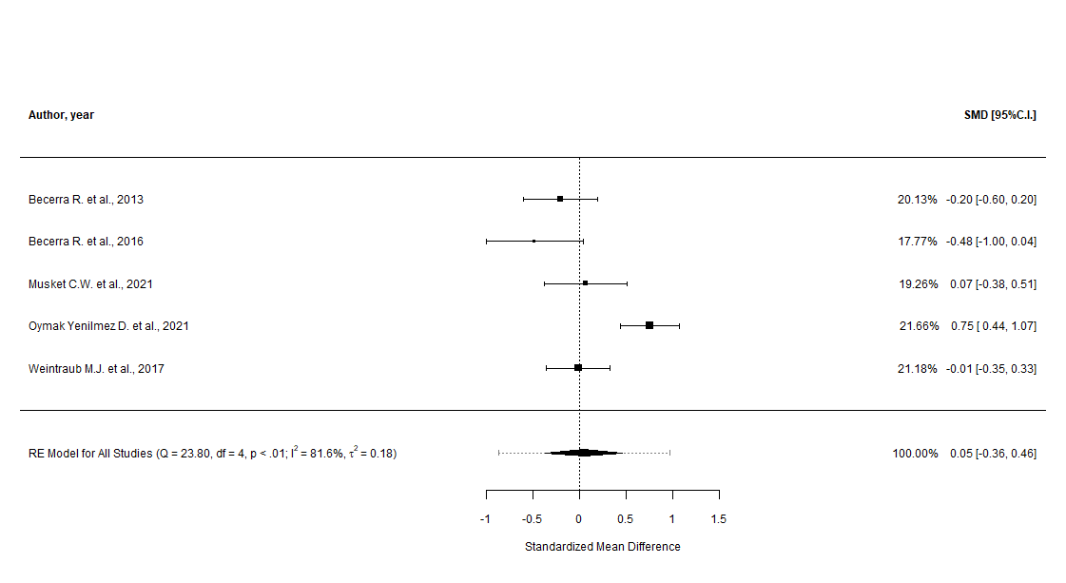

Supplementary Figure n.53 - DERS “goals” subscale (cumulative analysis)
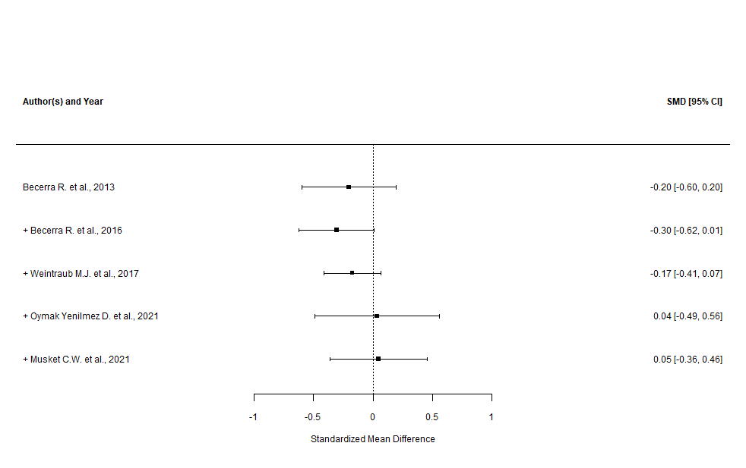

Supplementary Figure n.54 - DERS “goals” subscale (leave-one-out and good quality only sensitivity analysis)

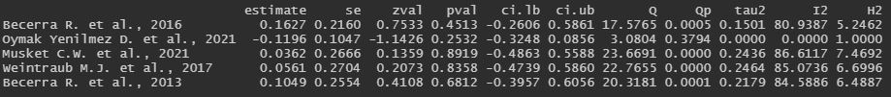
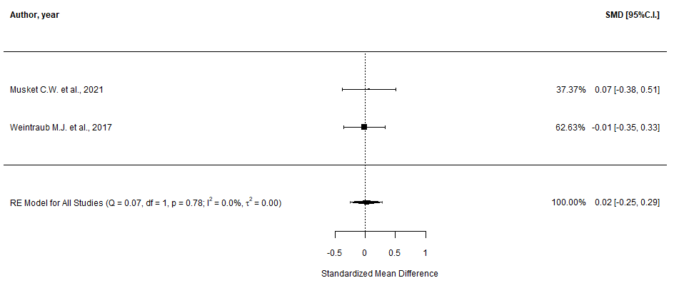

Supplementary Figure n.55 - DERS “goals” subscale (GOSH plots, overall and with “Oymak Y.D. et al., 2021” highlighted)

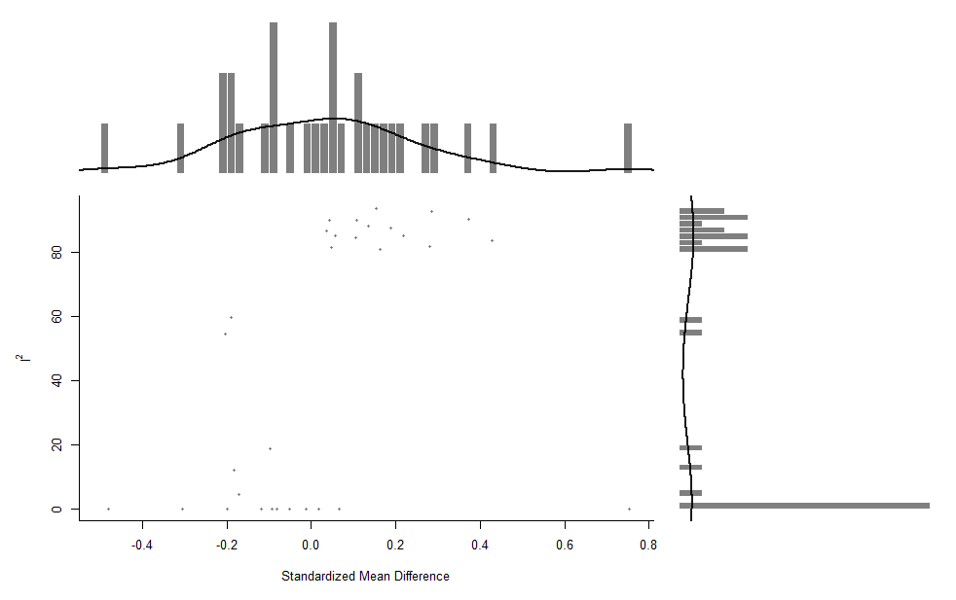
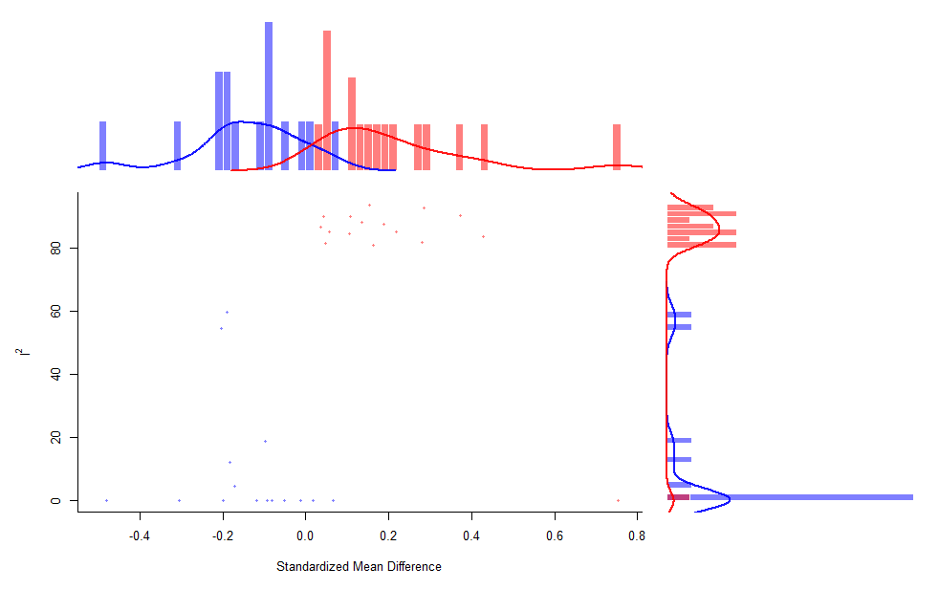

Supplementary Figure n.56 - DERS “impulse” subscale (main and subgroup analyses)
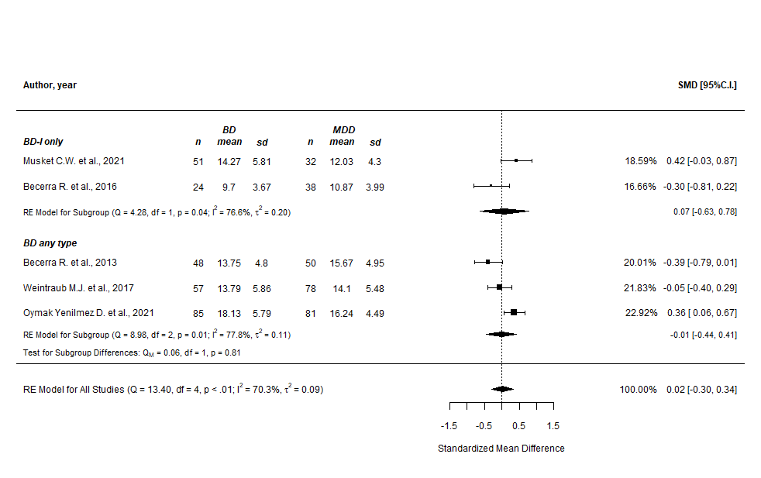
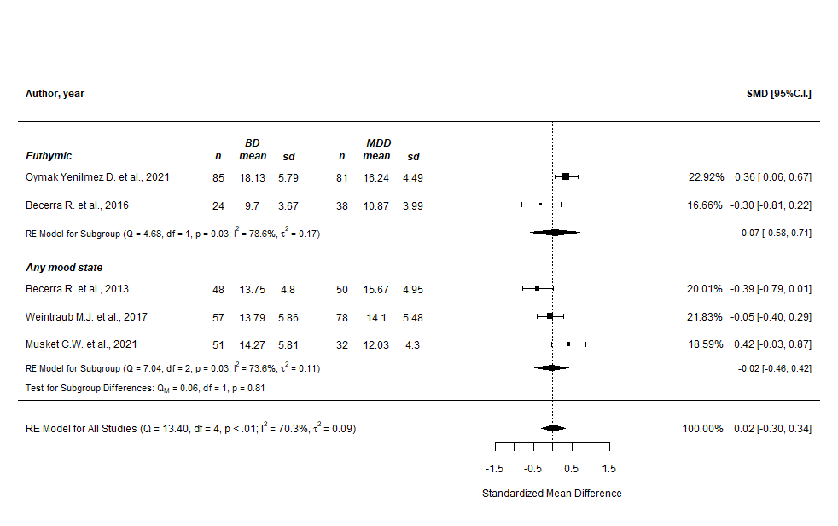

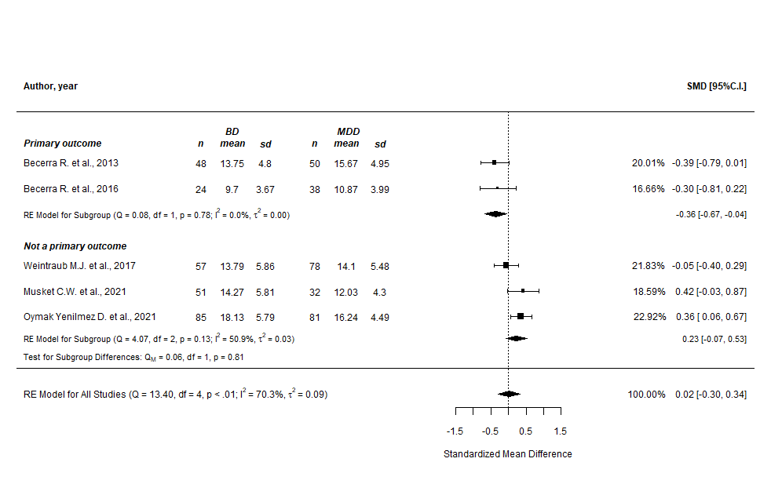

Supplementary Figure n.57 - DERS “impulse” subscale (prediction intervals)

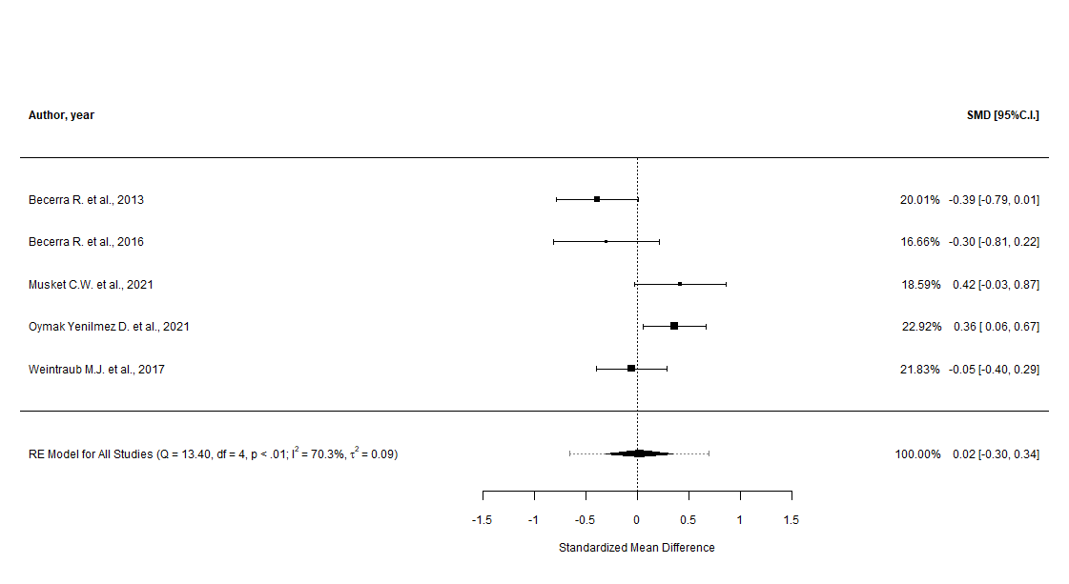

Supplementary Figure n.58 - DERS “impulse” subscale (cumulative analysis)
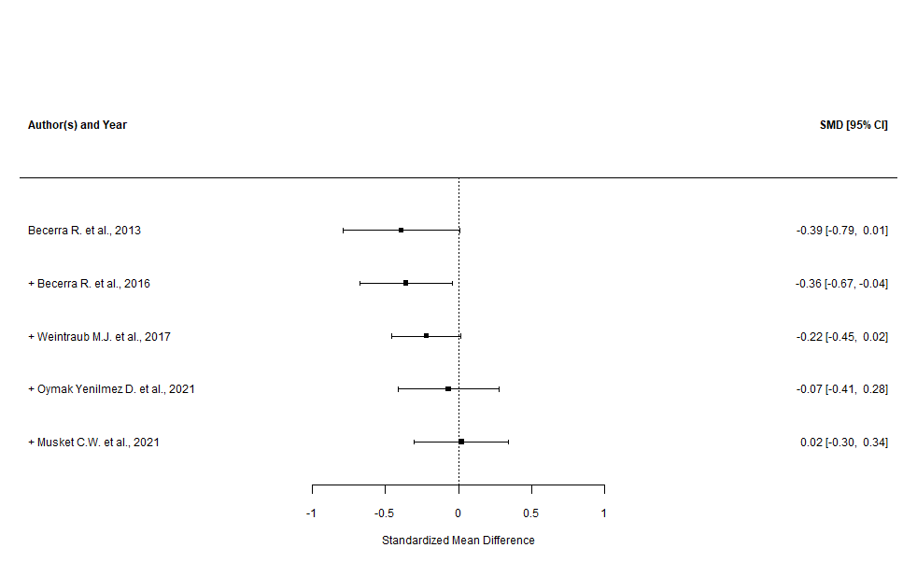

Supplementary Figure n.59 - DERS “impulse” subscale (leave-one-out and good quality only sensitivity analysis)

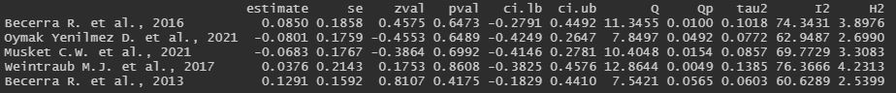

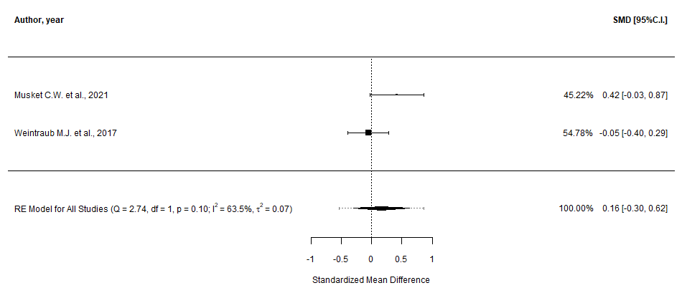
Supplementary Figure n.60 - DERS “impulse” subscale (GOSH plot)

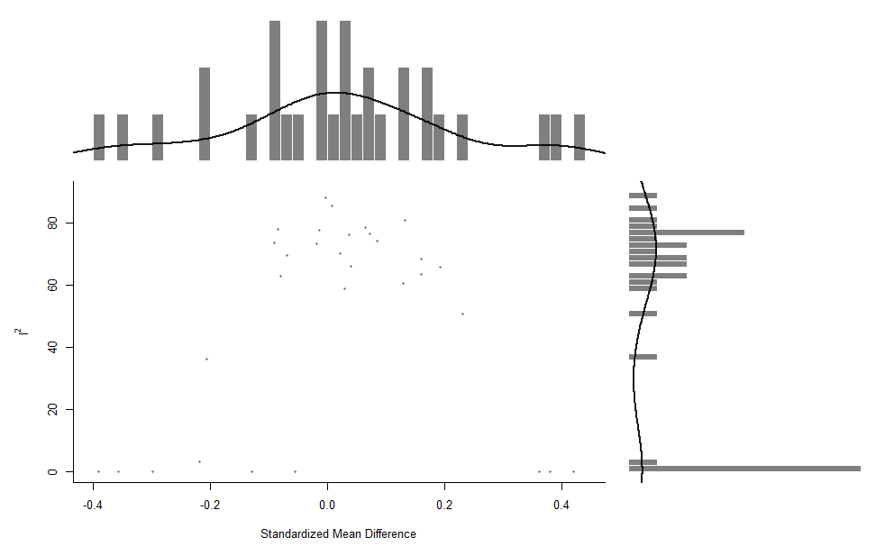

Supplementary Figure n.61 - DERS “awareness” subscale (main and subgroup analyses)
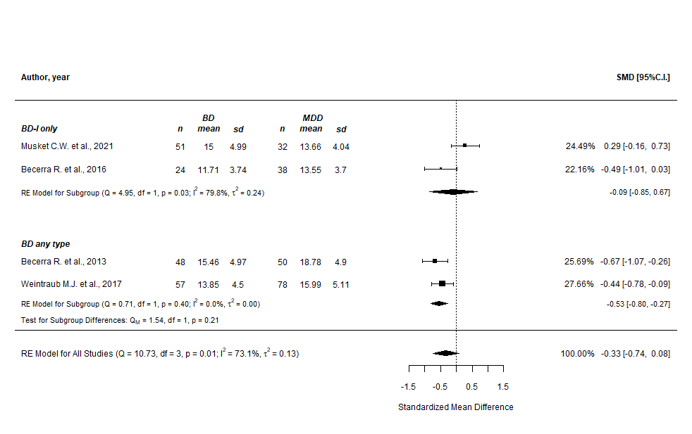
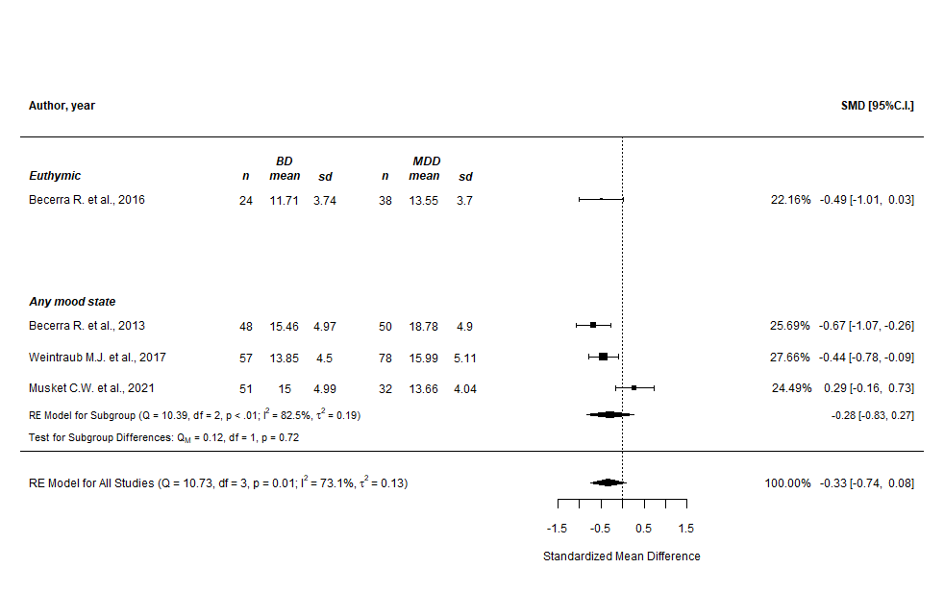
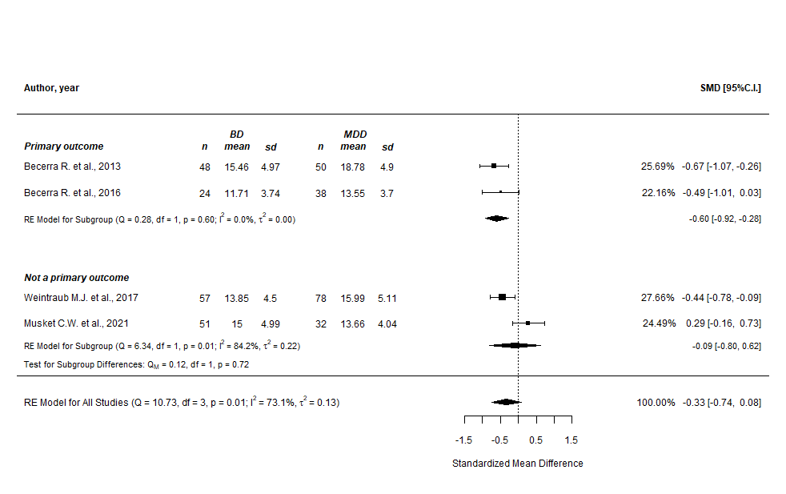

Supplementary Figure n.62 - DERS “awareness” subscale (prediction intervals)
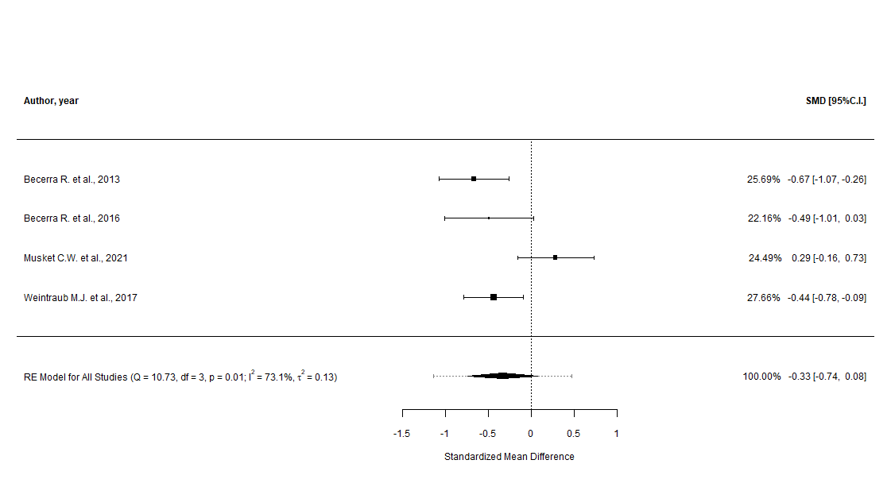

Supplementary Figure n.63 - DERS “awareness” subscale (cumulative analysis)
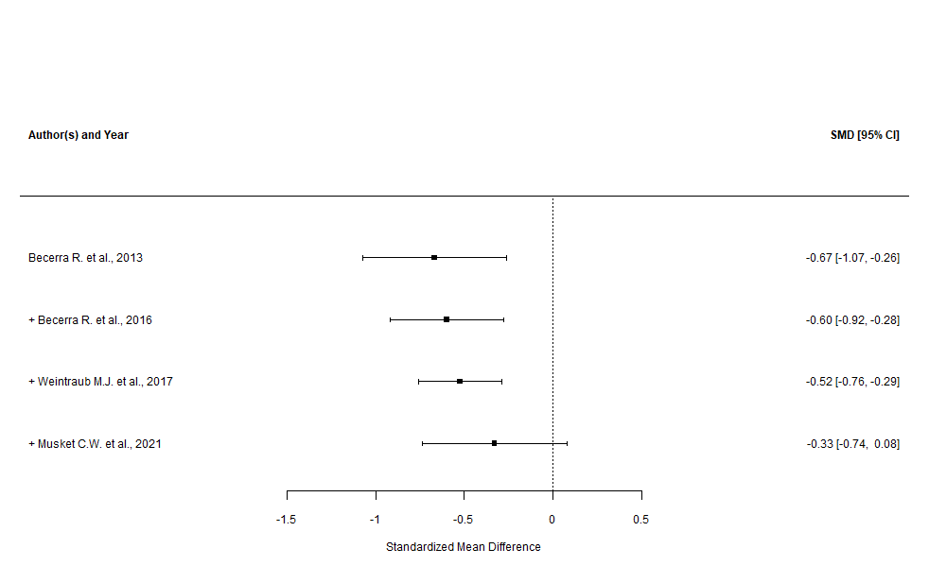

Supplementary Figure n.64 - DERS “awareness” subscale (leave-one-out and good quality only sensitivity analysis)

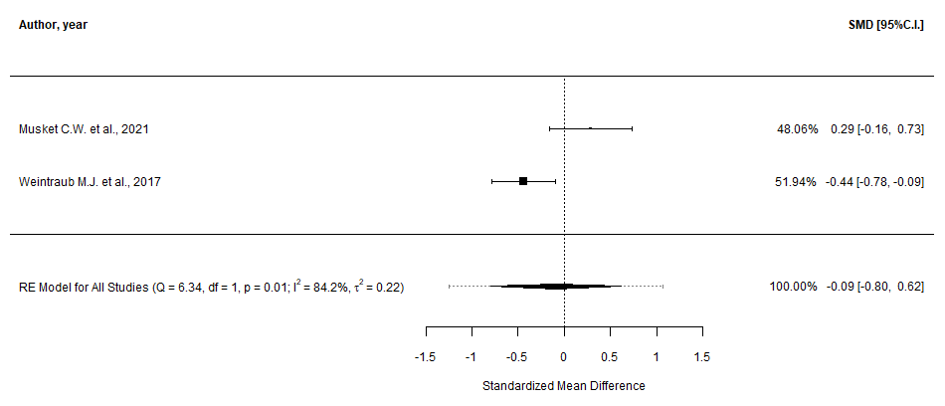
Supplementary Figure n.65 - DERS “awareness” subscale (GOSH plots, overall and with “Musket C.W. et al., 2021” highlighted)

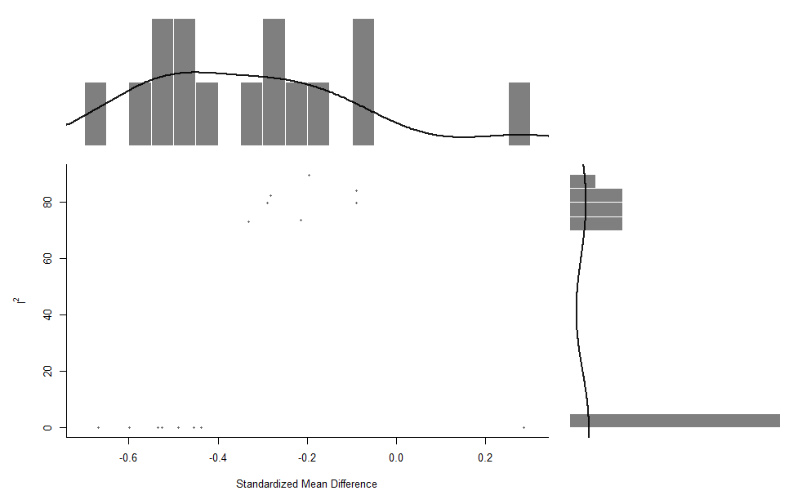
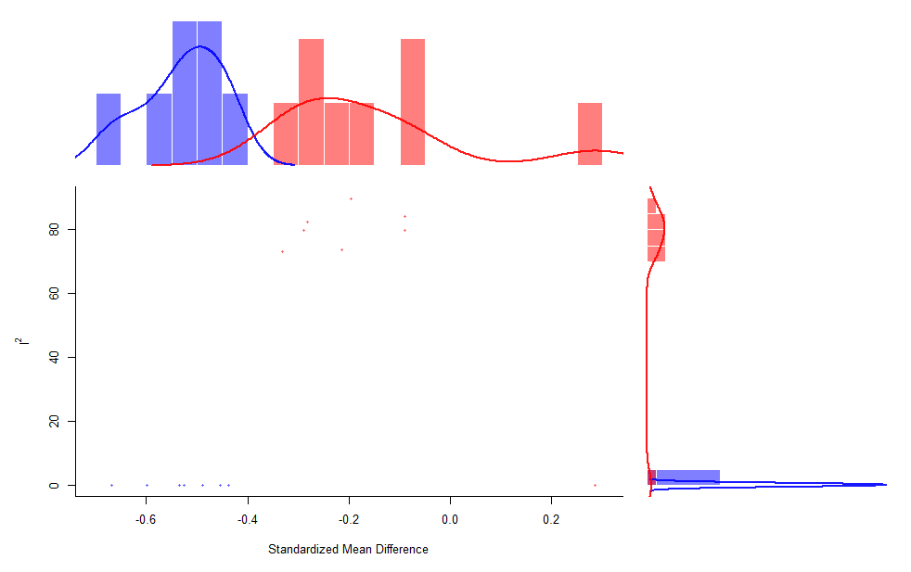

Supplementary Figure n.66 - DERS “strategies” subscale (main and subgroup analyses)
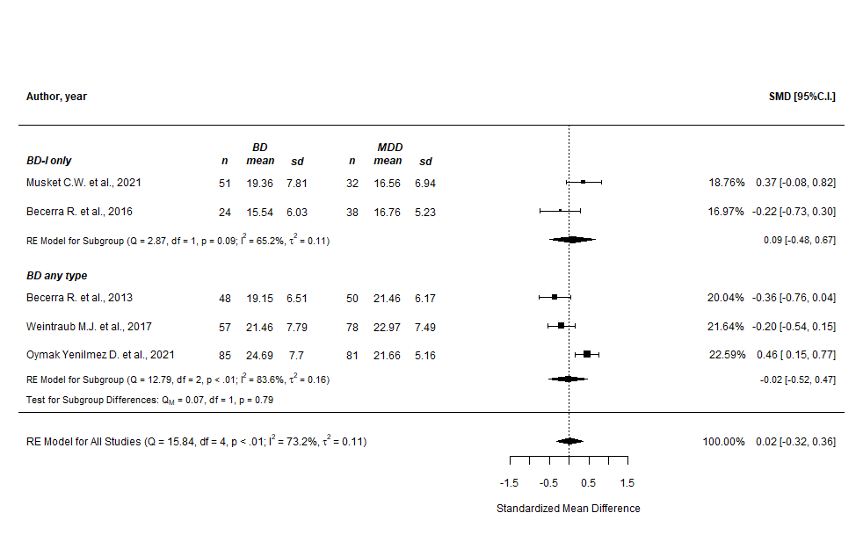
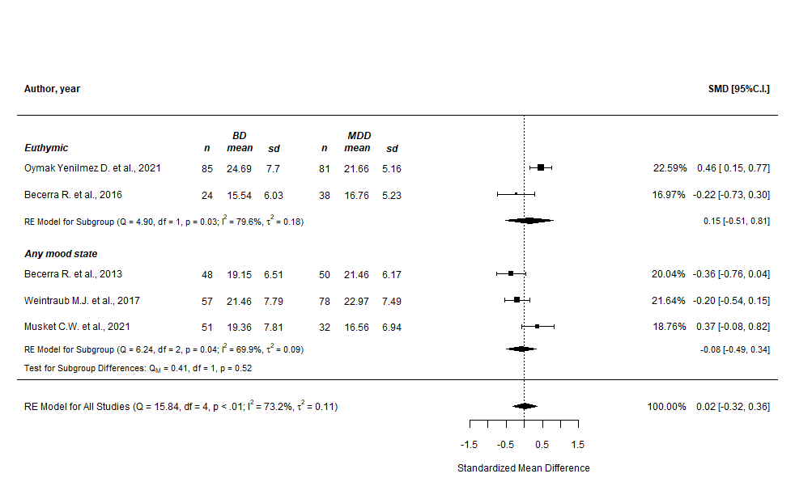

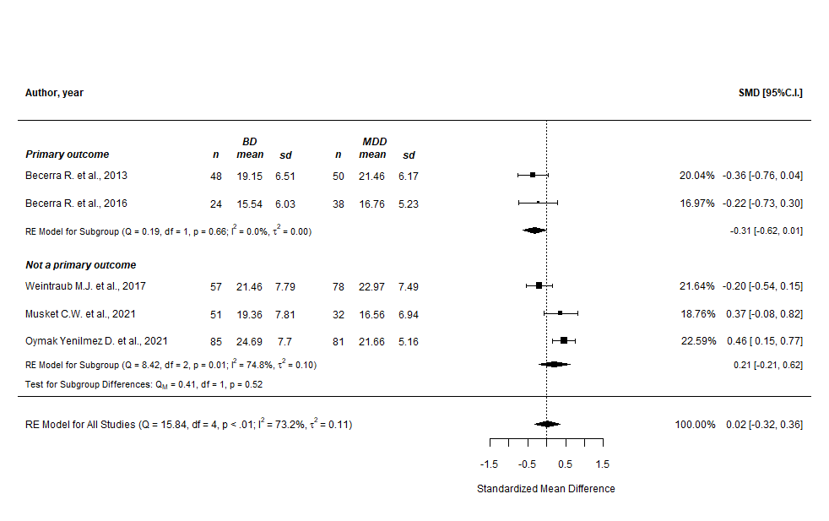

Supplementary Figure n.67 - DERS “strategies” subscale (prediction intervals)
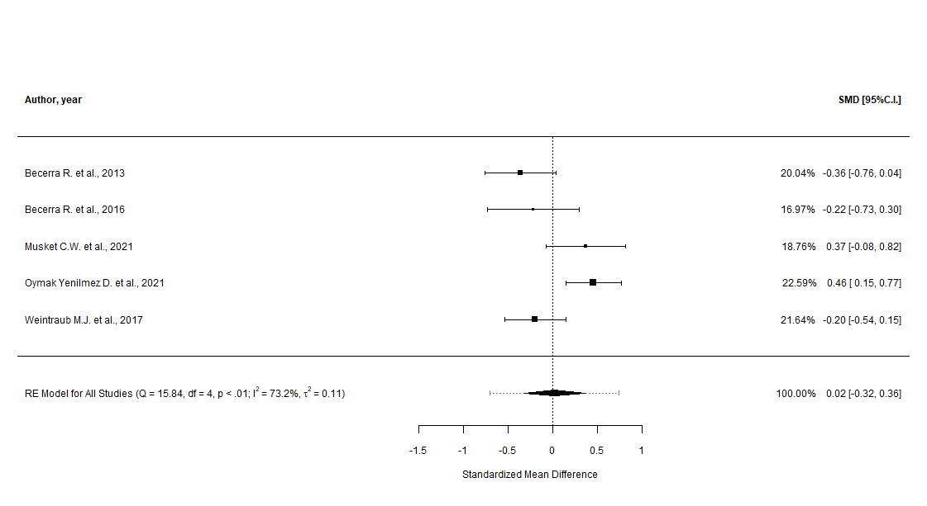

Supplementary Figure n.68 - DERS “strategies” subscale (cumulative analysis)
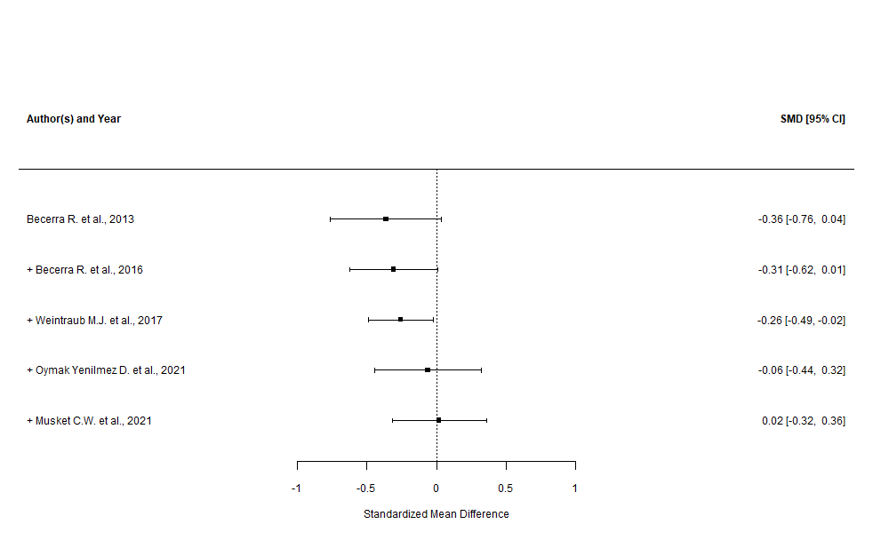
Supplementary Figure n.69 - DERS “strategies” subscale (leave-one-out and good quality only sensitivity analysis)

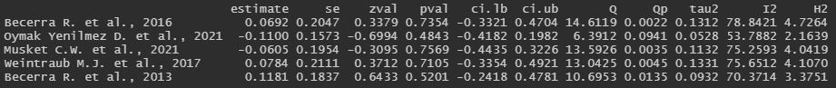

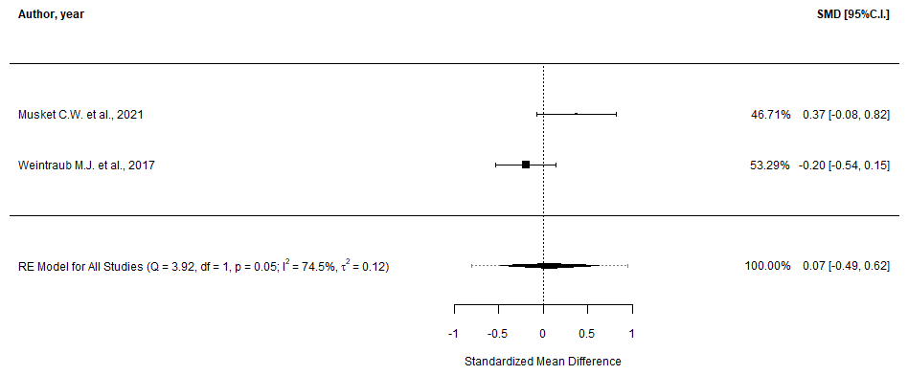
Supplementary Figure n.70 - DERS “strategies” subscale (GOSH plot)

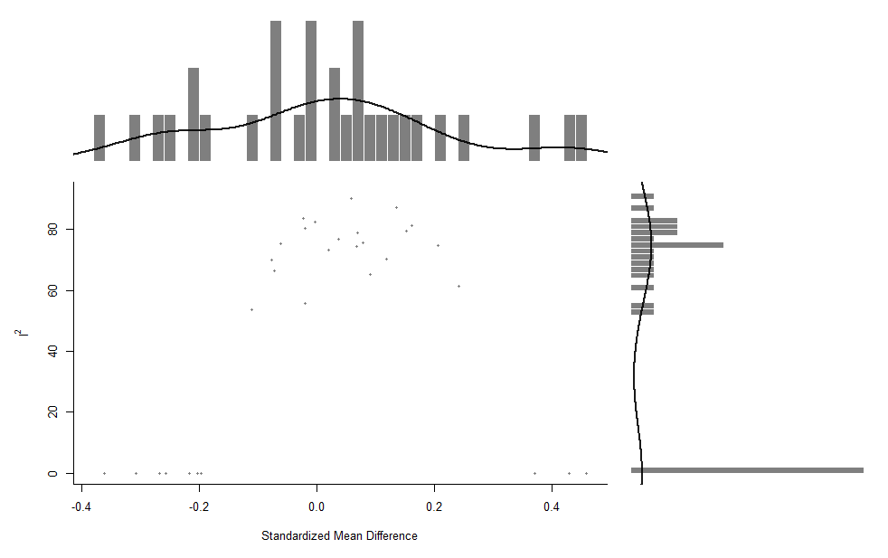

Supplementary Figure n.71 - DERS “clarity” subscale (main and subgroup analyses)
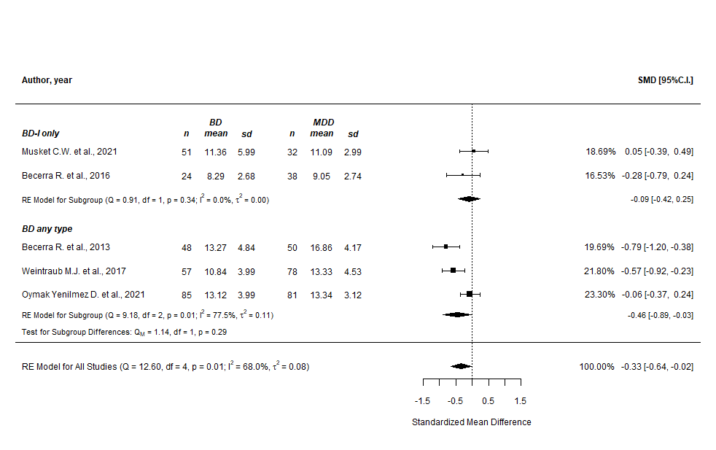
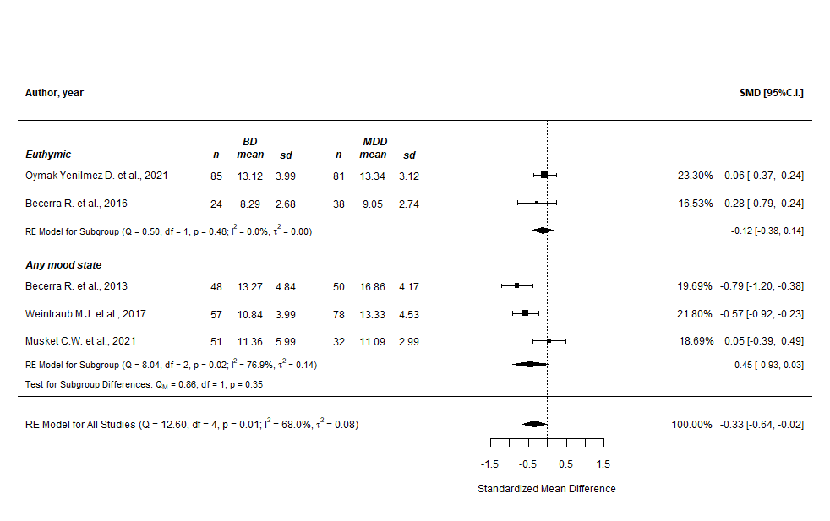
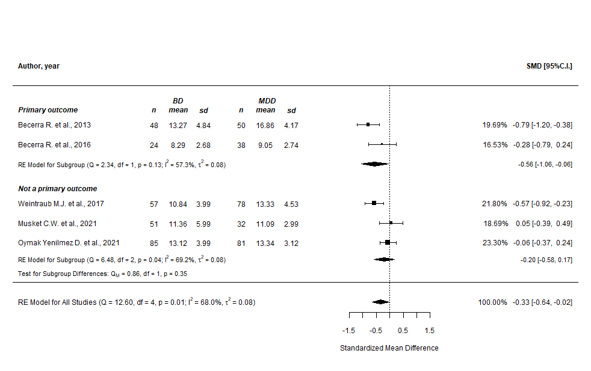

Supplementary Figure n.72 - DERS “clarity” subscale (prediction intervals)
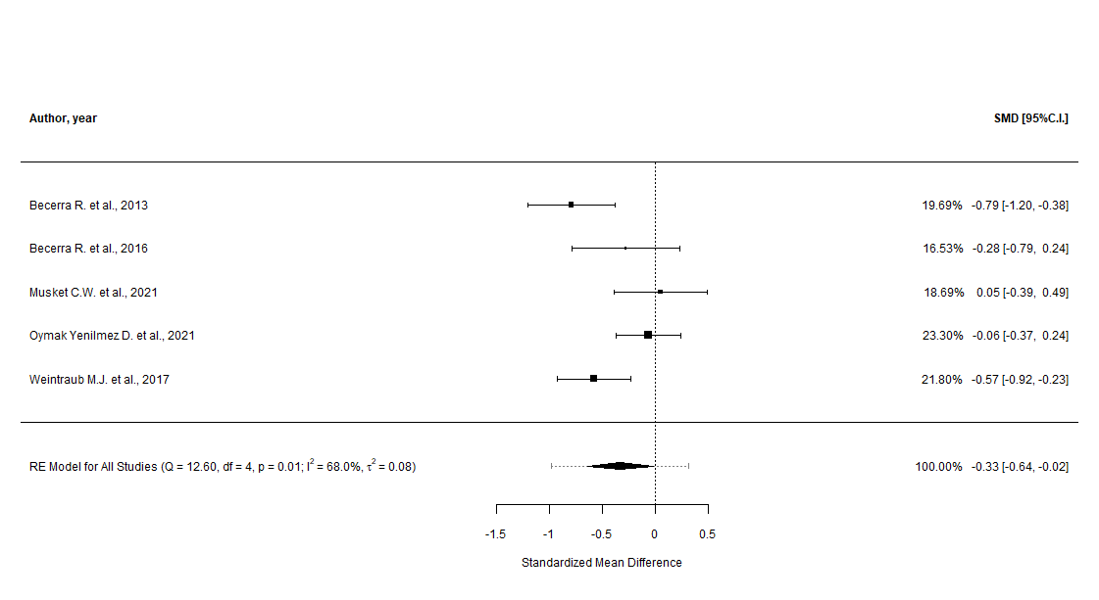

Supplementary Figure n.73 - DERS “clarity” subscale (cumulative analysis)
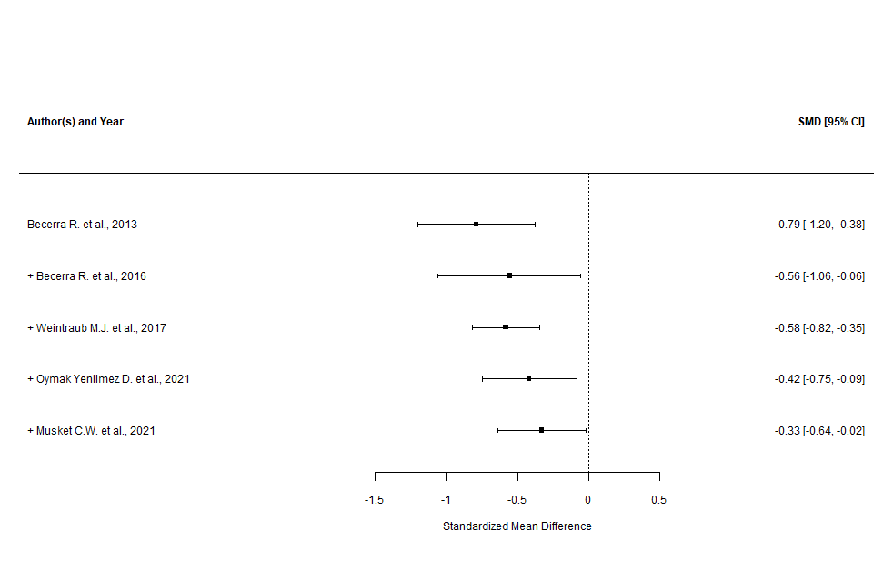

Supplementary Figure n.74 - DERS “clarity” subscale (leave-one-out sensitivity analysis)

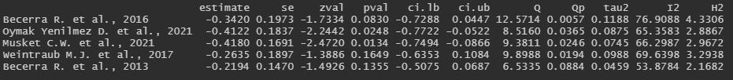

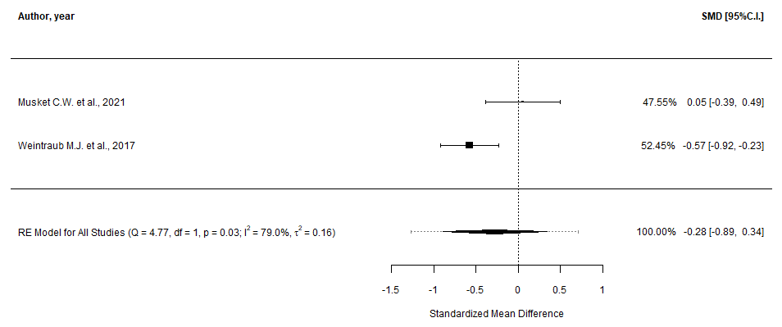
Supplementary Figure n.75 - DERS “clarity” subscale (GOSH plot)

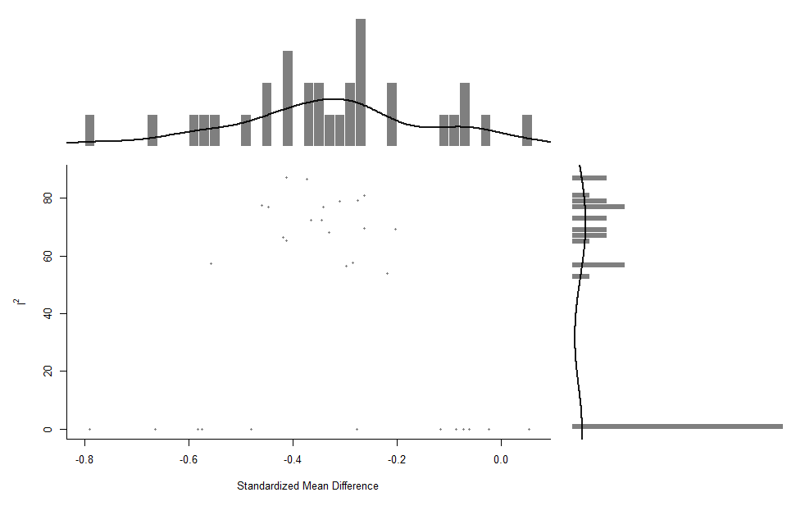

Response to Positive Affect, RPA (main, cumulative, and sensitivity analyses)

Supplementary Figure n.76 - RPA “dampening” subscale (main analysis)
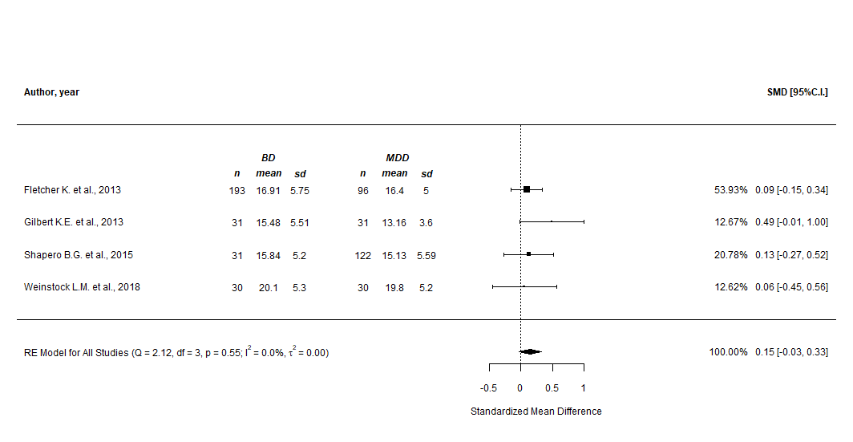

Supplementary Figure n.77 - RPA “dampening” subscale (prediction intervals)

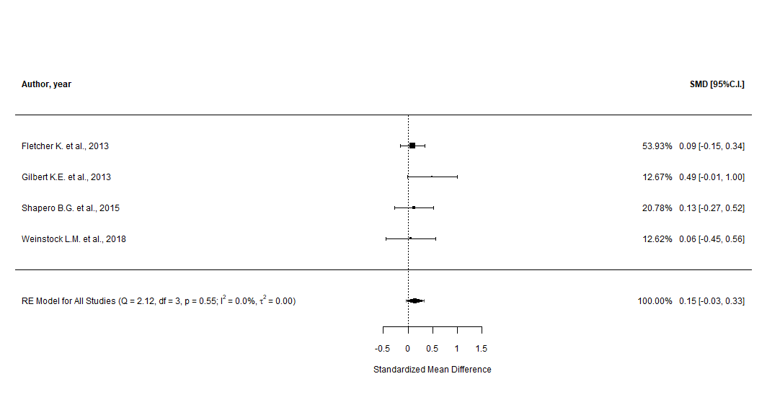

Supplementary Figure n.78 - RPA “dampening” subscale (cumulative analysis)
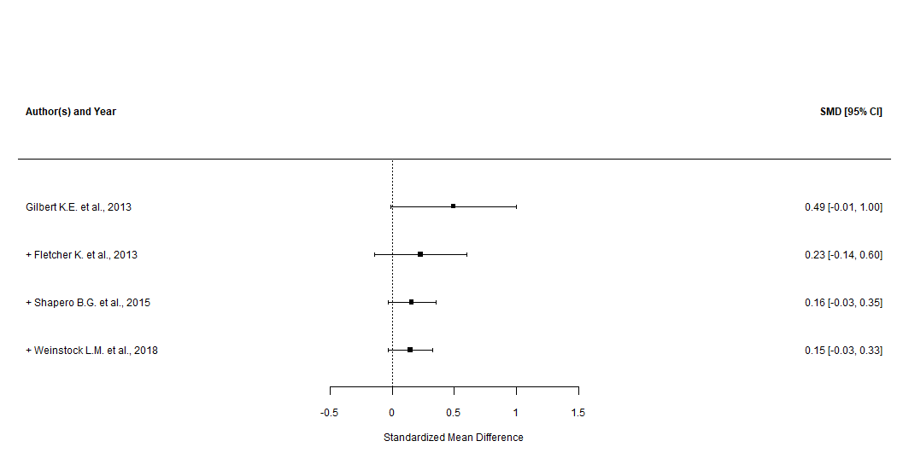

Supplementary Figure n.79 - RPA “dampening” subscale (leave-one-out sensitivity analysis)

Supplementary Figure n.80 - RPA “emotion focus” subscale (main analysis)
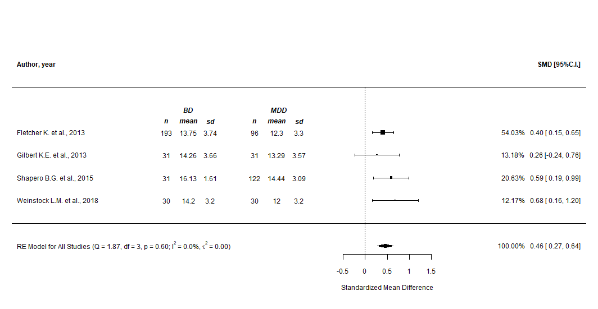

Supplementary Figure n.81 - RPA “emotion focus” subscale (prediction intervals)
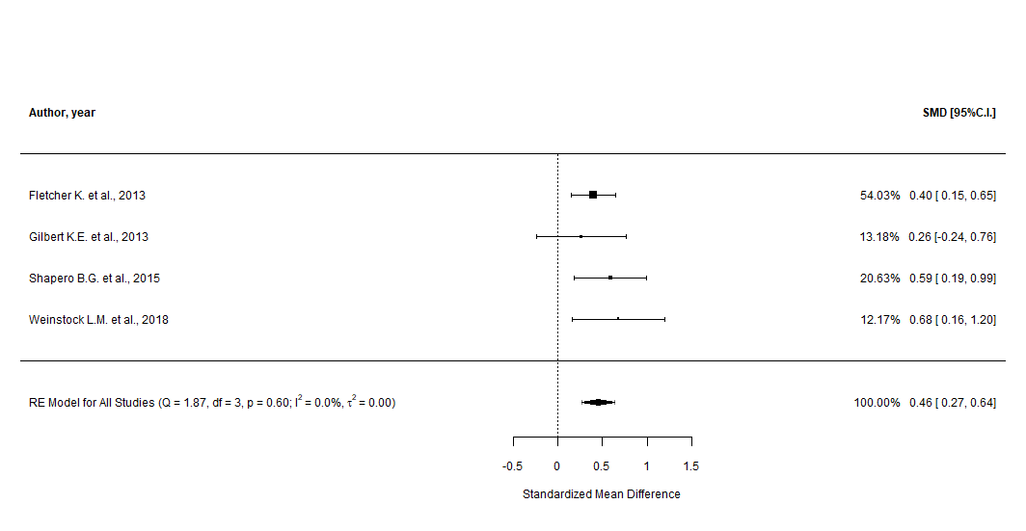

Supplementary Figure n.82 - RPA “emotion focus” subscale (cumulative analysis)
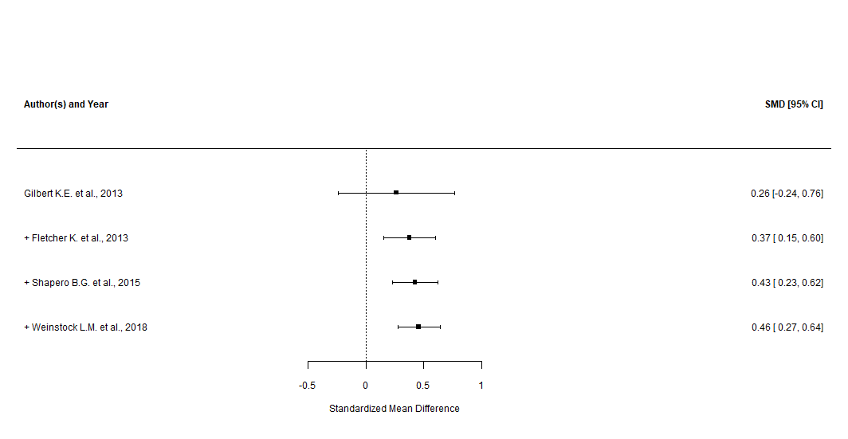

Supplementary Figure n.83 - RPA “emotion focus” subscale (leave-one-out sensitivity analysis)

Supplementary Figure n.84 - RPA “self-focus” subscale (main analysis)
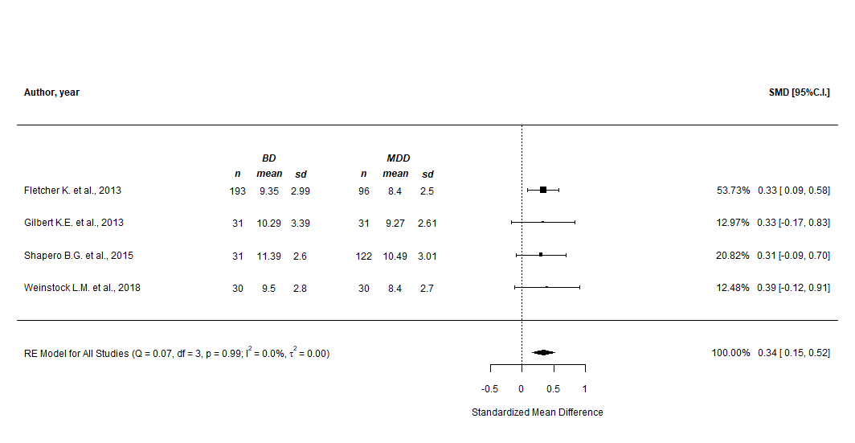

Supplementary Figure n.85 - RPA “self-focus” subscale (prediction intervals)
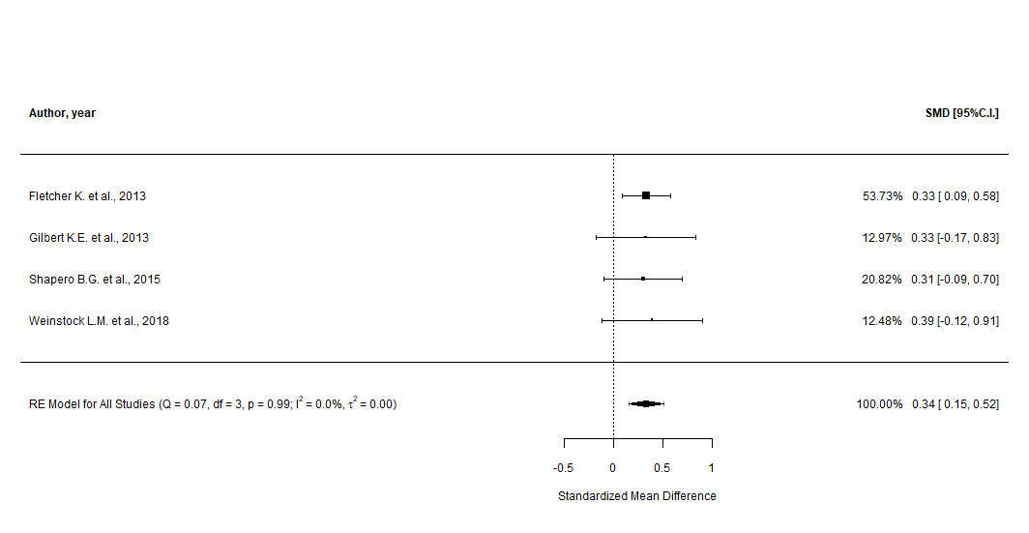

Supplementary Figure n.86 - RPA “self-focus” subscale (cumulative analysis)
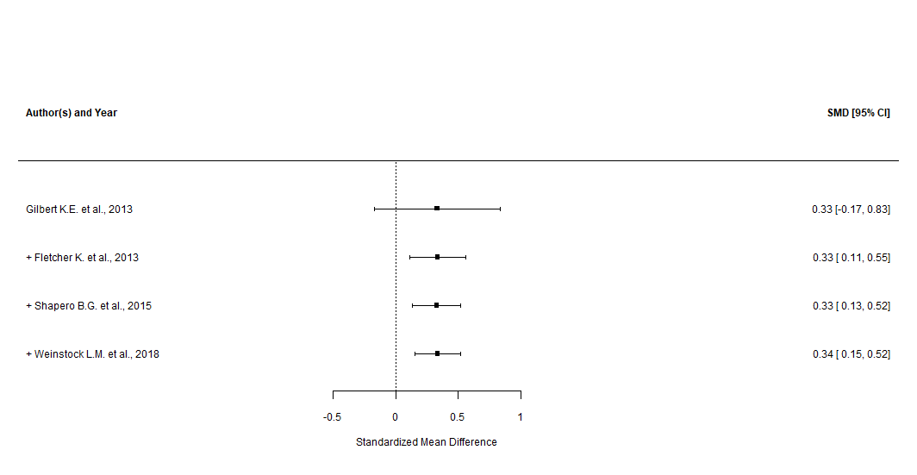

Supplementary Figure n.87 - RPA “self-focus” subscale (leave-one-out sensitivity analysis)

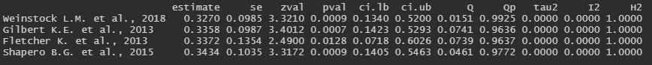

Ruminative Response Scale, RRS (main, cumulative, and sensitivity analyses)

Supplementary Figure n.88 - RRS “total” score (main analysis)
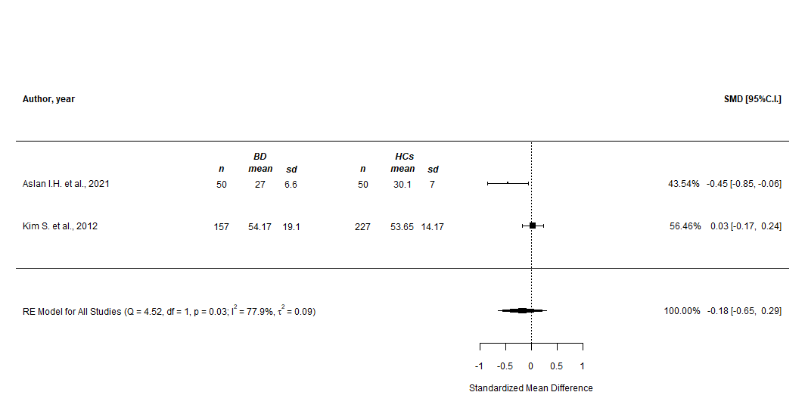

Supplementary Figure n.89 - RRS “total” score (prediction intervals)
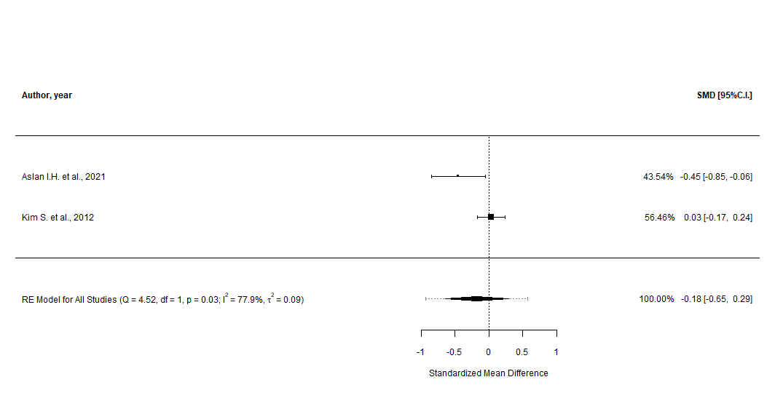

Supplementary Figure n.90 - RRS “brooding” subscale (main analysis)
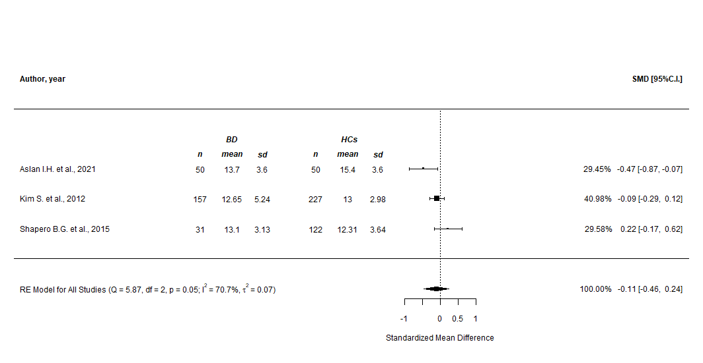

Supplementary Figure n.91 - RRS “brooding” subscale (prediction intervals)

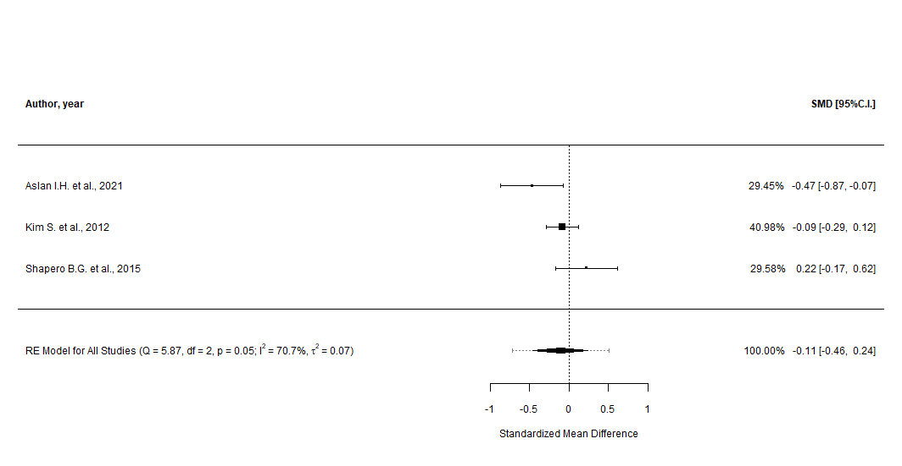

Supplementary Figure n.92 - RRS “brooding” subscale (cumulative analysis)
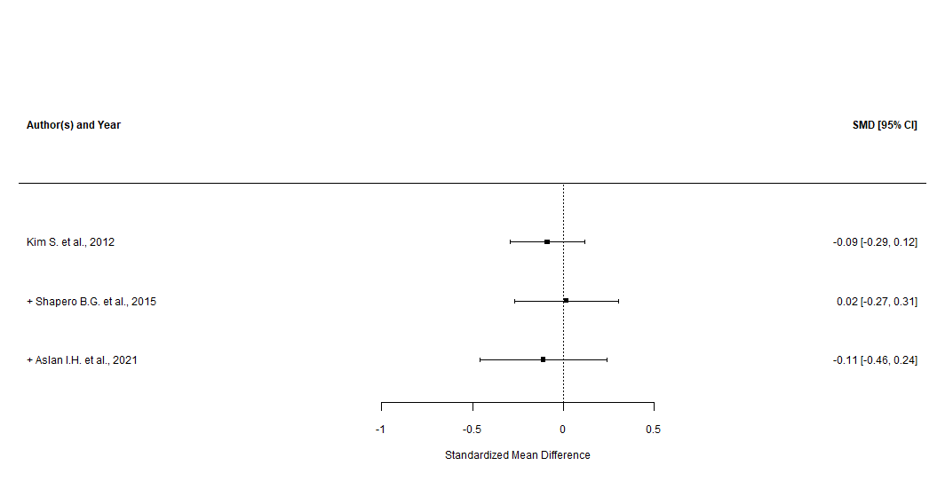

Supplementary Figure n.93 - RRS “brooding” subscale (leave-one-out and good quality only sensitivity analysis)

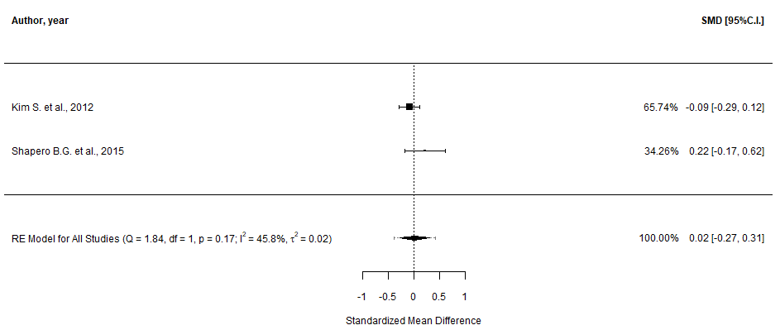

Supplementary Figure n.94 - RRS “reflective pondering” subscale (main analysis)
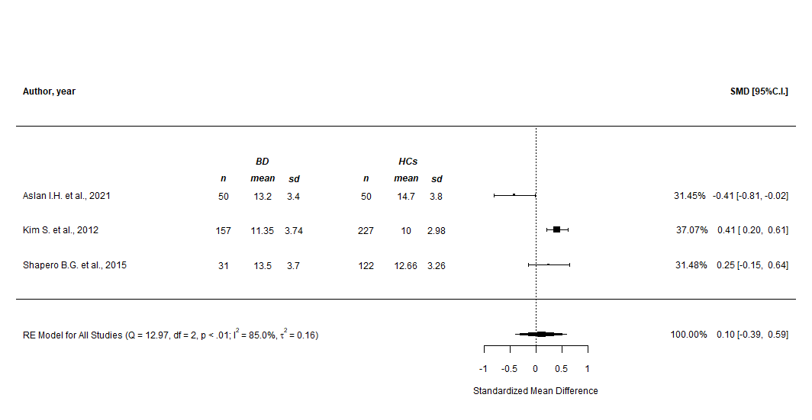

Supplementary Figure n.95 - RRS “reflective pondering” subscale (prediction intervals)

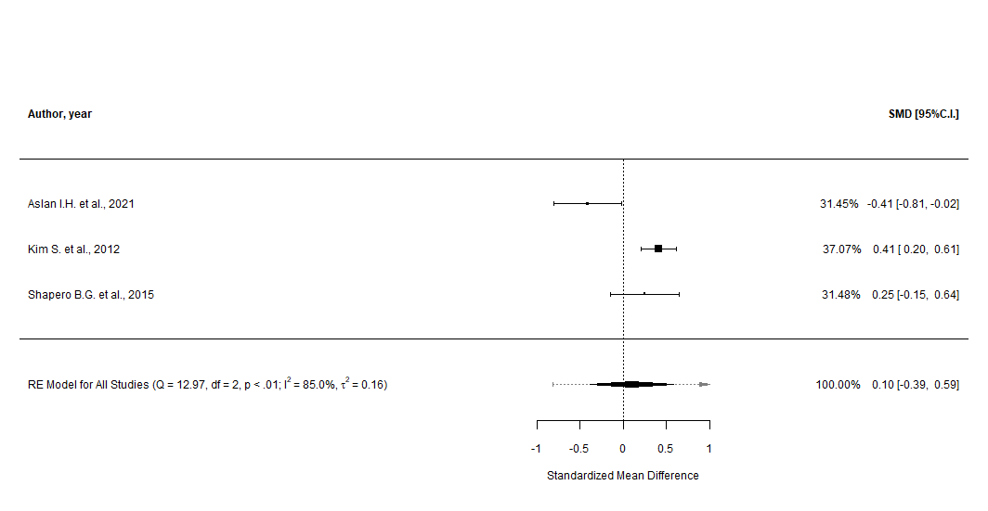

Supplementary Figure n.96 - RRS “reflective pondering” subscale (cumulative analysis)
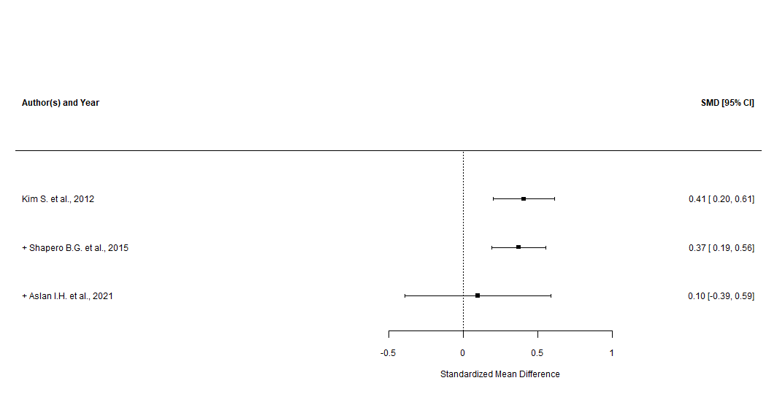

Supplementary Figure n.97 - RRS “reflective pondering” subscale (leave-one-out and good quality only sensitivity analysis)

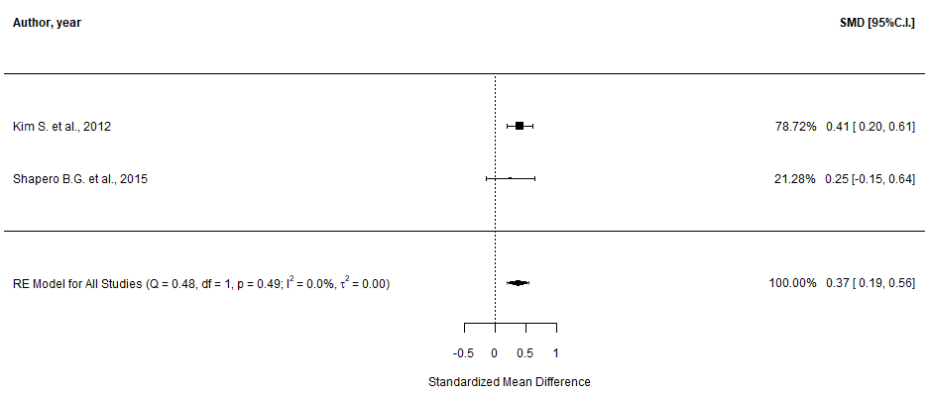

Response Style Questionnaire, RSQ (main analysis)

Supplementary Figure n.98 - RSQ “adaptive” subscale (main analysis)
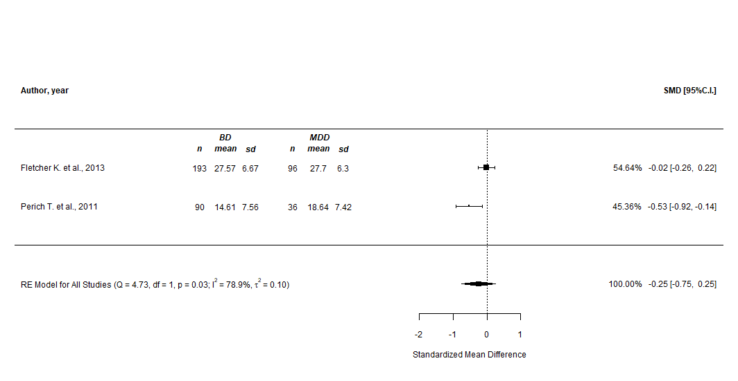

Supplementary Figure n.99 - RSQ “adaptive” subscale (prediction intervals)

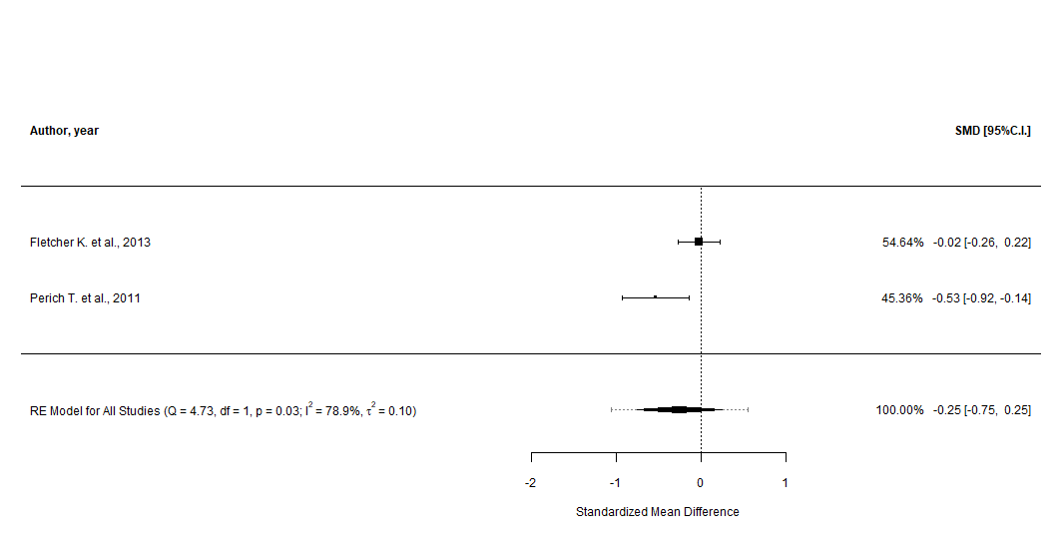

Supplementary Figure n.100 - RSQ “risk-taking” subscale (main analysis)
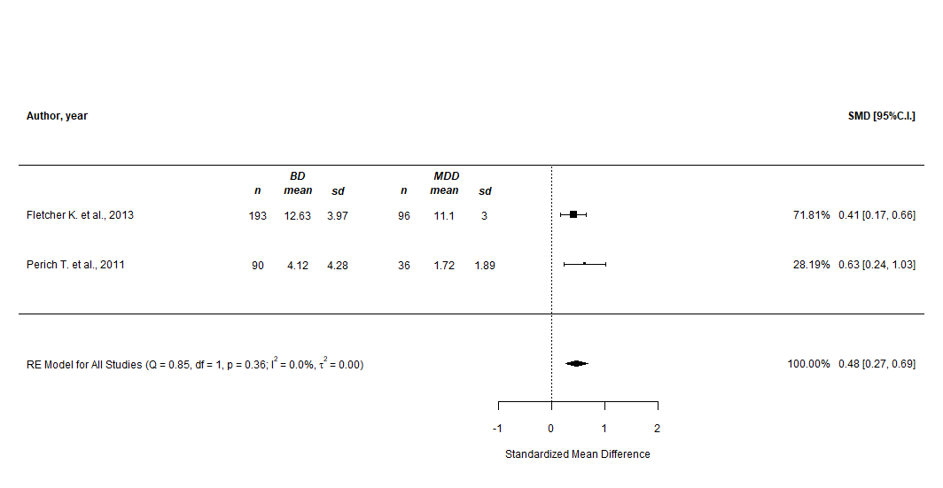

Supplementary Figure n.101 - RSQ “risk-taking” subscale (prediction intervals)

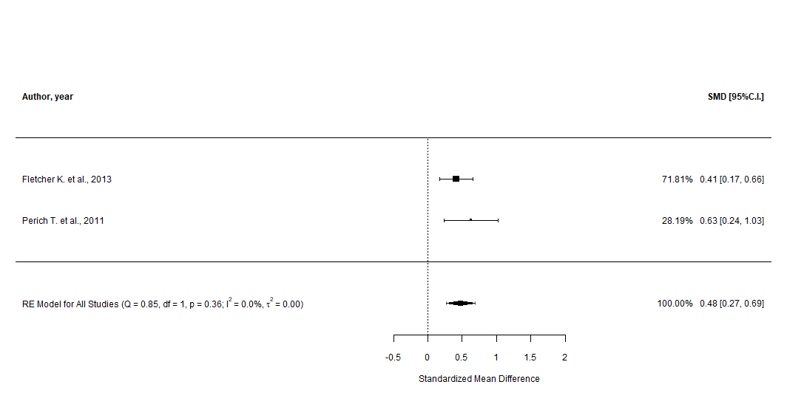

Supplementary Figure n.102 - RSQ “rumination” subscale (main analysis)
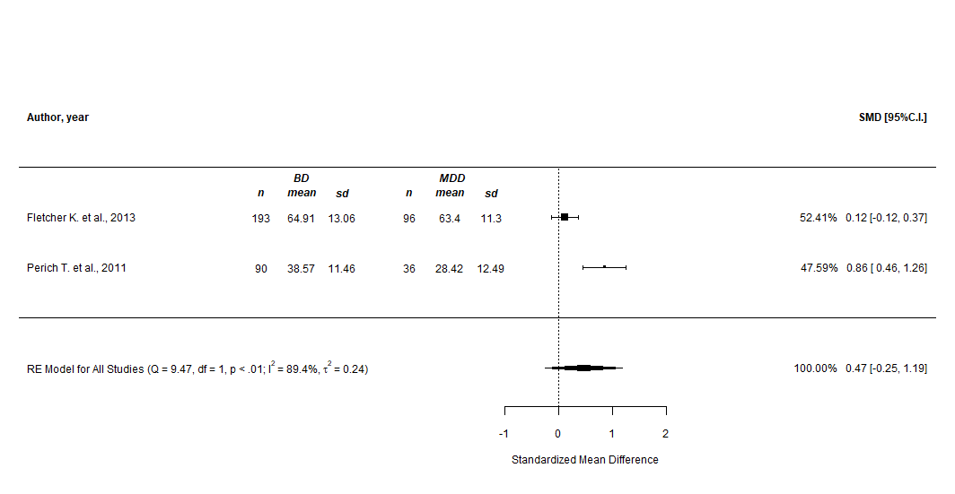

Supplementary Figure n.103 - RSQ “rumination” subscale (prediction intervals)

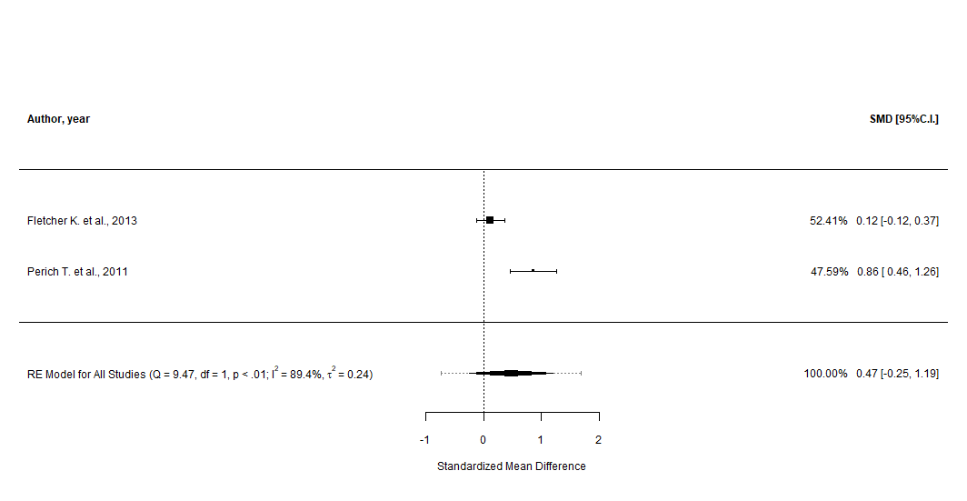

Emotion Regulation Questionnaire, ERQ (main analysis)

Supplementary Figure n.104 - ERQ “reappraisal” subscale (main analysis)
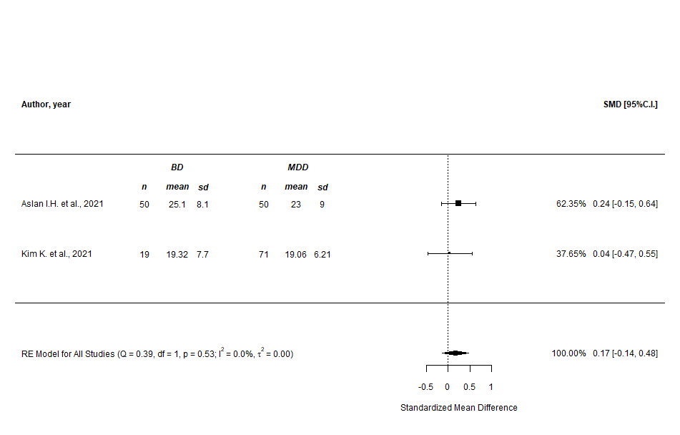
Supplementary Figure n.105 - ERQ “reappraisal” subscale (prediction intervals)
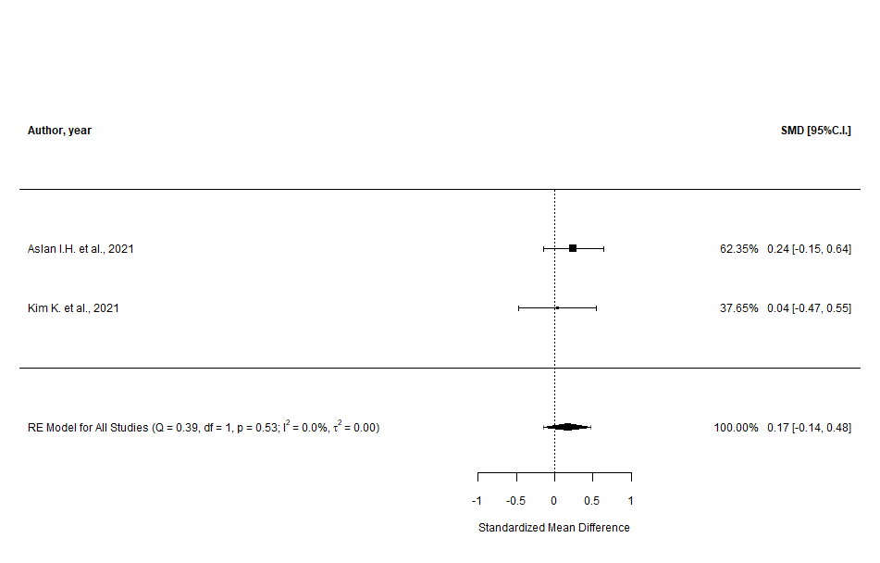
Supplementary Figure n.106 - ERQ “suppression” subscale (main analysis)
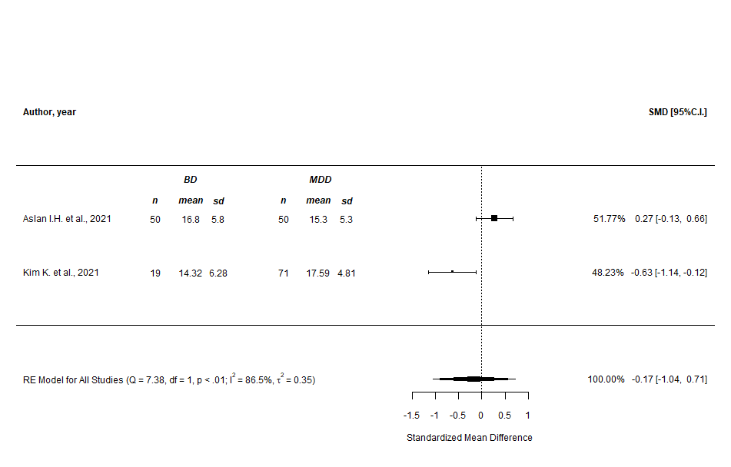

Supplementary Figure n.107 - ERQ “suppression” subscale (prediction intervals)
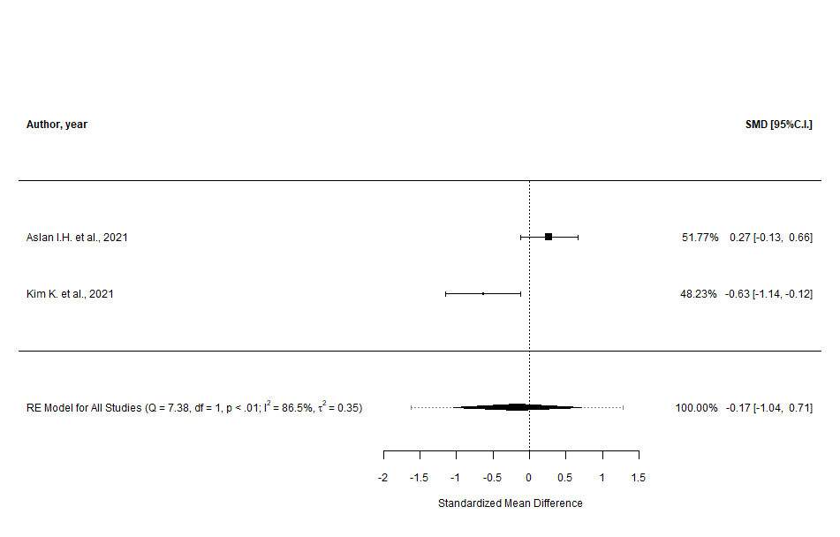

Control Group: Borderline Personality Disorder (BPD)

Summary Table - Characteristics of the comparisons to people with BPD included in the Systematic Review and Meta-analysis

Supplementary Table n.5 - Characteristics of the comparisons to people with BPD included in the Systematic Review and Meta-analysis
Author, year, country | Study design | Description of the study and population characteristics | Diagnostic criteria | Outcome BD vs. BPD, mean±SD | Quality of the study (NOS)
ACS - Affective Control Scale
Marwaha S. et al., 2018, United Kingdom | Cross-sectional | 11 outpatients (mean age=35.6±13.3; %females=48) recruited in outpatient departments or day-hospital services and diagnosed with BD and 12 patients (mean age=33.9±11; %females=43) diagnosed with BPD were evaluated to explore the differences in affect intensity, instability, and control among clinical and non-clinical groups. People who were experiencing an acute episode or diagnosed with substance use disorder, were excluded. In the present study, HCs and people diagnosed with other psychiatric disorders were also included | ICD-10 | Anger subscale: 4.31±0.83 vs. 5.21±0.96;  Positive-affect subscale: 4.17±0.93 vs. 4.12±1.02;  Depression subscale: 4.96±0.88 vs. 5.92±0.72;  Anxiety subscale: 4.31±0.84 vs. 5.63±0.6 | 4 / POOR
CERQ - Cognitive Emotion Regulation Questionnaire
Bayes A. et al., 2016, Australia | Cross-sectional | 83 patients (mean age=35.4±13.4; %females=54) recruited from several clinical services or via newspaper advertisement and diagnosed with BD, and 53 patients (mean age=32.9±11.3; %females=85) diagnosed with BPD were evaluated to explore the differences between their emotion regulation strategies. People who were experiencing psychotic symptoms, diagnosed with current substance abuse, with comorbid organic conditions, or who were not fluent in English, were excluded. The maladaptive and adaptive composite scale score reported is controlled for age and gender of the participants. In the present study, a group comprising people with BD comorbid with BPD was also included | DSM-IV (MINI) | Self-blame subscale: 12.2±3.6 vs. 15±3.5;  Blaming others subscale: 8.8±3.2 vs. 9.8±4.1;  Rumination subscale: 13.4±3.1 vs. 14.1±3.3;  Catastrophizing subscale: 9.6±3.8 vs. 11.5±3.8;  Putting into perspective subscale: 12.2±4.4 vs. 10.4±3;  Positive refocusing subscale: 11.7±4.6 vs. 9.8±3.5;  Positive reappraisal subscale: 11.7±4.6 vs. 9.8±3.5;  Acceptance subscale: 13.3±2.7 vs. 13.2±3.2;  Focus on replanning subscale: 11.8±4.3 vs. 10.3±3.8;  Maladaptive composite scale (self-blame subscale, blaming others subscale, rumination subscale, catastrophizing subscale, and acceptance subscale): 53.5±9.11 vs. 50.4±9.46;  Adaptive composite scale (putting into perspective subscale, positive refocusing subscale, positive reappraisal subscale, and focus on replanning subscale): 57.8±14.58 vs. 51.5±14.56 | 5 / FAIR
Fletcher L. et al., 2014, Australia | Cross-sectional | 24 outpatients recruited from tertiary referral mood disorder clinics, private and public outpatients’ hospital clinics, and from the general community via newspaper advertisements, and diagnosed with BD-II, and 24 outpatients diagnosed with BPD were evaluated to explore the differences between their emotion regulation strategies. People who were currently experiencing psychotic symptoms, diagnosed with current substance abuse, or with comorbid psychiatric (except for anxiety) or organic conditions, were excluded. The emotion regulation scores reported are controlled for current depression severity | DSM-IV (MINI) | Self-blame subscale: 12.3±3.43 vs. 14.6±1.47;  Blaming others subscale: 7.9±2.94 vs. 10.5±2.93;  Rumination subscale: 13.1±3.43 vs. 13.3±3.43;  Catastrophizing subscale: 8.8±3.43 vs. 11.8±3.43;  Putting into perspective subscale: 12.9±3.92 vs. 10.1±3.92;  Positive refocusing subscale: 8.6±3.43 vs. 7.1±3.43;  Positive reappraisal subscale: 12.3±3.92 vs. 9.3±3.92;  Acceptance subscale: 13.4±2.94 vs. 12.6±2.94;  Focus on replanning subscale: 12±3.43 vs. 9.8±3.43 | 6 / GOOD
Murray J.R. et al., 2021, Switzerland | Cross-sectional | 18 outpatients (mean age=28.3±6.2; %females=47) recruited through a specialized outpatient’s program of Geneva University Hospital and diagnosed with BD-I (8), BD-II (8), or BD-NOS (2), and 24 outpatients (mean age=26.1±4.9; %females=96) diagnosed with BPD were evaluated to explore the differences in whole-brain neural reactivity to psychosocial stress. People who had a positive history of head trauma or any contraindication for MRI safety prerequisites, were excluded. In the present study, HCs were also included | DSM-IV (SCID-II; MINI; DIGS) | Non-adaptive composite scale: 37.91 vs. 48.92
DERS - Difficulties in Emotion Regulation Scale
Bayes A. et al., 2016, Australia | Cross-sectional | 83 patients (mean age=35.4±13.4; %females=54) recruited from several clinical services or via newspaper advertisement and diagnosed with BD, and 53 patients (mean age=32.9±11.3; %females=85) diagnosed with BPD were evaluated to explore the differences between their emotion regulation strategies. People who were experiencing psychotic symptoms, diagnosed with current substance abuse, with comorbid organic conditions, or who were not fluent in English, were excluded. The maladaptive and adaptive composite scale score reported is controlled for age and gender of the participants. In the present study, a group comprising people with BD comorbid with BPD was also included | DSM-IV (MINI) | Total score: 101.8±22.77 vs. 124±23.29;  Non-acceptance subscale: 17±6.5 vs. 21.1±6.1;  Goals subscale: 18.4±4.1 vs. 19.8±3.6;  Impulse subscale: 15.1±5.5 vs. 20.1±5.8;  Awareness subscale: 15.9±5.1 vs. 18.9±5.3;  Strategies subscale: 23.9±7.7 vs. 28.6±7.2;  Clarity subscale: 13.2±4.5 vs. 16±4.4 | 5 / FAIR
Das P. et al., 2014, Australia | Cross-sectional | 16 outpatients (mean age=35.6±10.7; %females=100) recruited through the CADE clinic at Royal North Shore Hospital (Sidney, Australia) and via advertisement, and diagnosed with BD, and 14 patients (mean age=32±7.9; %females=100) diagnosed with BPD were evaluated with fMRI to investigate the functional connectivity between and within brain networks subserving social cognition or emotion regulation. People with BD were euthymic and mostly on medication at the time of the assessment. Patients with neurological illnesses, substance abuse, lifetime head injury or poor English proficiency, were excluded. In the present study, HCs were also included | DSM-IV | Total score: 86.63±19.59 vs. 130±18.6;  Non-acceptance subscale: 14±6.47 vs. 20.93±6.04;  Goals subscale: 17.44±4.16 vs. 20.29±3.29;  Impulse subscale: 14.88±6.44 vs. 22.14±4.56;  Awareness subscale: 14±5.57 vs. 19.86±5.26;  Strategies subscale: 18.31±5.45 vs. 29.71±6.03;  Clarity subscale: 11±3.83 vs. 17.07±3.79 | 4 / POOR
Fletcher L. et al., 2014, Australia | Cross-sectional | 24 outpatients recruited from tertiary referral mood disorder clinics, private and public outpatients’ hospital clinics, and from the general community via newspaper advertisements, and diagnosed with BD-II, and 24 outpatients diagnosed with BPD were evaluated to explore the differences between their emotion regulation strategies. People who were currently experiencing psychotic symptoms, diagnosed with current substance abuse, or with comorbid psychiatric (except for anxiety) or organic conditions, were excluded. The emotion regulation scores reported are controlled for current depression severity | DSM-IV (MINI) | Non-acceptance subscale: 18±6.85 vs. 19.9±6.86;  Goals subscale: 18.2±3.43 vs. 19.4±3.43;  Impulse subscale: 15.2±5.88 vs. 19±5.88;  Awareness subscale: 16.7±4.41 vs. 18.2±4.41;  Strategies subscale: 22.4±6.86 vs. 26.8±6.85;  Clarity subscale: 14.3±3.92 vs. 16.5±3.91 | 6 / GOOD
Fowler J.C. et al., 2019, USA | Cross-sectional | 341 inpatients (mean age=34.1±14.2; %females=44) consecutively admitted from July 2012 to December 2017 to a psychiatric hospital and diagnosed with BD, and 381 patients (mean age=28.5±14.2; %females=58) diagnosed with BPD were evaluated to explore the extent of emotion dysregulation in the two groups. Substance use was diagnosed both in patients with BD (62%) and BPD (73%) | DSM-IV (SCID-I) | Total score: 100.31±27.74 vs. 121.37±22.07;  Non-acceptance subscale: 16.15±6.88 vs. 19.99±6.72;  Goals subscale: 17.16±5.08 vs. 19.83±4.18;  Impulse subscale: 15.37±6.02 vs. 19.65±5.72;  Awareness subscale: 16.26±5.56 vs. 18.02±5.52;  Strategies subscale: 22.5±8.31 vs. 28.42±6.63;  Clarity subscale: 13.77±5.36 vs. 15.11±5.77 | 5 / POOR

Additional results – Results of the sensitivity analysis comparing Bipolar Disorder and Borderline Personality Disorder using a more conservative level of significance.

Supplementary Table n.6 – Results of the sensitivity analysis comparing Bipolar Disorder and Borderline Personality Disorder using a more conservative level of significance.

Scale adopted | Subscale | Studies, n | BD patients, n | Control, diagnosis | Control, n | SMD | 95% CI | p-value | 95% PI | I² (%) | tau² | Q-test p-value
Overall measures of Emotion Dysregulation
DERS | Total score | 3 | 440 | BPD | 448 | -1.22 | -1.94, -0.5 | 0.03822 | -2.57, 0.13 | 90.7 | 0.34 | 0.01
Maladaptive Emotion Regulation Strategies
Negative Rumination
CERQ | Rumination | 2 | 107 | BPD | 77 | -0.18 | -0.47, 0.12 | 1 | -0.47, 0.12 | 0 | 0 | 0.63
Negative Focus
CERQ | Self-blame | 2 | 107 | BPD | 77 | -0.80 | -1.11, -0.50 | 1.13e-5 | -1.11, -0.50 | 0 | 0 | 0.83
CERQ | Blaming others | 2 | 107 | BPD | 77 | -0.52 | -1.10, 0.05 | 1 | -1.40, 0.35 | 65.2 | 0.11 | 0.09
CERQ | Catastrophizing | 2 | 107 | BPD | 77 | -0.60 | -0.92, -0.28 | 0.00966 | -0.94, -0.25 | 6.8 | 0 | 0.30
Risk-taking Behavior
DERS | Impulse | 4 | 464 | BPD | 472 | -0.76 | -0.89, -0.63 | 2.27e-27 | -0.89, -0.63 | 0 | 0 | 0.51
Adaptive Emotion Regulation Strategies
Cognitive Reframing
CERQ | Putting into perspective | 2 | 107 | BPD | 77 | 0.52 | 0.22, 0.82 | 0.02646 | 0.22, 0.82 | 0 | 0 | 0.48
CERQ | Positive refocusing* | 2 | 107 | BPD | 77 | 0.44 | 0.15, 0.74 | 0.1428 | 0.15, 0.74 | 0 | 0 | 0.96
CERQ | Positive reappraisal* | 2 | 107 | BPD | 77 | 0.53 | 0.23, 0.83 | 0.2268 | 0.23, 0.83 | 0 | 0 | 0.38
CERQ | Refocus on planning* | 2 | 107 | BPD | 77 | 0.43 | 0.14, 0.73 | 0.1806 | 0.14, 0.73 | 0 | 0 | 0.44
Adaptive Coping
DERS | Goals (reverse) | 4 | 464 | BPD | 472 | 0.54 | 0.40, 0.67 | 1.18e-13 | 0.40, 0.67 | 0.6 | 0 | 0.57
DERS | Strategies (reverse) | 4 | 464 | BPD | 472 | 0.79 | 0.65, 0.92 | 5.04e-29 | 0.65, 0.92 | 0 | 0 | 0.05
Acceptance
CERQ | Acceptance | 2 | 107 | BPD | 77 | 0.10 | -0.20, 0.39 | 1 | -0.20, 0.39 | 0 | 0 | 0.49
DERS | Non-acceptance (reverse) | 4 | 464 | BPD | 472 | 0.57 | 0.44, 0.71 | 4.26e-16 | 0.44, 0.71 | 0 | 0 | 0.41
DERS | Awareness (reverse) | 4 | 464 | BPD | 472 | 0.44 | 0.22, 0.66 | 0.0042 | 0.09, 0.79 | 33.7 | 0.02 | 0.18
DERS | Clarity (reverse)* | 4 | 464 | BPD | 472 | 0.63 | 0.18, 1.09 | 0.27 | -0.27, 1.53 | 80.9 | 0.16 | 0.01

*significance changed after using a more conservative p-value.
The more conservative significance level was calculated by dividing the original significance level (0.05) by the number of total comparisons (42)

Cognitive Emotion Regulation Questionnaire, CERQ (main analysis)

Supplementary Figure n.108 - CERQ “self-blame” subscale (main analysis)
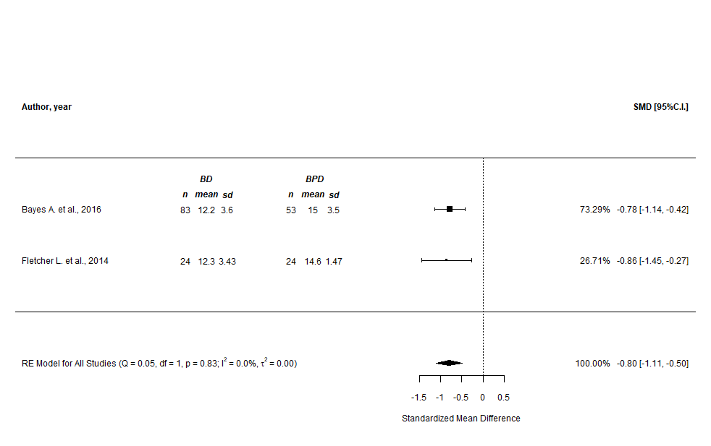

Supplementary Figure n.109 - CERQ “self-blame” subscale (prediction intervals)
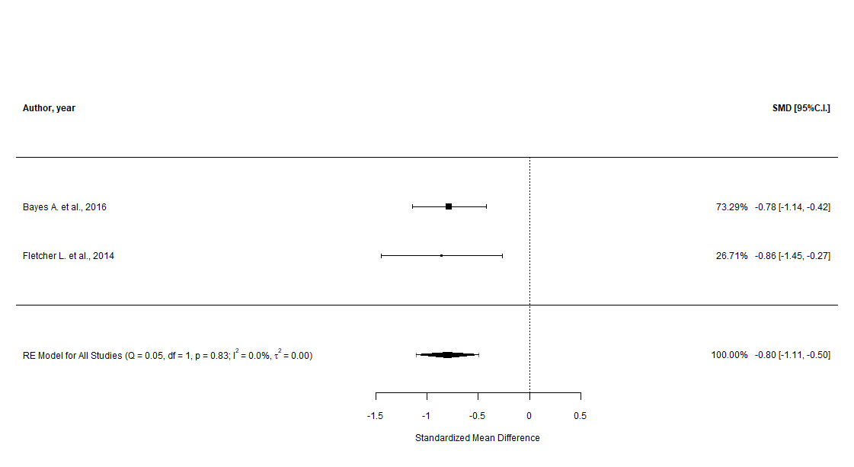

Supplementary Figure n.110 - CERQ “blaming others” subscale (main analysis)
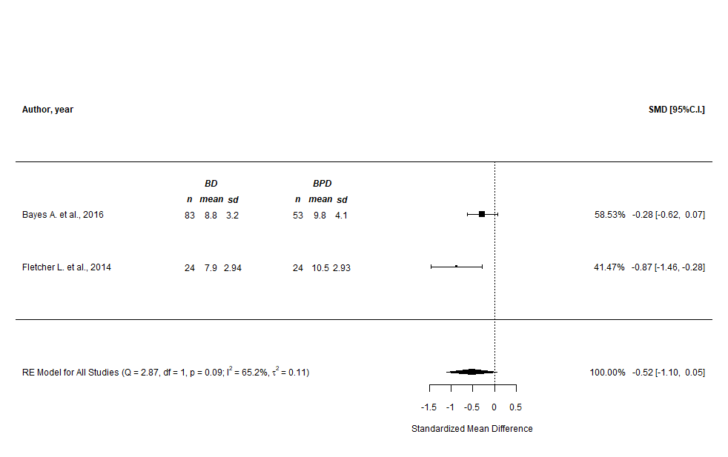

Supplementary Figure n.111 - CERQ “blaming others” subscale (prediction intervals)
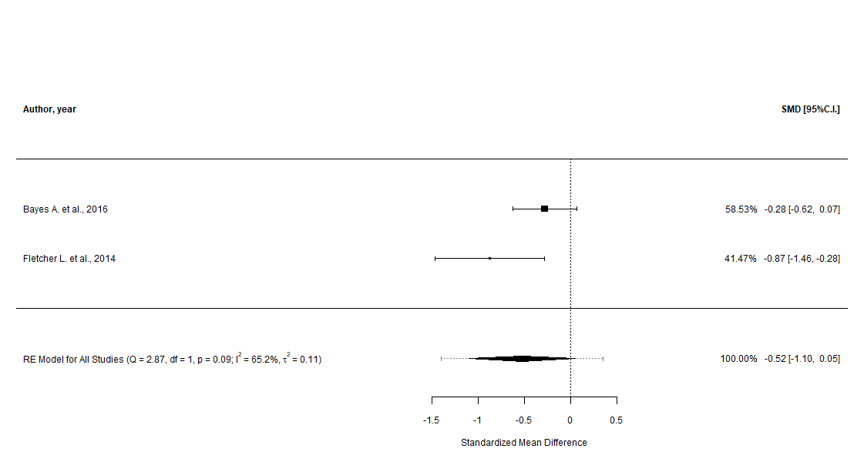

Supplementary Figure n.112 - CERQ “rumination” subscale (main analysis)
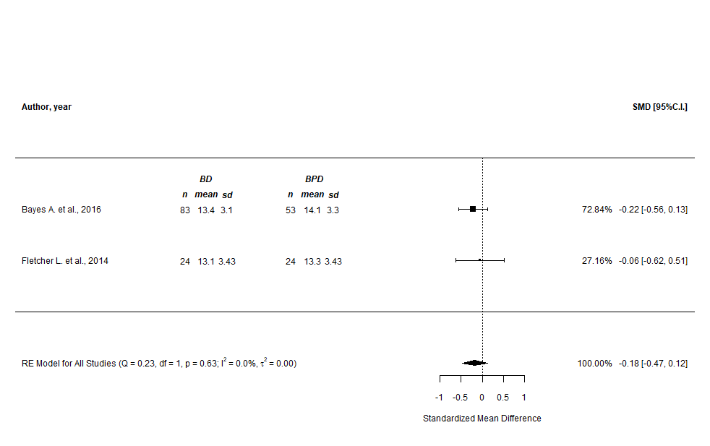

Supplementary Figure n.113 - CERQ “rumination” subscale (prediction intervals)
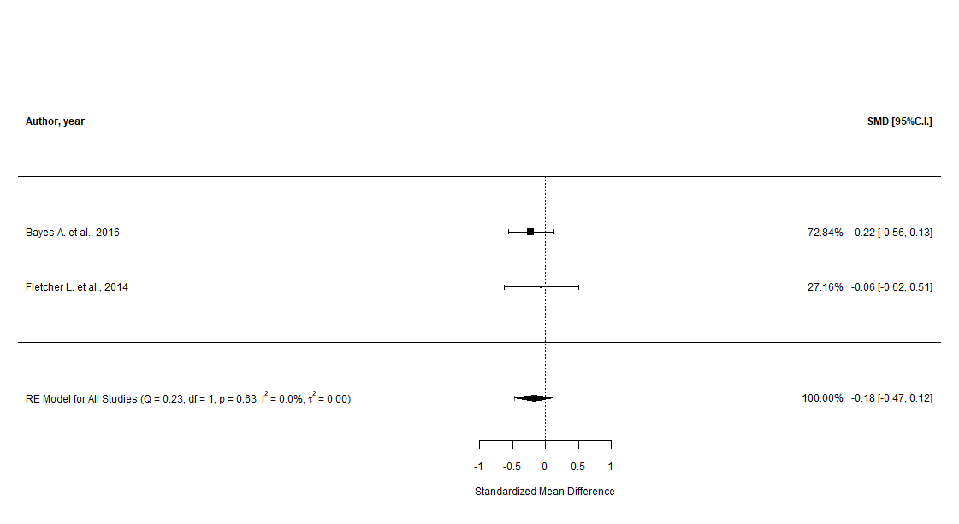

Supplementary Figure n.114 - CERQ “catastrophizing” subscale (main analysis)
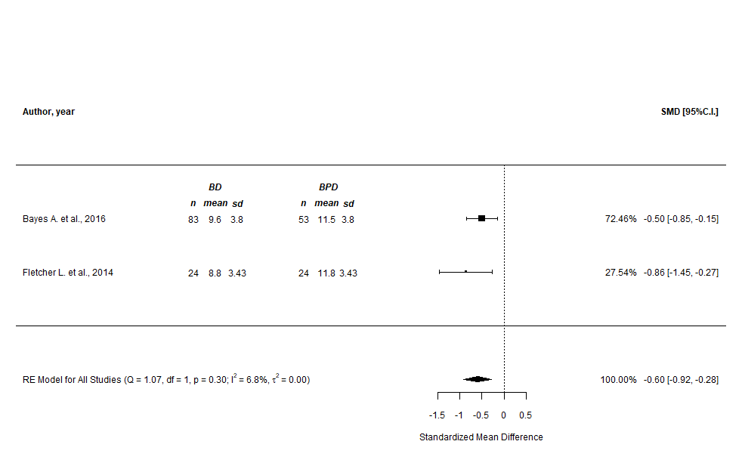

Supplementary Figure n.115 - CERQ “catastrophizing” subscale (prediction intervals)
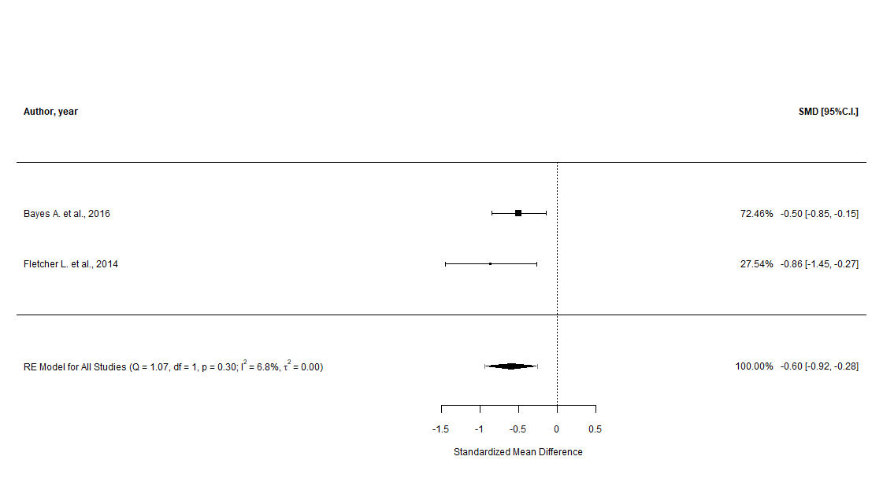

Supplementary Figure n.116 - CERQ “putting into perspective” subscale (main analysis)
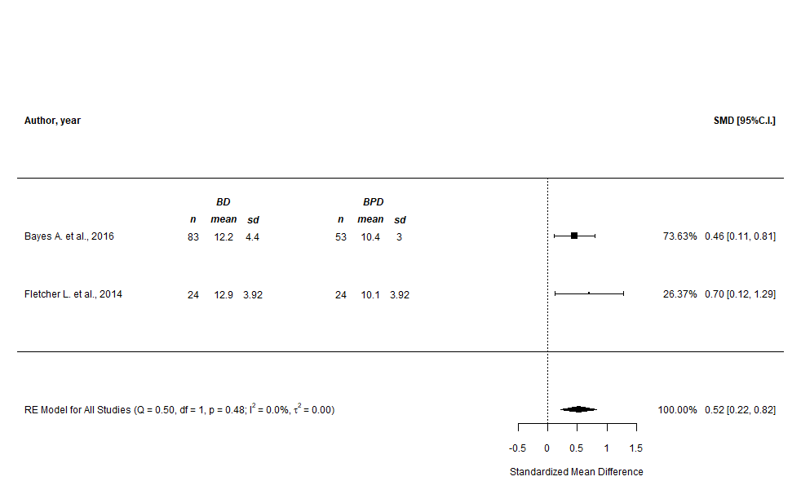

Supplementary Figure n.117 - CERQ “putting into perspective” subscale (prediction intervals)
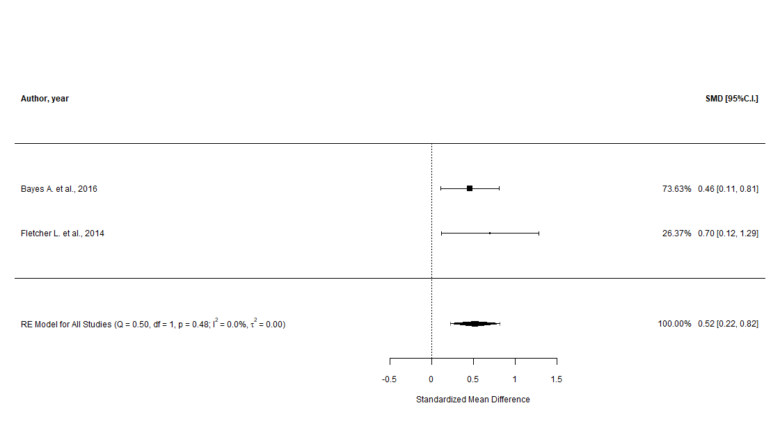

Supplementary Figure n.118 - CERQ “positive refocusing” subscale (main analysis)
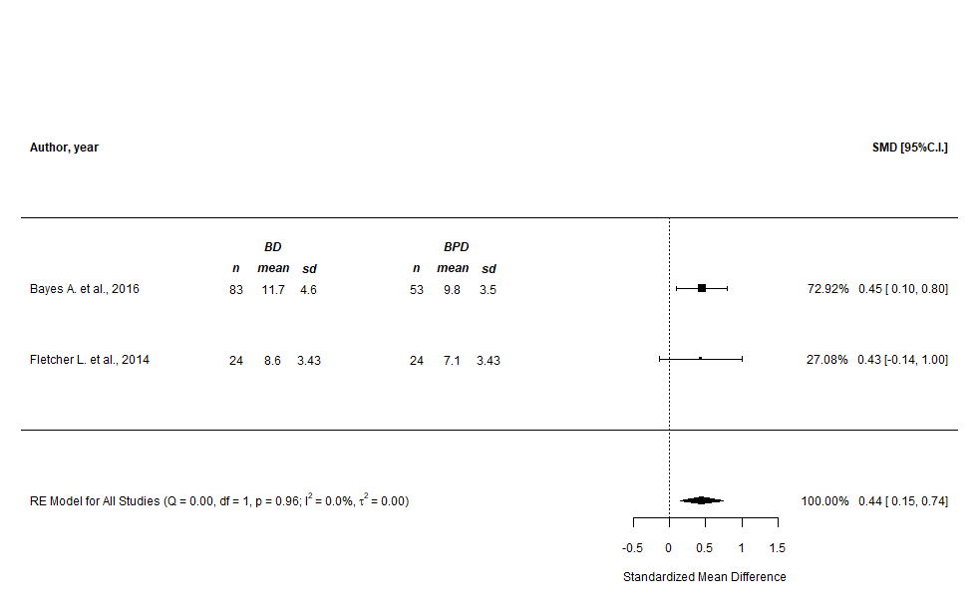

Supplementary Figure n.119 - CERQ “positive refocusing” subscale (prediction intervals)
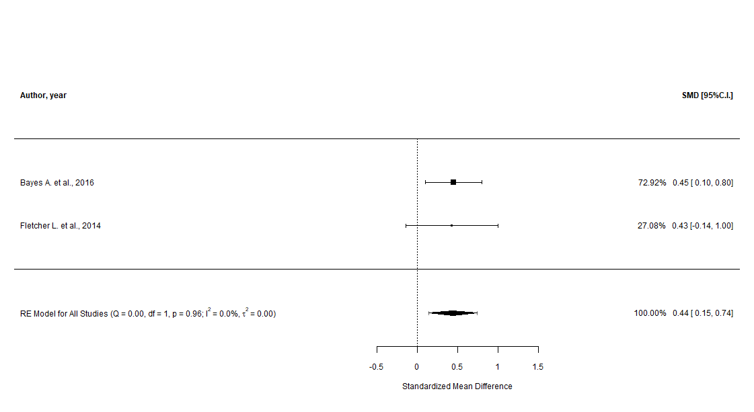

Supplementary Figure n.120 - CERQ “positive reappraisal” subscale (main analysis)
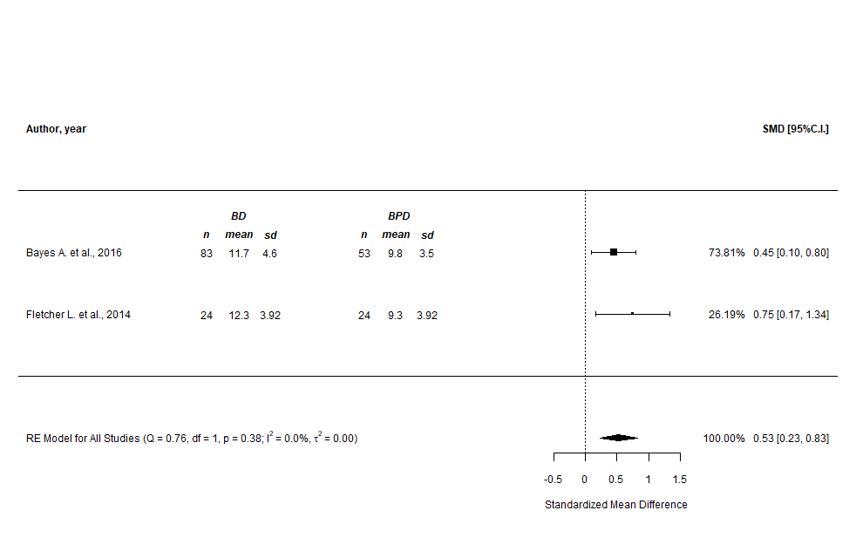

Supplementary Figure n.121 - CERQ “positive reappraisal” subscale (prediction intervals)
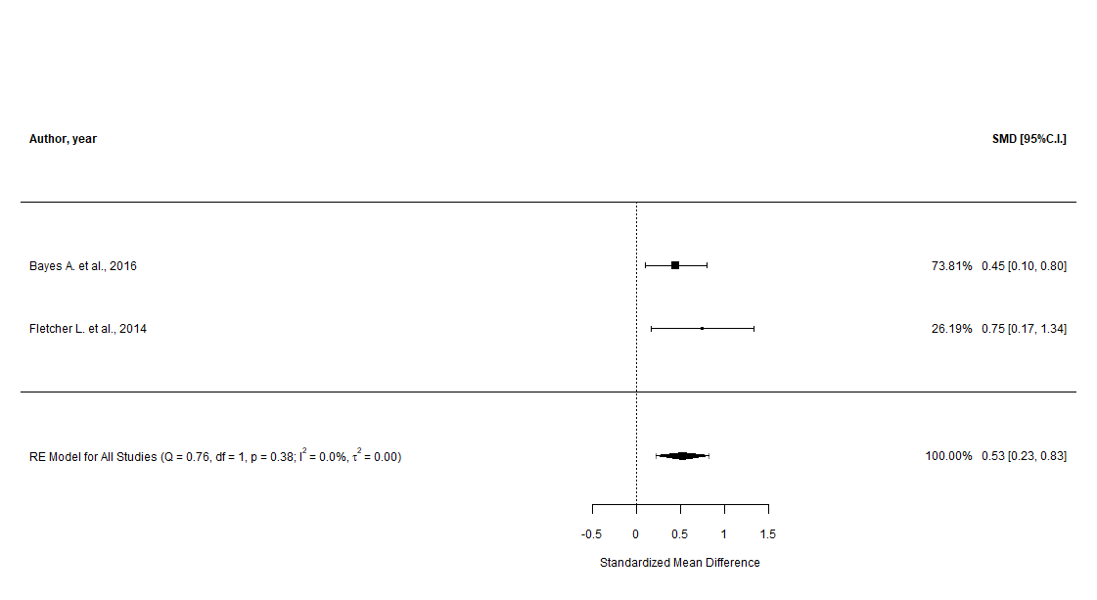

Supplementary Figure n.122 - CERQ “acceptance” subscale (main analysis)
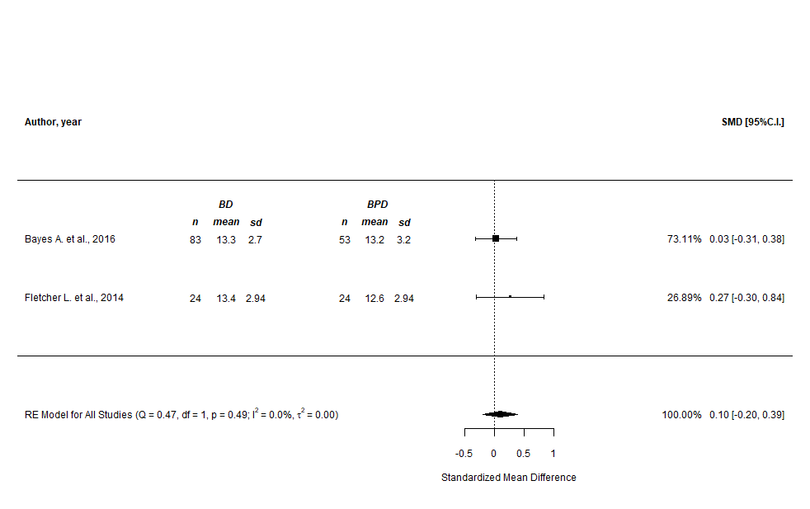

Supplementary Figure n.123 - CERQ “acceptance” subscale (prediction intervals)
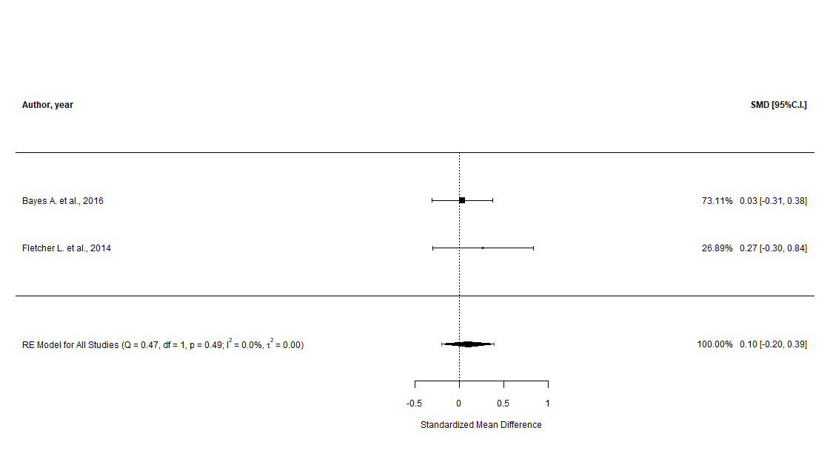

Supplementary Figure n.124 - CERQ “refocus on planning” subscale (main analysis)
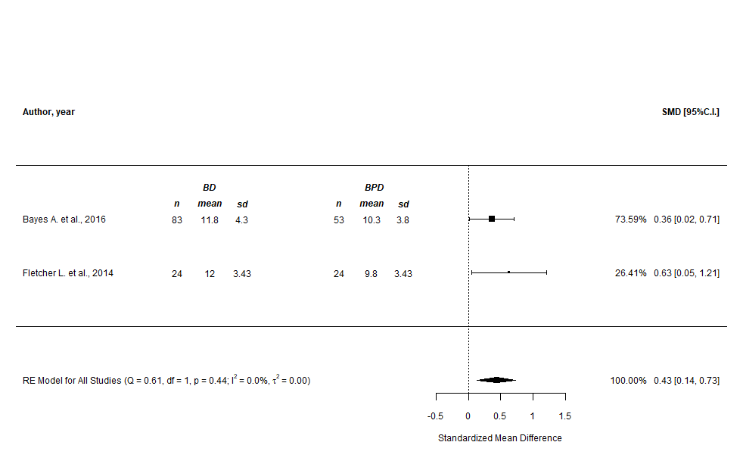

Supplementary Figure n.125 - CERQ “refocus on planning” subscale (prediction intervals)
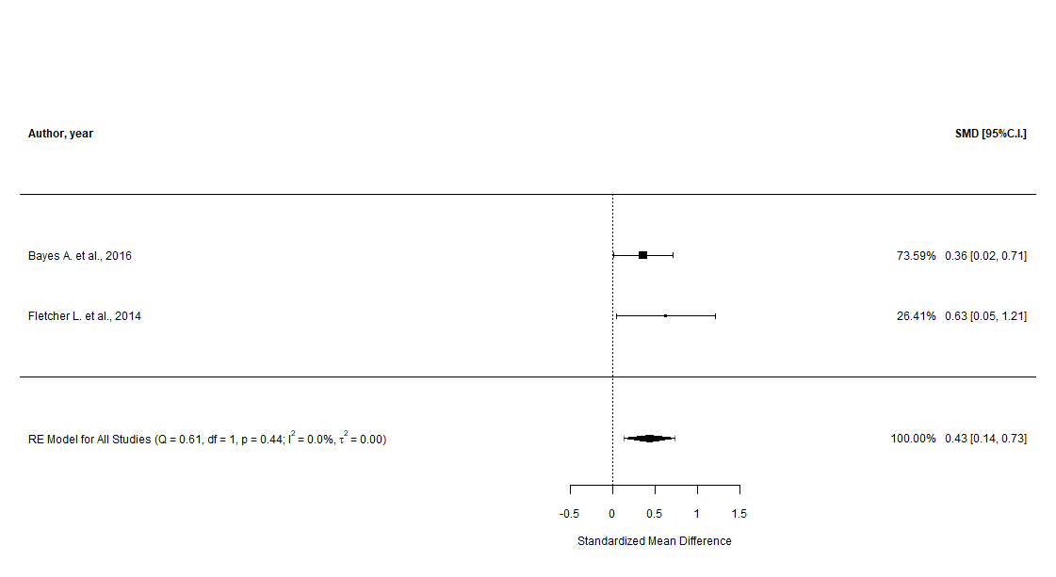

Difficulties in Emotion Regulation Scale, DERS (main, cumulative, and sensitivity analyses)

Supplementary Figure n.126 - DERS “total” score (main analysis)
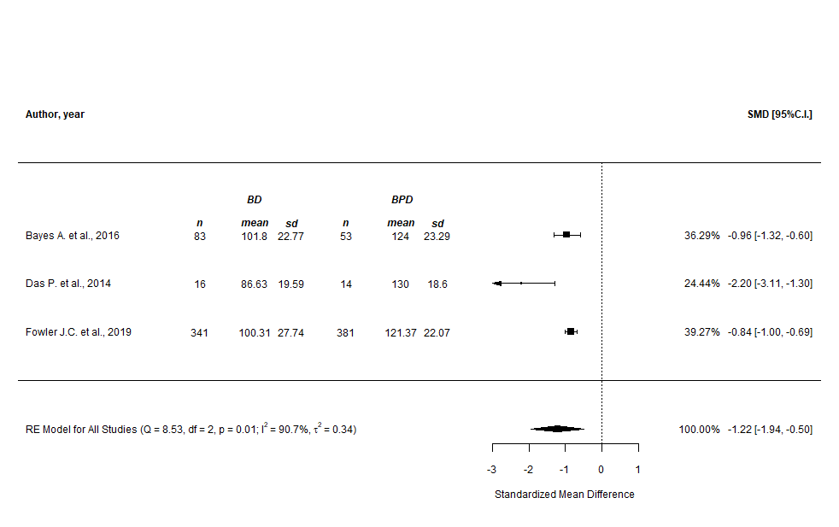

Supplementary Figure n.127 - DERS “total” score (prediction intervals)
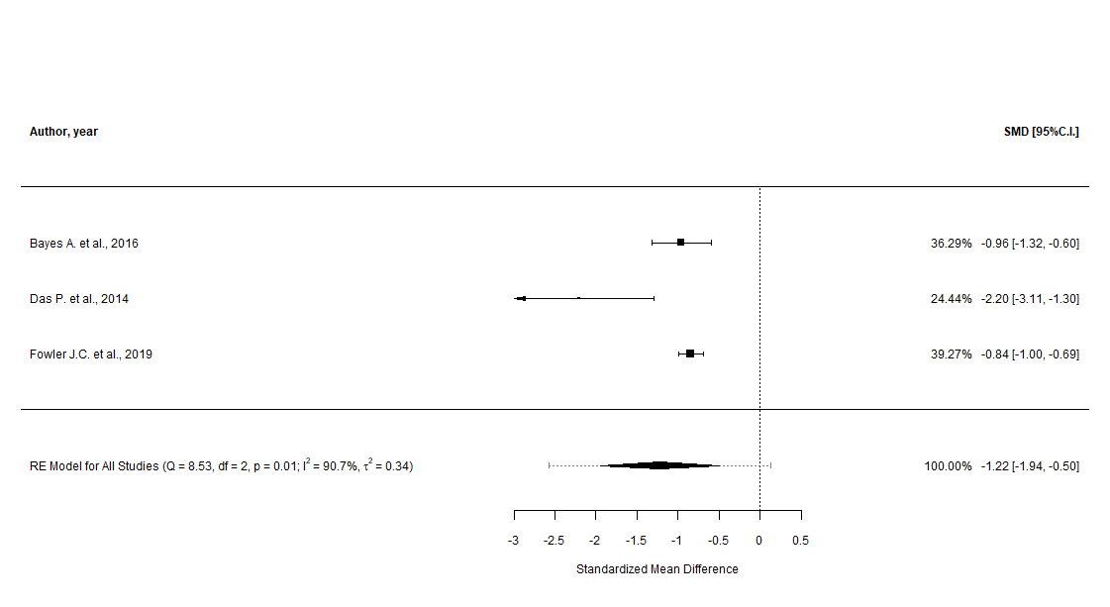

Supplementary Figure n.128 - DERS “total” score (cumulative analysis)
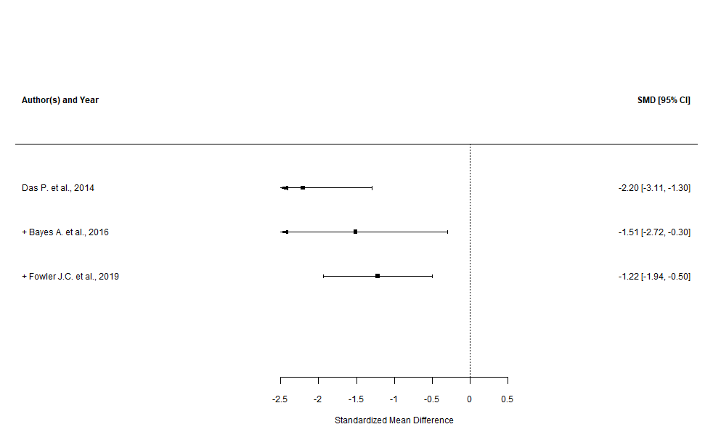

Supplementary Figure n.129 - DERS “total” score (leave-one-out sensitivity analysis)

Supplementary Figure n.130 - DERS “total” score (GOSH plots, overall and with “Das P. et al., 2014” highlighted)

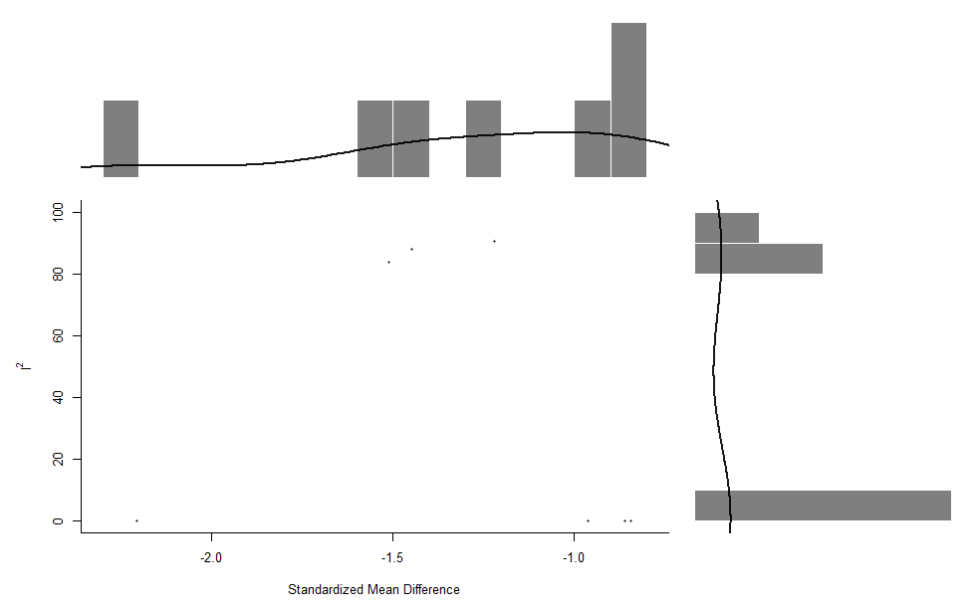
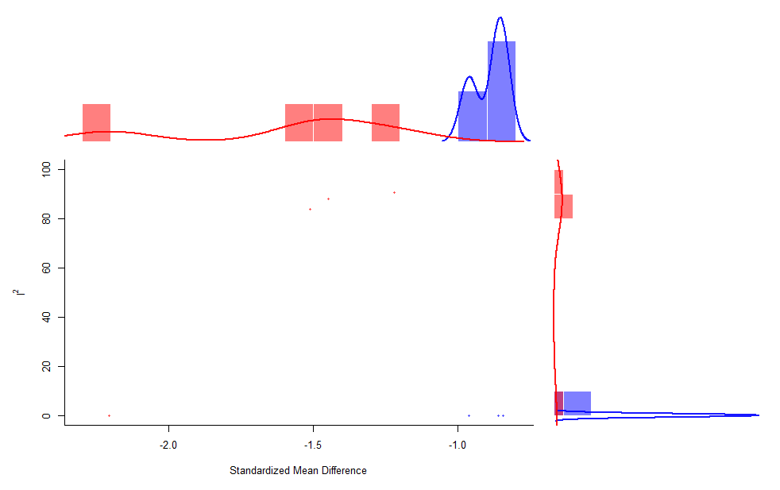

Supplementary Figure n.131 - DERS “non acceptance” subscale (main analysis)
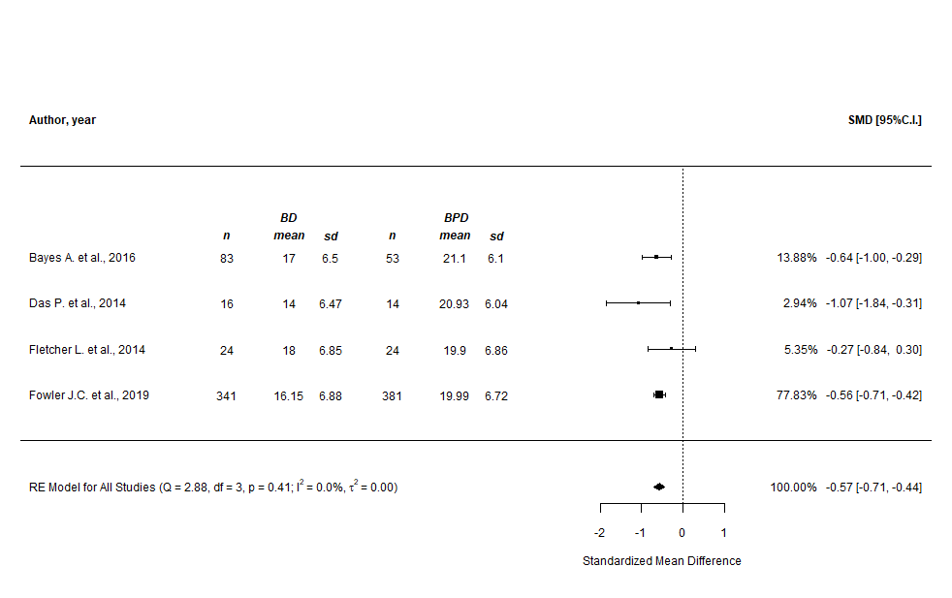

Supplementary Figure n.132 - DERS “non acceptance” subscale (prediction intervals)
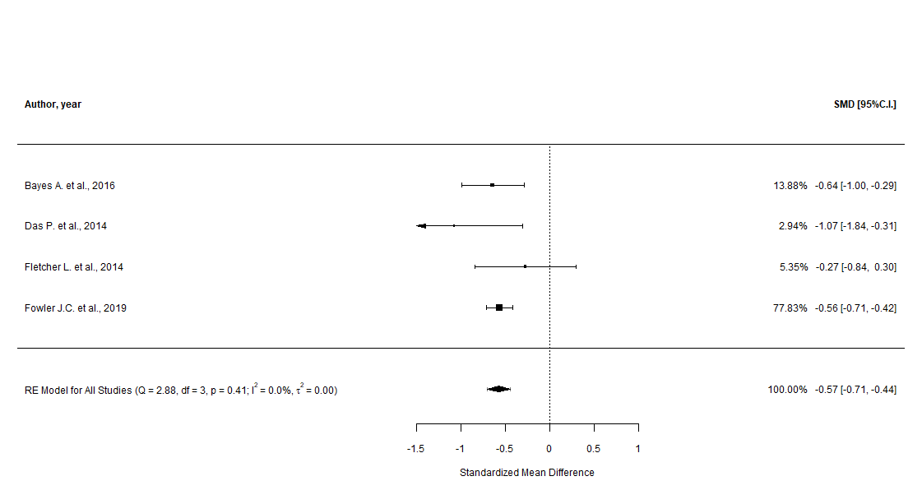

Supplementary Figure n.133 - DERS “non acceptance” subscale (cumulative analysis)
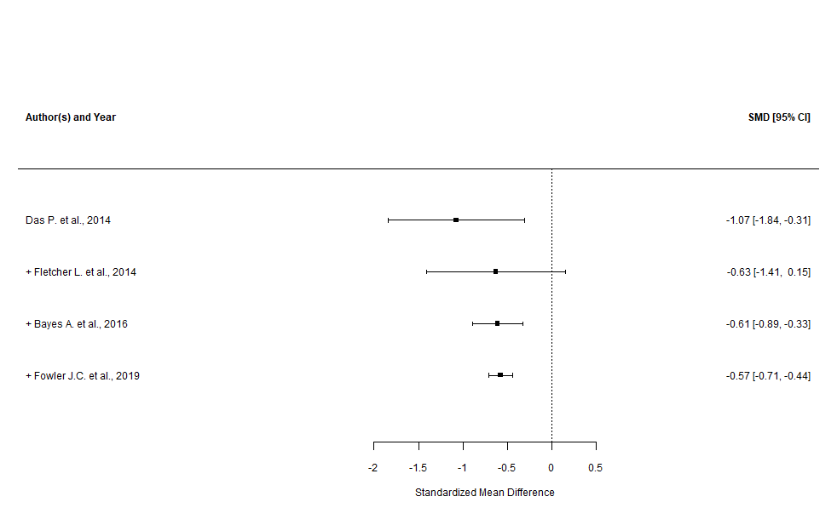

Supplementary Figure n.134 - DERS “non acceptance” subscale (leave-one-out sensitivity analysis)

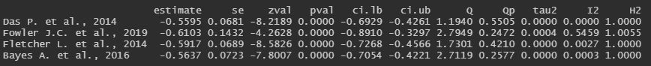

Supplementary Figure n.135 - DERS “non acceptance” subscale (GOSH plot)

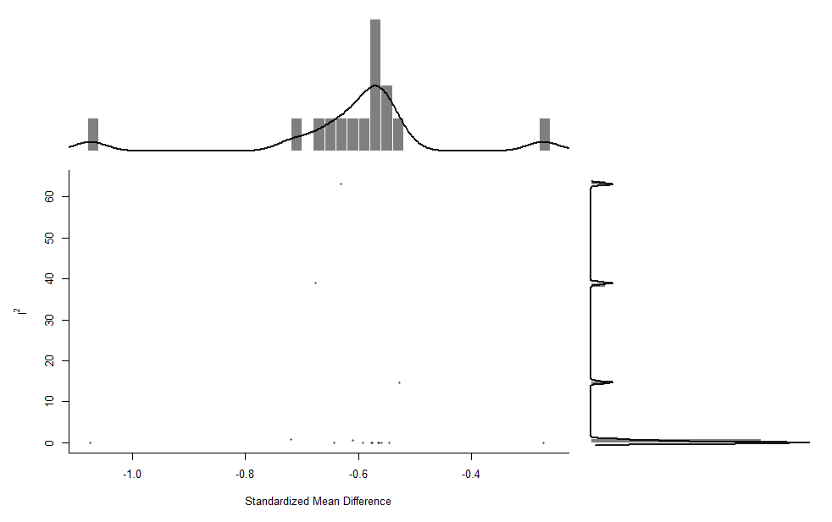

Supplementary Figure n.136 - DERS “goals” subscale (main analysis)
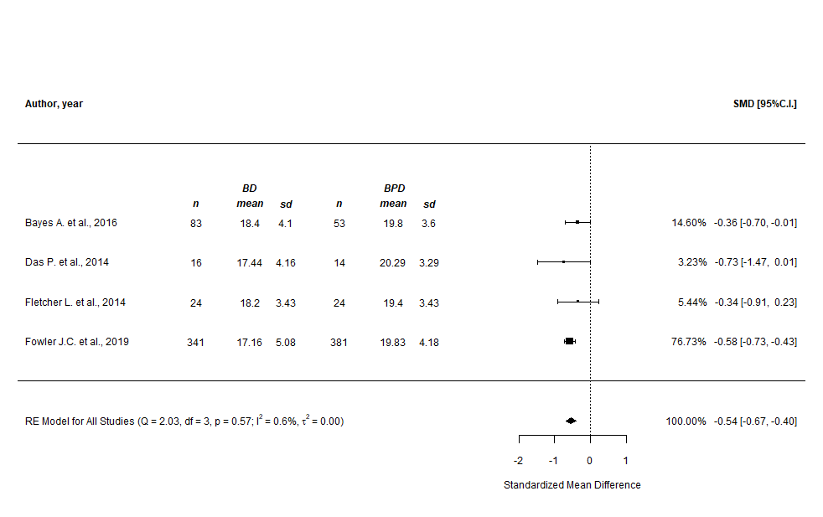
Supplementary Figure n.137 - DERS “goals” subscale (prediction intervals)
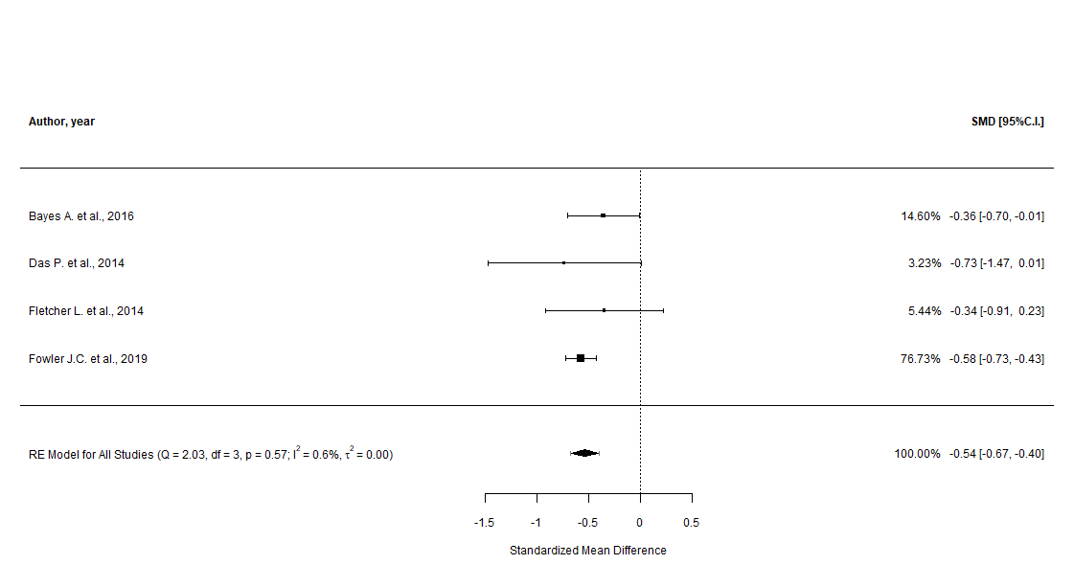

Supplementary Figure n.138 - DERS “goals” subscale (cumulative analysis)
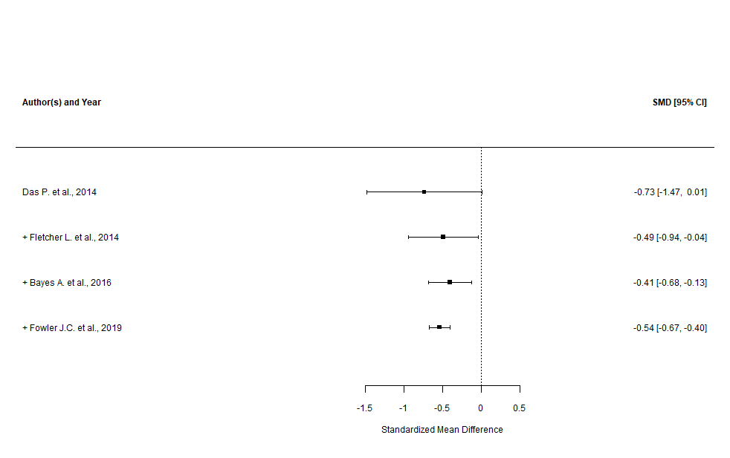

Supplementary Figure n.139 - DERS “goals” subscale (leave-one-out sensitivity analysis)

Supplementary Figure n.140 - DERS “goals” subscale (GOSH plot)

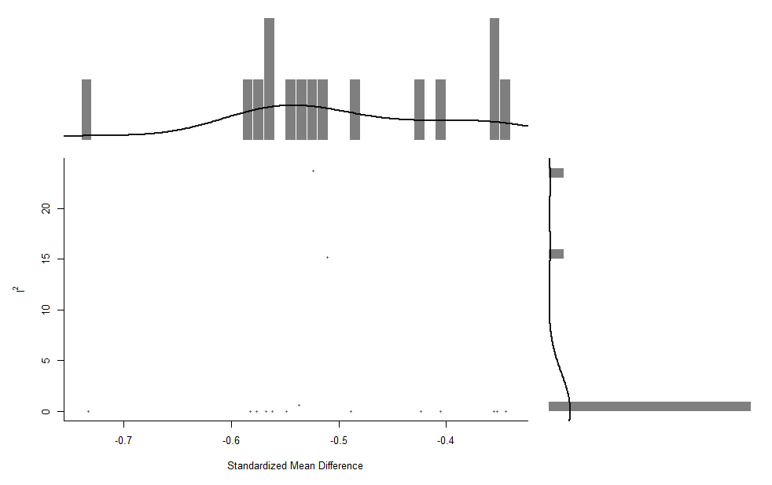

Supplementary Figure n.141 - DERS “impulse” subscale (main analysis)
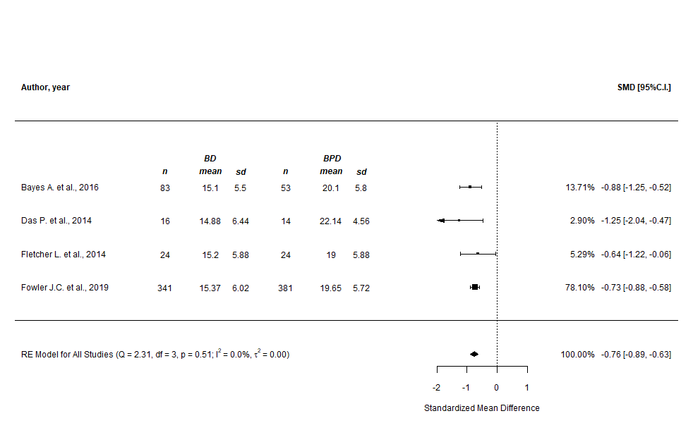

Supplementary Figure n.142 - DERS “impulse” subscale (prediction intervals)
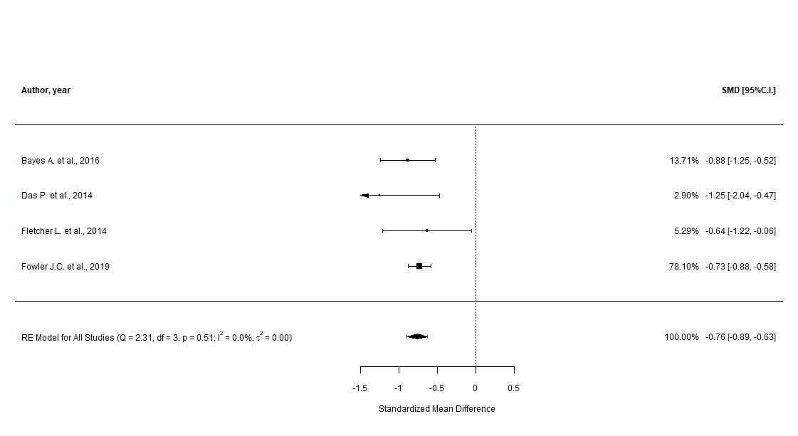

Supplementary Figure n.143 - DERS “impulse” subscale (cumulative analysis)
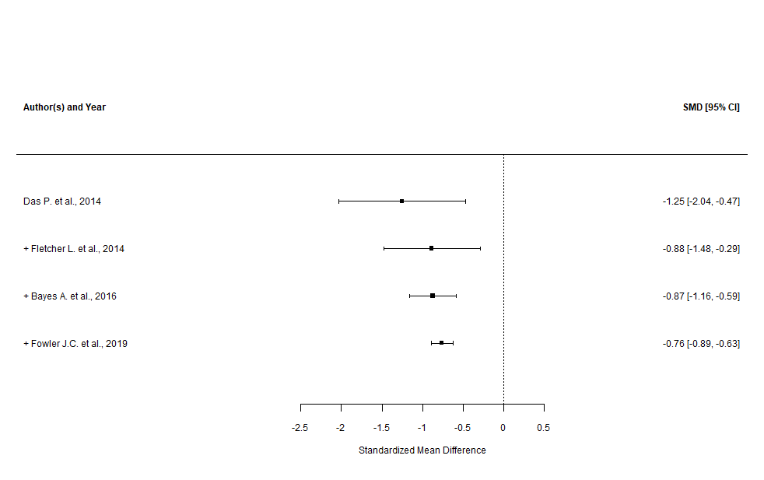

Supplementary Figure n.144 - DERS “impulse” subscale (leave-one-out sensitivity analysis)

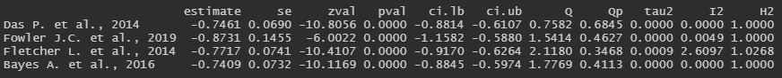

Supplementary Figure n.145 - DERS “impulse” subscale (GOSH plot)

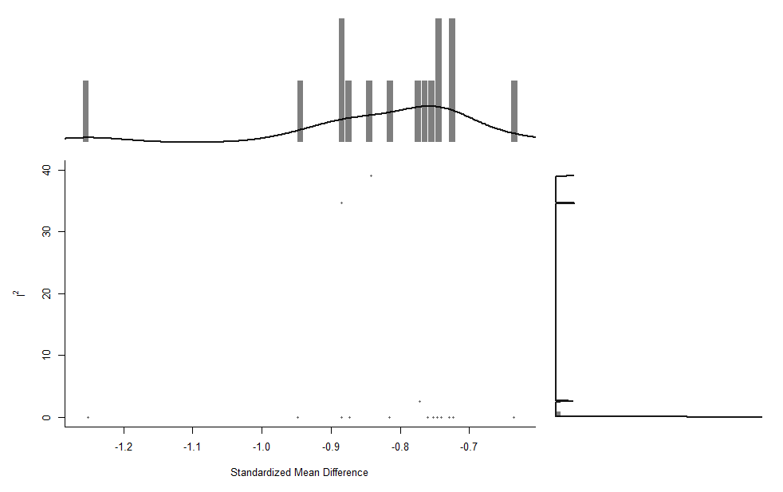

Supplementary Figure n.146 - DERS “awareness” subscale (main analysis)
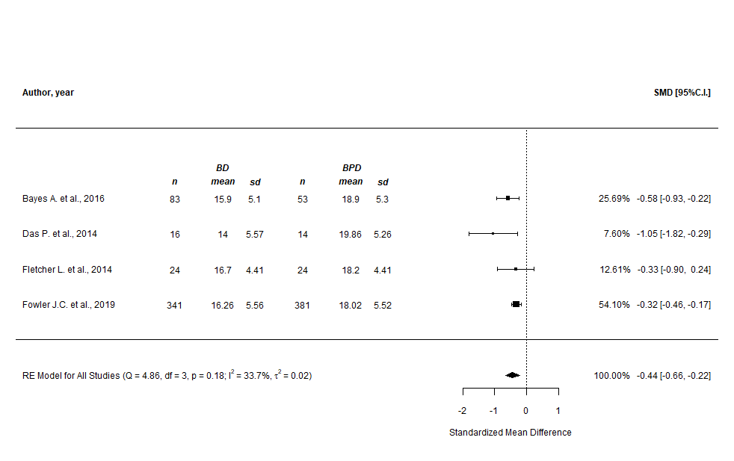
Supplementary Figure n.147 - DERS “awareness” subscale (prediction intervals)
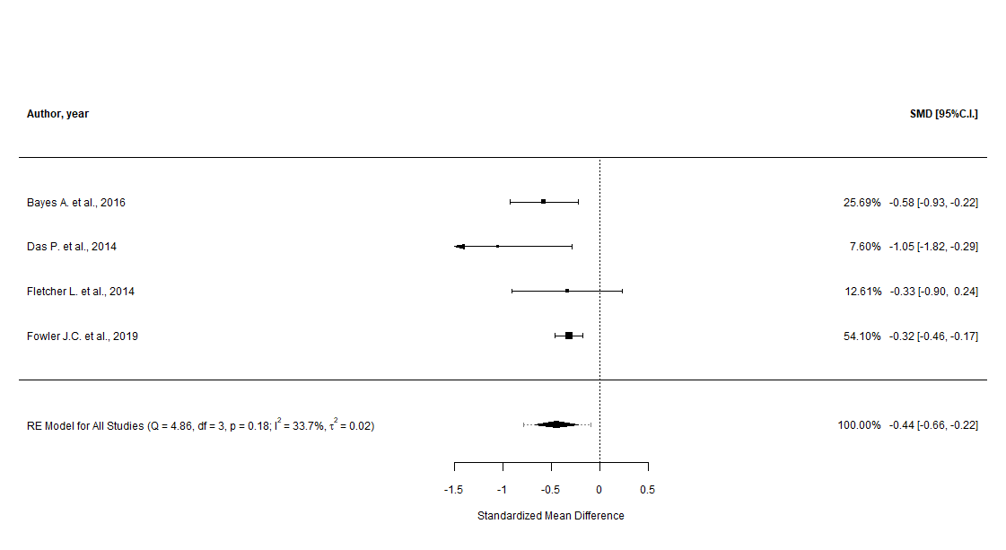

Supplementary Figure n.148 - DERS “awareness” subscale (cumulative analysis)
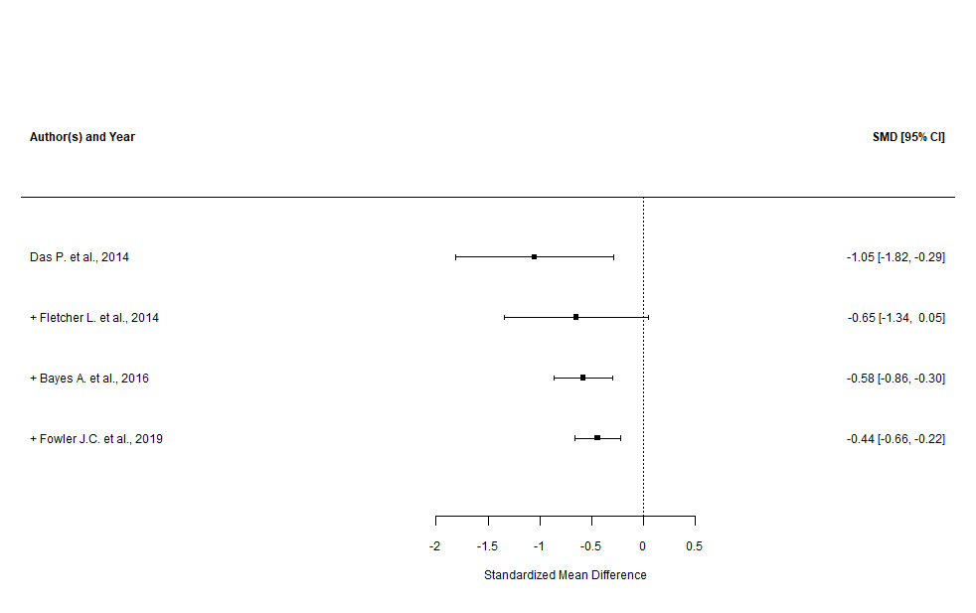

Supplementary Figure n.149 - DERS “awareness” subscale (leave-one-out sensitivity analysis)

Supplementary Figure n.150 - DERS “awareness” subscale (GOSH plot)

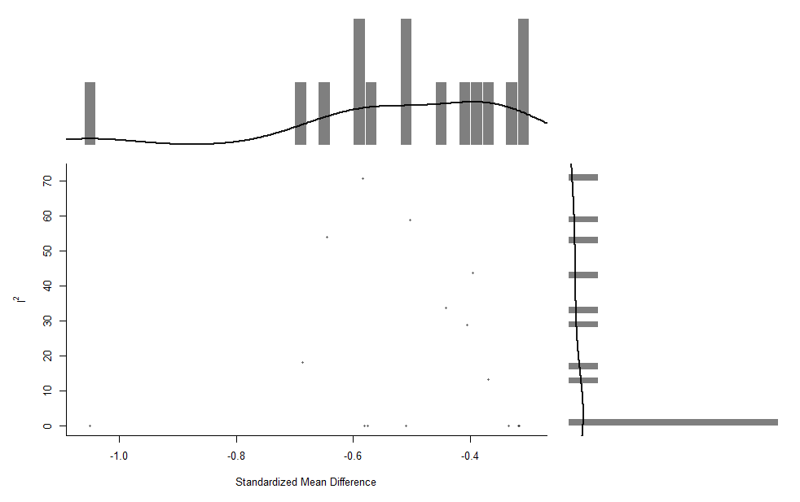

Supplementary Figure n.151 - DERS “strategies” subscale (main analysis)
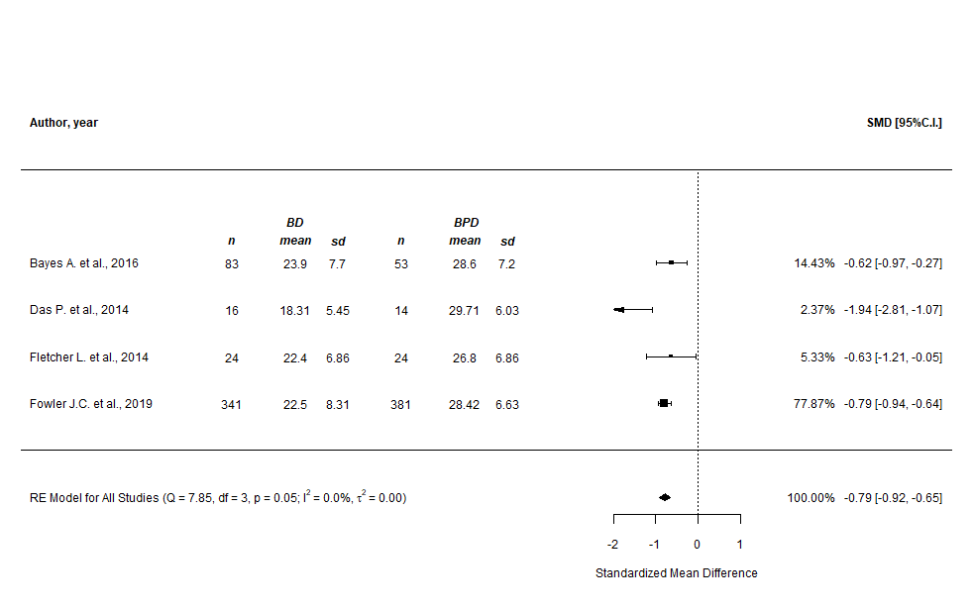
Supplementary Figure n.152 - DERS “strategies” subscale (prediction intervals)
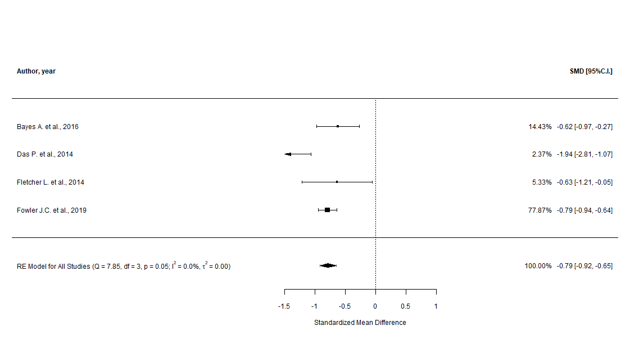

Supplementary Figure n.153 - DERS “strategies” subscale (cumulative analysis)
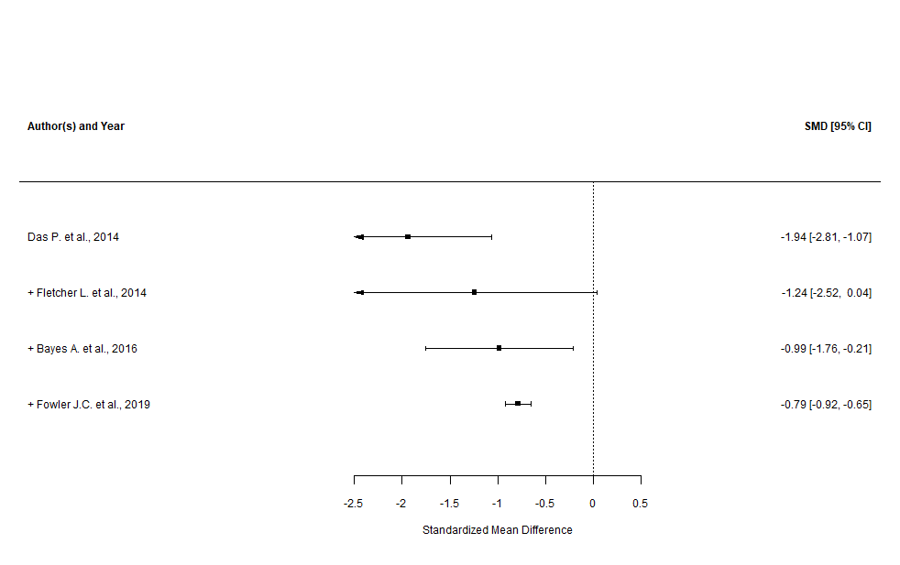
Supplementary Figure n.154 - DERS “strategies” subscale (leave-one-out sensitivity analysis)

Supplementary Figure n.155 - DERS “strategies” subscale (GOSH plots, overall and with “Das P. et al., 2014” highlighted)

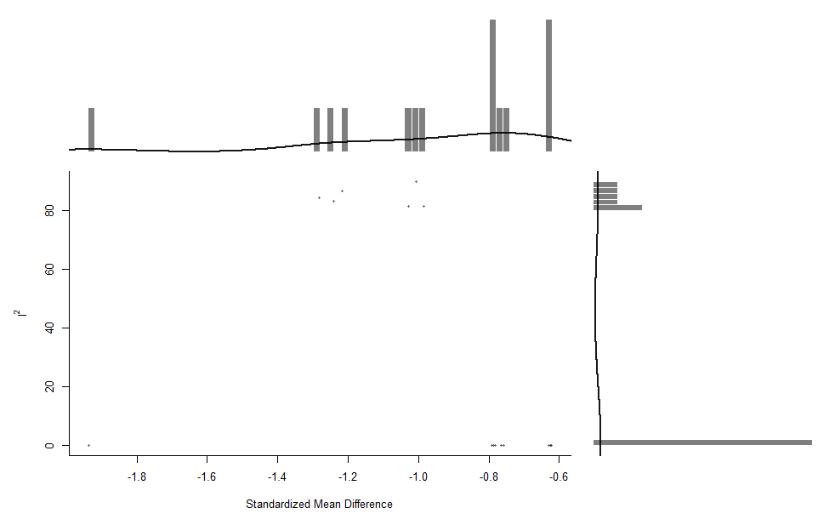

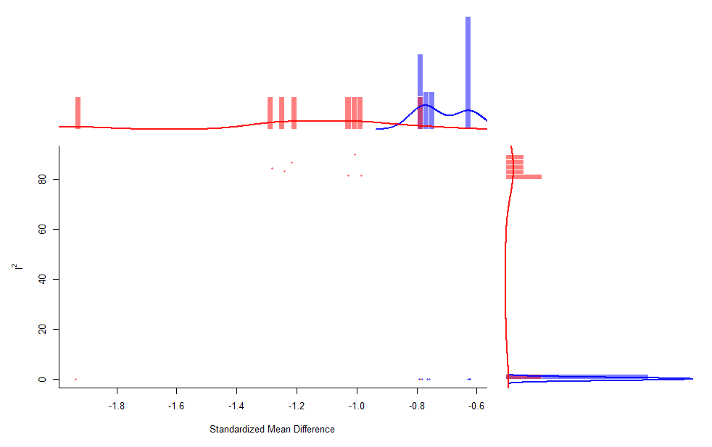
Supplementary Figure n.156 - DERS “clarity” subscale (main and subgroup analyses)
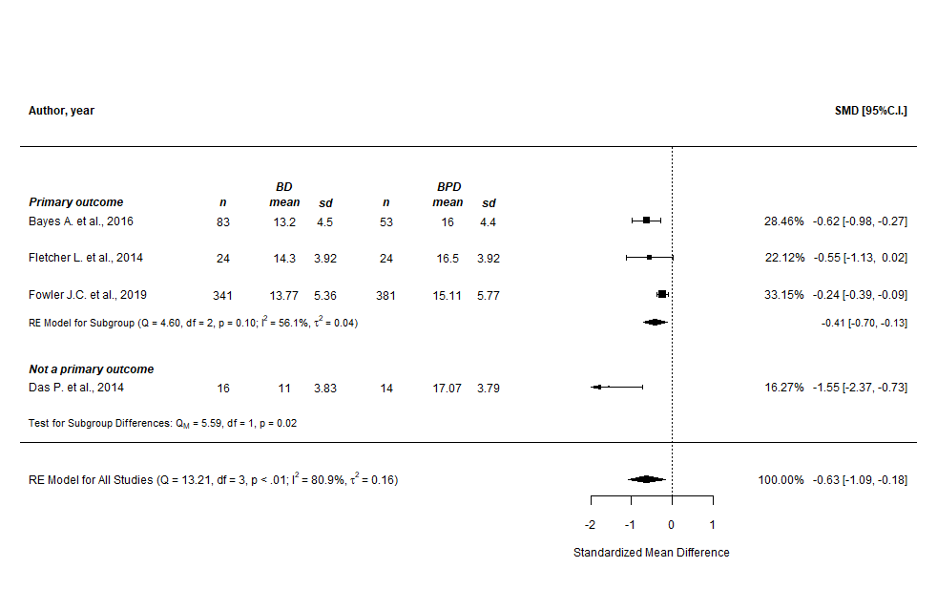

Supplementary Figure n.157 - DERS “clarity” subscale (prediction intervals)
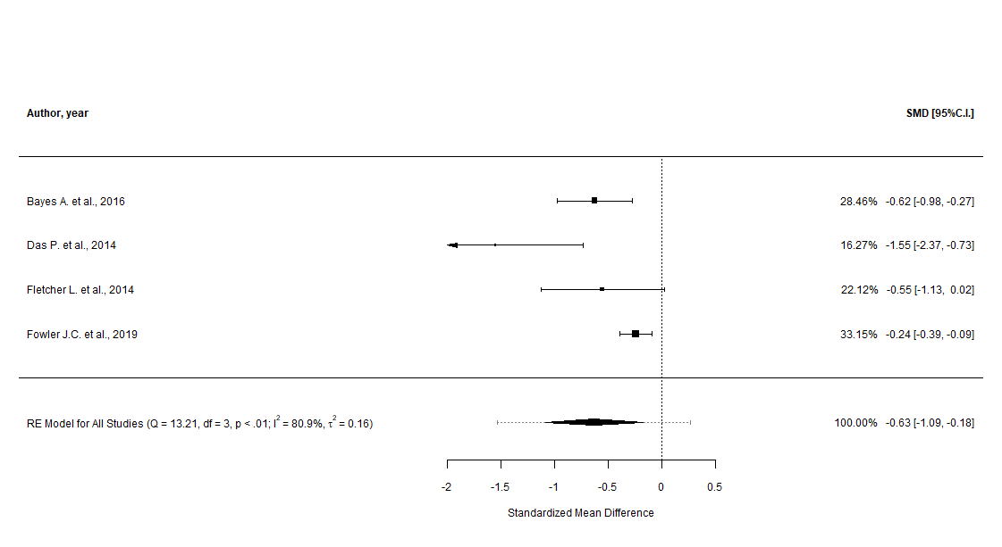

Supplementary Figure n.158 - DERS “clarity” subscale (cumulative analysis)
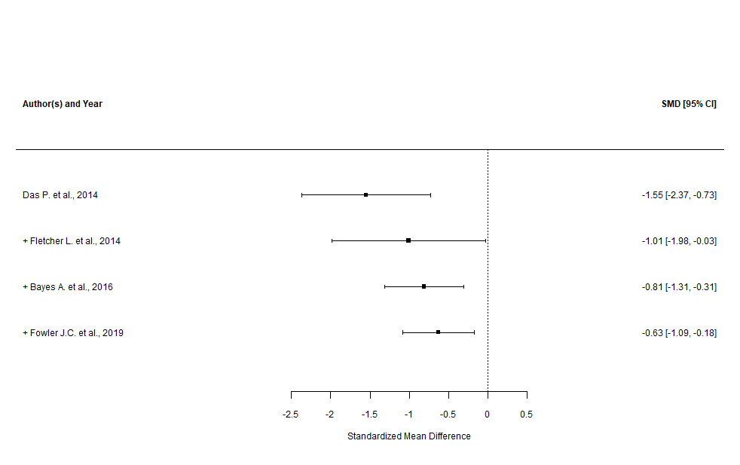

Supplementary Figure n.159 - DERS “clarity” subscale (leave-one-out sensitivity analysis)

Supplementary Figure n.160 - DERS “clarity” subscale (GOSH plot)

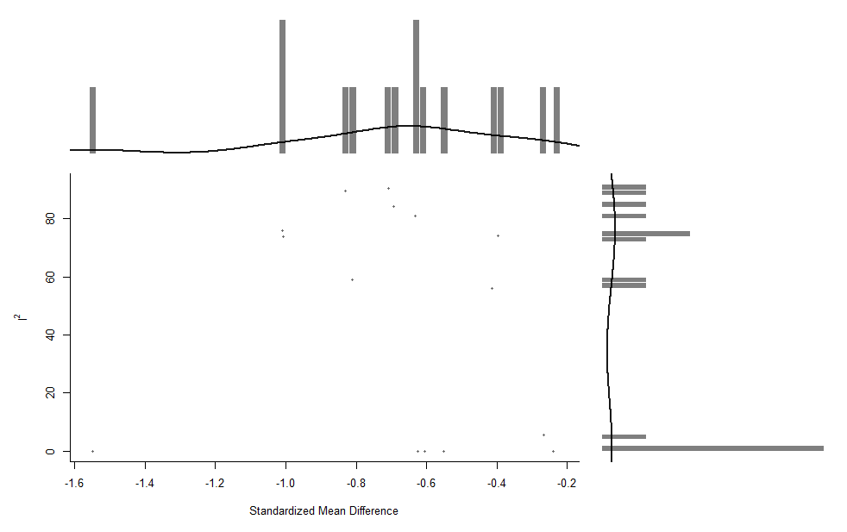

Control Group: Schizophrenia

Summary Table - Characteristics of the comparisons to people with schizophrenia included in the Systematic Review

Supplementary Table n.7 - Characteristics of the comparisons to people with schizophrenia included in the Systematic Review
Author, year, country | Study design | Description of the study and population characteristics | Diagnostic criteria | Outcome BD vs. HCs, mean±SD | Quality of the study (NOS)
CERQ (short version when indicated) - Cognitive Emotion Regulation Questionnaire
Rowland J. et al., 2013, Australia | Cross-sectional | 97 patients (mean age=51.3±12.1; %females=59) recruited from the Sidney Bipolar Disorder Clinic or from the Bipolar Disorder Family Study and diagnosed with BD-I, and 126 patients (mean age=45.5±11; %females=54) recruited from the Australian Schizophrenia Research Bank and diagnosed with SCZ* were evaluated to explore their differences in adopting adaptive and “maladaptive” emotion regulation strategies. In the present study, HCs were also included  *Less than 10% of data was not available for 31 patients diagnosed with BD or SCZ; authors replaced missing data with group median for each item | DSM-IV (DIGS) | Self-blame subscale: 11.86±4.3 vs. 10.96±3.27;  Blaming others subscale: 8.64±2.74 vs. 9.84±3.96;  Rumination subscale: 13.38±3.39 vs. 12.55±3.61;  Catastrophizing subscale: 9.46±3.64 vs. 10.39±3.99;  Putting into perspective subscale: 12.8±3.83 vs. 12.92±3.61;  Positive refocusing subscale: 9.93±4.07 vs. 10.97±3.6;  Positive reappraisal subscale: 13.3±4.06 vs. 13.6±3.77;  Acceptance subscale: 13.08±3.14 vs. 12.73±2.87;  Focus on replanning subscale: 13.23±3.39 vs. 13.4±3.42 | 6 / GOOD

Control Group: Attention Deficit Hyperactivity Disorder (ADHD)

Summary Table - Characteristics of the comparisons to people with ADHD included in the Systematic Review

Supplementary Table n.8 - Characteristics of the comparisons to people with ADHD included in the Systematic Review
Author, year, country | Study design | Description of the study and population characteristics | Diagnostic criteria | Outcome BD vs. ADHD, mean±SD | Quality of the study (NOS)
ERQ - Emotion Regulation Questionnaire
Kim K. et al., 2021, Republic of Korea | Cross-sectional | 19 patients diagnosed with BD-I (3) or BD-II (16) recruited at the psychiatric department of an university medical center  from February 2020 to March 2021, and 14 patients diagnosed with ADHD were asked to complete a clinical assessment to validate the ERQ, Korean version. People diagnosed with schizophrenia spectrum disorders, mood disorders with psychotic features, intellectual disability, or neurocognitive disorders were excluded. In the present study, people diagnosed with PTSD or MDD were also included | DSM-5 (SCID-5) | Reappraisal subscale: 19.32±7.7 vs. 17.36±7.13;  Suppression subscale: 14.32±6.28 vs. 18.36±6.87 | 4 / POOR
RIPoSt-40 - Reactivity, Intensity, Polarity and Stability questionnaire
Masi G. et al., 2021, Italy | Cross-sectional | 49 young patients (mean age=14.9±1.8; %females=66) diagnosed with Bipolar spectrum disorder and 72 patients (mean age=12.9±2.2; %females=14) diagnosed with ADHD were evaluated to compare the differences in emotion regulation between the groups. . People with a diagnosis of autism spectrum disorder or schizophrenia spectrum and other psychotic disorders, and the presence of comorbid intellectual disability were excluded. In the present study, a non-clinical sample was also included | DSM-5 (K-SADS-PL) | Affective instability subscale: 41.4±14.3 vs. 30.7±9.8;  Emotional impulsivity subscale: 28±9.6 vs. 25.3±7.5;  Negative emotionality subscale: 37.6±12.7 vs. 27.4±7.9;  Positive emotionality subscale: 36.8±12.7 vs. 37.8±9.4;  Negative emotion dysregulation composite subscale: 107.1±33 vs. 83.4±21.5 | 5 / FAIR
RIPoSt-Y - Reactivity, Intensity, Polarity and Stability questionnaire, Youth version
Sesso G. et al., 2021, Italy | Cross-sectional | 44 in- and young outpatients (mean age=15.2±1.6; %females=71) diagnosed with Bipolar spectrum disorder and 34 patients (mean age=14.8±1.7; %females=18) diagnosed with ADHD were asked to complete a clinical assessment to validate the scale RIPoSt-Y. Patients presented severe irritability with temper outbursts, mood lability and instability, low tolerance to frustration and low reactivity threshold, inappropriate expression of emotions with excessive intensity, and slow affective normalization. People with a diagnosis of autism spectrum disorder or schizophrenia spectrum and other psychotic disorders, and the presence of comorbid intellectual disability were excluded. In the present study, a non-clinical sample was also included | DSM-5 (K-SADS-PL) | Affective instability subscale: 58.35±18.54 vs. 46.12±15.14;  Positive emotionality subscale: 32.18±8.41 vs. 33.65±8.63;  Emotional reactivity subscale: 24.15±7.87 vs. 24.09±7.78;  Interpersonal sensitivity subscale: 28.03±9.8 vs. 22.76±6.6 | 5 / FAIR

Control Group: Anxiety Disorders

Summary Table - Characteristics of the comparisons to people with anxiety disorders included in the Systematic Review

Supplementary Table n.9 - Characteristics of the comparisons to people with anxiety disorders included in the Systematic Review
Author, year, country | Study design | Description of the study and population characteristics | Diagnostic criteria | Outcome BD vs. Anxiety Disorders, mean±SD | Quality of the study (NOS)
DERS - Difficulties in Emotion Regulation Scale
Becerra R. et al., 2013, Australia | Cross-sectional | 48 patients (mean age=44.9±11.6) recruited from a private psychiatrist, clinical psychologist, or as part of an ongoing study and diagnosed with BD, and 50 patients (mean age=44.1±11.7) with anxiety disorders were evaluated to explore the differences in emotion regulation difficulties. People with BD were euthymic (34) or mildly depressed (14). In the present study, HCs and people diagnosed with MDD were also included | ICD-10 | Total score: 93.42±22.59 vs. 105.52±29.65;  Non-acceptance subscale: 15.08±5.71 vs. 18.14±6.12;  Goals subscale: 16.71±4.73 vs. 17.24±5.52;  Impulse subscale: 13.75±4.8 vs. 16.14±6.44;  Awareness subscale: 15.46±4.97 vs. 17.78±5.06;  Strategies subscale: 19.15±6.51 vs. 20.91±8.41;  Clarity subscale: 13.27±4.84 vs. 15.96±5.52 | 4 / POOR
RRS - Ruminative Response Scale
Kim S. et al., 2012, Republic of Korea | Cross-sectional | 157 in- and outpatients recruited from November 2007 to August 2010 and diagnosed with BD-I (68), BD-II (52), or BD-NOS (37), and 65 in- and outpatients with panic disorder were evaluated to investigate the extension of rumination and its differences among the groups. Patients with mood disorders and comorbid anxiety disorders, as well as patients with anxiety disorders and comorbid mood disorders, were excluded. In the present study, people diagnosed with MDD were also included | DSM-IV (SCID) | Total score: 54.17±19.1 vs. 36.82±9.48;  Brooding subscale: 12.65±3.6 vs. 9.35±2.27;  Reflective pondering subscale: 11.35±3.74 vs. 7.53±2.65 | 6 / GOOD

Control Group: Post-Traumatic Stress Disorder

Summary Table - Characteristics of the comparisons to people with post-traumatic stress disorder included in the Systematic Review

Supplementary Table n.10 - Characteristics of the comparisons to people with post-traumatic stress disorder included in the Systematic Review
Author, year, country | Study design | Description of the study and population characteristics | Diagnostic criteria | Outcome BD vs. PTSD, mean±SD | Quality of the study (NOS)
ERQ - Emotion Regulation Questionnaire
Kim K. et al., 2021, Republic of Korea | Cross-sectional | 19 patients diagnosed with BD-I (3) or BD-II (16) recruited at the psychiatric department of an university medical center  from February 2020 to March 2021, and 12 patients diagnosed with PTSD were asked to complete a clinical assessment to validate the ERQ, Korean version. People diagnosed with schizophrenia spectrum disorders, mood disorders with psychotic features, intellectual disability, or neurocognitive disorders were excluded. In the present study, people diagnosed with MDD, or ADHD were also included | DSM-5 (SCID-5) | Reappraisal subscale: 19.32±7.7 vs. 25.58±8.03;  Suppression subscale: 14.32±6.28 vs. 19.08±6.49 | 4 / POOR

Quality appraisal of studies included in the Systematic Review and Meta-analysis

Supplementary Table n.11 - Quality appraisal of studies included in the Systematic Review and Meta-analysis
Author, year | Representativeness of the sample | Sample Size | Non-respondents | Ascerteinment of the exposure | Comparability | Assessment of the outcome | Statistical Test | TOTAL | AHRQ Standards
Ambrosi E. et al., 2017 | 1 | 0 | 0 | 2 | 2 | 1 | 1 | 7 | GOOD
Ariana Kia E. et al., 2014 | 0 | 0 | 0 | 2 | 0 | 1 | 1 | 4 | POOR
Aslan I.H. et al., 2021 | 0 | 0 | 0 | 2 | 1 | 1 | 1 | 5 | FAIR
Batmaz S. et al., 2014 | 1 | 0 | 0 | 0 | 1 | 1 | 1 | 4 | POOR
Bayes A. et al., 2016 | 0 | 0 | 0 | 2 | 1 | 1 | 1 | 5 | FAIR
Becerra R. et al., 2013 | 1 | 0 | 0 | 0 | 1 | 1 | 1 | 4 | POOR
Becerra R. et al., 2016 | 0 | 0 | 0 | 2 | 1 | 1 | 1 | 5 | FAIR
Das P. et al., 2014 | 0 | 0 | 0 | 2 | 0 | 1 | 1 | 4 | POOR
Fletcher K. et al., 2013 | 0 | 0 | 0 | 2 | 0 | 1 | 1 | 4 | POOR
Fletcher L. et al., 2014 | 1 | 0 | 0 | 2 | 1 | 1 | 1 | 6 | GOOD
Fowler J.C. et al., 2019 | 1 | 0 | 0 | 2 | 0 | 1 | 1 | 5 | POOR
Gilbert K.E. et al., 2013 | 0 | 1 | 1 | 0 | 1 | 0 | 1 | 0 | POOR
Kim K. et al., 2021 | 0 | 0 | 0 | 2 | 0 | 1 | 1 | 4 | POOR
Kim S. et al., 2012 | 1 | 0 | 0 | 2 | 1 | 1 | 1 | 6 | GOOD
Kjaerstad H.L. et al., 2016 | 0 | 0 | 0 | 0 | 1 | 1 | 1 | 3 | POOR
Lois G. et al., 2017 | 1 | 0 | 0 | 2 | 2 | 1 | 1 | 7 | GOOD
Marwaha S. et al., 2018 | 1 | 0 | 0 | 0 | 1 | 1 | 1 | 4 | POOR
Masi G. et al., 2021 | 0 | 0 | 0 | 2 | 1 | 1 | 1 | 5 | FAIR
Murray J.R. et al., 2021 | 1 | 0 | 0 | 2 | 2 | 1 | 1 | 7 | GOOD
Musket C.W. et al., 2021 | 0 | 1 | 0 | 2 | 1 | 1 | 1 | 6 | GOOD
Oymak Yenilmez D. et al., 2021 | 0 | 0 | 0 | 2 | 1 | 1 | 1 | 5 | FAIR
Perich T. et al., 2011 | 0 | 0 | 0 | 2 | 2 | 1 | 1 | 6 | FAIR
Rowland J. et al., 2013 | 1 | 0 | 0 | 2 | 1 | 1 | 1 | 6 | GOOD
Sesso G. et al., 2021 | 0 | 0 | 0 | 2 | 1 | 1 | 1 | 5 | FAIR
Shapero B.G. et al., 2015 | 1 | 0 | 0 | 2 | 1 | 1 | 1 | 6 | GOOD
Van Meter A.R. et al., 2016 | 0 | 0 | 0 | 2 | 2 | 1 | 1 | 6 | FAIR
Weinstock L.M. et al., 2018 | 0 | 0 | 0 | 2 | 1 | 1 | 1 | 5 | FAIR
Weintraub M.J. et al., 2017 | 1 | 0 | 0 | 2 | 1 | 1 | 1 | 6 | GOOD
Wolkenstein L. et al., 2013 | 0 | 0 | 0 | 2 | 0 | 1 | 1 | 4 | POOR

Excluded studies, with reason

Supplementary Table n.12 - Excluded studies, with reason

Alloy L.B. et al., 2009 | Not stratified results according to diagnoses
Apfelbaum S. et al., 2013 | No ED scale
Barton J. et al., 2021 | No control group
Bayes A. et al., 2021 | No ED scale results; Same sample of another study
Bayes A.J. et al., 2019 | No ED scale
Bebko G. et al., 2014 | Unrelated to our research topic
Benti L. et al., 2014 | No ED scale
Bernabei L. et al., 2018 | No ED scale results
Biederman J. et al., 2013 | No ED scale
Biederman J. et al., 2015 | No ED scale
Bilderbeck A.C. et al., 2016 | No control group; No ED scale
Carpenter R.W. et al., 2020 | No stratified results according to diagnoses; No ED scale results
Carruthers S.P., 2022 | No control group
Caruso D. et al., 2019 | Poster
Choppin S. et al., 2016 | No ED scale
DelBello M.P. et al., 2021 | Poster
Edge M.D. et al., 2013 | No control group
Ellard K.K. et al., 2017 | No control group
Favre P. et al., 2015 | No ED scale
Fleck D.E. et al., 2018 | No ED scale
Fletcher K. et al., 2014 | No control group
Fowler J.C. et al., 2016 | No stratified results according to diagnoses
Gay M.C. et al., 2019 | No Diagnostic criteria or structured interview; No reliable control group; No ED scale results
Green M.J., 2011 | No control group
Gruber J. et al., 2008 | No control group
Gruber J. et al., 2013 | No ED scale
Gruber J. et al., 2014 | No ED scale
Gul A. et al., 2014 | No ED scale results
Ha T.H. et al., 2018 | Poster
Hafeman D.M. et al., 2020 | No BD diagnosis
Hanssen I. et al., 2018 | No Diagnostic criteria or structured interview
Hassani J. et al., 2016 | No control group
Hay A.C. et al., 2015 | No ED scale
Ives-Deliperi V.L. et al., 2013 | No control group
Johnson S.L. et al., 2008 | No stratified results according to diagnoses
Johnson S.L. et al., 2016 (a) | No control group
Johnson S.L. et al., 2016 (b) | No control group
Johnson S.L. et al., 2017 | No ED scale results; not stratified results according to diagnoses
Jones S.H. et al., 2006 | Unrelated to our research topic
Kanske P. et al., 2015 | No control group
Kearns N.P. et al., 2015 | Not stratified results according to diagnoses
Kebets V. et al., 2021 | No ED scale
Kelman J. et al., 2021 | No control group
Khosravani V. et al., 2021 | No control group
Kim J. et al., 2020 | Poster
Kjaerstad H.L. et al., 2019 | No ED scale
Kullen K.R. et al., 2013 | Poster
Lee J. et al., 2013 | Unrelated to our research topic
Linke J.O. et al., 2020 | No control group
Liu X. et al., 2009 | No stratified results according to diagnoses
Malhi G.S., 2015 | Poster
Malhi G.S., 2015 | Duplicate
Martin K. et al., 2015 | Poster
Martin K. et al., 2016 | Same sample of another study
Martyn F.M. et al., 2020 | Poster
Masi G. et al., 2015 | Unrelated to our research topic
Mathieu F. et al., 2014 | No control group
McElroy S.E. et al., 2016 | Unrelated to our research topic
McGrogan C.L. et al., 2021 | Unrelated to our research topic
Millett C. et al., 2021 | Poster
Minciuna M.M. et al. | Poster
Muhtadie L. et al., 2014 | No control group
Mula M. et al., 2009 | Unrelated to our research topic
Muralidharan A. et al., 2015 | Unrelated to our research topic
Najt P. et al., 2016 | No ED scale
Nelson E.E. et al., 2007 | No ED scale
Nespie J. et al., 2012 | No ED scale
O' Garro-Moore J.K. et al., 2014 | Poster
Oh D.H. et al., 2014 | Poster
Oh D.H. et al., 2019 | No control group
Palagini L. et al., 2017 (a) | Poster
Palagini L. et al., 2017 (b) | Poster
Palagini L. et al., 2019 | No control group
Park J. et al., 2014 | No ED scale
Pavlickova H. et al., 2013 | No control group
Peckam A.D. et al., 2016 | No control group
Peckham A.D. et al., 2016 | No control group
Peckham A.D. et al., 2019 | No control group
Perugi G. et al., 2013 | Unrelated to our research topic
Pisano S. et al., 2021 | No ED scale
Pisano S. et al., 2021 | Duplicate
Plagini L. et al., 2018 | Poster
Plagini L. et al., 2019 | No control group
Reilly-Harrington N.A. et al., 2010 | No control group
Rive M.M. et al., 2015 | Abstract only
Romosan R. et al | Poster
Rowland J.E. et al., 2013 | Same sample of another study
Ruhe H. et al., 2015 | Poster
Saglam F. et al., 2020 | Same sample of another study
Saglam F. et al., 2020 | No control group
Sankar A. et al., 2020 | No ED scale
Scavone A. et al., 2015 | Poster
Scheuch K. et al., 2010 | No control group
Schonfelder S. et al., 2013 | Poster
Stange J.P. et al., 2015 | No control group
Steel C. et al., 2016 | Unrelated to our research topic
Szmulewicz A.G. et al., 2019 | No ED scale; No control group
Tas H.I. et al., 2020 | No BD diagnosis
Thomas J. et al., 2007 | No control group
Tseng M.M. et al., 2017 | No ED scale; BD comorbid with ED
Van der Gucht E. et al., 2009 | No control group
Van Rheenen T.E. et al., 2014 (a) | Unrelated to our research topic
Van Rheenen T.E. et al., 2014 (b) | No ED scale results
Van Rheenen T.E. et al., 2015 | No control group
Van Rheenen T.E. et al., 2020 | No control group
Velotti P. et al., 2020 | No Diagnostic criteria or structured interview; No reliable control group
Victor S.E. et al., 2011 | No control group
Walshaw P.D. et al., 2010 | Review
Wilens T.E. et al., 2013 | Unrelated to our research topic
Yelland C. et al., 2015 | Unrelated to our research topic
Yu H. et al., 2020 | No ED scale
Zhang I. et al., 2017 | No control group

PRISMA 2020 Checklist

Supplementary Table n.13 - PRISMA 2020 Checklist
1Section and Topic | Item # | Checklist item | Location where item is reported
TITLE
Title | 1 | Identify the report as a systematic review. | Page 1
ABSTRACT
Abstract | 2 | See the PRISMA 2020 for Abstracts checklist. | Page 2
INTRODUCTION
Rationale | 3 | Describe the rationale for the review in the context of existing knowledge. | Page 3
Objectives | 4 | Provide an explicit statement of the objective(s) or question(s) the review addresses. | Page 4
METHODS
Eligibility criteria | 5 | Specify the inclusion and exclusion criteria for the review and how studies were grouped for the syntheses. | Page 5
Information sources | 6 | Specify all databases, registers, websites, organisations, reference lists and other sources searched or consulted to identify studies. Specify the date when each source was last searched or consulted. | Page 5
Search strategy | 7 | Present the full search strategies for all databases, registers and websites, including any filters and limits used. | Supp Mat
Selection process | 8 | Specify the methods used to decide whether a study met the inclusion criteria of the review, including how many reviewers screened each record and each report retrieved, whether they worked independently, and if applicable, details of automation tools used in the process. | Page 5
Data collection process | 9 | Specify the methods used to collect data from reports, including how many reviewers collected data from each report, whether they worked independently, any processes for obtaining or confirming data from study investigators, and if applicable, details of automation tools used in the process. | Page 5
Data items | 10a | List and define all outcomes for which data were sought. Specify whether all results that were compatible with each outcome domain in each study were sought (e.g. for all measures, time points, analyses), and if not, the methods used to decide which results to collect. | Page 6
 | 10b | List and define all other variables for which data were sought (e.g. participant and intervention characteristics, funding sources). Describe any assumptions made about any missing or unclear information. | Page 6
Study risk of bias assessment | 11 | Specify the methods used to assess risk of bias in the included studies, including details of the tool(s) used, how many reviewers assessed each study and whether they worked independently, and if applicable, details of automation tools used in the process. | Page 6
Effect measures | 12 | Specify for each outcome the effect measure(s) (e.g. risk ratio, mean difference) used in the synthesis or presentation of results. | Page 6
Synthesis methods | 13a | Describe the processes used to decide which studies were eligible for each synthesis (e.g. tabulating the study intervention characteristics and comparing against the planned groups for each synthesis (item #5)). | Pages 5-6-7
 | 13b | Describe any methods required to prepare the data for presentation or synthesis, such as handling of missing summary statistics, or data conversions. | Page 6-7
 | 13c | Describe any methods used to tabulate or visually display results of individual studies and syntheses. | Page 6-7
 | 13d | Describe any methods used to synthesize results and provide a rationale for the choice(s). If meta-analysis was performed, describe the model(s), method(s) to identify the presence and extent of statistical heterogeneity, and software package(s) used. | Page 6-7
 | 13e | Describe any methods used to explore possible causes of heterogeneity among study results (e.g. subgroup analysis, meta-regression). | Pages 6-7
 | 13f | Describe any sensitivity analyses conducted to assess robustness of the synthesized results. | Page 6-7
Reporting bias assessment | 14 | Describe any methods used to assess risk of bias due to missing results in a synthesis (arising from reporting biases). | Page 6
Certainty assessment | 15 | Describe any methods used to assess certainty (or confidence) in the body of evidence for an outcome. | Page 6-7
RESULTS
Study selection | 16a | Describe the results of the search and selection process, from the number of records identified in the search to the number of studies included in the review, ideally using a flow diagram. | Page 8
 | 16b | Cite studies that might appear to meet the inclusion criteria, but which were excluded, and explain why they were excluded. | Supp Mat
Study characteristics | 17 | Cite each included study and present its characteristics. | Page 8, Table 1, Supp Mat
Risk of bias in studies | 18 | Present assessments of risk of bias for each included study. | Table 1, Supp Mat
Results of individual studies | 19 | For all outcomes, present, for each study: (a) summary statistics for each group (where appropriate) and (b) an effect estimate and its precision (e.g. confidence/credible interval), ideally using structured tables or plots. | Table 2, Supp Mat
Results of syntheses | 20a | For each synthesis, briefly summarise the characteristics and risk of bias among contributing studies. | Supp Mat
 | 20b | Present results of all statistical syntheses conducted. If meta-analysis was done, present for each the summary estimate and its precision (e.g. confidence/credible interval) and measures of statistical heterogeneity. If comparing groups, describe the direction of the effect. | Page 8-10, Table 2, Supp Mat
 | 20c | Present results of all investigations of possible causes of heterogeneity among study results. | Page 8-10, Table 2, Supp Mat
 | 20d | Present results of all sensitivity analyses conducted to assess the robustness of the synthesized results. | Page 8-10, Supp Mat
Reporting biases | 21 | Present assessments of risk of bias due to missing results (arising from reporting biases) for each synthesis assessed. | NA
Certainty of evidence | 22 | Present assessments of certainty (or confidence) in the body of evidence for each outcome assessed. | Page 8-10, Table 2, Supp Mat
DISCUSSION
Discussion | 23a | Provide a general interpretation of the results in the context of other evidence. | Pages 12-15
 | 23b | Discuss any limitations of the evidence included in the review. | Page 16
 | 23c | Discuss any limitations of the review processes used. | Page 16
 | 23d | Discuss implications of the results for practice, policy, and future research. | Pages 15-17
OTHER INFORMATION
Registration and protocol | 24a | Provide registration information for the review, including register name and registration number, or state that the review was not registered. | Page 5
 | 24b | Indicate where the review protocol can be accessed, or state that a protocol was not prepared. | Page 5
 | 24c | Describe and explain any amendments to information provided at registration or in the protocol. | NA
Support | 25 | Describe sources of financial or non-financial support for the review, and the role of the funders or sponsors in the review. | Page 18-19
Competing interests | 26 | Declare any competing interests of review authors. | Page 18-19
Availability of data, code and other materials | 27 | Report which of the following are publicly available and where they can be found: template data collection forms; data extracted from included studies; data used for all analyses; analytic code; any other materials used in the review. | Page 19

MOOSE Guidelines

Supplementary Table n.14 - MOOSE guidelines

