Online Supplementary Material for:

Hilbert, A., Rösch, S. A., Petroff, D., Prettin, C., Lührs, M., Ehlis, A.-C., & Schmidt, R.
Near-Infrared Spectroscopy and Electroencephalography Neurofeedback for Binge-Eating Disorder: An Exploratory Randomized Trial

eAppendix. Supplementary Information

1. Supplementary Methods

2. Supplementary Results

3. Supplementary Discussion

eTables. Supplemental Tables

eTable 1. Diagnostic criteria of binge-eating disorder required for study inclusion

eTable 2. Patients’ medication intake

eTable 3. Control variables at baseline

eTable 4. Number of valid data sets per arm and visit

eTable 5. Therapists’ evaluation of patients’ compliance

eTable 6. Patients’ evaluation of the NF paradigm

eTable 7. Raw data for secondary outcomes related to executive functioning

eTable 8. Intent-to-treat analyses for group effects on secondary outcomes related to executive functioning

eTable 9. Time effects for secondary outcomes on executive functioning

eTable 10. Arm x Time interaction for secondary outcomes in intent-to-treat analyses

eTable 11. HbO and Hb ROI signal changes in rtfNIRS-NF

eTable 12. Relative EEG band power in EEG-NF at pre- and posttreatment

eTable 13. Number of adverse events

eFigures. Supplemental Figures

eFigure 1. Patient recruitment

eFigure 2. Overview of the neurofeedback paradigms

eFigure 3. Overview of the setups depicted in the international 10-20 systems

eFigure 4. Session- and trial-wise changes in picture size and mean beta activity in rtfNIRS- and EEG-NF

eReferences. Supplementary References
eAppendix. Supplementary Information

eMethods

  - Binge-eating disorder

Binge-eating disorder (BED) is characterized by objective binge-eating episodes which are defined as eating an unambiguously large amount of food within a circumscribed time while experiencing a feeling of loss of control over eating, without regular compensatory behaviors to prevent weight gain. For a full-threshold diagnosis of BED according to the Diagnostic and Statistical Manual of Mental Disorders Fifth Edition (DSM-5),¹ objective binge-eating episodes are required to occur at least once per week over the past 3 months. A DSM-5 diagnosis of BED of low frequency and/or limited duration involves that objective binge-eating episodes occur at a lower frequency and/or for less than 3 months, whereas all other criteria for a diagnosis of BED are met. Detailed diagnostic criteria of BED and BED of low frequency/limited duration can be found in eTable 1.

eTable 1. Diagnostic criteria of binge-eating disorder required for study inclusion
Diagnosis | Diagnostic criteria
DSM-5 BED | - At least 1 episode of objective binge eating per week over the past 3 months  - At least 3 out of 5 behavioral indicators: Eating more rapidly than usual; eating until feeling full; eating large amounts of food when not hungry; eating alone because of food-related embarrassment; strong negative feelings after overeating  - Marked distress  - Absence of regular compensatory behaviors to avoid weight gain  - Absence of anorexia nervosa and bulimia nervosa
DSM-5 BED of low frequency and/or limited duration | - All DSM-5 criteria for DSM-5 BED are met, except that objective binge-eating episodes occur on average less than once a week and/or for less than 3 months
Abbreviations: BED, binge-eating disorder; DSM-5, Diagnostic and Statistical Manual of Mental Disorders Fifth Edition.¹

  - Changes in relation to the study protocol

The trial protocol stipulated that the number of objective binge-eating episodes over the past 14 days would be analyzed. Based on the commonly accepted endpoint in clinical studies of BED² using the Eating Disorder Examination (EDE),^{3,4,5} the number of objective binge-eating episodes over the past 28 days was used.

Although behavioral measures, such as a Bogus taste test, were initially planned to be included at each assessment point, they were omitted due to prioritizing a more comprehensive assessment of executive functions, limiting the temporal expenditure for patients in study participation.

The assessment of patients’ believed group assignment was omitted because treatment was not blinded for patients and therapists.

In order to improve recruitment, there were specifications for the two exclusion criteria “ongoing psychotherapy” and “use of medication that impacts weight or executive functioning” (see 1.4.). Due to the multi-comorbidity of patients with overweight/obesity and BED, the use of specific medication with possible influence (according to the Rote Liste ®; www.rote-liste.de) on eating behavior, weight, and/or executive functions was considered to be permissible with a specified minimum duration and stable dose of intake for several months (see eTable 2). Ongoing psychotherapy was considered a reason for exclusion only if it directly addressed eating behavior and weight loss. Four included patients (2 rtfNIRS-NF, 1 EEG-NF, 1 WL) were undergoing psychotherapy, mostly for depression.

Although the study protocol envisaged a sample size of N = 78, recruitment had to be terminated prematurely due to the COVID-19 pandemic, ending in a total sample of N = 75 eligible for analysis (note that the n = 3 first patients randomized to rtfNIRS-NF were excluded from the analysis, since technical problems with the fNIRS device were detected shortly after randomization). For the reason of the COVID-19 pandemic, n = 2 patients in the fNIRS-NF and n = 1 patient in the EEG-NF arm had to terminate the intervention early.
eTable 2. Patients’ medication intake at baseline
Number of participants with medication | Across arms  (n = 72) | rtfNIRS-NF  (n = 24) | EEG-NF  (n = 23) | Control  (n = 25)
Medication: n (%)
Atypical antipsychotics | 1 (1%) | 0 | 1 (4%) | 0
Blood pressure medication | 14 (19%) | 4 (17%) | 3 (13%) | 7 (28%)
Cholesterol medication | 3 (4%) | 1 (4%) | 2 (9%) | 0
Diabetes medication | 4 (6%) | 0 (0%) | 2 (9%) | 2 (8%)
Gout medication | 3 (4%) | 2 (8%) | 0 | 1 (4%)
Heart medication | 3 (4%) | 1 (4%) | 1 (4%) | 1 (4%)
Selective serotonin reuptake inhibitors | 3 (13%) | 4 (17%) | 3 (13%)0 | 1 (4%)
Serotonin norepinephrine reuptake inhibitors | 2 (3%) | 0 | 1 (4%) | 1 (4%)
Serotonin norepinephrine dopamine reuptake inhibitors | 2 (3%) | 0 | 1 (4%) | 1 (4%)
Thyroid medication | 17 (23%) | 4 (17%) | 6 (23%) | 7 (28%)
Tricyclic antidepressants | 3 (4%) | 1 (4%) | 2 (8%) | 0
Other | 30 (42%) | 12 (50%) | 6 (26%) | 12 (48%)
Abbreviations: EEG-NF, electroencephalography-neurofeedback; rtfNIRS-NF, real-time functional near-infrared spectroscopy-neurofeedback.

  - Inclusion criteria

- Age ≥ 18 years
- BED or BED of low frequency and/or limited duration according DSM-5¹
- Body mass index (BMI) 25.0 – 44.9 kg/m²
- Written informed consent
- Sufficient German language skills
- Feasible commute to the treatment center

  - Exclusion criteria

- Serious somatic conditions (e.g., neurological disorders, stroke, head injury)
- Serious mental disorders (e.g., psychotic disorder, suicidality, substance use disorder, attention-deficit/hyperactivity disorder, developmental or intellectual disability)
- Impediment in hearing, vision, or language with an effect on testing
- Previous or planned bariatric surgery
- Use of medication that impacts weight or executive functioning (e.g., antipsychotics)
- Ongoing psychotherapy
- Pregnancy or lactation

  - Measures

    - Feasibility

      - Recruitment and attrition
Recruitment and attrition rates will be described quantitatively.

      - Compliance
At the end of treatment, the therapist evaluated his/her patient’s compliance based on self-designed items, taking all treatment sessions into account. Specifically, therapists provided ratings on personal effort (0 = no attempt to improve training/performance, reluctance to 5 = high self-initiative, willingness to improve, strong interest), general motivation (1 = strongly unmotivated to 5 = strongly motivated), and treatment success (0 = not successful to 5 = highly successful) on 5-point Likert scales. Higher scores indicate greater compliance.

      - Patients’ treatment evaluation/acceptance
At the outset of the last treatment session, patients evaluated the helpfulness of the NF training in general, in relation to their eating behavior, and in relation to their ability to relax based on three items answered on a 7-point Likert scale ranging from 0 = not at all to 6 = very strong. Higher scores indicate greater satisfaction with NF training.

      - Adherence
Adherence was determined by the number of treatment sessions attended in each intervention arm. As the study fell into the COVID-19 pandemic, a number of treatment sessions had to be canceled, because face-to-face sessions were no longer allowed during lockdown. Therefore, nonadherence due to COVID-19 was reported separately from other dropout reasons.

      - Assessment completion
At postassessment, the number of patients providing the number of objective binge-eating episodes was used as a measure of assessment completion.

    - Primary outcome

The EDE^{3,4,5} was used to assess the number of objective binge-eating episodes (see 1.1) over the past 28 days at postassessment, representing the end of treatment for those in the real-time functional near-infrared spectroscopy (rtfNIRS) and electroencephalography (EEG) neurofeedback (NF) arms and the end of the waiting period for those in the waitlist (WL) arm. The EDE is a semi-structured interview with established reliability and validity⁶ and was conducted by trained research assistants blinded to randomization and under regular supervision by RS.

    - Secondary outcomes

Eating disorder symptomatology
Number of objective binge-eating episodes at follow-up. The EDE^{3,4,5} was used to determine the number of objective binge-eating episodes over the past 28 days at 6-month follow-up.

Abstinence. Abstinence from binge eating at postassessment and follow-up was determined as zero objective binge-eating episodes over the past 28 days assessed through the EDE.

Remission. Remission from BED was derived from the EDE and defined as not meeting the diagnostic criteria for BED (including BED of low frequency and/or limited duration) according to DSM-5¹ at postassessment and follow-up.

Eating disorder psychopathology. The Eating Disorder Examination-Questionnaire (EDE-Q),^{7,8} the self-report version of the EDE, was administered to assess eating disorder psychopathology. Beyond six diagnostic items, 22 items are assigned to the four subscales restraint, eating concern, weight concern, and shape concern, and provided with a 7-point Likert scale ranging from 0 = feature absent to 6 = feature present every day or to an extreme degree. Higher subscale mean scores and a higher global mean score are indicative of greater eating disorder psychopathology. Internal consistency in this study was α = 0.73 (95% CI, 0.61 – 0.80), 0.83 (95% CI, 0.74 – 0.88), 0.70 (95% CI, 0.54 – 0.78), 0.84 (95% CI, 0.77 – 0.88) and 0.91 (95% CI, 0.87 – 0.93) for restraint, eating concern, weight concern, shape concern, and the global score, respectively. Similarly, McDonald’s ω was 0.76 (95% CI, 0.68 – 0.84), 0.82 (95% CI, 0.75 – 0.89), 0.73 (95% CI, 0.64 – 0.81), 0.83 (95% CI, 0.78 – 0.89), and 0.90 (95% CI, 0.87 – 0.93).

Food cravings. The Food Cravings Questionnaire-Trait-reduced (FCQ-T-r)^{9–11} was used to measure food cravings with 15 items, supplied with a 6-point Likert scale ranging from 1 = never/not applicable to 6 = always. Higher total sum scores (15 – 90) represent greater food cravings. Internal consistency in this study’s sample was α = 0.94 (95% CI, 0.90 – 0.95), ω = 0.94 (95% CI, 0.91 – 0.96).

      - Weight management-related behaviors
Self-Efficacy. The 10-item General Self-Efficacy Scale (GSES)¹² was used to measure global self-confidence in coping with challenging situations. Patients were asked their own competence to cope with such situations on a 4-point Likert scale ranging from 1 = not at all true to 4 = exactly true. Higher total sum scores indicate greater general self-efficacy. In this study’s sample, internal consistency was α = 0.92 (95% CI, 0.88 – 0.95), ω = 0.92 (95% CI, 0.89 – 0.95).

Emotion regulation. The Difficulties in Emotion Regulation Scale (DERS)^{13,14} was used to measure deficits in emotion regulation. The 36 items were supplied with a 5-point Likert scale ranging from 1 = almost never (0% – 10%) to 5 = almost always (91% – 100%). Higher total sum scores (36 – 180) indicate greater deficits in emotion regulation. In this study, internal consistency of the DERS was α = 0.95 (95% CI, 0.94 – 0.97), ω = 0.96 (95% CI, 0.94 – 0.97).

      - Mental health
Depressive symptoms. The 9-item Patient Health Questionnaire (PHQ-D)^{15,16} was used to assess depressive symptoms over the last two weeks on a 4-point Likert scale ranging from 0 = not at all to 3 = almost every day. A higher global sum score (0 – 27) indicates more severe depression. Scores ≥ 5, ≥ 10, ≥ 15, and ≥ 20 indicated probable cases for mild, moderate, moderately severe and severe depression, respectively. Internal consistency in this study’s sample was α = 0.78 (95% CI, 0.70 – 0.84), ω = 0.80 (95% CI, 0.70 – 0.85).

Anxiety disorder symptoms. The seven items of the Generalized Anxiety Disorder 7 (GAD-7)^{17,18} were used to rate symptoms of generalized anxiety over the last two weeks on a 4-point Likert scale ranging from 0 = not at all to 3 = almost every day. A higher global sum score (0 – 21) indicates more severe generalized anxiety symptoms. Scores ≥ 5, ≥ 10, and ≥ 15, and ≥ 20 were applied determine probable cases of mild, moderate, and severe generalized anxiety disorder. Internal consistency in this study’s sample was α = 0.86 (95% CI, 0.79 – 0.90), ω = 0.87 (95% CI, 0.81 – 0.91).

Quality of Life. The 12-item Short Form Health Survey (SF-12)^{19,20} assesses eight domains describing physical and mental health functioning in diverse domains, including patients’ occupational, social, and emotional health, which are used to provide summary scores for mental and physical health (0 – 100), with higher sores indicating greater quality of life. Internal consistency in this study’s sample was α = 0.64 (95% CI, 0.49 – 0.73), ω = 0.75 (95% CI, 0.62 – 0.84).

      - Physical health
Body mass index (BMI, kg/m²) was determined using calibrated instruments to objectively measure body weight and height. Waist-to-hip ratio (WHR, cm) was derived from objectively measured waist and hip circumference.

      - Executive functioning
Cognitive flexibility. The computerized version of the Trail Making Test (TMT) of the Vienna Test System^{21,22} was used to measure cognitive flexibility. Patients were instructed to alternately connect numbers from 1 to 13 and letters from A to L in ascending or alphabetical order as quickly as possible (1 – A – 2 – B etc.) displayed on the screen using the computer mouse. The reaction time of the entire task in ms was calculated with lower scores indicating better cognitive flexibility and visuo-motor information processing.

Planning capability. The computerized version of the Tower of London task provided by the Vienna Test System^{21,23} was included to measure planning capability. Patients were presented with a number of problems about the placement of three differently colored balls on three rods with different capacities (one, two, or three balls). The three balls had to be transferred from an initial to a target state. The difficulty and the number of optimal moves to solve a problem increased constantly, starting from two-move tasks to six-move tasks. An overall planning ability score, ranging from 0 – 24, was calculated with higher values indicating better planning abilities.

Inhibition. The computerized versions of the Stop Signal Task (SST) and Go/NoGo paradigm provided by the Vienna Test System^{21,24} were used to assess motor and cognitive inhibition. In the SST, patients were instructed to respond as fast as possible to a stimulus (an arrow) by indicating the correct direction of an arrow through button press. In case that an auditory stop signal was presented during the 200 trials, patients were instructed to withhold their response (in 24% of trials). The delay between the “go” stimulus (the arrow) and the stop signal was -dynamically adapted to the patient’s performance. A higher stop signal reaction time (SSRT) in s, calculated by subtracting the mean stop delay from mean reaction times, indicated more impaired inhibitory control.
In the Go/NoGo task, patients were consecutively shown 250 stimuli (triangles or circles) for 200 ms and instructed to press the button as fast as possible if triangles appeared on the screen, but to withhold their responses if a circle was presented (in 19% of trials). The number of commission errors (false positive responses to a NoGo, i.e., circle trial) was used as an outcome measure, with more commission errors indicating decreased inhibitory control.

Decision making. The computerized Cards and Lottery Task^{25,26} was used to assess decision making. In 36 trials, patients chose between two card decks with explicit information about the probability of gaining or losing virtual money (short-term consequence) and winning an additional lottery jackpot at the end of the game (long-term consequence). The decks were designed in a way that choosing a card from the one deck led to immediate gains while increasing the risk of losing the lottery jackpot at the same time. In contrast, choosing the other deck predominantly led to immediate losses but an increased chance of winning the lottery jackpot. The number of advantageous decisions was calculated with a lower number of advantageous decisions representing riskier decision making, i.e., decision making focusing on positive short-term consequences despite future negative effects.

      - Exploratory measures
The following measures will not be reported because of their exploratory use in this research project. Specifically, the Behavioral Inhibition System/Behavioral Activation System (BIS/BAS²⁷) and the Cognitive Emotion Regulation Questionnaire (CERQ^{28,29}) were omitted as were computerized tests assessing food-specific attention (Dot Probe Task³⁰), food-specific approach and avoidance behavior (Approach Avoidance Task³¹) as well as food-specific inhibition (Food Stop Signal Task³²). The BIS/BAS was primarily included for prediction analyses. The CERQ and food-specific measures on executive functioning were included for exploratory purposes and lack reliability or validity, respectively.

    - Neurofeedback strategies and subjective regulation success

Neurofeedback strategies. After each session, patients were asked to write down the strategy(ies) they had used during the respective session to influence their brain activity in a free-text format.

Neurofeedback strategy transfer. Before each session, patients were asked to specify how often they applied the strategies learned during NF in their daily lives during the past 7 days on a 7-point Likert scale ranging from 0 = never to 6 = 6 times or more. They also rated their success in applying these strategies in relation to their eating behavior and in relation to their ability to relax on a 7-point Likert scale ranging from 0 = not at all to 6 = very much. Higher scores indicate greater transfer of the strategies learned during NF to daily life or greater success of strategy use in relation to patients’ eating behavior and their ability to relax, respectively.

Perceived success. After each session, patients were asked to rate their success in regulating brain activity on a 7-point Likert scale ranging from 0 = not at all to 6 = very much. Higher scores indicate greater perceived success in regulating brain activity.

    - Brain activity-related outcomes

      - Real-time (rt)fNIRS-NF
In offline analyses of brain activity outcomes related to rtfNIRS-NF, beta values from a general linear model (GLM) were derived (see 1.6.2.6), with the sign and magnitude of each beta coefficient providing an indicator of the direction (positive/negative) and intensity of change in hemoglobin oxygenation (i.e., cortical activity) occurring during a condition. The beta values were derived for oxygenated and deoxygenated hemoglobin for each session, task and trial type, and block (only for the NF task; see eFigure 2 for an overview of the task). Because we were only interested in the differences between the rtfNIRS-NF regulation, transfer, and mirror conditions, beta values were averaged over sessions and blocks and differences were compared between these conditions. Furthermore, for the online derived feedback success in the NF task, the mean picture size, minimum picture size, and percentage of successful trials (i.e., the percentage of online sampled oxygenated hemoglobin value points above the respective online sampled oxygenated hemoglobin value predecessor) were determined.

      - EEG-NF
For the EEG-NF group, brain activity-related outcomes comprised theta, alpha, and beta band activity in µV during resting-state eyes-closed (180 s) and eyes-open (180 s) and exposure to three binge-food pictures (90 s) measured before the first and before the final EEG-NF session. Four Ag/AgCl electrodes were placed at the EEG-NF training sites (Cz, Fz, Fc1, Fc2) at a sampling rate of 256 Hz and referred to linked mastoids. A band-pass filter of 0.53 – 70 Hz and a notch filter of 50 Hz were used. Additionally, an electrooculogram (EOG) and heart rate were assessed. Impedances were kept below 10 GΩ. EEG data were processed using the Brain Vision Analyzer 2 (Version 2.1; Brain Products, Gilching, Germany). Before analysis, the continuous EEG was (1) subjected to an infinite response filter (IRR), (2) segmented in 2 s intervals, and (3) ocular movement correction was applied.³³ (4), an automatic artefact rejection was applied removing voltage steps greater than 50 µV/ms and amplitudes exceeding ±100 µV, followed by (5) a manual artefact rejection (e.g., checking for artifacts, focal abnormalities, drowsiness). A total of 25% of pre- and posttreatment EEGs were co-rated by an independent research assistant. Because visual inspection of the EEG segments showed major artifacts to be caused by the pulse, a pulse correction was used. A minimum of 30 artifact-free segments of the filtered EEG were required to be incorporated into the analysis. Filtrated EEG data were Fourier-transformed with a Hanning window length of 20%, whereby theta (4 – 7 Hz), alpha (8 – 12 Hz), and beta (13 – 30 Hz) frequency bands were extracted. The extracted absolute power for each frequency band was aggregated to create an average for the central-frontal region, converted to relative band performance (%) in relation to the full spectrum of frequency bands (i.e., delta, theta, alpha, and beta; 1 – 30 Hz) and ln-transformed to obtain normally distributed data before testing statistical hypotheses.
Session-wise EEG outcomes included manually-noted task- and condition-wise beta activity values in µV during the baseline and feedback trial provided by the EEG-NF device.

    - Control variables at baseline

Vigilance. Alertness and the variability in early attentional processes were assessed with a computerized perception and attention functions battery (WAFA),³⁴ provided by the Vienna Test System.²¹ For the assessment of visual intrinsic alertness, patients were required to look at a fixation cross at the center of the screen and press a button as fast as possible when a target stimulus, a circle, appeared. Phasic alertness was measured via an auditory cue that appeared shortly before the visual stimulus, preparing the patient for next execution of the reaction. Performance in intrinsic and phasic alertness are reported as log-transformed mean reaction time, with higher scores indicating longer reaction times and thus less alertness. Variability in performance in intrinsic and phasic alertness was reported as a measure of dispersion, with higher scores indicating greater variability in intrinsic or phasic alertness.

Intelligence. Intelligence was measured using a computerized version of Raven’s Colored Progressive Matrices,³⁵ a language-free test provided by the Vienna Test System.²¹ Patients performed 32 trials, during which they were shown geometric figures or patterns in which an element had been left out. Out of eight response options, patients had to choose the one that correctly completes the pattern. A higher number of correct responses indicates higher general intelligence.

Working memory. Working memory was measured using a computerized version of an N-back task³⁶ provided by the Vienna Test System.²¹ Patients performed 100 trials with consonants being consecutively presented for 1.5 s with a 1.5 s inter-stimulus interval. Patients had to decide whether the currently presented consonant was identical to that presented two places earlier. A higher number of correct responses indicates a better working memory.

  - Treatment

Treatment included 12 individual, manualized 60-min sessions of the rtfNIRS-NF intervention or the control intervention, EEG-NF, over 8 weeks, with the first eight sessions taking place twice a week and the final four sessions once a week. All patients were informed that the purpose of the training was to examine whether voluntary regulation learned during the training would enable them to increase voluntary control over their eating behavior in daily life. Patients in the rtfNIRS- and EEG-NF arms (and the WL arm during delayed rtfNIRS-NF) performed regulation trials, during which real-time feedback was shown, and transfer trials, during which delayed feedback was shown at the end of each trial

    - Food Picture Selection

Before the rftNIRS- and EEG-NF training started, patients were shown 70 food pictures derived from the Food-pics database,³⁷ including 25 pictures of savory meals, 22 pictures of sweet meals, 11 pictures of salty meals, and 12 pictures of fruits and vegetables. The food picture selection was based on high ratings of recognizability, palatability,³⁷ variability, expert ratings provided by our research group, and frequently mentioned binge foods in formerly treated patients with BED at the study site. Patients indicated whether the respective food was part of a binge-eating episode during the past 30 days (yes, no) and rated each picture in terms of current craving on a 100-point continuous scale with 0 = no craving and 100 = maximal craving. Those twelve pictures which were part of a binge-eating episode and/or received the highest craving ratings were selected for the subsequent NF localizer task and the NF sessions 1 – 6. To avoid habituation effects, patients performed a second food picture rating after half of the sessions (i.e., before the seventh session). The selected food pictures were then shown to patients during NF sessions 7 – 12.

    - rtfNIRS Neurofeedback

      - Localizer task

Prior to the first rtfNIRS-NF session, participants underwent a passive viewing task and a Go/NoGo task^{38,39} that jointly served as a functional localizer to delineate individual brain regions implicated in cognitive control. During the passive viewing task, participants were instructed to passively watch pictures until a maximum viewing time of 5 s had expired. They could opt for the next picture prior to expiration of the maximum viewing time by pushing a joystick to the left. During the Go/NoGo task, patients were presented personally appetitive food pictures (see 1.6.1) which carried a red frame in 50% of the cases. Patients were instructed to push the joystick away as fast as possible, but to withhold this response for red-framed pictures. A jittered fixation cross (0.5 – 1.5 s) served as inter-stimulus-interval. The Go and NoGo condition equally accounted for 50% of the 144 trials performed in 6 blocks à 12 pictures of each condition in random order, with stimuli being presented for a maximum of 2.5 s for the Go and 1.0 s for the NoGo condition.

A GLM with the standard hemodynamic response function and two regressors corresponding to the Go/NoGo and Passive Viewing condition, respectively, was applied. The resulting highest t values of beta weights with the same sign for the difference between conditions (Go/NoGo minus Passive viewing) were used to select two adjacent channels as the primary location for the rtfNIRS-NF.

      - rtfNIRS-NF procedures
Patients were seated 80 cm away from of a monitor in a dark and sound-attenuated room. The trainer stood next to the trainee behind a trainer screen which was electronically connected to patients’ computer screen and the fNIRS device. The trainer did not interrupt the training unless necessary, but did praise the patients after each accomplished trial to ensure motivation. Each session consisted of 2 blocks of a NF condition, which consisted of 6 alternating regulation and mirror trials during which personally appetitive food pictures were presented as stimuli (see 1.6.1). The regulation and mirror trials each lasted for 30 s and were separated by 20 s rest blocks without stimulus presentation. During regulation trials, patients were instructed to minimize the picture on the screen as much as possible by using any mental strategy.⁴⁰ The pictures became smaller if the patient was able to upregulate brain activation in the individual ROI reflected by oxygenated hemoglobin signals exceeding the value of the previous sampling point; otherwise the pictures became larger, though they could not exceed their initial size. Once patients discovered an efficient strategy to minimize the size of the picture on the screen, they were asked to continue using this strategy, but were allowed to find and employ other strategies. The size of the picture in regulation trials served to visualize the neural activity level in the selected feedback channels, which is consistent with real motivational consequences in terms of food approach (increasing picture size) and avoidance (decreasing picture size).⁴⁰

The selection of a control condition in NF tasks is challenging, and no consensus has yet been reached as to the optimal approach.⁴¹ Our paradigm, including the control conditions, was based on previous rt-functional magnet resonance imaging NF research,^{40,42,43} where mirror trials acted as perceptual control condition, during which identical stimuli in the maximum picture size were displayed on the screen to control for nonspecific and task-unrelated effects like habituation. During mirror trials, patients were asked to passively watch the constantly sized pictures with a resolution of 600 x 450 pixels (96 dpi, sRGB color format). After the regulation and mirror trials, patients performed a transfer condition composed of 12 trials⁴⁴ à 30 s which were also separated by 20 s rest blocks, during which the instructions remained the same as in the NF regulation trials and patients received feedback on their cumulative performance in the corresponding trial for 2 s at the end of each trial. To accustom patients to the equipment and to reduce variance related to trial-and-error attempts during the initial training blocks, they underwent an exemplary NF regulation trial prior to the start of the rtfNIRS-NF training.

      - Data acquisition

fNIRS data recording was performed with a 28-channel continuous-wave NIRS system using NIRStar Software version 15.0 (NIRx Medical Technologies LLC, Berlin, Germany) with a sampling rate of 7.8125 Hz. The probe covered the prefrontal areas with 8 light sources and 12 light detectors (see eFigure 3). In accordance with the International 10-20 system,⁴⁵ Fz was used as a reference point for the channel placement and detectors 1 and 2 were placed on the nasion-inion line. Following recommendations for a source-detector separation between 2.5 and 3.5 cm in order to obtain optimal brain signal measurements,^{46,47} a source-channel separation of 3 cm was chosen, but two placements at 4.5 cm and 5.5 cm intervals each served to reach deeper brain structures.

      - Online data processing

Turbo-Satori 1.0.0. (BrainInnovation B.V., Maastricht, the Netherlands) was used for real-time preprocessing.⁴⁸ NIRStar 15.2 was connected to the NIRScout system via a universal serial bus cable and to Turbo-Satori via a TCP/IP Ethernet connection. A GLM with ordinary least squares was fitted to the data. Raw wavelength data were detrended with a second-order moving average low-pass filter (cut-off 0.4 Hz) to remove high-frequency noise. These raw wavelength data were online converted to values of oxygenated and deoxygenated hemoglobin based on the modified Beer-Lambert law.⁴⁹ In line with previous rtfNIRS-NF studies, the feedback was based on the oxygenated hemoglobin signal.^{44,50}

      - Online feedback signal calculation

The baseline of raw data, which was required to reference future time points for oxygenated hemoglobin values, was set to 20 s. The rtfNIRS-NF signal was computed from the signal of the selected target channels by comparing the currently scaled oxygenated hemoglobin value to the previously scaled oxygenated hemoglobin value. The picture sizes were scaled between 0.1 (minimum picture size) and 1.0 (maximum picture size), and the maximum picture size corresponded to a resolution of 600 x 450 pixels (96 dpi, sRGB color format). If the currently scaled hemoglobin value exceeded the previously scaled value (i.e., indicating upregulation), the picture size decreased in steps of 0.01, except for situations during which the a priori defined minimum of 0.1 had already been reached. Likewise, if the currently scaled hemoglobin value was below the previously scaled value (i.e., indicating upregulation), the picture size increased in steps of 0.01, except for situations during which the a priori defined maximum of 1.0 had already been reached.

      - Offline data processing

All offline analyses of fNIRS data were carried out with MATLAB R2018b using the Brain AnalyzIR Toolbox.⁵¹ The baseline of raw data was trimmed to 30 s before and after each NF trial. Prior to conversion of the raw data, we used the coefficient of variation (CV) to control signal quality. The CV assesses the signal-to-noise ratio of each channel for each patient, session, and condition according to CV(%) = 100 × standard deviation(data) /mean(data). If one or both channels of the individually selected ROI per patient, session, and condition showed a CV > 7.5%, the session was excluded from subsequent data analysis due to unphysiological noise.^{52–54} Data were converted to optical density values and to relative oxygenated and deoxygenated concentration changes using the modified Beer-Lambert law under consideration of an age-dependent differential pathlength factor that is validated for frontotemporal regions⁵⁵ and a partial pathlength factor. Regarding the GLM, the iteratively weighted least-squares method⁵⁶ avoided the necessity to apply filters and accounts for serially correlated errors. A third order polynomial served as high-pass filter.

      - First level analysis
After preprocessing, a GLM was calculated for each session of each patient, modeling event-related concentration changes with a canonical hemodynamic response and Gaussian error structure. The onset and duration of each condition were submitted to the GLM procedure as predictor variables. The GLM was solved with an iteratively weighted least-squares method.⁵⁶ The sign and magnitude of each beta coefficient are indicative of the direction (positive/negative) and intensity of change in hemoglobin oxygenation (i.e., cortical activity) that occurred during each condition.

    - EEG Neurofeedback

      - EEG-NF procedures

Patients were seated in a comfortable armchair 80 cm away from the computer screen. The trainer was seated opposite of the trainee behind the trainer screen. The trainer did not interrupt the training unless necessary, but did praise the patients after each accomplished trial to ensure motivation. The training took place in a quiet, semi-lit room. Each session consisted of a NF (12 blocks) and a transfer condition (6 blocks). Prior to each of these tasks, a baseline (180 s) was recorded, which served as an individual threshold for the subsequent regulation trials for each task. The NF and the transfer task consisted of alternating trials of regulation (60 s) and food presentation (25 s). During regulation, two bars were depicted on the screen, mirroring beta and muscle activity during the past 100 ms on a scale ranging from 0 to (individual baseline + 8) μV. Patients were instructed to decrease the bar of the beta band below the yellow line, which represented their baseline, and to keep muscle activity down. During food presentation, the trainer randomly presented six personally appetitive food pictures with the instruction to imagine the food as vividly as possible. The food presentation trials in the transfer task were identical with those used during the NF task, except that patients did not receive rt-feedback during the transfer regulation trials. The screen remained blank during these transfer regulation trials except for the trial’s last few seconds, during which the percentage of time patients managed to keep their activity below the threshold was shown.

      - EEG data acquisition

The NEURO PRAX® EEG-full-band DC-EEG Bio- and Neurofeedback-System by Neurocare (THERA PRAX® neurocare group AG, Ilmenau, Germany) was used for EEG-NF. In line with previous research,^{57–61} the EEG-NF protocol aimed at reducing fronto-central high beta activity (23 – 28 Hz). The EEG was derived from the training sites Fz, Cz, Fc1, and Fc2 in reference to the mastoids with a sampling rate of 256 samples per second. Eye-movements were controlled by an electrooculogram (EOG), with two bipolar EOG electrodes placed 1 cm beyond the outer edge of both eyes and 1 cm below and above the right eye and a high and low band-pass filter were implemented.

  - Safety

Before each NF session, adverse events were assessed in a written format using the 15-item Patient Health Questionnaire (PHQ-15).^{15,16} Patients rated their psychosomatic symptoms since the last session on a 3-point Likert scale ranging from 0 = not bothered to 2 = bothered a lot. A higher global sum score indicates more severe somatic symptoms. Internal consistency in this study’s sample before the first session was α = 0.71 (95% CI, 0.53 – 0.81). In addition, therapists verbally interviewed each patient prior to each session about adverse events and noted them in a free text format in a therapist protocol. Verbally reported adverse events were used to determine adverse events.

Supplementary Results

  - Control variables at baseline

As shown in eTable 3, intervention and control arms did not differ significantly in core executive functions necessary for regulation abilities during NF and the level of intelligence.

eTable 3. Control variables at baseline
 | rtfNIRS-NF (n = 23) | EEG-NF (n = 24) | Control (n = 25) | p
Vigilance (WAFA) | Mean (SD) | Mean (SD) | Mean (SD)
Reaction time (subtest 1, ms) | 286 (43) | 288 (46) | 274 (45) | .50
Reaction time (subtest 2, ms) | 274 (46) | 257 (68) | 267 (68) | .65
Dispersion measure (subtest 1) | 1.18 (0.06) | 1.21 (0.10) | 1.25 (0.35) | .47
Dispersion measure (subtest 2) | 1.35 (0.37) | 1.89 (1.28) | 1.71 (1.09) | .18
Intelligence (Raven’s CPM)
Number of correct responses | 9.6 (1.9) | 10.0 (2.0) | 9.7 (2.1) | .77
Working memory (N-back task)
Number of correct responses | 11.1 (3.8) | 12.5 (1.8) | 11.3 (3.3) | .26
Mean (SD) of control variables at baseline are presented. Note that the p value is not a test of significance since the null hypothesis holds due to randomization. It is a measure of the chance differences between groups. Numbers are mean ± standard deviation.
Abbreviations: CPM, Colored Progressive Matrices, EEG-NF, electroencephalography-neurofeedback. rtfNIRS-NF, real-time functional near-infrared spectroscopy-neurofeedback, WAFA, computerized perception and attention functions battery.

  - Data availability of primary and secondary outcomes

The range of available data for the primary and secondary outcomes is presented in eTable 4. The large range arises from the fact that some variables tend to have fewer valid data, such as measures of executive functioning, whereas others, such as the primary outcome of objective binge-eating episodes, have many valid data sets.

eTable 4. Number of valid data sets per arm and visit
 | rtfNIRS-NF (n = 23) | EEG-NF (n = 24) | Control (n = 25)
Pretreatment | 16 – 23 | 19 – 24 | 19 – 25
Posttreatment | 18 – 22 | 16 – 23 | 20 – 25
Follow-up | 13 – 21 | 16 – 22 | —
Abbreviations: EEG-NF, electroencephalography-neurofeedback; rtfNIRS-NF, real-time functional near-infrared spectroscopy-neurofeedback.

  - Feasibility

    - Recruitment

The mean recruitment rate was 47 patients per year, with a constant recruitment rate over the recruitment period, as shown in eFigure 1.

    - Compliance

Therapists’ ratings on patients’ compliance at the end of treatment revealed moderate-to-high personal effort and general motivation, and moderate treatment success. While no differences in patients’ general motivation were seen between intervention arms, therapists rated patients’ personal effort and treatment success higher for the rtfNIRS- than EEG-NF arm, with medium effects, as shown in eTable 5.

eTable 5. Therapists’ evaluation of patients’ compliance
 | rtfNIRS-NF | EEG-NF
 | Mean (SD) | Mean (SD) | B (95% CI) | β (95% CI)
Personal effort | 4.35 (0.93) | 3.67 (1.31) | 0.68 (0.01 to 1.35) | 0.60 (0.01 to 1.18)
General motivation | 4.43 (0.90) | 3.83 (1.24) | 0.60 (–0.03 to 1.24) | 0.55 (–0.03 to 1.13)
Treatment success | 3.36 (0.90) | 2.74 (1.10) | 0.62 (0.02 to 1.23) | 0.62 (0.02 to 1.22)
Scores ranged from 0 – 5, with 0 as the worst score.
Abbreviations: EEG-NF, electroencephalography-neurofeedback; rtfNIRS-NF, real-time functional near-infrared spectroscopy-neurofeedback.

    - Patients’ treatment evaluation/acceptance

Patients’ own evaluation of the treatment in general and its helpfulness for improving patients’ eating behavior was moderate-to-high, with higher ratings for the rtfNIRS- than EEG-NF arm. The interventions’ helpfulness for increasing relaxation was moderate, without difference between arms. Patients rated the frequency of applying and successfully applying learned strategies during NF in daily life as moderate in both arms. The success of applying learned strategies for improving eating behavior in daily life was rated moderate in the rtfNIRS-NF arm and higher than in the EEG-NF arm. No differences between arms were found for patients’ rating on whether learned strategies improved their relaxation abilities, which was rated low-to-moderate in both arms.

eTable 6. Patients’ evaluation of the NF paradigm
 | rtfNIRS-NF | EEG-NF
 | Mean (SD) | Mean (SD) | B (95% CI) | β (95% CI)
Helpful overall | 4.23 (1.07) | 3.39 (1.70) | 0.84 (–0.02 to 1.69) | 0.59 (–0.01 to 1.18)
Helpful for eating behavior | 4.32 (0.89) | 3.04 (1.66) | 1.27 (0.47 to .08) | 0.95 (0.33 to 1.56)
Helpful for relaxation | 2.95 (1.89) | 3.22 (1.93) | –0.26 (–1.41 to 0.89) | –0.14 (–0.72 to 0.45)
Frequency of applying strategies in daily life | 3.50 (1.57) | 3.12 (2.11) | 0.38 (–0.73 to 1.48) | 0.20 (–0.38 to 0.78)
Success of applying strategies in daily life | 3.45 (1.26) | 2.74 (1.60) | 0.72 (–0.15 to 1.58) | 0.49 (–0.10 to 1.09)
Strategy success for eating behavior | 3.55 (1.30) | 2.30 (1.69) | 1.24 (0.34 to 2.15) | 0.82 (0.21 to 1.43)
Strategy success for relaxation | 2.32 (1.89) | 2.83 (1.97) | –0.51 (–1.67 to 0.65) | –0.26 (–0.85 to 0.33)
Scores ranged from 0 – 6, with 0 as the worst score. The last available score from each patient was used.
Abbreviations: EEG-NF, electroencephalography-neurofeedback; NF, neurofeedback. rtfNIRS-NF, real-time functional near-infrared spectroscopy-neurofeedback.

    - Adherence to treatment sessions

The majority of patients received all 12 sessions, both in the rtfNIRS-NF (n = 17, 74%) and EEG-NF arm (n = 13, 54%). Further n = 5 (22%) and n = 8 (33%) patients receiving rtfNIRS- and EEG-NF attended between 6 and 11 sessions. The remaining rtfNIRS-NF patient attended only 1 session and the remaining three EEG-NF patients attended 1, 3, and 5 sessions.

  - Secondary outcomes

Raw data of secondary outcomes on executive functions are displayed in eTable 7. Intervention and time effects on these outcomes are presented in eTables 8 and 9.

In terms of time effects, at t1, the pooled intervention arms showed reduced food craving (medium effect), lower eating disorder psychopathology (except of higher restraint), less depressive and anxiety symptoms, and increased emotion regulation, physical quality of life, and planning (small effects). At t2, large-sized reductions in the number of OBEs and food craving were seen, lower eating disorder psychopathology (except of restraint, medium effects), less depressive symptoms, improved emotion regulation as well as better planning and decision-making abilities (small effects), see Table 4, Main Text, and eTable 9.

The only Arm x Time interaction effect was found for decision making, as presented in eTable 10. While patients in the rtfNIRS-NF arm showed improved decision making at t1 and t2, those in the EEG-NF arm showed a decline in decision making at the respective time points.
    - Raw data

eTable 7. Raw data for secondary outcomes related to executive functioning
 | rtfNIRS-NF |  |  | EEG-NF |  |  | Control
 | Pre-treatment | Post-assessment | 6-month follow-up | Pre-treatment | Post-assessment | 6-month follow-up | Pre-treatment | Post-assessment
 | Mean (SD) | Mean (SD) | Mean (SD) | Mean (SD) | Mean (SD) | Mean (SD) | Mean (SD) | Mean (SD)
Executive functioning
Cognitive flexibility (TMT-B), s | 35.4 (8.4) | 33.1 (10.6) | 34.3 (8.7) | 35.1 (11.8) | 35.6 (24.2) | 33.2 (19.1) | 31.1 (10.5) | 29.0 (8.0)
Planning (ToL), planning ability score | 14.7 (4.5) | 15.7 (3.1) | 15.3 (4.1) | 14.7 (2.8) | 15.4 (4.4) | 16.2 (3.4) | 13.8 (3.2) | 16.2 (3.4)
Inhibition
Stop signal reaction time (SST), s | 0.29 (0.07) | 0.26 (0.08) | 0.27 (0.10) | 0.27 (0.08) | 0.28 (0.09) | 0.26 (0.08) | 0.26 (0.09) | 0.25 (0.08)
Commission errors (Go/NoGo), number | 12.1 (5.0) | 12.5 (7.0) | 9.6 (4.5) | 12.8 (5.1) | 12.8 (7.5) | 13.9 (6.0) | 14.6 (7.8) | 14.7 (9.8)
Decision making (CLT), number of advantageous decisions | 12.0 (6.3) | 15.7 (7.4) | 19.0 (8.3) | 19.0 (7.0) | 16.9 (8.2) | 17.1 (7.6) | 15.8 (7.0) | 19.6 (7.8)
Abbreviations: CLT, Cards and Lottery Task; EEG-NF, electroencephalography-NF; rtfNIRS-NF, real-time functional near-infrared spectroscopy-neurofeedback; SST, Stop Signal Task; TMT-B, Trail-Making Task Part B; ToL, Tower of London.

    - Intent-to-treat analyses at post-assessment

eTable 8. Intent-to-treat analyses for group effects on executive functioning
 | Intervention (pooled) versus control |  |  |  |  | rtfNIRS-NF versus control |  | EEG-NF versus control
 | B (95% CI) | β (95% CI) | t (df) | p | B (95% CI) |  | β (95% CI) | B (95% CI) | β (95% CI)
Executive functioning
Cognitive flexibility (TMT-B), s | 1.1 (–5.4 to 7.6) | 0.07 (–0.37 to 0.51) | 0.34 (54) | .74 | 0.2 (–7.2 to 7.7) |  | 0.02 (–0.49 to 0.52) | 2.0 (–5.7 to 9.6) | 0.13 (–0.39 to 0.65)
Planning (ToL), planning ability score | 1.1 (–0.6 to 2.7) | 0.29 (–0.17 to 0.75) | 1.28 (51) | .21 | 1.0 (–0.9 to 2.9) |  | 0.28 (–0.25 to 0.80) | 1.1 (–0.9 to 3.1) | 0.30 (–0.24 to 0.84)
Inhibition
Stop signal reaction time (SST), s | 0.015 (–0.024 to 0.053) | 0.18 (–0.29 to 0.64) | 0.77 (53) | .44 | –0.001 (–0.044 to 0.043) |  | –0.01 (–0.53 to 0.52) | 0.030 (–0.016 to 0.076) | 0.36 (–0.19 to 0.92)
Commission errors (Go/NoGo), number | 0.2 (–3.5 to 3.8) | 0.02 (–0.41 to 0.44) | 0.09 (53) | .93 | 0.3 (–3.9 to 4.5) |  | 0.04 (–0.45 to 0.53) | –0.0 (–4.4 to 4.4) | –0.00 (–0.52 to 0.51)
Decision making (CLT), number of advantageous decisions | 2.2 (–1.7 to 6.1) | 0.27 (–0.22 to 0.77) | 1.12 (49) | .27 | 1.3 (–3.3 to 5.9) |  | 0.16 (–0.42 to 0.74) | 3.1 (–1.5 to 7.7) | 0.39 (–0.20 to 0.98)
A positive value indicates that B is clinically better than A for A vs B, e.g., the positive value for the first column of the row “Cognitive flexibility” indicates that the control arm is superior to the intervention arms.
Abbreviations: CLT, Cards and Lottery Task; EEG-NF, electroencephalography-NF; rtfNIRS-NF, real-time functional near-infrared spectroscopy-neurofeedback; SST, Stop Signal Task; TMT-B, Trail-Making Task Part B; ToL, Tower of London.

    - Intent-to-treat analyses at post-assessment and follow-up

eTable 9. Time effects for secondary outcomes on executive functioning
 | Posttreatment versus pretreatment |  | Follow-up versus pretreatment |  | EEG-NF versus rtfNIRS-NF
 | B (95% CI) | β (95% CI) | B (95% CI) | β (95% CI) | B (95% CI) | β (95% CI)
Executive functioning
Cognitive flexibility (TMT-B), s | –0.0 (–3.6 to 3.6) | –0.00 (–0.25 to 0.25) | –2.1 (–5.8 to 1.5) | –0.15 (–0.40 to 0.10) | 1.0 (–6.8 to 8.9) | 0.07 (–0.46 to 0.61)
Planning (ToL), planning ability score | –1.10 (–2.11 to  –0.09) | –0.30 (–0.57 to  –0.03) | –1.19 (–2.22 to  –0.16) | –0.32 (–0.60 to  –0.05) | 0.61 (–1.18 to 2.40) | 0.16 (–0.31 to 0.64)
Inhibition
Stop signal reaction time (SST), s | –0.009 (–0.031 to 0.012) | –0.12 (–0.38 to 0.15) | –0.010 (–0.032 to 0.012) | –0.12 (–0.40 to 0.15) | –0.005 (–0.051 to 0.040) | –0.07 (–0.61 to 0.48)
Commission errors (Go/NoGo), number | 0.3 (–1.3 to 2.0) | 0.06 (–0.22 to 0.33) | 0.4 (–1.3 to 2.1) | 0.07 (–0.22 to 0.35) | 1.0 (–2.3 to 4.4) | 0.17 (–0.38 to 0.73)
Decision making (CLT)^{c}, number of advantageous decisions | –0.80 (–3.14 to 1.54) | –0.10 (–0.41 to 0.20) | –2.12 (–4.53 to 0.30) | –0.28 (–0.59 to 0.04) | –2.75 (–6.74 to 1.25) | –0.36 (–0.87 to 0.15)
A negative value indicates that A is clinically better than B for A vs B, e.g., the minus sign for the first column of the row “Planning” indicates that planning abilities increased at posttreatment versus pretreatment.
Abbreviations: CLT, Cards and Lottery Task; EEG-NF, electroencephalography-neurofeedback; rtfNIRS-NF, real-time functional near-infrared spectroscopy-neurofeedback; SST, Stop Signal Task; TMT-B, Trail-Making Task Part B; ToL, Tower of London.

    - Models with interaction

eTable 10. Arm x Time interaction for secondary outcomes in intent-to-treat analyses
 | rtfNIRS-NF |  |  |  | EEG-NF
 | Posttreatment versus pretreatment |  | Follow-up versus pretreatment |  | Posttreatment versus pretreatment |  | Follow-up versus pretreatment
 | B (95% CI) | β (95% CI) | B (95% CI) | β (95% CI) | B (95% CI) | β (95% CI) | B (95% CI) | β (95% CI)
Executive functioning
Decision making (CLT) | –3.6 (–6.6 to  –0.5) | –0.47 (–0.87 to  –0.07) | –7.0 (–10.4 to  –3.6) | –0.92 (–1.36 to –0.48) | 5.3 (1.0 to 9.6) | 0.69 (0.13 to 1.25) | 8.8 (4.3 to 13.3) | 1.15 (0.56 to 1.73)
Models with an interaction term between arm and time are presented for variables that had a significant interaction term. A minus sign indicates improvement with respect to pretreatment.
Abbreviations: CLT, Cards and Lottery Task, EEG-NF, electroencephalography-neurofeedback, rtfNIRS-NF, real-time functional near-infrared spectroscopy-neurofeedback.
    - Brain-based changes

As depicted in eTable 11, the mean difference between the β coefficient in the second and first half of the regulation sessions for 850 nm (oxygenated) was 5.1 × 10⁻⁴ (95% CI, −7.9 × 10⁻⁴ to 18.1 × 10⁻⁴), indicating higher β coefficients in the second half of sessions. The change in β coefficient per session was estimated to be 0.8 × 10⁻⁴ (95% CI, −1.1 × 10⁻⁴ to 2.8 × 10⁻⁴) indicating an increase in β coefficient per chronologically later session. In a standardized model (without weighting), the mean difference in β coefficient was 0.00 (95% CI, −0.09 to 0.10) between the first and second half of the sessions. Per session, the standardized mean difference was −0.01 (95% CI, −0.11 to 0.08). As depicted in eFigure 4, mean picture size varied unsystematically across sessions. When treated linearly in a mixed model, the standardized coefficients for changes between and within sessions are −0.03 (95% CI, −0.07 to 0.00) and 0.00 (95% CI, −0.03 to 0.04), respectively, indicating less than mall effects. Note that for rtfNIRS-NF, the beta coefficients from the GLM were more often negative than positive, which may indicate a problem with the design matrix and hence the GLM.
As depicted in eFigure 4, for mean beta activity in the EEG-NF feedback condition, no between- or within-session decreases were observed. Standardized coefficients from a mixed model were −0.02 (95% CI, −0.05 to 0.01) and −0.00 (95% CI, −0.03 to 0.03), respectively, indicating less than small effects. Concerning EEG recordings at t0 and t1, there was a small-sized increase of alpha activity during resting state eyes open, as intended, but small-sized reduction of theta activity during food presentation, against expectations (eTable 12). No other at least small-sized changes in EEG activity were seen.

eTable 11. HbO and Hb ROIª signal changes in rtfNIRS-NF
 | Regulation | Transfer | Mirror | Regulation versus mirror^{b} |  | Transfer versus mirror^{b}
 | Coefficient (SE) | Coefficient (SE) | Coefficient (SE) | B (95% CI) | β (95% CI) | B (95% CI) | β (95% CI)
HbO in individual ROI, parameter estimates (× 10⁻⁴) | –6.8 (139) | –10.2 (55) | –9.1 (131) | 1.6 (–7.3 to 10.4) | 0.02 (–0.11 to 0.15) | –0.5 (–10.0 to 8.9) | 0.00 (–0.18 to 0.19)
HbR in individual ROI, parameter estimates (× 10⁻⁴) | –9.5 (89) | –3.0 (42) | –5.0 (78) | 0.2 (–5.1 to 5.6) | –0.05 (–0.18 to 0.08) | 1.2 (–4.5 to 7.0) | –0.05 (–0.18 to 0.08)
GLM outcomes in the experimental (i.e., regulation or transfer) vs. the mirror conditions were used.
Abbreviations: GLM, general linear model; HbO, oxygenated hemoglobin, Hb, deoxygenated hemoglobin, ROI, region of interest, rtfNIRS-NF, real-time functional near-infrared spectroscopy-neurofeedback.
ª The individual ROI was composed of two adjacent channels in the dorsolateral prefrontal cortex or inferior frontal gyrus selected through a functional localizer scan. Mean differences of the GLM „β_{GLM}“ coefficients (B) and a standardized version (β) as measures for effect size for the regulation and the transfer vs. mirror/passive viewing condition are shown across sessions and session halves.
^{b} For HbO, positive standardized betas indicate successful up-regulation of individual ROI signals during the regulation or transfer conditions, respectively. For HbR, negative standardized betas indicate successful up-regulation of individual ROI signals during the regulation or transfer conditions, respectively.

eTable 12. Relative EEG band power in EEG-NF at pre- and posttreatment
 | Pretreatment  (n = 24) | Posttreatment  (n = 12) | Posttreatment versus pretreatment
 | Mean (SD) | Mean (SD) | B (95% CI) | β (95% CI)
Eyes-open, %
Thetaª | 16.7 (4.1) | 15.9 (3.9) | 0.7 (0.8 to –2.3) | 0.18 (–0.20 to 0.57)
Alpha^{b} | 19.2 (7.3) | 20.6 (7.4) | –1.7 (–4.1 to 0.6) | –0.24 (–0.56 to 0.09)
Beta^{c} | 29.9 (10.3) | 30.3 (8.6) | 1.4 (–2.4 to 5.2) | 0.14 (–0.23 to 0.50)
High beta^{d} | 12.7 (7.3) | 13.7 (6.1) | 0.9 (–2.2 to 4.0) | 0.12 (–0.30 to 0.55)
Eyes-closed, %
Thetaª | 15.7 (5.3) | 15.4 (3.2) | –0.2 (–1.9 to 1.5) | –0.04 (–0.37 to 0.29)
Alpha^{b} | 26.1 (14.6) | 25.2 (11.7) | –1.8 (–6.3 to 2.5) | –0.13 (–0.43 to 0.17)
Beta^{c} | 27.8 (13.0) | 28.5 (10.4) | –0.2 (–5.3 to 4.9) | –0.01 (–0.40 to 0.38)
High beta^{d} | 12.0 (8.8) | 12.4 (7.0) | –0.1 (–3.1 to 2.9) | –0.01 (–0.35 to 0.33)
Food presentation, %
Thetaª | 17.5 (3.8)^{e} | 15.8 (3.3) | 1.4 (–1.0 to 3.8) | 0.36 (–0.27 to 0.98)
Alpha^{b} | 16.8 (4.2)^{e} | 15.9 (4.7) | 0.7 (–1.3 to 2.6) | 0.16 (–0.30 to 0.61)
Beta^{c} | 29.1 (6.4)^{e} | 29.7 (7.9) | –0.0 (–3.0 to 3.0) | –0.00 (–0.47 to 0.47)
High beta^{d} | 12.8 (4.4) | 13.9 (6.7) | 0.3 (–2.1 to 2.7) | 0.07 (–0.47 to 0.62)
Positive standardized betas as measures of effect size indicate an increase of beta or high beta activity and a decrease of alpha and theta activity, after vs. before the EEG-NF treatment.
Abbreviations: EEG, electroencephalography; EEG-NF, electroencephalography-neurofeedback.
ª Theta = 4 – 7 Hz
^{b} Alpha = 8 – 12 Hz
^{c} Beta = 13 – 30 Hz
^{d} High beta = 21 – 30 Hz
^{e} n = 23.

  - Safety

eTable 12 provides information about adverse events that were verbally collected from patients at the outset of each session (intervention arms) or assessment time points (control arm). Since the time of observation for the intervention groups included a follow-up period, the numbers cannot be compared to the control group. The two severe adverse events that were documented in the EEG-NF arm were acute hearing loss requiring hospitalization and a salivary gland tumor, neither of which was related to the intervention. Among eight adverse events with a relationship or possible relationship to the intervention seven were headaches (one mild and six moderate) and one tearing and irritated eye (mild).

eTable 13. Number of adverse events
 | rtfNIRS-NF  (n = 23) | EEG-NF  (n = 24) | Control  (n = 25)
 | No. (%) | No. (%) | No. (%)
Adverse events | 33 | 41 | 1
Patients with adverse events | 15 (65%) | 15 (62%) | 1 (4%)
Severity of adverse events
Mild | 7 (21%) | 6 (15%) | 0 (0%)
Moderate | 23 (70%) | 29 (71%) | 1 (100%)
Severe | 3 (9%) | 6 (15%) | 0 (0%)
Number of serious adverse events | 0 (0%) | 2 (5%) | 0 (0%)
Causal relationship to intervention
No | 28 (85%) | 38 (93%) | —
Possibly | 3 (9%) | 3 (7%) | —
Yes | 2 (6%) | 0 (0%) | —
Events are considered until follow-up in the case of the rtNIRS-NF and EEG-NF arms, but only until postassessment for the control arm.
Abbreviations: EEG-NF, electroencephalography-neurofeedback, rtfNIRS-NF, real-time functional near-infrared spectroscopy-neurofeedback.

Considering the raw data of questionnaire-based evaluation of somatic symptoms at the beginning of each session, the mean (SD) PHQ-15 score was 7.3 (4.4) immediately prior to the first session and 5.2 (3.9) immediately prior to the twelfth session. Severe somatic symptoms were reported by two patients immediately prior to the first intervention session (one from the rtfNIRS-NF and one from the EEG-NF arm) and by one patient immediately prior to the twelfth session (EEG-NF).

Supplementary Figures

eFigure 1. Patient recruitment
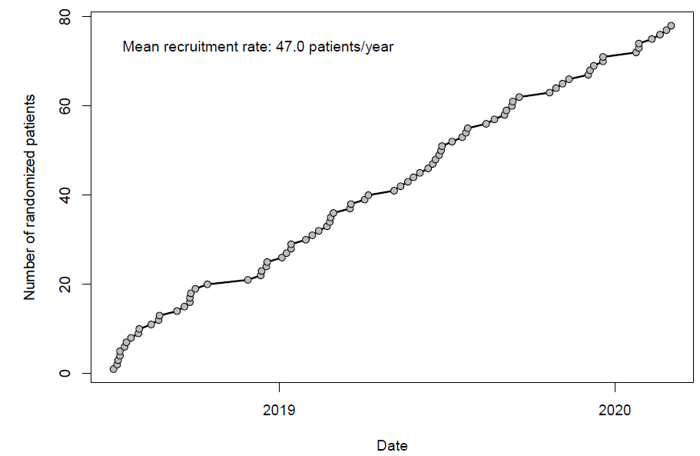

eFigure 2. Overview of the neurofeedback paradigms
A rtfNIRS-NF (2 blocks à 6 trials per condition)  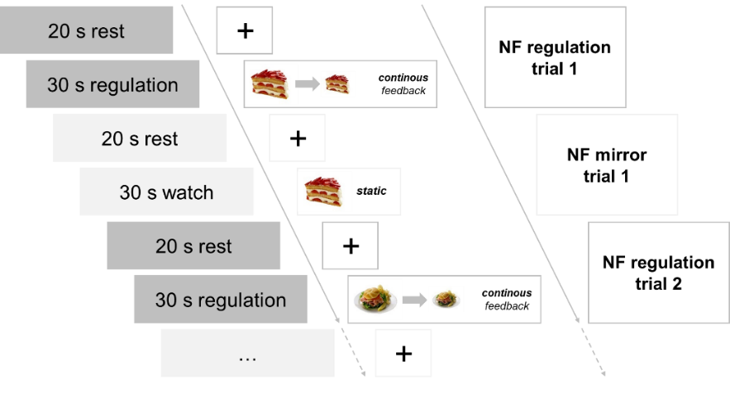 | B rtfNIRS-NF transfer (1 block à 12 trials)  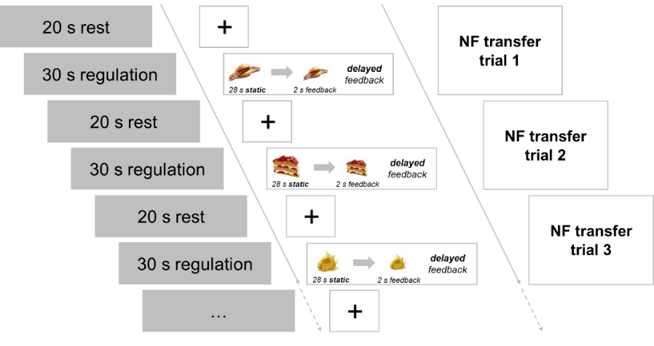
C EEG-NF (baseline + 12 regulation trials)  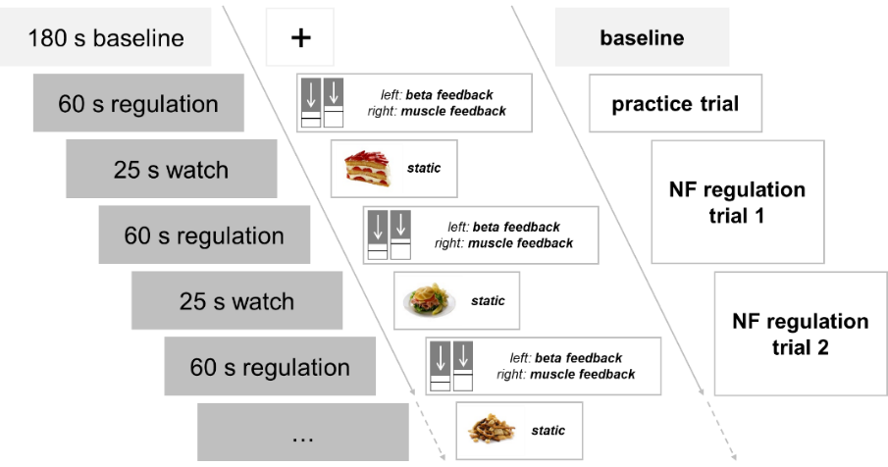 | D EEG-NF transfer (baseline + 6 transfer trials)  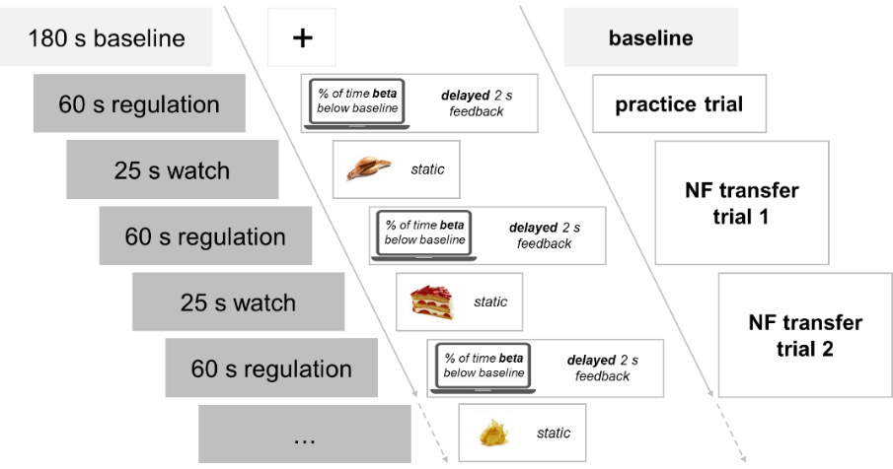
Pictures shown from the Food-pics database:³⁹ upper left panel A, strawberry cake, Food-pics image number 0089, ham sandwich with chips, Food-pics image number 0057; upper right panel B: fried sausage with roll, Food-pics image number 0318, strawberry cake, Food-pics image number 0089, chips, Food-pics image number 0113; lower left panel C: strawberry cake, Food-pics image number 0089, ham sandwich with chips, Food-pics image number 0057, snack mix, Food-pics image number 0008; lower right panel D: fried sausage with roll, Food-pics image number 0318, strawberry cake, Food-pics image number 0089, chips, Food-pics image number 0113. Patients first performed the NF task, which was composed of two blocks of alternating NF regulation and mirror trials in the rtfNIRS-NF arm, and 12 regulation trials in the EEG-NF arm. Patients had a short break in between blocks (rtfNIRS-NF) or after half of the trials (EEG-NF). After the NF task, patients performed the transfer block, during which delayed feedback was provided for 2 s at the end of the trial, without any break in between. Feedback in the regulation trials was provided from the target channels for patients receiving rtfNIRS-NF and from beta and muscle activity for patients receiving EEG-NF.
Abbreviations: EEG-NF: electroencephalography-neurofeedback, rtfNIRS-NF: real-time functional near-infrared spectroscopy-neurofeedback.

eFigure 3 Overview of the setups depicted in the international 10-20 system
A Training optodes of the rtfNIRS-NF | B Training electrodes of the EEG-NF
Among the training optodes of real-time functional near-infrared spectroscopy-based neurofeedback, sources are depicted in light and detectors depicted in dark grey.
Abbreviations: EEG-NF: electroencephalography-neurofeedback, rtfNIRS-NF: real-time functional near-infrared spectroscopy-neurofeedback

eFigure 4. Session- and trial-wise changes in picture size and mean beta activity in rtfNIRS- and EEG-NF
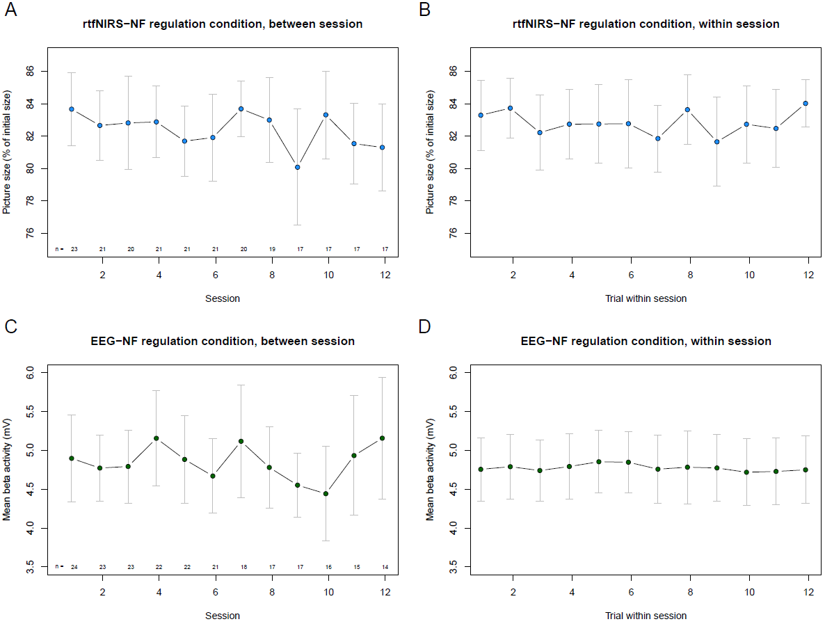
The whiskers depict a 95% CI and the number of available data sets is shown below each session in Panels A and C, respectively.
Abbreviations: EEG-NF: electroencephalography-neurofeedback, rtfNIRS-NF: real-time functional near-infrared spectroscopy-neurofeedback.

Supplementary References
1. American Psychiatric Association. Diagnostic and Statistical Manual of Mental Disorders. 5th ed. American Psychiatric Association; 2013.
2. Hilbert A, Petroff D, Herpertz S, et al. Meta-analysis of the efficacy of psychological and medical treatments for binge-eating disorder. J Consult Clin Psychol. 2019;87(1):91-105. doi:10.1037/ccp0000358
3. Hilbert A, Tuschen-Caffier B. Eating Disorder Examination: Deutschsprachige Übersetzung [Eating Disorder Examination: German Translation.] 2. Auflage. dgvt-Verlag; 2016. doi:10.1007/978-981-287-104-6_101
4. Fairburn CG. Eating Disorder Examination (Edition 16.0D). In: Cognitive Behavior Therapy and Eating Disorders. Guilford Press; 2008.
5. Fairburn CG, Cooper Z. The Eating Disorder Examination (12th edition). In: Fairburn CG, Wilson GT, eds. Binge Eating: Nature, Assessment, and Treatment. Guilford Press; 1993:317-360.
6. Berg KC, Peterson CB, Frazier P, Crow SJ. Psychometric evaluation of the eating disorder examination and eating disorder examination-questionnaire: A systematic review of the literature. Int J Eat Disord. 2012;45(3):428-438. doi:10.1002/eat.20931.Psychometric
7. Hilbert A, Tuschen-Caffier B. Eating Disorder Examination-Questionnaire: Deutschprachige Übersetzung [Eating Disorder Examination-Questionnaire: German Translation.] 2. Auflage. dgvt-Verlag; 2016. doi:10.1026/0012-1924.53.3.144
8. Fairburn CG, Beglin S. Eating disorder examination-questionnaire (EDE-Q 6.0). In: Fairburn CG, ed. Cognitive Behavior Therapy and Eating Disorders. Guilford Press; 2008:309-314.
9. Meule A, Hermann T, Kübler A. A short version of the Food Cravings Questionnaire-Trait: the FCQ-T-reduced. Front Psychol. 2014;5(190):1-10. doi:10.3389/fpsyg.2014.00190
10. Cepeda-Benito A, Gleaves DH, Williams TL, Erath SA. The development and validation of the state and trait food-cravings questionnaires. Behav Ther. 2000;31(1):151-173. doi:https://doi.org/10.1016/S0005-7894(00)80009-X
11. Cepeda-Benito A, Gleaves DH, Fernández MC, Vila J, Williams TL, Reynoso J. The development and validation of Spanish versions of the State and Trait Food Cravings Questionnaires. Behav Res Ther. 2000;38(11):1125-1138. doi:https://doi.org/10.1016/S0005-7967(99)00141-2
12. Schwarzer R, Jerusalem M. Generalized self-efficacy scale. In: Weinman J, Wright S, Johnston M, eds. Measures in Health Psychology: A User’s Portfolio. Causal and Control Beliefs. Nfer-Nelson; 1995:35-37.
13. Gratz KL, Roemer L. Multidimensional assessment of emotion regulation and dysregulation. J Psychopathol Behav Assess. 2004;26(1):41-54. doi:10.1023/B:JOBA.0000007455.08539.94
14. Ehring T, Fischer S, Schnülle J, Bösterling A, Tuschen-Caffier B. Characteristics of emotion regulation in recovered depressed versus never depressed individuals. Pers Individ Dif. 2008;44(7):1574-1584. doi:10.1016/j.paid.2008.01.013
15. Gräfe K, Zipfel S, Herzog W, Löwe B. Screening psychischer Störungen mit dem “Gesundheitsfragebogen für Patienten (PHQ-D)”: Ergebnisse der deutschen Validierungsstudie [Screening for psychiatric disorders with the Patient Health Questionnaire (PHQ). Results from the German validation study]. Diagnostica. 2004;50(4):171-181. doi:10.1026/0012-1924.50.4.171
16. Spitzer RL, Kroenke K, Williams JB. Validation and utility of a self-report version of PRIME-MD: The PHQ primary care study. JAMA. 1999;282:1737-1744.
17. Löwe B, Decker O, Müller S, et al. Validation and standardization of the generalized anxiety disorder screener (GAD-7) in the general population. Med Care. 2008;46(3). https://journals.lww.com/lww-medicalcare/Fulltext/2008/03000/Validation_and_Standardization_of_the_Generalized.6.aspx
18. Spitzer RL, Kroenke K, Williams JBW, Löwe B. A brief measure for assessing generalized anxiety disorder: The GAD-7. Arch Intern Med. 2006;166(10):1092-1097. doi:10.1001/archinte.166.10.1092
19. Ware J, Kosinski M, Keller SD. A 12-Item short-form health survey. Med Care. 1996;34(3):220-233.
20. Wirtz MA, Morfeld M, Glaesmer H, Brähler E. Normierung des SF-12 Version 2.0 zur Messung der gesundheitsbezogenen Lebensqualität in einer deutschen bevölkerungsrepräsentativen Stichprobe. Diagnostica. 2018;64(4):215-226. doi:10.1026/0012-1924/a000205
21. Vienna Test System. Published online 2015.
22. Rodewald K, Weisbrod M, Aschenbrenner S. Trail Making Test – Langensteinbacher Version. Published online 2014.
23. Kaller CP, Unterrainer JM, Kaiser S, Weisbrod M, Aschenbrenner S. Wiener Testsystem: Tower of London-Freiburger Version. Published online 2012.
24. Kaiser S, Aschenbrenner S, Pfüller U, Roesch-Ely D, Weisbrod M. Wiener Testsystem: Response Inhibition. Published online 2015.
25. Mueller SM, Schiebener J, Stöckigt G, Brand M. Short- and long-term consequences in decision-making under risk: immediate feedback about long-term prospects benefits people tending to impulsive processing. J Clin Exp Neuropsychol. 2017;41(5):484-496. doi:https://doi.org/10.1080/20445911.2016.1245660
26. Schäfer L, Schmidt R, Müller SM, Dietrich A, Hilbert A. The cards and lottery task: Validation of a new paradigm assessing decision making under risk in individuals with severe obesity. Front Psychiatry. 2020;11:1-12. doi:10.3389/fpsyt.2020.00690
27. Strobel A, Beauducel A, Debener S, Brocke B. A german version of Carver and White’s BIS/BAS scales. Zeitschrift für Differ und Diagnostische Psychol. 2006;22(3):216-227. doi:10.1024//0170-1789.22.3.216
28. Loch N, Hiller W, Witthöft M. Der Cognitive Emotion Regulation Questionnaire (CERQ): Erste teststatistische Überprüfung einer deutschen Adaption. Z Klin Psychol Psychother. 2011;40(2):94-106. doi:10.1026/1616-3443/a000079
29. Garnefski N, Kraaij V, Spinhoven P. Negative life events, cognitive emotion regulation and emotional problems. Pers Individ Dif. 2001;30:1311-1327. doi:10.1017/S0003356100012952
30. Miller MA, Fillmore MT. The effect of image complexity on attentional bias toward alcohol-related images in adult drinkers. Addiction. 2010;105(5):883-890. doi:10.1111/j.1360-0443.2009.02860.x.
31. Wiers RW, Rinck M, Dictus M, Van Den Wildenberg E. Relatively strong automatic appetitive action-tendencies in male carriers of the OPRM1 G-allele. Genes, Brain Behav. 2009;8(1):101-106. doi:10.1111/j.1601-183X.2008.00454.x
32. Manasse SM, Goldstein SP, Wyckoff E, et al. Slowing down and taking a second look: Inhibitory deficits associated with binge eating are not food-specific. Appetite. 2016;96:555-559. doi:10.1016/j.appet.2015.10.025
33. Gratton G, Coles MGH, Donchin E. A new method for off-line removal of ocular artifact. Electroencephalogr Clin Neurophysiol. 1983;55(4):468-484. doi:10.1016/0013-4694(83)90135-9
34. Sturm W. Wiener Testsystem: Wahrnehmungs- und Aufmerksamkeitsfunktionen. Published online 2005.
35. Raven JC, Court JH, Raven J. Wiener Testsystem: Raven’s Advanced Progressive Matrices. Published online 1998.
36. Schellig D, Schuri U. Wiener Testsystem: N-Back Verbal. Mödling: Published online 2015.
37. Blechert J, Meule A, Busch NA, Ohla K. Food-pics: An image database for experimental research on eating and appetite. Front Psychol. 2014;5:1-10. doi:10.3389/fpsyg.2014.00617
38. Donders F. On the speed of mental processes. In: Koster W, ed. Attention and Performance II. ; 1868:412-431.
39. Verbruggen F, Logan GD. Automatic and controlled response inhibition: associative learning in the Go/No-Go and Stop-Signal paradigms. J Exp Psychol Gen. 2008;137(4):649-672. doi:10.1037/a0013170
40. Ihssen N, Sokunbi MO, Lawrence AD, Lawrence NS, Linden DEJ. Neurofeedback of visual food cue reactivity: a potential avenue to alter incentive sensitization and craving. Brain Imaging Behav. 2017;11(3):915-924. doi:10.1007/s11682-016-9558-x
41. Sorger B, Scharnowski F, Linden DEJ, Hampson M, Young KD. Control freaks: Towards optimal selection of control conditions for fMRI neurofeedback studies. Neuroimage. 2019;186:256-265. doi:10.1016/j.neuroimage.2018.11.004.Control
42. Sokunbi MO, Linden DEJ, Habes I, Johnston S, Ihssen N. Real-time fMRI brain-computer interface: Development of a “motivational feedback” subsystem for the regulation of visual cue reactivity. Front Behav Neurosci. 2014;8. doi:10.3389/fnbeh.2014.00392
43. Kohl SH, Veit R, Spetter MS, et al. Real-time fMRI neurofeedback training to improve eating behavior by self-regulation of the dorsolateral prefrontal cortex: A randomized controlled trial in overweight and obese subjects. Neuroimage. 2019;191:596-609. doi:10.1016/j.neuroimage.2019.02.033
44. Marx A-M, Ehlis A-C, Furdea A, et al. Near-infrared spectroscopy (NIRS) neurofeedback as a treatment for children with attention deficit hyperactivity disorder (ADHD) - a pilot study. Front Hum Neurosci. 2015;8:1-13. doi:10.3389/fnhum.2014.01038
45. Chatrian GE, Lettich E, Nelson PL. Ten percent electrode system for topographic studies of spontaneous and evoked EEG activities. Am J EEG Technol. 1985;25(2):83-92. doi:10.1080/00029238.1985.11080163
46. Wang L, Ayaz H, Izzetoglu M. Investigation of the source-detector separation in near infrared spectroscopy for healthy and clinical applications. J Biophotonics. 2019;12(11). doi:10.1002/jbio.201900175
47. Althobaiti M, Al-Naib I. Recent developments in instrumentation of functional near-infrared spectroscopy systems. Appl Sci. 2020;10(18):6522. doi:10.3390/APP10186522
48. Lührs M, Goebel R. Turbo-Satori: A neurofeedback and brain–computer interface toolbox for real-time functional near-infrared spectroscopy. Neurophotonics. 2017;4(4):041504. doi:10.1117/1.NPh.4.4.041504
49. Delpy DT, Cope M, Van Der Zee P, Arridge S, Wray S, Wyatt J. Estimation of optical pathlength through tissue from direct time of flight measurement. Phys Med Biol. 1988;33(12):1433-1442. doi:10.1088/0031-9155/33/12/008
50. Liu N, Cliffer S, Pradhan AH, Lightbody A, Hall SS, Reiss AL. Optical-imaging-based neurofeedback to enhance therapeutic intervention in adolescents with autism: Methodology and initial data. Neurophotonics. 2016;4(1):011003. doi:10.1117/1.nph.4.1.011003
51. Santosa H, Zhai X, Fishburn F, Huppert T. The NIRS Brain AnalyzIR Toolbox. Algorithms. 2018;11(5):73. doi:10.3390/a11050073
52. Hocke LM, Oni IK, Duszynski CC, Corrigan A V., Frederick B de B, Dunn JF. Automated processing of fNIRS data-A visual guide to the pitfalls and consequences. Algorithms. 2018;11(5):1-25. doi:10.3390/a11050067
53. Mehlhose C, Risius A. Signs of warning: Do health warning messages on sweets affect the neural prefrontal cortex activity? Nutrients. 2020;12(12):1-16. doi:10.3390/nu12123903
54. Zimeo Morais GA, Scholkmann F, Balardin JB, et al. Non-neuronal evoked and spontaneous hemodynamic changes in the anterior temporal region of the human head may lead to misinterpretations of functional near-infrared spectroscopy signals. Neurophotonics. 2017;5(01):1. doi:10.1117/1.nph.5.1.011002
55. Scholkmann F, Wolf M. General equation for the differential pathlength factor of the frontal human head depending on wavelength and age. J Biomed Opt. 2013;18(10):105004. doi:10.1117/1.JBO.18.10.105004
56. Barker JW, Aarabi A, Huppert TJ. Autoregressive model based algorithm for correcting motion and serially correlated errors in fNIRS. Biomed Opt Express. 2013;4(8):1366. doi:10.1364/BOE.4.001366
57. Blume M, Schmidt R, Schmidt J, Martin A, Hilbert A. EEG neurofeedback in the treatment of adults with binge-eating disorder: A randomized controlled pilot study. Neurother J Am Soc Exp Neurother. 2022;19:352-365.
58. Blume M, Schmidt R, Hilbert A. Abnormalities in the EEG power spectrum in bulimia nervosa, binge-eating disorder, and obesity: a systematic review. Eur Eat Disord Rev. 2019;27(2):124-136. doi:10.1002/erv.2654
59. Schmidt J, Martin A. Neurofeedback reduces overeating episodes in female restrained eaters: A randomized controlled pilot-study. Appl Psychophysiol Biofeedback. 2015;40(4):283-295. doi:10.1007/s10484-015-9297-6
60. Schmidt J, Martin A. Neurofeedback against binge eating: A randomized controlled trial in a female subclinical threshold sample. Eur Eat Disord Rev. 2016;24(5):406-416. doi:10.1002/erv.2453
61. Schmidt J, Martin A. The influence of physiological and psychological learning mechanisms in neurofeedback vs. mental imagery against binge eating. Appl Psychophysiol Biofeedback. 2020;45(4):295-305. doi:10.1007/s10484-020-09486-9

