Supplementary Figure: PRISMA flow chart of the article selection process.

ERIC
25 citations
CINAHL
819 citations
Medline
144 citations
PsycInfo
406 citations
Embase
662 citations
Clinicaltrials.gov
13 citations
Cochrane
271 citations

2340 Citations combined
523 duplicates removed

1817 citations

1392 Excluded at title screening stage

425 citations

355 Excluded at abstract screening stage
70 citations

31 Excluded at full text screening stage
39 citations

Supplementary Figure: Forest plot on CGI-I data (after sensitivity analysis).

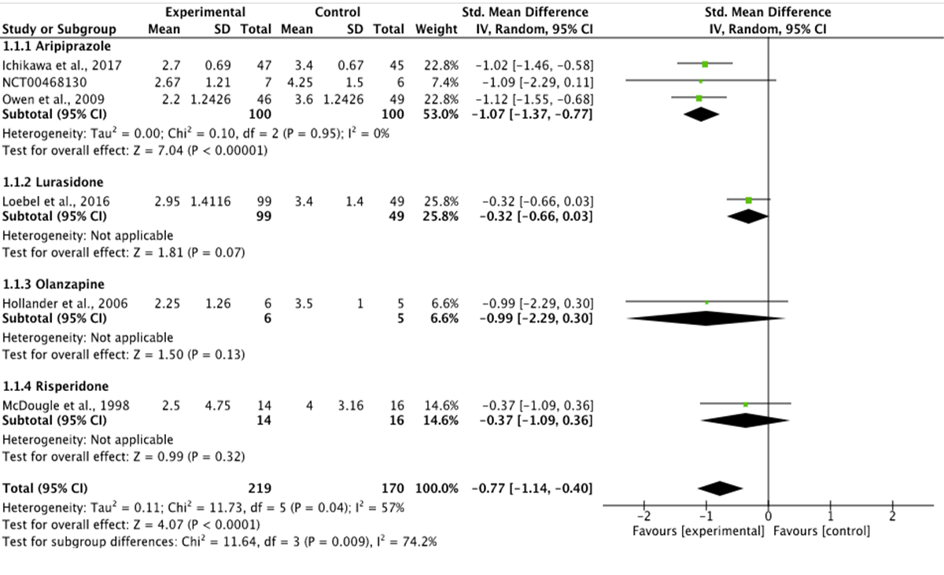

Supplementary Figure: Forest plot on C-YBOCS data.

Supplementary Figure: Forest plot on the rate of increased appetite data.
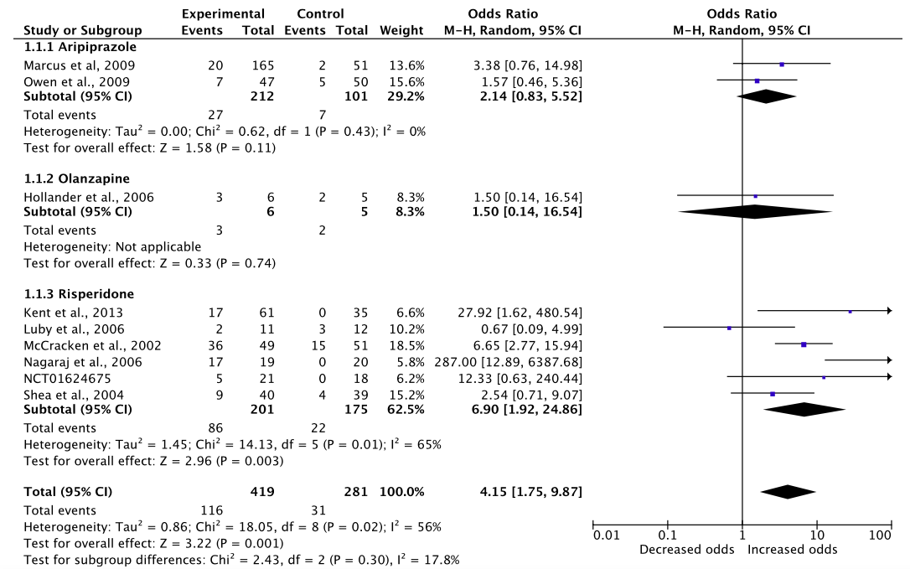
Supplementary Figure: Forest plot on the dropout rate due to any cause.
Supplementary Figure: Forest plot on the dropout rate due to adverse events.
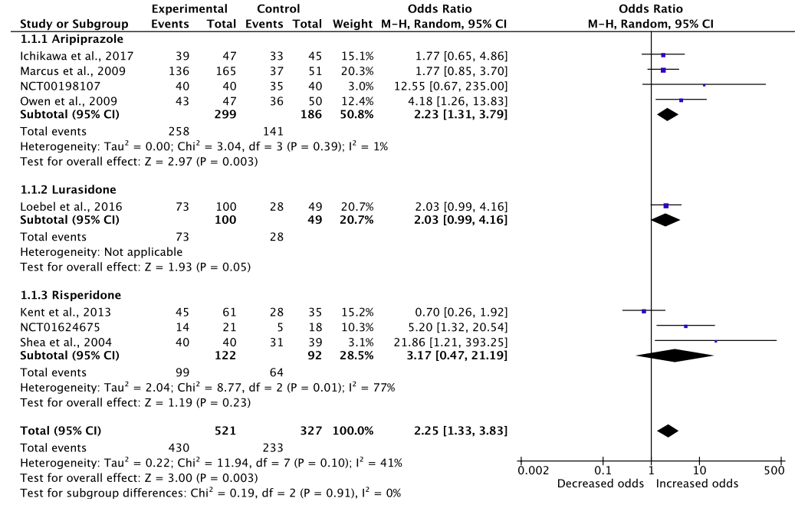

Supplementary Figure: Funnel plots.

Dropout rate due to adverse events

C-YBOCS data

Increased appetite data

Dropout rate due to any cause

ABC-I data

CGI-I data (after sensitivity analysis)
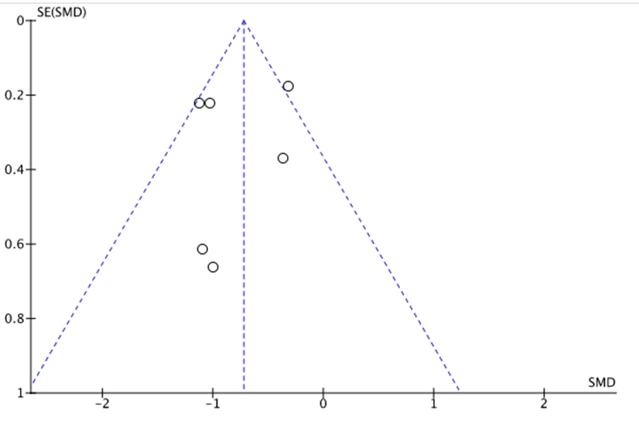
CGI data (before sensitivity analysis)
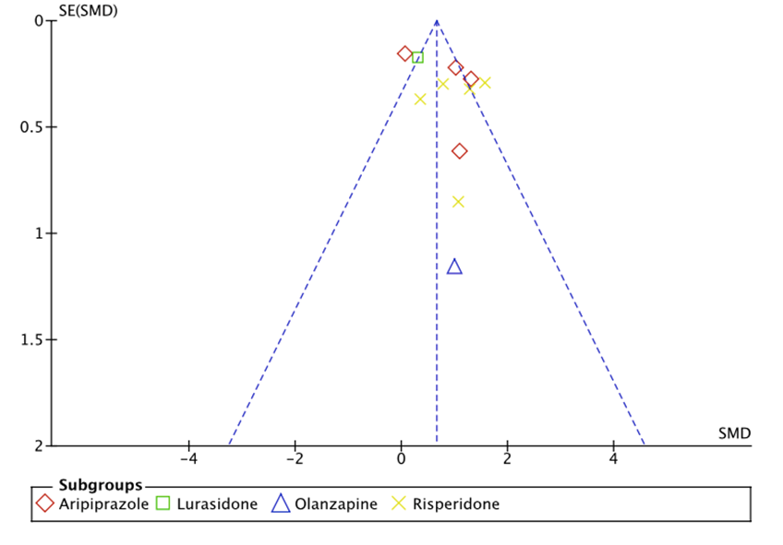

Weight gain data
Sedation data

