Supplemental Figure 1: Frequency distributions of Edinburgh Postnatal Depression Scale scores
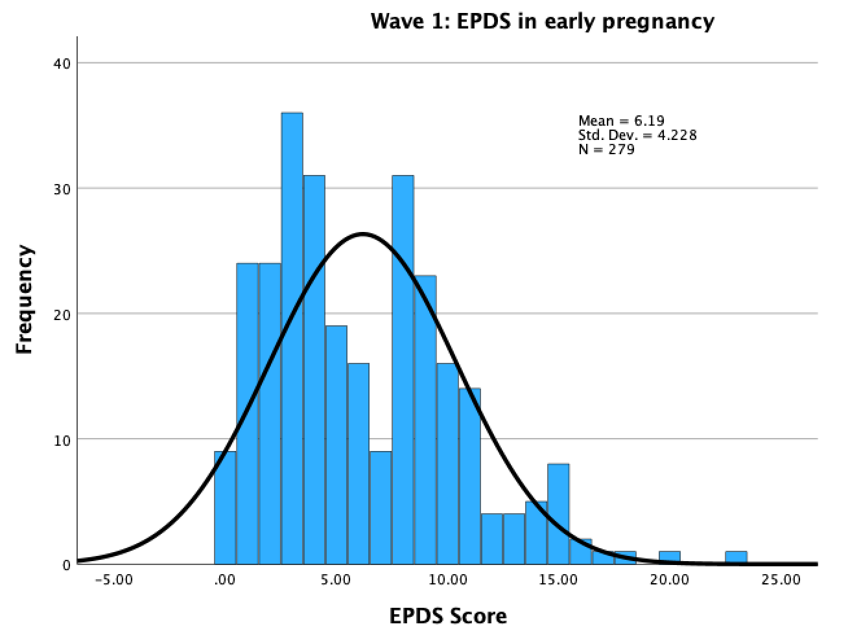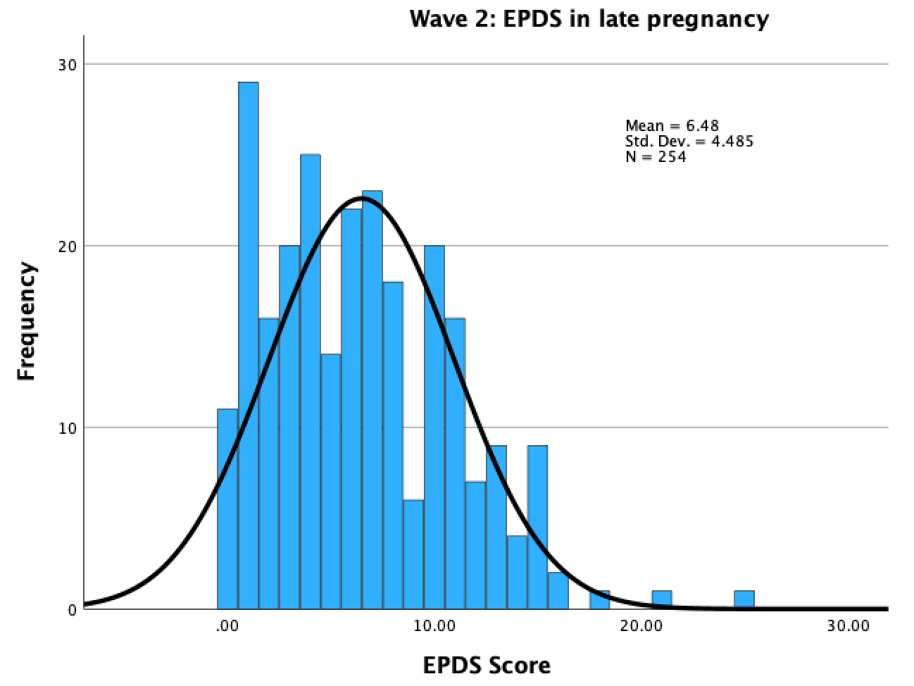
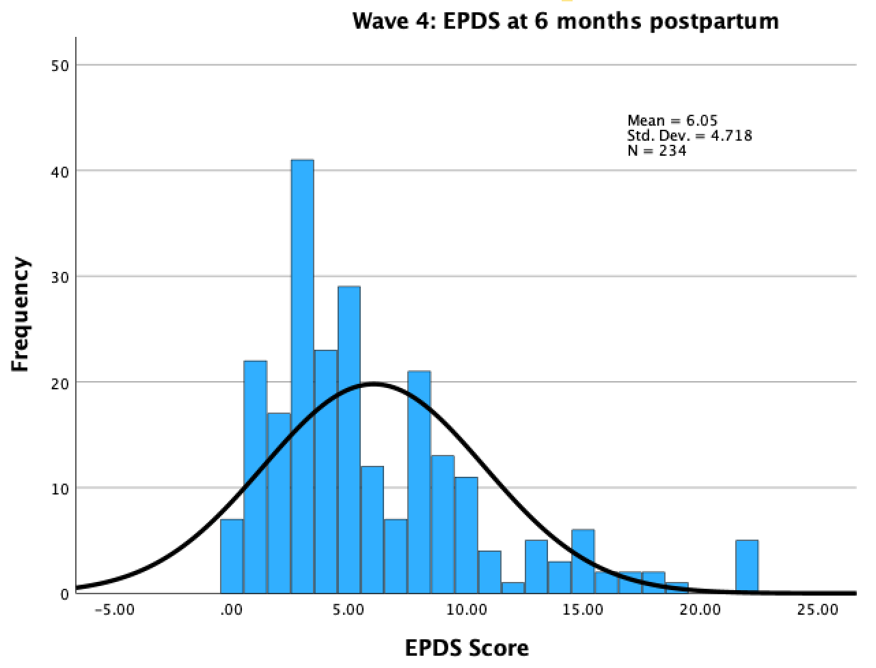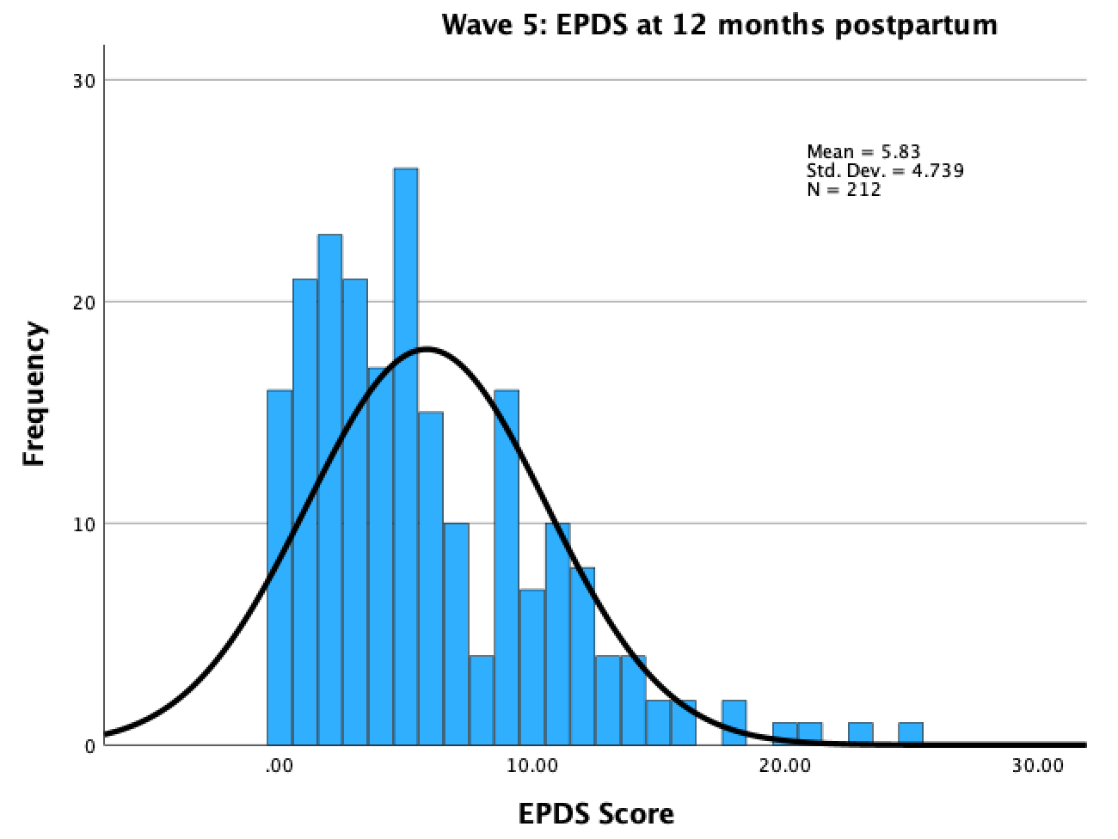

Supplemental Table 1:
Fit Indices for Latent Growth Curve in Maternal Depressive Symptoms Models.
Maternal Depressive Symptoms Models | aBIC | Χ² | d.f. | p | CFI | RMSEA (95% CIs)
Intercept-only | 4184.26 | 49.62 | 8 | 0 | 0.868 | .16 (.12, .21)
Linear Slope | 4150.67 | 9.17 | 5 | 0.102 | 0.987 | .07 (.0, .13)
Quadratic | 4149.73 | 0.28 | 1 | 0.598 | 1.00 | .06 (.00, .15)
Conditional Growth Model | 3826.26 | 4.81 | 7 | 0.684 | 1.00 | .00 (.00, .7)

