Supplementary Materials:
Scatter plots for significant correlation analyses – Life Engagement

Clinical variables
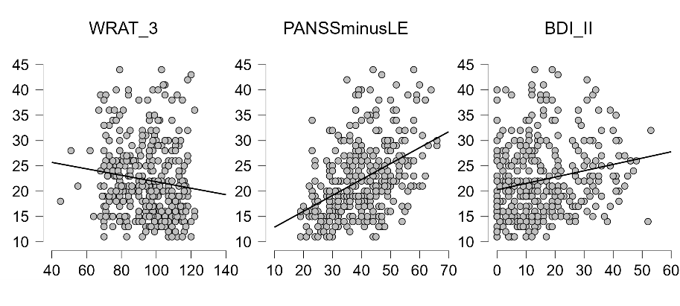
Cognitive variables
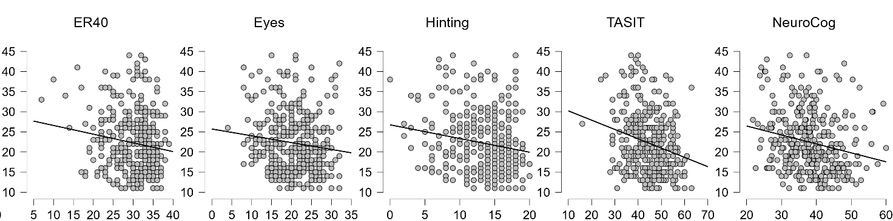

Functional variables
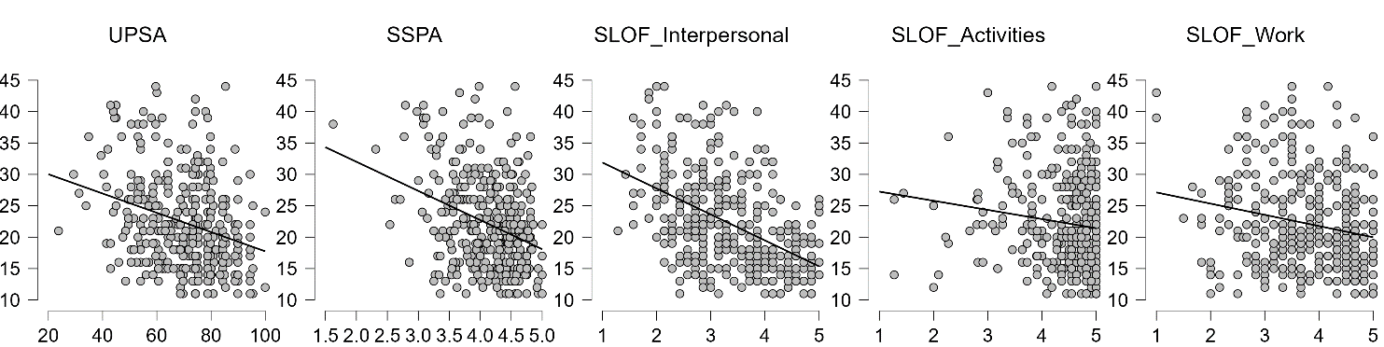

BDI-II: Beck Depression Inventory
ER40: Penn Emotion Recognition Test
Eyes: Reading the Mind in the Eyes
Hinting: Hinting Task
LE: Life Engagement
NeuroCog: Global Cognitive Composite Score (t-score)
PANSS: Positive and Negative Syndrome Scale
SLOF: Specific Level OF Functioning
SSPA: Social Skills Performance Assessment
TASIT: The Awareness of Social Inferences Task
UPSA: UCSD Performance-Based Skills Assessment
WRAT-3: Wide Range Achievement Test-3 Reading subscale

