Associations between polygenic risk scores and accelerated brain ageing in smokers
Zeyu Yang, Wei Zhao, Zeqiang Linli, Shuixia Guo, Jianfeng Feng

Supplementary Materials

Contents
Method
Smoker grouping 1
Smoking parameters 1
Brain Age Gap prediction 2
Polygenic risk score 5
Mediation analysis 6
Other significant pathways in enrichment analysis 7
Genome wide association study 9
Sample relatedness in UK-biobank dataset 12
Tables 14
Figures 28

Method

Smoker grouping
The smokers were split into 6 subgroups based on their smoking characteristics (Smoking status and Smoking frequency, Table S1). Specifically, those who currently smoke on most or all days were classified as “Current smoker” (n = 1254); those who previously smoked on most or all days but occasionally still smoked were classified as “Ex-smoker1” (n = 240); those who previously smoked on most or all days and had stopped smoking at the time of the study were classified as “Ex-smoker2” (n = 6749); those who had smoked occasionally in the past and now and had smoked a total of at least 100 times were classified as “Light smoker1” (n = 418); those who used to smoke occasionally and smoked a total of at least 100 times but quit smoking currently were classified as “Light smoker2” (n = 3751); and those who had extremely lightly smoked and failed to meet the standards of light smokers (i.e., a total of at least 100 times in their lifetime) were classified as “Other smoker” (n = 6214).

Smoking parameters
The other two key smoking parameters calculated were: i) pack-years was calculated as cigarettes per day divided by 20 and then times the number of years smoked and was only available for current and ex-smokers, measuring the amount of smoking; ii) quitting duration, which was calculated as age at the time of data collection minus the age when the participant stopped smoking on most days and this was only available for ex-smokers.

Brain Age Gap prediction
In this study, extreme gradient boosting (XGBoost) predictors, a popular technique in recent brain age studies, was used to build a brain-age estimating model across all controls, with chronological age as the dependent variable and 166 regional GMV as independent variables, and was implemented using the R package xgboost (https://github. com/dmlc/xgboost). XGBoost is an implementation of gradientboosted trees designed for speed and performance; the final model is based on a collection of individual models. Compared to regular gradient boosting, which uses the loss function of the base model as a proxy for minimizing error, XGBoost computes second-order derivatives to provide information about the direction of gradients and how to obtain the minimum loss function. It also includes advanced regularization to reduce overfitting.
In this study, the tuning parameter ranges were set to maximum depth M = [2, 3, 4, 5, 6, 7, 8, 9, 10], number of estimators N = [50, 100, 150, 200, 250], and learning rate η = [0.01, 0.05, 0.1, 0.2, 0.5], and the default values were used for all other parameters. For each set of (M, N, η), the mean squared error was measured for each inner five-fold CV loop, and a mean value for all the five-fold inner loops was then obtained to indicate the inner prediction performance. The parameter set with the highest inner prediction accuracy among the inner five-fold CVs was chosen as the optimal parameter. Finally, all samples of the inner five-fold CV were trained with the best parameters, and the testing subjects of the outer five-fold CV were predicted. The training and testing procedures of the outer five-fold CV were repeated five times, with each subset used once as the testing set.
Therefore, a full nested five-fold CV loop finally produced five XGBoost predictors with optimal parameters, and all training data (controls) had a predicted age (interpreted as BrainAge). The BrainAge Gap can be computed by subtracting the chronological age from the estimated brain age (i.e., BrainAge – True age). The BrainAge of smokers was predicted using five XGBoost predictors and then averaged across the five predicted values as the final BrainAge of smokers, and the BrainAge Gap was also calculated for every smoker.
Specifically, we divided the brain into 166 regions based on the AAL3 brain atlas and extracted their grey matter volume (GMV), and regressed potential images for confounding variables such as gender, ethnicity, handedness, BMI, alcohol consumption, and TIV separately for regional GMV of all 166 regions using linear regression models. Then, an XGBoost prediction model was built to predict age in a non-smoking group of 𝑛 = 14,667 non-smoking subjects using the residuals of 166 linear regression models as features. To simultaneously train the predictive ability of the model and assess the generalization ability of the model, we used a nested 5-fold Cross Validation (5-fold CV) method to train the model, where the inner 5-fold CV was used to determine the optimal parameters and the outer 5-fold CV to estimate the generalization capability. The nested 5-fold CV loops produced five XGBoost prediction models with optimal parameters, and all training data had a predicted age (i.e. brain age). In the smoking group (N=18626), the brain age predicted using the 5 XGBoost prediction models and the mean of the 5 predicted values will be used as the final predicted brain age (BrainAge). Pearson's correlation coefficient (r), mean absolute error (MAE) and root mean squared error (RMSE) between predicted and chronological ages were calculated for the non-smoker and smoker groups respectively to assess the accuracy of the predictors.
Finally, BrainAge Gap (BAG) is defined as the difference between predicted age and chronological age (brain age - true age). Probably due to problems such as regression dilution and the non-Gaussian distribution of age, practical applications of brain age estimation often show age bias: BrainAge is overestimated in younger subjects and underestimated in older subjects, while BrainAge predictions are more accurate for subjects whose age is closer to the average age (of the training data set). Therefore, in order to avoid spurious correlations between BrainAge Gap and age-related variables in subsequent statistical analyses, a bias correction step is necessary. A common approach is to apply a linear regression model to remove the effect of chronological age on the estimated BrainAge. In the present study, we used the following BrainAge correction model in the non-smoker group.
The residuals of this regression equation represent the difference between BrainAge and chronological age after controlling for confounders, including linear and quadratic effects of chronological age, which we refer to as the Corrected BrainAge Gap and are calculated using the following formula (2). Further, Corrected BrainAge can be calculated using the following formula(3).
The BrainAge Gap (BAG) used in the statistical analysis was adjusted for bias unless stated otherwise.

Polygenic risk score
In our calculation of PRS, the base data was a meta-analysis of over 30 genome wide association studies (GWAS) in over 1.2 million participants with European ancestry on nicotine and substance use (https://doi.org/10.1038/s41588-018-0307-5). Specifically, it targeted different stages and kinds of substance use from initiation (smoking initiation and age of regular smoking initiation) to regular use (drinks per week and cigarettes per day) to cessation (smoking cessation). The GWAS included have all been imputed to Haplotype Reference Consortium, 1000 Genomes or a combination including more specific reference panels. (more see https://conservancy.umn.edu/handle/11299/201564)
The PRS was generated using PRSice-2 software (choishingwan.github.io/PRSice/) and calculated in the target sample according to the following equation:
where, 𝑃_{𝑇} represents the p-value threshold, 𝑖=1,2, ..., 𝑚 denotes the 𝑖-th SNP under the 𝑃_{𝑇} threshold, 𝛽_{𝑖} denotes the effect size of the 𝑖-th SNP, 𝑗=1,2, ..., 𝑛 represents the 𝑗-th sample, 𝐺_{𝑖𝑗} =0,1,2 denotes the number of risk alleles for the 𝑖-th SNP in the 𝑗-th sample. The PRS at 𝑃_{𝑇} refers to the cumulative polygenic risk, that is, the weighted sum of the SNPs with GWAS p value less than 𝑃_{𝑇}.

Mediation analysis
To verify whether there is a mediating effect among Pack-year, BAG and PRS, a standard three-variable path mediation model was implemented using the R package “mediation”, and the specific model as follows:
(1) 𝑌 = 𝑘₁ + 𝜏𝑋 + ω₁Covar + 𝜀₁ .
(2) 𝑍 = 𝑘₂ + 𝛼𝑋 + ω₂Covar +𝜀₂ .
(3) 𝑌 = 𝑘₄ + 𝜏′𝑋 + 𝛽’𝑍 + ω₄Covar + 𝜀₄ .
where X is the predictor variable, Y is the response variable, and Z is the mediating variable, Covar is a covariate, as our hypotheses;
Further, we used a 4-variable mediation analysis model to test whether the relationship between PRS and Pack-year was mediated by tGMV and BAG, and whether the relationship between PRS and BAG was mediated by Pack-year and tGMV. The specific model was as follow:
(1) 𝑌 = 𝑘₁ + 𝜏𝑋 + ω₁Covar + 𝜀₁ .
(2) 𝑍 = 𝑘₂ + 𝛼𝑋 + ω₂Covar + 𝜀₂ .
(3) 𝑌 = 𝑘₃ + δ𝑍 + ω₃Covar + 𝜀₃ .
(4) 𝑀= 𝑘₄ + 𝜁𝑋 + λ𝑍 + ω₄Covar + 𝜀₄ .
(5) 𝑌 = 𝑘₅ + 𝜏′𝑋 + 𝛾𝑀 + 𝜂𝑍 + ω₅Covar + 𝜀₅ .
where X is the predictor variable, Y is the response variable, and M and Z are the mediating variables, Covar is a covariate;
The significance of the mediation, that is, whether the relationship had been significantly reduced with the inclusion of the mediator, was estimated using the bias-corrected bootstrap approach (with 1000 random samplings). Confounding variables, as in the association analysis, were regressed in the mediation model. The percentage of the mediation effect (PM) that could be explained by the mediator (indirect effect) was measured using the formula: 100% × (𝜏−𝜏′)/(𝜏).
Since not all participants had Pack-year and PRS data, the mediation analysis was restricted to smokers who had Pack-year data (N=5799). It is worth mentioning that significant mediation effects indicate to what extent is the correlation between the independent and dependent variables related to the mediating variable, and that this is strictly a measure of association and does not imply causal relationships.

Other significant pathways in enrichment analysis

Morphine addiction
Morphine addiction can cause alterations in dopaminergic neurotransmission, and stress depression is associated with reduced dopaminergic nerve function, suggesting that morphine addiction is closely related to stress depression affective psychosis and that they may share one or more of the same neurobiological mechanisms. The region, from the ventral tegmental area (VTA) to the nucleus accumbens (NAc), the medial prefrontal cortex (mPFC), the amygdala (Amy), the hippocampus (Hip) and the striatum (ST), play an important role in morphine addiction and stress depression.

ErbB signaling pathway
The ErbB receptor tyrosine kinase family consists of four cell membrane receptors that are activated following ligand binding and receptor dimerization. Insufficient ErbB signaling is associated with the development of neurodegenerative diseases, such as multiple sclerosis and Alzheimer's disease. Additionally, several types of cancer are associated with the mutation or increased expression of members of the ErbB family including lung, breast, stomach, and pancreatic cancers. Because ErbB family members are critical factors in the development and malignancy of these tumors, they have been important therapeutic targets.

Focal adhesion kinase
Focal adhesion kinase (FAK) is a non-receptor protein tyrosine kinase that is overexpressed and activated in several cancers, including SCLC, and contributing to cancer progression and metastasis through its important role in cell proliferation, survival, adhesion, spreading, migration, and invasion. Increased FAK expression or activity has been observed by various methods in many human cancers, including lung cancer.
Someone believes that Glutamate is the real workhorse of all transmitters in the brain. Dopamine is the more popularly known neurotransmitter, a lack of which contributes to depression, anxiety, attention deficit hyperactivity disorder and Parkinson's disease—but it actually accounts for less than 5 percent of all synaptic activity. By contrast, glutamate accounts for about 50 percent of this activity and is especially involved in the reward-motivation circuits integral to addiction.(from Study finds neurotransmitter may play a role in alcohol relapse, addiction (medicalxpress.com) by Indiana University)

Genome wide association study
Genome wide association study (GWAS) is a genotype-phenotype association test for a dense set of hundreds of thousands to millions of genetic variants across the genome Genotype-phenotype association tests are performed on hundreds of thousands to millions of genetic variants across the genome to investigate common genetic variants in disease or to identify heritable quantitative traits for disease risk factors. GWAS has many advantages . First, the genetic loci identified by GWAS genetic loci identified by GWAS often involve new disease-causing genes of unknown function or previously unanticipated, and subsequent studies of these genes may reveal new biological aspects of the disease. Subsequent studies of these genes may reveal new biological mechanisms of disease, which in turn may provide insight into the structure of disease susceptibility. Secondly. GWAS can help to discover new drug targets and disease biomarkers. Finally, the genetic variants identified by GWAS can be used to identify high GWAS can be used to identify individuals at high risk of certain diseases for early detection, prevention, or treatment, thus contributing to the development of personalized medicine. The genetic variants identified by GWAS can be used to identify individuals at high risk of certain diseases for early detection, prevention, or treatment, thus contributing to personalized medicine.
In order to look for such sequence variants, we ran a genome wide association scan (GWAS) in the UK Biobank sample on Pack-year which quantifies smoking and associates with accelerated brain ageing using Plink software.
As for GWAS quality control, SNPs with minor allele frequencies (MAF) <1%, call rates <95%, Hardy-Weinberg equilibrium p<10⁻⁵ were excluded from analysis, and individuals with excessive missingness >5% and sex mismatches >0.90 were excluded from the study.
To protect against potential confounding effects, we adjusted for potential nuisance variables, such as sex, age, TIV, handedness, BMI, alcohol consumption and the first ten components generated. In our GWAS, the exome-wide significance threshold was set to be 0.05/number of the tests, which is 0.05/616,339 = 8.112419e-08 and the suggestive significance was set to be 1/number of the tests, which is 1/616,339 = 1.622484e-06, as suggested by a previous GWAS study.
Finally, two genome-wide significance associations and six suggestive significance association were identified (Table S9, Figure S3, S4). In our GWAS, Genomic Inflation Factor = 1.082, indicating that there is no population stratification, and it is harder to have a false positive result, and there is no need to correct the population stratification.
The sequence variant with the strongest association, rs199533 (p=8.825e-19), is located at 17q21.31, a region involved in inversion polymorphism. This inversion spans ~1 Mb and includes 10 genes, including CRHR1, MAPT, NSF and a protein-coding gene (LRRC37A2 leucine-rich repeat sequence). Among them, the MAPT gene is associated with several dementias, the CRHR1 gene is closely related to the development of depression, anxiety, suicide, bipolar disorder and other psychiatric disorders of affective disorders, and the gene NSF, in which the sequence variant rs199533 is located, LRRC37A2 is associated with progressive myoclonic epilepsies. Due to extensive linkage disequilibrium (LD) in the 17q21.31 inversion region, markers of various associations in this region often differ in studies.
Another genome-wide significant sequence variant, rs7542 (p=1.689e-11), is located in MAPK3, a protein-coding gene, and the diseases associated with MAPK3, including pancreatic and cholangiocarcinoma cancer. Individuals with 16p11.2, the chromosomal location where the sequence variant rs7542 is located, deletion syndrome typically have developmental delays and intellectual disabilities, and most also have at least some features of autism spectrum disorders, which may account for its association with positive BAG. Smoking is currently the only recognized risk factor with a definite role in the development of pancreatic cancer. Numerous prospective and case-control studies have shown that the risk ratio of death in pancreatic cancer patients who smoke versus non-smokers is between 1.6 and 3.1:1, and that the amount of smoking is positively associated with the development of pancreatic cancer.
The six suggestive significant sequence variants were rs864736 (p=9.715e-08), rs12650174 (p=9.475e-07), rs75298305 (p=8.422e-07), rs12146713 (p=5.368e-07), rs11618612 (p=7.590e-07), and rs6119728 (p=1.081e-07);
rs864736 is located near KCNK2 (also known as TREK1), the eQTL for the KCNK2 gene. This gene regulates the entry of immune cells into the central nervous system (CNS) and controls CNS inflammation, which is associated with cortical atrophy and cognitive decline. Significantly associated with posterior margin of the left corpus callosum, intraparietal and central sulcus sulci and grey matter thickness.
The gene in which rs12650174 is located is GRID2, which encodes a protein that is a member of the family of ionotropic glutamate receptors, the major excitatory neurotransmitter receptors in the mammalian brain.
The gene nearest to rs12146713 on chromosome 12 (associated with medial nuclei volume) is NUAK1, which regulates the Tau protein level. Cerebral Tau accumulation is a defining characteristic of Alzheimer’s disease (AD) and other neurodegenerative disorders.

Sample relatedness in UK-biobank dataset
Given the nested nature of the data and the fact that many related samples were included in the UKB, we adjusted BAG prediction and association analysis for sample relatedness (the first 5 principal from components genetic ancestry analysis) which could measure the independence of the family members. Specifically, the gray matter of images were segmented after the common preprocessing procedure and partitioned into 166 regions of interest based on the automated anatomical labeling 3 (AAL3) atlas, which further were residualized for sex, ethnicity, handedness, BMI, scanning site, alcohol consumption, TIV and sample relatedness using linear regression models and then input to XGBoost predictor. And in the association analysis, sample relatedness was added to the covariates to correct for confound effect. All this adjustment only had a small effect on our results. In the Brain Age Gap prediction(Table S10, Figure S13-S15), the brain age predicted by considering sample relatedness was highly correlated with age without considering sample relatedness (r= 0.9636619, p < 2.2e-16 in test data, Figure S15).

Tables

Table S1. Demographic variables
 | Non-smoker  (n = 14667) | Smoker  (n = 18626) | p-value
Age (mean (SD)) | 63.12 (7.52) | 64.20 (7.51) | <0.001
Male (%) | 6418 (43.8) | 9233 (49.6) | <0.001
Handedness: right (%) | 13087 (89.2) | 16535 (88.8) | 0.195
BMI (mean (SD)) | 26.33 (4.19) | 26.62 (4.18) | <0.001
Alcohol consumption (mean (SD)) | 27.06 (29.74) | 40.03 (38.59) | <0.001
Pack year (mean (SD)) | / | 18.62 (15.06) | /
TIV (mean (SD))  Education (mean (SD)) | 1549.29 (152.67) | 1564.88 (151.82) | <0.001
 | 4.40 (1.89) | 4.35 (1.94) | 0.027
Note: TIV was calculated as the sum of grey matter, white matter, and cerebrospinal fluid volumes in natural space. Education was the top qualification participants ,encoded using Data-Coding 100305 (https://biobank.ndph.ox.ac.uk/showcase/coding.cgi?id=100305).

Table S2. Demographic variables of subgroups of smokers
 | Current Smoker  (n = 1254) | Ex-smoker1  (n = 240) | Ex-smoker2  (n = 6749) | Light Smoker1  (n = 418) | Light Smoker2  (n = 3751) | Other Smoker  (n = 6214)
Age (mean (SD)) | 61.84 (7.29) | 62.59 (7.37) | 65.64 (7.21) | 61.72 (7.64) | 64.36 (7.48) | 63.25 (7.58)
Male (%) | 644 (51.4) | 130 (54.2) | 3557 (52.7) | 259 (62.0) | 1918 (51.1) | 2725 (43.9)
Handedness: right (%) | 1108 (88.4) | 212 (88.3) | 5966 (88.4) | 379 (90.7) | 3311 (88.3) | 5559 (89.5)
BMI (mean (SD)) | 26.34 (4.17) | 26.76 (4.64) | 27.37 (4.24) | 26.57 (3.52) | 26.33 (3.90) | 26.04 (4.19)
Alcohol consumption (mean (SD)) | 47.89 (51.16) | 47.67 (43.01) | 45.83 (42.27) | 51.44 (37.86) | 39.36 (34.96) | 31.50 (30.96)
Pack year (mean (SD)) | 24.08 (15.91) | 17.38 (13.93) | 17.65 (14.72) | / | / | /
TIV (mean (SD)) | 1561.15 (154.18) | 1583.90 (157.65) | 1570.75 (151.42) | 1605.19 (152.20) | 1566.21 (149.63) | 1555.01 (152.04)
Education (mean (SD)) | 4.16 (2.01) | 4.38 (1.87) | 4.27 (2.00) | 4.24 (1.91) | 4.30 (1.97) | 4.52 (1.84)
Quitting duration (mean (SD)) | / | 19.09 (9.66) | 29.28 (11.50) | / | / | /

Table S3. Characteristics of smoking subgroups
Groups | N | Smoking status |  | Smoking frequency |  | Note
 |  | Current | Past | Regular | Occasional
Current smoker | 1254 | √ |  | √
Ex-smoker1 | 240 |  | √ | √ |  | Current smoking occasionally
Ex-smoker2 | 6749 |  | √ | √
Light smoker1 | 418 | √ |  |  | √ | At least 100 smokes in lifetime
Light smoker2 | 3751 | √ | √ |  | √ | At least 100 smokes in lifetime
Oher smoker | 6214 | √ | √ |  | √ | Less than 100 smokes in lifetime
Non-smoker | 14667 |  |  |  |  | Never smoking

Table S4. The anatomical regions defined in each hemisphere and their label in the automated anatomical labeling atlas AAL3.
No. | Anatomical description | Label | Possible | Network
 |  | aal2.nii.gz | abbreviation
1,2 | Precentral gyrus | Precentral | PreCG | Sensorimotor
3, 4 | Superior frontal gyrus, dorsolateral | Frontal_Sup | SFG | Frontal
5, 6 | Middle frontal gyrus | Frontal_Mid | MFG | Frontal
7, 8 | Inferior frontal gyrus, opercular part | Frontal_Inf_Oper | IFGoperc | Frontal
9, 10 | Inferior frontal gyrus, triangular part | Frontal_Inf_Tri | IFGtriang | Frontal
11, 12 | IFG pars orbitalis, | Frontal_Inf_Orb | IFGorb | Frontal
13, 14 | Rolandic operculum | Rolandic_Oper | ROL | Frontal
15, 16 | Supplementary motor area | Supp_Motor_Area | SMA | Sensorimotor
17, 18 | Olfactory cortex | Olfactory | OLF | Frontal
19, 20 | Superior frontal gyrus, medial | Frontal_Sup_Med | SFGmedial | Frontal
21, 22 | Superior frontal gyrus, medial orbital | Frontal_Med_Orb | PFCventmed | Frontal
23, 24 | Gyrus rectus | Rectus | REC | Frontal
25, 26 | Medial orbital gyrus | OFCmed | OFCmed | Frontal
27, 28 | Anterior orbital gyrus | OFCant | OFCant | Frontal
29, 30 | Posterior orbital gyrus | OFCpost | OFCpost | Frontal
31, 32 | Lateral orbital gyrus | OFClat | OFClat | Frontal
33, 34 | Insula | Insula | INS | Subcortical
35, 36 | Anterior cingulate & paracingulate gyri | Cingulate_Ant | ACC | Frontal
37, 38 | Middle cingulate & paracingulate gyri | Cingulate_Mid | MCC | Frontal
39, 40 | Posterior cingulate gyrus | Cingulate_Post | PCC | Parietal
41, 42 | Hippocampus | Hippocampus | HIP | Temporal
43, 44 | Parahippocampal gyrus | ParaHippocampal | PHG | Temporal
45, 46 | Amygdala | Amygdala | AMYG | Subcortical
47, 48 | Calcarine fissure and surrounding cortex | Calcarine | CAL | Occipital
49, 50 | Cuneus | Cuneus | CUN | Occipital
51, 52 | Lingual gyrus | Lingual | LING | Occipital
53, 54 | Superior occipital gyrus | Occipital_Sup | SOG | Occipital
55, 56 | Middle occipital gyrus | Occipital_Mid | MOG | Occipital
57, 58 | Inferior occipital gyrus | Occipital_Inf | IOG | Occipital
59, 60 | Fusiform gyrus | Fusiform | FFG | Temporal
61, 62 | Postcentral gyrus | Postcentral | PoCG | Sensorimotor
63, 64 | Superior parietal gyrus | Parietal_Sup | SPG | Parietal
65, 66 | Inferior parietal gyrus, excluding supramarginal and angular gyri | Parietal_Inf | IPG | Parietal
67, 68 | SupraMarginal gyrus | SupraMarginal | SMG | Parietal
69, 70 | Angular gyrus | Angular | ANG | Parietal
71, 72 | Precuneus | Precuneus | PCUN | Parietal
73, 74 | Paracentral lobule | Paracentral_Lobule | PCL | Parietal
75, 76 | Caudate nucleus | Caudate | CAU | Subcortical
77, 78 | Lenticular nucleus, Putamen | Putamen | PUT | Subcortical
79, 80 | Lenticular nucleus, Pallidum | Pallidum | PAL | Subcortical
81, 82 | Thalamus | Thalamus | THA | Subcortical
83, 84 | Heschl’s gyrus | Heschl | HES | Temporal
85, 86 | Superior temporal gyrus | Temporal_Sup | STG | Temporal
87, 88 | Temporal pole: superior temporal gyrus | Temporal_Pole_Sup | TPOsup | Temporal
89, 90 | Middle temporal gyrus | Temporal_Mid | MTG | Temporal
91, 92 | Temporal pole: middle temporal gyrus | Temporal_Pole_Mid | TPOmid | Temporal
93, 94 | Inferior temporal gyrus | Temporal_Inf | ITG | Temporal
95, 96 | Crus I of cerebellar hemisphere | Cerebellum_Crus1 | CERCRU1 | Cerebellum
97, 98 | Crus II of cerebellar hemisphere | Cerebellum_Crus2 | CERCRU2 | Cerebellum
99, 100 | Lobule III of cerebellar hemisphere | Cerebellum_3 | CER3 | Cerebellum
101, 102 | Lobule IV, V of cerebellar hemisphere | Cerebellum_4_5 | CER4_5 | Cerebellum
103, 104 | Lobule VI of cerebellar hemisphere | Cerebellum_6 | CER6 | Cerebellum
105, 106 | Lobule VIIB of cerebellar hemisphere | Cerebellum_7b | CER7b | Cerebellum
107, 108 | Lobule VIII of cerebellar hemisphere | Cerebellum_8 | CER8 | Cerebellum
109, 110 | Lobule IX of cerebellar hemisphere | Cerebellum_9 | CER9 | Cerebellum
111, 112 | Lobule X of cerebellar hemisphere | Cerebellum_10 | CER10 | Cerebellum
113 | Lobule I, II of vermis | Vermis_1_2 | VER1_2 | Cerebellum
114 | Lobule III of vermis | Vermis_3 | VER3 | Cerebellum
115 | Lobule IV, V of vermis | Vermis_4_5 | VER4_5 | Cerebellum
116 | Lobule VI of vermis | Vermis_6 | VER6 | Cerebellum
117 | Lobule VII of vermis | Vermis_7 | VER7 | Cerebellum
118 | Lobule VIII of vermis | Vermis_8 | VER8 | Cerebellum
119 | Lobule IX of vermis | Vermis_9 | VER9 | Cerebellum
120 | Lobule X of vermis | Vermis_10 | VER10 | Cerebellum
121, 122 | Thalamus, Anteroventral Nucleus | Thal_AV | tAV | Subcortical
123, 124 | Lateral posterior | Thal_LP | tLP | Subcortical
125, 126 | Ventral anterior | Thal_VA | tVA | Subcortical
127, 128 | Ventral lateral | Thal_VL | tVL | Subcortical
129, 130 | Ventral posterolateral | Thal_VPL | tVPL | Subcortical
131, 132 | Intralaminar | Thal_IL | tIL | Subcortical
133, 134 | Reuniens | Thal_Re | tRe | Subcortical
135, 136 | Mediodorsal medial magnocellular | Thal_MDm | tMDm | Subcortical
137, 138 | Mediodorsal lateral parvocellular | Thal_MDl | tMDl | Subcortical
139, 140 | Lateral geniculate | Thal_LGN | tLGN | Subcortical
141, 142 | Medial Geniculate | Thal_MGN | tMGN | Subcortical
143, 144 | Pulvinar anterior | Thal_PuA | tPuA | Subcortical
145, 146 | Pulvinar medial | Thal_PuM | tPuM | Subcortical
147, 148 | Pulvinar lateral | Thal_PuL | tPuL | Subcortical
149, 150 | Pulvinar inferior | Thal_PuI | tPuI | Subcortical
151, 152 | Anterior cingulate cortex, subgenual | ACC_sub | ACCsub | Frontal
153, 154 | Anterior cingulate cortex, pregenual | ACC_pre | ACCpre | Frontal
155, 156 | Anterior cingulate cortex, supracallosal | ACC_sup | ACCsup | Frontal
157, 158 | Nucleus accumbens | N_Acc | Nacc | Brainstem
159, 160 | Ventral tegmental area | VTA | VTA | Brainstem
161, 162 | Substantia nigra, pars compacta | SN_pc | SNpc | Brainstem
163, 164 | Substantia nigra, pars reticulata | SN_pr | SNpr | Brainstem
165, 166 | Red nucleus | Red_N | RedN | Brainstem
167, 168 | Locus coeruleus | LC | LC | Brainstem
169 | Raphe nucleus, dorsal | Raphe_D | RapheD | Brainstem
170 | Raphe nucleus, median | Raphe_M | RapheM | Brainstem
Note. Column 4 provides a set of possible abbreviations for the anatomical descriptions. The original numbers in AAL2 for the anterior cingulate cortex (35, 36) and thalamus (81, 82) are left empty in AAL3, as those voxels were substituted by the new subdivisions (Thalamic nuclei: 121-151; anterior cingulate cortex: 151-156). Thus, the total number of parcellations in AAL3 is 166, with maximum label number 170. This ensures that most of the numbers used in AAL2 remain the same in AAL3, while AAL3 mainly adds new areas starting at number 121.

Table S5. Results of correlation analysis between PRS and smoking at different P_{T} thresholds.
P_{T} | r | p-value | P_{T} | r | p-value | P_{T} | r | p-value | P_{T} | r | p-value
5e.08 | 0.00422 | 0.52702 | 0.125 | 0.02110 | 0.00157 | 0.250 | 0.01917 | 0.00407 | 0.375 | 0.01892 | 0.00459
0.005 | 0.01794 | 0.00717 | 0.130 | 0.02141 | 0.00134 | 0.255 | 0.01912 | 0.00418 | 0.380 | 0.01885 | 0.00474
0.010 | 0.01709 | 0.01043 | 0.135 | 0.02050 | 0.00213 | 0.260 | 0.01922 | 0.00398 | 0.385 | 0.01859 | 0.00535
0.015 | 0.01827 | 0.00619 | 0.140 | 0.02006 | 0.00264 | 0.265 | 0.01896 | 0.00450 | 0.390 | 0.01850 | 0.00557
0.020 | 0.01905 | 0.00430 | 0.145 | 0.02018 | 0.00249 | 0.270 | 0.01884 | 0.00476 | 0.395 | 0.01836 | 0.00593
0.025 | 0.02141 | 0.00134 | 0.150 | 0.01997 | 0.00276 | 0.275 | 0.01897 | 0.00448 | 0.400 | 0.01812 | 0.00664
0.030 | 0.01994 | 0.00281 | 0.155 | 0.02047 | 0.00216 | 0.280 | 0.01867 | 0.00515 | 0.405 | 0.01812 | 0.00661
0.035 | 0.02112 | 0.00155 | 0.160 | 0.02086 | 0.00178 | 0.285 | 0.01883 | 0.00478 | 0.410 | 0.01811 | 0.00665
0.040 | 0.02305 | 0.00055 | 0.165 | 0.02107 | 0.00159 | 0.290 | 0.01892 | 0.00457 | 0.415 | 0.01833 | 0.00601
0.045 | 0.02276 | 0.00065 | 0.170 | 0.02060 | 0.00202 | 0.295 | 0.01886 | 0.00471 | 0.420 | 0.01830 | 0.00610
0.050 | 0.02277 | 0.00064 | 0.175 | 0.02060 | 0.00202 | 0.300 | 0.01884 | 0.00475 | 0.425 | 0.01814 | 0.00656
0.055 | 0.02167 | 0.00117 | 0.180 | 0.02061 | 0.00201 | 0.305 | 0.01877 | 0.00492 | 0.430 | 0.01791 | 0.00727
0.060 | 0.02106 | 0.00160 | 0.185 | 0.02113 | 0.00154 | 0.310 | 0.01887 | 0.00468 | 0.435 | 0.01781 | 0.00761
0.065 | 0.02044 | 0.00219 | 0.190 | 0.02125 | 0.00145 | 0.315 | 0.01910 | 0.00422 | 0.440 | 0.01751 | 0.00871
0.070 | 0.01970 | 0.00315 | 0.195 | 0.02106 | 0.00160 | 0.320 | 0.01949 | 0.00349 | 0.445 | 0.01784 | 0.00750
0.075 | 0.02110 | 0.00157 | 0.200 | 0.02117 | 0.00152 | 0.325 | 0.01921 | 0.00400 | 0.450 | 0.01787 | 0.00741
0.080 | 0.02085 | 0.00179 | 0.205 | 0.02090 | 0.00173 | 0.330 | 0.01888 | 0.00468 | 0.455 | 0.01770 | 0.00798
0.085 | 0.02054 | 0.00208 | 0.210 | 0.02093 | 0.00171 | 0.335 | 0.01909 | 0.00422 | 0.460 | 0.01753 | 0.00862
0.090 | 0.02071 | 0.00191 | 0.215 | 0.02039 | 0.00224 | 0.340 | 0.01891 | 0.00460 | 0.465 | 0.01757 | 0.00846
0.095 | 0.02006 | 0.00265 | 0.220 | 0.02045 | 0.00218 | 0.345 | 0.01900 | 0.00442 | 0.470 | 0.01739 | 0.00916
0.100 | 0.02042 | 0.00222 | 0.225 | 0.02067 | 0.00195 | 0.350 | 0.01885 | 0.00472 | 0.475 | 0.01748 | 0.00883
0.105 | 0.01985 | 0.00294 | 0.230 | 0.01992 | 0.00284 | 0.355 | 0.01898 | 0.00444 | 0.480 | 0.01732 | 0.00947
0.110 | 0.02057 | 0.00205 | 0.235 | 0.01947 | 0.00353 | 0.360 | 0.01906 | 0.00428 | 0.485 | 0.01745 | 0.00892
0.115 | 0.02113 | 0.00154 | 0.240 | 0.01959 | 0.00333 | 0.365 | 0.01891 | 0.00461 | 0.490 | 0.01749 | 0.00875
0.120 | 0.02132 | 0.00140 | 0.245 | 0.01920 | 0.00400 | 0.370 | 0.01897 | 0.00448 | 0.495 | 0.01747 | 0.00885

Table S6. Results of partial correlation analysis between PRS and Pack-year under TOP10 threshold
P_{T} | r | p-value | n
0.040 | 0.02305 | 0.00055 | 16363
0.050 | 0.02277 | 0.00064 | 16363
0.045 | 0.02276 | 0.00065 | 16363
0.055 | 0.02167 | 0.00117 | 16363
0.130 | 0.02141 | 0.00134 | 16363
0.025 | 0.02141 | 0.00134 | 16363
0.120 | 0.02132 | 0.00140 | 16363
0.190 | 0.02125 | 0.00145 | 16363
0.200 | 0.02117 | 0.00152 | 16363
0.115 | 0.02113 | 0.00154 | 16363

Table S7. Results of correlation analysis between PRS and GM of brain regions (P_{T}=0.41).
NO.in AAL3 | LABEL in AAL3 | r | p
134 | Thal_Re_R | -0.02926 | 1.16E-05
122 | Thal_AV_R | -0.02873 | 1.67E-05
12 | Frontal_Inf_Orb_2_R | -0.028 | 2.72E-05
6 | Frontal_Mid_2_R | -0.02668 | 6.39E-05
32 | OFClat_R | -0.02604 | 9.54E-05
46 | Amygdala_R | -0.02583 | 0.000108
31 | OFClat_L | -0.02414 | 0.000298
22 | Frontal_Med_Orb_R | -0.02399 | 0.000325
86 | Temporal_Sup_R | -0.02397 | 0.000328
45 | Amygdala_L | -0.02328 | 0.000485
90 | Temporal_Mid_R | -0.02237 | 0.000803
24 | Rectus_R | -0.02215 | 0.0009
126 | Thal_VA_R | -0.02184 | 0.001066
66 | Parietal_Inf_R | -0.02124 | 0.001461
153 | ACC_pre_L | -0.02107 | 0.001592
11 | Frontal_Inf_Orb_2_L | -0.02087 | 0.001765
89 | Temporal_Mid_L | -0.02066 | 0.001963
5 | Frontal_Mid_2_L | -0.02026 | 0.002397
44 | ParaHippocampal_R | -0.02009 | 0.002606
18 | Olfactory_R | -0.01995 | 0.00279
154 | ACC_pre_R | -0.01994 | 0.002813
136 | Thal_MDm_R | -0.0199 | 0.002865
133 | Thal_Re_L | -0.01985 | 0.002939
10 | Frontal_Inf_Tri_R | -0.01979 | 0.003028
33 | Insula_L | -0.01972 | 0.003125
138 | Thal_MDl_R | -0.0194 | 0.003649
65 | Parietal_Inf_L | -0.01884 | 0.004755
9 | Frontal_Inf_Tri_L | -0.01884 | 0.004765
26 | OFCmed_R | -0.01878 | 0.004886
135 | Thal_MDm_L | -0.01874 | 0.004977
34 | Insula_R | -0.01819 | 0.006409
55 | Occipital_Mid_L | -0.01809 | 0.006721
139 | Thal_LGN_L | -0.01804 | 0.006867
94 | Temporal_Inf_R | -0.01802 | 0.006919
152 | ACC_sub_R | -0.0177 | 0.008008
29 | OFCpost_L | -0.01768 | 0.008054
21 | Frontal_Med_Orb_L | -0.01765 | 0.008165
141 | Thal_MGN_L | -0.01762 | 0.008294
128 | Thal_VL_R | -0.01751 | 0.008682

Table S8. The difference in BrainAge Gap between the smoker subgroups and the non-smoker group
 | Mean difference (CI) | t-value | p-value | Cohen’s d
All Smoker - Non-smoker | 0.296 [0.216, 0.377] | 7.227 | 5.06×10⁻¹³ | 0.074
Current - Non-smoker | 1.010 [0.799, 1.223] | 9.338 | 1.04×10⁻²⁰ | 0.307
Ex1 - Non-smoker | 0.706 [0.240, 1.173] | 2.966 | 3.02×10⁻⁰³ | 0.219
Ex2 - Non-smoker | 0.384 [0.276, 0.493] | 6.941 | 3.98×10⁻¹² | 0.133
Light1 - Non-smoker | 0.288 [-0.068, 0.645] | 1.585 | 1.13×10⁻⁰¹ | 0.100
Light2 - Non-smoker | -0.011 [-0.143, 0.121] | -0.157 | 8.75×10⁻⁰¹ | 0.016
Other - Non-smoker | -0.090 [-0.198, 0.019] | -1.621 | 1.05×10+ | -0.012
Note: As illustrated in Table S7, smokers had a bigger BrainAge Gap than non-smokers, with a mean difference (MD) of 0.296 years, p < 0.001, CI = 0.598–0.646, and Cohen’s d = 0.074. To further quantify the difference in the BrainAge Gap of smokers and non-smokers, each smoking subgroup was compared with the non-smoking group. urrent smokers had the largest BrainAge Gap, with MD = 1.101 years, p < 0.001, and Cohen’s d = 0.307, followed by the Ex-smoker1 group (MD = 0.706 years, p < 0.001, and Cohen’s d = 0.219), and Ex-smoker2 group (MD = 0.384 years, p < 0.001, and Cohen’s d = 0.133). There were no significant differences in the BrainAge Gap between the Light smoker1, Light smoker2 group and Other smoker group and the non-smokers.

Table S9. The difference in PRS between the smoker subgroups and the non-smoker group
 | Mean difference (CI) | t-value | p-value | Cohen’s d
All Smoker - Non-smoker | 0.622 [0.598,0.646] | 50.381 | 0 | 0.633
Current - Non-smoker | 1.023 [0.960, 1.086] | 31.923 | 5.2×10⁻²¹⁹ | 1.138
Ex1 - Non-smoker | 1.000 [0.867, 1.142] | 14.333 | 2.13×10⁻⁴⁶ | 1.095
Ex2 - Non-smoker | 0.941 [0.910, 0.972] | 59.230 | 0 | 0.999
Light1 - Non-smoker | 0.890 [0.784, 0.995] | 16.516 | 6.11×10⁻⁶¹ | 0.969
Light2 - Non-smoker | 0.851 [0.813, 0.889] | 43.890 | 0 | 0.907
Other - Non-smoker | 0.057 [0.027, 0.088] | 3.652 | 2.61×10⁻⁴ | 0.059
Note: As illustrated in Table S8, smokers had a bigger PRS than non-smokers, with a mean difference (MD) of 0.622, p < 0.001, CI = 0.598–0.646, and Cohen’s d = 0.633. To further quantify the difference in the PRS of smokers and non-smokers, each smoking subgroup was compared with the non-smoking group. Current smokers had the largest PRS, with MD = 1.1023, p < 0.001, and Cohen’s d = 1.138, followed by the Ex-smoker1 group (MD = 1.000, p < 0.001, and Cohen’s d = 1.095), Ex-smoker2 group (MD = 0.941, p < 0.001, and Cohen’s d = 0.999), Light smoker1 (MD = 0.890，p < 0.001，Cohen’s d = 0.969) and Light smoker2 (MD = 0.851，p < 0.001，Cohen’s d = 0.907).

Table S10. Sequence variants associated with Pack-year
 | RsNumber | Position (GRCh38) | Allele | MAF (%) | Effect(β) | p-value
exome-wide significance | rs199533 | chr17:46751565 | A/G | 21.25 | 0.362 | 8.825e-19
 | rs7542 | chr16:30114519 | C/G | 43.98 | -0.2287 | 1.689e-11
suggestive significance | rs864736 | chr1:214976917 | C/A | 45.19 | 0.1794 | 9.715e-08
 | rs12650174 | chr4:93308358 | G/A | 7.1 | 0.3203 | 9.475e-07
 | rs75298305 | chr7:131471760 | T/G | 6.919 | 0.3259 | 8.422e-07
 | rs12146713 | chr12:106083027 | C/T | 9.544 | 0.2868 | 5.368e-07
 | rs11618612 | chr13:109710128 | T/C | 26.1 | -0.1894 | 7.590e-07
 | rs6119728 | chr20:31825318 | A/G | 29.21 | -0.196 | 1.081e-07

Table S11. Association of PRS (PT=0.04) with BAG, tGMV and smoking parameter with more adjusting for sample relatedness.
Group | Model1 |  |  | Model2
 | β(SE) | t-value | p-value | β(SE) | t-value | p-value
 | BAG
Smoking group  (unadjusted Pack.year) | 0.09(0.032) | 2.686 | 0.0072 | 0.08(0.032) | 2.563 | 0.0104
Smoking group  (adjust Pack.year) | 0.04(0.049) | 0.890 | 0.374 | 0.04(0.049) | 0.785 | 0.433
Smoking and control group | 0.08(0.025) | 3.464 | 5.33×10⁻⁴ | 0.08(0.025) | 3.453 | 5.55×10⁻⁴
 | tGMV
Smoking and control group  (unadjusted Pack.year) | -350.90(74.371) | -4.718 | 2.39×10⁻⁶ | -161.2(49.47) | -3.258 | 0.0011
Smoking and control group  (adjusted Pack.year) | -256.48(89.838) | -2.855 | 0.00431 | -136.11(59.777) | -2.277 | 0.0228
 | Quitting duration
Unadjusted Pack.year | -0.76(0.179) | -4.222 | 2.46×10⁻⁵ | -0.75(0.179) | -4.182 | 2.94×10⁻⁵
Adjusting Pack.year | -0.31(0.151) | -2.071 | 0.0383 | -0.36(0.151) | -2.357 | 0.0185
Note: In this association analysis, the predictor variable was PRS and response variables were shown in the table. Model 1: Adjusted for sex, age and sample relatedness (the first 5 principal from components genetic ancestry analysis). Model 2: Adjusted for sex, age, TIV, handedness, BMI, alcohol status, site, education and sample relatedness (the first 5 principal from components genetic ancestry analysis)

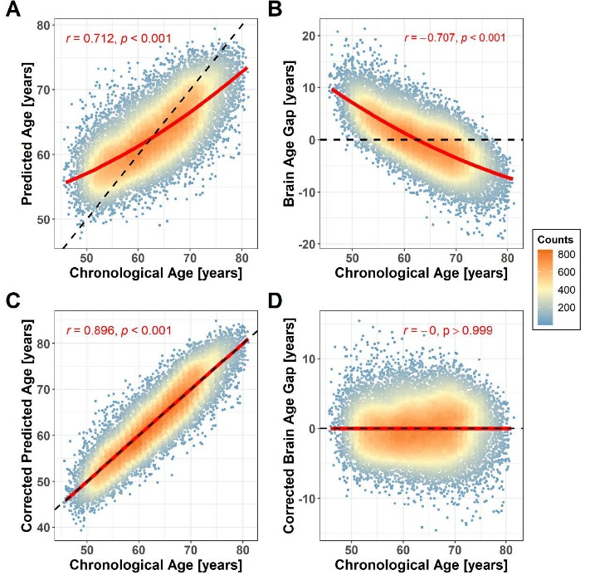
Figures

Figure S1. The XGBoost predictor’s performance of BAG in the non-smokers
The brain age prediction models that were run on the control group using XGBoost implemented in a nested five-fold CV framework showed a prediction accuracy of r = 0.712, CI = 0.703–0.719 (Fig. A), RMSE = 5.280, and MAE = 4.220. The BrainAge Gap for every non-smokers (Fig. B) showed a negative association with chronological age, as expected (r = − 0.707). After bias adjusting using linear regression with the formula BrainAge = 51.68 + 0.151× age + 0.005 × age2, the corrected BrainAge of non-smokers was correlated more with chronological age (r = 0.896, CI = 0.893–0. 899 [Fig. C], RMSE = 3.722, and MAE = 2.997), and the corrected BrainAge Gap was orthogonal to the chronological age (r ≈ 0; Fig. D).

Figure S2. Correlation between the Chronological Age (X-axis) and the BrainAge (Y-axis) with age bias adjustment in all smoker subgroups.
Correlation between the corrected predicted age (i.e., BrainAge) and chronological age in the six smoking groups with r = 0.90, p < 0.001. The slope of the black dotted line is 1. The red line is the fitted curve with the linear effect of chronological age. (For interpretation of the references to color in this figure legend, the reader is referred to the web version of this article.)

Figure S3. Difference between each smoker subgroup and non-smokers in the mean corrected BrainAge Gap. The error bar shows the 95% confidence interval. The statistical significance level is shown above each bar (****, p < 0.0001, ***, p < 0.001, **, p < 0.01, *, p < 0.5, NS, non-significant).

Figure S4. Difference between each smoker subgroup and non-smokers in the PRS. The error bar shows the 95% confidence interval. The statistical significance level is shown above each bar (****, p < 0.0001, ***, p < 0.001, **, p < 0.01, *, p < 0.5, NS, non-significant).

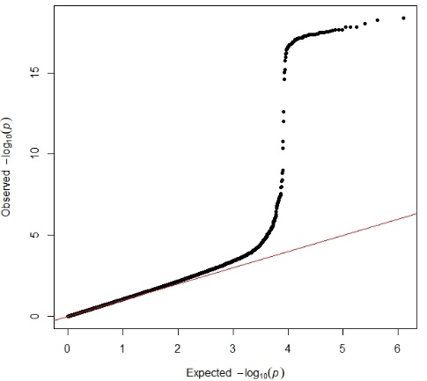

Figure S5. The Q-Q plot of GWAS

Figure S6. The manhattan plot of GWAS
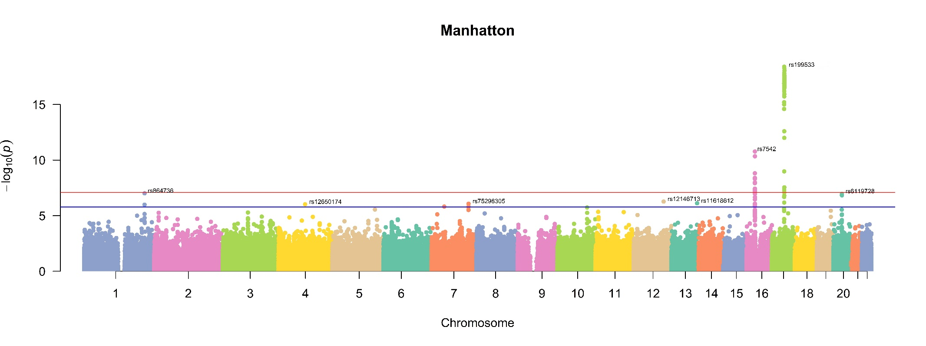

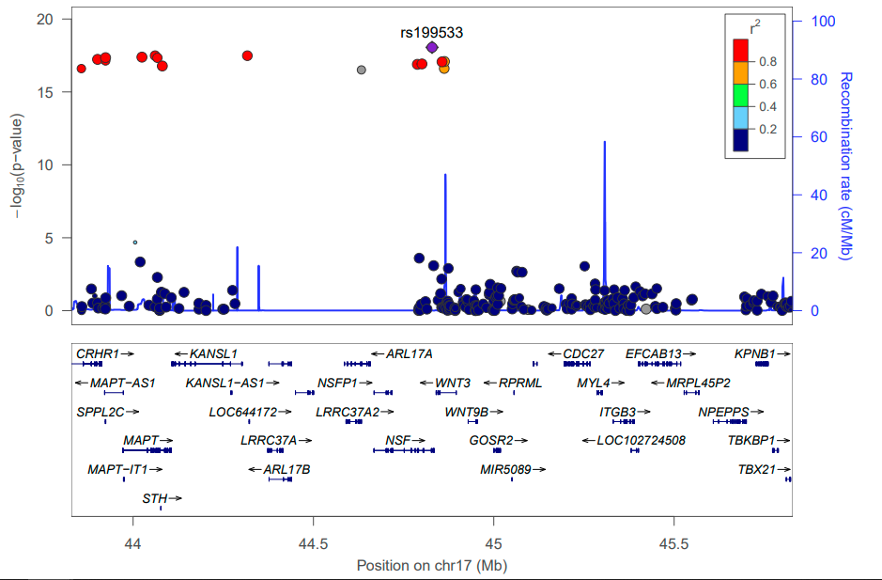
Figure S7. LocusZoom plot showing the GWAS results for the neighborhood of rs199533. r²: a measure of the linkage disequilibrium between rs199533 and SNPs

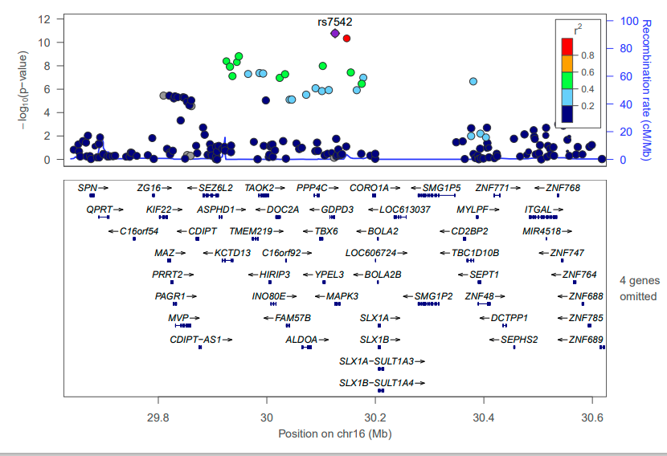
Figure S8. LocusZoom plot showing the GWAS results for the neighborhood of rs7542. r²: a measure of the linkage disequilibrium between rs7542 and SNPs

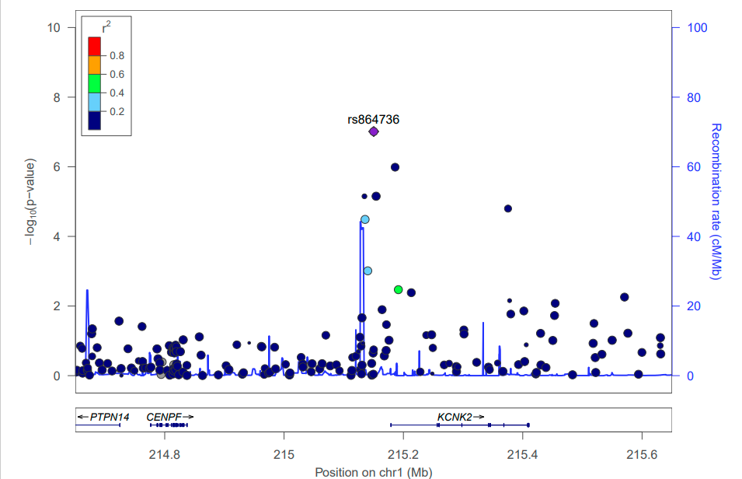
Figure S9. LocusZoom plot showing the GWAS results for the neighborhood of rs864736. r²: a measure of the linkage disequilibrium between rs864736 and SNPs

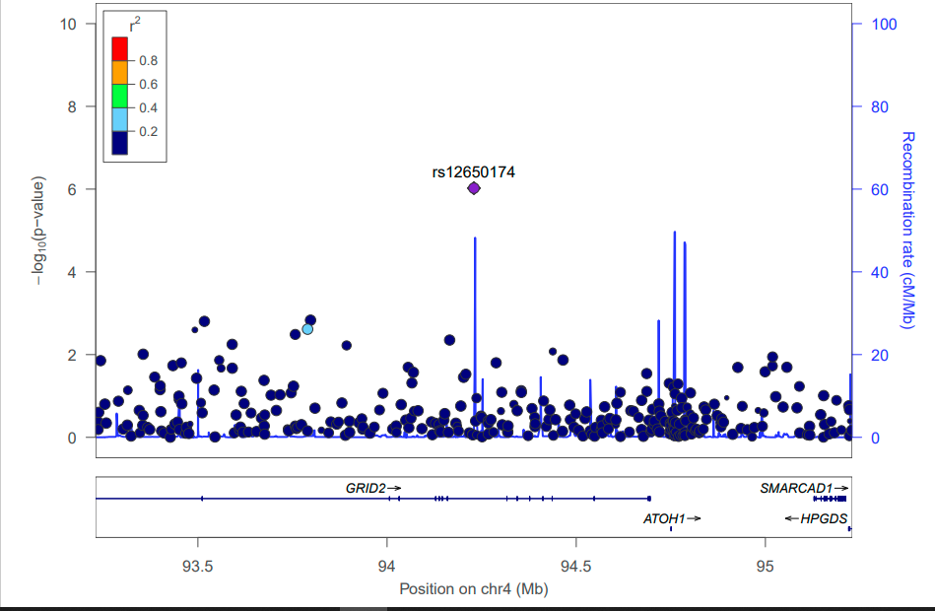
Figure S10. LocusZoom plot showing the GWAS results for the neighborhood of rs199533. r²: a measure of the linkage disequilibrium between rs199533 and SNPs

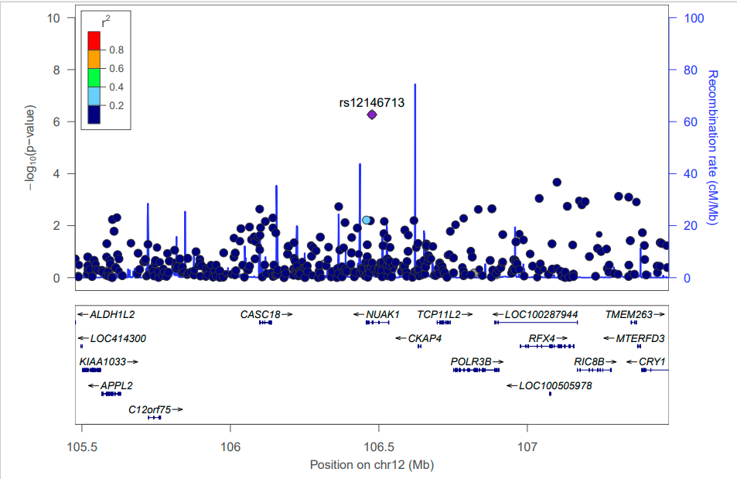
Figure S11. LocusZoom plot showing the GWAS results for the neighborhood of rs12146713. r²: a measure of the linkage disequilibrium between rs12146713 and SNPs

Figure S12. The XGBoost predictor’s performance of BAG in the non-smokers after adjusting for sample relatedness

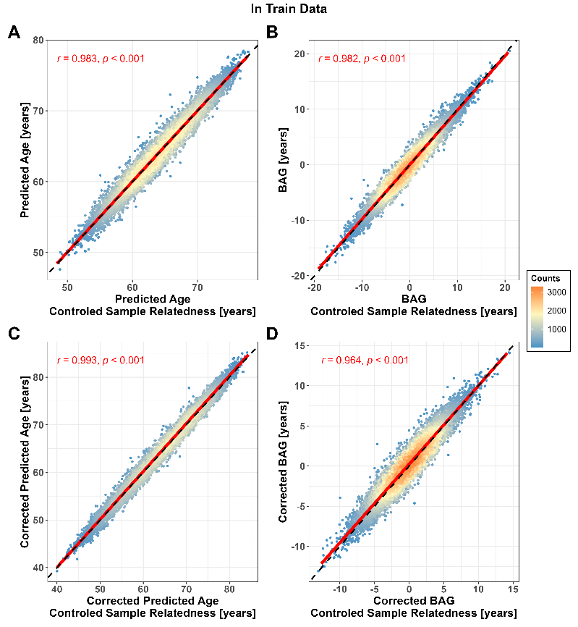
Figure S13. Correlation between prediction results with and without adjusting sample correlation in train data

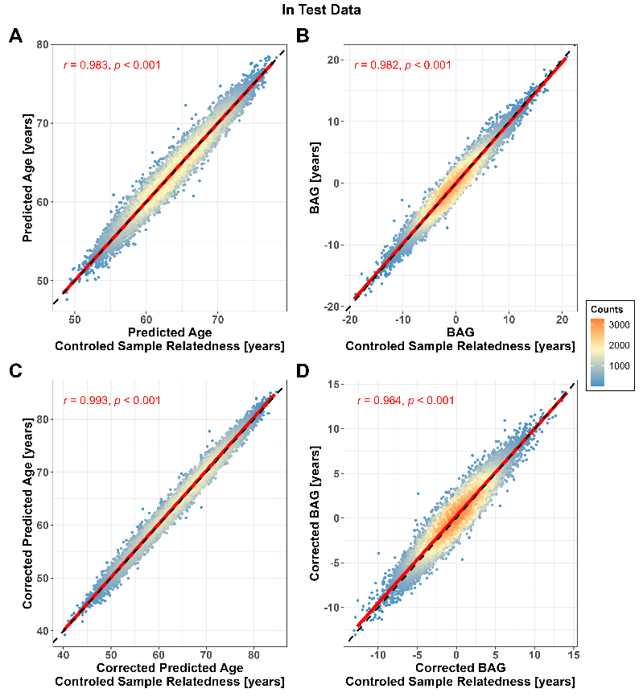
Figure S14. Correlation between prediction results with and without adjusting sample correlation in test data

