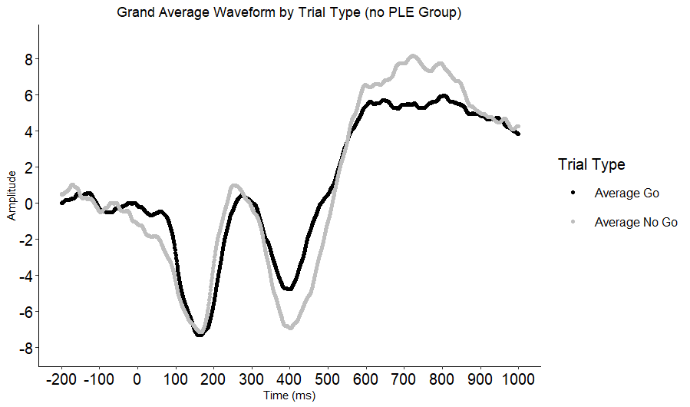Supplementary Figure 3. Grand average waveform for Go and No-go trials for participants who later denied all PLEs. Negative amplitudes are plotted down.

