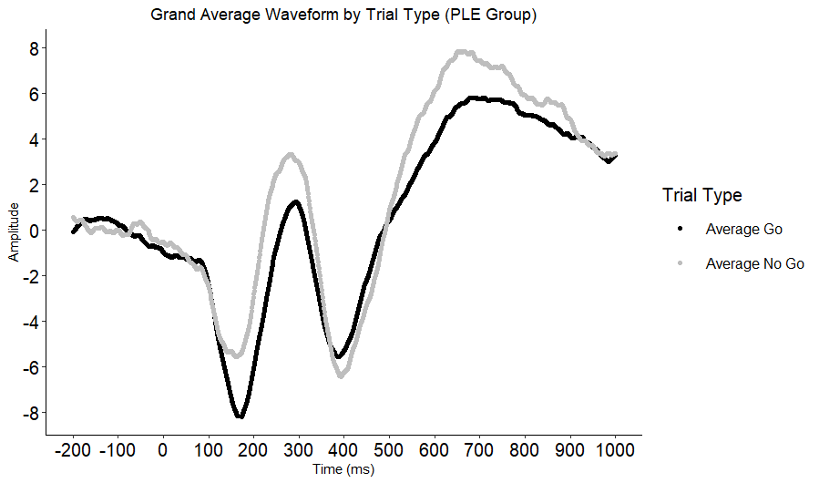Supplementary Figure 2. Grand average waveform for Go and No-go trials for participants who later reported PLEs. Negative amplitudes are plotted down.

