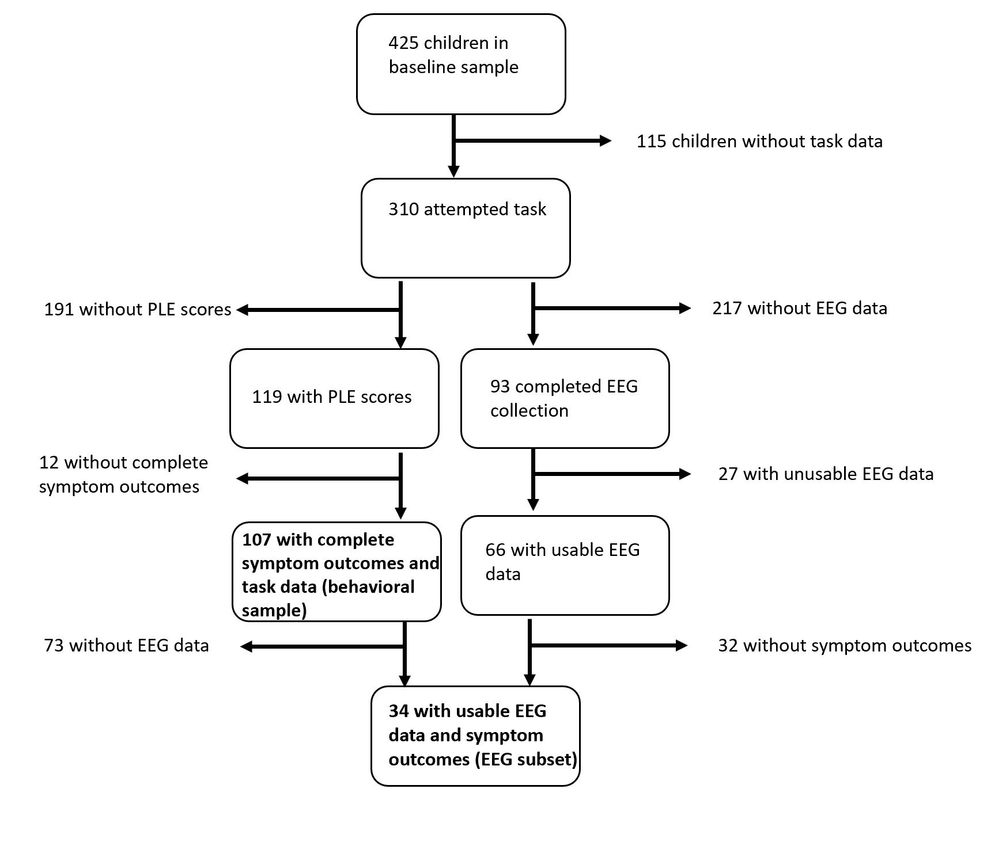Supplementary Figure 1. Flowchart of sample selection from full baseline sample to final behavioral and EEG samples.

