Appendices and Supplementary
Neural habituation during acute stress signals a blunted endocrine response and poor resilience
Yadong Liu^{a,b,1}, Xiaolin Zhao^{a, b,1}, Weiyu Hu^{a,b}, Yipeng Ren^{a,b}, Zhenni Wei^{a,b}, Xi Ren^{a,b}, Zihan Tang^{a,b}, Nan Wang^{a,b}, Haopeng Chen^{a,b}, Yizhuo Li^{a,b}, Zhenhao Shi ^{c}, Shaozheng Qin ^{d}, and Juan Yang^{a,b*}
Contents
I. Detailed Materials and Methods for MIST study
a. Participants
b. Procedures
c. Chronic stress measurement
II. Supplemental Tables and Figures
a. Supplemental Tables
Table S1. Main effects of Stress VS. Control in the ScanSTRESS paradigm
Table S2. Correlation between acute stress responses, resilience, and depression in the ScanSTRESS paradigm
Table S3. Detailed information about ANOVA analysis in the ScanSTRESS paradigm
Table S4. Moderating effect of resilience between brain dynamics (first block - last block) and cortisol response in the ScanSTRESS paradigm
b. Supplemental Figures
Figure S1. Demonstration for how AUCg and AUCi were calculated.
Figure S2. An overview of the MIST experimental procedure.
Figure S3. Neural habituation difference between cortisol responder and non-responder in the ScanSTRESS paradigm.
Figure S4. Moderating effect of resilience between neural habituation (first block-last block) and the cortisol response in the ScanSTRESS paradigm.
Figure S5. Subjective and endocrine response to the MIST paradigm
Figure S6. Neural response to the MIST paradigm
Figure S7. Neural habituation between cortisol responder and non-responder in the MIST paradigm
III. References

I. Detailed Materials and Methods for the MIST study
a. Participants
Task fMRI data from 48 healthy participants was collected (mean age: 19.10 years, range 17–22, 24 women). Exclusion criteria consisted of psychological disorders, severe physical illness, head injury, and a history of alcoholism or drug abuse. Female participants were tested during their luteal phase (around ten days before menstruation) and did not use oral contraceptives leading up to the experiment (Roche, King, Cohoon, & Lovallo, 2013; Sharma et al., 2020). All participants were asked not to eat, exercise, drink wine or coffee, or brush their teeth for one hour before the experiment was conducted. All participants provided written informed consent and received 50 yuan for attending the experiment. This study was approved by the Ethics Committee of Southwest University, China (No. H20003).
b. Procedures
The MIST paradigm and Experiment procedure
To mediate the effect of cortisol rhythm on experimental results, participants were required to arrive at the laboratory in the mid-afternoon between 3:00 and 5:00 pm. After arriving at the laboratory, participants were asked to rest for 30 min before entering the MRI scanner. A TI image was acquired first, followed by a resting-state image. Immediately afterward, the MIST paradigm was used to induce a stress response for 30 min. The MIST is a well-validated tool to induce psychosocial stress during fMRI scanning. Similar to the SanSTRESS study, participants were asked to answer arithmetic questions with a time limit and a visible progress bar, leading to a higher rate of incorrect responses. Participants can also see an expert on the screen who is monitoring his/her performance. In this way, the social evaluative threat was introduced. After the stress induction was completed, participants were asked to evaluate the degree of uncontrollability and social evaluation threat they experienced during stress induction. Then participants were allowed another 25 min to rest before leaving the laboratory. Subjective stress reports and salivary cortisol data were collected seven times throughout the experiment (Figure S2).
c. Chronic stress measurement
Daily Stress Inventory (DSI)
Daily Stress Inventory (DSI) contains 58 items, and each item represents a daily stress event. Participants need to answer whether this event happened during the last 24 hours, if so, how stressful it is based on a 7-point Likert scale ranging from 1, corresponding to ‘Not stressed at all, to 7, corresponding to ‘totally stressed’.

II. Supplemental Tables and Figures
a. Supplemental Tables
Table S1. Main effects of Stress VS. Control in the ScanSTRESS paradigm
 |  | Peak coordinate
Condition | Location | X | Y | Z | Voxel | BA | t
Stress > Control | Frontal_Mid_R | -6 | 22 | 38 | 439 | 7 | 9.71
 | Frontal_Mid_L | 8 | -38 | 40 | 132 | 7 | 4.73
 | Frontal_Sup_R | -20 | 8 | 60 | 522 | 18 | 9.23
 | Frontal_Sup_L | 20 | 10 | 60 | 910 | 40 | 10.16
 | Frontal_Sup_Medial_L | 0 | 26 | 42 | 461 | 10 | 10.55
 | Frontal_Sup_Medial_R | 4 | 30 | 42 | 196 | 10 | 9.57
 | Frontal_Inf_Tri_L | -52 | 22 | 26 | 2090 | 24 | 11.07
 | Frontal_Inf_Tri_R | 44 | 28 | 20 | 1759 | 24 | 12.28
 | Frontal_Inf_Orb_L | -30 | 30 | -4 | 342 | 4 | 10.63
 | Frontal_Inf_Orb_R | 30 | 28 | -6 | 254 | 4 | 10.96
 | Precuneus_R | 40 | 6 | 50 | 739 | 19 | 11.74
 | Precuneus_L | -10 | -72 | 38 | 1300 | 19 | 9.50
 | Parietal_Inf_R | -38 | -54 | 42 | 1293 | 9 | 14.56
 | Parietal_Inf_L | 38 | -48 | 40 | 972 | 37 | 12.32
 | Temporal_Mid_L | -56 | -50 | 4 | 1151 | 19 | 7.39
 | Temporal_Mid_R | 40 | -68 | 10 | 1975 | 19 | 9.90
 | Temporal_Sup_R | -60 | -46 | 18 | 273 | 37 | 6.82
 | Temporal_Sup_L | 48 | -38 | 10 | 807 | 24 | 9.17
 | Temporal_Inf_L | -52 | -54 | -8 | 490 | 32 | 7.04
 | Temporal_Inf_R | 58 | -54 | -10 | 1046 | 8 | 9.03
 | Cingulum_Mid_R | -6 | 22 | 38 | 439 | 19 | 9.71
 | Cingulum_Mid_L | 8 | -38 | 40 | 132 | 10 | 4.73
 | Cingulum_Ant_R | -4 | 28 | 30 | 228 | 10 | 6.18
 | Cingulum_Ant_L | 8 | 26 | 30 | 353 | 10 | 8.22
 | Insula_L | -30 | 26 | -6 | 870 | 24 | 14.20
 | Insula_R | 30 | 24 | 6 | 986 | 31 | 10.36
 | Thalamus_R | 10 | -6 | 6 | 237 | 37 | 6.82
 | Hippocampus_R | 22 | -34 | 6 | 45 | 47 | 4.52
 | Hippocampus_L | -24 | -12 | -22 | 17 | 34 | -8.59
 | Angular_R | -36 | -54 | 36 | 586 | 47 | 13.32
 | Angular_L | 42 | -48 | 36 | 959 | 11 | 9.73
 | Caudate_R | 18 | -2 | 24 | 76 | 4 | 5.68
Stress < Control | Temporal_Sup_L | -58 | -16 | 4 | 1307 | 6 | -7.19
 | Temporal_Sup_R | 68 | -14 | 2 | 1098 | 6 | -7.47
 | Precuneus_L | 0 | -58 | 22 | 757 | 21 | -12.23
 | Precuneus_R | 4 | -56 | 22 | 530 | 38 | -12.49
 | Insula_R | -34 | -20 | 16 | 525 | 31 | -9.14
 | Insula_L | 34 | -20 | 14 | 574 | 38 | -8.23
 | Cingulum_Mid_L | -12 | -48 | 34 | 322 | 38 | -5.15
 | Cingulum_Mid_R | 4 | -28 | 54 | 71 | 7 | -4.19
 | Cingulum_Post_L | -2 | -50 | 24 | 488 | 30 | -11.35
 | Cingulum_Post_R | 4 | -46 | 24 | 171 | 40 | -8.79
 | ParaHippocampal_L | -26 | -24 | -20 | 297 | 11 | -9.68
 | Frontal_Sup_L | -12 | 52 | 28 | 1167 | 10 | -7.51
 | Frontal_Sup_R | 16 | 42 | 34 | 287 | 9 | -5.20
 | Frontal_Sup_Medial_L | -10 | 64 | 10 | 1205 | 10 | -7.98
 | Frontal_Sup_Medial_R | 6 | 62 | 8 | 804 | 10 | -7.24
 | Cingulum_Ant_R | -6 | 48 | -2 | 987 | 9 | -8.84
 | Cingulum_Ant_L | 4 | 30 | -6 | 676 | 8 | -9.69
 | Amygdala_L | -26 | 0 | -14 | 16 | 53 | -6.79
 | Amygdala_R | 28 | 0 | -26 | 13 | 53 | -6.40

Table S2. Correlation between acute stress responses, resilience, and depression in the ScanSTRESS paradigm
Variable | M | SD | 1 | 2 | 3 | 4 | 5 | 6
1. Age | 20.07 | 1.95
2. CortiAUCg | 16.43 | 7.39 | .14
 |  |  | [-.09, .36]
3. CortiAUCi | 2.24 | 8.29 | .15 | .44**
 |  |  | [-.08, .37] | [.23, .61]
4. SSAUCg | 241.37 | 94.10 | -.20 | -.10 | -.09
 |  |  | [-.41, .03] | [-.32, .14] | [-.31, .15]
5. SSAUCi | 62.24 | 71.99 | -.07 | .10 | .01 | .49**
 |  |  | [-.30, .16] | [-.14, .32] | [-.22, .24] | [.29, .65]
6. Depression | 17.15 | 4.30 | -.07 | -.04 | -.23 | .27* | -.02
 |  |  | [-.30, .16] | [-.27, .19] | [-.47, .04] | [.04, .49] | [-.25, .21]
7. Resilience | 7.33 | 1.19 | .02 | .08 | .11 | -.18 | -.14 | -.08
 |  |  | [-.21, .25] | [-.15, .31] | [-.12, .33] | [-.40, .05] | [-.36, .10] | [-.31, .16]
Note. M and SD represent the mean and standard deviation, respectively. SSAUCg and SSAUCi indicate the area under the curve with respect to the ground (AUCg) and area under the curve with respect to the increase (AUCi) for subjective stress reports, respectively. CortiAUCg and CortiAUCi indicate the area under the curve with respect to the ground (AUCg) and area under the curve with respect to increase (AUCi) for salivary cortisol, respectively. Values in square brackets indicate the 95% confidence intervals for each correlation. * indicates p < .05, ** indicates p < .01.

Table S3. Detailed information about ANOVA analysis in the ScanSTRESS paradigm
Location  Cluster |  | Brain area | abbreviation | Voxel | BA | F | Peak coordinate
 | dlPFC | Frontal_Mid_R | MFG_R | 1280 | 46 | 12.62 | 42 24 39
 |  | Frontal_Mid_L | MFG_L | 1094 | 46 | 13.21 | -27 51 15
 |  | Frontal_Sup_R | SFG_R | 982 | 9 | 8.25 | 30 57 12
 |  | Frontal_Sup_L | SFG_L | 567 | 9 | 8.62 | -24 57 15
 | vmPFC | Frontal_Inf_Orb_L | IFGorb_L | 81 | 47 | 9.51 | -42 20 -10
 |  | Frontal_Inf_Orb_L | IFGorb_L | 81 | 47 | 9.51 | -42 20 -10
 |  | Frontal_Sup_Medial_L | SFGmed_L | 1185 | 9 | 9.56 | 0 39 33
 |  | Frontal_Sup_Medial_R | SFGmed_R | 602 | 32 | 9.00 | 30 57 12
 |  | Frontal_Inf_Tri_R | IFGtri_R | 519 | 45 | 11.60 | 51 21 9
 |  | Frontal_Inf_Tri_L | IFGtri_L | 60 | 45 | 10.12 | -51 18 6
 |  | Cingulum_Ant_R | ACC_R | 519 | 24 | 11.02 | 9 42 9
 |  | Cingulum_Ant_L | ACC_L | 443 | 24 | 10.11 | 0 30 27
 |  | Frontal_Inf_Orb_R | IFGorb_R | 323 | 47 | 5.70 | 30 27 -6
 |  | Frontal_Inf_Orb_L | IFGorb_L | 183 | 47 | 9.82 | -33 21 -12
 |  | Frontal_Med_Orb_R | SFGmorb_R | 316 | 23 | 18.32 | 7 52 -7
 |  | Frontal_Med_Orb_L | SFGmorb_L | 298 | 23 | 14.02 | -8 54 -7
 |  | Frontal_Mid_Orb_R | MFGorb_R | 115 | 47 | 6.64 | 32 53 -11
 |  | Frontal_Mid_Orb_L | MFGorb_L | 110 | 47 | 8.91 | -30 52 10
 |  | Frontal_Sup_Orb_R | SFGorb_R | 115 | 26 | 7.78 | -18 47 -13
 |  | Frontal_Sup_Orb_L | SFGorb_L | 85 | 26 | 5.63 | 17 -18 -14
 |  | Frontal_Inf_Tri_L | IFGtri_L | 134 | 45 | 12.99 | -56 16 14
Limbic area |  | Hippocampus_R | HIP_R | 39 | 20 | 8.35 | 30 -4 -22
 |  | Amygdala_R | AMY_R | 21 | 34 | 8.25 | 25 21 -26
 |  | Insula_R | INS_R | 210 | 48 | 11.46 | 28 20 -14
 |  | Insula_L | INS_L | 133 | 48 | 10.36 | -28 24 -8

Table S4. Moderating effect of resilience between brain dynamics (first block - last block) and cortisol response
Predictor | b | b  95% CI  [LL, UL] | beta | beta  95% CI  [LL, UL] | sr² | sr²  95% CI  [LL, UL] | r | Fit
Model 1
(Intercept) | 4.97 | [-8.05, 17.99]
Resilience | -0.24 | [-1.96, 1.49] | -0.03 | [-0.28, 0.21] | .00 | [-.01, .01] | .11
MFG_L | -18.14* | [-32.24, -4.05] | -1.81 | [-3.21, -0.40] | .08 | [-.04, .21] | -.24*
I(Resilience * MFG_L) | 2.29* | [0.29, 4.30] | 1.59 | [0.20, 2.97] | .07 | [-.04, .17]
 |  |  |  |  |  |  |  | R² = .127*
 |  |  |  |  |  |  |  | 95% CI[.00,.25]
Model 2
(Intercept) | 4.24 | [-8.85, 17.33]
Resilience | -0.17 | [-1.89, 1.55] | -0.02 | [-0.27, 0.22] | .00 | [-.01, .01] | .11
MFG_R | -21.58** | [-36.34, -6.82] | -2.30 | [-3.88, -0.73] | .11 | [-.03, .25] | -.09
I(Resilience * MFG_R) | 2.89** | [0.87, 4.90] | 2.23 | [0.67, 3.80] | .11 | [-.03, .24]
 |  |  |  |  |  |  |  | R² = .123*
 |  |  |  |  |  |  |  | 95% CI[.00,.25]
Model 3
Predictor | b | b  95% CI  [LL, UL] | beta | beta  95% CI  [LL, UL] | sr² | sr²  95% CI  [LL, UL] | r | Fit
(Intercept) | 3.46 | [-8.95, 15.86]
Resilience | 0.01 | [-1.63, 1.66] | 0.00 | [-0.23, 0.24] | .00 | [-.00, .00] | .11
MFGorb_L | -27.29** | [-44.85, -9.73] | -2.62 | [-4.31, -0.93] | .12 | [-.02, .26] | -.24*
I(Resilience * MFGorb_L) | 3.41** | [1.03, 5.79] | 2.41 | [0.73, 4.08] | .10 | [-.03, .23]
 |  |  |  |  |  |  |  | R² = .159**
 |  |  |  |  |  |  |  | 95% CI[.01,.29]
Model 4
(Intercept) | 2.70 | [-9.42, 14.81]
Resilience | 0.11 | [-1.49, 1.71] | 0.02 | [-0.21, 0.24] | .00 | [-.01, .01] | .11
MFGorb_R | -29.72** | [-45.74, -13.69] | -2.92 | [-4.49, -1.35] | .16 | [.01, .32] | -.17
I(Resilience * MFGorb_R) | 3.92** | [1.71, 6.13] | 2.78 | [1.21, 4.35] | .15 | [.00, .30]
 |  |  |  |  |  |  |  | R² = .185**
 |  |  |  |  |  |  |  | 95% CI[.03,.32]
Model 5
(Intercept) | 10.65 | [-3.99, 25.29]
Resilience | -0.90 | [-2.80, 0.99] | -0.13 | [-0.40, 0.14] | .01 | [-.03, .06] | .11
SFGmed_L | -24.50** | [-42.16, -6.84] | -2.51 | [-4.31, -0.70] | .10 | [-.03, .22] | -.24*
I(Resilience * SFGmed_L) | 3.03* | [0.65, 5.41] | 2.25 | [0.48, 4.02] | .08 | [-.04, .20]
 |  |  |  |  |  |  |  | R² = .142*
 |  |  |  |  |  |  |  | 95% CI[.01,.27]

Note. A significant b-weight indicates the beta-weight and semi-partial correlation are also significant. b represents unstandardized regression weights. beta indicates the standardized regression weights. sr² represents the semi-partial correlation squared. r represents the zero-order correlation. LL and UL indicate the lower and upper limits of a confidence interval, respectively. Only ROI located in the vmPFC (right middle frontal gyrus [MFG], orbital part [orb]) could survive the multiple corrections. The other regions were included in the supplement because of their uncorrected p<0.05, these results were reported solely for the purpose of completeness and should be interpreted with caution. * indicates p < .05. ** indicates p < .01.

b. Supplemental Figures
Figure S1. Demonstration for how AUCg and AUCi were calculated. The area under the curve with respect to ground (AUCg) will be represented by the area of the horizontal stripe areas and the grey box. The area under the curve with respect to increase (AUCi) will be represented by the area of the horizontal stripe areas alone. The AUCg and AUCi for subjective stress feelings were also calculated by the same approach.
Figure S2. An overview of the MIST experimental procedure.

Figure S3. Neural habituation difference between cortisol responder and non-responder in the ScanSTRESS paradigm. Participants were divided into two groups, the responder (35 participants, 25 women) and the non-responder group (37 participants, 2 women). Results showed that compared to responders, non-responders have greater neural habituation during stress induction. There is a significant difference between the responder and non-responder in the last block (p = 0.026)

Figure S4. Moderating effect of resilience between neural habituation (first block-last block) and the cortisol response in the ScanSTRESS paradigm. Note that only ROI located in the vmPFC (right middle frontal gyrus [MFG], orbital part [orb]) could survive the multiple corrections. The other regions were included in the supplement because of their uncorrected p<0.05, these results were reported solely for the purpose of completeness and should be interpreted with caution.
Figure S5. Subjective and endocrine response to the MIST paradigm. Salivary cortisol level increased after stress induction, reached peak point at the end of stress induction, and recovered to baseline before leaving the laboratory.

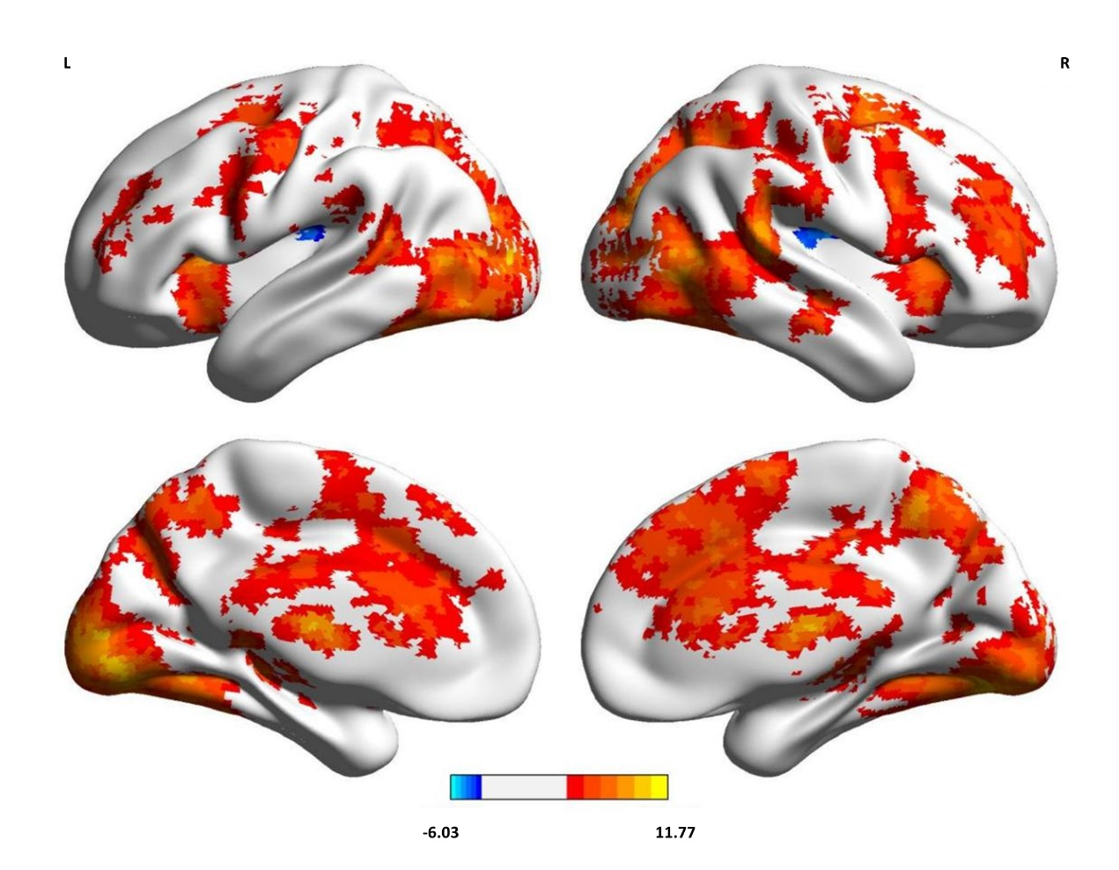 Figure S6. Neural response to the MIST paradigm. Compared to the control condition, the stress condition exhibits a higher level of activation in the dmPFC, ACC, and PCC area.

Figure S7. Neural habituation between cortisol responder and non-responder in MIST paradigm. Participants were divided into two groups, the responder (24 participants, 14 women) and the non-responder group (22 participants, 8 women). Results showed that compared to responders, non-responders have greater neural decline during stress induction. There is a significant difference between the responder and non-responder in the second block (p = 0.015). Note that the neural habituation between different stress blocks in the MIST paradigm is insignificant.

III. References
Roche, D. J. O., King, A. C., Cohoon, A. J., & Lovallo, W. R. (2013). Hormonal contraceptive use diminishes salivary cortisol response to psychosocial stress and naltrexone in healthy women. Pharmacology Biochemistry and Behavior, 109, 84–90. https://doi.org/10.1016/j.pbb.2013.05.007
Sharma, R., Smith, S. A., Boukina, N., Dordari, A., Mistry, A., Taylor, B. C., … Ismail, N. (2020). Use of the birth control pill affects stress reactivity and brain structure and function. Hormones and Behavior, 124, 104783. https://doi.org/10.1016/j.yhbeh.2020.104783

