Supplementary Information for
Abnormalities in Brain Structure Following Childhood Unpredictability: A Mechanism Underlying Depressive and Anxiety Symptoms

Wang Zhengxinyue, Xinyu Cao, Xiaoyu Zheng, Yuanyuan Chen, Jianjun Zhu*
*Author for correspondence:
Jianjun Zhu,
E-mail: jianjunzhu722@gmail.com

This file include: Supplementary Figures

Figure S1. Relationship between childhood unpredictability and grey matter volume in occipital gyrus, inferior temporal gyrus and lingual gyrus. Standardized scores of mean values were used for both the X and Y axes, with the X axis representing the index of childhood unpredictability and the Y axis representing the mean gray matter volume in specific brain regions.
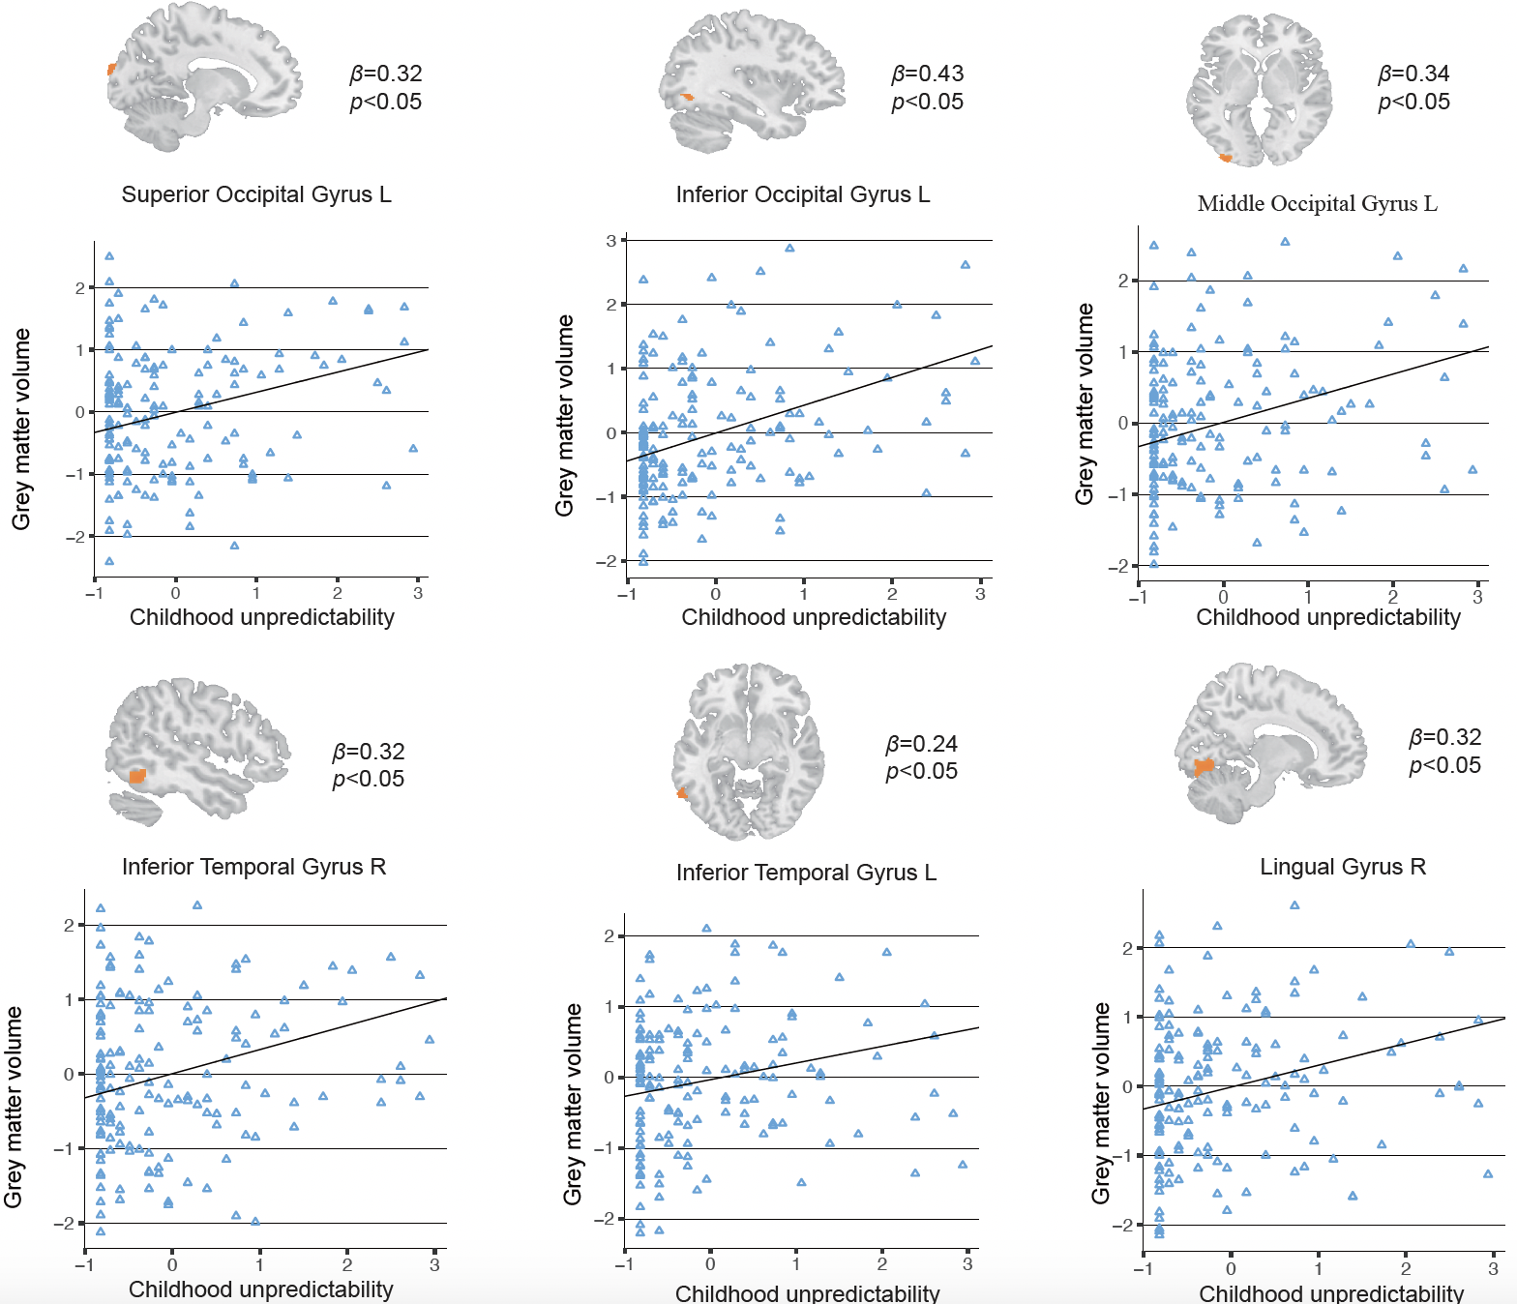

Figure S2. Mediation models explaining the associations between childhood unpredictability and psychopathology. The numbers are standardized regression coefficients and 95% confidence intervals. Not displayed are paths between controlled variables (e.g., age, SSES, TIV and childhood trauma) and each of the variables in the model.
