Supplemental Methods
Participants
Participants were selected for inclusion based on available and valid resting-state functional neuroimaging data, lifetime history of suicide attempt or self-directed violence thoughts (SDVT) (Figure 1). The Mental Health Web-based Questionnaire, which included questions regarding suicidal thoughts and behaviors, was emailed to all UK Biobank participants with valid email addresses. Additional responses were solicited by UK Biobank participants via the UK Biobank website and their annual newsletter. Participants who answered “yes” to the question “Have you ever deliberately harmed yourself, whether or not you meant to end your life?” (UK Biobank field 20480) were prompted to answer further detailed questions regarding “harm behaviours.” Among those questions were “Have you harmed yourself with the intention to end your life?” (suicide attempt history; UK Biobank field 20483). All participants who completed the mental health follow-up packet were asked the question “Have you contemplated harming yourself (for example, by cutting, biting, hitting yourself, or taking an overdose)?” (suicide-related thought history; UK Biobank field 20485). UK Biobank Mental Health Web-based Questionnaire and supporting materials can be found on their website (https://biobank.ndph.ox.ac.uk/ukb/ukb/docs/mental_health_online.pdf).
Measures
The UK Biobank Mental Health Web-based Questionnaire includes several questions regarding suicidal thoughts and behaviors, each with their own strengths and limitations. Each question has varying time frames, from past two weeks to lifetime. For the purposes of this study, we utilized UK Biobank field 20483 to define suicide attempt history and field 20485 to define SDVT. These two variables were chosen primarily for three reasons. First, these variables uniquely had sufficient sample sizes of participants with valid functional neuroimaging to support well-powered analyses. Second, these variables both utilize the same “lifetime” timeframe, allowing for comparison between groups on the same time scale. Third, both variables were asked using the same UK Biobank branching logic, meaning that no specific diagnostic criteria needed to be met in order to answer either of these questions.
Network Nodes
Network Node Identification and Classification. For each of the 21 ICA component nodes, two raters independently (1) identified sets of coordinates with highest activation, (2) cross-examined node coordinates with the Neurosynth meta-analytic database, and (3) cross-referenced coordinates, anatomical regions, functional associations, and Neurosynth associations with well-respected peer-reviewed articles to assign network identification. First, sets of coordinates with high activation for each node were determined using UK Biobank network maps axial, coronal, and sagittal views. All coordinates were noted in Montreal Neurological Institute (MNI) space.
Then, for each coordinate within each ICA node, we cross-examined node coordinates with the Neurosynth meta-analytic database. The Neurosynth database is a platform for large-scale, automated synthesis of functional magnetic resonance imaging (fMRI) data, which includes over 500,000 activations pooled from over 14,000 independent studies and has been used widely in functional network connectivity methodology (e.g.(Barredo et al., 2018)). Once entered into the Neurosynth database, coordinates were visually inspected using the Neurosynth viewer (axial, coronal, and sagittal views) to confirm correspondence with the UK Biobank viewer. Using Neurosynth’s “Associations” feature, preliminary networks were identified based on anatomical, functional, and network associations using z-scores and posterior probabilities.
For each of the 21 ICA nodes, several well-respected peer-reviewed articles identifying large- and small-scale functional brain networks were referenced (Cole, Bassett, Power, Braver, & Petersen, 2014; Power et al., 2011; Uddin, Yeo, & Spreng, 2019; Yeo et al., 2011). MNI coordinates and anatomical labels tying regions to networks were prioritized, while functional labels were used a s a secondary tool for assigning network identifiers.
The process described above was developed as an iterative process and was independently followed by two raters. First, the primary rater (MT) established and refined the above-mentioned process with the first node, based on previous studies (Barredo et al., 2018). The primary rater then completed this process independently for all 21 nodes. For nodes with multiple network identifications or no clear network identification, the primary rater consulted with the lead author (JG).
After all 21 ICA nodes were assigned network identifications, the primary coder trained the second coder (MM) on independent set of nodes (first three from the UK Biobank 55 ICA node matrix). The secondary rater (MM) then completed this process independently for the first two nodes. Following the first two nodes, the primary and secondary raters met to compare categorization of the first two nodes troubleshoot any potential issues that may have arisen. After this meeting, the secondary rater completed this process independently for the remaining 19 nodes. Following network identification for all 21 nodes by the secondary rater, both raters met to discuss network assignment and reach consensus. Any discrepancies that could not be immediately resolved were discussed with lead author.

Supplemental Figures
Figure 1: Node 7 characterization. (a) Notable coordinates were identified within this node. (b) Coordinates were entered into the Neurosynth database. (c) Associations for coordinates using the Neurosynth database were cross-referenced with extant literature. Using these coordinates and three other coordinates from Node 7, it was identified as medial frontoparietal (default mode) network.
- Node 7 from the UK Biobank
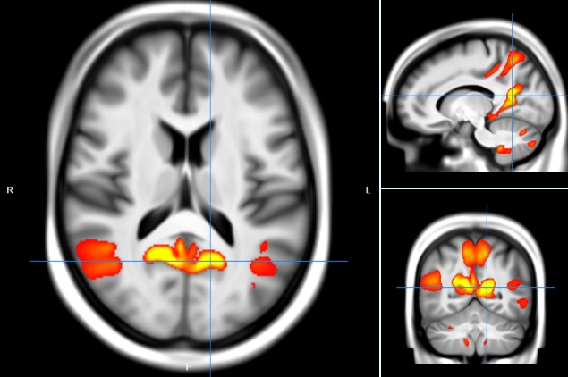
- One set of coordinates in Neurosynth meta-analytic database
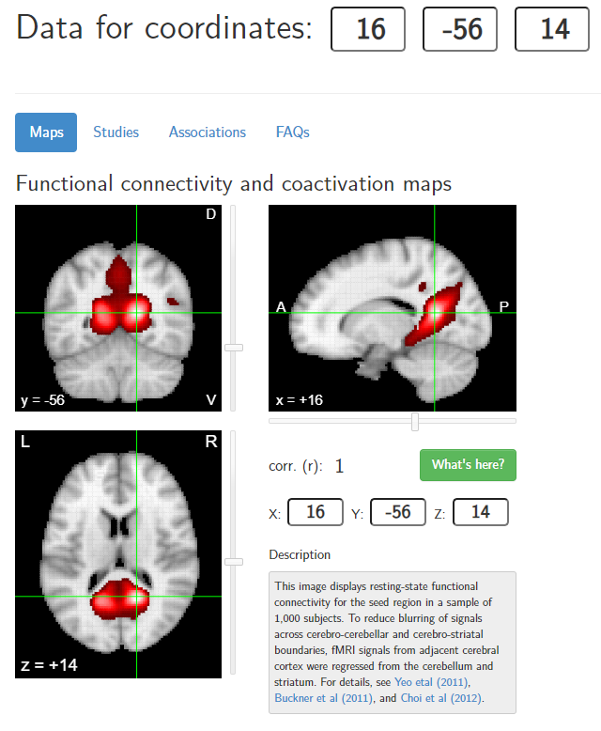

- Associations for coordinates using the Neurosynth meta-analytic database
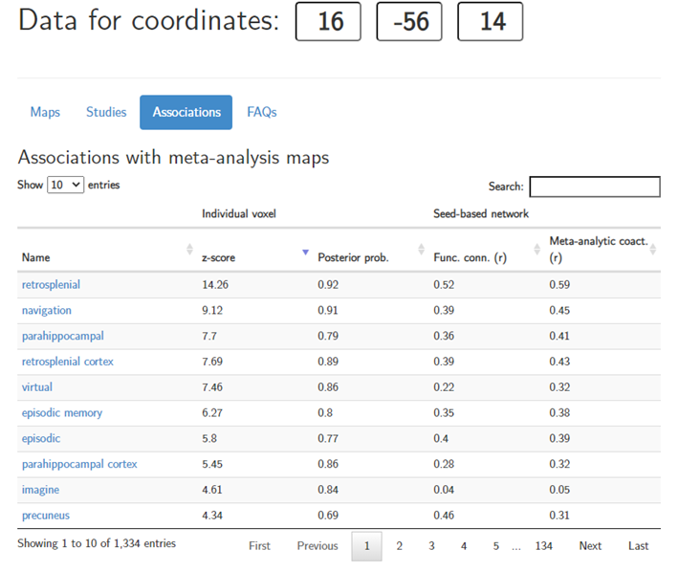

Figure S2. Lifetime suicide attempt(s) was nominally associated with altered within-network connectivity in M-FPN when compared with lifetime SDVT alone prior to FDR correction for multiple comparisons. Those with a history of suicide attempt had lower connectivity between M-FPN nodes 1 and 7 (blue line) and greater connectivity between M-FPN nodes 14 and 20 (red line). Lifetime suicide attempt(s) was also associated with lower connectivity between M-CIN nodes 13 and 21 (blue line) prior to FDR correction for multiple comparisons. Models were adjusted for age, sex, ethnicity, and BMI.

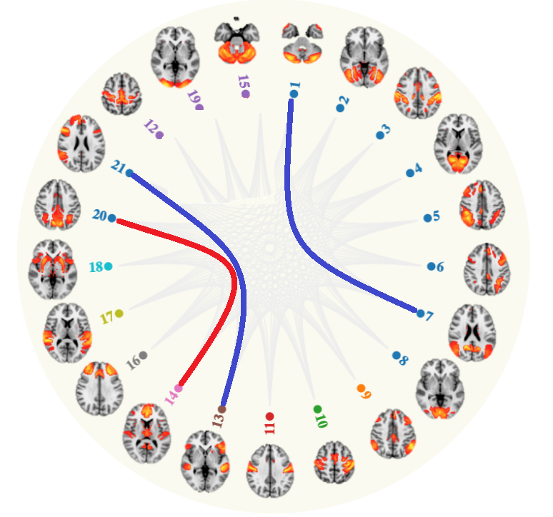

Figure S3. Lifetime suicide attempt(s) was nominally associated with stronger connectivity (red lines) between the L-FPN (node 16) and M-FPN (node 7) and M-CIN (node 18) when compared with lifetime SDVT alone prior to FDR correction for multiple comparisons. Lifetime suicide attempt(s) was also associated with greater connectivity between the M-FPN (node 14) and the M-CIN (node 13). Models were adjusted for age, sex, ethnicity, and BMI.

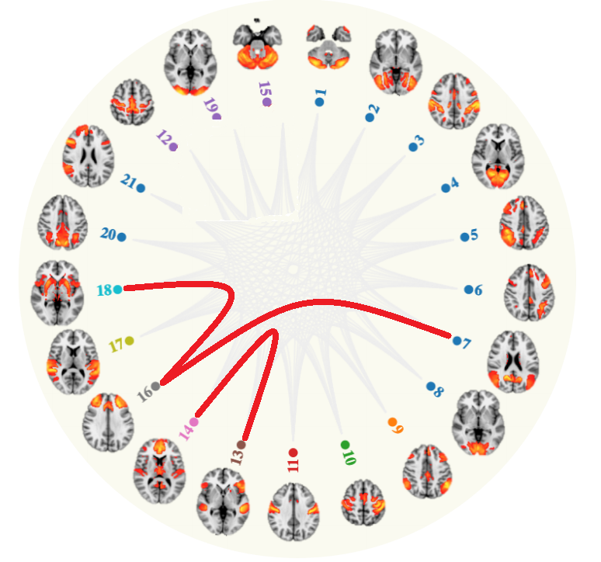

References
Barredo, J., Aiken, E., van't Wout-Frank, M., Greenberg, B. D., Carpenter, L. L., & Philip, N. S. (2018). Network functional architecture and aberrant functional connectivity in post-traumatic stress disorder: A clinical application of network convergence. Brain connectivity, 8(9), 549-557.
Cole, M. W., Bassett, D. S., Power, J. D., Braver, T. S., & Petersen, S. E. (2014). Intrinsic and task-evoked network architectures of the human brain. Neuron, 83(1), 238-251.
Power, J. D., Cohen, A. L., Nelson, S. M., Wig, G. S., Barnes, K. A., Church, J. A., . . . Schlaggar, B. L. (2011). Functional network organization of the human brain. Neuron, 72(4), 665-678.
Uddin, L. Q., Yeo, B. T. T., & Spreng, R. N. (2019). Towards a Universal Taxonomy of Macro-scale Functional Human Brain Networks. Brain Topogr, 32(6), 926-942. doi:10.1007/s10548-019-00744-6
Yeo, B. T., Krienen, F. M., Sepulcre, J., Sabuncu, M. R., Lashkari, D., Hollinshead, M., . . . Buckner, R. L. (2011). The organization of the human cerebral cortex estimated by intrinsic functional connectivity. J Neurophysiol, 106(3), 1125-1165. doi:10.1152/jn.00338.2011

