Supplementary material
Model selection
We conduct a model selection procedure based on the group-wise estimation that results in the three conditions with complete information. Tables below report the AIC and BIC of those estimations.
Symmetric condition
Model | Group | LL | AIC | BIC
Model I | HC | -1302.605 | 2615.209 | 2646.719
Model I | MDD | -1264.619 | 2539.237 | 2570.747
Model II | HC | -1302.595 | 2617.189 | 2655.002
Model II | MDD | -1264.206 | 2540.413 | 2578.225

Asymmetric condition
Model | Group | LL | AIC | BIC
Model I | HC | -869.041 | 1748.082 | 1779.592
Model I | MDD | -951.865 | 1913.731 | 1945.241
Model II | HC | -865.225 | 1742.449 | 1780.261
Model II | MDD | -950.983 | 1913.967 | 1951.779

Reversal condition
Model | Group | LL | AIC | BIC
Model I | HC | -844.633 | 1699.265 | 1730.775
Model I | MDD | -1029.497 | 2068.994 | 2100.504
Model II | HC | -842.468 | 1696.935 | 1734.747
Model II | MDD | -1023.639 | 2059.279 | 2097.091

In all conditions, the AICs and BICs show that the improvements in the LL of Model II, compared to Model I, are not very significant.

Simulation recovery
(1) To check the capacity of recovering the correct parameters using simulated datasets, we simulate performance with our behavioral task using participants with two models’ parameters values corresponding to those retrieved from our experimental participants. For the parameters of the two models, for each subject, we simulate corresponding 100 virtual subjects for each combination of parameters. For model II, the corresponding response time from the original data was used as a substitute since it was not possible to generate the response time in the simulation of model II.
We then recover the parameters of Model I and Model II with the simulated data. As shown in following figure (Figure I1-I3), we find that both Model I and Model II can recover the parameters of learning rates at a reasonable level in all the three conditions. We also note that the correlation of parameter $g$ of Model II is bit lower than that of other parameter in the asymmetric condition and the reversal condition. This may stem from the fact that we cannot simultaneously simulate the response time for each trial in the simulation of Model II, and thus, the response times of original data may introduce some biases in the recovery estimation of Model II.

Figure I1 Symmetric condition

Figure I2 Asymmetric condition

Figure I3 Reversal condition

In addition to the model recovery exercise we illustrated above, we illustrate the choice accurary differences between the HC and MDD for the true and simulated data in a pairwise manner (Figure I4-I5). Similar to Figure 2, the accuracy of choices is only defined in the asymmetric condition and the reversal condition. As shown in these figures, in the asymmetric condition, the accuracy of HC is significantly higher than that of MDD in the posterior predictions of the two models (Model I : Wilcoxon signed-rank test : Z = 4.257, p = 2.384*10⁻⁰⁷; Model II: Wilcoxon signed-rank test : Z = 4.257, p = 2.384*10⁻⁰⁷). Moreover, the reversal condition results are consistent with the asymmetric condition (Model I : Wilcoxon signed-rank test : Z =4.086, p = 2.265*10⁻⁰⁶; Model II: Wilcoxon signed-rank test : Z = 3.829, p = 2.015*10⁻⁰⁵).
Figure I4 Asymmetric condition
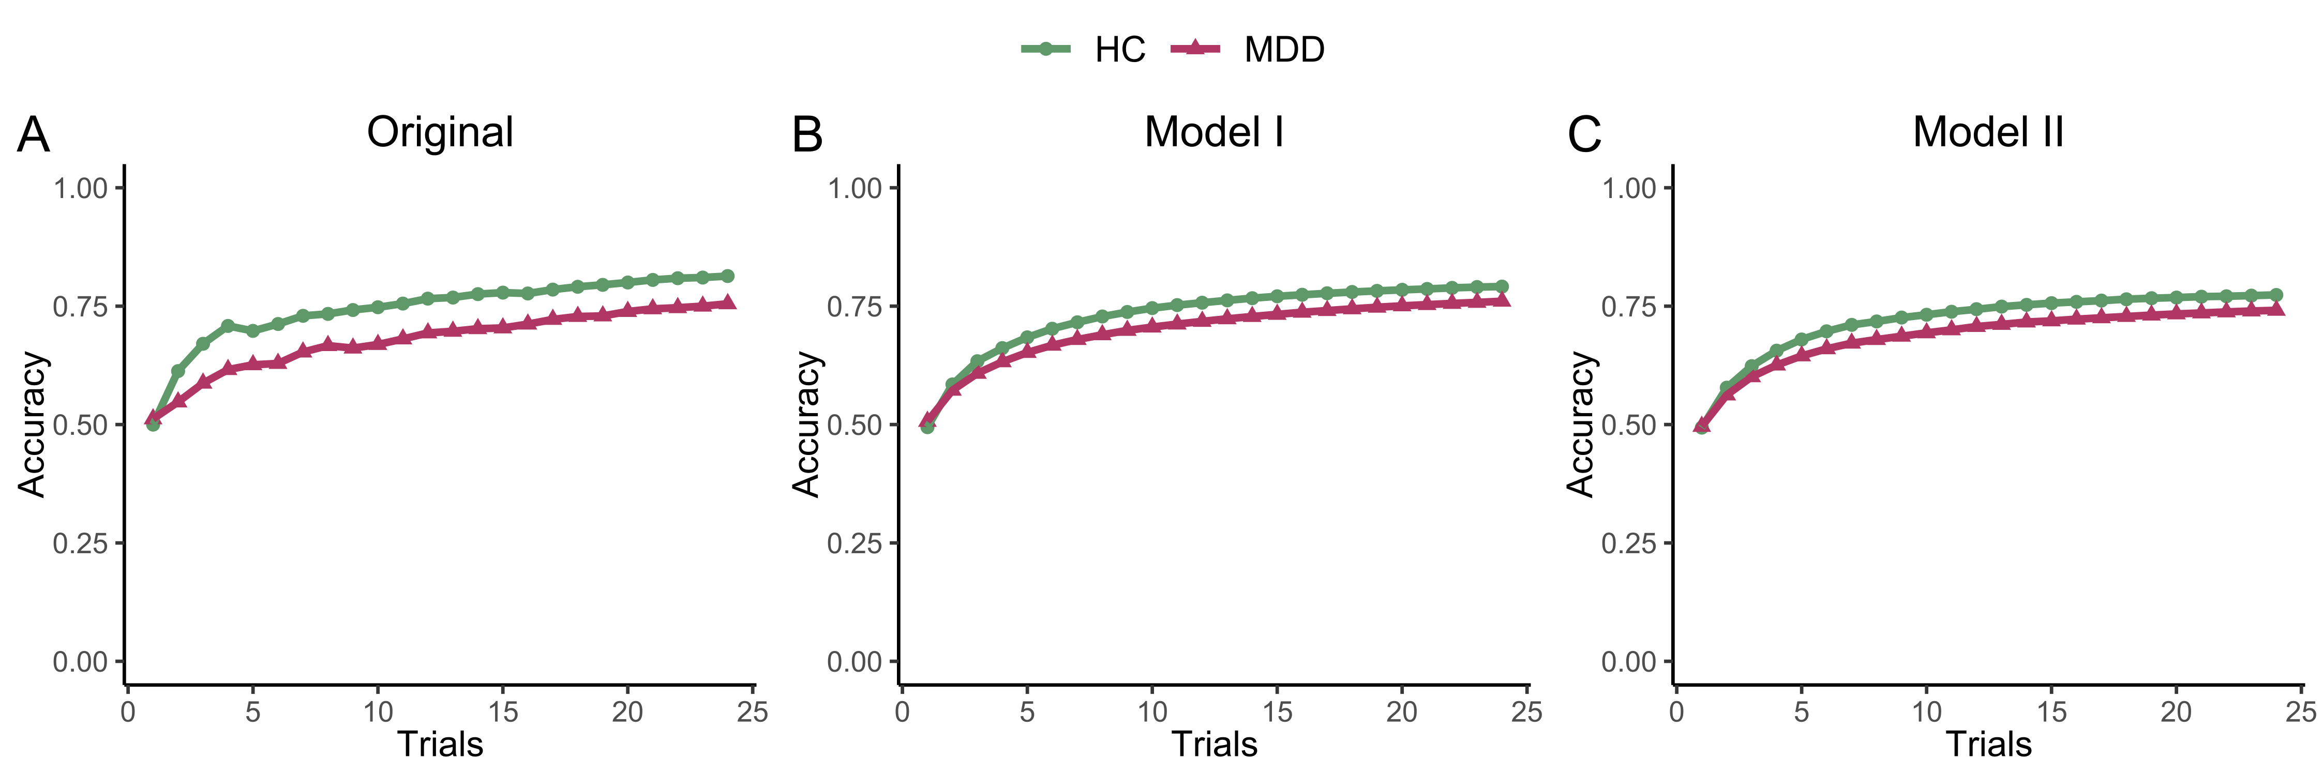
Figure I5 Reversal condition
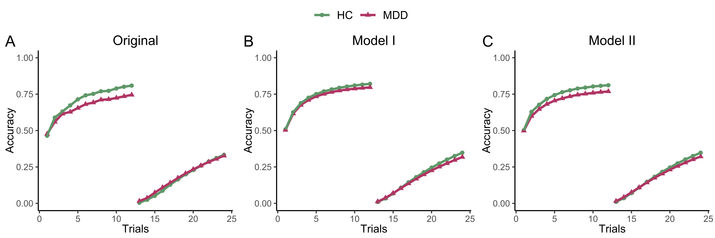

(2) To further validate the argument of Webb (2019), we conduct a new simulation recovery exercise. Since the asymmetric condition represents the main findings of our paper, we focus on the asymmetric condition. As the learning rate is usually in the range between 0 and 1, we divide it into three intervals (low: 0-1/3, median: 1/3-2/3 and large: 2/3-1) and in each interval, we randomly generate a number for each of the four parameters ($α_{c+},α_{c-},α_{u+},α_{u-}$), which results in $3^{4}=81$ different combinations. In the new simulation recovery exercise, we first apply the RLDDM framework to simulate the data with these generated parameters, and then, we further use Model I and Model II to recover the parameters.
First, we use the rtdists package (Singmann, Brown, Gretton & Heathcote, 2022) to generate 48 trials (2 blocks) in the original fitting parameters of Model I and Model II with the task of our asymmetric condition for a virtual subject to get both the choice and response time data. For each parameter combination, we repeat the data generation procedure for 100 virtual subjects. This will result in a dataset of 100 subjects and 48 trials (2 blocks) for each subject. Furthermore, in the generating process, we fix the drift rate coefficient to be one and choose three different levels of the standard deviation of the random noise, i.e., sd = 0.1, 0.25 and 0.5. The difference between the upper bound and the lower bound is set to 2 and the accumulation starts at the middle of the two bounds. However, because the response time in the first trial was too long in the case with sd = 0.1, only the datasets with sd = 0.25 and sd = 0.5 were reserved for the following estimation.
Second, we run the maximum likelihood estimation (MLE) for both model I and model II to recover the learning rates. For each parameter combination, we calculate the mean estimate of each parameter across the 100 virtual subjects. Then, for each parameter combination, we construct a mean squared error (MSE) between the four mean estimates and the four original parameters for the two models. The results show that on average, the model II outperforms model I with a relatively smaller MSE (Wilcoxon signed-rank test, in the case with sd=0.25: Z = 5.671, p = 1.438$×$10⁻⁰⁸, n = 81; in the case with sd = 0.5: Z = 4.466, p = 8.065$×$10⁻⁰⁶, n = 81). See the figure below for the results of the two simulations.
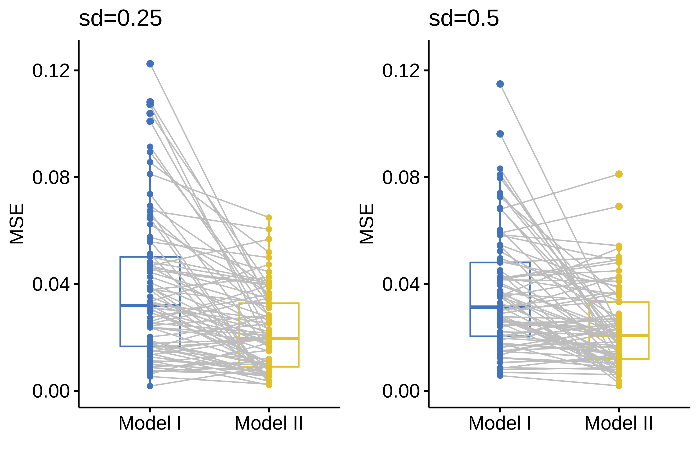
Third, for a more robust check, we repeat the above whole procedure for 20 times with each of sd = 0.25 and sd = 0.5. We find that, when sd = 0.25, there are 19 of 20 simulations, in which the MSE of Model II is significantly smaller than that of Model I at a significant level of 0.05. However, when sd = 0.5, there are only 7 simulations, in which the MSE of Model II is significantly smaller than that of Model I, and in 11 cases, the difference between the two models is not statistically significant. In the other 2 cases, the MSE of Model II is significantly larger than that of Model I. These results indicate that, when there is more noise, the improvement of introducing response time into the decision error parameter becomes negligible. When noise is less, the choices in a decision sequence of the asymmetric condition change less. The information provided by the response time can play a greater role in the estimation.

Patient’s demographics
For the MDD patients, we summarized the detailed characteristics of the adolescent patients in Table S1. Antidepressant medications included fluvoxamine (4 participants), sertraline (9), fluoxetine (11), venlafaxine (5), duloxetine (3), agomelatine (1). There were 8 participants with Quetiapine. Only a single participant with MDD was taking more than one antidepressant (venlafaxine and agomelatine). Two participants were not receiving any medications.

Learning index
To implement Post Hoc comparison between MDD and HC with multiple parameters and link it with severity of MDD symptoms in the clinical group, we constructed learning indexes with the following strategy. We consider the following two cases in the asymmetric and complete condition.
When choosing the correct option (75% chance of winning) at the current period, the difference in the expected learning outcome between MDD and HC for the right option should be $D=(+1)*\left(α_{c+}^{HC}-α_{c+}^{MDD}\right)*0.75+\left(-1\right)*\left(α_{c-}^{HC}-α_{c-}^{MDD}\right)*0.25$. For the HC group, $α_{c}^{HC}$ is divided in to $α_{c+}^{HC}$ and $α_{c-}^{HC}$ according to ${PE}_{c}^{HC}$. For the MDD group, $α_{c}^{MDD}$ is divided in to $α_{c+}^{MDD}$ and $α_{c-}^{MDD}$ according to ${PE}_{c}^{MDD}$ (${PE}_{c}$ see Reinforcement learning model with standard random utility specification). If we have $D>0$, then HC will value the right option more than the MDD group does in the next period, and thus, the HC group may be more likely to choose the right option again compared to the MDD group in the next period. The sufficient condition for $D>0$ is that $α_{c+}^{HC}-α_{c+}^{MDD}>0$ and $α_{c-}^{HC}-α_{c-}^{MDD}<0$.
When choosing the wrong option (25% chance of winning) at the current period, the difference in the expected learning outcome between HC and MDD for the right option should be $D'=\left(+1\right)*\left(α_{u+}^{HC}-α_{u+}^{MDD}\right)*0.75+\left(-1\right)*\left(α_{u-}^{HC}-α_{u-}^{MDD}\right)*0.25$. For the HC group, $α_{u}^{HC}$ is divided in to $α_{u+}^{HC}$ and $α_{u-}^{HC}$ according to ${PE}_{u}^{HC}$. For MDD group, $α_{u}^{MDD}$ is divided in to $α_{u+}^{MDD}$ and $α_{u-}^{MDD}$ according to ${PE}_{u}^{MDD}$ (${PE}_{u}$ see Reinforcement learning model with standard random utility specification). Similarly, if we have $D'>0$, the HC group may be more likely to choose the right option compared to the MDD group in the next period. The sufficient condition is that $α_{u+}^{HC}-α_{u+}^{MDD}>0$ and $α_{u-}^{HC}-α_{u-}^{MDD}<0$. Therefore, we can integrate the complete condition and obtain:
$D+D'>0$ (1)
${(α}_{c+}^{HC}-α_{c+}^{MDD})+(α_{c-}^{MDD}-α_{c-}^{HC})+(α_{u+}^{HC}-α_{u+}^{MDD})+(α_{u-}^{MDD}-α_{u-}^{HC})>0$ (2)
$α_{c+}^{HC}-α_{c-}^{HC}-\left(α_{u-}^{HC}-α_{u+}^{HC}\right)>α_{c+}^{MDD}-α_{c-}^{MDD}-\left(α_{u-}^{MDD}-α_{u+}^{MDD}\right)$ (3)
Finally, we constructed the parameters separately based on partial and complete feedback and the specific formulas are as follows:
$M=α_{+}-α_{-}$ (4)
$N=α_{c+}-α_{c-}+α_{u+}-α_{u-}$ (5)
The learning index M is for the factual model (Equation 4), and index N is for the complete model with both factual and counterfactual information (Equation 5). By comparing the index M and N between the two samples of HC and MDD, we connect the behavioral deficits we observed from the summarized results (see Fig. 2) with the learning rates derived from the model.

Computational model
Based on the model without RT (model I), we carry out a statistical analysis of the difference in learning rates between HC and MDD.
For the partial condition, we ran 3$×$2 $×2$ repeated measures ANOVA and the results showed a significant effect of probability ($F\left(2,164\right)=7.146,p=0.001,η^{2}p=0.080$), no effect for group ($F\left(1,82\right)=0.256,p=0.615,η^{2}p=0.003$), whereas there is a prominent interaction between probability and valence ($F\left(2,164\right)=7.887,p<0.001,η^{2}p=0.088$). For the three probability conditions, we ran 3$×$2 repeated measures ANOVA. For the symmetric condition, the ANOVA results showed no effect of group ($F\left(1,82\right)=3.399,p=0.069,η^{2}p=0.040$), and no effect of valence ($F\left(1,82\right)=3.658,p=0.059,η^{2}p=0.043$). For the asymmetric condition, the ANOVA results showed no effect of group ($F\left(1,82\right)=0.190,p=0.664,η^{2}p=0.002$), whereas there is a significant effect of valence ($F\left(1,82\right)=7.149,p=0.009,η^{2}p=0.080$). For the reversal condition, the ANOVA results showed no effect of group ($F\left(1,82\right)=0.121,p=0.729,η^{2}p=0.002$), and no effect of valence ($F\left(1,82\right)=2.727,p=0.102,η^{2}p=0.032$).
For the complete condition, we ran 3$×$2 $×2×$2 repeated measures ANOVA. The ANOVA results showed a significant effect of probability ($F\left(2,164\right)=8.669,p<0.001,η^{2}p=0.097$), and a significant effect of selection ($F\left(1,82\right)=11.667,p<0.001,η^{2}p=0.125$), no effect for group ($F\left(1,82\right)=0.106,p=0.745,η^{2}p=0.001$), whereas there is a prominent interaction between probability and selection ($F\left(2,164\right)=5.384,p=0.005,η^{2}p=0.062$). For the three probability conditions, we ran 2$×$2 $×2$ repeated measures ANOVA. For the symmetric condition, the ANOVA results showed no effect of group ($F\left(1,82\right)=0.005,p=0.943,η^{2}p=0.0001$), no effect of valence ($F\left(1,82\right)=0.048,p=0.827,η^{2}p=0.001$), no effect of selection ($F\left(1,82\right)=0.095,p=0.759,η^{2}p=0.001$), and no interaction between valence and selection ($F\left(1,82\right)=0.629,p=0.430,η^{2}p=0.008$). For the asymmetric condition, the ANOVA results showed no effect of group ($F\left(1,82\right)=0.206,p=0.651,η^{2}p=0.003$), no effect of valence ($F\left(1,82\right)=0.702,p=0.404,η^{2}p=0.009$), no effect of selection ($F\left(1,82\right)=1.812,p=0.182,η^{2}p=0.022$), whereas there is a significant interaction between valence and selection ($F\left(1,82\right)=15.915,p<0.001,η^{2}p=0.163$). For the reversal condition, the ANOVA results showed no effect of group ($F\left(1,82\right)=0.005,p=0.945,η^{2}p=0.0001$), no effect of valence ($F\left(1,82\right)=0.240,p=0.625,η^{2}p=0.003$), whereas there is a significant effect of selection ($F\left(1,82\right)=20.086,p<0.001,η^{2}p=0.197$), and a significant effect between valence and selection ($F\left(1,82\right)=12.790,p<0.001,η^{2}p=0.135$).
With respect to model with RT (model II), we used the same method as Model I for the statistical analysis.
For the partial condition, the ANOVA results showed a significant effect of probability ($F\left(2,164\right)=5.667,p=0.004,η^{2}p=0.065$), no effect for group ($F\left(1,82\right)=0.288,p=0.593,η^{2}p=0.004$), whereas there is a prominent interaction between probability and valence ($F\left(2,164\right)=3.844,p=0.023,η^{2}p=0.045$). For the three probability conditions, we ran 2$×$2 repeated measures ANOVA. For the symmetric condition, the ANOVA results showed no effect of group ($F\left(1,82\right)=4.104,p=0.046,η^{2}p=0.048$), and no effect of valence ($F\left(1,82\right)=0.110,p=0.741,η^{2}p=0.001$). For the asymmetric condition, the ANOVA results showed no effect of group ($F\left(1,82\right)=0.190,p=0.065,η^{2}p=0.800$), whereas there is a significant effect of valence ($F\left(1,82\right)=9.245,p=0.003,η^{2}p=0.101$). For the reversal condition, the ANOVA results showed no effect of group ($F\left(1,82\right)=1.121,p=0.293,η^{2}p=0.014$), and no effect of valence ($F\left(1,82\right)=0.361,p=0.549,η^{2}p=0.004$).
For the complete condition, we ran 3$×$2 $×2×$2 repeated measures ANOVA. The ANOVA results showed a significant effect of probability ($F\left(2,164\right)=9.043,p<0.001,η^{2}p=0.100$), and a significant effect of selection ($F\left(1,82\right)=4.500,p=0.037,η^{2}p=0.052$), no effect for group ($F\left(1,82\right)=1.249,p=0.267,η^{2}p=0.015$) whereas there is a prominent interaction between probability and selection ($F\left(2,164\right)=4.081,p=0.019,η^{2}p=0.047$). For the three probability conditions, we ran 2$×$2 $×2$ repeated measures ANOVA. For the symmetric condition, the ANOVA results showed no effect of group ($F\left(1,82\right)=2.915,p=0.092,η^{2}p=0.034$), no effect of valence ($F\left(1,82\right)=0.454,p=0.502,η^{2}p=0.006$), no effect of selection ($F\left(1,82\right)=0.788,p=0.377,η^{2}p=0.010$), whereas there is a significant interaction between valence and selection ($F\left(1,82\right)=4.129,p=0.045,η^{2}p=0.048$). For the asymmetric condition, the ANOVA results showed no effect of group ($F\left(1,82\right)=0.002,p=0.960,η^{2}p<0.001$), no effect of valence ($F\left(1,82\right)=0.673,p=0.414,η^{2}p=0.008$), no effect of selection ($F\left(1,82\right)=3.002,p=0.087,η^{2}p=0.035$), whereas there is a significant interaction between valence and selection ($F\left(1,82\right)=19.402,p<0.001,η^{2}p=0.191$). For the reversal condition, the ANOVA showed no effect of group ($F\left(1,82\right)=0.244,p=0.623,η^{2}p=0.003$), no effect of valence ($F\left(1,82\right)=0.061,p=0.806,η^{2}p=0.001$), whereas there is a significant effect of selection ($F\left(1,82\right)=8.346,p=0.005,η^{2}p=0.092$), and a significant interaction between valence and selection ($F\left(1,82\right)=11.551,p=0.001,η^{2}p=0.124$).
In conclusion, the results of the statistical analysis showed that there were different learning rates under different probability conditions, especially in the complete condition. Moreover, the selection condition also affected the learning rate, leading to the implementation of the post hoc pairwise comparisons were implemented. Results were corrected for multiple comparisons when appropriate.

（1）Computational modeling -Asymmetric
In asymmetric condition, for the model without RT (Model I), the result was illustrated in Fig. S2. For the normal adolescent subjects, there was a positive bias in the partial condition ($α_{+}=0.518, s.e. =0.062,α_{-}=0.303, s.e. =0.054, t\left(82\right)=2.574,p=0.012)$. For the complete condition, the positive bias still holds for the chosen option ($α_{c+}=0.458,s.e. =0.066,α_{c-}=0.291, s.e. =0.053,t\left(82\right)=2.320,p=0.023)$ and there was no difference for the unchosen option ($α_{u+}=0.288,s.e. =0.045,{ α}_{u-}=0.346, s.e. =0.065,t\left(82\right)=-0.817,p=0.416)$. For the adolescent MDD group, there was no difference between learning rate from positive and negative reward prediction error ($α_{+}=0.436,s.e.=0.062,α_{-}=0.335, s.e. =0.054, t\left(82\right)=1.207,p=0.231)$. For the complete condition, there was a trend between positive and negative RPE ($α_{c+}=0.427,s.e.=0.066,α_{c-}=0.260, s.e. =0.053, t\left(82\right)=2.320,p=0.023)$. Critically, we found an increased negative prediction error for the unchosen option compared with the positive reward prediction error ($α_{u+}=0.226,s.e.=0.045$), and there was a higher learning rate for the negative RPE ($α_{u-}=0.376,s.e.=0.065,t\left(82\right)=-2.120,p=0.037)$.

（2）Computational modelling – Symmetric
For the RL modelling estimation over symmetric condition (Model I), we used the same method as applied in the asymmetric conditions (see Fig. S3). For the normal adolescent subjects, there was no difference for the partial condition $(α_{+}=0.229, s.e. =0.058,α_{-}=0.404, s.e. =0.061, t\left(82\right)=-2.011,p=0.048)$. For the complete condition, there was no difference either for the chosen option $(α_{c+}=0.288,s.e. =0.049,α_{c-}=0.293, s.e. =0.054,t\left(82\right)=0.716,p=0.476)$ or the unchosen option ($α_{u+}=0.288,s.e. =0.049,α_{u-}=0.293, s.e. =0.055,t\left(82\right)=-0.058,p=0.954)$. For the adolescent MDD group, we did not observe any difference for learning rates between positive and negative reward prediction error in partial condition ($α_{+}=0.392,s.e.=0.058,α_{-}=0.453, s.e. =0.061, t\left(82\right)=-0.694,p=0.490).$ For the complete condition, we also failed to observe differences of learning rates between positive and negative reward prediction error both for the chosen ($α_{c+}=0.305,s.e.=0.058,α_{c-}=0.298, s.e. =0.052, t\left(82\right)=0.069,p=0.945)$ and the unchosen option ($α_{u+}=0.225,s.e.=0.049,α_{u-}=0.246, s.d. =0.054, t\left(82\right)=-0.260,p=0.796)$.
With respect to the model with RT (model II), for the normal adolescent subjects, there was nevertheless no difference in the partial condition $(α_{+}=0.284,s.e.=0.059,α_{-}=0.318, s.e. =0.057, t\left(82\right)=-0.400,p=0.690)$. For the complete condition, there was no difference both for the chosen $(α_{c+}=0.336,s.e.=0.058,α_{c-}=0.293, s.e. =0.052, t\left(82\right)=0.512,p=0.610)$ and the unchosen option${(α}_{u+}=0.287,s.e.=0.052,α_{u-}=0.404, s.e. =0.062,t\left(82\right)=-1.290,p=0.201)$. For the adolescent MDD group, we found no difference between positive and negative reward prediction error in the partial condition$(α_{+}=0.412,s.e.=0.059,α_{-}=0.418, s.e. =0.057, t\left(82\right)=-0.069,p=0.945)$. For the complete condition, there was no difference for the chosen $(α_{c+}=0.259,s.e.=0.058,α_{c-}=0.242, s.e. =0.064, t\left(82\right)=0.203,p=0.839)$ and the unchosen option$(α_{u+}=0.235,s.e.=0.052,α_{u-}=0.319, s.e. =0.062, t\left(82\right)=-0.928,p=0.356)$.
Finally, we used the same method as in asymmetric conditions to run an individual heterogeneity analysis for the adolescent MDD patients to tell whether the constructed learning index (M, N) are correlated with the scores in the HAMD questionnaire. As shown in Fig. S6 and Table S10, for the partial condition, the result was$β_{LI}=-2.110,p=0.203$, and$β_{LI}=1.077,p=0.178$ for the complete feedback condition.

（3）Computational modelling – Reversal
For the model estimation over the reversal condition (Model I), we also adopted the same method as those in symmetric and asymmetric condition (see Fig. S4). For the normal adolescent subjects, we found no difference of learning rates between positive and negative reward prediction error in the partial condition $(α_{+}=0.557, s.e. =0.066,α_{-}=0.485, s.e. =0.055, t\left(82\right)=0.887,p=0.377)$. For the complete condition, there was no difference over learning rates between the positive and negative RPE for both the chosen ($α_{c+}=0.556,s.e. =0.065,α_{c-}=0.403, s.e. =0.054,t\left(82\right)=1.782,p=0.078)$ and the unchosen option $(α_{u+}=0.284,s.e. =0.043,α_{u-}=0.379, s.e. =0.066,t\left(82\right)=-1.303,p=0.196)$. For the adolescent MDD group, there was no difference of it in the partial condition $(α_{+}=0.558,s.e.=0.066,α_{-}=0.440, s.e. =0.055, t\left(82\right)=1.448,p=0.151)$. For the complete condition, we found no difference between positive and negative RPE for the chosen option $(α_{c+}=0.500,s.e.=0.065,α_{c-}=0.463, s.e. =0.054, t\left(82\right)=0.422,p=0.674)$. Nevertheless, similar to the results in the asymmetric context, we nevertheless found a significant negative bias for the unchosen option $(α_{u+}=0.231,s.e.=0.043,α_{u-}=0.415,s.e.=0.066,t\left(82\right)=-2.512,p=0.014)$.
As regards to model with RT (model II), for the normal adolescent subjects, there was no difference for the positive and negative RPE comparison in the partial condition $(α_{+}=0.545,s.e.=0.067,α_{-}=0.528, s.e. =0.060, t\left(82\right)=0.200,p=0.842)$. For the complete condition, we find no difference for learning rates relating to positive and negative RPE both for the chosen $(α_{c+}=0.562,s.e.=0.069,α_{c-}=0.433, s.e. =0.056, t\left(82\right)=1.456,p=0.149)$ and the unchosen option ${(α}_{u+}=0.307,s.e.=0.054,α_{u-}=0.469, s.e. =0.064,t\left(82\right)=-1.884,p=0.063)$. With respect to the adolescent MDD group, we found no difference between positive negative reward prediction error in the partial condition $(α_{+}=0.493,s.e.=0.067,α_{-}=0.438, s.e. =0.060, t\left(82\right)=0.650,p=0.517)$. For the complete condition, there was again no difference for the chosen option $(α_{c+}=0.506,s.e.=0.069,α_{c-}=0.430, s.e. =0.056, t\left(82\right)=0.858,p=0.393)$ and the unchosen option $(α_{u+}=0.323,s.e.=0.054,α_{u-}=0.416, s.e. =0.064, t\left(82\right)=-1.072, p=0.287)$.
Lastly, for the link between learning index and the HAMD score, as shown in Fig. S6 and Table S10, for the partial condition, the result was $β_{LI}=-0.904,p=0.610$, and $β_{LI}=0.473,p=0.691$ for the complete feedback condition.
Fig. S1. Payoff for HC and MDD

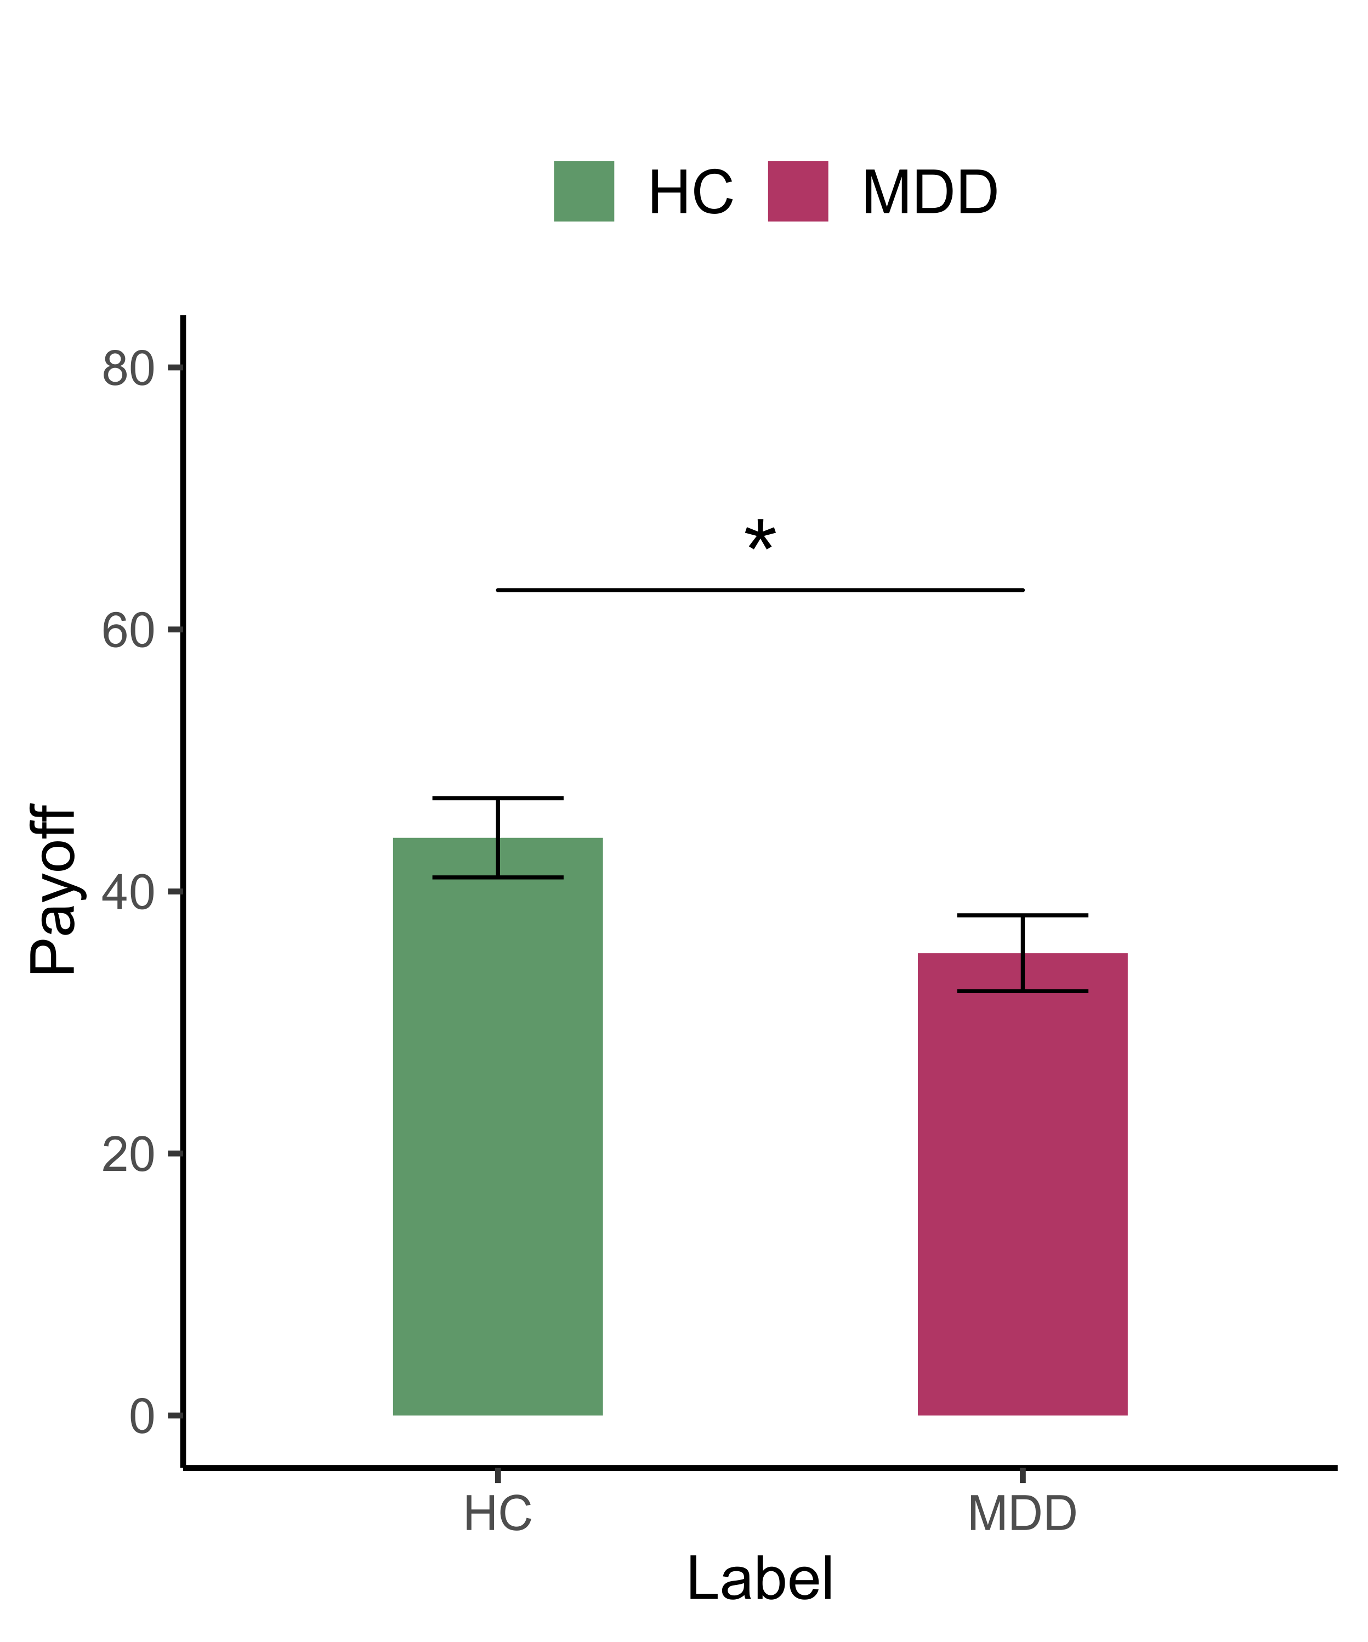
Note. Error bars describe standard errors. * p < 0.05, ** p < 0.01, *** p < 0.001

Fig. S2. Learning Rate for Partial and Complete Condition in Model I

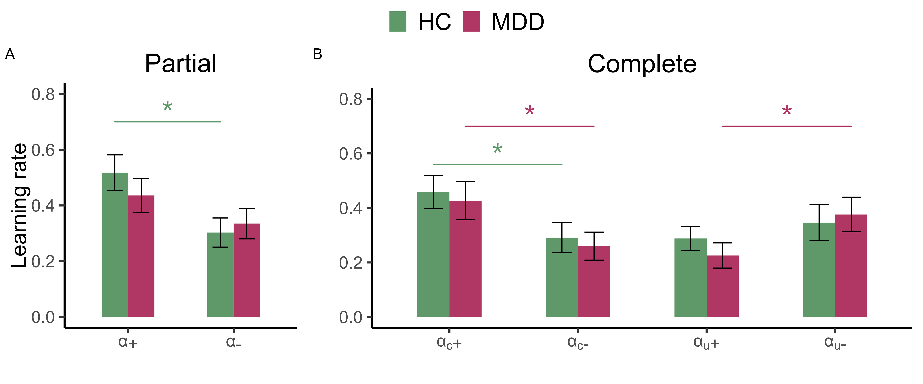
Note. The learning rates for model I from the asymmetric condition
(Error bars describe standard errors, * p < 0.05, ** p < 0.01, *** p < 0.001)

Fig. S3. Learning Rate for Partial and Complete Condition in Model I and Model II

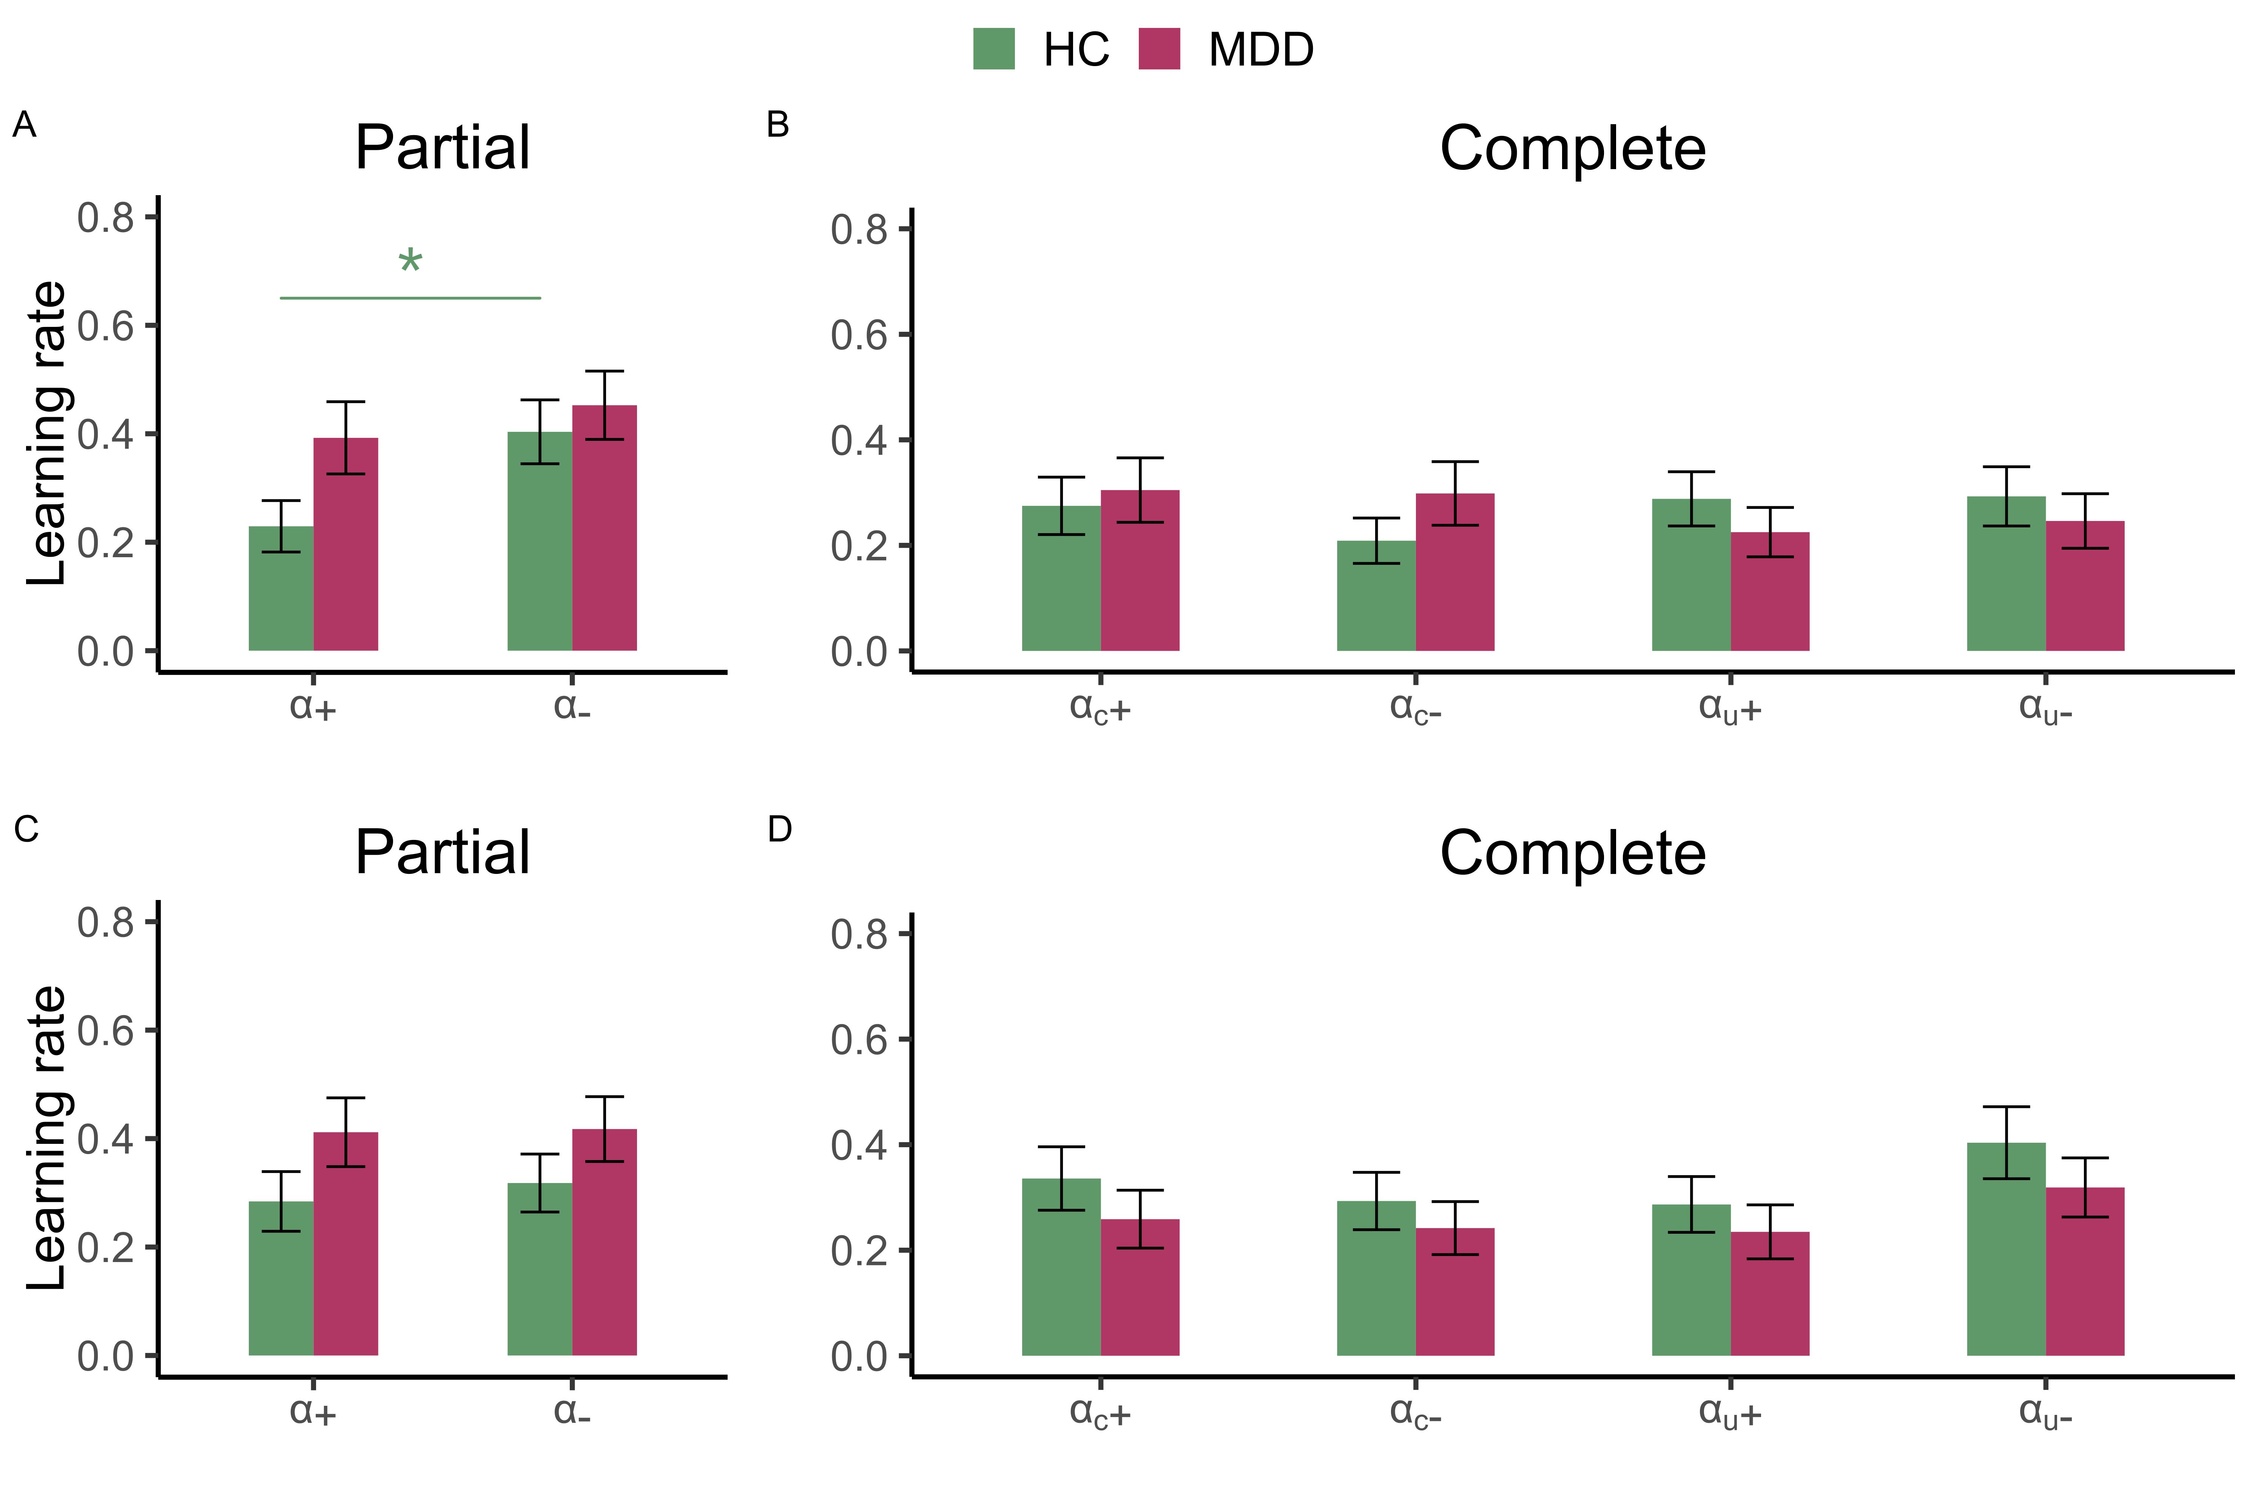
Note. The top panel illustrates the learning rates from model I and the bottom panel is the learning rates for model II from the symmetric condition (Error bars describe standard errors, * p < 0.05, ** p < 0.01, *** p < 0.001).

Fig. S4. Learning Rate for Partial and Complete Condition in Model I and Model II

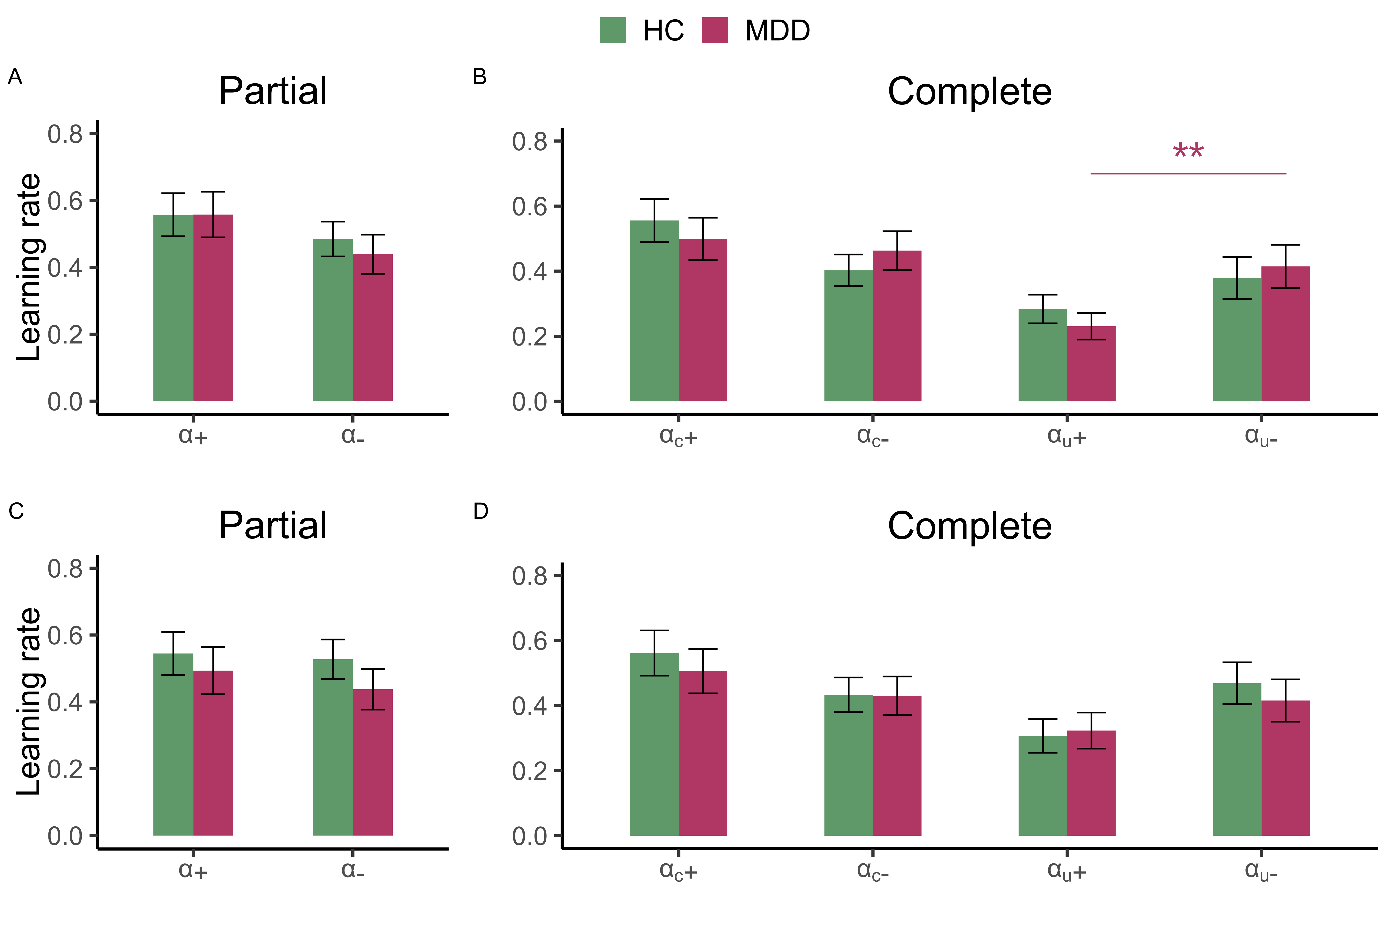
Note. The top panel illustrates the learning rates from model I and the bottom panel is the learning rates for model II from the reversal condition (Error bars describe standard errors, * p < 0.05, ** p < 0.01, *** p < 0.001).

Fig. S5. The average distribution of observed PEs corresponding to each parameter
Partial Information
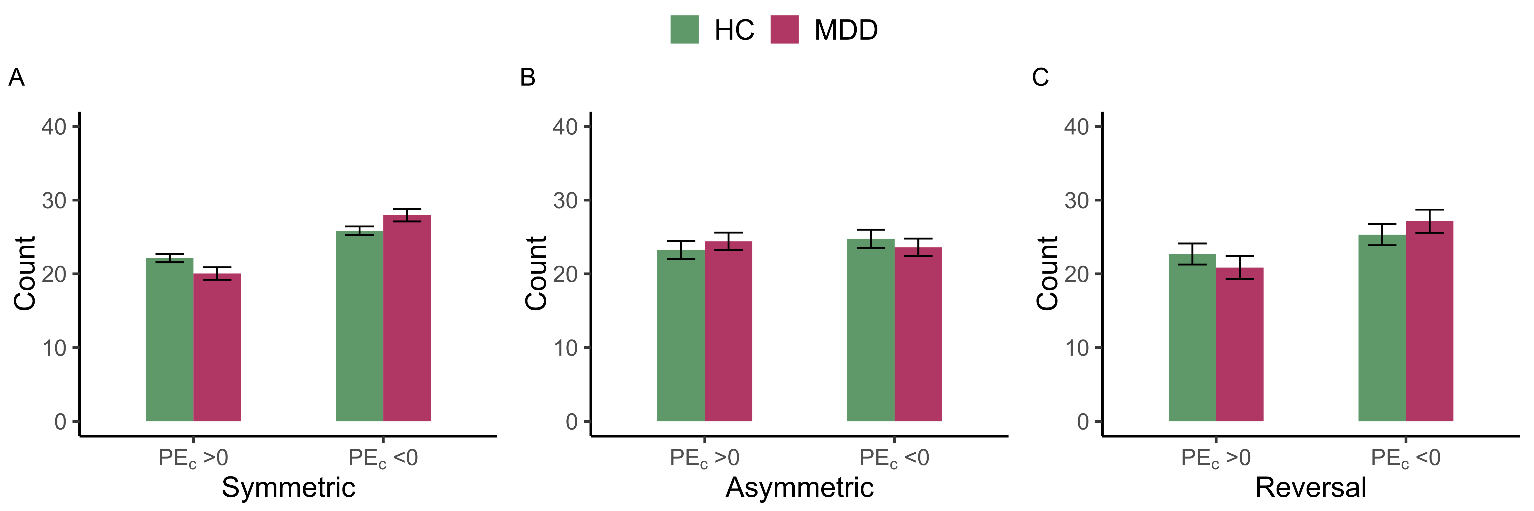

Complete Information
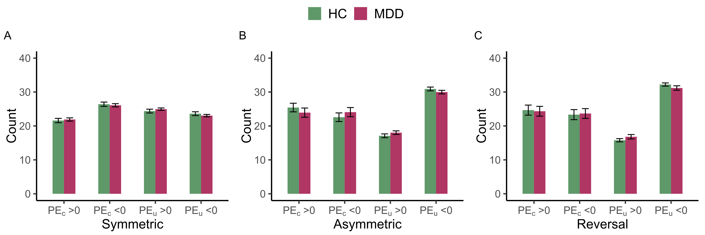

Fig. S6. Links Between Learning Index and HAMD Scores
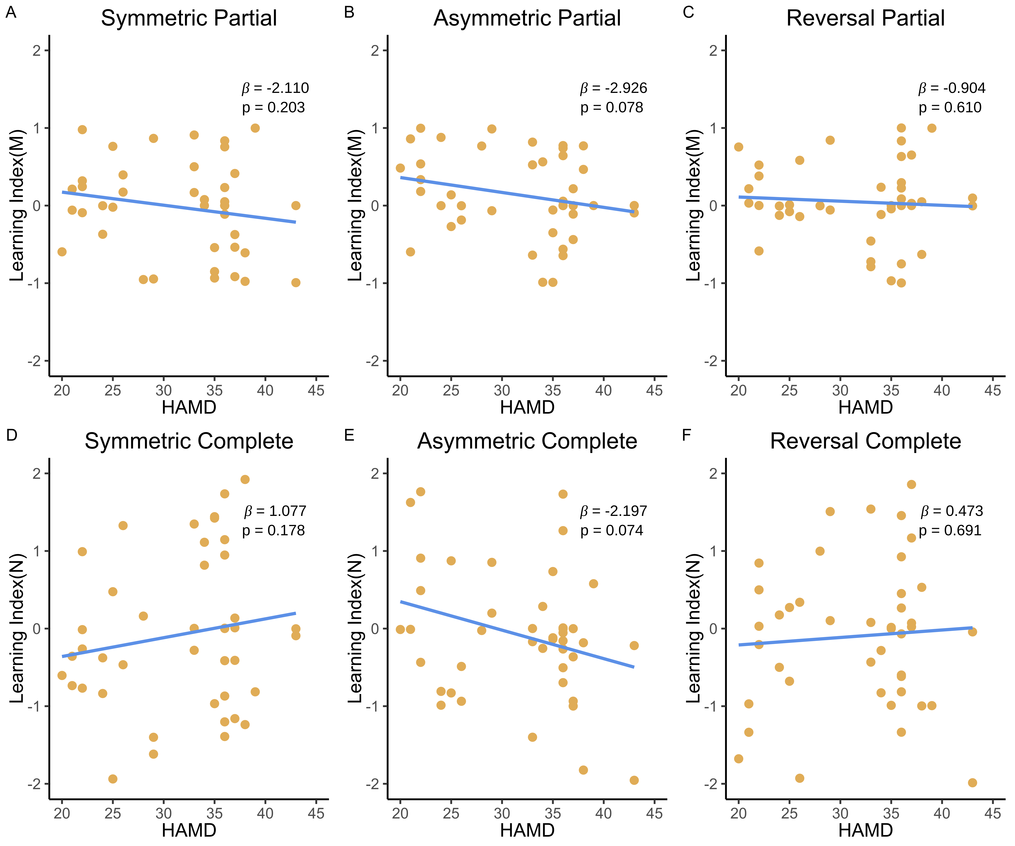
Note. Links between HAMD scores for different probability (Symmetric, Asymmetric and Reversal) and learning index (LI) in Partial (top panel, y index is learning index M) and Complete information (bottom panel, Y axis is learning index N).

Table S1. Subjects’ Characteristics
Subjects’ characteristics | MDD | HC
Number of patients | 42 | 42
Gender | 4 males | 13 males
Age | 15.19 (s.d. = 1.73) | 14.88 (s.d. = 2.00)
IQ | 6.38 (s.d. = 2.06) | 6.69(s.d. = 1.75)
HAMD | 31.69 (s.d. =6.55) | /
Number of admissions | 1.24 (s.d. =0.53) | /
Time from first onset (months) | 23.4 (16.8) | /
Family History | 5 with self-reported depression at grandparents’ generation | /
Comorbidity | 5 concurrent with anxiety | /

Table S2. Results of Multiple Regression for Payoff
Dependent Variable | Payoff
 | Pooled | HC | MDD
Intercept | -0.046***  (0.012) | 0.181***  (0.012) | 0.144***  (0.013)
Group | 0.031*  (0.014)
Information | -0.049***  (0.011) | -0.055***  (0.017) | -0.043**  (0.014)
Probability (Asymmetric) | 0.263***  (0.017)
Probability (Reversal) | 0.315***  (0.017)
Observation | 24192 | 12096 | 12096
R² | 0.020 | 0.001 | 0.000
Note. * p < 0.05, ** p < 0.01, *** p < 0.001

Table S3. Results of Multiple Logit Regression for Choice Accuracy
Dependent Variable | Choice Accuracy
 | Pooled | Pooled | HC | MDD | Asymmetric | Reversal First | Reversal Second | Asymmetric and  Reversal First
Intercept | 0.594 ***  (0.081) | 0.557 ***  (0.092) | 0.762 ***  (0.082) | 0.609 ***  (0.099) | 0.564 ***  (0.130) | 0.274 *  (0.124) | -0.850 ***  (0.134) | 0.652 ***  (0.110)
Group | 0.182 *  (0.089) | 0.260 *  (0.111) |  |  | 0.354 *  (0.169) | 0.381 *  (0.175) | 0.061  (0.128) | 0.360 *  (0.149)
Information | -0.306 ***  (0.056) | -0.236 **  (0.083) | -0.383 ***  (0.072) | -0.235 **  (0.083) | -0.245  (0.151) | -0.005  (0.126) | -0.485 ***  (0.117) | -0.166  (0.112)
Probability | 0.318 ***  (0.056) | 0.318 ***  (0.056) | 0.365 ***  (0.081) | -0.276 ***  (0.078)
Trials | 0.022 ***  (0.003) | 0.022 ***  (0.003) | 0.025 ***  (0.005) | 0.019 ***  (0.005) | 0.047 ***  (0.005) | 0.130 ***  (0.014) | 0.245 ***  (0.020) | 0.046 ***  (0.005)
Group $×$ Information |  | -0.147  (0.110) |  |  | -0.223  (0.193) | -0.343  (0.176) | 0.119  (0.161) | -0.259  (0.152)
Observation | 16128 | 16128 | 8064 | 8064 | 8064 | 4032 | 4032 | 12096
R² | 0.023 | 0.023 | 0.027 | 0.015 | 0.040 | 0.057 | 0.193 | 0.033
L.R. | 254.535 | 258.797 | 150.994 | 84.385 | 221.372 | 157.204 | 616.056 | 269.600
Note. * p < 0.05, ** p < 0.01, *** p < 0.001

Table S4. Results of Multiple Logit Regression for Choice Accuracy
Dependent Variable | Choice Accuracy
 | Asymmetric  Partial | Asymmetric  Complete | Reversal First  Partial | Reversal Second  Partial | Reversal First  Complete | Reversal Second  Complete
Intercept | 0.471 ***  (0.115) | 0.385 **  (0.126) | 0.431 **  (0.139) | -1.147 **  (0.143) | 0.092  (0.139) | -1.049 ***  (0.162)
Group | 0.130  (0.151) | 0.359 *  (0.171) | 0.038  (0.175) | 0.174  (0.141) | 0.388 *  (0.178) | 0.064  (0.133)
Trials | 0.034 ***  (0.006) | 0.063 ***  (0.007) | 0.102 ***  (0.016) | 0.215 ***  (0.022) | 0.162 ***  (0.023) | 0.280 ***  (0.028)
Observation | 4032 | 4032 | 2016 | 2016 | 2016 | 2016
R² | 0.017 | 0.054 | 0.034 | 0.153 | 0.083 | 0.220
L.R. | 47.830 | 143.826 | 46.346 | 243.889 | 113.101 | 349.237
Note. * p < 0.05, ** p < 0.01, *** p < 0.001

Table S5. Results of Multiple Regressions for Response Time
Dependent Variable | Response Time
 | Pooled | Symmetric | Asymmetric | Reversal
Intercept | -0.783***  (0.035) | -0.773***  (0.037) | -0.764***  (0.035) | -0.771***  (0.039)
Group | -0.165**  (0.047) | -0.175***  (0.050) | -0.156**  (0.048) | -0.165***  (0.049)
Probability (Asymmetric) | 0.016  (0.011)
Probability (Reversal) | 0.025  (0.013)
Information | -0.014  (0.011) | 0.025  (0.021) | -0.029  (0.019) | 0.012  (0.017)
Observation | 19618 | 6532 | 6558 | 6528
R² | 0.025 | 0.027 | 0.023 | 0.025
Note. * p < 0.05, ** p < 0.01, *** p < 0.001

Table S6. Results of Multiple Regressions for Response Time
Dependent Variable | Response Time
 | Partial & Symmetric | Partial & Asymmetric | Partial & Reversal | Complete & Symmetric | Complete & Asymmetric | Complete & Reversal
Intercept | -0.781***  (0.040) | -0.790***  (0.038) | -0.756***  (0.037) | -0.790***  (0.039) | -0.768***  (0.037) | -0.775***  (0.042)
Group | -0.208***  (0.054) | -0.162**  (0.052) | -0.172***  (0.050) | -0.143**  (0.054) | -0.150**  (0.052) | -0.158**  (0.053)
Observation | 3230 | 3288 | 3268 | 3302 | 3270 | 3260
R² | 0.037 | 0.024 | 0.028 | 0.018 | 0.021 | 0.023
Note. * p < 0.05, ** p < 0.01, *** p < 0.001

Table S7. Parameter Statistics of Model I
Group | Probability | Information | $$β$$ | LL | AIC | BIC
HC | Symmetric | Partial | 9.518±8.311 | 27.55±4.178 | 61.099±8.356 | 66.713±8.356
HC | Asymmetric | Partial | 5.373±6.409 | 22.321±7.976 | 50.642±15.951 | 56.256±15.951
HC | Reversal | Partial | 5.643±6.327 | 20.095±7.650 | 46.190±15.300 | 51.803±15.300
MDD | Symmetric | Partial | 8.557±8.546 | 27.051±5.870 | 60.101±11.740 | 65.715±11.740
MDD | Asymmetric | Partial | 6.576±7.139 | 23.111±7.330 | 52.223±14.661 | 57.836±14.661
MDD | Reversal | Partial | 7.638±7.754 | 20.154±7.432 | 46.308±14.863 | 51.921±14.863
HC | Symmetric | Complete | 10.687±8.002 | 25.893±6.246 | 61.787±12.493 | 71.143±12.493
HC | Asymmetric | Complete | 10.313±8.414 | 16.129±8.555 | 42.258±17.11 | 51.614±17.110
HC | Reversal | Complete | 9.438±8.647 | 14.951±8.567 | 39.902±17.135 | 49.258±17.135
MDD | Symmetric | Complete | 13.252±8.032 | 24.303±6.720 | 58.607±13.439 | 67.963±13.439
MDD | Asymmetric | Complete | 9.011±8.239 | 18.195±8.956 | 46.39±17.912 | 55.746±17.912
MDD | Reversal | Complete | 7.944±7.465 | 18.191±8.505 | 46.382±17.010 | 55.738±17.010

Table S8. Parameter Statistics of Model II
Group | Probability | Information | s | g | LL | AIC | BIC
HC | Symmetric | Partial | 1.590±3.101 | -1.200±8.449 | 26.521±4.445 | 61.043±8.891 | 68.528±8.891
HC | Asymmetric | Partial | 0.841±3.710 | -1.359±6.607 | 21.288±7.849 | 50.576±15.697 | 58.061±15.697
HC | Reversal | Partial | 1.834±2.368 | -2.013±6.018 | 18.844±7.590 | 45.688±15.179 | 53.173±15.179
MDD | Symmetric | Partial | -0.083±5.682 | -2.992±7.585 | 25.733±5.794 | 59.465±11.588 | 66.95±11.588
MDD | Asymmetric | Partial | 0.102±5.314 | -2.362±7.197 | 22.014±7.159 | 52.027±14.319 | 59.512±14.319
MDD | Reversal | Partial | 1.165±3.394 | -1.717±6.073 | 18.790±7.080 | 45.581±14.16 | 53.066±14.16
HC | Symmetric | Complete | 0.646±3.276 | -1.298±11.013 | 24.526±5.939 | 61.051±11.879 | 72.278±11.879
HC | Asymmetric | Complete | 1.959±3.482 | -2.847±7.524 | 14.944±8.139 | 41.888±16.278 | 53.115±16.278
HC | Reversal | Complete | 2.259±2.646 | -0.689±7.671 | 13.552±8.269 | 39.103±16.538 | 50.33±16.538
MDD | Symmetric | Complete | 1.419±4.605 | -2.169±8.387 | 22.614±6.581 | 57.228±13.163 | 68.455±13.163
MDD | Asymmetric | Complete | 1.346±4.220 | -3.661±6.547 | 16.349±8.098 | 44.698±16.196 | 55.925±16.196
MDD | Reversal | Complete | 0.561±4.659 | -2.872±6.742 | 16.217±8.055 | 44.434±16.11 | 55.661±16.11

Table S9. Results of Regressions for Learning Index
Dependent Variable | HAMD Scores
 | Pooled | Symmetric | Asymmetric | Reversal
Intercept | 31.643 ***  (1.010) | 31.709 ***  (1.009) | 31.493 ***  (0.991) | 31.707 ***  (1.006)
LI | -0.550  (0.563) | 0.243  (0.706) | -2.402 *  (1.051) | 0.164  (0.937)
Information | 0.077  (0.091) | -0.013  (0.057) | 0.526  (0.430) | -0.024  (0.140)
Observation | 252 | 84 | 84 | 84
R² | 0.004 | 0.001 | 0.067 | 0.000
Note. * p < 0.05, ** p < 0.01, *** p < 0.001

Table S10. Results of Regressions for Learning Index
Dependent Variable | HAMD Scores
 | Symmetric  Partial | Asymmetric  Partial | Reversal  Partial | Symmetric  Complete | Asymmetric  Complete | Reversal  Complete
Intercept | 31.641 ***  (1.007) | 32.091 ***  (0.991) | 31.734 ***  (1.003) | 31.773 ***  (0.997) | 31.510 ***  (0.991) | 31.737 ***  (0.990)
LI | -2.110  (1.632) | -2.926  (1.615) | -0.904  (1.757) | 1.076  (0.786) | -2.197  (1.197) | 0.473  (1.180)
Observation | 42 | 42 | 42 | 42 | 42 | 42
R² | 0.036 | 0.056 | 0.005 | 0.026 | 0.081 | 0.005
Note. * p < 0.05, ** p < 0.01, *** p < 0.001

Reference
Singmann, H., Brown, S., Gretton, M., & Heathcote, A. (2022). rtdists: Response Time Distributions. R package version 0.11-5. Retrieved from
https://CRAN.R-project.org/package=rtdists
Webb, Ryan. (2019). The (neural) dynamics of stochastic choice. Management Science, 65(1), 230-255. doi: 10.1287/mnsc.2017.2931

