A longitudinal study of childhood maltreatment, subcortical development, and subcortico-cortical structural maturational coupling from early to late adolescence
Supplementary materials

Methods:
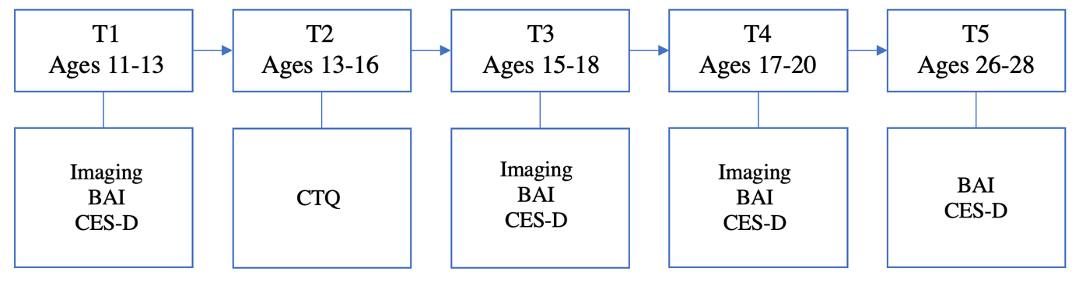 Supplementary Figure S1: Diagram depicting age ranges and measures (symptoms, maltreatment, imaging) taken at each time point between T1 and T5.

Interpretation of slopes and maturational coupling
If both the slope of amygdala growth and PFC thickness were significantly more negative (i.e., flatter amygdala growth and increased PFC thinning), this would represent positive coupling. On the other hand, if the slope of amygdala growth was significantly steeper (relatively more positive; increased growth), while the slope of PFC thickness was steeper (relatively more negative; increased thinning), this would represent negative coupling. See Figure S2 for a visual depiction of positive vs negative coupling classifications in this study.
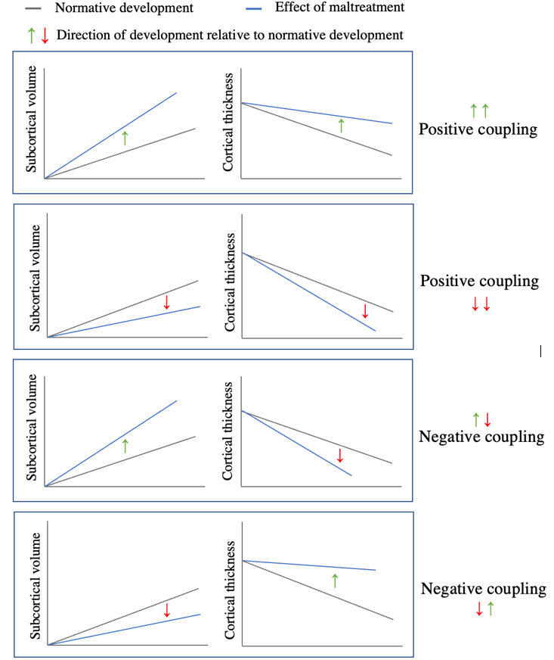
Supplementary Figure S2: A visual depiction of positive vs negative maturational coupling. Diagram depicting how positive and negative subcortico-cortical maturational coupling is defined in the present study. Black lines represent the normative trajectory of brain development. Blue lines represent the developmental trajectory associated with maltreatment. Upward and downward arrows represent increases and decreases in development relative to normative development, respectively. Paired relative increases or decreases in development reflect positive maturational coupling. Opposite directions of relative development (i.e., increase and decrease), reflect negative maturational coupling.

MRI Acquisition parameters:
At baseline, magnetic resonance imaging (MRI) scans were performed at the Brain Research Institute, Melbourne, on a 3-T scanner (repetition time 36 ms, echo time 9 ms, flip angle 35°, field of view 20 cm²; GE Healthcare, Milwaukee, WI, USA) to obtain 124 T1-weighted contiguous slices (i.e., voxel dimensions = 0.4883 × 0.4883 × 1.5 mm). Follow-up scans were conducted at the Royal Children’s Hospital, Melbourne, on a 3-T scanner (repetition time 1,900 ms, echo time 2.24 ms, flip angle 9°, field of view 23 cm²; Siemens Magnetrom TrioTim, Erlangan, Germany), producing 176 T1-weighted contiguous 0.9-mm thick slices (voxel dimensions 0.9 mm³). We have taken several steps to ensure that we used only high-quality data. Each individual’s cortical reconstruction was visually inspected by a trained researcher to ensure that optimal grey/white and grey/cerebrospinal fluid classification had occurred based on differences in tissue intensity signals, and manual edits were made (and edited images re-processed) where necessary to ensure/improve quality of the output. Further, given that different scanners were used at the first vs the second and third MRI assessment, we have previously conduced reliability analyses to address concerns that changes in structure over time may be due to measurement bias from the different scanner platforms and acquisition parameters. These reliability analyses have been described previously (Dennison et al., 2013; Whittle et al., 2017). These analyses did not reveal a systematic bias due to changing scanners.

Internal consistency (Cronbach α) of BAI and CES-D at each time point

 | T1 | T3 | T4 | T5
BAI | 0.89 | 0.74 | 0.9 | 0.95
CESD | 0.88 | 0.86 | 0.89 | 0.92

Correlation between abuse/neglect and mental health:

 | CESD (T1) | BAI (T1) | CESD (T3) | BAI (T3) | CESD (T4) | BAI (T4) | CESD (T5) | BAI (T5)
Abuse | 0.11 (0.37) | 0.15 (0.22) | 0.27 (0.014) | 0.22 (0.06) | 0.11 (0.37) | 0.08 (0.52) | 0.098 (0.36) | 0.11 (0.3)
Neglect | 0.18 (0.14) | 0.35 (0.77) | 0.25 (0.027) | 0.08 (0.5) | 0.16 (0.17) | 0.02 (0.93) | 0.16 (.12) | 0.4 (0.74)

Pearson r (p value) provided in the table

Number of participants meeting cut-offs for CTQ subscales (as described by Walker et al. (1999)
Number of participants meeting cut-off for:

- Any of the maltreatment types: 43
- Physical neglect: 22
- Physical abuse: 10
- Emotional neglect: 13
- Emotional abuse: 20

Model equations
The (1 | Subject) term represents the random effect of the intercept in each subject. The e represents the normally distributed residual error term. Age, sex and IQ were fixed effects in all equations, with β representing the parameter estimates for each of the main effects and interactions. Where we were investigating maltreatment (CTQ) as the predictor, total CTQ/neglect/abuse was used as a fixed effect. Additionally, in maturational coupling analyses, an interaction between CTQ and hippocampus/amygdala random slope was used as a fixed effect. Y and age are time-varying variables, and values for each time point are entered in the model. CTQ refers to total maltreatment, abuse, and neglect – each of which was tested in separate models. All models were run with standardized variables. Lower order effects for each equation containing a 3-way interaction were automatically included. Specific model equations are as follows:

3.9.1 Normative models where Y is time-varying variable of amygdala and hippocampus volume (in separate models):

Y = Intercept + (1 | Subject) + β1 (age) + β2 (sex) + βn (covariates) + e.
With sex as a moderator:
Y = Intercept + (1 | Subject) + β1 (age) + β2 (sex) + β3(age*sex) + βn (covariates) + e.

3.9.2 Subcortical analysis models where Y is time-varying variable of amygdala and hippocampal volume (in separate models):

Y = Intercept + (1 | Subject) + β1(age) + β2(CTQ) + β3(age*CTQ) + β4(sex) + βn (covariates) + e.
With sex as a moderator:
Y = Intercept + (1 | Subject) + β1(age) + β2(CTQ) + β3(sex) + β4(age*CTQ*sex) + βn(covariates) + e.

3.9.3 Maturational coupling models where Y is time-varying variable of PFC thickness (each region in a separate model):

Y = Intercept + (1 | Subject) + β1(age) + β2(CTQ) + β3(amygdala/hippocampus random slope) + β4(age*CTQ*amygdala/hippocampus random slope) + β5(sex) + βn (covariates) + e.
With sex as a moderator:
Y = Intercept + (1 | Subject) + β1(age) + β2(CTQ) + β3(amygdala/hippocampus random slope) + β4(sex) + β5(age*CTQ*amygdala/hippocampus random slope*sex) + βn (covariates) + e.

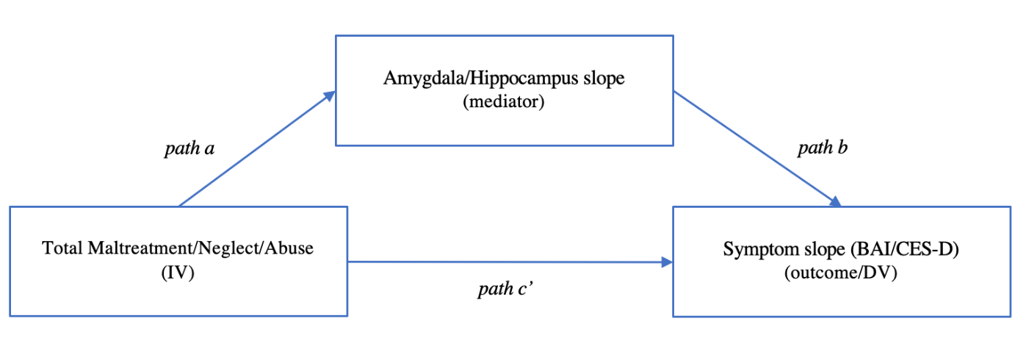Supplementary Figure S3: Conceptual mediation model. Diagram depicting mediation analysis with total maltreatment/neglect/abuse as the IV, amygdala/hippocampus slope as the mediator, and symptom slope as the outcome/DV. Path a represents the effect of maltreatment on subcortical slope, path b represents the effect of subcortical slope on symptom slope, and path c’ represents the direct effect between maltreatment and symptom slope.

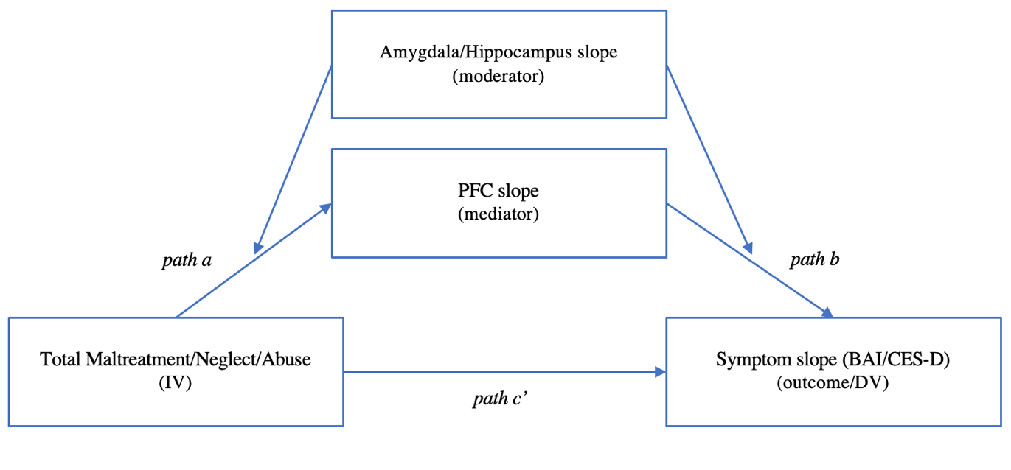Supplementary Figure S4: Conceptual moderated mediation model. Diagram depicting moderated mediation analysis with total maltreatment/neglect/abuse as the IV, PFC slope as the mediator, amygdala/hippocampus slope as the moderator and symptom slope as the outcome/DV. Path a represents the effect of maltreatment on subcortical slope, path b represents the effect of subcortical slope on symptom slope, and path c’ represents the direct effect between maltreatment and symptom slope.
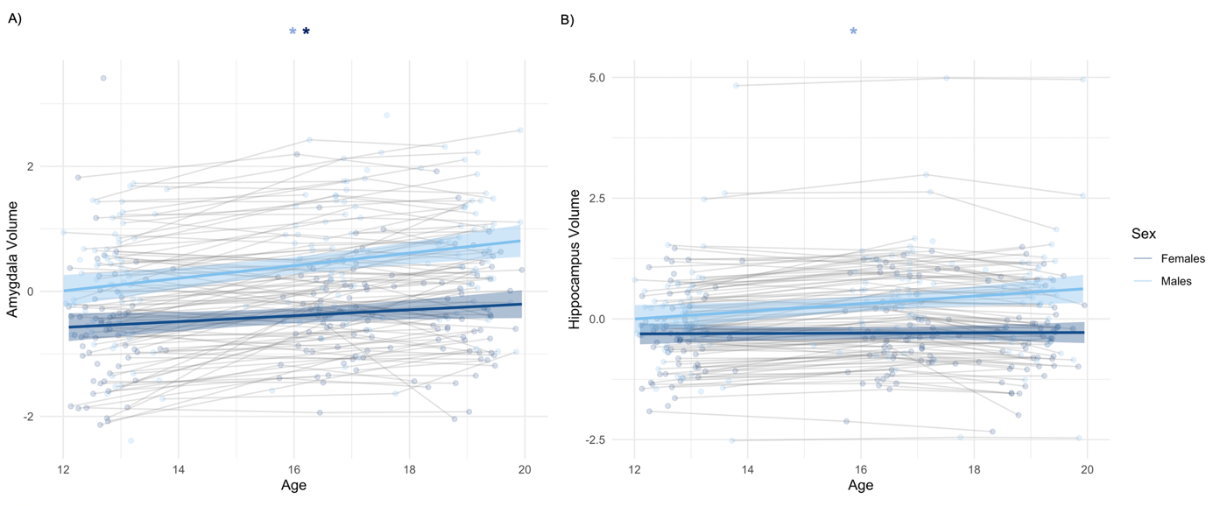Supplementary Figure S5: Normative developmental trajectories of amygdala and hippocampal volume. (A) Amygdala development in females (p<0.001) and males (p<0.001), and (B) Hippocampal development in females (p = 0.855) and males (p<0.001). Statistics reported in Table 2. Slopes represent average trajectories for males (in dark blue) and females (in light blue). (* = significant age effect, pFDR < 0.05).

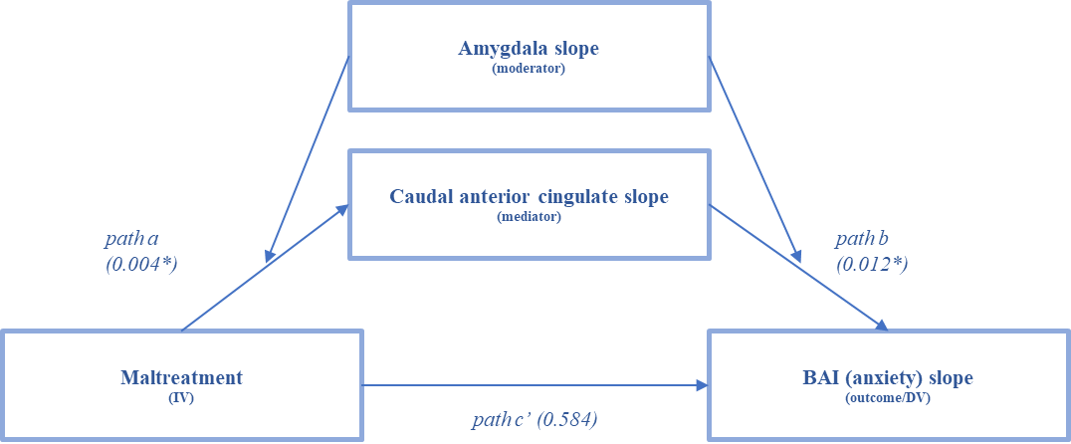

Supplementary Figure S6: Moderated mediation pathway between neglect, amygdala-caudal anterior cingulate coupling, and anxiety symptoms. Moderated mediation analysis featuring total maltreatment (IV), amygdala random slope (moderator), caudal anterior cingulate slope (mediator) and BAI slope (outcome/DV). Path a (p = 0.004) depicts the effect of the interaction between neglect and amygdala slope on caudal anterior cingulate slope. Path b (p = 0.012) depicts the effect of the interaction between caudal anterior cingulate slope and amygdala slope on BAI slope. Path c’ (p = 0.584) illustrates the direct relationship between neglect and BAI slope.

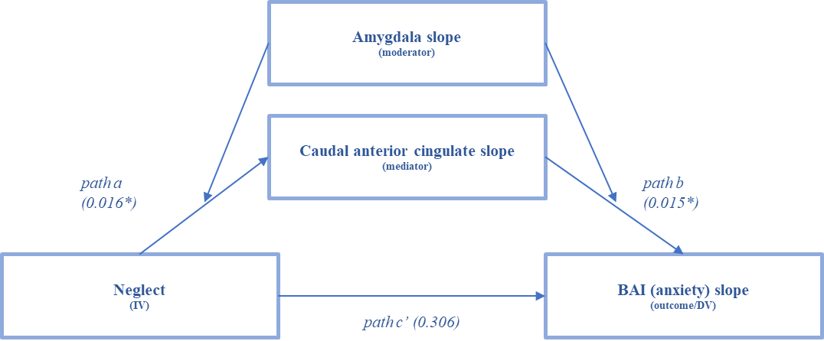

Supplementary Figure S7: Moderated mediation pathway between neglect, amygdala-caudal anterior cingulate coupling, and anxiety symptoms. Moderated mediation analysis featuring neglect (IV), amygdala random slope (moderator), caudal anterior cingulate slope (mediator) and BAI slope (outcome/DV). Path a (p = 0.016) depicts the effect of the interaction between neglect and amygdala slope on caudal anterior cingulate slope. Path b (p = 0.015) depicts the effect of the interaction between caudal anterior cingulate slope and amygdala slope on BAI slope. Path c’ (p = 0.306) illustrates the direct relationship between neglect and BAI slope.

Results:

Tables

Supplementary Table S1: Normative amygdala and hippocampus development

Dependent variable | Predictor | B | SE | t | p
Amygdala | Age | 0.17 | 0.02 | 8.82 | < 0.001*
Hippocampus | Age | 0.05 | 0.01 | 3.96 | < 0.001*
Amygdala | Age x Sex | -0.09 | 0.04 | -2.33 | 0.021*
Hippocampus | Age x Sex | -0.1 | 0.026 | -3.92 | < 0.001*
*= pFDR
SE = Standard Error

Supplementary Table S2: Associations between total maltreatment, neglect and abuse with amygdala/hippocampus development

Dependent variable | Predictor | B | SE | t | p
Amygdala | Total CTQ x Age | -0.002 | 0.02 | 0.10 | 0.922
 | Neglect x Age | 0.009 | 0.02 | 0.526 | 0.599
 | Abuse x Age | 0.027 | 0.02 | 1.45 | 0.147
Hippocampus | Total CTQ x Age | -0.017 | 0.01 | -1.32 | 0.189
 | Neglect x Age | -0.022 | 0.01 | -1.79 | 0.075
 | Abuse x Age | -0.02 | 0.01 | -1.5 | 0.1337
Amygdala | Total CTQ x Age x Sex | 0.052 | 0.04 | 1.46 | 0.146
 | Neglect x Age x Sex | 0.102 | 0.04 | 2.91 | 0.004*
 | Abuse x Age x Sex | 0.034 | 0.04 | 0.91 | 0.365
Hippocampus | Total CTQ x Age x Sex | 0.032 | 0.03 | 1.26 | 0.208
 | Neglect x Age x Sex | 0.019 | 0.03 | 0.77 | 0.441
 | Abuse x Age x Sex | 0.04 | 0.03 | 1.49 | 0.138
*= pFDR < 0.05
SE = Standard Error

The effect of neglect x age x sex on amygdala volume was even significant when covarying for estimated total intracranial volume (B = 0.11, SE = 0.04, t = 2.99, p = 0.003).

Supplementary Table S3: Model output for Associations between total maltreatment and amygdala-PFC maturational coupling (i.e., Total CTQ x Age x Amygdala Random Slope predicting cortical thickness)

Dependent variable (cortical thickness) | B | SE | t | p
Lateral Orbitofrontal | -0.225 | 0.246 | -0.917 | 0.361
Medial Orbitofrontal | -0.145 | 0.261 | -0.554 | 0.580
Pars Opercularis | 0.086 | 0.227 | 0.380 | 0.705
Caudal Anterior Cingulate | 0.597 | 0.190 | 3.136 | 0.002*
Rostral Middle Frontal | 0.220 | 0.259 | 0.850 | 0.396
Caudal Middle Frontal | -0.089 | 0.286 | -0.311 | 0.756
Superior Frontal | 0.326 | 0.245 | 1.331 | 0.185
Rostral Anterior Cingulate | -0.209 | 0.256 | -0.817 | 0.415
Pars Orbitalis | 0.013 | 0.230 | 0.056 | 0.955
Pars Triangularis | -0.067 | 0.248 | -0.269 | 0.788
With sex as a moderator | B | SE | t | p
Lateral Orbitofrontal | -1.053 | 0.584 | -1.801 | 0.073
Medial Orbitofrontal | -0.811 | 0.623 | -1.302 | 0.195
Pars Opercularis | -0.195 | 0.546 | -0.357 | 0.722
Caudal Anterior Cingulate | 0.294 | 0.456 | 0.645 | 0.520
Rostral Middle Frontal | -0.077 | 0.620 | -0.125 | 0.901
Caudal Middle Frontal | -0.233 | 0.686 | -0.340 | 0.734
Superior Frontal | -0.022 | 0.583 | -0.038 | 0.970
Rostral Anterior Cingulate | -0.456 | 0.614 | -0.743 | 0.458
Pars Orbitalis | -0.668 | 0.552 | -1.210 | 0.228
Pars Triangularis | -0.482 | 0.585 | -0.823 | 0.412
*= pFDR < 0.05
SE = Standard Error

Supplementary Tables S4: Model output for Associations between total maltreatment and hippocampus-PFC maturational coupling (i.e., Total CTQ x Age x Hippocampus Random Slope predicting cortical thickness)

Dependent variable (cortical thickness) | B | SE | t | p
Lateral Orbitofrontal | 1.749 | 1.811 | 0.966 | 0.335
Medial Orbitofrontal | 2.703 | 1.908 | 1.416 | 0.158
Pars Opercularis | -0.049 | 1.639 | -0.030 | 0.976
Caudal Anterior Cingulate | -2.485 | 1.409 | -1.764 | 0.079
Rostral Middle Frontal | 2.843 | 1.863 | 1.526 | 0.129
Caudal Middle Frontal | 1.428 | 2.066 | 0.691 | 0.490
Superior Frontal | 1.328 | 1.756 | 0.756 | 0.451
Rostral Anterior Cingulate | 0.153 | 1.885 | 0.081 | 0.936
Pars Orbitalis | 1.331 | 1.670 | 0.797 | 0.426
Pars Triangularis | -1.017 | 1.758 | -0.578 | 0.564
With sex as a moderator | B | SE | t | p
Lateral Orbitofrontal | -0.559 | 4.060 | -0.138 | 0.891
Medial Orbitofrontal | 4.394 | 4.220 | 1.041 | 0.299
Pars Opercularis | -1.453 | 3.654 | -0.398 | 0.691
Caudal Anterior Cingulate | -2.590 | 3.127 | -0.828 | 0.409
Rostral Middle Frontal | 4.808 | 4.079 | 1.179 | 0.240
Caudal Middle Frontal | 2.501 | 4.606 | 0.543 | 0.588
Superior Frontal | 0.110 | 3.834 | 0.029 | 0.977
Rostral Anterior Cingulate | -4.838 | 4.226 | -1.145 | 0.254
Pars Orbitalis | 5.245 | 3.735 | 1.404 | 0.162
Pars Triangularis | -1.840 | 3.906 | -0.471 | 0.638

SE = Standard Error

Supplementary Table S5: Associations between neglect and amygdala-PFC maturational coupling (i.e., Neglect x Age x Amygdala Random Slope predicting cortical thickness)

Dependent variable (cortical thickness) | B | SE | t | p
Lateral Orbitofrontal | -0.326 | 0.204 | -1.602 | 0.111
Medial Orbitofrontal | -0.146 | 0.219 | -0.667 | 0.506
Pars Opercularis | -0.138 | 0.194 | -0.712 | 0.478
Caudal Anterior Cingulate | 0.478 | 0.159 | 2.998 | 0.003*
Rostral Middle Frontal | -0.099 | 0.221 | -0.448 | 0.655
Caudal Middle Frontal | -0.637 | 0.246 | -2.585 | 0.010
Superior Frontal | -0.437 | 0.217 | -2.012 | 0.046
Rostral Anterior Cingulate | -0.137 | 0.216 | -0.634 | 0.527
Pars Orbitalis | -0.251 | 0.193 | -1.301 | 0.195
Pars Triangularis | -0.182 | 0.207 | -0.881 | 0.379
With sex as a moderator | B | SE | t | p
Lateral Orbitofrontal | -1.006 | 0.514 | -1.957 | 0.052
Medial Orbitofrontal | -0.971 | 0.553 | -1.757 | 0.081
Pars Opercularis | -0.566 | 0.492 | -1.150 | 0.252
Caudal Anterior Cingulate | -0.196 | 0.409 | -0.480 | 0.632
Rostral Middle Frontal | -0.642 | 0.558 | -1.150 | 0.252
Caudal Middle Frontal | -0.844 | 0.623 | -1.355 | 0.177
Superior Frontal | -1.171 | 0.545 | -2.150 | 0.033
Rostral Anterior Cingulate | -0.580 | 0.552 | -1.051 | 0.294
Pars Orbitalis | -1.025 | 0.486 | -2.107 | 0.036
Pars Triangularis | -0.758 | 0.517 | -1.464 | 0.145
SE = Standard Error

Supplementary Table S6: Model output for associations between neglect and hippocampus-PFC maturational coupling (i.e., Neglect x Age x Hippocampus Random Slope predicting PFC thickness)

Dependent variable (cortical thickness) | B | SE | t | p
Lateral Orbitofrontal | 1.329 | 1.411 | 0.942 | 0.347
Medial Orbitofrontal | 3.762 | 1.478 | 2.546 | 0.012*
Pars Opercularis | 1.681 | 1.313 | 1.281 | 0.202
Caudal Anterior Cingulate | -3.138 | 1.087 | -2.887 | 0.004*
Rostral Middle Frontal | 4.339 | 1.460 | 2.972 | 0.003*
Caudal Middle Frontal | 3.348 | 1.667 | 2.008 | 0.046
Superior Frontal | 3.935 | 1.439 | 2.735 | 0.007*
Rostral Anterior Cingulate | 0.330 | 1.473 | 0.224 | 0.823
Pars Orbitalis | 2.498 | 1.301 | 1.920 | 0.056
Pars Triangularis | 0.482 | 1.380 | 0.349 | 0.727
With sex as a moderator | B | SE | t | p
Lateral Orbitofrontal | -0.294 | 3.174 | -0.093 | 0.926
Medial Orbitofrontal | 2.633 | 3.319 | 0.793 | 0.429
Pars Opercularis | -0.981 | 2.952 | -0.332 | 0.740
Caudal Anterior Cingulate | -1.101 | 2.457 | -0.448 | 0.655
Rostral Middle Frontal | 4.201 | 3.239 | 1.297 | 0.196
Caudal Middle Frontal | 4.064 | 3.714 | 1.094 | 0.275
Superior Frontal | 3.095 | 3.171 | 0.976 | 0.330
Rostral Anterior Cingulate | 0.359 | 3.355 | 0.107 | 0.915
Pars Orbitalis | 3.495 | 2.946 | 1.187 | 0.237
Pars Triangularis | -0.442 | 3.082 | -0.144 | 0.886
*= pFDR
SE = Standard Error

Supplementary Table S7: Model output for associations between abuse and amygdala-PFC maturational coupling (i.e., Abuse x Age x Amygdala Random Slope predicting PFC thickness)

Dependent variable (cortical thickness) | B | SE | t | p
Lateral Orbitofrontal | -0.287 | 0.253 | -1.134 | 0.258
Medial Orbitofrontal | -0.403 | 0.270 | -1.493 | 0.137
Pars Opercularis | -0.204 | 0.240 | -0.847 | 0.398
Caudal Anterior Cingulate | 0.447 | 0.197 | 2.272 | 0.024
Rostral Middle Frontal | -0.061 | 0.272 | -0.225 | 0.822
Caudal Middle Frontal | -0.448 | 0.310 | -1.443 | 0.151
Superior Frontal | -0.193 | 0.268 | -0.720 | 0.472
Rostral Anterior Cingulate | -0.452 | 0.263 | -1.715 | 0.088
Pars Orbitalis | -0.169 | 0.240 | -0.706 | 0.481
Pars Triangularis | -0.177 | 0.256 | -0.691 | 0.490
With sex as a moderator | B | SE | t | p
Lateral Orbitofrontal | -1.097 | 0.708 | -1.549 | 0.123
Medial Orbitofrontal | -0.460 | 0.755 | -0.609 | 0.543
Pars Opercularis | -0.139 | 0.675 | -0.206 | 0.837
Caudal Anterior Cingulate | 1.120 | 0.548 | 2.042 | 0.043
Rostral Middle Frontal | -0.118 | 0.758 | -0.155 | 0.877
Caudal Middle Frontal | -0.486 | 0.863 | -0.563 | 0.574
Superior Frontal | -0.190 | 0.739 | -0.257 | 0.797
Rostral Anterior Cingulate | -0.343 | 0.736 | -0.467 | 0.641
Pars Orbitalis | -0.800 | 0.672 | -1.190 | 0.235
Pars Triangularis | -0.483 | 0.709 | -0.681 | 0.496
*= p < 0.05 but did not survive multiple comparisons
SE = Standard Error

Supplementary Table S8: Model output for associations between abuse and hippocampus-PFC maturational coupling (i.e., Abuse x Age x Hippocampus random slope predicting PFC thickness)

Dependent variable (cortical thickness) | B | SE | t | p
Lateral Orbitofrontal | 2.169 | 2.055 | 1.055 | 0.293
Medial Orbitofrontal | -2.142 | 2.172 | -0.987 | 0.325
Pars Opercularis | -2.406 | 1.910 | -1.260 | 0.209
Caudal Anterior Cingulate | 0.353 | 1.600 | 0.221 | 0.826
Rostral Middle Frontal | -0.731 | 2.156 | -0.339 | 0.735
Caudal Middle Frontal | 1.724 | 2.459 | 0.701 | 0.484
Superior Frontal | 1.485 | 2.098 | 0.708 | 0.480
Rostral Anterior Cingulate | 2.037 | 2.130 | 0.956 | 0.340
Pars Orbitalis | -1.188 | 1.919 | -0.619 | 0.537
Pars Triangularis | -3.372 | 1.996 | -1.690 | 0.093
With sex as a moderator | B | SE | t | p
Lateral Orbitofrontal | -0.288 | 4.954 | -0.058 | 0.954
Medial Orbitofrontal | -0.863 | 5.162 | -0.167 | 0.867
Pars Opercularis | 0.700 | 4.552 | 0.154 | 0.878
Caudal Anterior Cingulate | 0.283 | 3.775 | 0.075 | 0.940
Rostral Middle Frontal | 1.685 | 5.046 | 0.334 | 0.739
Caudal Middle Frontal | 9.725 | 5.712 | 1.702 | 0.090
Superior Frontal | 11.607 | 4.722 | 2.458 | 0.015
Rostral Anterior Cingulate | -3.151 | 5.097 | -0.618 | 0.537
Pars Orbitalis | 5.982 | 4.592 | 1.303 | 0.194
Pars Triangularis | -3.029 | 4.754 | -0.637 | 0.525

Supplementary Table S9: Correlation of random effects during individual random slope extraction

Subcortical region | Correlation coefficient | Uncorrelated correlation coefficient
Amygdala | -0.20
Hippocampus | 0.93 | 0.13
PFC region | Correlation coefficient | Uncorrelated correlation coefficient
Caudal Anterior Cingulate | 0.006
Caudal Middle Frontal | 0.46
Superior Frontal | 0.44
Pars Orbitalis | -0.54
Symptom measures | Correlation coefficient | Uncorrelated correlation coefficient
CES-D | 0.92 | 0.19
BAI | 0.46

Random effects were extracted to obtain individual random slope values for hippocampal and amygdala growth, as well as for depressive and anxiety symptom trajectories. Where the correlation coefficient of random effects > ±0.9, an uncorrelated correlation coefficient was calculated.

Supplementary Table S10: Mediation analysis output testing the influence of amygdala slope as a mediator of the relationship between neglect and anxiety (BAI) and depressive (CES-D) symptoms in females

Model/Path | b | SE | p
Neglect prediction of amygdala slope (path a) | 0.023 | 0.01 | 0.034*
Amygdala slope prediction of BAI slope (path b) | -2.88 | 2.9 | 0.323
Direct effect of neglect on BAI slope (path c’) | -0.20 | 0.27 | 0.443
 | Effect | BootLLCI | BootULCI
Indirect effect of neglect on BAI slope | -0.067 | -0.269 | 0.128
 | b | SE | p
Neglect prediction of amygdala slope (path a) | 0.023 | 0.01 | 0.034*
Amygdala slope prediction of CES-D slope (path b) | 0.423 | 1.28 | 0.741
Direct effect of neglect on CES-D slope (path c’) | -0.03 | 0.12 | 0.778
 | Effect | BootLLCI | BootULCI
Indirect effect of neglect on CES-D slope | 0.01 | -0.062 | 0.095

*= p < 0.05
SE = Standard Error
BootLLCI = Bootstrap lower level of confidence interval
BootULCI = Bootstrap upper level of confidence interval

Supplementary Table S11: Mediation analysis output testing the influence of caudal anterior cingulate slope as a mediator of the relationship between total CTQ and anxiety (BAI) and depressive (CES-D) symptoms, moderated by amygdala slope

 | b | SE | p
Total CTQ x amygdala slope prediction of caudal anterior cingulate slope (path a) | 0.44 | 0.15 | 0.004*
Caudal anterior cingulate slope x amygdala slope prediction of BAI slope (path b) | -23.61 | 9.25 | 0.012*
Direct effect of total CTQ on BAI slope (path c’) | 0.09 | 0.17 | 0.58
 | Effect | BootLLCI | BootULCI
Indirect effect of total CTQ on BAI slope (at -1SD amygdala slope) | -0.20 | -0.45 | < 0.01
Indirect effect of total CTQ on BAI slope (at mean amygdala slope) | -0.02 | -0.12 | 0.07
Indirect effect of total CTQ on BAI slope (at +1SD amygdala slope) | 0.004 | -0.11 | 0.10
 | b | SE | p
Total CTQ x amygdala slope prediction of caudal anterior cingulate slope (path a) | 0.44 | 0.15 | 0.004*
Caudal anterior cingulate slope x amygdala slope prediction of CES-D slope (path b) | -3.60 | 4.79 | 0.453
Direct effect of total CTQ on CES-D slope (path c’) | 0.07 | 0.09 | 0.45
 | Effect | BootLLCI | BootULCI
Indirect effect of total CTQ on CES-D slope (at -1SD amygdala slope) | -0.05 | -0.14 | 0.01
Indirect effect of total CTQ on CES-D slope (at mean amygdala slope) | 0.02 | -0.05 | 0.02
Indirect effect of total CTQ on CES-D slope (at +1SD amygdala slope) | 0.02 | -0.03 | 0.07

*= p < 0.05
SE = Standard Error
BootLLCI = Bootstrap lower level of confidence interval
BootULCI = Bootstrap upper level of confidence interval

Supplementary Table S12: Mediation analysis output testing the influence of caudal anterior cingulate slope as a mediator of the relationship between neglect and anxiety (BAI) and depressive (CES-D) symptoms, moderated by hippocampus slope

 | b | SE | p
Neglect x hippocampus slope prediction of caudal anterior cingulate slope (path a) | -2.42 | 0.84 | 0.005*
Caudal anterior cingulate slope x hippocampus slope prediction of BAI slope (path b) | 38.19 | 39.29 | 0.333
Direct effect of neglect on BAI slope (path c’) | 0.06 | 0.17 | 0.747
 | Effect | BootLLCI | BootULCI
Indirect effect of neglect on BAI slope (at -1SD hippocampus slope) | -0.006 | -0.046 | 0.088
Indirect effect of neglect on BAI slope (at mean hippocampus slope) | 0.003 | -0.094 | 0.047
Indirect effect of neglect on BAI slope (at +1SD hippocampus slope) | 0.018 | -0.260 | 0.212
 | b | SE | p
Neglect x hippocampus slope prediction of caudal anterior cingulate slope (path a) | -2.42 | 0.84 | 0.005*
Caudal anterior cingulate slope x hippocampus slope prediction of CES-D slope (path b) | 14.19 | 19.95 | 0.478
Direct effect of neglect on CES-D slope (path c’) | 0.109 | 0.09 | 0.216
 | Effect | BootLLCI | BootULCI
Indirect effect of neglect on CES-D slope (at -1SD hippocampus slope) | -0.005 | -0.02 | 0.04
Indirect effect of neglect on CES-D slope (at -mean hippocampus slope) | 0.003 | -0.04 | 0.02
Indirect effect of neglect on CES-D slope (at +1SD hippocampus slope) | 0.018 | -0.11 | 0.02
*= p < 0.05
SE = Standard Error
BootLLCI = Bootstrap lower level of confidence interval
BootULCI = Bootstrap upper level of confidence interval

Supplementary Table S13: Mediation analysis output testing the influence of superior frontal slope as a mediator of the relationship between neglect and anxiety (BAI) and depressive (CES-D) symptoms, moderated by hippocampus slope

 | b | SE | p
Neglect x hippocampus slope prediction of superior frontal slope (path a) | 2.41 | 0.81 | 0.004*
superior frontal slope x hippocampus slope prediction of BAI slope (path b) | 13.76 | 44.30 | 0.757
Direct effect of neglect on BAI slope (path c’) | 0.0267 | 0.17 | 0.877
 | Effect | BootLLCI | BootULCI
Indirect effect of neglect on BAI slope (at -1SD hippocampus slope) | 0.006 | -0.05 | 0.10
Indirect effect of neglect on BAI slope (at mean hippocampus slope) | 0.003 | -0.03 | 0.05
Indirect effect of neglect on BAI slope (at +1SD hippocampus slope) | -0.02 | -0.13 | 0.11
 | b | SE | p
Neglect x hippocampus slope prediction of superior frontal slope (path a) | 2.41 | 0.81 | 0.004*
Superior frontal slope x hippocampus slope prediction of CES-D slope (path b) | -9.38 | 22.36 | 0.676
Direct effect of neglect on CES-D slope (path c’) | 0.098 | 0.09 | 0.266
 | Effect | BootLLCI | BootULCI
Indirect effect of neglect on CES-D slope (at -1SD hippocampus slope) | -0.006 | -0.03 | 0.06
Indirect effect of neglect on CES-D slope (at mean hippocampus slope) | 0.003 | -0.02 | 0.03
Indirect effect of neglect on CES-D slope (at +1SD hippocampus slope) | -0.02 | -0.08 | 0.04
*= p < 0.05
SE = Standard Error
BootLLCI = Bootstrap lower level of confidence interval
BootULCI = Bootstrap upper level of confidence interval

Supplementary Table S14: Mediation analysis output testing the influence medial orbitofrontal slope as a mediator of the relationship between neglect and anxiety (BAI) and depressive (CES-D) symptoms, moderated by hippocampus slope

 | b | SE | p
Neglect x hippocampus slope prediction of medial orbitofrontal slope (path a) | 1.86 | 0.73 | 0.012*
Medial orbitofrontal slope x hippocampus slope prediction of BAI slope (path b) | -27.50 | 43.67 | 0.53
Direct effect of neglect on BAI slope (path c’) | 0.049 | 0.173 | 0.777
 | Effect | BootLLCI | BootULCI
Indirect effect of neglect on BAI slope (at -1SD hippocampus slope) | -0.006 | -0.135 | 0.0473
Indirect effect of neglect on BAI slope (at mean hippocampus slope) | 0.003 | -0.087 | 0.032
Indirect effect of neglect on BAI slope (at +1SD hippocampus slope) | 0.018 | -0.083 | 0.099
 | b | SE | p
Neglect x hippocampus slope prediction of medial orbitofrontal slope (path a) | 1.86 | 0.73 | 0.012*
Medial orbitofrontal slope x hippocampus slope prediction of CES-D slope (path b) | -25.93 | 22.07 | 0.242
Direct effect of neglect on CES-D slope (path c’) | 0.11 | 0.09 | 0.223
 | Effect | BootLLCI | BootULCI
Indirect effect of neglect on CES-D slope (at -1SD hippocampus slope) | -0.005 | -0.06 | 0.02
Indirect effect of neglect on CES-D slope (at mean hippocampus slope) | 0.003 | -0.03 | 0.02
Indirect effect of neglect on CES-D slope (at +1SD hippocampus slope) | 0.019 | -0.06 | 0.04
*= p < 0.05
SE = Standard Error
BootLLCI = Bootstrap lower level of confidence interval
BootULCI = Bootstrap upper level of confidence interval

Supplementary Table S15: Mediation analysis output testing the influence of caudal anterior cingulate slope as a mediator of the relationship between neglect and anxiety (BAI) and depressive (CES-D) symptoms, moderated by amygdala slope

 | b | SE | p
Neglect x amygdala slope prediction of caudal anterior slope (path a) | 0.32 | 0.13 | 0.016*
Caudal anterior slope x amygdala slope prediction of BAI slope (path b) | -21.02 | 8.57 | 0.015*
Direct effect of neglect on BAI slope (path c’) | 0.17 | 0.17 | 0.306
 | Effect | BootLLCI | BootULCI
Indirect effect of neglect on BAI slope (at -1SD hippocampus slope) | -0.16 | -0.45 | 0.03
Indirect effect of neglect on BAI slope (at mean hippocampus slope) | -0.02 | -0.13 | 0.07
Indirect effect of neglect on BAI slope (at +1SD hippocampus slope) | 0.01 | -0.08 | 0.1
 | B | SE | p
Neglect x amygdala slope prediction of caudal anterior cingulate slope (path a) | 0.32 | 0.13 | 0.016*
Caudal anterior cingulate slope x amygdala slope prediction of CES-D slope (path b) | -3.74 | 4.41 | 0.398
Direct effect of neglect on CES-D slope (path c’) | 0.123 | 0.088 | 0.144
 | Effect | BootLLCI | BootULCI
Indirect effect of neglect on CES-D slope (at -1SD hippocampus slope) | -0.044 | -0.14 | 0.01
Indirect effect of neglect on CES-D slope (at mean hippocampus slope) | -0.007 | -0.05 | 0.03
Indirect effect of neglect on CES-D slope (at +1SD hippocampus slope) | 0.009 | -0.02 | 0.07
*= p < 0.05
SE = Standard Error
BootLLCI = Bootstrap lower level of confidence interval
BootULCI = Bootstrap upper level of confidence interval

Supplementary Table S16: Model outputs of robust linear mixed models for analyses that survived FDR testing

Dependent variable  (subcortical volume) | Predictors | B | SE | t | p
Amygdala | Neglect x Age | 0.1 | 0.03 | 3.01 | 0.003*
Dependent variable  (cortical thickness) | Predictors | B | SE | t | p
Caudal Anterior Cingulate | Total CTQ x Age x Amygdala slope | 0.59 | 0.17 | 3.45 | <0.001*
Caudal Anterior Cingulate | Neglect x Age x Hippocampus slope | -3.28 | 0.96 | -3.43 | <0.001*
Medial Orbitofrontal | Neglect x Age x Hippocampus slope | 2.04 | 1.4 | 1.46 | 0.015*
Rostral Middle Frontal | Neglect x Age x Hippocampus slope | 2.32 | 1.46 | 1.59 | 0.011*
Superior Frontal | Neglect x Age x Hippocampus slope | 1.91 | 1.36 | 1.40 | 0.016*
Caudal Anterior Cingulate | Neglect x Age x Amygdala slope | 0.47 | .14 | 3.36 | <0.001*
SE = Standard Error
*= p < 0.05

Supplementary Table S17: Model outputs of controlling for abuse * age in significant neglect *age results and vice versa

Interaction | Dependent variable | B | SE | T | P
Neglect *age | Amygdala volume | 0.097 | 0.035 | 2.736 | 0.006
Neglect * age * hippocampus random slope | Medialorbitofrontal_thickness | 7.223 | 2.923 | 2.471 | 0.014
 | Caudalanteriorcingulate_thickness | -6.516 | 2.139 | -3.047 | 0.003
 | Rostralmiddlefrontal_thickness | 8.362 | 2.881 | 2.903 | 0.004
 | Superiorfrontal_thickness | 7.400 | 2.810 | 2.633 | 0.009
Neglect * age * amygdala random slope | Caudalanteriorcingulate_thickness | 0.455 | 0.159 | 2.855 | 0.005

Exploratory analyses: sex as a moderator
Results
A three-way interaction between sex, neglect and age significantly predicted amygdala volume (see Table 1), such that the relationship between neglect and amygdala development was significant in females but not males (Figure S7). In females, higher neglect exposure was associated with relatively increased amygdala development.

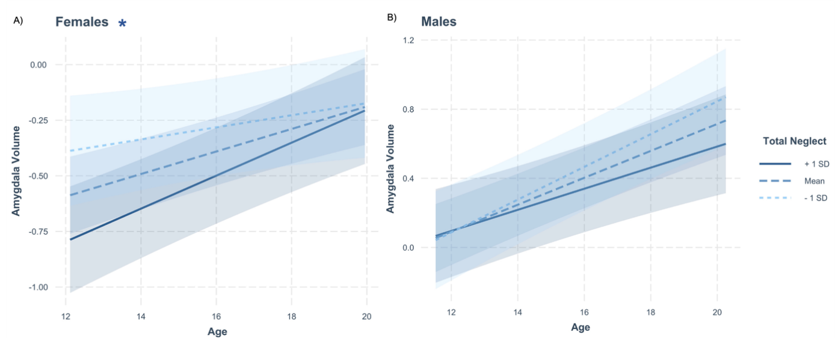

Supplementary Figure S7: Neglect-associated development of amygdala volume. Amygdala development between the ages of 12 and 19 in (A) females and (B) males. Slopes represent average trajectories for +1SD, mean, and -1SD of total neglect scores. (* = significant neglect by age interaction, pFDR < 0.05).

Discussion
The association between neglect and amygdala development was present in females but not males. This is the first study to examine sex differences in the effects of neglect on longitudinal changes in amygdala volume. Many studies have examined the role of sex in behavioural and socioemotional consequences of neglect (White & Kaffman, 2019), but few have examined its role in neglect-related neurodevelopmental alterations. Cross-sectionally, male-specific adversity-related findings have been reported in several brain regions, including the amygdala (De Bellis & Keshavan, 2003; M et al., 2018; Samplin et al., 2013; Whittle et al., 2016). However, contrary to these cross-sectional findings, our findings suggest that females may be more sensitive to neurodevelopmental consequences of maltreatment. While there is a body of literature that supports this notion, particularly following puberty (Bale et al., 2015), sex-specific effects of maltreatment on neurodevelopment are not well understood. Further research is required to understand these underlying mechanisms.

