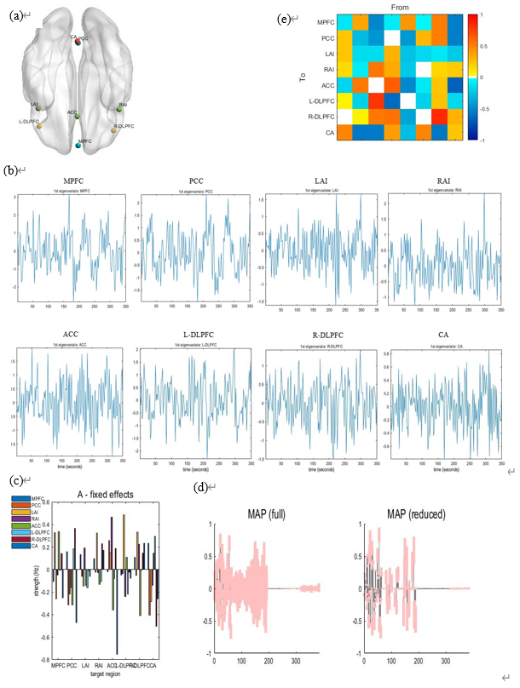
Fig S1. Workflow. (a) Locations of eight nodes are marked with light blue indicating DMN, green indicating SN, yellow indicating FPN and red indicating cerebellum. (b) Time series extraction of each node. (c) First-level model specification and estimation. (d) Second-level model specification, estimation and reduction. (e) Second-level effective connectivity patterns.

