Supplemental materials: a network analysis of depressive symptoms and metabolomics

Journal:
Psychological medicine
Authors:
Arja Rydin,, Yuri Milaneschi^{1,2}, Rick Quax, Jie Li³, Jos Bosch, Robert Schoevers, Erik Giltay, Brenda WJH Penninx^{1,2,}, Femke Lamers^{1,2}
Correspondence address:
Oldenaller 1
1081 HJ Amsterdam
The Netherlands
E-mail: a.o.rydin@amsterdamumc.nl
Number of tables and figures:
3 figures, 2 tables
Number of supplements:
2 figures, 1 table

Supplemental materials: Methods
Table S1. Variable numbers, names and grouping.
Node number | Node name | Group | Abbreviation if applicable
1 | Problems falling asleep | Somatic symptoms
2 | Problems sleeping during the night
3 | Early morning awakenings
4 | Sleeping too much
20 | Psychomotor agitation
21 | Aches and pains
22 | Other bodily symptoms
23 | Panic/phobic symptoms
24 | Constipation/diarrhea
27 | Increased appetite
28 | Decreased appetite
29 | Increased weight
30 | Decreased weight
5 | Feeling sad | Mood/cogntion symptoms
6 | Feeling irritable
7 | Feeling anxious or tense
8 | Mood reactivity
10 | Quality of mood
11 | Concentration/decision making problems
12 | Self-criticism and blame
13 | Future pessimism
14 | Suicidal thoughts
15 | Diminished interest in people/activities
16 | Low energy level/fatigue
17 | Diminished capacity of pleasure/enjoyment
18 | Reduced interest in sex
19 | Psychomotor retardation
25 | Interpersonal sensitivity
26 | Leaden Paralysis
9 | Diurnal variation of mood | No category
31 | Alanine (mmol/l) | Amino acids | Alanine
32 | Histidine (mmol/l) |  | Histidine
33 | Phenylalanine (mmol/l) |  | Phenylalanine
34 | Tyrosine (mmol/l) |  | Tyrosine
35 | Isoleucine (mmol/l) |  | Isoleucine
36 | Leucine (mmol/l) |  | Leucine
37 | Valine (mmol/l) |  | Valine
38 | Apolipoprotein A-I (g/l) | Apolipoproteins | Apo A
39 | Apolipoprotein B (g/l) |  | Apo B
40 | Serum total cholesterol (mmol/l) | Cholesterol | Serum total cholesterol
41 | Esterified cholesterol (mmol/l) |  | Esterified cholesterol
42 | Free cholesterol (mmol/l) |  | Free cholesterol
43 | RemNAt cholesterol (non-HDL, non-LDL -cholesterol) (mmol/l) |  | RemNAt Cholesterol
44 | Total cholesterol in VLDL (mmol/l) |  | Tot chol in VLDL
45 | Total cholesterol in LDL (mmol/l) |  | Tot chol in LDL
46 | Total cholesterol in HDL (mmol/l) |  | Tot chol in HDL
47 | Total cholesterol in HDL2 (mmol/l) |  | Tot chol in HDL2
48 | Total cholesterol in HDL3 (mmol/l) |  | Tot chol in HDL3
49 | Mean diameter for VLDL particles (nm) | Lipoprotein particle size | Mean diam VLDL
50 | Mean diameter for LDL particles (nm) |  | Mean diam LDL
51 | Mean diameter for HDL particles (nm) |  | Mean diam HDL
52 | Serum total triglycerides (mmol/l) | Glycerides & phospholipids | Serum total triglycerides
53 | Triglycerides in VLDL (mmol/l) |  | Triglycerides in VLDL
54 | Triglycerides in LDL (mmol/l) |  | Triglycerides in LDL
55 | Triglycerides in HDL (mmol/l) |  | Triglycerides
56 | Total phosphoglycerides (mmol/l) |  | Total phosphoglycerides
57 | Total cholines (mmol/l) |  | Total cholines
58 | Sphingomyelins (mmol/l) |  | Sphingomyelins
59 | Saturated fatty acids (mmol/l) | Fatty acids | Sat FAs
60 | Monounsaturated fatty acids; 16:1, 18:1 (mmol/l) |  | Monounsat FAs
61 | Polyunsaturated fatty acids (mmol/l) |  | Polyunsat FAs
62 | Omega-6 fatty acids (mmol/l) |  | w6 FAs
63 | Omega-3 fatty acids (mmol/l) |  | w3 FAs
64 | 18:2, linoleic acid (mmol/l) |  | Linoleic acid
65 | 22:6, docosahexaenoic acid (mmol/l) |  | Docosahexaenoic acid
66 | Total fatty acids (mmol/l) |  | Total FAs
67 | Estimated description of fatty acid chain length, not actual carbon number () | Total fatty acids and saturation measures | Est descr FA chain length
68 | Estimated degree of unsaturation () |  | Est deg of unsaturation
69 | Albumin (signal area) | Fluid balance | Albumin
70 | Creatinine (mmol/l) |  | Creatinine
71 | Citrate (mmol/l) | Glycolysis related metabolites | Citrate
72 | Glucose (mmol/l) |  | Glucose
73 | Lactate (mmol/l) |  | Lactate
74 | Glycoprotein acetyls, mainly a1-acid glycoprotein (mmol/l) | Inflammation | Glycoprotein acetyls
75 | Acetate (mmol/l) | Ketone bodies | Acetate
76 | Acetoacetate (mmol/l) |  | Acetoacetate

Mathematical elaboration on Mixed Graphical Models
In the Methods section we briefly explained the assumptions of Mixed Graphical Models (MGM) and how these assumptions allow the dataset to contain both continuous and discrete variables. In this section we go deeper into the mathematics. For real understanding of the matter however we do refer the reader to Haslbeck (2015). For simplicity, we assume only pairwise interactions.
The dataset can be represented as a p-dimensional vector of random variables X, with each X_s taking values in some space. We assume the graph G to have the Markov property over X. This property means that a variable X_s is independent of its indirect neighbours when conditioning on X_s's direct neighbours. It implies that the distribution of X can be represtented as a product of so-called clique-functions. This is the case when the distribution is part of the exponential family distributions. This family consists of several types of distributions (e.g. the normal distribution, exponential distribution, binomial distribution), which can be written as a product of exponential functions.
The class of MGM considers a p-dimensional random vector which has an undirected graph G with p nodes corresponding to it. We assume that the node-conditional distribution of each node X_s is given by an arbitrary univariate exponential familiy distribution conditioned on all the other variables, which as a result gives an explicit joint distribution. These assumptions are necessary because conditional distributions can become impossible to solve analytically, and the exponential family distributions prohibit this from happening.
The joint distribution takes in a number of parameters. How many numbers is dependent on the distributions of the other nodes. If all nodes in the network are continuous, MGM simplifies to a multitvariate Gaussian distribution, parameterised by p intercepts and p*p partial correlations. The estimation of MGM happens through an algorithm that first constructs the edge weights of each node to all other nodes of the network, then combines these edge weight for each pair of nodes, and then constructs the graph according to these edge weights.

Supplemental materials: Results

Descriptives
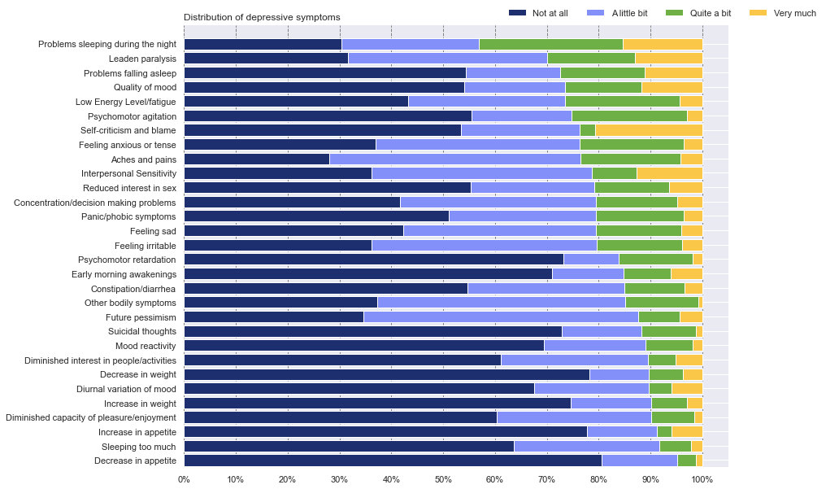
Figure S1. Distribution of depressive symptoms at baseline (n=2498).
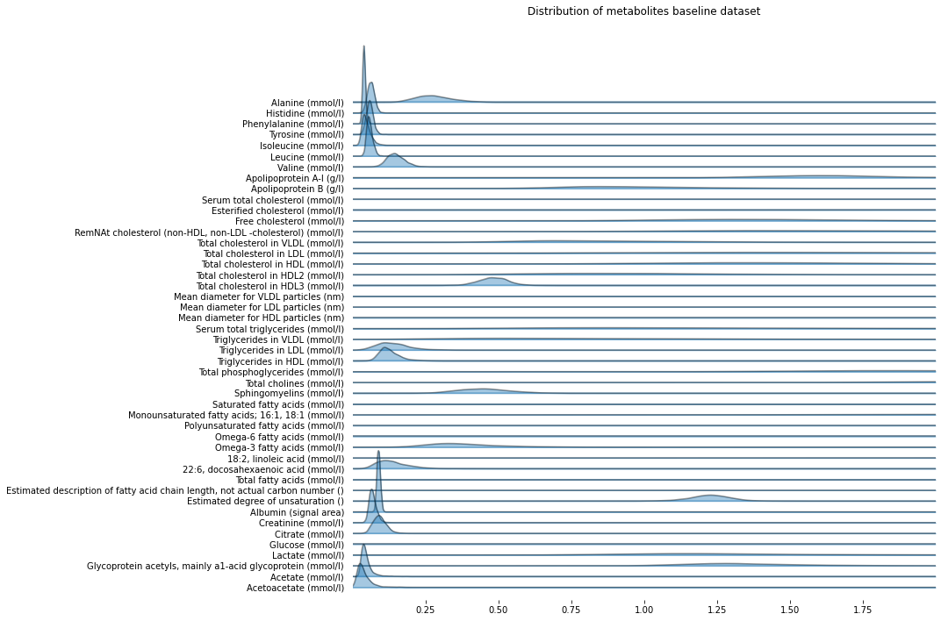
Figure S2 Joyplot of the metabolite distribution baseline dataset (n=2498).

Amsterdam UMC location Vrije Universiteit Amsterdam, Department of Psychiatry, Boelelaan 1117, Amsterdam, The Netherlands;
Amsterdam Public Health, Mental Health program, Amsterdam, The Netherlands
Computational Science Lab, Informatics Institute, Faculty of Science, University of Amsterdam, Amsterdam, The Netherlands;
Clinical Psychology, Faculty of Social and Behavioural Sciences, University of Amsterdam, Amsterdam, The Netherlands;
Department of Psychiatry, Faculty of Medical Sciences, University Medical Centre Groningen, University of Groningen, Groningen, The Netherlands;
Department of Psychiatry, Leiden University Medical Centre, Leiden University, Leiden, The Netherlands;
Department of Psychiatry and Neuroscience Campus Amsterdam, Amsterdam UMC, Vrije Universiteit, Amsterdam Public Health Research Institute, Amsterdam, The Netherlands

