Supplementary material to the manuscript

Blunted neurobiological reactivity and attentional bias to threat underlie stress-related disorders in women survivors of intimate partner violence

X. Goldberg, C. Espelt, R. Nadal, Y. Alon, D. Palao, Y. Bar-Haim, A. Armario

Adapted dot probe task ……………………..………………………………………………………………………… p. 2
Supplementary Table 1 ……………………..………………………………………………………………………… p. 3
Supplementary Figure 1 (A to D) ………..………………………………………………………………………… p. 4
Supplementary Table 2 ………………………..……………………………………………………………………….. p. 5
Supplementary Table 3 ………………………..………………………………………………………………………. p. 6

Adapted Dot probe task.

Participants were presented with a pair of face stimuli, one with emotional valence (happy or threat) and one neutral, followed by a target probe (< or >) that replaced one of the two faces. Participants were asked to indicate the direction of the arrowhead as accurately and quickly as possible by pressing one of two prespecified keys. The face stimuli were photographs of 12 different individuals taken from the NimStim stimulus set (31). Face pairs were same-actor neutral-threat (NA), neutral-happy (NH), neutral-neutral (N-N) combinations. Each trail began with a fixation cross (500 ms), followed by a pair of faces (500 ms), and the probe (until response). The screen background was black, the top stimulus was position 20mm from the top edge of the screen, pairs were presented vertically with equal distance from the top and bottom of the fixation cross, and a distance of 14 mm between them. Trials with reaction times lower than 150ms or higher 2,000ms or incorrect responses were excluded. Mean reaction time per trial type was calculated. Trials with reaction times deviating over 2.5 SDs from the mean were excluded. AB scores were calculated by subtracting the mean reaction times of emotion trials from the mean reaction time of neutral trials. In this study we used only the measures of treat-related AB. Positive values indicate bias towards threat stimuli (vigilance AB), and negative values indicate bias away from threat stimuli (avoidance AB).

Supplementary Table 1. Hair cortisol and levels of physiological and emotional responses to the TSST at each time point, by Group

 | IPV | Control
 | N=69 | N=36 | Unadjusted (*) |  | Fully-adjusted (**)
 | mean (sd) | mean (sd) | F | p-value | F | p-value
Hair cortisol (pgml)
 | 6.7 (5.1) | 5.9 (2.7) | 0.59 | 0.44 | 0.01 | 0.98
Cortisol (pgml)
T0 | 1760.0 (919.2) | 1824.5 (874.4) | 0.30 | 0.59 | 0.67 | 0.42
T1 | 1793.6 (1207.6) | 2003.2 (1066.5) | 2.12 | 0.15 | 0.63 | 0.43
T2 | 2004.8 (2021.5) | 2406.7 (1659.1) | 3.10 | 0.08 | 0.32 | 0.57
sAA (Uml)
T0 | 115.3 (71.3) | 141.3 (82.3) | 2.80 | 0.10 | 7.42 | <0.01
T1 | 201.1 (144.7) | 227.4 (148.6) | 0.58 | 0.44 | 1.34 | 0.25
T2 | 174.1 (125.2) | 193.1 (124.1) | 0.64 | 0.42 | 1.19 | 0.28
State anxiety (STAI)
Pre | 17.9 (11.1) | 11.8 (8.8) | 8.29 | <0.01 | 0.33 | 0.57
Post | 26.6 (13.9) | 19.0 (9.9) | 7.71 | <0.01 | 0.88 | 0.35
Emotional arousal (SAM)
Pre | 4.5 (2.2) | 3.8 (1.9) | 2.85 | 0.09 | 1.08 | 0.30
Post | 6.1 (2.0) | 5.0 (2.1) | 6.45 | <0.05 | 2.97 | 0.09
(*) Univariate analysis of variance by Group, unadjusted.
(**) Univariate analysis of variance with Group and AB as main predictors and age, education level, lifetime psychological and psychiatric treatment, total childhood maltreatment score, and levels of anxiety, depression and symptoms of PTSD as covariates.

Supplementary Figure 1. Changes in levels of physiological and emotional responses across time points for the complete sample.
A) B)

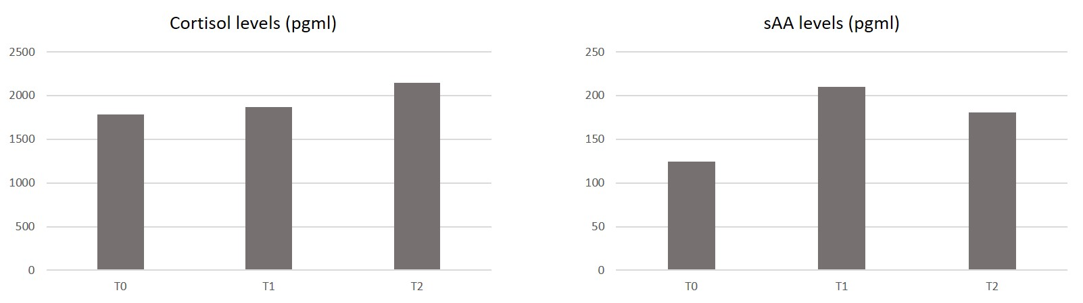

C) D)
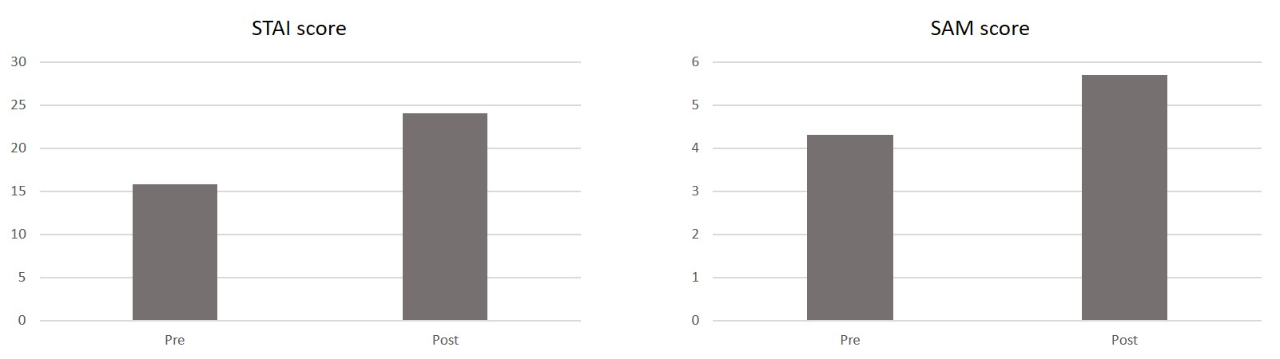
Changes across time points were examined using unadjusted repeated measures ANOVAs for each outcome. A) Changes in cortisol levels from T0 to T2 [F(1.319,134.5)=0.97, p=0.35]. B) Changes in sAA levels from T0 to T2 [F(1.900,191.9)=65.1, p<0.01]. C) Change in STAI score from pre-TSST to post-TSST [F(1, 104)=50.1, p<0.01]. D) Change in SAM scores from pre-TSST to post-TSST [F(1,104)=112.9, p<0.01].

Supplementary Table 2.1: Frequency of cortisol responders and non-responders by Group. Non-response was determined following the criteria by Miller et. al., (2013) Psychosom Med 75: 832–840.
 | Non-responders | Responders
 | N=68 | N=37
 | n (%) | n (%) | chi2 | p-value*
Control | 21 (58.3) | 15 (41.7) | 0.99 | 0.32
IPV | 47 (68.1) | 22 (31.9)
(*)Chi2 test

Supplementary Table 2.2: sAA response in responders and non-responders. Non-response was determined following the criteria by Miller et. al., (2013) Psychosom Med 75: 832–840.
 | Non-responders | Responders
 | N=68 | N=37
 | mean (sd) | mean (sd) | t | p-value*
sAA (Uml)
T0 | 126.6 (80.3) | 123.0 (64.9) | -0.11 | 0.91
T1 | 205.3 (141.7) | 220.1 (154.1) | -0.96 | 0.34
T2 | 186.5 (128.1) | 171.4 (120.3) | 0.55 | 0.58
(*)t-test.

Supplementary Table 3. Levels of physiological and emotional responses to the TSST at each time point, by AB (Attentional Bias) category.

 | Avoidance AB |  | Vigilance AB
 | N=49 |  | N=56
 | mean (sd) |  | mean (sd) |  | F | p-value*
Cortisol (pgml)
T0 | 1761.8 (835.8) |  | 1799.8 (960.5) |  | 0.08 | 0.78
T1 | 1728.7 (822.2) |  | 1988.6 (1390.2) |  | 0.33 | 0.57
T2 | 1825.1 (1219.5) |  | 2427.9 (2329.9) |  | 1.39 | 0.24
sAA (Uml)
T0 | 125.5 (87.6) |  | 123.2 (64.6) |  | 0.55 | 0.46
T1 | 208.3 (140.3) |  | 211.9 (151.9) |  | 0.01 | 0.99
T2 | 185.1 (143.1) |  | 177.0 (106.9) |  | 0.06 | 0.80
State anxiety (STAI)
Pre | 15.1 (11.7) |  | 16.5 (9.9) |  | 0.94 | 0.34
Post | 22.0 (13.5) |  | 25.8 (12.8) |  | 2.67 | 0.11
Emotional arousal (SAM)
Pre | 4.6 (2.3) |  | 4.0 (2.0) |  | 1.60 | 0.21
Post | 5.6 (2.2) |  | 5.8 (2.1) |  | 0.13 | 0.72
(*) Univariate analysis of variance by group, unadjusted.

