Supplementary Figures
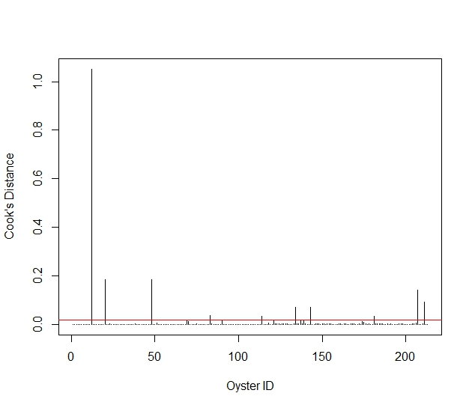
Fig. S1. Influence of individual oysters on the Bonamia exitiosa-only negative binomial generalized liner model as measured by Cook’s distance. The y-axis shows Cook’s distance (higher values indicate greater influence) and the x-axis shows oyster ID. Points above the reference threshold (red line) indicate potentially influential data. The oyster with a Cook’s distance >1.0 is from Foveaux Strait.

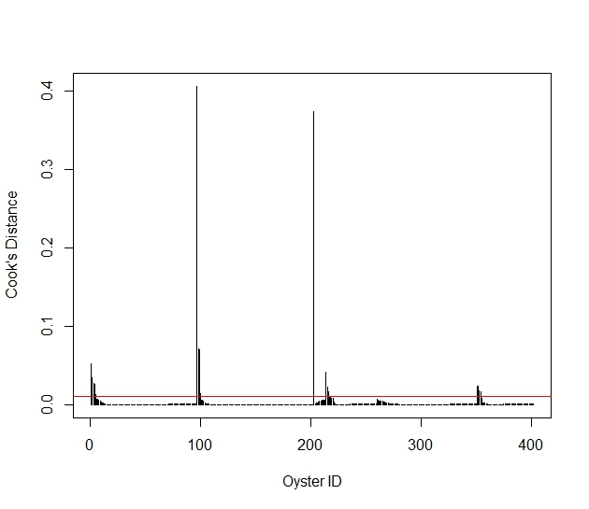
Fig. S2. Influence of individual oysters on the negative binomial generalized liner model for all groups and locations, measured by Cook’s distance. The y-axis shows Cook’s distance (higher values indicate greater influence) and the x-axis shows oyster ID. Points above the reference threshold (red line) indicate potentially influential data. The oyster previously identified as highly influential in Fig. S1 (Foveaux Strait) is oyster #100 in this plot, with a Cook’s distance of 0.4, indicating much lower influence in the combined dataset.

