Supplementary material
Supplementary Table 1. Data corresponding to pregnancies included in the group 1 of patients treated at Centro Hospitalario Pereira Rossell (CHPR)
Year | IgG - IgM + | IgG- IgM - | IgG + IgM- | IgG + IgM + | Number of Seroconversion cases | Calculated Seroconversion rate | Confirmed CT cases | Valid Tests | Total Births
2019 | 13 | 2476 | 2259 | 35 | 13 | 0,52 | 4 | 4796 | 5884
2020 | 9 | 2623 | 2309 | 39 | 18 | 0,68 | 3 | 4998 | 5875
2021 | 8 | 2601 | 2108 | 28 | 15 | 0,57 | 2 | 4760 | 5765
2022 | 8 | 2416 | 1913 | 39 | 17 | 0,70 | 2 | 4393 | 5283
2023 | 5 | 2324 | 2022 | 24 | 10 | 0,43 | 3 | 4385 | 5121
Average/yr | 8,6 | 2488 | 2122,2 | 33 | 14,6 | 0,58 | 2,8 | 4666,4 | 5585,6
Total | 43 | 12440 | 10611 | 165 | 73 | - | 14*** | 23,332 | 27,928
*CT= congenital toxoplasmosis **seroconversion was calculated as the number of IgM+/IgG- patients over the total number of valid tests, minus those valid tests corresponding to IgG+ patients at the time of first serology and normalized for every 1000 births ***Note that 13 of these cases were followed up. Details are shown in supplementary table 2.

Supplementary Table 2. Congenital Toxoplasmosis (CT) cases included in group 2 of this study.
CASE | Trimester of diagnosis | Maternal treatment | Clinical manifestations | Detailed clinical manifestations | Year
1 | UD | No | Yes | Ventricular dilatation, chorioretinitis, neurological affectations and altered Transfontanelar echography | 2019
2 | 3 | Yes | No |  | 2019
3 | 2 | Yes | No |  | 2019
4 | 3 | Yes | Yes | Calcifications, neurological affectations and altered Transfontanelar echography | 2019
5 | UD | No | No |  | 2020
6 | 2 | No | Yes | Chorioretinitis, neurological affectations | 2020
7 | 3 | Yes | Yes | Ventricular dilatation, calcifications, chorioretinitis, neurological affectations and altered Transfontanelar | 2021
8 | 2 | Yes | Yes | Ventricular dilatation, calcifications, chorioretinitis, neurological affectations and altered Transfontanelar echography | 2021
9 | UD | Yes | No |  | 2022
10 | 3 | No | No |  | 2022
11 | 1 | No | Yes | Chorioretinitis | 2023
12 | 3 | No | Yes | Chorioretinitis | 2023
13 | 3 | No | Yes | Chorioretinitis | 2023
*UD; undetermined

Supplementary Table 3. Correlation among samples in cases where multiple samples were collected for a given mother-newborn pair.

 | Mother's peripheral blood | Placenta tissue | Umbilical cord blood | Newborn's peripheral blood
TG47 | Negative | Positive | Negative | Negative
TG02 | Positive | Positive | Positive
TG11 | Positive | Positive | Positive
TG38 | Positive | Positive | Positive
TG09 | Positive | Negative | Positive
TG42 | Positive | Negative | Positive
TG52 | Positive | Negative | Negative
TG50 | Positive | Negative |  | Positive
TG20 | Positive | Positive
TG22 | Positive | Positive
TG23 | Positive | Positive
TG26 | Positive | Negative
TG41 | Positive |  | Positive
TG14 |  | Positive | Positive
TG15 |  | Positive | Positive
TG16 |  | Positive | Positive
TG18 |  | Positive | Positive
TG39 |  | Positive | Positive
TG10 |  | Positive | Negative
TG35 |  | Positive |  | Positive
* Positive and Negative refer to the result of the diagnostic PCR
Supplementary Table 4. Accession number and ToxoDB IDs of alleles used for constructing the phylogenetic tree
 | AS2 | Bub | C22-8 | C29-2 | Gra6 | L358 | Pk1
CASTELLS | JX045472 | JX045460 |  |  | JX044194
TgARI | TGARI_271050 | TGARI_266960 | TGARI_321370 | TGARI_252890 | TGARI_275440 | TGARI_285780 | TGARI_243500
TgBR9 | TGBR9_271050 | TGBR9_266960 | TGBR9_321370 | TGBR9_252890 | TGBR9_275440 | TGBR9_285780 | TGBR9_243500
TgCAST | TGCAST_271050 | TGCAST_266960 | TGCAST_321370 | TGCAST_252890 | TGCAST_275440 | TGCAST_285780A | TGCAST_243500
TgCatBr1 | JX045470 | JX045466 |  |  | JX044196
TgCatBr10 | JX045483 | JX045461 |  |  | JX044189
TgCatBr18 | JX045476 | JX045465 |  |  | JX044224
TgCatBr2 | JX045487 | JX045450 |  |  | JX044203
TgCatBr3 | JX045486 | JX045458 |  |  | JX044194
TgCatBr5 | EU258532 |  | EU258488 |  | JX044228 | EU258502 | EU258517
TgCatBr6 | JX045485 | JX045462 |  |  | JX044227
TgCatBr9 | JX045484 | JX045464 |  |  | JX044204
TgCOUG | TGCOUG_271050 | TGCOUG_266960 | TGCOUG_321370 | TGCOUG_252890 | TGCOUG_275440 | TGCOUG_285780 | TGCOUG_243500
TgDgCo11 | EU258533 |  | EU258489 |  |  | EU258503 | EU258518
TgDOM2 | TGDOM2_271050 | TgDOM2_Btub | TGDOM2_250780 | TGDOM2_252890 | TGDOM2_275440 | TGDOM2_285780A | TGDOM2_243500
TgFOU | TGFOU_271050 | TGFOU_266960 | TGFOU_321370 | TGFOU_252890 | TGFOU_275440 | TGFOU_285780 | TGFOU_243500
TgGT1 | TGGT1_271050 | TGGT1_266960 | TGGT1_250780 | TGGT1_252890 | TGGT1_275440 | TGGT1_285780 | TGGT1_243500
TgMAS | TGMAS_271050 | TGMAS_266960 | TGMAS_321370 | TGMAS_252890 | TGMAS_275440 | TGMAS_285780A | TGMAS_243500
TgME49 | TGME49_271050 | TGME49_266960 | TGME49_321370 | TGME49_252890 | TGME49_275440 | TGME49_285780 | TGME49_243500
TgP89 | TGP89_271050 | TGP89_266960 | TGP89_321370 | TGP89_252890 | TGP89_275440 | TGP89_285780A | TGP89_243500
TgRH88 | TGRH88_022160 | TGRH88_011050 | TGRH88_064050 | TGRH88_005240 | TGRH88_038710 | TGRH88_026240 | TGRH88_028910
TgRUB | TGRUB_271050 | TGRUB_266960 | TGRUB_321370 | TGRUB_252890 | TGRUB_275440 | TGRUB_285780A | TGRUB_243500
TgVEG | TGVEG_271050 | TGVEG_266960 | TGVEG_321370 | TGVEG_252890 | TGVEG_275440 | TGVEG_285780 | TGVEG_243500

Supplementary Table 5. Accession numbers of new sequences generated in this study
Sample | Marker | GenBank accession number
Tg2 | Btub | PV564118
 | Gra6 | PV564146
 | C228 | PV564166
Tg7 | Btub | PV564119
Tg8 | Gra6 | PV564147
Tg9 | Btub | PV564120
 | Gra6 | PV564148
Tg11 | Btub | PV564121
 | Gra6 | PV564149
 | C228 | PV564167
 | C292 | PV564173
Tg14 | Btub | PV564122
 | Gra6 | PV564150
 | C292 | PV564174
Tg15 | Btub | PV564123
 | Gra6 | PV564151
Tg18 | Btub | PV564124
 | Gra6 | PV564152
Tg19 | Btub | PV564125
 | Gra6 | PV564153
Tg20 | Btub | PV564126
 | Gra6 | PV564154
 | C228 | PV564168
Tg21 | Btub | PV564127
 | Gra6 | PV564155
Tg22 | Btub | PV564128
Tg23 | Btub | PV564129
Tg24 | Btub | PV564130
 | C292 | PV564175
Tg25 | Btub | PV564131
Tg26 | Btub | PV564132
Tg33 | Gra6 | PV564156
Tg34 | Btub | PV564133
 | Gra6 | PV564157
Tg35 | Btub | PV564134
 | Gra6 | PV564158
 | C228 | PV564169
Tg36 | Btub | PV564135
Tg37 | Btub | PV564136
 | C292 | PV564176
Tg38 | Btub | PV564137
 | Gra6 | PV564159
Tg40 | Btub | PV564138
 | Gra6 | PV564160
 | C228 | PV564170
 | C292 | PV564177
Tg41 | Btub | PV564139
 | Gra6 | PV564161
 | C292 | PV564178
Tg42 | Gra6 | PV564162
 | C292 | PV564179
Tg43 | Btub | PV564140
 | Gra6 | PV564163
Tg45 | Btub | PV564141
 | Gra6 | PV564164
Tg46 | Btub | PV564142
Tg47 | Btub | PV564143
 | Gra6 | PV564165
Tg49 | Btub | PV564144
 | C228 | PV564171
Tg50 | Btub | PV564145
Tg51 | C228 | PV564172

Supplementary Figure 1.

Supplementary Figure 1. Antibody titers in cases of maternal seroconversion with confirmed transplacental transmission of Toxoplasma gondii. IgG and IgM titers are shown for two sequential serological surveys of pregnant women whose babies were born with congenital toxoplasmosis. The 13 cases correspond to those shown in Tables 2 and 3. Cases in red correspond to those who did not receive treatment. Titers of 0–3 were considered negative, 4–7 equivocal and ≥8 positive

Supplementary Figure 2

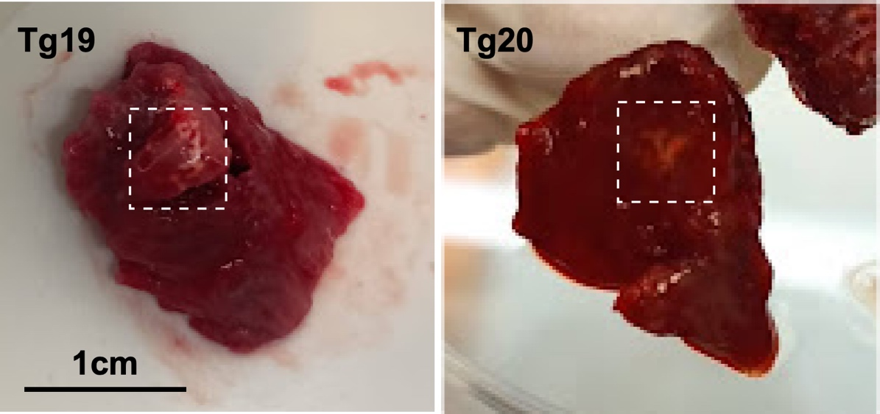
Supplementary Figure 2. Representative images of lessions observed in placental samples from two patients. Lessions are highlighted within a dashed square. Histopathological analysese of other sections of the same placenta did not reveal significant tissue damage (not shown).

