**Supplementary file 1: Photographs of parasites found during microscopic examination.**

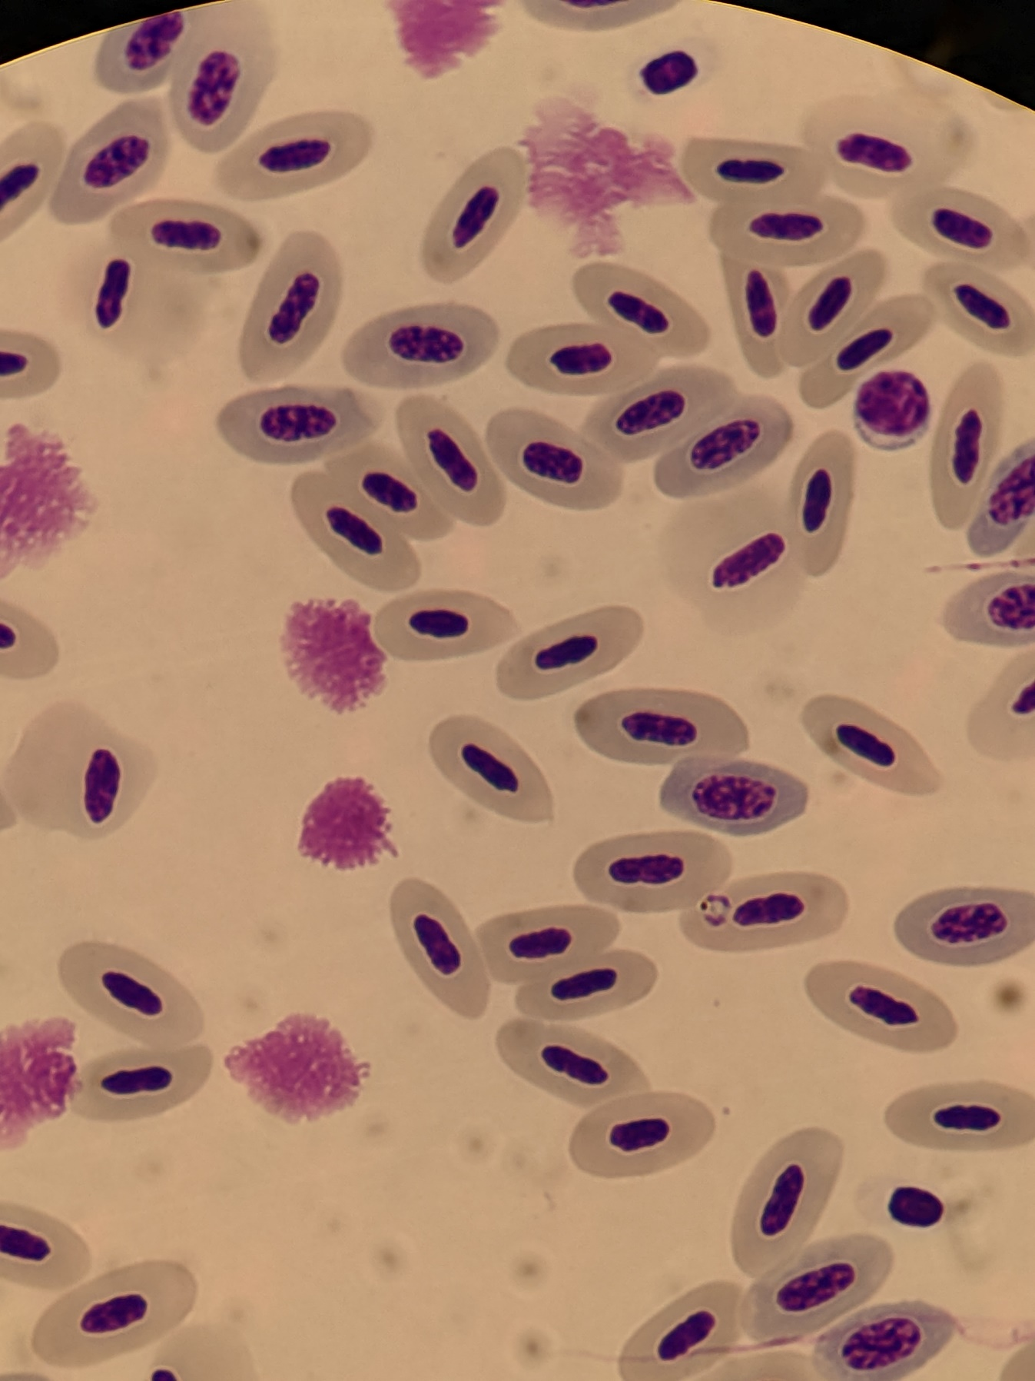

***Plasmodium* parasite**

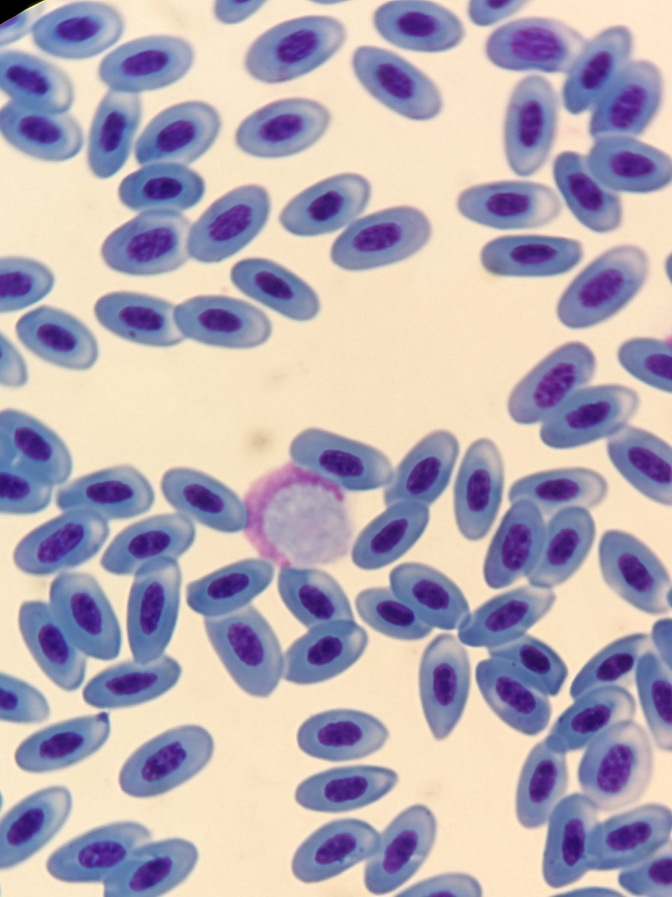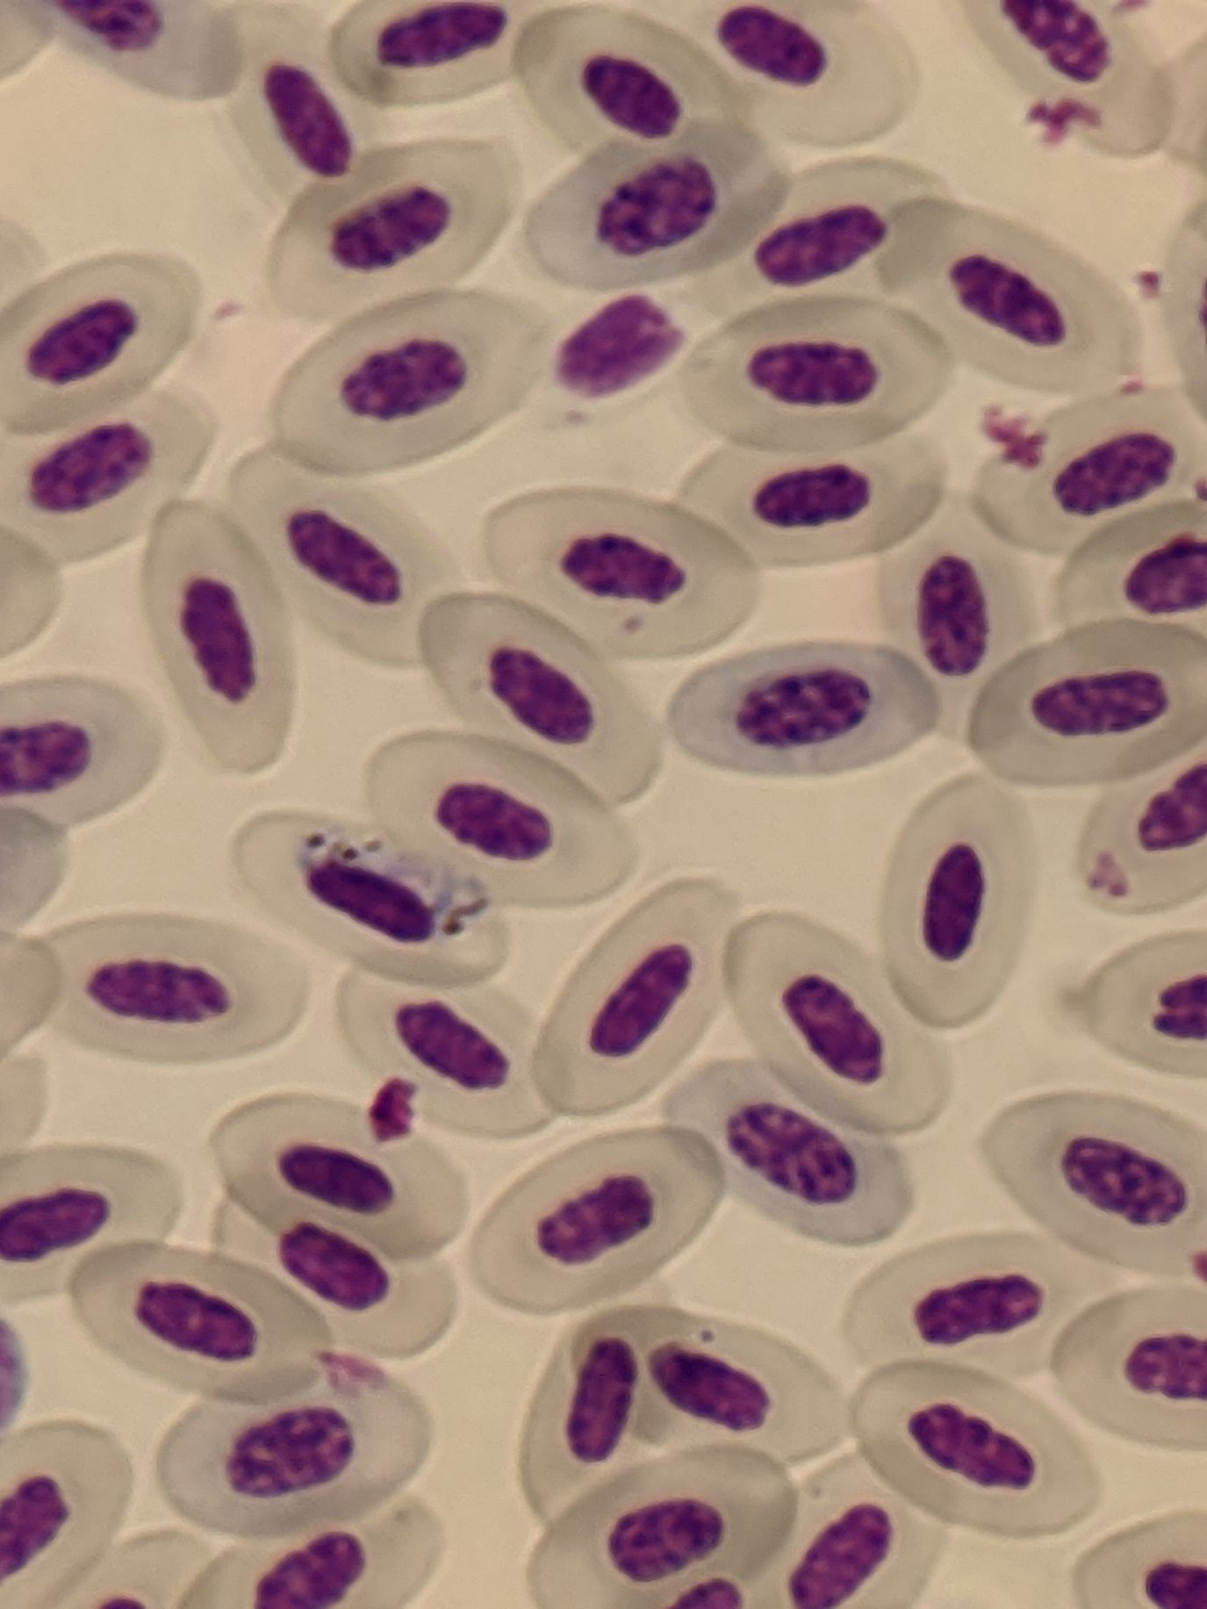

***Leucocytozoon* parasite**

***Haemoproteus* parasite**