Supplementary Material

Title: A systematic review of the diversity and virulence correlates of metastrongyle lungworms in marine mammals

Authors: Fischbach, J.R. & Seguel, M.

Supplementary Figures:

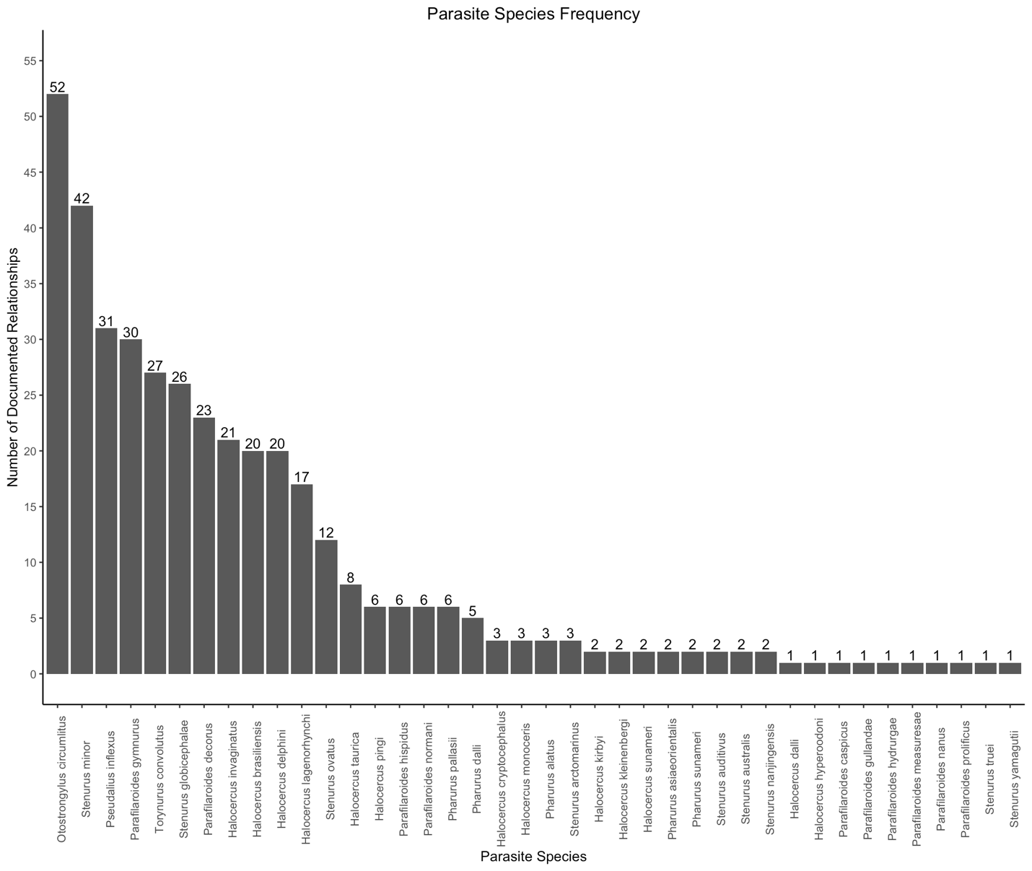
Supplementary Figure 1: Frequency of metastrongyle species documented.

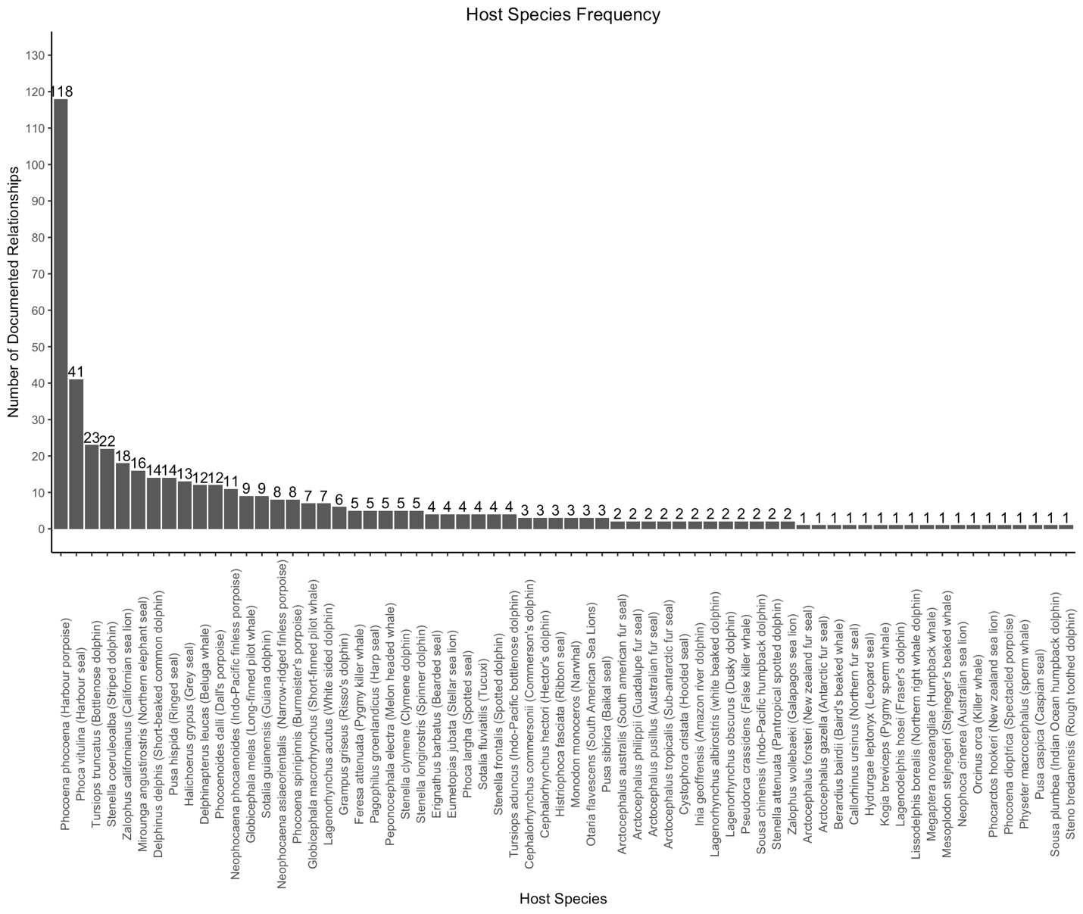
Supplementary Figure 2: Frequency of marine mammal host species documented.

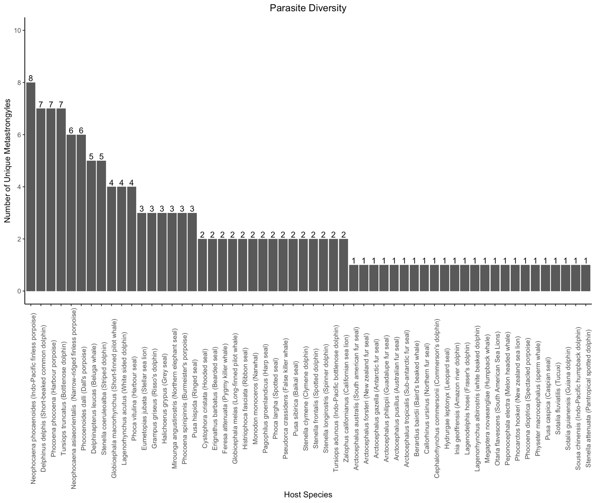
Supplementary Figure 3: Parasite diversity for metastrongyles in marine mammals (number of unique metastrongyle species hosted by each marine mammal).

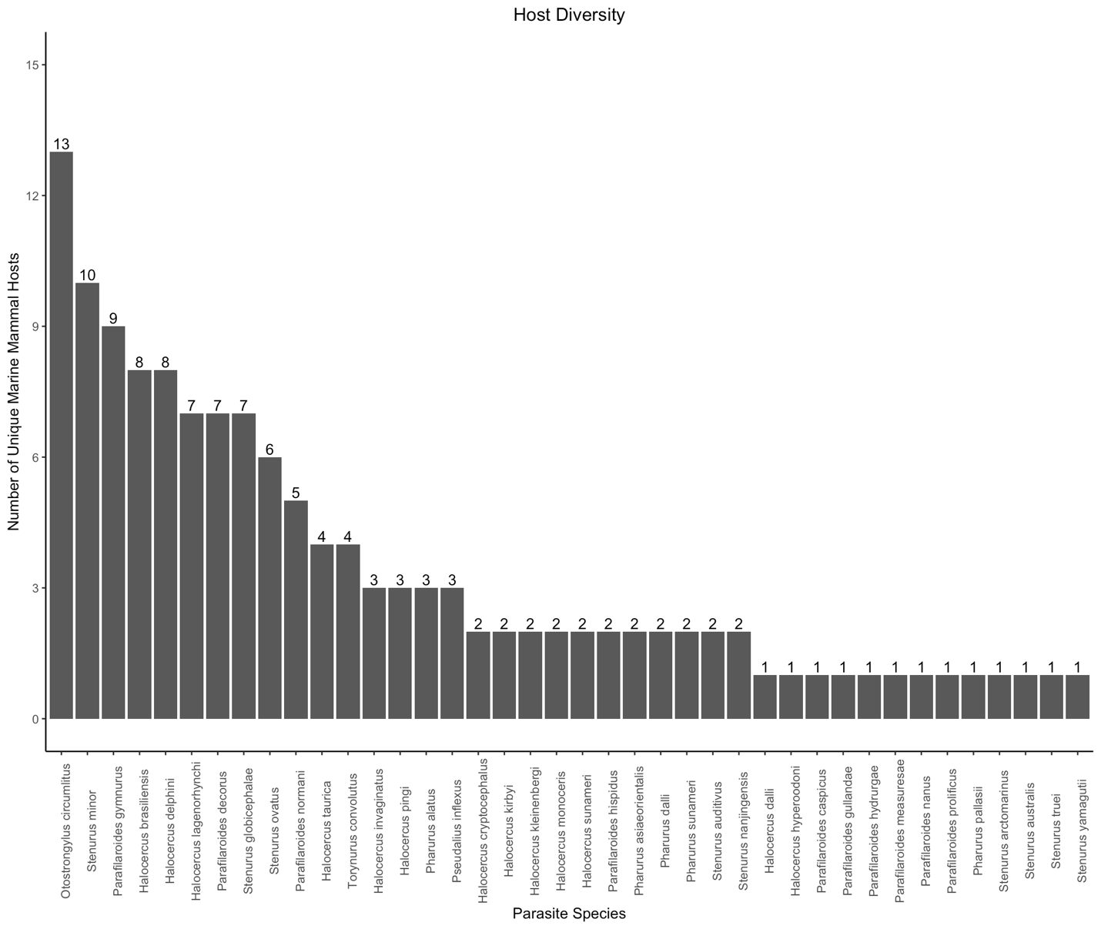
Supplementary Figure 4: Host diversity for metastrongyles in marine mammals (number of host species parasitized by each metastrongyle).

