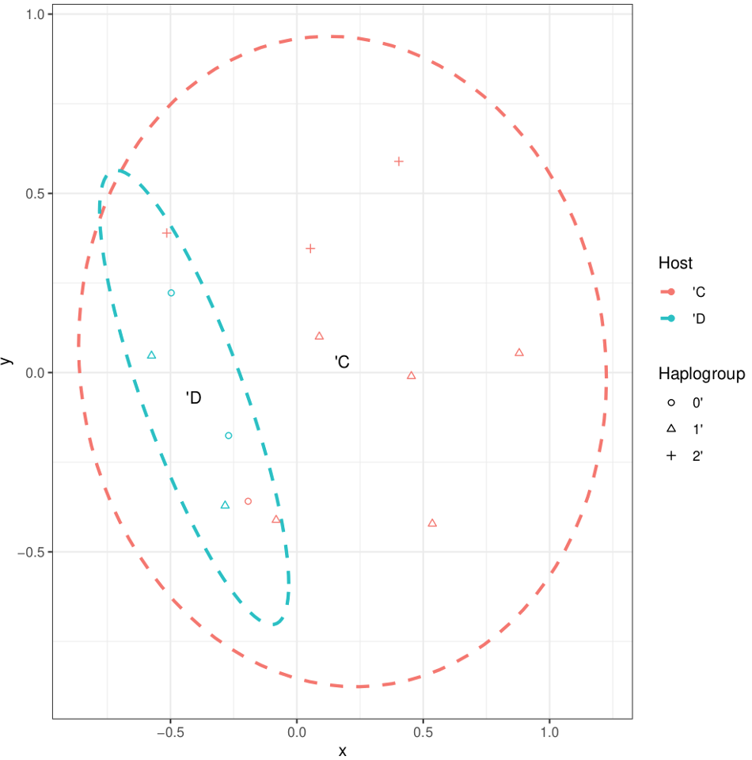

Supplementary Figure 1: Non-metric multidimensional scaling plot of bacterial composition discerned using Bray-Curtis dissimilarity between C. f. felis samples from Canine (D) and Feline (C) vertebrate hosts. Haplogroups correspond to genetic assemblages as described in Table 1

