Using local scientific knowledge for transboundary conservation: distribution modelling for the taruka in South America

Nicolás Fuentes-Allende, Cristina Mata, Javier Barrio, Paulo Corti, Gabriel Llerena, Velia Mendoza, Ángela Nuñez, Ramiro Ovejero, Luis F. Pacheco, Hernán Pastore, Josef Rechberger, Hector A. Regidor, Jhonson Vizcarra,
Esteban Zúñiga and Benito A. González

Supplementary material is published as supplied by the authors. It is not checked for accuracy, copyedited, typeset or proofread. The responsibility for accuracy and file functionality remains with the authors.
Supplementary Material 1 Additional details on the Methods.

Data sources of taruka Hippocamelus antisensis locations

Location data was gathered from personal information from all the collaborators of this group, as well as the following literature:
- Anderson, S. 1997. Mammals of Bolivia, Taxonomy and Distribution. Bulletin of the American Museum of Natural History 231:652p.
- Brunetto, L., Sarapura, D., Saravia, M., Jara, R. 2020. Monitoreo de taruca (Hippocamelus antisensis) en las Serranías de Calilegua. INVESTIGACIÓN Y MONITOREO EN ÁREAS PROTEGIDAS DE LA REGIÓN NOA 3:13-14.
- Gomez-Puerta, L. A., Pacheco, J., Gonzales-Viera, O., Lopez-Urbina, M. T., Gonzalez, A. E. 2015. The taruca (Hippocamelus antisensis) and the red brocket deer(Mazama americana) as intermediate hosts of Taenia hydatigena in Peru, morphological and molecular evidence. Veterinary Parasitology.
- Guillemi, E. C., De la Fourniere, S., Orozco, M., Peña-Martinez, J., Correa, E., Fernandez, J., Lopez-Arias, L., Paoletta, M., Corona, B., Pinarello, V., Wilkowsky, S. E., Farber, M. D. 2016. Molecular identification of Anaplasma marginale in two autochthonous South American wild species revealed an identical new genotype and its phylogenetic relationship with those of bovines. Parasites & Vectors 9(305).
- Jungius, H. 1974. Beobachtungen am Weisswedelhirsch und an anderen Cerviden in Bolivien. Zeitschrift Saugetierkunde 39:373-383.
- Hofmann, R. 1970. La población de vicuñas en Negromayo y Yaurihuiri (Dpto. de Ayacucho). Instituto de Investigaciones Forestales.UNA/DGFCT. Informe Técnico Nº 26. 4 p.
- Hofmann, R. y Ponce, C. 1970. Evaluaciones preliminares de las poblaciones de taruka y ciervo de los pantanos. Inst. de Inv. Forestales. UNA/DGFCT. Informe de trabajo. 6 p.
- Merkt, J. 1985. Social structure of Andean deer (Hippocamelus antisensis) in southern Peru. M.S. Thesis. University of British Columbia, Vancouver, Canada.
- Patrón, H.Z., Pacheco, V., Baraybar, L. 2001. Diversity and conservation of mammals from Arequipa, Peru. Revista Peruana de Biología 8(2):94-104.
- Reider, K. 2015. Libreta de campo, Proyecto Sibinacocha.
- Roe, N., and Rees, W. 1976. Preliminary observations of the taruca (Hippocamelus antisensis: Cervidae) in southern Peru. J. Mammal., 57: 722-730.
- Rumiz, D. I., Eulert, C. F., Arispe, R. 1998. Assessing diversity og large and medium size mammals in the Carrasco National Park (Cochabamba-Bolivia). Revista Boliviana de Ecología y Conservación Ambiental 4:77-90.
- Salazar-Bravo, J., Yensen, E., Tarifa, T., Yates, T. L. 2002. Distributional records of Bolivian mammals. Mastozoología Neotropical 9(1).
- Sanborn, C. 1953. Mammals from the departments of Cusco and Puno, Peru. Publicaciones del Museo de Historia Natural "Javier Prado". Serie A. Zoología N° 12. 8 p.
- Sielfeld, W., Guzmán, J. A. 2011. Distribution, reproduction and grouping patterns in the taruca deer (Hippocamelus antinsensis D'=rbigny, 1834) in the extreme north of Chile. Animal Production Science 51(4).
- Velarde, E. 1987. Determinación de la población actual de vicuñas en el Dpto. de Huancavelica. INFOR, CORDE-Huancavelica, Subproyecto Vicuña-Huancavelica. 2 tomos. 46 p.
- Zeballos, H., Pacheco, V., Baraybar, L. 2001. Diversidad y conservación de los mamíferos de Arequipa, Perú. Rev. Per. Biol., 8 (2)

Location data was also shared with us by the following people and institutions:
Agricultural and Livestock Service of Chile (SAG), Alain Escóbar, Alberto Barrio Miguel Cura, Alfaro Huaranca, Alfredo Ugarte, Alianza Gato Andino (AGA; https://gatoandino.org), Alvaro Garitano, Ana Venegas, Andre Vielma, Andrés Huanca, Andrés Puigross, Anita Venegas, Ben Schweinhart, Carla Gazzolo, Carlos Lemuz Aguirre, Christian Navarrete, Constanza Vivanco, Craig Stobie, Cristian Carrasco, Daniel Lane, Daniela Velasquez, Deiby Germán Cuellar Castellón, Diego Davis, Edilberto Pardo, Emily Larson, Esteban Argerich, Esteban Martinez, Fabian Beltran, Fauna Australis (PUC, Chile), Fernando Harold Calderon Quispe, Field Museum of Natural History (Chicago, USA), Francisca Montecinos, Francisco Cornell, Francisco Osorio, Francois Cuynet, GBIF (gbif.org), Gonzalo Cano Sanz, Gonzalo Cristofani, Gustavo A Ordinola, Gustavo Bárcena, Herminio Ticona, Hugo Castillo, Hugo Hulsberg, Inaturalist (www.inaturalist.org), Ivo Tejeda, Jaime Valenzuela, Jan Ebr, Javiera Cortez, Jose Luis Lineros, Jose Luis Paz Soria, Juan Carlos Chébez, Juan Jaeger, Julián Hernández, Luordes Marón Mollinedo, Maria Alisa Alvarez, Maria Jose Harder, Maria Viscarra, Mario Andrada, Martin Pekarek, Mathias Jacob, Matias Treumun, Mauricio Lea del Valle, Miguel Angel Salazar Ponce, Museo de Historia Natural de la UNMSM (Lima, Peru), Museo Historia Natural UNSA (Arequipa, Peru), Museum of Vertebrate Zoology (University of California Berkeley, USA), National Forestry Corporation of Chile, National Museum of Natural History (Smithsonian Institution, USA), National Parks Administration of Argentina (APN), Omar Miranda Bayron, Oscar Loayza, Pablo Gutierrez, Pablo Valladares, Paola Poch, Patricio Quijada, Quebrada Blanca 2 (TECK Chile), Robert Wallace, Roberto Elias, Rodrigo Barros, Rutger Koperdraad, Sabina Segovia Segovia, Santiago M. Carrillo, Saul Callancho Quispe, Sebastian Garcia, Sebastian Saiter, Sebastian Vidal, Simon Graesboell, Soledad Marianela Carvajal Taucare, Tarukari NGO (Chile), Tomás Saratscheff, Victoria Lassaga, Virginia Chirila, Wildlife Conservation Society Bolivia (WCS Bolivia), Wildlife Conservation Society Peru (WCS Peru), Wildlife Ecology Lab (Uchile, Chile), Wilfredo Choque, Xavier Claros and Ximena Jáuregui.

Supplementary Table 1 Summary of taruka Hippocamelus antisensis records by decade and country.
Decade | Peru | Bolivia | Chile | Argentina | Total
1972-1981 | 6 | 2 | 0 | 0 | 8
1982-1991 | 43 | 1 | 1 | 2 | 47
1992-2001 | 48 | 76 | 0 | 3 | 127
2002-2011 | 50 | 158 | 18 | 46 | 272
2012-2022 | 55 | 149 | 258 | 331 | 793
Total | 202 | 386 | 277 | 382 | 1247

Environmental variables for model construction

Topographic variables, including mean altitude, standard deviation of altitude, and mean slope were derived from the ASTER Global Digital Elevation Map (ASTER GDEM; METI & NASA). However, given that the Aster GDEM has a spatial resolution of 230 m, we upscaled the images to a 1 km² grid to comply with analysis requirements (mean and standard deviation of altitude were calculated considering all the pixels within 1 km² grid). Mean slope was calculated using bilinear interpolation (Mata et al., 2019). For anthropogenic influence on taruka presence, we incorporated distance of taruka sighting to nearest settlement (CIESIN, 2016). To assess vegetation quality affecting taruka presence, we used the normalized difference vegetation index (NDVI) for the months of August (dry season, NDVIdry) and February (rainy season, NDVIrain) from 2000 to 2022 (AppEEARS Team, 2022). Images were obtained from MODIS-Terra (Didan, 2015). We excluded images with significant atmospheric corruptions, calculating mean NDVIdry based on images from 2003, 2014, 2016, 2017, and 2019 (atmospheric corruption < 30%) and mean NDVIrain from images captured in 2004, 2007, 2010, 2014, 2016 and 2021 (atmospheric corruption < 40%).

Supplementary Table 2 Variables used to model distribution range, from both the study area and the location data.

Type | Variable | Study area | Sightings
Topographic | Mean altitude (m) | (951 - 6702) | (2009.51 - 5256.93)
 | SD altitude | (0 - 911) | (0.95 - 222.25)
 | Mean slope | (0 - 89.63) | (0.47 - 29.79)
Location | Dist to settlements | (0 - 126621.5) | (922.51 - 67671.5)
Climatic | MERR1 | (28 - 306) | (74.18 - 232.13)
 | MERR2 | (55 - 282) | (114.39 - 281)
 | MERR3 | (42 - 86) | (63.89 - 82)
 | MERR4 | (688 - 7631) | (810.44 - 3889.78)
 | MERR7 | (115 - 502) | (169.77 - 399.23)
 | MERR12 | (28 - 1025) | (94.02 - 753.96)
 | BIO1 | (-11.25 - 23.2) | (0.29 - 18.46)
 | BIO2 | (4.35 - 27.27) | (10.75 - 24.96)
 | BIO3 | (31.75 - 97.12) | (51.47 - 91.61)
 | BIO4 | (9.13 - 591.53) | (46.76 - 421.83)
 | BIO7 | (9.9 - 36.7) | (14.37 - 30.97)
 | BIO12 | (1 - 3440) | (32.09 - 1503.18)
Vegetation | NDVIdry | (-0.11 - 0.89) | (0.03 - 0.79)
 | NDVIrain | (-0.15 - 0.91) | (0.02 - 0.84)

Model Selection

We used ENMTools to compare the performance of various species distribution models (Warren et al., 2010). These models differed in the regularisation parameter (Radosavljevic et al., 2014), the functions used for environmental variables (Merow et al., 2013), and incorporated two different sets of feature classes, the auto-features option and a selection that only allowed linear, quadratic, and product (LQP) features. We identified the best-fitting models using the Akaike information criterion (AIC; Warren et al., 2010), and subsequently constructed these models through five-fold cross-validation. To assess the significance of each environmental variable explaining taruka presence, we conducted jackknife analysis (Yost et al., 2008) and examined response curves of presence (Phillips et al., 2017). Model consistency was evaluated using the area under the receiver operating characteristic curve index (AUC; Liu et al., 2005), and the logistic output format to facilitate the interpretation of results (Phillips and Dudik, 2008).

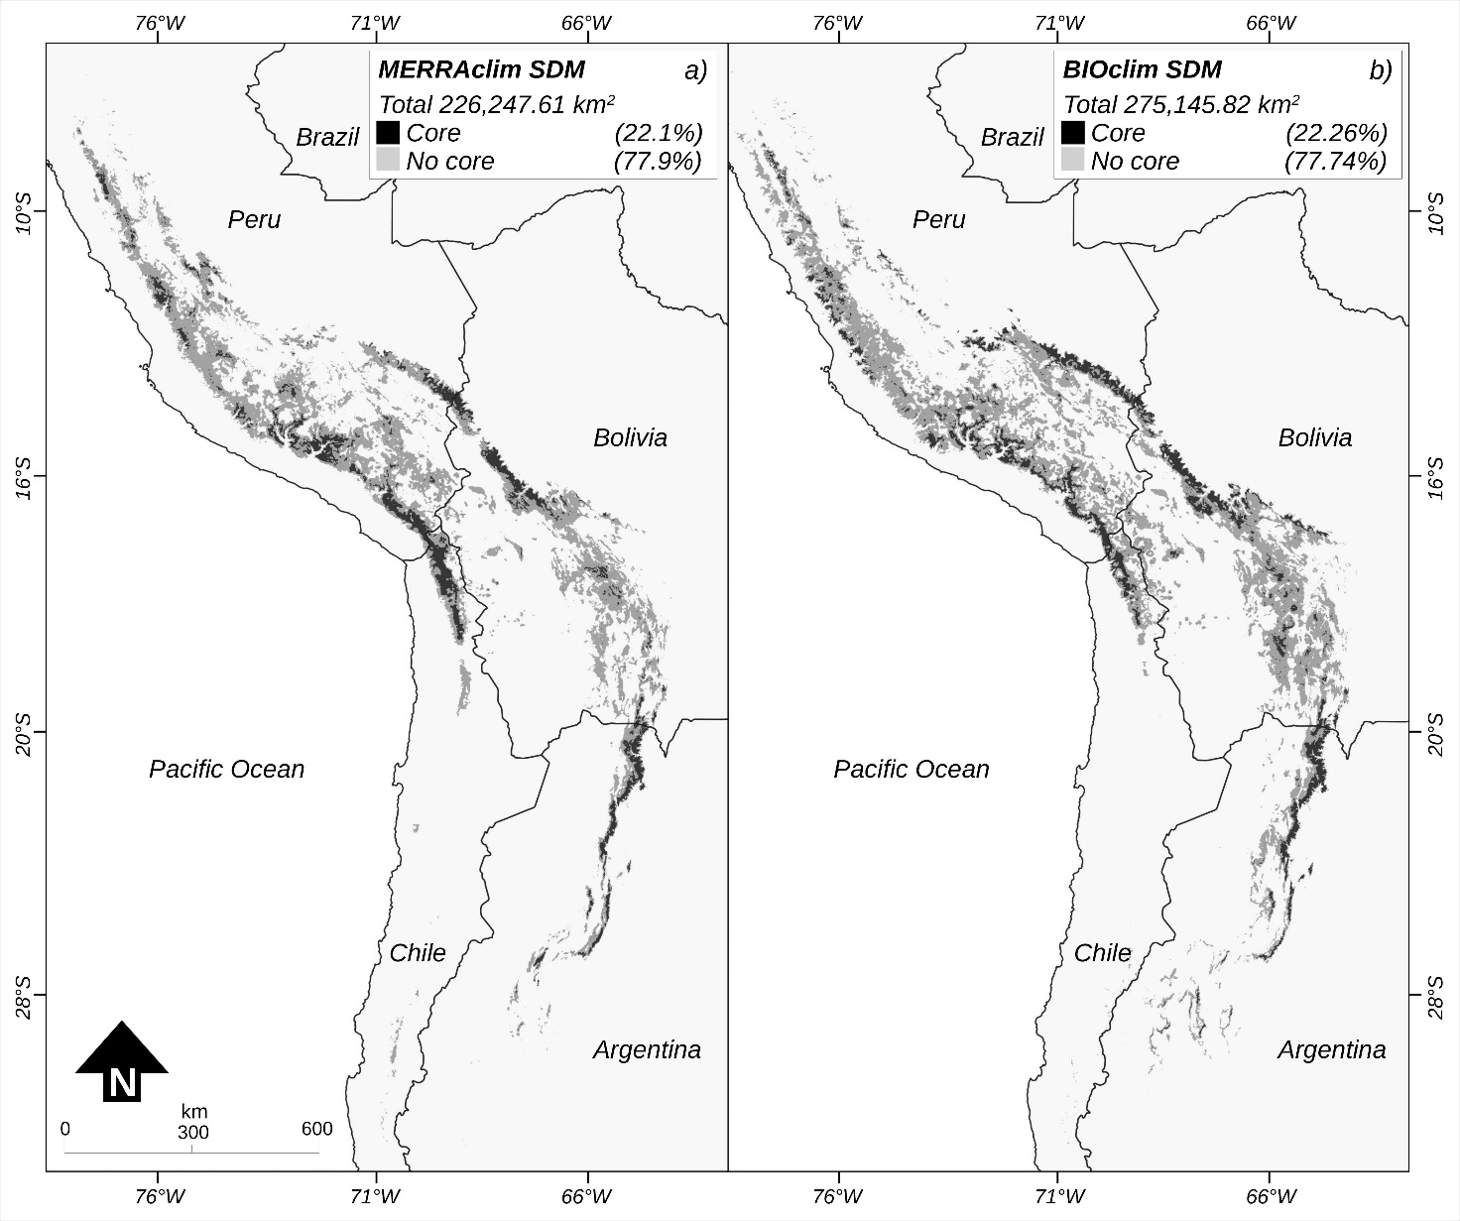
Supplementary Fig. 1 Predicted taruka distribution for each bioclimatic database: (a) MERRAclim, (b) BIOclim. Black areas represent core distribution, dark grey areas the non-core distribution.

Supplementary Material 2 Additional details on the Results.

Peruvian distribution

More than half (54%) of the taruka’s global distribution is within the borders of this country (c. 172,722 km²; Fig. 3a), including 13% of the global core distribution (c. 41,648 km²; with western and eastern strips represented), and 41% of the non-core distribution (c. 131,074 km²). Only 6% of the Peruvian distribution (ca. 10,942 km²) is currently under protection. This protected distribution includes c. 3,907 km² of core distribution (2% of the total distribution and 9% of the core distribution in this country), and c. 7,035 km² non-core distribution (4% of the total distribution and 5% of the non-core distribution in this country). The protected distribution in Peru can be divided into 12 distinct units, with five units located along the western strip of the core distribution, three units located along the eastern strip, and four units located in the non-core distribution.

Bolivian distribution

Approximately one-third of the of the global distribution (30%; c. 96,916 km²; Fig. 3b) and roughly one-quarter of the global core distribution (6%; c. 20,221 km²), represented by the eastern strip, is in Bolivia. The eastern strip remains well connected and continuous from the Peru-Bolivia border to Cochabamba (17.5°S), but it becomes patchy and fragmented to the south from that point. Only 9% of the Bolivian distribution (c. 9,015 km²) is under protected status, covering 17% (c. 3,397 km²) of the Bolivian core distribution and 7% (ca. 5,619 km²) of its non-core distribution. The protected distribution in Bolivia can be categorized into eight units, with two units dedicated to safeguarding the non-core distribution, and six units scattered along the eastern strip of core distribution.

Chilean distribution

Chile encompasses 6% (c. 18,294 km²; Fig. 3c) of the global distribution of the taruka within its boundaries. More than a one-third of the Chilean distribution (c. 6,716 km²) corresponds to core distribution, which extends from northern border with Peru and stretches 290 km southward. The non-core distribution expands further south, featuring a 150 km long patch located 40 km south the southern limit of the core distribution (Huatacondo area, 20.6°S, 69°W). The model predicted two extra patches of non-core distribution further south, but only historical (24.5°S, 70°W) and paleontological (29.7°S, 70.6°W) records have been documented in those areas. Currently, 17% (c. 3,123 km²) of the Chilean distribution is protected, ensuring the conservation of 19% (c. 1,250 km²) of its core distribution and 16% (c. 1,873 km²) of its non-core distribution. The protected distribution can be classified into three units, all of them located around the western strip of core distribution.
Argentinian distribution

Argentina is host to 10% of the global distribution of the taruka (c. 31,376 km²; Fig. 3d). Over one-third of this Argentinean distribution (c. 11,198 km²) corresponds to “core” distribution primarily located in the eastern strip. The Argentinian distribution spans a latitudinal range of 970 km, extending from the land border with Bolivia to La Rioja Province (29.7°S, 70.6°W). The first two-thirds of the distribution, from the Bolivian border to San Miguel de Tucuman (Tucuman Province, 27.35°S), remain continuous and well connected. However, the distribution becomes patchy and highly fragmented south of that latitude. Currently, 15% of the Argentinian distribution (c. 4,784 km²) is under protection, ensuring the conservation of 10% (c. 1,165 km²) of its core distribution and 18% (c. 3,620 km²) of its non-core distribution. The protected distribution can be categorised into eight distinct units, with three units located within the non-core distribution, and five units located along the eastern strip of core distribution.

References
AppEEARS Team (2022) Application for Extracting and Exploring Analysis Ready Samples (AppEEARS). Version 3.6. NASA Earth Observing System Data and Information System (EOSDIS) Land Processes Distributed Active Archive Center (LP DAAC), USGS/Earth Resources Observation and Science (EROS) Center, Sioux Falls, South Dakota, USA. appeears.earthdatacloud.nasa.gov [accessed July 20, 2022].

CIESIN (2016) Gridded Population of the World, Version 4 (Gpwv4): Population Count Adjusted to Match 2015 Revision of UN WPP Country Totals. NASA Socioeconomic Data and Applications Center (SEDAC), Palisades, New York, USA. sedac.ciesin.columbia.edu/data/collection/gpw-v4/documentation [accessed 2022].

Didan, K. (2015) MOD13A3 MODIS/Terra vegetation Indices Monthly L3 Global 1km SIN Grid V006. Data set. NASA Earth Observing System Data and Information System (EOSDIS) Land Processes Distributed Active Archive Center (LP DAAC) USGS/Earth Resources Observation and Science (EROS) Center, Sioux Falls, South Dakota, USA.

Liu, C., Berry, P.M., Dawson, T.P. & Pearson, R. (2005) Selecting thresholds of occurrence in the prediction of species distributions. Ecography, 28, 385-393.

Mata, C., Fuentes-Allende, N., Malo, J., Vielma, A. & González, B.A. (2019) The mismatch between location of protected areas and suitable habitat for the Vulnerable taruka Hippocamelus antisensis. Oryx, 53, 752-756.

Merow, C., Smith, M.J. & Silander, J.A. (2013) A practical guide to MaxEnt for modeling species’ distributions: what it does, and why inputs and settings matter. Ecography, 36, 1058-1069.

Phillips, S.J., Anderson, R.P., Dudík, M., Schapire, R.E. & Blair, M.E. (2017) Opening the black box: an open-source release of Maxent. Ecography, 40, 887-893.

Phillips, S.J. & Dudik, M. (2008) Modeling of species distributions with Maxent: new extensions and a comprehensive evaluation. Ecography, 31, 161-175.

Radosavljevic, A. & Anderson, R.P. (2014) Making better Maxent models of species distributions: complexity, overfitting and evaluation. Journal of Biogeography, 41, 629-643.

Warren, D. L., Glor, R. E. & Turelli, M. (2010) ENMTools: a toolbox for comparative studies of environmental niche models. Ecography, 33, 607-611.

Yost, A.C., Petersen, S.L., Gregg, M. & Miller, R. (2008) Predictive modelling and mapping sage grouse (Centrocercus urophasianus) nesting habitat using Maximum Entropy and a long-term dataset from Southern Oregon. Ecological Informatics, 3, 375-386.

