**A species under siege: modelling habitat suitability for the bear cuscus *Ailurops ursinus* in South Sulawesi**

Rahmia Nugraha and Siti Nurleily Marliana

Supplementary material is published as supplied by the authors. It is not checked for accuracy, copyedited, typeset or proofread. The responsibility for scientific accuracy and file functionality remains with the authors.

Supplementary Table 1 Environmental variable data used to build the bear cuscus *Ailurops ursinus* habitat suitability model. BBNP: Bantimurung Bulusaraung National Park; HUEF: Hasanuddin University Educational Forest; MoEF: Ministry of Environment and Forestry.

|  |  |  |
| --- | --- | --- |
| Environmental variable | Data source | Format |
| Elevation, slope | SRTM Digital Elevation (30 m); <https://earthexplorer.usgs.gov> | Raster |
| Land surface temperature, normalised difference vegetation index (NDVI) | Landsat 8 Surface Reflectance Tier 1 (30 m); <https://earthexplorer.usgs.gov> | Raster |
| Distance from the nearest path | 1. Indonesian Topographic Map (RBI) <http://tanahair.indonesia.go.id/portal-web>  2. BBNP’s road map  3. HUEF’s road map | Shapefile |
| Distance from the nearest settlement, distance from the nearest river | Indonesian Topographic Map (RBI) <http://tanahair.indonesia.go.id/portal-web> | Shapefile |
| Land cover | MoEF’s 2020 land cover map | Shapefile |

Supplementary Table 2 Area size and proportion, and respective recorded bear cuscus occurrences in various land cover categories in the southern landscape of South Sulawesi, Indonesia.

|  |  |  |  |
| --- | --- | --- | --- |
| Main land cover categories | Area (km²) | Proportion (%) | Bear cuscus occurrence |
| Primary forest | 136.58 | 0.71 | 3 |
| Secondary forest | 2,155.60 | 11.28 | 182 |
| Shrubland | 1,161.75 | 6.08 | 12 |
| Combined open habitats | 198.91 | 1.04 | 0 |
| Combined highly disturbed areas, vegetated | 13,609.64 | 71.20 | 10 |
| Non-vegetated areas | 1,744.76 | 9.13 | 2 |
| Wetland habitat | 108.23 | 0.57 | 0 |

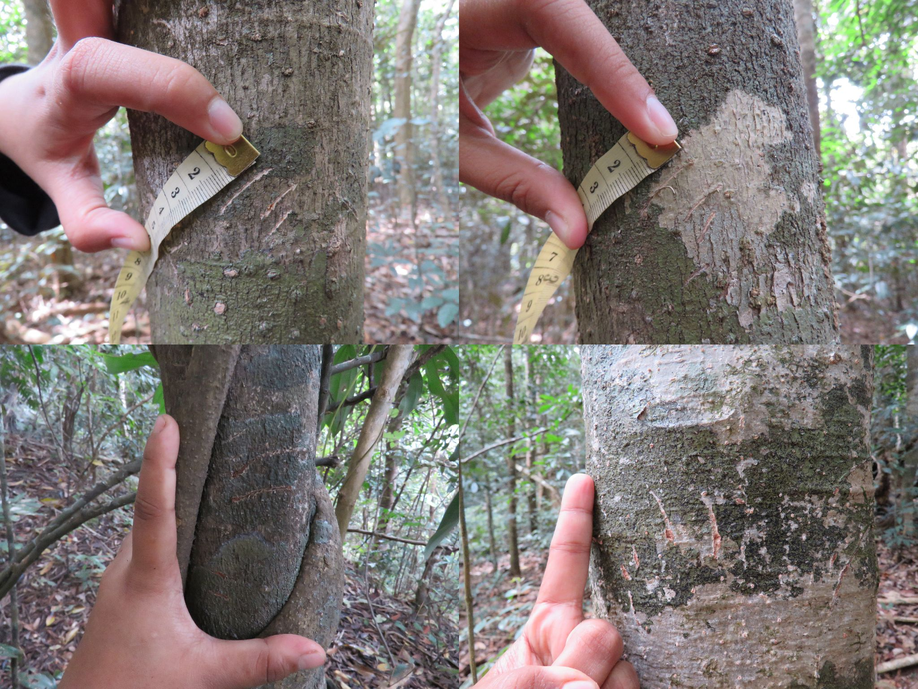

Supplementary Plate 1 Example identification of bear cuscus claw marks, which show a distinctive pattern of three long scratches clustered together along with two long scratches together, reflecting their method of gripping the trunk with three fingers on one side and two the other. These claw marks are further assumed to belong to the bear cuscus because the only other large mammal in South Sulawesi that lives in trees (the moor macaque *Macaca maura*) does not have sharp claws. Photos by Rahmia Nugraha.

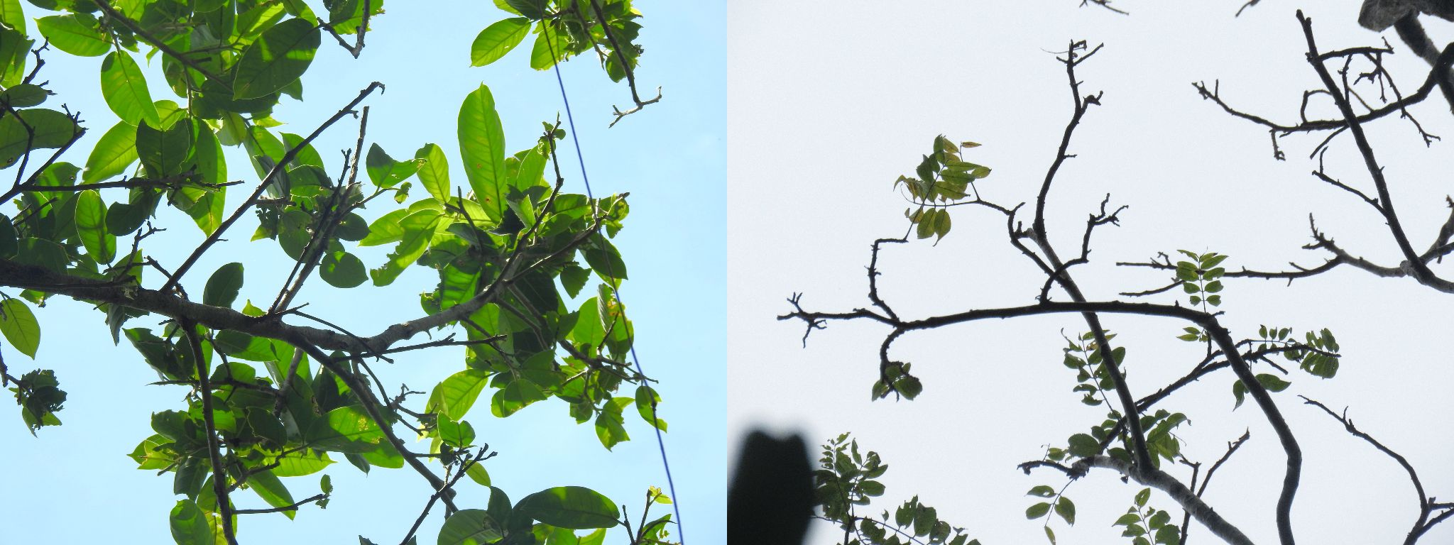

Supplementary Plate 2 Example identification of bear cuscus feeding signs. As the only folivorous member of South Sulawesi’s three arboreal species, it specifically prefers buds and young leaves, and tends to nip the ends of branches, resulting in treetops with missing and empty branches, and half-eaten leaves. Photos by Rahmia Nugraha.

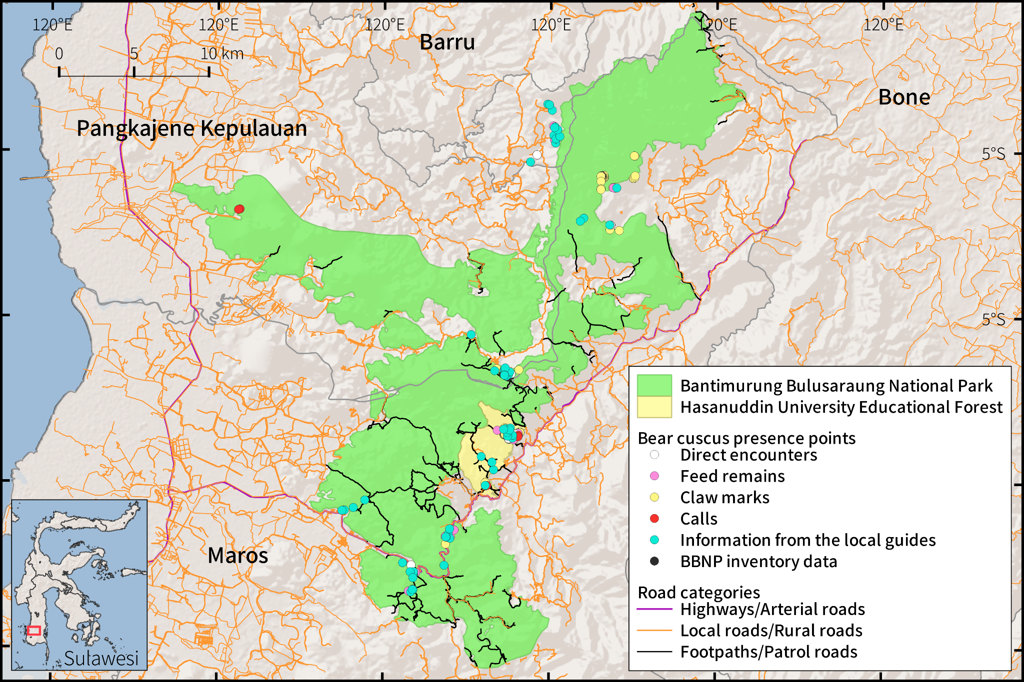  
Supplementary Fig. 1 Distribution of bear cuscus records against roads and paths.

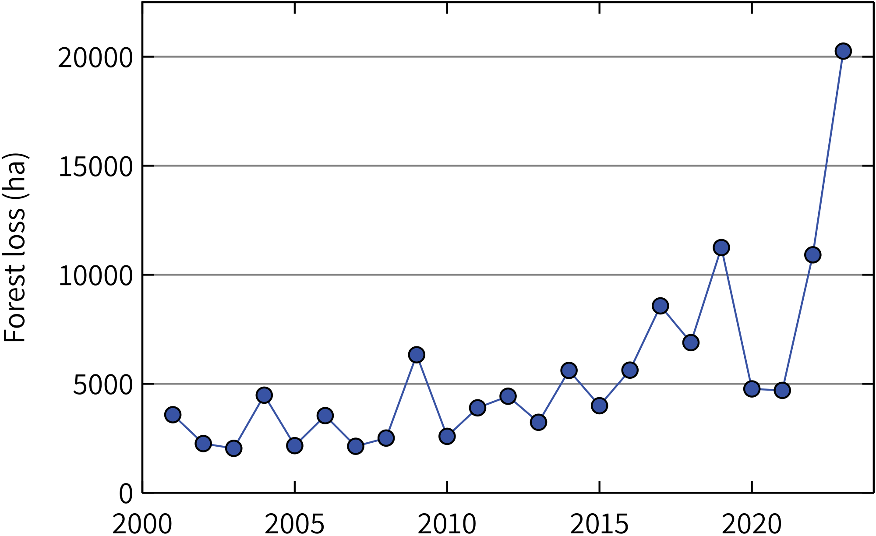

Supplementary Fig. 2 Loss of forest cover in the southern landscape of South Sulawesi, 2001–2023.