Designing and evaluating alternative livelihoods for thresher shark conservation: a case study in Alor Island, Indonesia

Rafid A. Shidqi, Dewi R. Sari, Jeheskiel Alopen, Yodhikson M. Bang,
Igo Arianto, Primiaty N. S. Kopong, Vivekananda Gitandjali TD,
Etoile Smulders and Hollie Booth

Supplementary material is not checked for accuracy. The responsibility for accuracy and file functionality remains with the authors.

Supplementary Plate 1 An oath was taken by the participating fishers in front of 200 attendees at a community event. During the oath, participants verbally vowed to stop fishing for thresher sharks Alopias pelagicus and abide by the rules of the livelihood intervention.
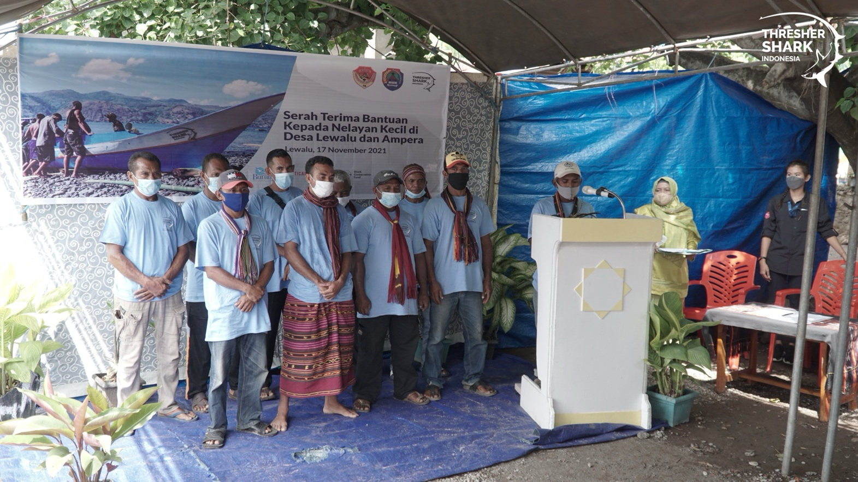

Supplementary Table 1 Result of t test to measure variance for thresher shark Alopias pelagicus catch by three groups (participants, non-participants, other fishers).
The t test was conducted using the hypothesis below:
- H0 = Means of thresher shark catch by two groups are equal
- HA = Means of thresher shark catch by two groups are not equal

Supplementary Table 1.1 Result of t test to compare participant and non-participant groups.

 | Participants | Non-Participants
Mean | 1.074074074 | 5.66666667
Variance | 4.071225071 | 19.3846154
Observations | 27 | 27
Hypothesized mean difference | 0
df | 36
t stat | -4.927360113
P(T ≤ t) one-tail | 9.37721E-06
t critical one-tail | 1.688297714
P(T ≤ t) two-tail | 1.87544E-05
t critical two-tail | 2.028094001

P value < 0.05, meaning H0 is rejected; the mean thresher shark catches by participants and non-participants are significantly different.

Supplementary Table 1.2 Result of t test to compare participants and other fishers.

 | Participants | Other fishers
Mean | 1.07407407 | 5.55555556
Variance | 4.07122507 | 42.6410256
Observations | 27 | 27
Hypothesized mean difference | 0
df | 31
t stat | -3.4071252
P(T ≤ t) one-tail | 0.00091807
t critical one-tail | 1.69551878
P(T ≤ t) two-tail | 0.00183613
t critical two-tail | 2.03951345
P value < 0.05, meaning that H0 is rejected; the mean thresher shark catches by participants and other fishers are significantly different.

Supplementary Table 2 F test result for measuring variance for thresher shark catch by three groups (participants, non-participants, other fishers).
The F test was conducted using the hypothesis below:
- H0 = Numbers of thresher sharks caught by two groups have equal variance
- HA = Numbers of thresher sharks caught by two groups do not have equal variance

Supplementary Table 2.1 F test result to compare participants and non-participants.

 | Participants | Non-participants
Mean | 1.07407407 | 5.66666667
Variance | 4.07122507 | 19.3846154
Observations | 27 | 27
df | 26 | 26
F | 0.21002352
P(F ≤ f) one-tail | 8.3006E-05
F critical one-tail | 0.51834617

P value < 0.05, meaning H0 is rejected; the numbers of thresher sharks caught by the participant and non-participant groups do not have equal variance.

Supplementary Table 2.2 F test result for participants and other fishers.

 | Participants | Other fishers
Mean | 1.07407407 | 5.55555556
Variance | 4.07122507 | 42.6410256
Observations | 27 | 27
Df | 26 | 26
F | 0.09547672
P(F ≤ f) one-tail | 3.1711E-08
F critical one-tail | 0.51834617

P value < 0.05, meaning H0 is rejected; the number of thresher sharks caught by the participants and other fishers do not have equal variance.

Supplementary Table 3 Summary of the District Government Conservation Action Plan following the establishment of the District’s Decree.
No. | Government agencies | Proposed Action Plan(s) | Realization
1 | District Secretary | - Advocate for the establishment of provincial regulation as a follow-up to this district regulation  - Promote the integration of district and village policies for thresher shark protection  - Allocate budgets to each government agency to contribute to the development of alternative livelihoods | - Assisted the lobbying process for Governor’s Instruction  - Partially achieved (village policy is not established)  - Not enough information
2 | Department of Marine and Fisheries (DKP) | - Provide equipment to support the transition to alternative fisheries  - Facilitate access to the fisheries supply chain to accommodate fish catches with better prices outside of Alor  - Support the formation of fishers’ groups | - Two small-scale fishing boats distributed to fishers in Lewalu and Ampera & assistance provided in the production house for the women’s small/medium enterprise group  - Provided training on post-harvest production to women’s group  - Assisted in the formation of Alternative Livelihood Groups
3 | Department of Village Development (DPMP) | - Adjust the use of village funds for 2021-2022, focusing on providing capital for village business units or tourism in villages with thresher fisheries & critical habitats  - Facilitate empowerment programs in the transition to new livelihoods.  - Support the development of the Head of Village’s degree for thresher shark protection. | - Assisted the village government to restructure village funds’ budget allocation; assist in production house agreement  - Collaborate with Alternative Livelihood Groups  - Achieved via informal policy
4 | Department of Industry | - Provide facilities for alternative fisheries products; e.g. shredded fish  - Facilitate development of other home industries; e.g. pottery and Indigenous weaving | - Provided Fish waste processor to community member.  - Facilitated the halaal certification for products of the women’s small/medium enterprise group
5 | Bappelitbang | - Distribute the annual development budget as agreed in the Conservation Action Plan to every government agency | - Bappelitbang lobbied other government bodies.
6 | Department of Small and Medium Enterprise | - Preparing financial allocations for the head of fisher/community groups that already have institutionalization & for individuals  - Assisting in efforts to educate the public about thresher sharks | - Funded women’s small/medium enterprise group Collaborated with Alternative Livelihood Groups
7 | Department of Tourism | - Promote development of thresher shark tourism in targeted villages  - Training for empowering creative economic endeavors for the fisher groups in the target villages | - Ongoing  - Provided training on creative production for women’s small/medium enterprise group

Supplementary Table 4 The mean income of fishers from the baseline collected before the intervention (June–August 2018) was compared with the mean income of the participants after the intervention (August 2021–November 2023).

Initials | Type of new livelihood | Income before intervention (IDR) | Income after intervention (IDR) | % Increase of income
HT | Kiosk | 1,000,000 | 6,248,214 | 525
AM | Chicken farm | 2,500,000 | 13,747,636 | 450
MS | Tuna fishing | 1,000,000 | 2,535,526 | 154
MT | Tuna fishing | 2,500,000 | 3,962,000 | 58
SM | Tuna fishing | 2,500,000 | 3,597,778 | 44
AD | Tuna fishing | 1,000,000 | 1,274,804 | 27
BP | Tuna fishing | 2,500,000 | 2,174,991 | -13
RA | Tuna fishing | 2,500,000 | 1,751,963 | -30
SUM | Tuna fishing | 2,500,000 | 1,189,630 | -52

Supplementary Table 5 Income data from the women’s small/medium enterprise group.

Month | Monthly income per product (IDR) |  |  | Total monthly income (IDR)
 | Tuna floss | Granola | Weaving
Apr. 2022 | 1,195,000 | 1,290,000 | - | 2,485,000
May 2022 | 1,185,000 | 930,000 | - | 2,115,000
June 2022 | 270,000 | 575,000 | - | 845,000
July 2022 | 270,000 | 130,000 | 1,500,000 | 1,900,000
Aug. 2022 | 1,980,000 | 4,415,000 | 1,500,000 | 7,895,000
Sep. 2022 | 220,000 | 465,000 | 450,000 | 1,135,000
Oct. 2022 | - | - | 2,750,000 | 2,750,000
Nov. 2022 | 300,000 | 180,000 | 2,600,000 | 3,080,000
June 2023 | 465,000 | 250,000 | 700,000 | 1,415,000
July 2023 | 220,000 | - | 250,000 | 470,000
Aug. 2023 | 675,000 | - | 1,050,000 | 1,725,000
Sep. 2023 | 970,000 | 1,215,000 | 1,900,000 | 4,085,000
Oct. 2023 | 980,000 | 84,000 | 750,000 | 1,814,000
Nov. 2023 | 1,610,000 | 240,000 | - | 1,850,000
Mean monthly income (IDR) |  |  |  | 2,397,429

Supplementary Table 6 Data on thresher shark catches from all three groups (participants, non-participants, other fishers) post-intervention, from August 2021 to November 2023.

Month | Catch by participants | Catch by non-participants | Catch by other fishers
Aug. 2021 | 0 | 7 | 2
Oct. 2021 | 0 | 6 | 6
Nov. 2021 | 0 | 5 | 0
Dec. 2021 | 0 | 1 | 2
Jan. 2022 | 0 | 3 | 8
Feb. 2022 | 0 | 8 | 20
Mar. 2022 | 0 | 11 | 19
Apr. 2022 | 0 | 13 | 4
May 2022 | 0 | 3 | 2
June 2022 | 0 | 3 | 1
July 2022 | 1 | 1 | 0
Aug. 2022 | 0 | 0 | 0
Sep. 2022 | 0 | 3 | 1
Oct. 2022 | 0 | 9 | 1
Nov. 2022 | 0 | 6 | 3
Dec. 2022 | 0 | 2 | 0
Jan. 2023 | 0 | 4 | 0
Feb. 2023 | 0 | 2 | 0
Mar. 2023 | 0 | 14 | 9
Apr. 2023 | 1 | 12 | 23
May 2023 | 8 | 7 | 14
June 2023 | 2 | 2 | 9
July 2023 | 1 | 5 | 3
Aug. 2023 | 3 | 15 | 8
Sep. 2023 | 4 | 9 | 6
Oct. 2023 | 5 | 0 | 3
Nov. 2023 | 4 | 2 | 6
Total catch | 29 | 153 | 150

