Hunting strategies, wild meat preferences, and perception of wildlife conservation in Nagaland, India.
SATEM LONGCHAR, MANJARI ROY, QAMAR QURESHI, and MATT W HAYWARD

Supplementary Material 1: Questionnaires’ for the Hunters
- Village name
Age 15-25 25-35 35-45 45+
Education
Occupation
Community name
Family size
Annual Income
- At what age did you start hunting?
- 5-15
- 16-25
- 25-35
- 35-
- How often do you go hunting?
- Daily
- Once a week
- Month
- Year
- Do you hunt in any particular season?
- Dry
- Winter
- Spring
- All-season
- Which species do you prefer?
(their explanations)
- Reason?
- Easy to catch
- High price in the market
- Both
- What is the sale price of the item (species wise)?
(their explanation)
- What is the cost per trip in INR?
- 0-100
- 100-500
- 500-1000
- 1000+
- What is the average time to reach their hunting destination?
- What is the best time for hunting?
- Early morning
- Morning
- Noon
- Afternoon
- Evening
- Late evening
- Night
- Which moon cycle do you prefer for hunting?
- No moon
- Full moon
- Half moon
- No preference
- What forest vegetation do you prefer for hunting? (what is the success rate in that vegetation)
- Dense forest
- Less dense forest
- Bamboo dominant
- Sparse forest
- Agricultural areas
- Do you have a gun?
- Yes
- No
- Do you have a license for keeping a gun?
- Yes
- No

- Any changes in animal sightings over time?
- Yes
- No
Conservation perspective
- Has anybody (person, organisation, government) opposed to your hunting practice?
- Yes
- No
- I don’t know
- Are you aware of the fact that hunting has depleted the population of animals?
- I am not aware
- I am aware
- I do not think that hunting is the issue
- Others
- Would you accept alternative ways for protein consumption?
- No, I prefer the wildmeat
- Yes, I want substitute for wildmeat
- I want both the wild meat and substitute for protein consumption.
- I do not know
- Would you be interested in conserving wild flora and fauna?
- Yes, I am interested
- No I am not interested
- Maybe
- I do not know.
- How do you think you can help?
(their explanation)
- Hunting frequency Covid after and before

Supplementary Material 2: Questionnaire Surveys for the Village Household Members, Conservation Awareness, the Village Elders and Human-Wildlife Conflict
Household Surveys:
Name of the Village
Family size
Family income annually
Occupation
Interviewer's gender
Are you a permanent resident of this village? YES/NO

1. What type of agriculture do you practice?
- Jhum cultivation
- Paddy
- Both
- None

2. Which agricultural methods gives the best yield
- Jhum cultivation
- Paddy
- Both
- None

3. How many acres of land do you use for agriculture?
(Their explanation)

4. Have you purchased any wild meat during your lifetime?
Yes/ No

5. If yes, how much do you spend on buying?
(Their explanation)

6. Have you collected any wildlife products from the forest?
- Yes I have
- No I haven’t

7. Any special occasion or some traditional practices where you actually spent money on buying or spent time to go to the jungle and hunt?
Yes/ No

8. What kind of support do you receive from the government? (their explanation)

9. What is the value of hunted meat?
- Taste
- Value
- Symbol of status
- Others

10. Any practices of hunting wild animals (skin/fur/feather) related to ceremonial or any cultural practices?
Yes/ No

Conservation awareness survey

Village:
Age
Gender-

1. Based on your experiences, which are the wild mammal species that you see in your forest have changed?
Species

2. What animal are you interested to see most in the wild and why?

3. What value does Biodiversity play in your life?Economic values
- Aesthetic value
- Both
- I don’t know

4. What do you think is the main cause of biodiversity loss?
- Clearing for agriculture
- Habitat fragmentation
- Poaching and hunting
- Timber logging
- Don’t know

5. How concerned are you about biodiversity loss in your village
- Highly concerned
- Moderately concerned
- Slightly concerned
- Not at all concerned

6. What is your opinion on wildlife conservation and awareness program?
- I learn about the importance of wildlife
- I didn’t learn anything
- I do not know

7. Do you agree that you need more education and awareness on wildlife conservation?
- I agree
- I strongly agree
- I do not agree
- I strongly do not agree
- Don’t know

8. What are the challenges in biodiversity conservation?
- No economic benefits
- No incentives
- No time to focus on biodiversity conservation
- Others

9. What can you do for biodiversity conservation in your village?

10. The status of hunting activities post and pre-COVID-19?

Target Group- Hunters/ Village elders/ Village Head man

- What are the different traditional methods of hunting?

- Based on your experiences, which wild mammal species that you see in your forest are used for traditional purpose
- Species

- Any practices of hunting wild animals (skin/fur/feather) related to ceremonial or any cultural practices?

- If yes, would you elaborate on the usage?

- What is your preferred traditional method for hunting?

- Any special occasion or some traditional practices where you actually spent money on buying or spent time to go to the jungle and hunt?
Yes /No

- If yes, can you explain the occasion?

Supplementary Table 1: Names of the tribes and villages, along with the respective counts of villages, households, and the number of hunters interviewed around Intangki National Park (INP) (n=7) and Khelia Community Forest (KCF) (n=3).
Village name | Tribes | Number of village households | No of hunter’s interviewed
New Nkio (INP) | Zeliang | 55 | 7
Sailhem (INP) | Kuki | 43 | 0
New soget (INP) | Kuki | 27 | 3
Buisiumpoilo (INP) | Zeliang | 30 | 4
Pelhang (INP) | Kuki | 30 | 2
Khelma (INP) | Kuki | 40 | 7
Beisumpuikam (INP) | Zeliang tribe (dominant), Chakesang, Dimasa (minorities) | 400 | 4
Choklangan (KCF) | Khiamniugan | 180 | 10
Kingpao (KCF) | Khiamniugan | 22 | 3
Wui (KCF) | Khiamniugan | 147 | 5

Supplementary Table 2: Response to conservation values and challenges in the study areas for the household surveys, and within genders (male and female) for biodiversity values and main cause of biodiversity loss.* (F= Female and M= Male)
Age group in years |  | Biodiversity values |  | The main cause of biodiversity loss |  | Concern for biodiversity loss in the village |  | What are the challenges in biodiversity conservation? |  | Hunting before and after COVID
15-25 | 13 | Response | Total | Response | Total | Response | Total | Response | Total | Response | Total
25-35 | 24 | Economic values | 15  (M=15,  F=0) | Clearing for agriculture | 38  (F=3, M=35) | Highly concerned | 40 | No time to focus on biodiversity conservation | 29 | No change in hunting | 50
35-45 | 19 | Aesthetic value | 8  (F=4,  M=4) | Habitat fragmentation | 6  (F=1, M=5) | Moderately concerned | 21 | Others | 27 | More hunting | 9
45+ | 24 | Both | 42  (F=7,M=35 | Poaching and hunting | 38  (F=0, M=17) | Slightly concern | 3 | No incentives | 9
Female | 15 | Unsure | 9  (F=4,  M= 11) | Timber logging | 24  (F=0, M=19) | Not at all concern | 8 | No economic benefits | 7
Male | 65 |  |  | Unsure | 5  (F=2, M=3)

Supplementary Table 3: Indigenous tools for aiding hunting in Nagaland communities.
Traditional tools | Usage
- Daos:  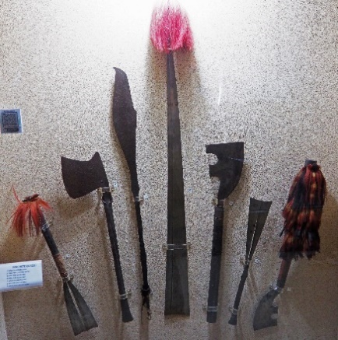  PLATE 1: Museum exhibition from State Museum Kohima, Nagaland. | Local Nagamese name for a machete. Multipurpose weapons from kitchen use to warfare. They are unique to each Naga tribal community, and the differences are in the design of the blade, its length, and the handle.
- Spears  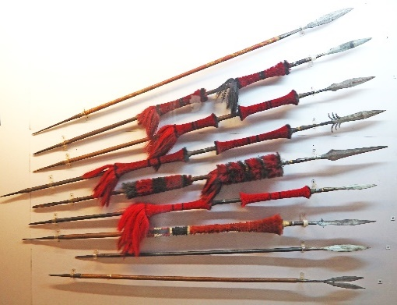  PLATE 2: Museum exhibition, State Museum Kohima, Nagaland. | Most common. Ranges from hunting and multipurpose spear to dancing/ceremonial spears. They are still utilised during traditional ceremonies or festivals or spearing local poultry animals.
C. Bows and arrows.  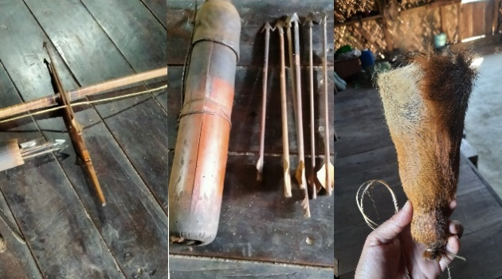  Long bow and arrows with barking deer skin arrow holder from Choklangan Village, Nagaland. | Another technique used for hunting is bows and arrows, which vary according to the wildlife hunted. Longbows are for larger animals, and short crossbows are for birds
D. Slings and catapult | Mainly used to shoot down birds and monkeys
E. Shield | Elephant skin, bear, and Tiger, as recorded by Verrier Elwin (Elwin, 1959), skins were used as a shield. In addition, in some cases, buffalo or Mithun skin was used as shields.

Supplementary Table 4: A comparison of occupations of all respondents, comparisons of hunters that own guns and hunting methods between the Intangki and Khelia communities, including the number of individuals using each method, their preferences for traditional tools, and the T-test results for both.
Occupations of the respondents |  |  | Number of hunter preferring methods of hunting |  |  | No of hunters preferring traditional tools
Occupation | INP | KCF |  | INP | KCF |  | INP | KCF
Farmer | 38 | 14 | Spear | 8 | 3 | Spear | 2 | 0
Govt.employee | 8 | 0 | Dao | 8 | 0 | Dao | 2 | 0
Laborer | 5 |  | Trap | 8 | 3 | Gun | 5 | 1
Animal herder | 1 | 2 | Handmade Gun | 2 | 1 | Traps | 0 | 1
Owning Gun |  |  | Bow and Arrow | 0 | 2
YES | 33 |  | Degree of freedom | 4 |  | Degree of freedom | 3
NO | 10 |  | test stat | 8.66 |  | Test stat | 5.39
Hand made gun (Additional) | 9 |  | p-value | 0.07 |  | P-Value | 0.14

Supplementary Table 5: Different types of hunting methods and description of methods for targeted species by tribal communities of Zeliang, Kuki, Chakesang, Dimasa Kachari Naga residing near Intangki National Park, and Khiamnuingan Naga tribe from Khelia Community Forest.

Traditional Hunting technique | Strategy | Targeted wildlife
A. Pitfall traps | Hole in the ground with bamboo spiked to impale the baited animal | Large herbivores like deer and elephants.
B. Box trap | Baited traps with falling door | Primarily for primates but also larger carnivores
C. Triangular snares  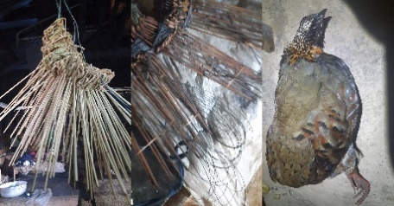  PLATE 3: Triangular snares made from bamboo to catch partridge from Wui village. | Small fences with noose with regular gaps are set for any small animals that may try to run through | Pheasants
D. Deadfall traps along the rock crevices | Heavy stones or wooden stumps, usually larger than the target animal, are set up to fall on the animal when a tripwire triggers it, killing it quickly | Murids
E. Gun trap | Modified version of a traditional trap; the noose of the trap is attached to a muzzle-loading gun, aligned in the direction of the animal path, and when the trap is triggered, it is set to fire at the target. | Larger herbivores
F. Frog traps  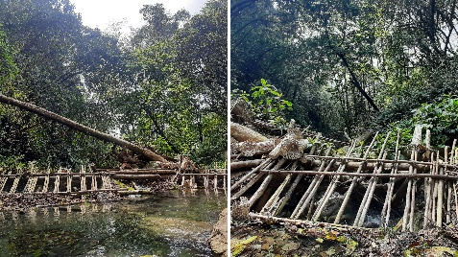  PLATE 4: Frog traps along Chokla river in Choklangan Village | Conical-shaped collection bamboo baskets are tugged in between several vertical posts along many edges of the streams; the frogs are washed down to the stream’s edge by the strong currents and collected in the baskets. | Frogs, fish and crabs
G. Group chase hunting | Ambush hunting and finally spearing with spears and machetes | Wild pigs, large herbivores
H. Hunting dog  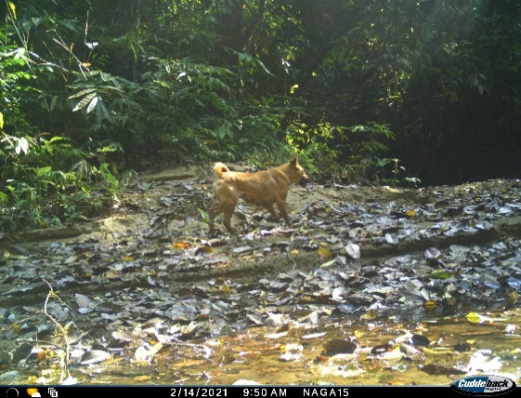  PLATE 5: Hunting dog photographed in camera trap inside Intangki National Park. | Flushing out the wild animal | Herbivores, pheasants, reptiles- Varanus bengalensis
I. Poison/ plant toxins  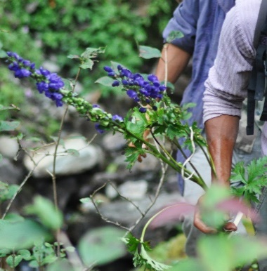  PLATE 6: Aconitum sp collected from Choklangan Village | Using plant toxins to paralyse the animals they hunt or poison the river for fishing | Herbivores and fishes
J. Bird lime  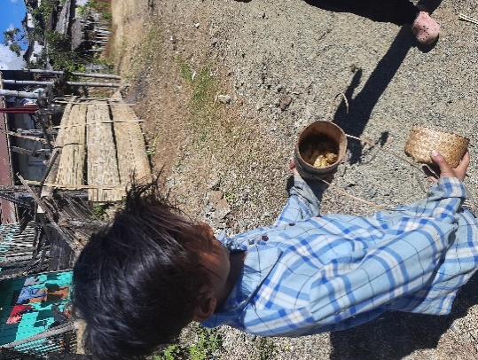  PLATE 7: Ficus sap prepared to trap birds in Wui village. | Baiting by smearing Ficus spp sap on bamboo skewers. The baits (seeds, worms, fruits) attract birds, and then glue the bird with the sticky saps. | Birds and smaller mammals.

