**Assessing the conservation status of and challenges facing Asiatic black bears and Malayan sun bears in Bangladesh**

Muntasir Akash, Haris Debbarma, Sultan Ahmed, Amarta Galib Chowdhury,

Tania Zakir, Khondokar Newaz M.D. Sarafat and Sandeep Sharma

Supplementary material is published as supplied by the authors. It is not checked for accuracy, copyedited, typeset or proofread. The responsibility for accuracy and file functionality remains with the authors.

Supplementary Table 1 Re-classified land cover categories for eastern Bangladesh and the corresponding categories (code, text code and legend) provided with the Sentinel-3 Sea and Land Surface Temperature Radiometer (SLSRT) level 2 dataset (Donlon et al., 2012).

| Re-classified category | Code | Text code | Legends |
| --- | --- | --- | --- |
| **Floodplain** | | | |
|  | 11 | Irrigated cropland | post flooding or irrigated croplands |
|  | 14 | Rainfed croplands | rain-fed cropland |
| **Grassland-cropland mosaic** | | | |
|  | 20 | Mosaic cropland | mosaic cropland (50–70%) / vegetation (grassland, shrubland, forest) (20–50%) |
|  | 30 | Mosaic vegetation | mosaic vegetation (grassland/shrubland/forest) (50–70%) / cropland (20–50%) |
|  | 110 | Mosaic forest | mosaic forest/shrubland (50–70%) / grassland (20–50%) |
| **Old growth forest** | | | |
|  | 40 | Broadleaved evergreen forest | closed to open (< 15 %) broadleaved evergreen and/or semi-deciduous forest (> 5m) |
|  | 50 | Closed broadleaved deciduous forest | closed (> 40%) broadleaved deciduous forest (> 5 m) |
|  | 60 | Open broadleaved deciduous forest | open (15–40%) broadleaved deciduous forest (> 5 m) |
| **Secondary forest**–**orchard**–**tea garden mosaic (north-east)**  **Secondary forest**–**orchard**–**swidden cultivation mosaic (south-east)** | | | |
|  | 100 | Mixed forest | closed to open (> 15%) mixed leave broadleaved and needleleaved forest (< 5 m) |
|  | 130 | Shrubland | closed to open (> 15%) shrubland (< 5m) |
|  | 140 | Grassland | closed to open (> 15%) grassland |
| **Urban area** |  |  |  |
|  | 190 | Artificial surface | artificial surfaces and associated areas (urban areas > 50%) |
| **Waterbody** |  |  |  |
|  | 210 | Waterbody | waterbody |

Supplementary Table 2 Records of the Tibetan black bear *Ursus thibetanus thibetanus* and Malayan sun bear *Helarctos malayanus malayanus* in Bangladesh extracted from literature.

| Site | Latitude | Longitude | Presence | Evidence |
| --- | --- | --- | --- | --- |
| **Black bear, north-east Bangladesh (Islam et al., 2010)** | | | | |
| Rajkandi | 24.24392 | 91.9058 | Yes | Yes |
| Chautali | 24.35153 | 91.7909 | Yes | No |
| Lawachara NP | 24.32658 | 91.7874 | No | No |
| Jangal Bari | 24.17096 | 91.74508 | Yes | Yes |
| Patharkhola | 24.24845 | 91.79008 | Yes | Yes |
| Nahar Punji | 24.17578 | 91.74106 | Yes | Yes |
| Sheshil Bari | 24.23233 | 91.74624 | Yes | Yes |
| Longlia Punji | 24.18535 | 91.74793 | Yes | Yes |
| Mechanicheera | 24.15705 | 91.72546 | Yes | Yes |
| Horinchara | 24.17231 | 91.74501 | Yes | Yes |
| Biddabeel | 24.16473 | 91.70462 | Yes | Yes |
| Shibbari | 24.24575 | 91.73857 | Yes | Yes |
| Horinchara sector 87 | 24.16217 | 91.69427 | Yes | Yes |
| Horinchara sector 10 | 24.14547 | 91.73779 | Yes | Yes |
| Valu Kuchi | 24.15705 | 91.72548 | Yes | Yes |
| Nirala Punji | 24.15903 | 91.73863 | Yes | Yes |
| Kuttamara | 24.18804 | 91.74965 | Yes | Yes |
| Alubari | 24.14745 | 91.75122 | Yes | Yes |
| Sukcheera | 24.15327 | 91.73606 | Yes | Yes |
| Mohadebtila | 24.14761 | 91.7500 | Yes | Yes |
| Chalta Punji | 24.21861 | 91.74689 | Yes | Yes |
| Nihar Tea Garden | 24.18480 | 91.75176 | Yes | Yes |
| Tipracheera | 24.19175 | 91.72083 | Yes | Yes |
| Aslam Punji | 24.17241 | 91.74444 | Yes | Yes |
| Satchari National Park | 24.122121 | 91.445535 | Yes | Yes |
| Lebucheera | 24.127482 | 91.417569 | Yes | No |
| Chankhola | 24.144212 | 91.440077 | Yes | No |
| Duncan Brothers Tea Garden | 24.116657 | 91.471881 | No | No |
| Garo Hills | 25.2473828 | 90.0357136 | Yes | No |
| Madhutila | 25.203386 | 90.151658 | Yes | No |
| Madhupur Gar | 24.687173 | 90.102402 | Yes | No |
| **Black bear, south-eastern Bangladesh (Islam et al., 2010)** | | | | |
| Pransa | 22.05855 | 92.4794 | Yes | No |
| Ghalangya | 22.0493 | 92.49181 | Yes | No |
| Thanchi Sadar | 21.821096 | 92.435696 | No | No |
| Alikadam | 21.653009 | 92.314768 | Yes | Yes |
| Naikhongchhari | 21.4167 | 92.1833 | Yes | Yes |
| Budenjhiri | 22.0048 | 92.26926 | Yes | No |
| Kapru Para | 21.82081 | 92.304982 | Yes | No |
| Rinikhyang Bagan Para | 22.18535 | 92.39026 | Yes | No |
| Ranglai Chairman Para | 22.14625 | 92.41986 | Yes | No |
| Empu Para | 22.62738 | 92.50016 | Yes | No |
| Chini Para | 22.64191 | 92.43728 | Yes | No |
| Kurang Para | 22.62221 | 92.50795 | Yes | No |
| Swanglu Para | 22.26436 | 92.57555 | Yes | No |
| Bijoy Para | 22.32565 | 92.55536 | Yes | No |
| Khamtang Para | 22.103152 | 92.386721 | No | No |
| Paglachara Para | 22.25205 | 92.53273 | Yes | No |
| Rowangchhari Sadar Para | 22.25513 | 92.57891 | No | No |
| Tulachari Para | 22.31546 | 92.5756 | Yes | No |
| Garjantali | 22.64386 | 92.157406 | Yes | No |
| Dumoujjechara | 22.746637 | 92.382405 | Yes | No |
| Jakkobajei | 22.767503 | 92.409024 | Yes | No |
| Begenachari | 22.745646 | 92.378222 | Yes | No |
| Nah-Vanga | 22.6817 | 92.418641 | Yes | No |
| Bagchari | 22.702971 | 92.464249 | Yes | Yes |
| Ajachara-Bilaichari Moan | 22.432756 | 92.409521 | Yes | Yes |
| Punkua Para | 22.426566 | 92.344187 | Yes | No |
| Pukurpar | 22.01885 | 92.54311 | Yes | Yes |
| Boratoli | 22.45901 | 92.521697 | Yes | No |
| Baghaihat | 23.304788 | 92.191079 | No | No |
| Masalong | 23.366526 | 92.226599 | No | No |
| Lui-Lui para, Sajek | 23.391639 | 92.314127 | Yes | No |
| Bame Atarokchara | 23.026483 | 92.258639 | Yes | No |
| Maddochara | 23.62141 | 92.26078 | Yes | No |
| Badalchari Badichara | 22.961236 | 92.128742 | Yes | No |
| Ronjit Para | 22.842309 | 92.16013 | Yes | No |
| Duluchari | 22.968853 | 92.15275 | No | No |
| Rangi Para | 22.958652 | 92.287725 | Yes | No |
| Madya Karikata | 23.44825 | 92.26996 | Yes | No |
| Kalaboyna | 23.3836 | 92.32583 | Yes | No |
| Dhanuchari Para | 22.69683 | 92.40816 | Yes | No |
| Arachori Para | 22.66951 | 92.4243 | Yes | No |
| Kukkye Chari | 22.654 | 92.43436 | Yes | No |
| Rose Para | 22.51325 | 92.53673 | Yes | No |
| Baro Para | 21.878687 | 92.031242 | Yes | No |
| Krista Para | 21.822258 | 92.344924 | Yes | No |
| Boli Para | 21.895915 | 92.368169 | Yes | Yes |
| Kaptai NP | 22.541537 | 92.1536 | No | No |
| Wagga | 22.934201 | 92.262267 | Yes | No |
| Kamolchari | 23.142796 | 92.001241 | No | No |
| Kaptola Para | 23.089391 | 92.030058 | Yes | No |
| Chenachara Para | 22.992738 | 92.28001 | Yes | No |
| Alutila | 23.074757 | 91.960627 | Yes | No |
| Tarabunia | 23.37545 | 92.1645 | No | No |
| Khetropur | 23.37731 | 92.18628 | No | No |
| Matiranga Sadar | 23.039698 | 91.845315 | No | No |
| **Black bear, south-eastern Bangladesh (Chakma, 2016)** | | | | |
| Alikadam | - | - | Yes | Yes |
| Naikhongchhari | - | - | Yes | Yes |
| Naikhongchhari | - | - | Yes | Yes |
| Baghaichhari | - | - | Yes | Yes |
| Baghaichhari | - | - | Yes | Yes |
| Baghaichhari | - | - | Yes | Yes |
| Alikadam | - | - | Yes | Yes |
| Baghaichhari | - | - | Yes | Yes |
| Thanchi | - | - | Yes | Yes |
| Ruma | - | - | Yes | Yes |
| Lama | - | - | Yes | Yes |
| Kaptai National Park | - | - | Yes | Yes |
| Rajasthali | - | - | Yes | Yes |

|  |  |  |  |  |
| --- | --- | --- | --- | --- |
|  |  |  |  |  |
| Site | Latitude | Longitude | Presence | Evidence |
| **Black bear, south-eastern Bangladesh (Creative Conservation Alliance, 2016)** | | | | |
| Alikadam | - | - | Yes | Yes |
| **Sun bear, south-eastern Bangladesh (Islam et al., 2010)** | | | | |
| Remakri | 21.6861 | 92.5333 | Yes | No |
| **Sun bear, south-eastern Bangladesh (Sarker et al., 2016)** | | | | |
| Kassalong | - | - | Yes | No |
| Korerhat | - | - | Yes | No |
| Dulahazra | - | - | Yes | No |
| Inani | - | - | Yes | No |
| Teknaf | - | - | Yes | No |
| Rangkheong | - | - | Yes | No |
| Sangu matamuhuri | - | - | Yes | No |
| Naikhongchhari | - | - | Yes | No |
| **Sun bear, south-eastern Bangladesh (Creative Conservation Alliance, 2016)** | | | | |
| Alikadam | - | - | Yes | Yes |
| **Sun bear, south-eastern Bangladesh (IUCN Bangladesh, 2022)** | | | | |
| Baghaichhari | - | - | Yes | Yes |

Supplementary Table 3 Characteristics of human–bear conflicts in Bangladesh collated from 2003–2023 media reports.

|  |  |  |  |  |  |  |  |  |  |  |  |  |  |
| --- | --- | --- | --- | --- | --- | --- | --- | --- | --- | --- | --- | --- | --- |
|  |  |  |  |  |  |  |  | Outcome1 | | | |  |  |
| No. | Date | District | Subdistrict | Type of incident |  | Season | Reason/  activity | HD | HI | BD | BR | Photo evidence | News Agency |
| 1 | 3 Apr. 2003 | Sherpur | Jhenaigati | Conflict |  | Summer | Unknown | 0 | 50 | 1 | 0 | No | AP |
| 2 | 3 Apr.2005 | Feni | Parshuram | Conflict |  | Summer | Unknown | 0 | 8 | 0 | 0 | No | bdnews24.com |
| 3 | 5 May 2014 | Khagrachhari | Panchhari | Conflict |  | Summer | Logging | 0 | 1 | 0 | 0 | No | parbattanews.com |
| 4 | 5 May 2014 | Bandarban | Rowangchhari | Poaching |  | Summer | Hunting | 1 | 0 | 1 | 0 | No | priyo.com |
| 5 | 29 Aug. 2015 | Rangamati | Baghaichhari | Poaching |  | Monsoon | Hunting | 0 | 0 | 2 | 1 | Yes | Daily Star |
| 6 | 8 Dec. 2015 | Bandarban | Rowangchhari | Conflict |  | Winter | Logging | 0 | 3 | 1 | 0 | No | Chttimes24.com |
| 7 | 13 Mar. 2016 | Dhaka | Unknown | Poaching |  | Summer | Trafficking | 0 | 0 | 1 | 0 | Yes | Facebook |
| 8 | 7 June 2018 | Rangamati | Barkal | Conflict |  | Monsoon | Swidden cultivation | 0 | 1 | 0 | 0 | No | Bangladesh Pratidin |
| 9 | 10 May 2019 | Rangamati | Baghaichhari | Conflict |  | Summer | Swidden cultivation | 0 | 1 | 0 | 0 | No | sarabangla.com |
| 10 | 22 May 2019 | Bandarban | Ruma | Conflict |  | Summer | Swidden cultivation | 0 | 1 | 0 | 0 | No | parbattanews.com |
| 11 | 1 Aug. 2019 | Moulvibazar | Juri | Conflict |  | Monsoon | Logging | 1 | 0 | 0 | 0 | No | bd-journal.com |
| 12 | 16 Nov. 2019 | Rangamati | Baghaichhari | Conflict |  | Winter | Logging | 0 | 1 | 0 | 0 | No | parbattanews.com |
| 13 | 20 Dec. 2019 | Rangamati | Baghaichhari | Conflict |  | Winter | Swidden cultivation | 0 | 1 | 0 | 0 | No | paharer-alo.com |
| 14 | 12 Apr. 2020 | Sherpur | Nalitabari | Conflict |  | Summer | Logging | 1 | 2 | 0 | 0 | No | Daily Inqilab |
| 15 | 24 June 2020 | Bandarban | Lama | Conflict |  | Monsoon | Stray dog | 0 | 0 | 0 | 1 | Yes | Dhaka Tribune |
| 16 | 26 Feb. 2021 | Bandarban | Ruma | Conflict |  | Summer | Swidden cultivation | 0 | 2 | 0 | 0 | No | Business Standard |
| 17 | 15 Mar. 2021 | Bandarban | Alikadam | Conflict |  | Summer | Fishing | 0 | 1 | 0 | 0 | No | surjodoy.com |
| 18 | 20 Apr. 2021 | Bandarban | Ruma | Conflict |  | Summer | Swidden cultivation | 0 | 1 | 0 | 0 | No | banglanews24.com |
| 19 | 25 May 2021 | Rangamati | Baghaichhari | Poaching |  | Summer | Trafficking | 0 | 0 | 0 | 1 | No | amarsangbad.com |
| 20 | 30 July 2021 | Bandarban | Ruma | Conflict |  | Monsoon | Swidden cultivation | 0 | 1 | 0 | 0 | No | parbattanews.com |
| 21 | 08 Oct. 2021 | Bandarban | Ruma | Conflict |  | Winter | Swidden cultivation | 0 | 1 | 0 | 0 | No | bartapost.com |
|  |  |  |  |  |  |  |  | Outcome1 | | | |  |  |
| No. | Date | District | Subdistrict | Type of incident |  | Season | Reason/  activity | HD | HI | BD | BR | Photo evidence | News Agency |
| 22 | 10 Apr. 2022 | Bandarban | Rowangchhari | Poaching |  | Summer | Trafficking | 0 | 0 | 0 | 1 | Yes | Business Standard |
| 23 | 17 May 2022 | Bandarban | Alikadam | Poaching |  | Summer | Trafficking | 0 | 0 | 0 | 1 | Yes | paharbarta.com |
| 24 | Apr. 2018 | Moulvibazar | Kamalganj | Conflict |  | Summer | Honey collecting | 0 | 1 | 0 | 0 | Yes | paharbarta.com |
| 25 | Apr. 2022 | Moulvibazar | Kamalganj | Conflict |  | Summer | Honey collecting | 0 | 1 | 0 | 0 | Yes | paharbarta.com |
| 26 | 19 July 2022 | Bandarban | Ruma | Conflict |  | Monsoon | Swidden cultivation | 0 | 1 | 0 | 0 | Yes | banglanews24.com |
| 27 | 07 July 2021 | Rangamati | Baghaichhari | Conflict |  | Monsoon | Logging | 0 | 1 | 0 | 0 | No | prothom alo |
| 28 | 23 Jan. 2023 | Cox's Bazar | Chakaria | Poaching |  | Winter | Trafficking | 0 | 0 | 0 | 2 | Yes | Chanel24.com |
| 29 | 23 May 2023 | Khagrachhari | Guimara | Conflict |  | Summer | Swidden cultivation | 0 | 1 | 0 | 0 | Yes | parbattanews.com |

1The Outcome columns provide the numbers of the following for each incident: BD, bear death; BR, bear rescue; HD, human death; HI, human injury.

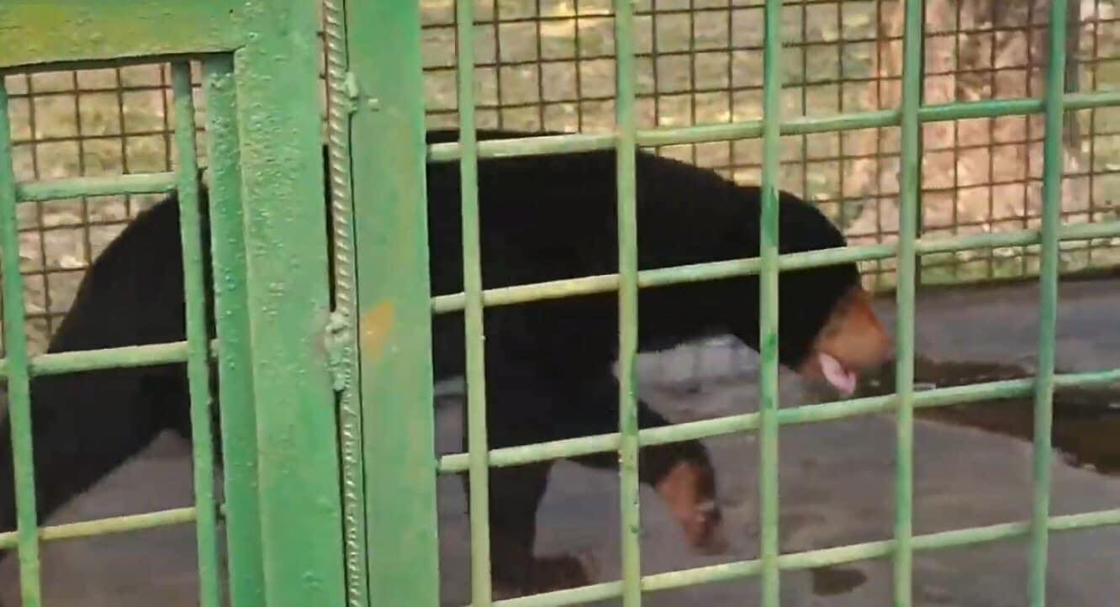

Supplementary Plate 1 A Malayan sun bear *Helarctos malayanus malayanus* being illicitly kept at the Binodia Family Park, Jessore-Jhenaidah Highway, Jessore, Bangladesh. Photo: Amarta Galib Chowdhury.

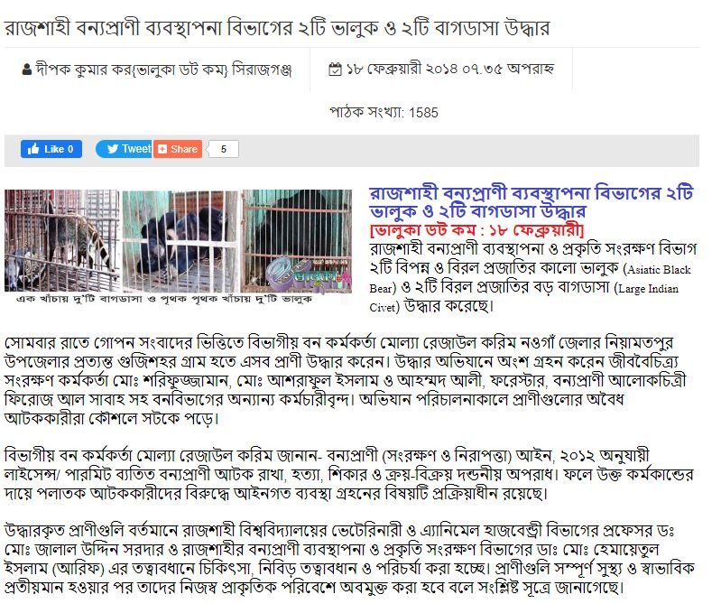

Supplementary Plate 2 Screenshot of the report on the drive by the Bangladesh Forest Department that led to the confiscation of two live adult Tibetan black bears *Ursus thibetanus thibetanus* (Kar, 2014).

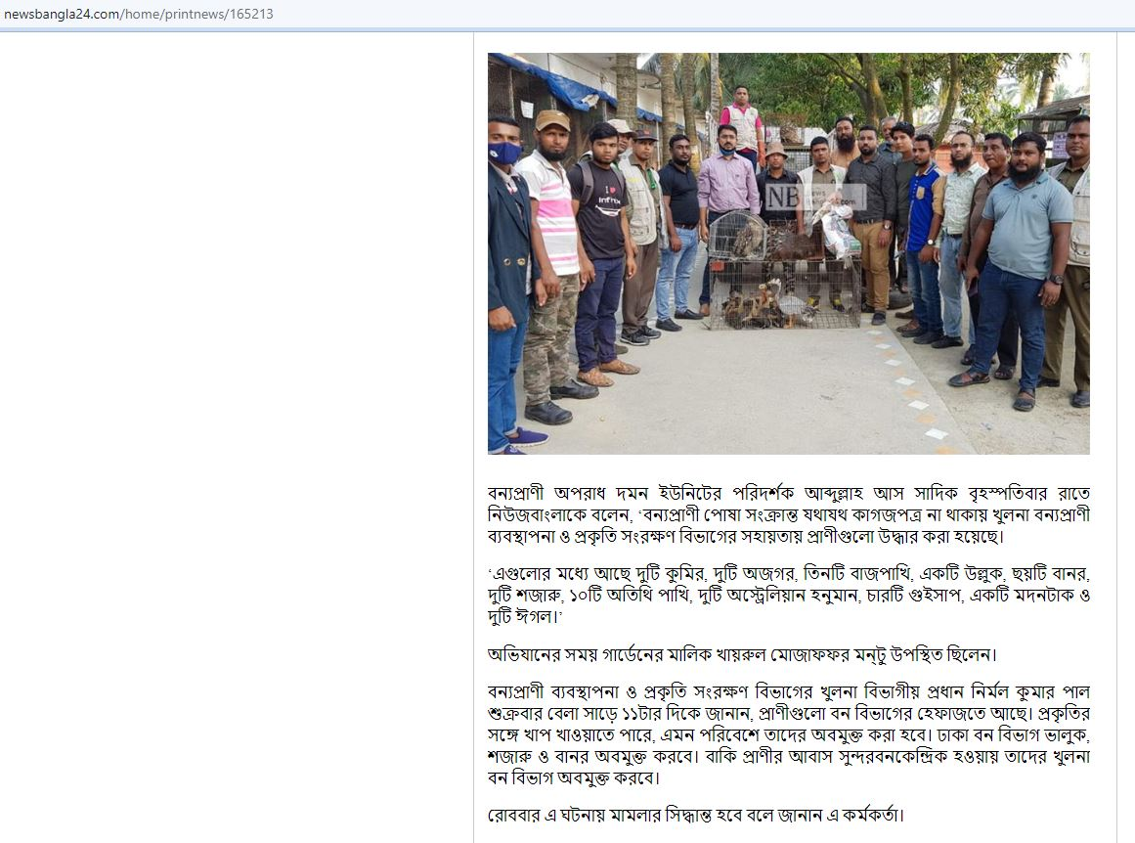

Supplementary Plate 3 Screenshot of the report on the drive by the Bangladesh Forest Department that led to the confiscation of one live adult Asiatic black bear (Shawan, 2021).

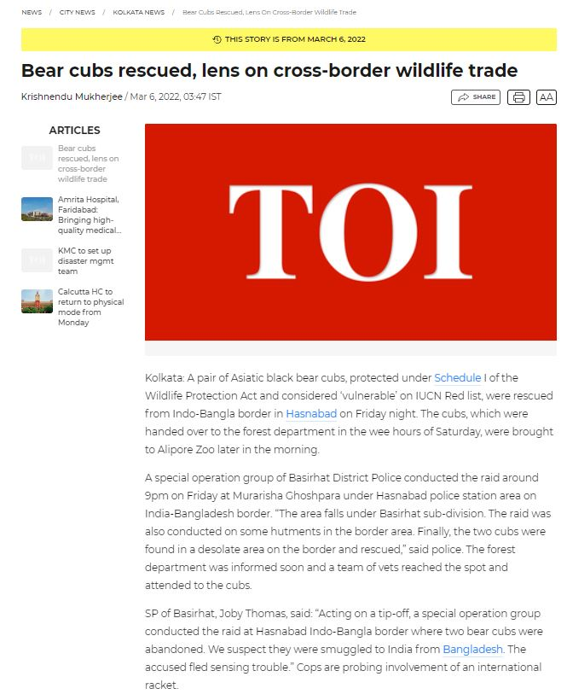

Supplementary Plate 4 Screenshot of the *Times of India* report on the cross-border trade of bears (Mukherjee, 2022).

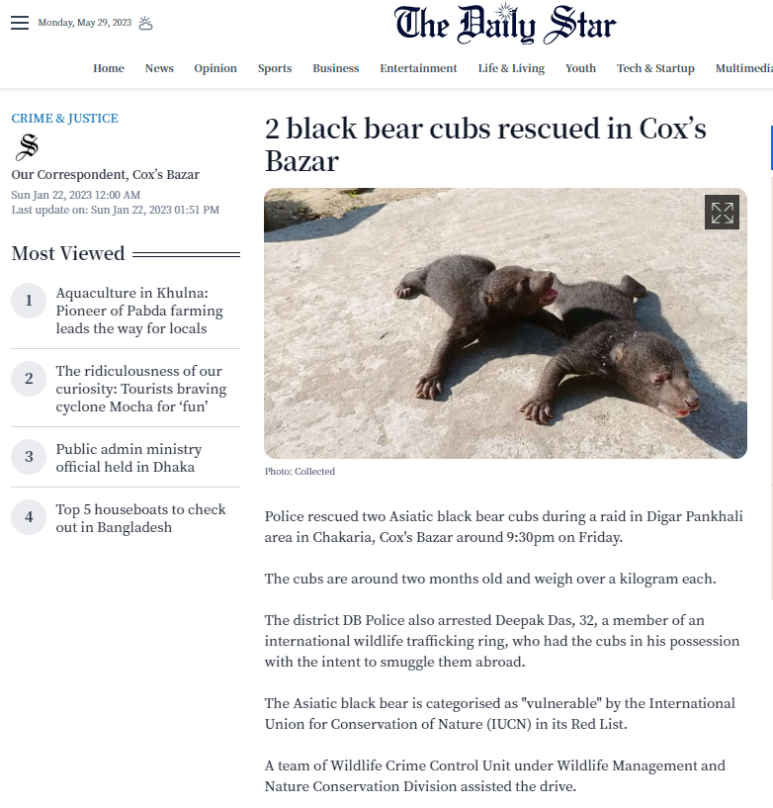

Supplementary Plate 5 Screenshot of the *Daily Star* report on two new-born bear cubs rescued from Chakaria, Cox’s Bazar District (The Daily Star, 2023).

**References**

Creative Conservation Alliance (2016) *A Preliminary Wildlife Survey in Sangu-Matamuhuri Reserve Forest, Chittagong Hill Tracts, Bangladesh.* Unpublished report submitted to Bangladesh Forest Department, Dhaka, Bangladesh.

Chakma, S. (2016) *Assessment of large mammals of the Chittagong Hill Tracts of Bangladesh with emphasis on tiger (*Panthera tigris*)*. PhD thesis. University of Dhaka, Dhaka, Bangladesh.

Donlon, C., Berruti, B., Buongiorno, A., Ferreira, M. H., Féménias, P., Frerick, J. et al. (2012) The global monitoring for environment and security (GMES) Sentinel-3 mission. *Remote Sensing of Environment*, 120, 37–57.

IUCN Bangladesh (2022) *Report on the Feasibility Study of Transboundary Wildlife Corridor in Chattogram, Chattogram Hill Tracts and Cox’s Bazar with Myanmar and India*. IUCN, Bangladesh Country Office, Dhaka, Bangladesh.

Islam, M.A., Muzaffar, S.B., Aziz, M.A., Kabir, M.M., Uddin, M., Chakma, S. et al. (2010) *Baseline Survey of Bears in Bangladesh*. WildTeam, Dhaka, Bangladesh.

Kar, D.K. (2014) Two bears and two civets rescued by Wildlife Management Department, Rajshahi. *The Daily Star*, 18 February 2014. [valuka.com/News/NewsDetail/12260](https://www.valuka.com/News/NewsDetail/12260) [accessed 16 May 2022]. [In Bengali]

Mukherjee, K. (2022) Bear cubs rescued, lens on cross-border wildlife trade. *The Times of India*, 6 March 2022. [timesofindia.indiatimes.com/city/kolkata/bear-cubs-rescued-lens-on-cross-border-wildlife-trade/articleshow/90022812.cms?from=mdr](https://timesofindia.indiatimes.com/city/kolkata/bear-cubs-rescued-lens-on-cross-border-wildlife-trade/articleshow/90022812.cms?from=mdr) [accessed 16 May 2022].

Sarkar, M.S.U. (2006) The status and conservation of bears in Bangladesh. In *Understanding Asian Bears to Secure their Future* (compiler Japan Bear Network), pp. 41–44. Japan Bear Network, Ibaraki, Japan.

Shawan, R.S. (2021) Crocodile, bear, python, porcupine rescued from picnic spot. *NewsBangla24.com*, 5 November 2021. [newsbangla24.com/news/165213/59-wildlife-rescued-from-picnic-spot](https://www.newsbangla24.com/news/165213/59-wildlife-rescued-from-picnic-spot) [accessed 16 May 2022]. [In Bengali]

The Daily Star (2023) 2 black bear cubs rescued in Cox’s Bazar. *The Daily Star*, 22 January 2023. [thedailystar.net/news/bangladesh/crime-justice/news/2-black-bear-cubs-rescued-coxs-bazar-3227281](https://www.thedailystar.net/news/bangladesh/crime-justice/news/2-black-bear-cubs-rescued-coxs-bazar-3227281) [accessed 29 May 2023].