**First photographic evidence of the Critically Endangered Chinese pangolin *Manis pentadactyla* in Kavrepalanchok community forests, Nepal**

Nischal Shrestha, Sadip Raj Pandey, Sandeep Shrestha and Ashish Bashyal

Supplementary Table 1 The other mammalian species recorded in the camera traps along with their scientific name and IUCN Red List category.

|  |  |  |  |
| --- | --- | --- | --- |
| S. N. | Common Name | Scientific Name | IUCN Red List Category |
| 1 | Common leopard | *Panthera pardus* | Vulnerable |
| 2 | Jungle cat | *Felis chaus* | Least Concern |
| 3 | Large Indian civet | *Viverra zibetha* | Least Concern |
| 4 | Masked palm civet | *Paguma larvata* | Least Concern |
| 5 | Yellow–throated marten | *Martes flavigula* | Least Concern |
| 6 | Himalayan porcupine | *Hystrix brachyura* | Least Concern |
| 7 | Northern red muntjac | *Muntiacus vaginalis* | Least Concern |
| 8 | Wild boar | *Sus* sp. | Least Concern |
| 9 | Rhesus macaque | *Macaca mulatta* | Least Concern |

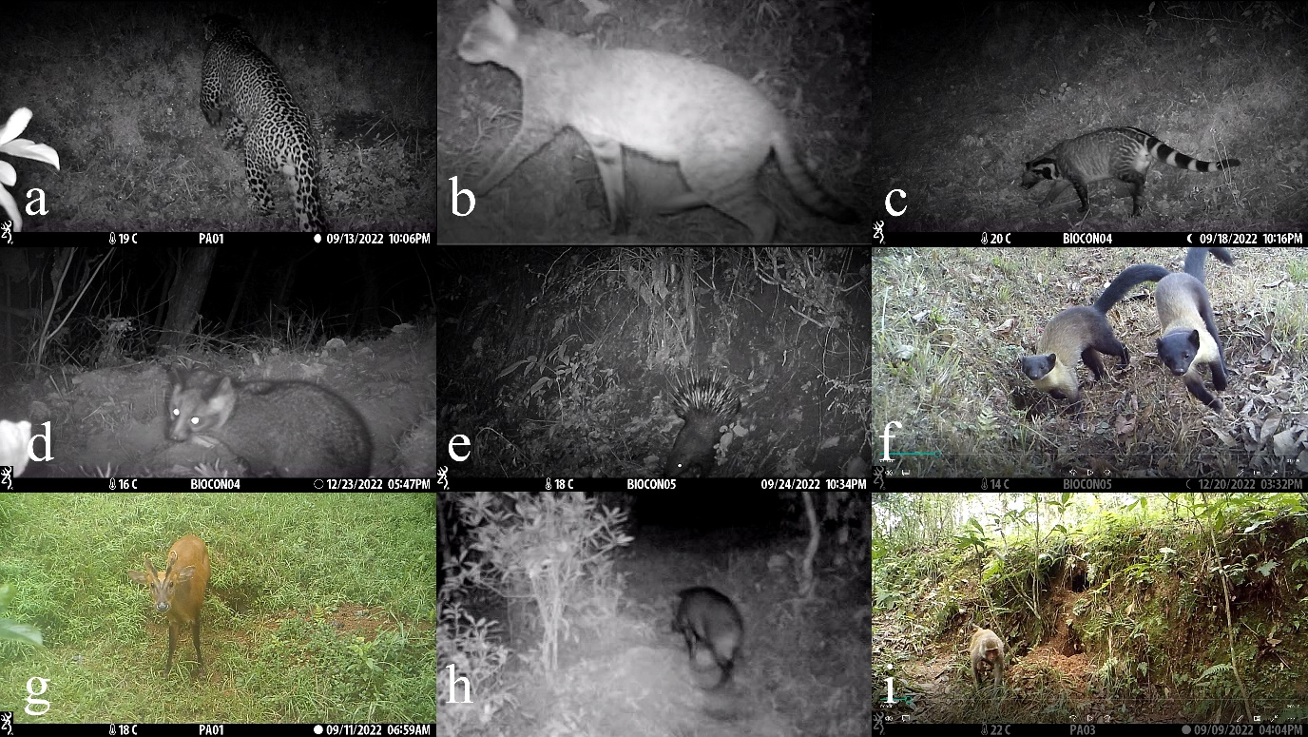

Supplementary Plate 1 Photographic evidences of mammalian species recorded. a) common leopard, b) jungle cat, c) large Indian civet, d) masked palm civet, e) Himalayan porcupine, f) Yellow–throated marten, g) Northern red muntjac, h) wild boar and i) rhesus macaque.