Participatory modeling across Kenyan villages facilitates insights into the complexity of human–elephant interactions

Lynn Von Hagen, Steven Gray, Bruce A. Schulte, Mwangi Githiru, Helen Kiute and Christopher A. Lepczyk

Supplementary material is published as supplied by the authors. It is not checked for accuracy, copyedited, typeset or proofread. The responsibility for accuracy and file functionality remains with the authors.

Supplementary Table 1 Number of participants by village and their gender from participatory sessions in the Kasigau Wildlife Corridor of Kenya.
Village | Total Participants | Male/Female
Buguta | 13 | 7/6
Bungule | 12 | 6/6
Itinyi | 12 | 6/6
Kisimenyi | 12 | 6/6
Makwasinyi | 13 | 7/6
Miasenyi | 15 | 7/8
Total | 77 | 39/38

Supplementary Table 2 Literature and local references for variables in the co-created model including quotes from participants during participatory sessions that helped to inform the model (see Fig. 4 in the main text).
Variable | Literature reference | Local references (quotes from participants)
Access to transportation | Karidozo et al., 2016; Virtanen et al., 2020 | “During the rains, our roads are dangerous to use, also when livestock farmers wake up in the early hours to go milk their cows, sometimes they use motorbikes, if they meet elephants on the way it can cause a fatal accident.”
Alternative crops | Gross et al., 2016; Mmbaga et al., 2017; Hill, 2018 | “Having alternative crops that are not so pleasing to the elephant would reduce human–elephant conflict at a large percentage, but, we do not have market, expertise, good weather conditions for other crops other than what we are already used to.”
Alternative livelihoods | Nyirenda et al., 2018; Salerno et al., 2020 | “We have been farmers all our life, …..we have minimal alternatives to do other than farm.”
Bushmeat poaching | Nyaki et al., 2014; Larson et al., 2016 | “I only depend on bushmeat for my family. It’s the only way we get to at least consume a better meal. This places us at crossroads with wildlife officers, but, until they solve our issues of elephant conflict then we will continue consuming the bushmeat. As long as its harmless to our health.”
Carnivore conflicts | di Minin et al., 202; Patterson et al., 2004 | “We have had lions crossing our roads late at night and hyenas scaring our school going children and this is never addressed by the wildlife services.”
Conflict compensation | Mackenzie & Ahabyona, 2012; Ravenelle & Nyhus, 2017; Salerno et al., 2020 | “Compensation forms that are to be filled by the farmers experiencing destruction of crops and property by elephants are always available but the funds are rarely processed.”
Crop yields | Davies et al., 2011; Lobell & Gourdji, 2012; Gross et al., 2018 | “Pests or drought affects the quantity of crop yields, we may have a small range of the harvest but when elephants raid your farm, you are assured of zero percent of the produce.”
Deterrent methods | Dublin & Hoare, 2004; Graham & Ochieng, 2008; Killion et al., 2020 | "We have tried a few techniques as use of fire, guarding the farms with torches, making noise out of iron sheets, putting up thorny branches around the farms among others. The elephants get used to most of the techniques and thereafter, they no longer react to any of them. We need better and more effective ways."
Drought/climate change | Lobell & Gourdji, 2012; Salite, 2019; Shiferaw et al., 2014 | “Drought reduces our crop yields, and at the same time when this happens in our farms it also happens in the parks which prompts the elephants in moving towards the residential and farming lands in search of plantations.”
Education on elephants | EHRA Peace Project, 2020; Makecha & Ghosal, 2017; Zarestky & Ruyle, 2016 | “We are unaware of the effective ways of peacefully living with elephants. If we could’ve been a bit knowledgeable, then HEC would be reduced by now.”
Diverse agricultural practices/CSA | Asante et al., 2021; Bryan et al., 2013; Nyamwamu et al., 2015; Partey et al., 2018 | “Our county leadership does not effectively support the farmers at least in providing for fertilizers, seeds and irrigation measures in the wildlife corridor; leaving farmers in this side of Taita poor in agriculture and also in our general being.”
Illegal charcoal harvest | Haro et al., 2005; Zulu & Richardson, 2013; Asante et al., 2021 | “Charcoal harvest is one of the reasons that we as a community contribute to HEC by cutting of trees in the wildlife parks such that the elephants do not have enough plantings in the parks.” (contributed by local Chief)
Illegal grazing | Kamau & Sluyter, 2018; Mackenzie & Ahabyona, 2012; Okita‐Ouma et al., 2021 | “Untouchable political leaders, who are allowed to graze their cattle in the parks especially during drought period enhance HEC as the elephants now have to move towards the residential and farming area in Kasigau”
Income levels | Naughton-Treves et al., 2006; Guerbois et al., 2012; Mackenzie & Ahabyona, 2012 | “When elephants attack and raid our farms then it reduces our crop yields which is always meant for sale, thus reducing our income levels and leaving farmers poor.”
Large family sizes | Kideghesho et al., 2007; Nyumba et al., 2020 | “Large family sizes come with poverty and early marriages that happen due to low-income levels brought about by lack of crop yields (majorly destroyed by elephants) to sell to generate income.”
Payment of school fees | Distefano, 2005; Glazebrook et al., 2020 | “Low-income levels due to low crop yields, means that community members sustain themselves with minimum economic means, thus a struggle in paying school fees for their school going children. Students sometimes have to dropout due to these reasons.”
Proximity to ranches | Galanti et al., 2006; Monney et al., 2010; von Gerhardt et al., 2014 | “Our close proximity to the ranches enables the elephants to easily pave their way to residential and farming lands and that is why the metal strip fences would be much effective in our area.”
Wildlife officers available | Smith and Kasiki, 2000; Western et al., 2015 | “Wildlife officers are not located next to our residential areas, so even apart from their response being slow, they cannot make it into the villages when called upon during destruction by elephants.”

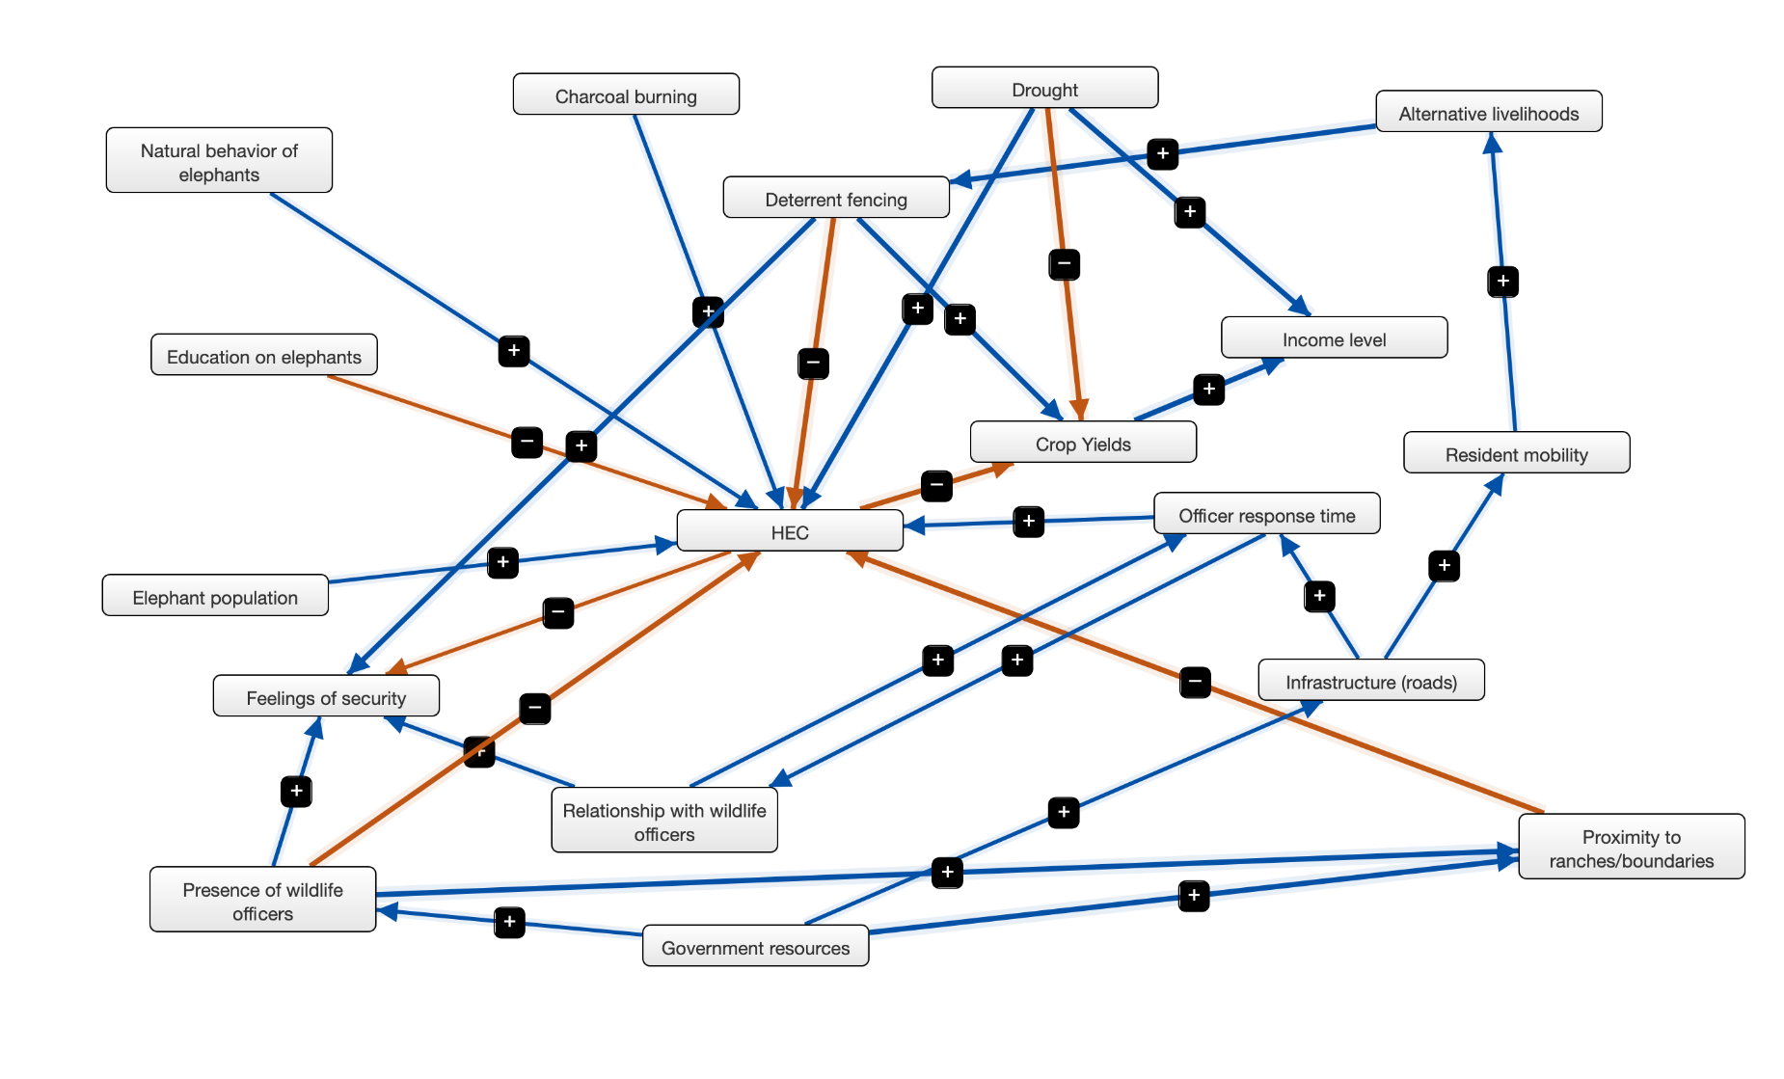
Supplementary Fig. 1 A fuzzy cognitive map of variables related to human–elephant conflict (HEC). The map was created with Mental Modeler software from a participatory session in the village of Makwasinyi in the Kasigau Wildlife Corridor, Kenya. Variables are linked together through connecting lines (edges) with the strength of association represented by the thickness of the lines. To read the model, take any variable with an arrow originating from it and with an increase of said variable it will have either a positive and increasing (a plus (+) sign) or a negative and decreasing (a minus (–) sign) causal influence on the variable it is connected to.
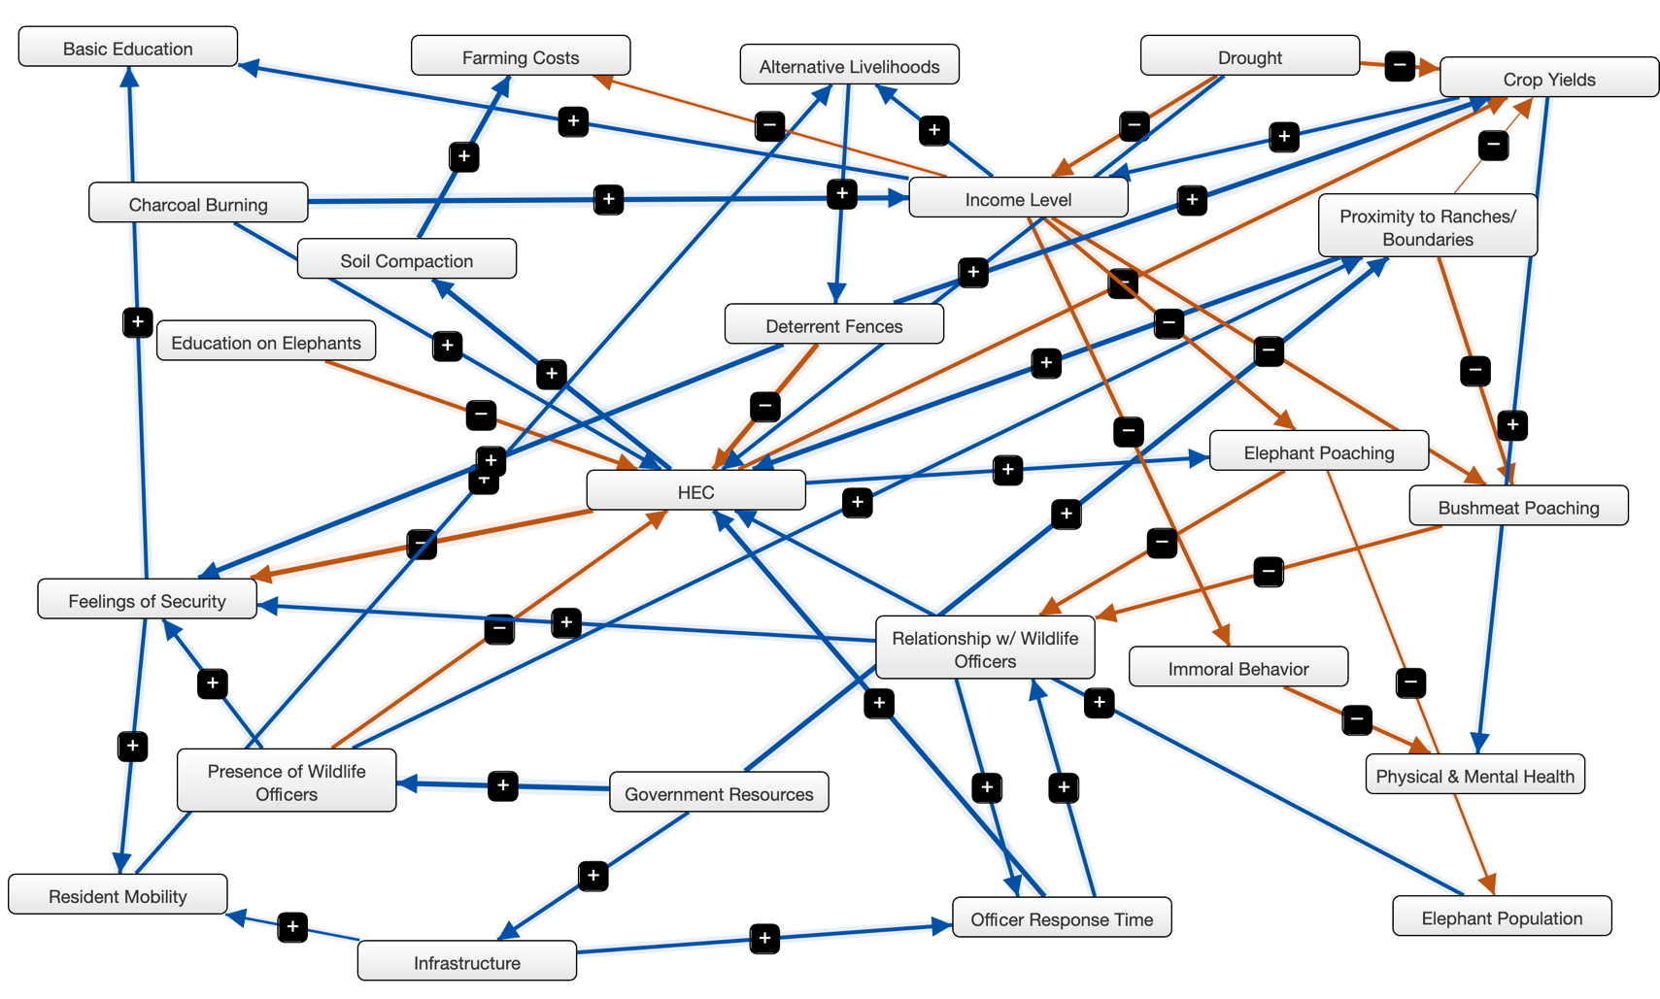

Supplementary Fig. 2 A fuzzy cognitive map of variables related to human–elephant conflict (HEC). The map was created with Mental Modeler software from a participatory session in the village of Kisimenyi in the Kasigau Wildlife Corridor, Kenya. Variables are linked together through connecting lines (edges) with the strength of association represented by the thickness of the lines. To read the model, take any variable with an arrow originating from it and with an increase of said variable it will have either a positive and increasing (a plus (+) sign) or a negative and decreasing (a minus (–) sign) causal influence on the variable it is connected to.

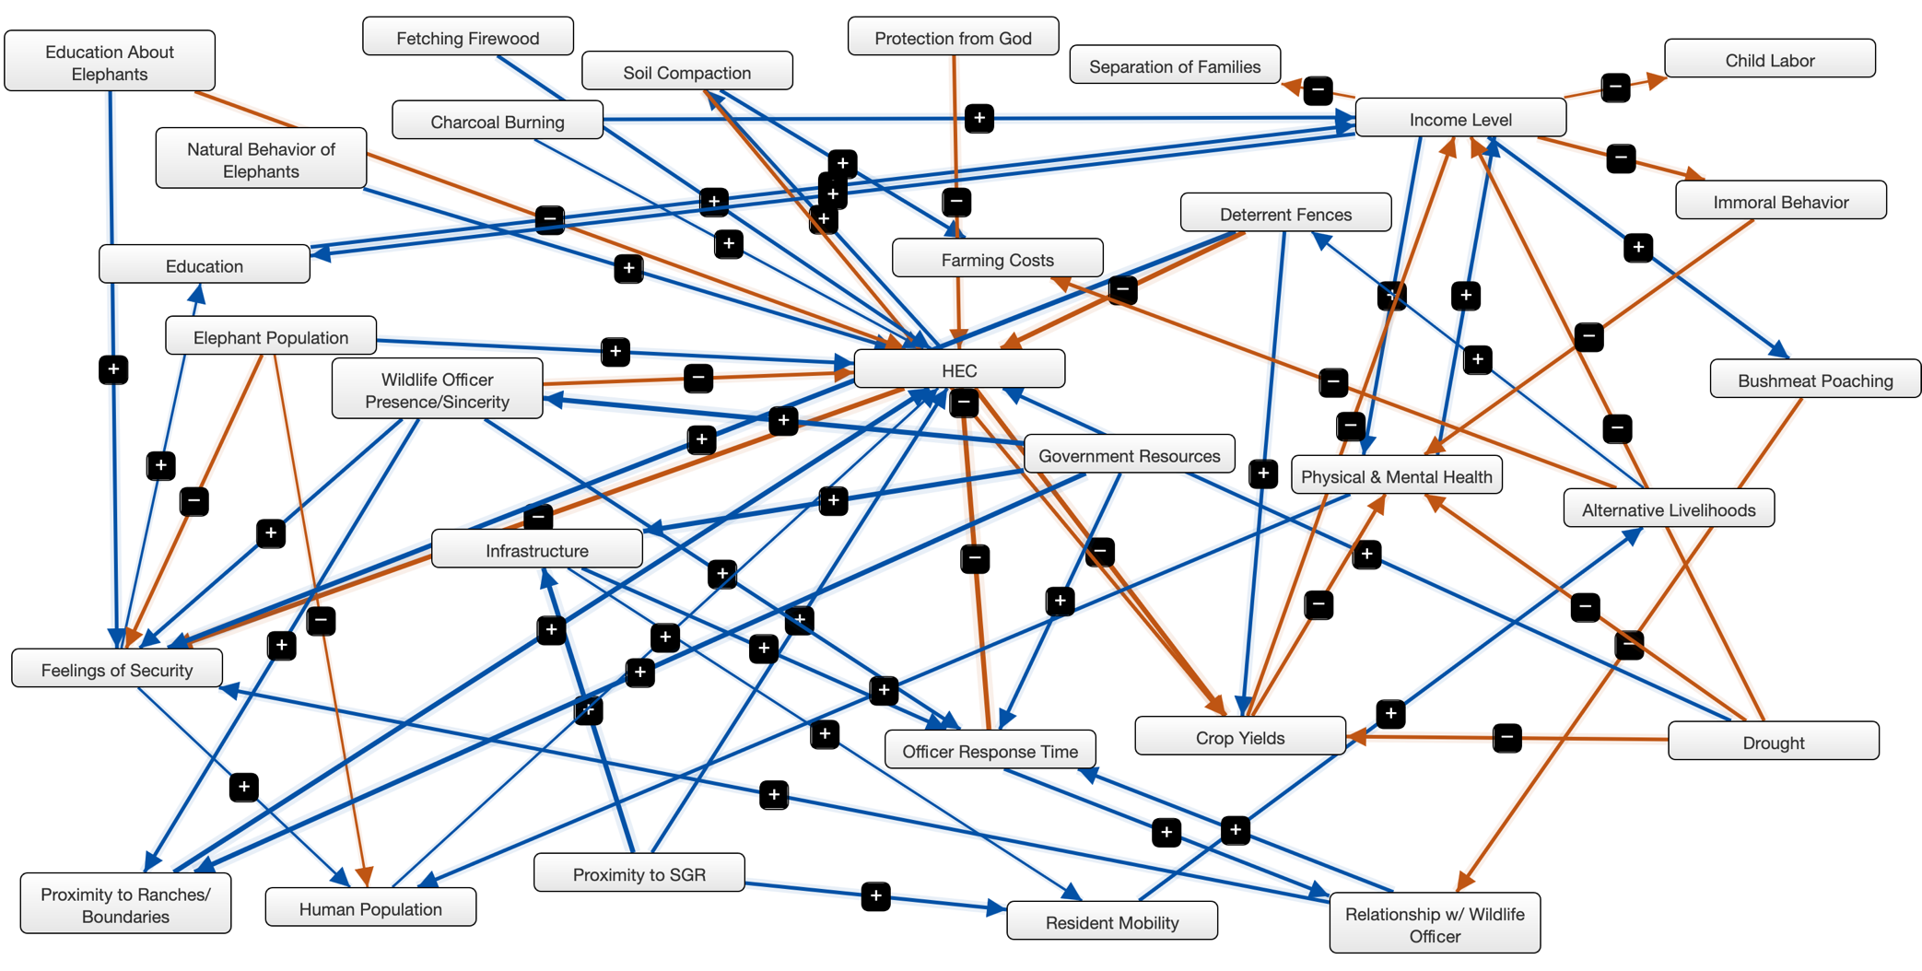

Supplementary Fig. 3 A fuzzy cognitive map of variables related to human–elephant conflict (HEC). The map was created with Mental Modeler software from a participatory session in the village of Buguta in the Kasigau Wildlife Corridor, Kenya. Variables are linked together through connecting lines (edges) with the strength of association represented by the thickness of the lines. To read the model, take any variable with an arrow originating from it and with an increase of said variable it will have either a positive and increasing (a plus (+) sign) or a negative and decreasing (a minus (–) sign) causal influence on the variable it is connected to.
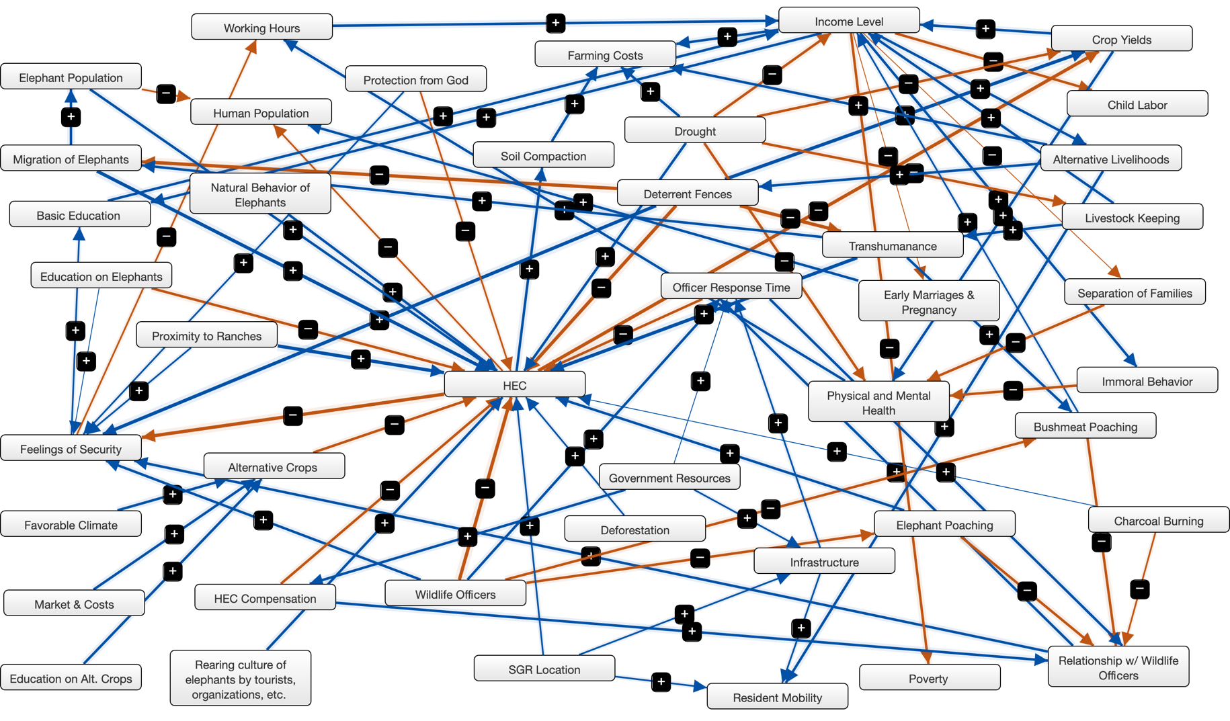

Supplementary Fig. 4 A fuzzy cognitive map of variables related to human–elephant conflict (HEC). The map was created with Mental Modeler software from a participatory session in the village of Itinyi in the Kasigau Wildlife Corridor, Kenya. Variables are linked together through connecting lines (edges) with the strength of association represented by the thickness of the lines. To read the model, take any variable with an arrow originating from it and with an increase of said variable it will have either a positive and increasing (a plus (+) sign) or a negative and decreasing (a minus (–) sign) causal influence on the variable it is connected to.
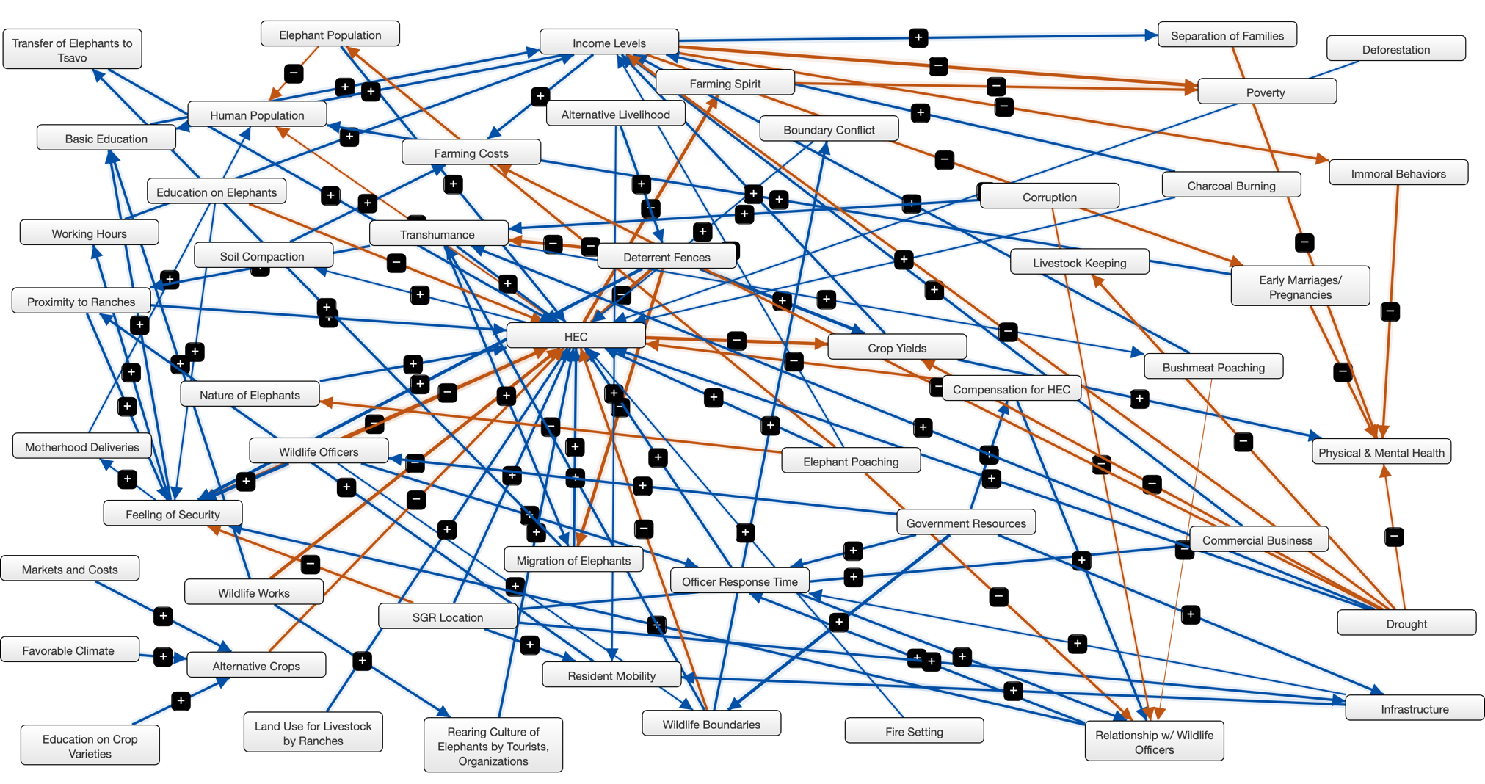

Supplementary Fig. 5 A fuzzy cognitive map of variables related to human–elephant conflict (HEC). The map was created with Mental Modeler software from a participatory session in the village of Makwasinyi in the Kasigau Wildlife Corridor, Kenya. Variables are linked together through connecting lines (edges) with the strength of association represented by the thickness of the lines. To read the model, take any variable with an arrow originating from it and with an increase of said variable it will have either a positive and increasing (a plus (+) sign) or a negative and decreasing (a minus (–) sign) causal influence on the variable it is connected to.
Buguta West | Bungule | Itinyi | Kisimenyi | Makwasinyi | Miasenyi
Alternative Livelihoods | Alternative Livelihoods | Alternative Crops | Alternative Livelihoods | Alternative Livelihoods | Alternative Crops
Basic Education | Basic Education | Alternative Livelihoods | Basic Education | Charcoal Burning | Alternative Livelihood
Bushmeat Poaching | Behavioural Nature of Elephants | Basic Education | Bushmeat Poaching | Crop Yields | Basic Education
Charcoal Burning | Bushmeat Poaching | Bushmeat Poaching | Charcoal Burning | Deterrent Fencing | Boundary Conflict
Child Labor | Charcoal Burning | Charcoal Burning | Crop Yields | Drought | Bushmeat Poaching
Crop Yields | Child Labor | Child Labor | Deterrent Fences | Education on Elephants | Commercial Business
Deterrent Fences | Crop Yields | Crop Yields | Drought | Elephant Population | Charcoal Burning
Drought | Deterrent Fencing | Deforestation | Education on Elephants | Feelings of Security | Child Labor
Education About Elephants | Drought | Deterrent Fences | Elephant Poaching | Government Resources | Compensation for HEC
Elephant Population | Education on Elephants | Drought | Elephant Population | HEC | Corruption
Farming Costs | Elephant Population | Early Marriages & Pregnancy | Farming Costs | Income Level | Crop Yields
Feelings of Security | Farming Costs | Education on Alt. Crops | Feelings of Security | Infrastructure | Deforestation
Fetching Firewood | Feelings of Security | Education on Elephants | Government Resources | Natural Behaviour of Elephants | Deterrent Fences
Government Resources | Government Resources | Elephant Poaching | HEC | Officer Response Time | Drought
HEC | HEC | Elephant Population | Income Level | Presence of Wildlife Officers | Early Marriages/ Pregnancies
Human Population | Human Population | Farming Carts | Immoral Behaviour | Proximity to Ranches/Boundaries | Education on Crop Varieties
Immoral Behaviour | Immoral Behaviour | Favorable Climate | Infrastructure | Relationship with Wildlife Officer | Education on Elephants
Income Level | Income Levels | Feelings of Security | Officer Response Time | Resident Mobility | Elephant Poaching
Infrastructure | Infrastructure | Government Resources | Physical & Mental Health |  | Elephant Population
Natural Behaviour of Elephants | Officer Response Time | HEC | Presence of Wildlife Officers |  | Farming Costs
Officer Response Time | Physical and Mental Health | HEC Compensation | Proximity to Ranches/Boundaries |  | Farming Spirit
Physical & Mental Health | Presence of Wildlife Officers | Human Population | Relationship with Wildlife Officers |  | Favorable Climate
Protection from God | Proximity to Ranches | Immoral Behaviour | Resident Mobility |  | Feeling of Security
Proximity to Ranches | Relationship with Wildlife Officers | Income Level | Soil compaction |  | Fire setting
Proximity to SGR | Resident Mobility | Infrastructure |  |  | Government Resources
`Relationship with Wildlife Officers | Separation of Families | Livestock Keeping |  |  | HEC
Resident Mobility | SGR Location | Market & Costs |  |  | Human Population
Separation of Families | Soil Compaction | Migration of Elephants |  |  | Immoral Behaviours
Soil Compaction |  | Natural Behaviour of Elephants |  |  | Income Levels
Wildlife Officer Presence/Sincerity |  | Officer Response Time |  |  | Infrastructure
 |  | Physical and Mental Health |  |  | Land Use for Livestock by Ranches
 |  | Poverty |  |  | Livestock Keeping
 |  | Protection from God |  |  | Markets and Costs
 |  | Proximity to Ranches |  |  | Migration of Elephants
 |  | Rearing culture of elephants. |  |  | Motherhood Deliveries
 |  | Relationship with Wildlife Officers |  |  | Nature of Elephants
 |  | Resident Mobility |  |  | Officer Response Time
 |  | Separation of Families |  |  | Physical & Mental Health
 |  | SGR Location |  |  | Poverty
 |  | Soil Compaction |  |  | Proximity to Ranches
 |  | Transhumance |  |  | Rearing Culture of Elephants
 |  | Wildlife Officers |  |  | Relationship with Wildlife Officers
 |  | Working Hours |  |  | Resident Mobility
 |  |  |  |  | Separation of Families
 |  | 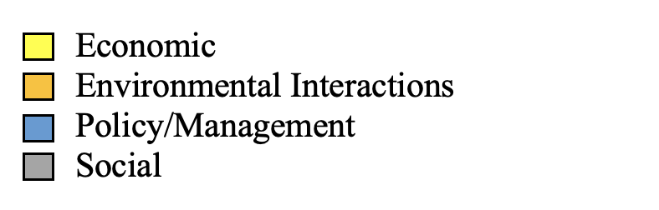 |  |  | SGR Location
 |  |  |  |  | Soil Compaction
 |  |  |  |  | Transfer of Elephants to Tsavo
 |  |  |  |  | Transhumance
 |  |  |  |  | Wildlife Boundaries
 |  |  |  |  | Wildlife Officers
 |  |  |  |  | Wildlife Works
 |  |  |  |  | Working Hours

Supplementary Fig. 6 A qualitative colour aggregation that categorizes and aids in visualization of variable types from participatory models created with six villages in the Kasigau Wildlife Corridor, Kenya (see Fig 2. in the main text, and Supplementary Figs 1–5).

References
di Minin, E., Slotow, R., Fink, C., Bauer, H. & Packer, C. (2021) A pan-African spatial assessment of human conflicts with lions and elephants. Nature Communications, 12, 2978.

Distefano, E. (2005) Human–Wildlife Conflict Worldwide: Collection of Case Studies, analysis of Management Strategies and Good Practices. Sard Initiative Report. Rome, Italy.

Dublin, H.T. & Hoare, R.E. (2004) Searching for solutions: The evolution of an integrated approach to understanding and mitigating human–elephant conflict in Africa. Human Dimensions of Wildlife, 9, 271–278.

EHRA Peace Project (2020) Elephant Safety. Elephant–Human Relations Aid, Swakopmund, Namibia. ehranamibia.org/volunteer-resources [accessed May 2024].

Galanti, V., Preatoni, D., Martinoli, A., Wauters, L.A. & Tosi, G. (2006) Space and habitat use of the African elephant in the Tarangire-Manyara ecosystem, Tanzania: implications for conservation. Mammalian Biology, 71, 99–114.

Glazebrook, T., Noll, S. & Opoku, E. (2020) Gender matters: climate change, gender bias, and women’s farming in the global south and north. Agriculture (Switzerland), 10, 1–25.

Graham, M.D. & Ochieng, T. (2008) Uptake and performance of farm-based measures for reducing crop raiding by elephants Loxodonta africana among smallholder farms in Laikipia District, Kenya. Oryx, 42, 76–82.

Killion, A.K., Ramirez, J.M. & Carter, N.H. (2020) Human adaptation strategies are key to co-benefits in human–wildlife systems. Conservation Letters, 14, e12769.

Larson, L., Conway, A., Hernandez, S. & Carroll, J. (2016) Human-wildlife conflict, conservation attitudes, and a potential role for citizen science in Sierra Leone, Africa. Conservation and Society, 14, 205–217.

Lobell, D.B. & Gourdji, S.M. (2012) The influence of climate change on global crop productivity. Plant Physiology, 160, 1686–1697.

Mackenzie, C.A. & Ahabyona, P. (2012) Elephants in the garden: financial and social costs of crop raiding. Ecological Economics, 75, 72–82.

Makecha, R.N. & Ghosal, R. (2017) Elephant conservation: reviewing the need and potential impact of cognition-based education. International Journal of Comparative Psychology, 30, 33595.

Monney, K.A., Dakwa, K.B. & Wiafe, E.D. (2010) Assessment of crop raiding situation by elephants (Loxodonta africana cyclotis) in farms around Kakum conservation area, Ghana. International Journal of Biodiversity and Conservation, 2, 243–249.

Nyamwamu, R.O., Mwangi, J.G. & Ombati, J.M. (2015) Untapped potential of agricultural extension mitigation strategies in influencing the extend of human-wildlife conflict: A case of smallholder agro-pastoralists in Laikipia County, Kenya. International Journal of Agricultural Extension, 3, 73–81.

Nyirenda, V.R., Tembo, O. & Nkhata, B.A. (2018) Elephant crop damage: subsistence farmers’ social vulnerability, livelihood sustainability and elephant conservation. Sustainability, 10, 3572.

Nyumba, T.O., Emenye, O.E. & Leader-Williams, N. (2020) Assessing impacts of human–elephant conflict on human wellbeing: an empirical analysis of communities living with elephants around Maasai Mara National Reserve in Kenya. PLOS One, 15, e0239545.

Okita-Ouma, B., Koskei, M., Tiller, L., Lala, F., King, L., Moller, R. et al. (2021) Effectiveness of wildlife underpasses and culverts in connecting elephant habitats: a case study of new railway through Kenya’s Tsavo National Parks. African Journal of Ecology, 59, 624–640.

Partey, S.T., Zougmoré, R.B., Ouédraogo, M. & Campbell, B.M. (2018) Developing climate-smart agriculture to face climate variability in West Africa: challenges and lessons learnt. Journal of Cleaner Production, 187, 285–295.

Patterson, B.D., Kasiki, S.M., Selempo, E. & Kays, R.W. (2004) Livestock predation by lions (Panthera leo) and other carnivores on ranches neighboring Tsavo National Parks, Kenya. Biological Conservation, 119, 507–516.

Ravenelle, J. & Nyhus, P.J. (2017) Global patterns and trends in human–wildlife conflict compensation. Conservation Biology, 31, 1247–1256.

Salerno, J., Bailey, K., Gaughan, A.E., Stevens, F.R., Hilton, T., Cassidy, L. et al. (2020) Wildlife impacts and vulnerable livelihoods in a transfrontier conservation landscape. Conservation Biology, 34, 891–902.

Salite, D. (2019) Explaining the uncertainty: understanding small-scale farmers’ cultural beliefs and reasoning of drought causes in Gaza Province, Southern Mozambique. Agriculture and Human Values, 36, 427–441.

Shiferaw, B., Tesfaye, K., Kassie, M., Abate, T., Prasanna, B.M. & Menkir, A. (2014) Managing vulnerability to drought and enhancing livelihood resilience in sub-Saharan Africa: technological, institutional and policy options. Weather and Climate Extremes, 3, 67–79.

Smith, R.J. & Kasiki, S.M. (2000) A Spatial Analysis of Human–elephant Conflict in the Tsavo Ecosystem, Kenya. A Report to the African Elephant Specialist Group, Gland, Switzerland.

Treves, A., Wallace, R.B., Naughton-Treves, L. & Morales, A. (2006) Co-managing human–wildlife conflicts: a review. Human Dimensions of Wildlife, 11, 383–396.

von Gerhardt, K., van Niekerk, A., Kidd, M., Samways, M. & Hanks, J. (2014) The role of elephant Loxodonta africana pathways as a spatial variable in crop-raiding location. Oryx, 48, 436–444.

Western, D., Waithaka, J. & Kamanga, J. (2015) Finding space for wildlife beyond national parks. Parks, 21, 51–62.

