**High carnivore richness despite human pressure and prey depletion in overlooked region of the Kavango–Zambezi Transfrontier Conservation Area**

Stijn Verschueren, Tim Hofmann, Mikael Kakove, Hans Bauer, Bogdan Cristescu and Laurie Marker

Supplementary material is published as supplied by the authors. It is not checked for accuracy, copyedited, typeset or proofread. The responsibility for scientific accuracy and file functionality remains with the authors.

[AQ Please arrange/resize the plates and figures so that the captions are on the same page as the item being referred to, and place figure first and plate second for both records.]

Supplementary Material 1 IUCN range expansion records.

**Bushpig *Potamochoerus larvatus***

IUCN status: Least Concern

Date: 19 September 2022 3:25:00

Location: Ondjou Conservancy, Namibia (20.581, -20.09)

Observation type: Camera trap (Browning Strike Force Pro XD)

Data ownership: Cheetah Conservation Fund

Description: Bushpigs are associated with relatively dense vegetation types with available food, cover and water, in forests and riverine or xeric scrub forests and thicket formations (Seydack, 2016). Bushpigs are believed to be absent in Namibia, except for the Zambezi region. Here, we demonstrate its presence in eastern Namibia, 69 km west from its known IUCN range (Supplementary Fig. 1 & Supplementary Plate 1). Habitat conditions in Ondjou conservancy are similar to their ecological needs and this area has the potential to accommodate a viable population that could present a valuable prey source for larger carnivores.

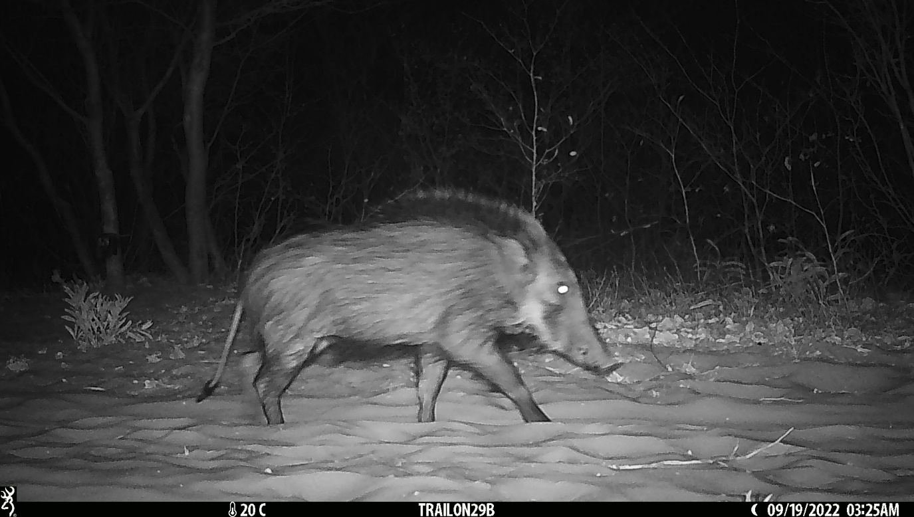

Supplementary Plate 1 Camera trap observation of bushpig *Potamochoerus larvatus* in Ondjou Conservancy located outside the known IUCN range.



Supplementary Fig. 1 Location of the observation of bushpig *Potamochoerus larvatus* in Ondjou Conservancy located outside the known IUCN range

**White-tailed mongoose *Ichneumia albicauda***

IUCN status: Least Concern

Date: 25 Aug 2022 22:27:00

Location: Ondjou Conservancy, Namibia (20.458, -20.109)

Observation type: Camera trap (Browning Strike Force Pro XD)

Data ownership: Cheetah Conservation Fund

Description: White-tailed mongooses occur in grasslands, savanna and woodland areas, and are adaptable to human-modified habitats (Do Linh San, 2015). Although mainly found in wet systems, the species may occur in fairly arid areas (Pallett & Thomson, 2022). In Namibia, the species is believed to be present only in the north-eastern area, although there is one record from the Grootfontein area. Here, we demonstrate its presence in eastern Namibia, 114 km west of its known IUCN range (Supplementary Fig. 2 & Supplementary Plate 2). Habitat conditions are dry, which suggests that white-tailed mongooses may indeed tolerate more arid conditions.

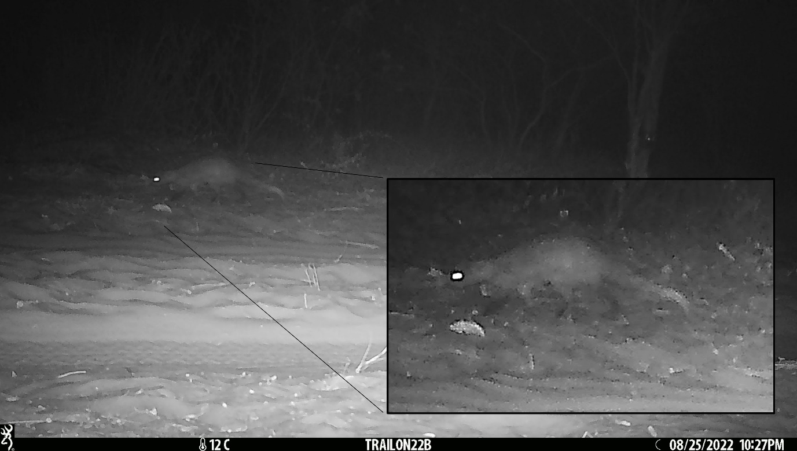

Supplementary Plate 2 Camera trap observation of white-tailed mongoose *Ichneumia albicauda* in Ondjou Conservancy located outside the known IUCN range



Supplementary Fig. 2 Location of the observation of white-tailed mongoose *Ichneumia albicauda* in Ondjou Conservancy located outside the known IUCN range

Supplementary Table 1 95% Confidence intervals for summary values in Table 1 (probability of site use (ψ), probability of detection (p), covariate associations (β)).

|  |  |  |  |  |  |
| --- | --- | --- | --- | --- | --- |
| **Species** | **ψ** | ***p*** | ***β*Gam** | ***β*Nyae** | ***β*Prey** |
| Carnivore community | 0.48 - 0.896 | 0.144 - 0.471 | 0.065 - 1.103 | -0.812 - 0.429 | -0.272 - 0.929 |
| Aardwolf | 0.452 - 0.987 | 0.113 - 0.332 | -0.425 - 2.11 | -0.908 - 1.228 | -1.414 - 1.322 |
| *Proteles cristata* |
| African wild cat | 0.703 - 0.993 | 0.277 - 0.493 | -0.367 - 1.617 | -0.985 - 1.041 | -1.836 - 0.621 |
| *Felis lybica* |
| African wild dog | 0.431 - 0.849 | 0.329 - 0.601 | 0.243 - 1.978 | -0.702 - 0.908 | -0.857 - 0.979 |
| *Lycaon pictus* |
| Bat-eared fox | 0.233 - 0.956 | 0.085 - 0.381 | -0.627 - 1.309 | -0.392 - 2.253 | -2.1 - 0.552 |
| *Otocyon megalotis* |
| Black-backed jackal | 0.834 - 0.988 | 0.777 - 0.902 | -0.256 - 1.531 | -0.679 - 1.202 | -1.153 - 1.107 |
| *Canis mesomelas* |
| Brown hyena | 0.834 - 0.989 | 0.815 - 0.932 | -0.183 - 1.692 | -0.839 - 1.062 | -0.515 - 1.993 |
| *Parahyaena brunnea* |
| Cape fox | 0.462 - 0.967 | 0.129 - 0.346 | -0.169 - 1.941 | -1.044 - 1.455 | -2.306 - 0.362 |
| *Vulpes chama* |
| Caracal | 0.716 - 0.99 | 0.278 - 0.49 | -0.668 - 1.318 | -0.958 - 1.175 | -2.572 - 0.348 |
| *Caracal caracal* |
| Cheetah | 0.078 - 0.956 | 0.043 - 0.439 | -0.722 - 1.266 | -0.272 - 2.113 | -1.696 - 1.197 |
| *Acinonyx jubatus* |
| Common genet | 0.516 - 0.979 | 0.202 - 0.443 | -1.172 - 1.01 | -0.731 - 2.303 | -2.049 - 0.771 |
| *Genetta genetta* |
| Honey badger | 0.535 - 0.995 | 0.084 - 0.259 | -0.471 - 1.845 | -1.296 - 1.087 | -1.185 - 1.841 |
| *Mellivora capensis* |
| Leopard | 0.366 - 0.969 | 0.123 - 0.37 | -0.335 - 1.846 | -1.514 - 0.96 | -0.597 - 2.369 |
| *Panthera pardus* |
| Serval | 0.019 - 0.964 | 0.004 - 0.298 | -0.66 - 1.926 | -1.025 - 1.745 | -2.115 - 1.044 |
| *Leptailurus serval* |
| Slender mongoose | 0.542 - 0.89 | 0.47 - 0.693 | -0.387 - 1.028 | -0.232 - 1.628 | -0.498 - 1.378 |
| *Galerella sanguinea* |
| Spotted hyena | 0.02 - 0.939 | 0.016 - 0.52 | -0.562 - 1.88 | -0.541 - 2.078 | -2.539 - 0.666 |
| *Crocuta crocuta* |
| Striped polecat | 0.398 - 0.821 | 0.435 - 0.708 | 0.127 - 1.66 | -0.601 - 0.962 | -1.402 - 0.462 |
| *Ictonyx striatus* |
| White-tailed mongoose | 0.032 - 0.981 | 0.004 - 0.303 | -0.808 - 1.79 | -1.202 - 1.735 | -2.118 - 1.347 |
| *Ichneumia albicauda* |
| Yellow mongoose | 0.074 - 0.988 | 0.017 - 0.346 | -0.946 - 1.458 | -0.801 - 1.763 | -1.272 - 1.721 |
| *Cynictis penicillata* |

**References**

Do Linh San, E. (2015) Ichneumia albicauda. *The IUCN Red List of Threatened Species*, e.T41620A45208640.

Pallett, J. & Thomson, G. (2022) A conservation assessment of White-tailed Mongoose. In *Conservation Status and Red List of the Terrestrial Carnivores of Namibia* (eds NCE, LCMAN & MEFT), pp. 146–147. MEFT, LCMAN & NCE, Windhoek, Namibia.

Seydack, A.H.W. (2016) Potamochoerus larvatus. *The IUCN Red List of Threatened Species*, e.T41770A44140926.