**Exploring links between socio-ecological systems and psychological distress: a case study in rural Uganda**

THOMAS PIENKOWSKI, AIDAN KEANE, EUGENE KINYANDA, BIRTHE LOA KNIZEK, CAROLINE ASIIMWE, GEOFFREY MUHANGUZI, and E.J. MILNER-GULLAND

Supplementary Material 1: Conceptual Framework

The conceptual framework has three primary components related to a) how stressors affect the risk of psychological distress, b) the types of stressors people experience, and c) the ways people’s socio-ecological context can influence these stressors.

The first component of the framework describes how excessive exposure to stressors may increase the risk of psychological distress. Stressors are events, conditions, or forces that result in emotional or physical stress (VandenBos, 2007). Prolonged or severe stress becomes problematic when it causes psychological distress (Ridner, 2004). Psychological distress can be experienced along the spectrum of stage-based models of mental health and illness (McGorry & van Os, 2013; McGorry et al., 2014). Individuals can move in both directions along this spectrum, and experiences of stressors over an individual’s life course can be risk factors within this stage-based model (Johnstone et al., 2018; Lund et al., 2018). We explored experiences of distress using locally appropriate terms. These idioms of distress are culturally and socially situated ways of experiencing and describing distress (Nichter, 2010).

An individual’s risk of poor mental health is influenced by multiple biological and environmental factors (Tsuang et al., 2004), including the external stressors experienced over their life course (Koenen et al., 2013; Patel et al., 2018). These stressors can relate to the social, economic, demographic, environmental, and cultural pressures, collectively termed *social determinants* in public health research (Lund et al., 2018). The second component of the framework describes broad categories of stressors faced by populations experiencing poverty, drawing on the Voices of the Poor initiative (Narayan et al., 2000). This initiative identified five categories of stressors: material lack and want; physical ill-being; bad social relations; insecurity and vulnerability; and powerlessness, frustration, and anger. These broad categories represent potential social determinants of psychological distress among those experiencing poverty.

The final component describes how the interaction of social and ecological systems defines the context of people’s lives, including the stressors they face. Ostrom and colleagues provide a multi-level framework for organising and structuring the many features found in socio-ecological systems (Ostrom, 2007; Colding & Barthel, 2019). Social elements of this framework include governance systems and local actors (and their socio-economic, cultural, religious, and other characteristics). Ecological aspects of this framework include natural resource systems and their characteristics. Interactions of these elements over time result in the co-evolution of socio-ecological systems (Liu et al., 2007). This socio-ecological systems framework is often used to examine a specific phenomenon of interest, termed the action situation. Within our exploratory study, the action situation was not known in advance and so is not specified at this stage. In summary, our overall framework describes how interactions with ecosystems may influence social determinants of psychological distress, as expressed in locally appropriate terms.

Supplementary Material 2: Study site description

Budongo Forest Reserve, neighbouring the smaller and fragmented Rwensama Forest Reserve, was gazetted for timber production by the British in the 1930s (Paterson, 1991). By 1960, Budongo Sawmills was the largest timber producer in the country and was a driver of in-migration before closing in the late 1990s (Babweteera et al., 2012; Babweteera et al., 2018). The refurbishment of Kinyara Sugar Works in the 1990s was another pull factor for migrants and now represents an important source of employment in mid-western Uganda (Babweteera et al., 2012). As a result of these migration patterns, Nyabyeya Parish is linguistically and culturally diverse while being home to the indigenous Banyoro people.

Since 2000, the Ugandan government has adopted policies seeking to alleviate rural poverty through agricultural industrialization (Nabwire, 2015). These policies, accompanied by increased global demand, contributed to the expansion of commercial sugarcane farming in Masindi District and other parts of Uganda (Jeary et al., 2018). Most of Nyabyeya’s residents are small-scale farmers who grow food crops for subsistence and sale (Babweteera et al., 2018). However, some wealthier land-owning residents have transitioned to small-scale contract sugarcane farming (termed out-growers) to supply Kinyara Sugar Works, which sells to national and international markets (Twongyirwe et al., 2017). Nyabyeya also includes several large-scale commercial sugarcane estates that supply Kinyara Sugar Works.

Nyabyeya Parish has experienced significant forest loss over the last 50 years, much of which occurred before the 2000s and outside the boundaries of the forest reserves (Twongyirwe et al., 2017). As a result, the forest edge now largely coincides with the boundaries of the two reserves. Budongo Forest Reserve forms an important component of the Albertine Rift, a valuable region for conservation in Africa (Plumptre et al., 2007). However, the smaller Rwensama Forest Reserve appears to be heavily degraded. Moreover, illegal timber extraction, charcoal production, and hunting occur within both forests. The latter often involves using snares, a significant threat to endangered chimpanzees and other wildlife (Babweteera et al., 2018). Nevertheless, Nyabyeya’s forests are important sources of firewood, medicine, wild food, and other products (Eilu & Bukenya-Ziraba, 2004; Tumusiime et al., 2010; Babweteera et al., 2018). At the same time, chimpanzees, baboons, and other wildlife are reportedly significant causes of crop losses for farmers on the edges of the two forest reserves (Hill, 2015).

There appear to be no nationally representative estimates of the prevalence and severity of psychological distress in Uganda. However, one regional study suggested that 0.9% of 6,663 respondents’ in southwestern Uganda screened positive for severe psychological distress (Kinyanda et al., 2011a). More broadly, depressive disorders were estimated to be the third-largest source of years lived with disability in Uganda in 2016 (IHME, 2021). One nationally representative study of 4,660 Ugandans estimated that 29.3% of respondents might have met the diagnostic criteria for current major depressive disorder in 2003 or 2004 (Kinyanda et al., 2011b).

Supplementary Material 3: Purposeful sampling approach

Respondents were purposively sampled by walking through each community (SUPPLEMENTARY TABLE 1). Purposeful sampling is an approach for selecting “information-rich cases” related to a topic of interest and is often used to capture a range of perspectives from different groups (Palinkas et al., 2015; Sharma, 2017). This approach was suitable for our study aim, which sought to identify potential mechanisms linking peoples’ interactions with ecosystems to their experiences of psychological distress. Respondents were sampled to capture variation in demographic and socio-economic characteristics. We sought to capture an approximately equal balance between men and women by visually assessing candidate respondents’ gender. We also sought to sample from a range of age groups, including those between 18 and 35 who were considered ‘young’, between 35 and 55 who were ‘middle-aged’, and those over 55 who were ‘older’. Candidate respondents were asked their age prior to starting the interview. We also sought to sample a range of socio-economic groups based on a visual inspection of assets identified through consultation with local leaders. Items including plastic chairs, solar panels, goats and chickens, shoes, and the state of household members’ clothing were used to identify those with ‘middle’ socio-economic status. Homes with brick walls, tin roofs, cement floors, and cars or motorbikes indicated ‘high’ status. Those without these assets were considered to be of low socio-economic status. We also sought to capture variation in forest proximity, including those visually estimated to be living within 30 meters of a Forest Reserve, those between 30 and 100 meters, and those over 100 meters.

Supplementary Table 1. The sampling effort in each community and respondents’ approximate age, gender, socio-economic status, and forest proximity. Socio-economic status was subjectively judged based on indicators suggested to us by the Local Council members, including the type of house construction, cooking and toilet facilities, presence of assets such as cars, chairs, and other visual cues. Key: TC = Trading Centre.

|  |  |  |  |  |  |
| --- | --- | --- | --- | --- | --- |
| Community | Gender | Age | Socioeconomic status | Forest proximity | Study ID |
| Nyabyeya TC | Female | Middle-aged | Middle | Far | 1 |
| Nyabyeya TC | Male | Middle-aged | Middle | Far | 2 |
| Nyabyeya TC | Male | Middle-aged | Low | Closer | 3 |
| Nyabyeya TC | Female | Middle-aged | High | Far | 4 |
| Nyabyeya TC | Female | Older | Low | Closer | 5 |
| Nyabigoma | Male | Older | High | Far | 6 |
| Nyabigoma | Female | Older | Low | Far | 7 |
| Nyabigoma | Female | Young | Middle | Closer | 8 |
| Nyabigoma | Male | Middle-aged | Middle | Far | 9 |
| Nyabigoma | Female | Young | Middle | Far | 10 |
| Nyabigoma | Male | Young | Middle | Far | 11 |
| Nyakafunjo | Male | Young | Middle | Adjacent | 12 |
| Nyakafunjo | Male | Young | Middle | Adjacent | 13 |
| Nyakafunjo | Male | Older | Middle | Adjacent | 14 |
| Nyakafunjo | Female | Young | Low | Adjacent | 15 |
| Nyakafunjo | Female | Young | Low | Adjacent | 16 |
| Kyempunu | Male | Young | Middle | Adjacent | 17 |
| Kyempunu | Female | Middle-aged | Middle | Adjacent | 18 |
| Kyempunu | Male | Young | High | Far | 19 |
| Kyempunu | Female | Older | Middle | Closer | 20 |
| Kyempunu | Male | Middle-aged | Middle | Adjacent | 21 |
| Nyabyeya 2 | Male | Young | Middle | Closer | 22 |
| Nyabyeya 2 | Female | Older | Low | Closer | 23 |
| Nyabyeya 2 | Female | Middle-aged | High | Adjacent | 24 |
| Nyabyeya 2 | Male | Middle-aged | Middle | Far | 25 |
| Nyabyeya 2 | Female | Middle-aged | Middle | Closer | 26 |
| Kanyege | Female | Middle-aged | Low | Far | 27 |
| Kanyege | Female | Middle-aged | High | Far | 28 |
| Kanyege | Male | Middle-aged | Low | Far | 29 |
| Kanyege | Female | Young | Low | Closer | 30 |
| Karongo | Female | Middle-aged | High | Closer | 31 |
| Karongo | Male | Middle-aged | High | Adjacent | 32 |
| Karongo | Female | Middle-aged | Low | Closer | 33 |
| Karongo | Male | Middle-aged | Middle | Closer | 34 |
| Karongo | Male | Middle-aged | Low | Far | 35 |
| Maramu | Female | Middle-aged | High | Far | 36 |
| Maramu | Female | Middle-aged | Low | Adjacent | 37 |
| Maramu | Male | Older | Middle | Closer | 38 |
| Maramu | Male | Middle-aged | High | Closer | 39 |
| Maramu | Male | Middle-aged | Middle | Adjacent | 40 |
| Nyabyeya 1 | Female | Older | Middle | Far | 41 |
| Nyabyeya 1 | Female | Older | Middle | Far | 42 |
| Nyabyeya 1 | Female | Middle-aged | High | Far | 43 |
| Nyabyeya 1 | Female | Young | Middle | Closer | 44 |
| Nyabyeya 1 | Male | Older | Middle | Closer | 45 |

Supplementary Material 4: Interview guide

**[*Actors*]:** Tell me about the people that live in this area?

History of the community and people within it

Leaders

Community groups, other groups

Socioeconomic attributes

Gender

Ethnicity

Age

[***Resource systems***]: Tell me about the important places in and around the community?

Important places

Important resources

Access to what areas/resources

Human facilities

Productivity of system

Seasonality and variation over time

[***Resource units***]: What are the most important resources in your daily lives?

Resources

Location of resources

Abundance or size of the resource

Wildlife

Plants

State of resources

Change over time

[***Interactions and Outcomes***]: What do people do in the area?

Livelihoods

Food

Fuel

Water

Medicine

Spiritual and cultural

Recreation

Harvesting

Information sharing

Conflicts

Deliberation and decision

Investment

Lobbying

Networks and social relations

[***Governance systems***]: How are decisions made about the community and environment?

Laws and rules

Governance organizations

Access and property rights

Informal and formal decision making

Civil society organizations

Relations between actors and systems

Sanctions

[***Social, economic, and political settings***]: How does the wider economy influence the community?

Economic development

Business

National government

[***Related ecosystems***]: Changes in the wider world?

Climate change

**‘VoP’**

***Material lack and want***

[***Material lack and want***]: What problems do people have about having enough in life?*

Food

Livelihood, assets, and money

Housing and shelter

[***Vulnerability***]: Who is most affected by these problems?‡

[***SESF-link***]: Why do people have these problems?

***Physical ill-being***

[***Physical illbeing***]: What problems do people have with their health?*

Hunger, pain, and discomfort

Exhaustion and poverty of time

[***Vulnerability***]: Who is most affected by these problems?‡

[***SESF-link***]: Why do people have these problems?

***Bad social relations***

[***Bad social relations***]: What problems do people have with their relationships with others?*

[***Vulnerability***]: Who is most affected by these problems?‡

[***SESF-link***]: Why do people have these problems?

***Insecurity, vulnerability, worry, and fear***

[***Insecurity, vulnerability, worry, and fear***]: What are people worried about and what causes them fear?*

[***Vulnerability***]: Who is most affected by these problems?‡

[***SESF-link***]: Why do people have these problems?

***Powerlessness, helplessness, frustration, and anger***

[***Powerlessness, helplessness, frustration, and anger***]: What makes people feel angry or like they have no control in their lives?*

[***Vulnerability***]: Who is most affected by these problems?‡

[***SESF-link***]: Why do people have these problems?

**Secondary questions**

*To be asked in relation to major stressors identified in the interview*

*[***Idioms of distress***]: What feelings do people have when they have these problems?

*[***Stressor characteristics***]: How long do these feelings last, and how often do they happen?

‡[***Factors affecting stressor exposure***]: Why are these people most affected by these problems?

Supplementary Material 5: Piloting and translation

Interviews were piloted with two individuals from a community outside the study area. The dialogue was translated between English and Kiswahili and Runyoro (spoken by indigenous Banyoro) by three research assistants and was recorded on a Dictaphone. The three research assistants included two women (in their late 20s) who lived within the study communities and one man (in his mid-30s) from a neighbouring district who had previously assisted with research within the study area. The in-situ translations were transcribed as we did not have the resources to translate the interviews verbatim. However, the three research assistants listened through all interview recordings, checking the accuracy of the transcripts against the original dialogue in Kiswahili and Runyoro. Moreover, the thematic analysis (discussed below) was largely semantic, focusing on what respondents explicitly stated rather than looking for latent meaning. Consequently, it is unlikely that the use of verbatim translation would have significantly changed the results.

Supplementary Material 6: Steps in the thematic analysis

We employed inductive thematic analysis identifying, analysing, organizing, and reporting patterns of themes within data through the following steps, following Braun and Clarke (2006).

* Familiarization with data: Two research assistants who lived in the study communities and TP discussed the themes and topics immediately after each interview, which were documented in a post-script. TP read each transcript, as well as compared word clouds between different groups (based on gender, apparent socioeconomic status, age, and proximity to the forest edge).
* Generating codes and coding text: Two sets of codes were developed by TP. The first was created following the initial round of familiarization. These five codes were broad and used to cluster related text. The second set of codes was developed by reading the clustered text. These were then systematically applied by TP to all transcripts through a second round of coding the clustered text. In some cases, codes were revised (split or combined), and new codes were identified during the second round of coding.
* Searching and clustering into themes: Themes were identified by TP by clustering related codes. Some themes emerged during the development of the second set of codes. Other themes were identified when reviewing text within each code. These themes were explored by visualizing connections between codes as a network. Specifically, for each interview, any given section of the text may have been given multiple codes. When a section of text was coded as two more codes, then this represented a connection between those codes. A maximum of one connection was recorded for each interview for any given pair of codes. These connections are represented as a network for selected themes of interest. Within the network, the width of the connector correspondents to the number of interviews reporting the connection. The size of the nodes corresponds to the number of interviews mentioning that code. For instance, if a section of text was coded under codes’ A’ and ‘B,’ then a connection between the two was recorded for that interview. A maximum of one connection was recorded for any two codes in an interview. These were then visualized as network diagrams in the ‘R’ programming language, using the package ‘igraph’ (Csárdi & Nepusz, 2006; R Core Team, 2020).
* Reviewing themes: The codes and related text were reviewed to ensure that there was consistency within the theme but discrete differences between themes. In some cases, themes were merged or split apart.
* Defining and naming themes: A short description was provided for each theme.

Supplementary Table 2. Definitions of key themes used in the study.

|  |  |
| --- | --- |
| Theme name | Definition |
| Symptoms of thinking too much | The physical and psychological ‘symptoms’ experienced when thinking too much, illustrated in the main text (Figure 3). |
| Causes of thinking too much | The causes of thinking too much, illustrated in the main text (Figure 4). |
| Causes of poverty | The causes of poverty. Poverty is often used synonymously with not having enough money but also as a more general state defined by multiple deficiencies. |
| Farm productivity | The factors influencing subsistence and small-scale commercial farming. |
| Causes of not enough land | The explanations for why respondents said there was not enough land. |
| Sugarcane displacing crop farming | The reasons why respondents said that sugarcane farming was perceived to be displacing sugarcane farming (although many said this was happening, without providing a reason). |
| Drivers of development | The factors that bring development to a household. |
| Consequences of poverty | The consequences of experiencing poverty. |
| Causes of hunger | The causes of hunger or not having enough food. |
| Crops losses or poor harvests | The causes of crop losses and poor harvests. |
| Crop-raiding consequences | The consequences of crop-raiding by wildlife for affected households. |
| Consequences of hunger | The consequences and coping strategies associated with hunger or not having enough food. |
| Using the forest | The ways that people used the forest. |
| Illegal forest use risks | The risks associated with engaging in illegal forest activities. |

Supplementary Material 7: Positionality statement

The following describes my (TP) positionality as the lead author of the research. I am a straight white young and educated male who grew up in a middle-class, politically left-leaning family in the United Kingdom. I am not religious or spiritual, have socially and economically progressive views, and have worked in and studied nature conservation for ten years. Within the case study, I would be positioned as an outsider, with many of my characteristics contrasting sharply with residents. These are likely to influence multiple aspects of the project, as described below.

The project was conceptualized and developed primarily by myself, AK, EK, and EJMG. As a result, the choice of research questions, the conceptualization of the problem, and the way the research was approached were mostly developed by those least similar to Budongo’s residents. This research is largely extractive, with most of the direct benefits accruing to the academics, but with the intention that the results are useful to local conservation (such as Budongo Conservation Field Station) and residents. There are several key implications of my positionality in the interviews:

* Some residents expected that, because an outsider with my characteristics was leading the research, it would lead to a project that might benefit them, despite the pre-interview information telling them otherwise. As a result, some respondents may have exaggerated the challenges they face in the expectation of future gain.
* Residents within one community were concerned that I might have been there to appropriate their land. This concern was because they had an ongoing land dispute with a local estate owner, whom residents suspected I might have been working for. Consequently, residents in this community appeared hesitant to discuss land issues openly.
* Relatedly, residents probably withheld sensitive information, including regarding illegal behaviours (such as logging in the forest) or witchcraft. Whereas illegal behaviours were not central to the research, witchcraft plays an important role in the causes and experiences of illness. When discussing witchcraft, residents would sometimes report the experiences or beliefs of others rather than themselves. Furthermore, being non-religious and non-spiritual may have limited my understanding and, therefore, my ability to investigate these topics.
* Being a male also likely influenced what I was told and my ability to investigate gendered topics. For example, women were unlikely to have disclosed experience of accessing contraception or items used during periods. Although potentially prevalent, issues of sexual violence were only raised by a few respondents.
* HIV/AIDS is stigmatized, and residents reportedly did not openly discuss it. The three people I worked with during the interviews pointed out that during interviews, residents would intimate that they had HIV/AIDS and how it affected them without openly disclosing it.

I was told that people would only talk about thinking too much among close friends and family. However, the topic of thinking too much was elicited unprompted by a relatively large number of respondents when asked how a given stressor affected them. This may be because discussing the topic with a stranger had relatively low social costs, with the belief among some that I would help them.

Supplementary Material 8: Other pathways

The main text presented themes relating interactions with ecosystems to experiences of distress that were most consistently mentioned by respondents. However, there was some evidence of other potential pathways for how interacting with ecosystems may influence social determinants of psychological distress.

1. One mechanism by which land reportedly transitioned from subsistence to small-scale commercial farmland was through the voluntary sale of land. When asked why respondents sold land, several said this was a means of getting money to meet immediate needs. These immediate needs included paying for healthcare, school fees, or house construction. However, a few suggested that men would sell land to pay for alcohol, gambling, or affairs. All of these were mentioned as contributors to household conflict, as well as food insecurity, and therefore potentially psychological distress.
2. Several respondents said that water sources within the two forest reserves were better quality than those outside the reserves, in farmland. A few respondents said that water quality affected the risk of diarrheal disease and other illnesses, affecting physical health. Physical health was a major stressor associated with psychological distress. However, the physical illnesses associated with distress were typically major disabilities, chronic illness, and HIV/AIDs – suffering diarrheal disease itself did not appear to be a major source of distress.
3. Many female respondents reported fear of chimpanzees, particularly when they were working on farms close to the forest edge or when collecting firewood from Budongo Forest Reserve. This fear was not a reported cause of psychological distress. However, during data collection, a young child who had been taken into the forest by their mother was severely injured by a chimpanzee. Such events are rare, but one of the research assistants said the family subsequently left the community because of stigmatization. This may have represented a source of distress for this family.
4. Several respondents said that two local NGOs and the National Forestry Authority intended to reforest buffer strips within river valleys. Several of these respondents claimed that riparian buffer areas were under the jurisdiction of the National Forestry Authority. However, some households were farming in these areas and were informed they would be removed from riparian buffer land, which was to be subsequently reforested. This did not appear to have commenced at the time of data collection. However, given concerns about land availability and its possible role in poverty and food insecurity, this may be a source of distress.

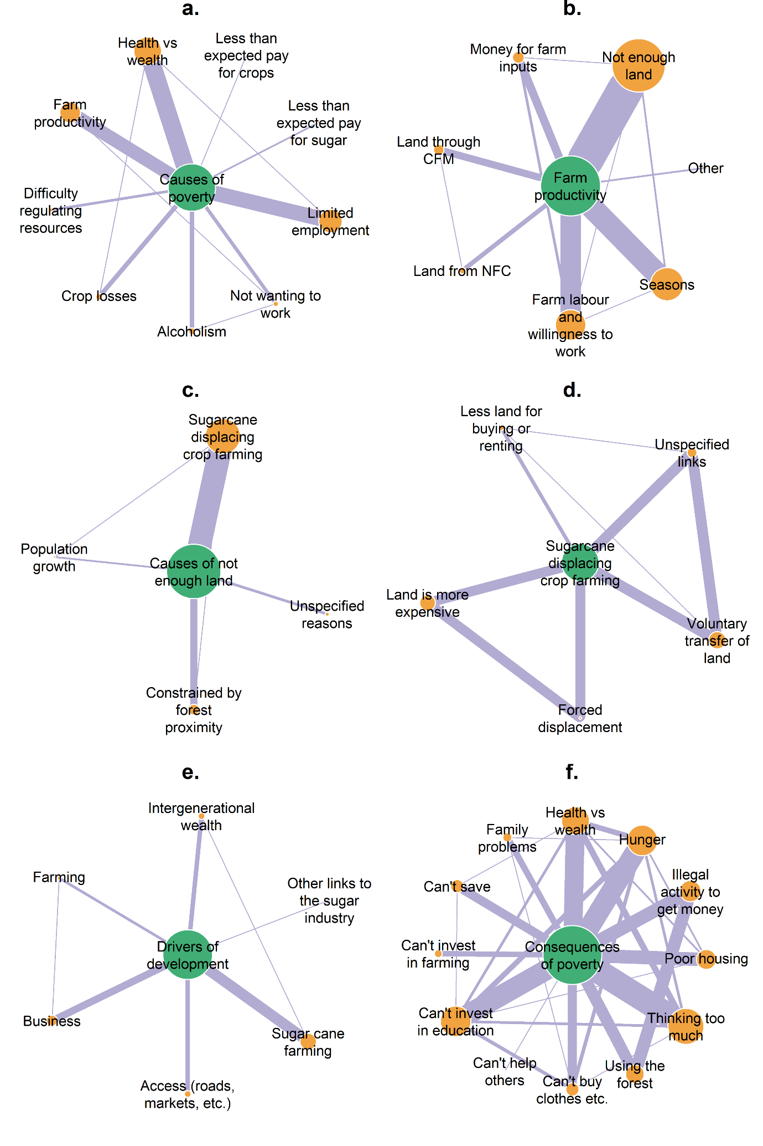

Supplementary Fig. 1. The width of the lines illustrates the number of interviews that reported connections between nodes but did not imply the direction of the causality of connections. The size of the node represents the number of interviews mentioning the associated theme for that node. Panel a. illustrates the reported causes of poverty and inadequate money. Panel b. illustrates reported factors affecting farm productivity (CFM = Community Forest Management, NFC = Nyabyeya Forestry College). Panel c. describes the reported causes of inadequate land. Panel d. illustrates the reported role of the sugarcane industry in displacing smallholder farming. Panel e. describes reported factors that contributed to household development. Panel f. illustrates the reported consequences of poverty and inadequate money.

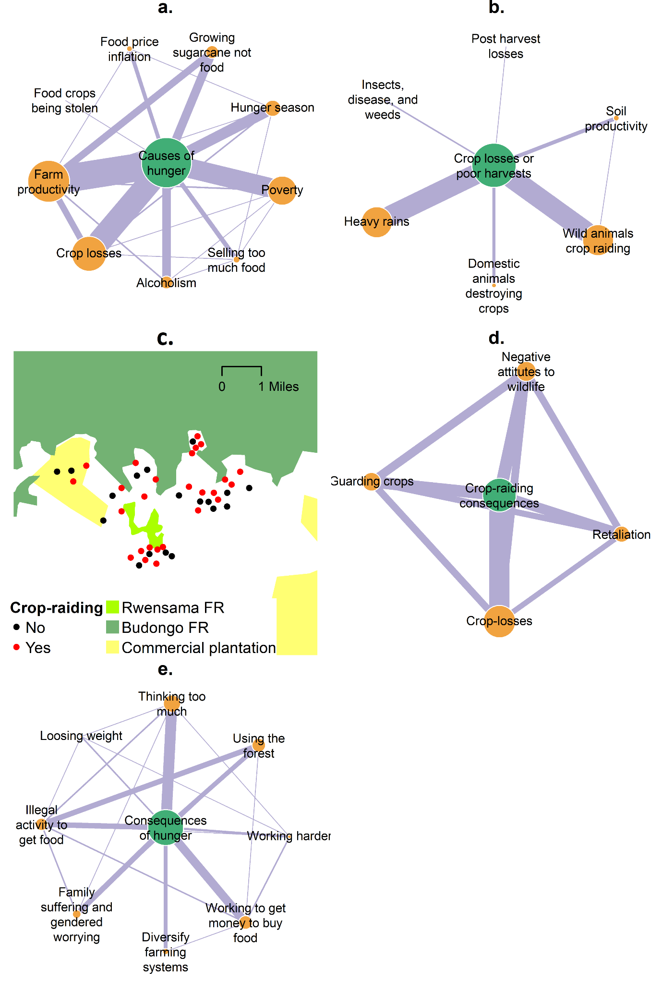

Supplementary Fig. 2. The width of the lines illustrates the number of interviews that reported connections between nodes but did not imply the direction of the causality of connections. The size of the node represents the number of interviews mentioning the associated theme for that node. Panel a. illustrates the reported causes of hunger and inadequate food. Panel b. describes reported factors causing crop losses. Panel c. shows the locations of interviews that report crop-raiding by wildlife (manually dislocated to retain anonymity). Panel d. illustrates the consequences of crop-raiding by wildlife, particularly among farmers bordering the Budongo and Rwensama Forest Reserves. Illustrates the reported consequences of experiencing hunger or inadequate food.

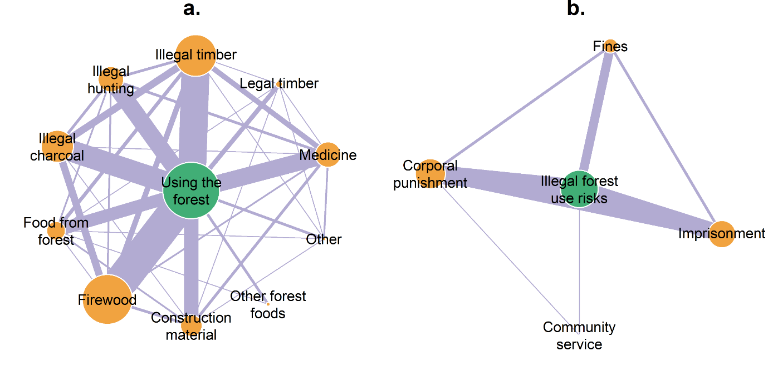

Supplementary Fig. 3. The width of the lines illustrates the number of interviews that reported connections between nodes but did not imply the direction of the causality of connections. The size of the node represents the number of interviews mentioning the associated theme for that node. Panel a. illustrates the reported uses of the forest. Panel b. describes the risks associated with illegal activities in the forest.

**References**

Babweteera, F., Sheil, D., Reynolds, V., Plumptre, A.J., Zuberbuhler, K., Hill, C.M., Webber, A. & Tweheyo, M. (2012) Environmental and anthropogenic changes in and around Budongo Forest Reserve. In *The Ecological Impact of Long-term Changes in Africa’s Rift Valley* (ed A.J. Plumptre), pp. 31-53. Nova Science Publishing Inc., Hauppauge, United States.

Colding, J. & Barthel, S. (2019) Exploring the social-ecological systems discourse 20 years later. *Ecology and Society,* **24,** 2.

Csárdi, G. & Nepusz, T. (2006) The igraph software package for complex network research. *InterJournal Complex Systems,* **1695,** 1-9.

Eilu, G. & Bukenya-Ziraba, R. (2004) Local use of climbing plants of Budongo Forest Reserve, western Uganda. *Journal of Ethnobiology,* **24,** 307–327.

Hill, C.M. (2015) Perspectives of “conflict” at the wildlife–agriculture boundary: 10 years on. *Human Dimensions of Wildlife,* **20,** 296-301.

Jeary, K., Kandel, M., Martiniello, G. & Twongyirwe, R. (2018) Conservation and agriculture: Finding an optimal balance? In *Conservation and Development in Uganda* (eds C. Sandbrook, C.J. Cavanagh & D.M. Tumusiime), pp. 189-205. Routledge, London, United Kingdom.

Johnstone, L., Boyle, M., Cromby, J., Dillon, J., Harper, D., Kinderman, P. & Read, J. (2018) *The power threat meaning framework*. British Psychological Society, Leicester, United Kingdom.

Kinyanda, E., Waswa, L., Baisley, K. & Maher, D. (2011a) Prevalence of severe mental distress and its correlates in a population-based study in rural south-west Uganda. *BMC Psychiatry,* **11,** 1-9.

Koenen, K., Rudenstine, S., Susser, E. & Galea, S. (2013) Life course approaches to mental illness: The emergence of a concept. In *A Life Course Approach to Mental Disorders* (eds K. Koenen, S. Rudenstine, E. Susser & S. Galea), pp. 1-7. Oxford University Press, Oxford, United Kingdom.

Liu, J., Dietz, T., Carpenter, S.R., Alberti, M., Folke, C., Moran, E., Pell, A.N., Deadman, P., Kratz, T., Lubchenco, J., Ostrom, E., Ouyang, Z., Provencher, W., Redman, C.L., Schneider, S.H. & Taylor, W.W. (2007) Complexity of coupled human and natural systems. *Science,* **317,** 1513-1516.

McGorry, P., Keshavan, M., Goldstone, S., Amminger, P., Allott, K., Berk, M., Lavoie, S., Pantelis, C., Yung, A., Wood, S. & Hickie, I. (2014) Biomarkers and clinical staging in psychiatry. *World Psychiatry,* **13,** 211-223.

McGorry, P. & van Os, J. (2013) Redeeming diagnosis in psychiatry: Timing versus specificity. *The Lancet,* **381,** 343-345.

Nabwire, L. (2015) *Uganda’s dilemmas in the transition to modern commercial agriculture: Implications for the poverty reduction agenda*. Future Agricultures Consortium Secretariat at the University of Sussex, Brighton, United Kingdom.

Oryx (2001) Code of conduct for researchers contributing articles to Oryx - The International Journal of Conservation. *Oryx,* **35,** 99-100.

Palinkas, L.A., Horwitz, S.M., Green, C.A., Wisdom, J.P., Duan, N. & Hoagwood, K. (2015) Purposeful sampling for qualitative data collection and analysis in mixed method implementation research. *Administration and Policy in Mental Health,* **42,** 533-544.

Paterson, J.D. (1991) The ecology and history of Uganda's Budongo forest. *Forest & Conservation History,* **35,** 179-187.

Plumptre, A.J., Davenport, T.R.B., Behangana, M., Kityo, R., Eilu, G., Ssegawa, P., Ewango, C., Meirte, D., Kahindo, C., Herremans, M., Peterhans, J.K., Pilgrim, J.D., Wilson, M., Languy, M. & Moyer, D. (2007) The biodiversity of the Albertine Rift. *Biological Conservation,* **134,** 178-194.

R Core Team (2020) R: A language and environment for statistical computing. R Foundation for Statistical Computing, Vienna, Austria.

Ridner, S.H. (2004) Psychological distress: Concept analysis. *Journal of Advanced Nursing,* **45,** 536-545.

Sharma, G. (2017) Pros and cons of different sampling techniques. *International Journal of Applied Research,* **3,** 749-752.

Tsuang, M.T., Bar, J.L., Stone, W.S. & Faraone, S.V. (2004) Gene-environment interactions in mental disorders. *World Psychiatry,* **3,** 73-83.

Tumusiime, D.M., Eilu, G., Tweheyo, M. & Babweteera, F. (2010) Wildlife snaring in Budongo forest reserve, Uganda. *Human Dimensions of Wildlife,* **15,** 129-144.

VandenBos, G.R. (2007) *APA Dictionary of Psychology,* American Psychological Association, Washington, DC, United States.