Supplementary materials
Safeguarding Asian tapir habitat in Sumatra, Indonesia
Irene M.R. Pinondang*^{Ɨ}, Nicolas J. Deere, Maria Voigt, Ardiantiono, Agus Subagyo, Alexander Moßbrucker, Antika Fardilla, Desy S. Chandradewi, Fahrudin Surahmat, Febri A. Widodo, Gabriella Frediksson, Hariyo T. Wibisono, Jatna Supriatna, M. Irfansyah Lubis, Nuri Asmita, Sunarto, Tengku Lidra, Tomi Ariyanto, Wido R. Albert, Wilson Novarino, Wulan Pusparini, Yoan Dinata, Matthew J. Struebig

Table S1. Details of camera trap campaigns and total survey effort in each of nine landscapes surveyed in Sumatra.
Landscape | Government partner | Survey periods | Target species | Grid size (km) | Total stations | Camera trap/  station | Camera station description | Total trapdays | Trap spacing (km) | Description of human activities in the area
Bukit Barisan Selatan | Wildlife Conservation Society | May- Nov 2015 | Tiger and prey | 3x3 | 63 | Pair | High probability to capture tiger | 8799 | 2,14  (1.51 – 46.47) | Illegal hunting, encroachment
Berbak Sembilang |  | Mar 2015 - May 2016 | Tiger and prey | 3x3 | 105 | Pair | High probability to capture tiger | 14178 | 2.15  (0.5 - 67.78) | Illegal hunting (low), encroachment (medium), fire forest (medium)
Dangku |  | Jan-Apr 2015 | Tiger and prey | 2x2 | 10 | Pair | Forest cover | 801 | 3.54  (1.82 - 18.42) | Illegal hunting (low), encroachment (medium), fire forest (medium)
Bukit Rimbang Bukit Baling |  | Aug-Dec 2015 | Tiger and prey | 2x2 | 72 | Pair | NA | 6913 | 2.24  (1.34 - 82.81) | Illegal hunting, encroachment
Tesso Nilo |  | Jul 2013-Oct 2015 | Tiger and prey, elephant | 2x2 | 25 | Pair | NA | 2364 | 2.52  (1.87 - 20.57) | Illegal hunting (low), encroachment (medium), fire forest (medium)
Kerinci Seblat | Fauna & Flora International, Andalas University | Mar 2016 -Feb 2017 | Tiger and prey | 3.5x3.5 | 75 | Pair, single | High probability to capture tiger | 9993 | 2.20  (0.9 - 123) | Illegal hunting, encroachment
Batang Toru | Sumatran Orangutan Conservation Program | Feb-Jun 2015 | Not specified | Not specified | 58 | Single | Primary and secondary forest | 1966 | 1.19  (1.03 - 11.78) | Not specified
Way Kambas | Sumatran Tiger Trust | Jun-Dec 2015 | Tiger and prey | 2x2 | 69 | Single | High probability to capture tiger | 7833 | 1.89  (1.04 - 30.21) | Illegal hunting, encroachment
Bukit Tigapuluh | Sumatran Tiger Trust, Frankfurt Zoological Society | Jun-Dec 2015 | Tiger and prey | 2x2 | 107 | Single | High probability to capture tiger | 7471 | 1.71  (1.01 - 63.41) | Illegal hunting, encroachment

Table S2. The amount of critical and suitable tapir habitat predicted in protected and non-protected areas.
Status/Name | Area size  (km²) | Landscape-specific prediction (km²) |  | Sumatra-wide prediction  (km²)
 |  | Critical  (20th percentile) | Suitable (60-20th percentile) | Critical  (20th percentile) | Suitable (60-20th percentile)
Prediction
Suitable area |  |  |  | 15,363 | 28,525
Protected areas |  | 5,997 | 12,466 | 5,431 | 11,998
Arau Hilir & Air Terusan¹ | 914 |  | - | 612 | 204
Air Putih⁴ | 64 |  | - | 27 | 37
Barisan¹ | 41 |  | - | 23 | 23
Barumun¹ | 403 |  | - | 80 | 210
Batang Gadis³ | 731 |  | - | 8 | 307
Batang Pangean I, II² | 483 |  | - | 129 | 266
Berbak Sembilang³ | 4,118 | 2 | 208 | 37 | 434
Bukit Barisan Selatan³ | 3,177 | 1,009 | 1,512 | 715 | 1,182
Bukit Batu¹ | 217 |  | - | 71 | 182
Bukit Bungkuk² | 140 |  | - | 102 | 124
Bukit Duabelas³ | 551 |  | - | - | 1
Bukit Kaba⁴ | 147 |  | - | 37 | 3
Bukit Rabang⁵ | 5 |  | - | 1 | 1
Bukit Rimbang Bukit Baling¹ | 1,426 | 272 | 911 | 241 | 809
Bukit Tigapuluh³ | 1,451 | - | 9 | - | 6
Buluh Cina⁴ | 11 |  | - | 4 | 3
Dangku¹ | 483 | - | 31 | - | 36
Dolok Sibual-buali^{2,*} | 50 | 390 | 1,351 | 45 | 9
Dolok Sipirok^{2,*} | 72 |  | - | 53 | 56
Dolok Surungan¹ | 216 |  | - | 148 | 130
Giam Siak Kecil¹ | 787 |  | - | 21 | 147
Gumai Pasemah¹ | 482 |  | - | 87 | 198
Gunung Marapi⁴ | 80 |  | - | 48 | 30
Gunung Raya¹ | 453 |  | - | 76 | 53
Gunung Sago Malintang⁴ | 53 |  | - | - | 53
Isau-isau Pasemah¹ | 168 |  | - | 30 | 27
Kerinci Seblat³ | 13,653 | 4,226 | 8,015 | 2,209 | 6,592
Kerumutan¹ | 953 |  | - | - | 7
Lembah Anai² | 3 |  | - | 1 | 2
Lembah Harau² | 41 |  | - | 22 | 14
Lubuk Raya^{2,*} | 30 |  | - | 18 | 4
Malampah Alahan Panjang¹ | 394 |  | - | 220 | 131
Maninjau² | 220 |  | - | 118 | 34
Mega Mendung⁴ | 1 |  | - | - | 1
Orang Kayo Hitam⁵ | 183 |  | - | 38 | 79
Rimbo Panti^{2,4} | 31 |  | - | 8 | 15
Seblat⁴ | 78 |  | - | 1 | 9
Singgalang Tandikek⁴ | 98 |  | - | 70 | 18
Tasik Belat¹ | 25 |  | - | - | 14
Tasik Besar¹ | 50 |  | - | - | 11
Tasik Serkap-Tasik Sarang Burung ¹ | 67 |  | - | - | 15
Tesso Nilo³ | 822 | - | 41 | 6 | 159
Wan Abdul Rahman⁵ | 218 |  | - | 26 | 8
Way Kambas³ | 1,292 | 98 | 388 | 74 | 205
Zamrud³ | 316 |  | - | 25 | 150
Non-protected areas |  |  | - | 9,932 | 16,527
Non-forest (area penggunaan lain) | 176,264 |  | - | 1,217 | 1,630
Wastersheds-protected forests (hutan lindung) | 54,256 |  | - | 5,501 | 7,168
Production forest (hutan produksi) | 63,146 |  | - | 1,179 | 3,322
Convertible production forests (hutan produksi konversi) | 52,626 |  | - | 158 | 374
Limited production forests (hutan produksi terbatas) | 38,361 |  | - | 1,877 | 4,033

Remark
¹ Wildlife reserve
² Nature reserve
³ National park
⁴ Nature recreational park
*Batang Toru landscape

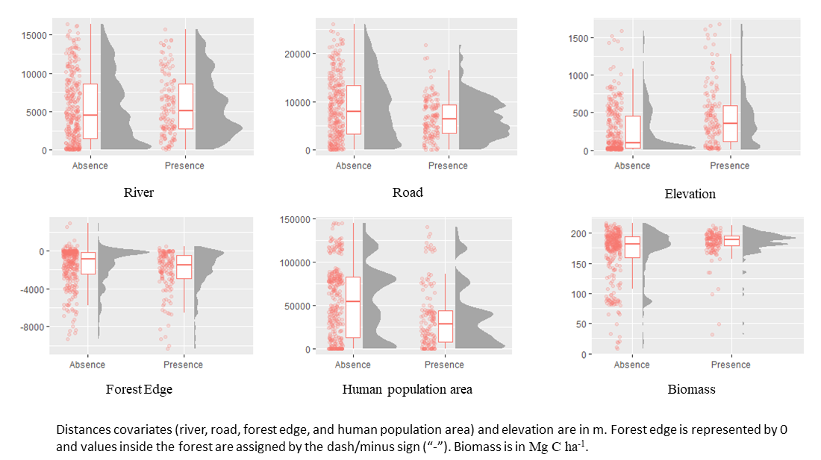
Figure S1. The distributions of tapir presences and absences at camera trap localities in relation to each covariate used to model habitat suitability.

