Assessment of the global population size of the Mongolian gazelle Procapra gutturosa

Bayarbaatar Buuveibaatar, Samantha Strindberg, Barkhasbaatar Ariunbaatar, Sodnompil Batdorj, Tsogt Batzaya, Tserendeleg Dashpurev, Nandintsetseg Dejid, Vadim E. Kiriliuk, Thomas Mueller, Galsandorj Naranbaatar, Baatargal Otgonbayar, Enkhtuvshin Shiilegdamba, Jambalsuren Tsolmon, Dorj Usukhjargal,
Ganbold Uuganbayar, Kirk A. Olson

Supplementary material is published as supplied by the authors. It is not checked for accuracy, copyedited, typeset or proofread. The responsibility for accuracy and file functionality remains with the authors.

Supplementary Fig. 1 Detection probability functions for Mongolian gazelle Procapra gutturosa groups in the Southern Gobi in 2019. Note that the resulting density estimates using the hazard rate or any of the other two (below) detection functions are very similar and the difference in Akaike information criterion (AIC) values for these models is < 2, so they have equal weight in the data. (a) Half-normal with no adjustment terms detection function with same right-truncation at 350m and 4 intervals. 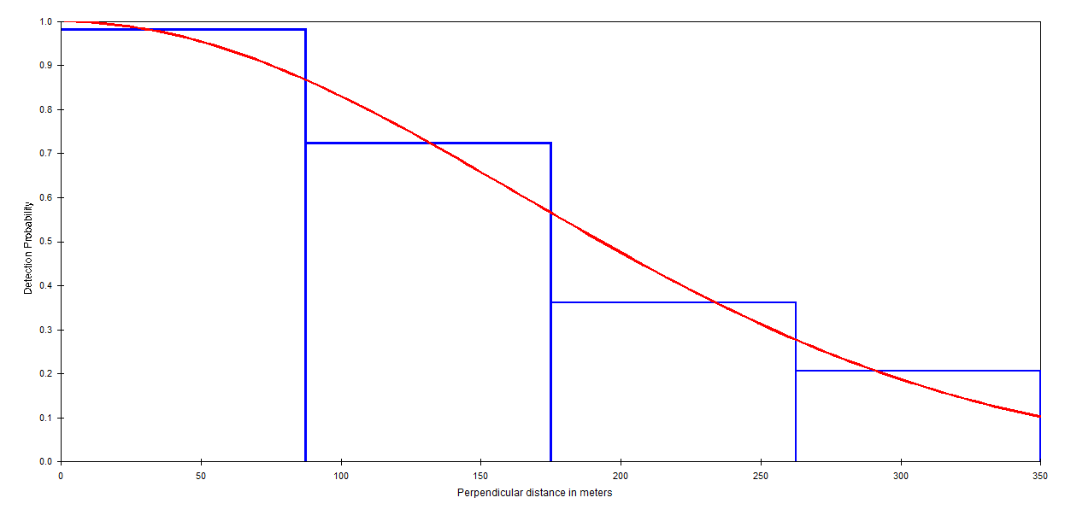
(b) Uniform with cosine adjustment terms detection function with same right-truncation at 350 m and 4 intervals. 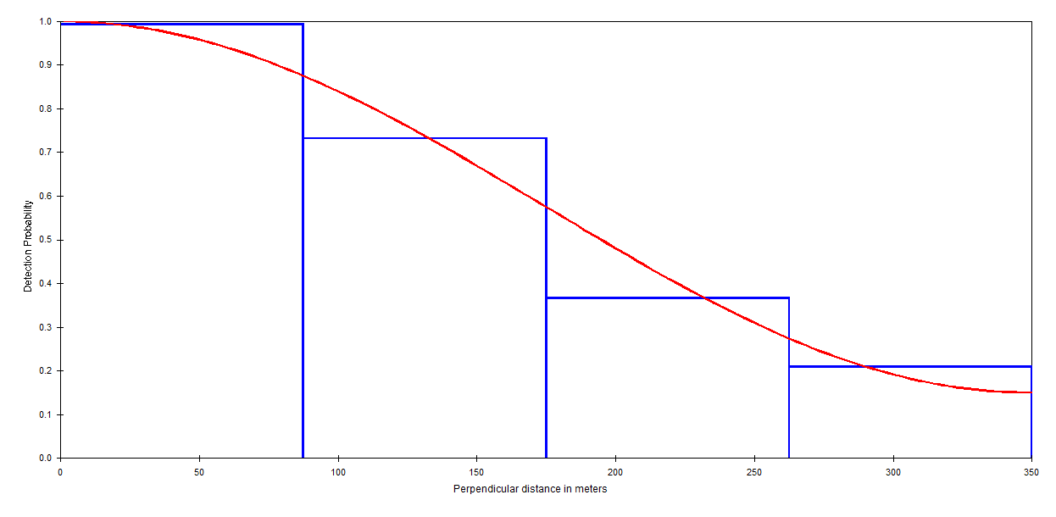

(c) Log(cluster size) plotted against detection probability g(x):
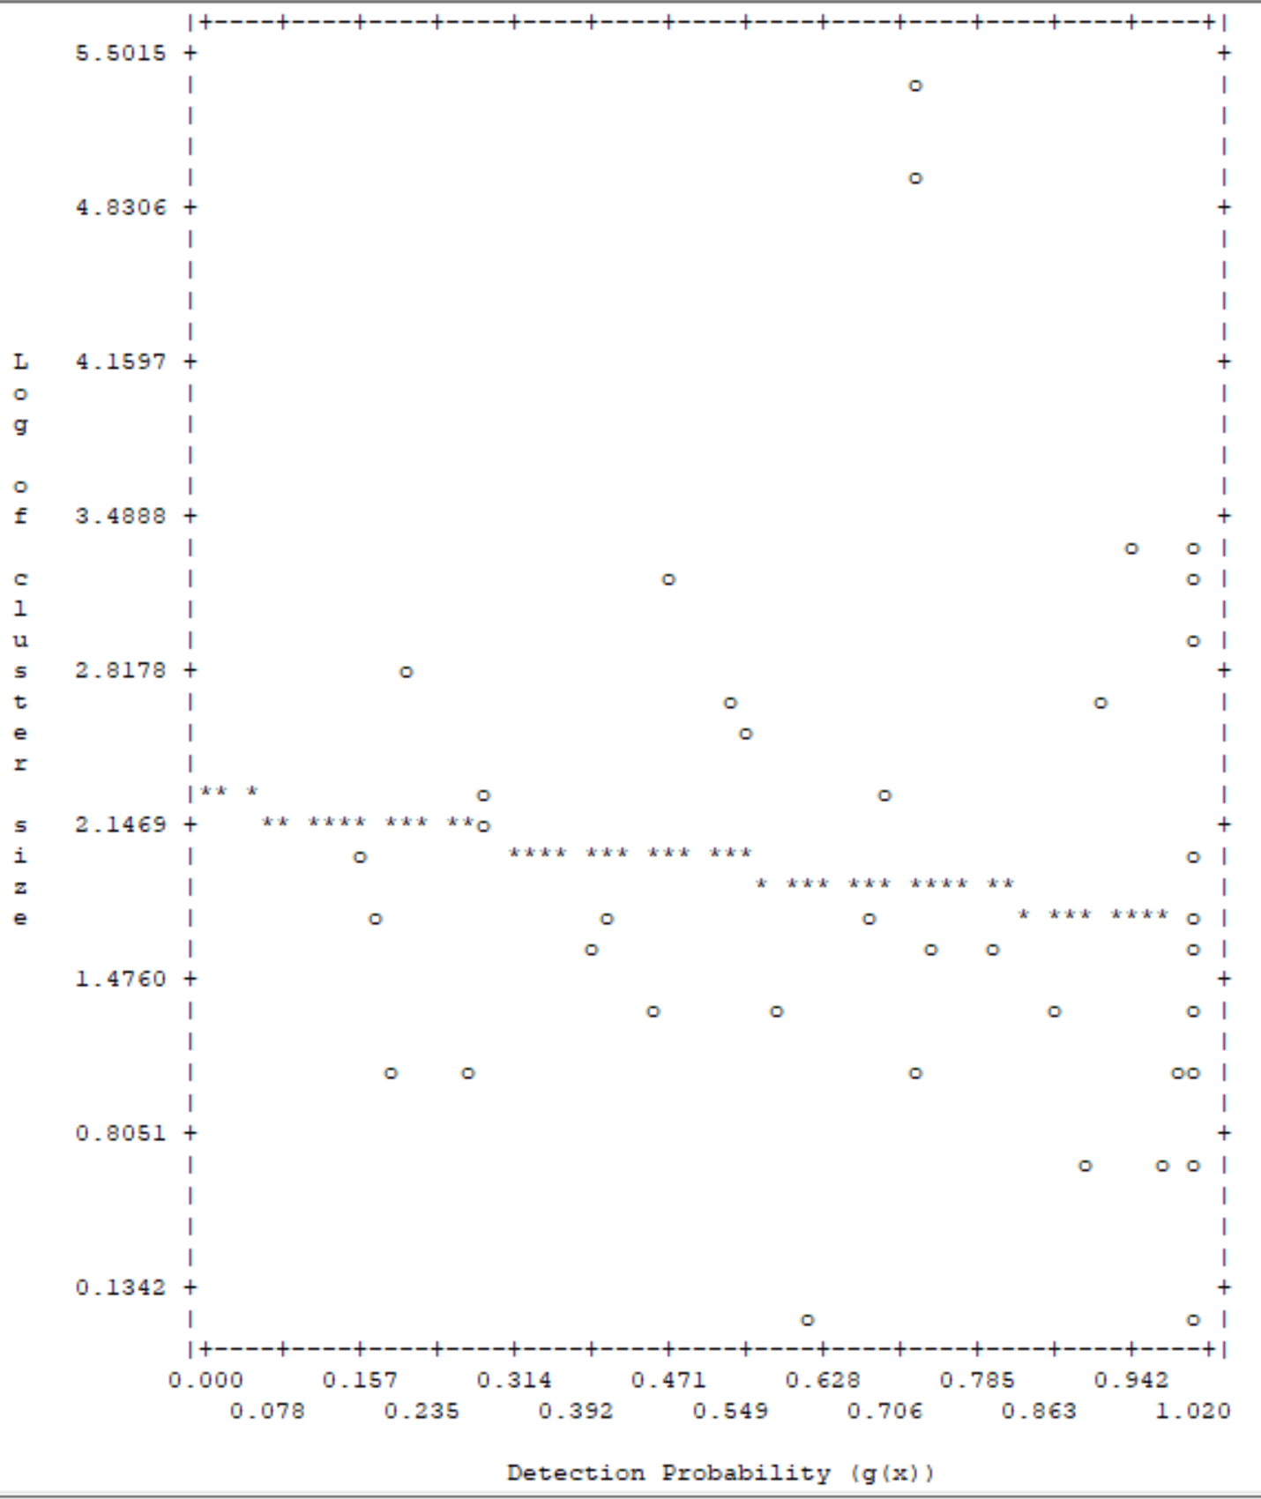

(d) Detailed plot of the distance sampling data in 30 intervals out to the maximum distance (841m):
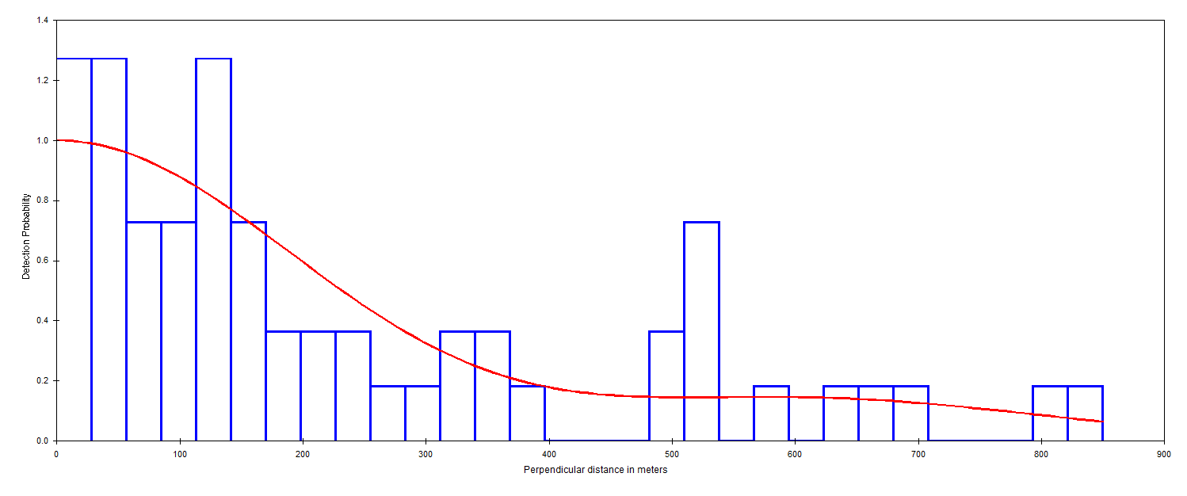
(e) Detailed plot of the distance sampling data in 15 intervals out to the truncation distance (350m):
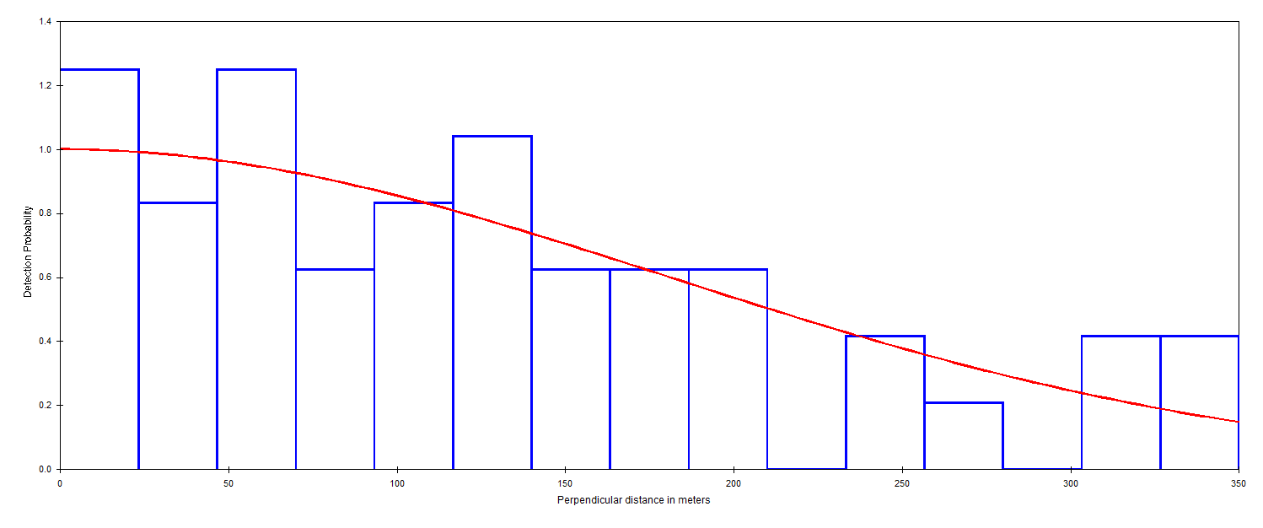

Supplementary Fig. 2 Detection probability functions for Mongolian gazelle groups in the Central and Eastern Mongolia region in 2020. Note that the resulting density estimates using the hazard rate or any of the other two (below) detection functions are very similar and the difference in AIC values for these models is < 3.35.
(a) Half-normal with cosine adjustment terms detection function with same right-truncation at 1,221m (5% of the data) and 7 intervals:
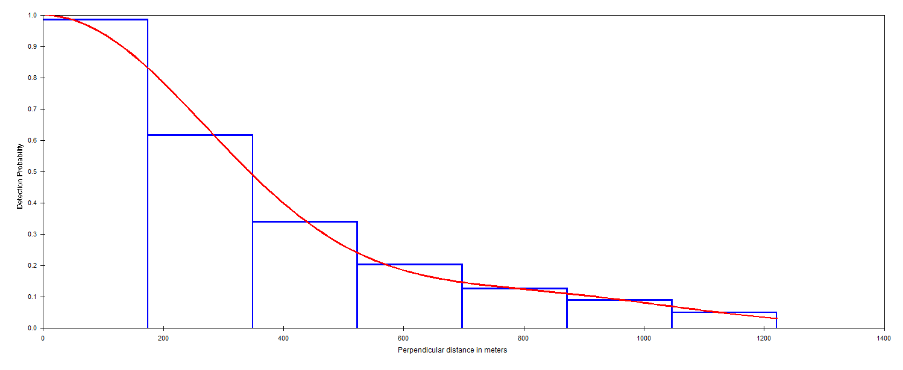
(b) Uniform with cosine adjustment terms detection function with same right-truncation at 1,221m (5% of the data) and 7 intervals:
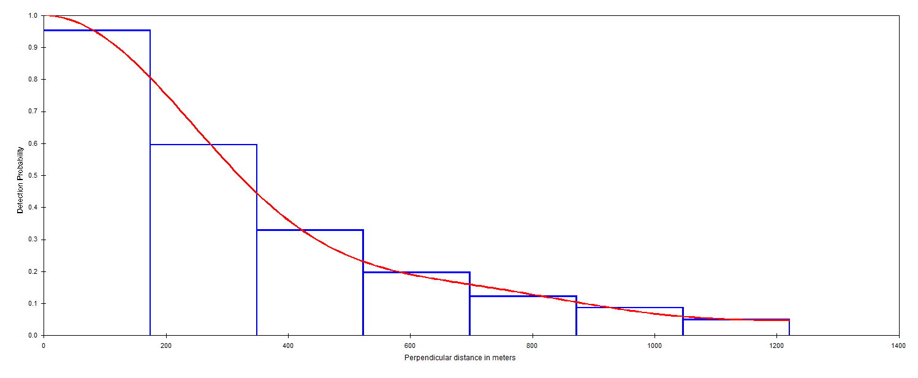

(c) Log(cluster size) plotted against detection probability g(x):

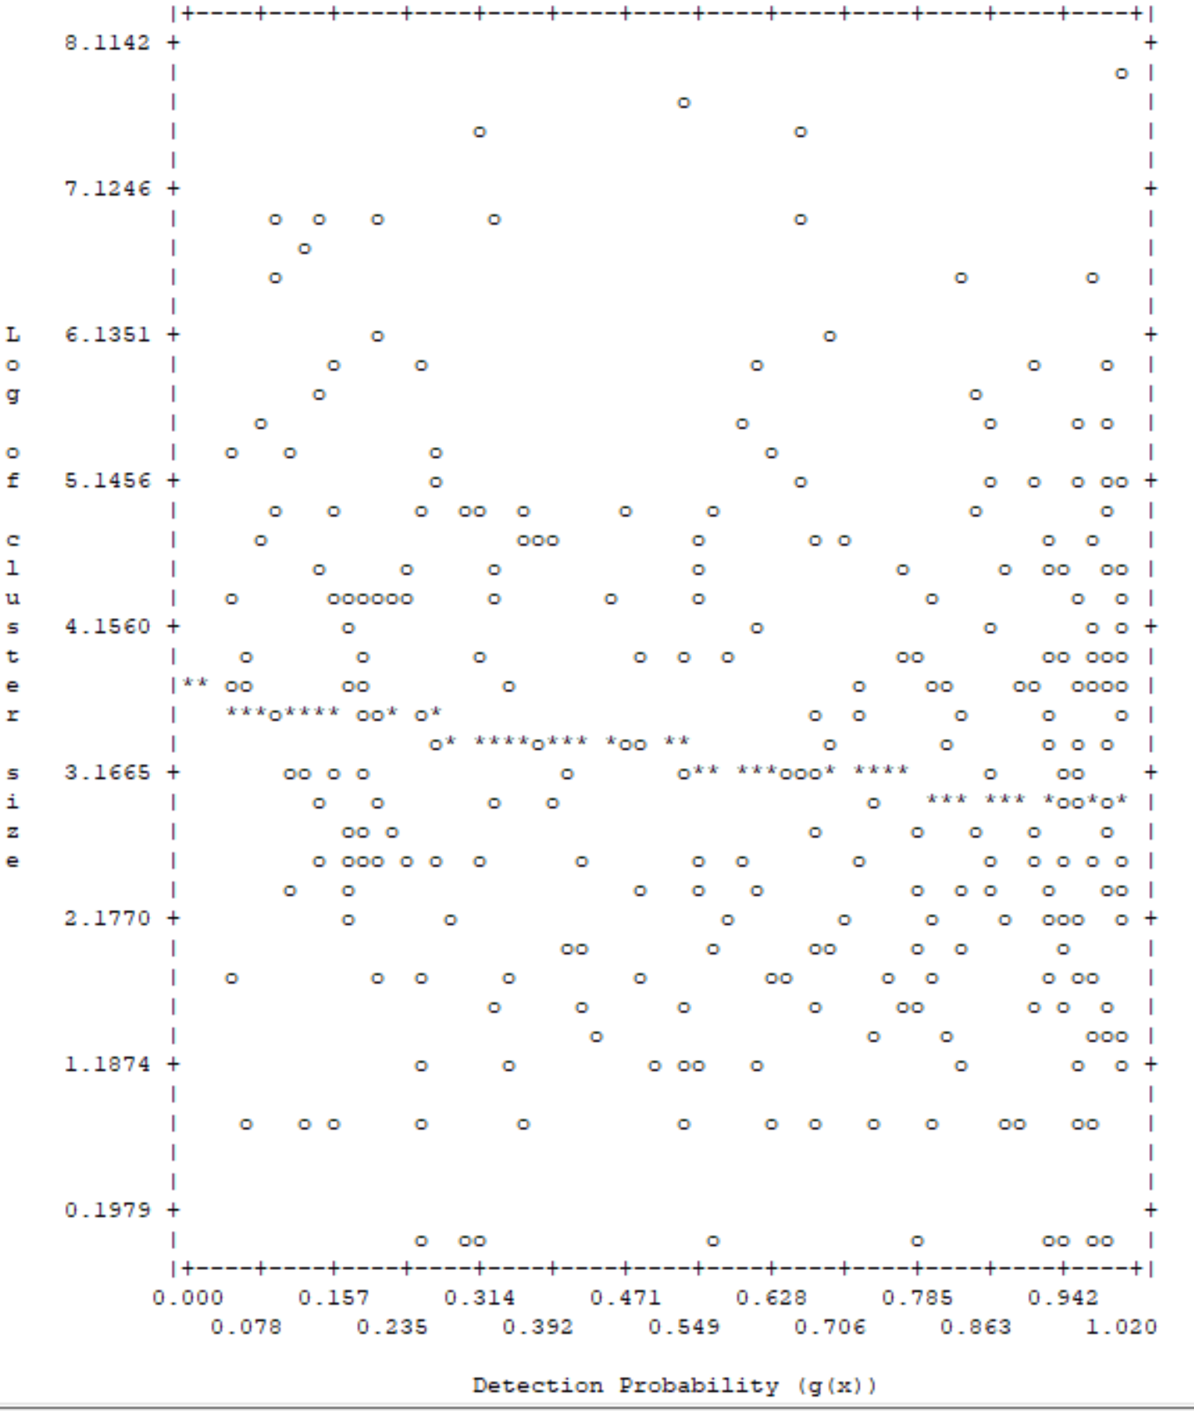

(d) Detailed plot of the distance sampling data in 30 intervals out to the maximum distance (2,989m):
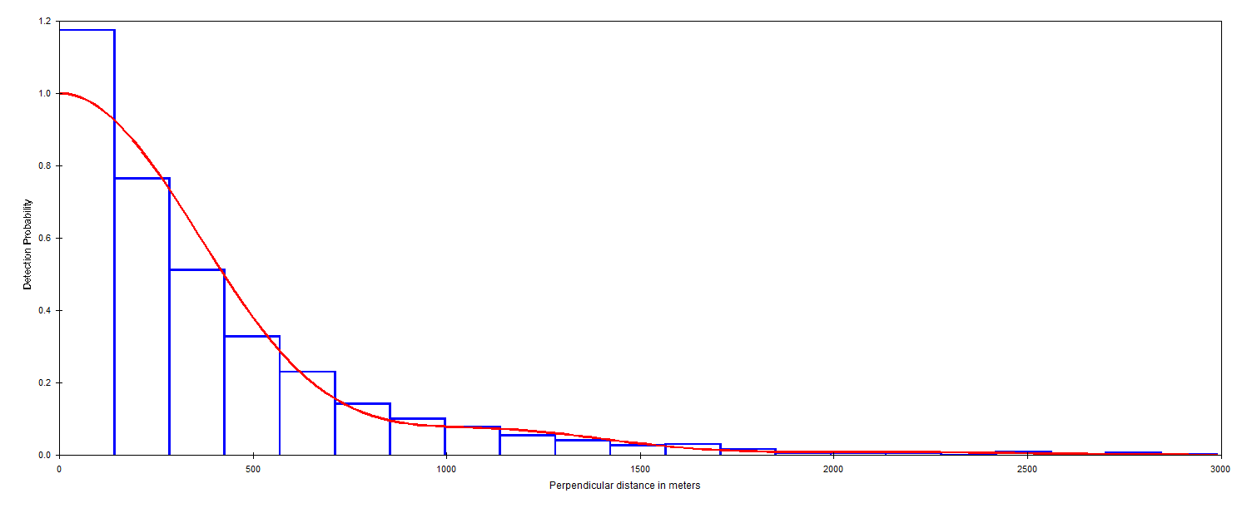
(e) Detailed plot of the distance sampling data in 30 intervals out to the truncation distance (1,221m):
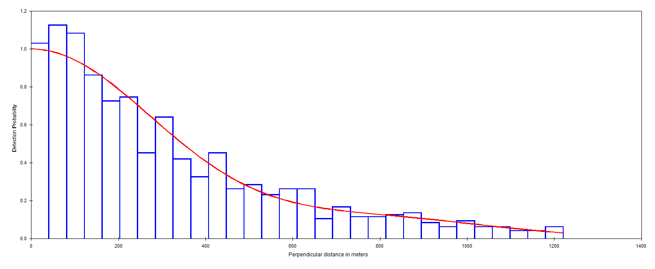

Supplementary Table 1 Overall density and abundance estimate of gazelle Procapra gutturosa populations in Mongolia and Russia.
Countries | Survey regions | Density  (/km²) | Study area  (km²) | Abundance  (95% CI)
Mongolia | Southern Gobi | 0.52 | 98,216 | 40,899  (16,307–102,580)
 | Central & eastern Mongolia | 4.72 | 433,245 | 1,991,300  (1,464,900–2,706,700)
 | Khomiin Tal National Park | 0.27 | 4,114 | 1,134
 | South-western Mongolia | 0.75 | 146,288 | 109,716
 |  | Overall | 681,863 | 2,143,049
Russia | Daursky and Dzeren Valley Protected Areas | 3.30 | 6,572 | 21,701  (20,616–22,785)
 | West Krasnokamensk | 5.50 | 766 | 4,214
 | North Onon River | 0.37 | 1,320 | 485
 | Sokhondinsky Nature Reserve | 3.43 | 962 | 3,300
 | North Daursky | 0.75 | 469 | 350
 |  | Overall | 10,089 | 30,050

