Evaluating the effectiveness of protected area management in Indonesia

Rudijanta Tjahja Nugraha, Wenda Yandra Komara, Peggy Awanti Nila Krisna, Oktafa Rini Puspita, Muhamad Muslich, Ulfah Mardhiah, and William Marthy

Supplementary material is published as supplied by the authors. It is not checked for accuracy, copyedited, typeset or proofread. The responsibility for accuracy and file functionality remains with the authors.

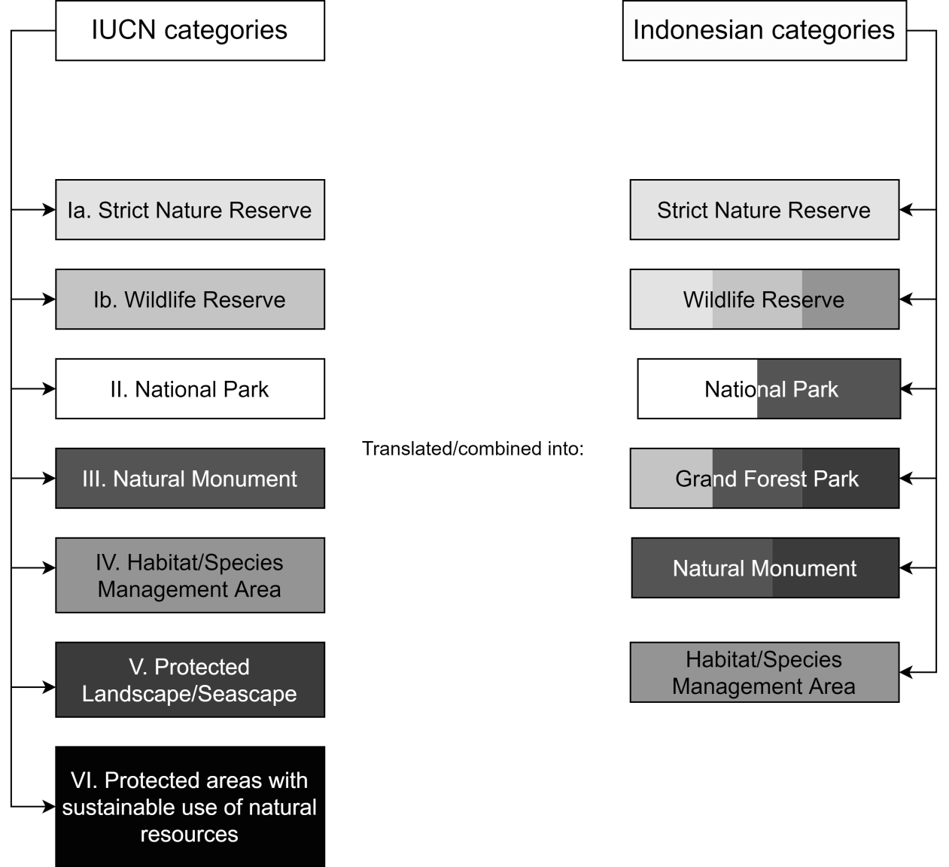

Supplementary Fig. 1 Mapping of Indonesian protected area categories to equivalent IUCN definitions.

Supplementary Material 1 Example of an adapted METT evaluation form question (question 2, regarding protected area regulations). The Indonesian version is shown (top), with the English translation (bottom).

- Peraturan kawaasan konservasi
Indikator | Apakah ada peraturan yang memadai untuk mengendalikan penggunaan lahan dan kegiatan?
Pengertian | Indikator peraturan kawasan dapat merujuk pada hukum (legal) yakni seluruh peraturan terkait pengelolaan kawasan konservasi, maupun kontrol adat bagi kawasan yang dikelola secara kolaboratif harus memiliki aturan yang jelas mengenai batas-batas penggunaan lahan dan air yang kemudian diakomodasi dalam zona/blok pengelolaan dan disahkan oleh Dirjen KSDAE.
Nilai 0 | Tidak ada peraturan yang mengatur penggunaan lahan dan kegiatan di kawasan konservasi | Di Indonesia sudah ada peraturan mengenai kegiatan dan penggunaan lahan di KK | Peran fasilitator:  - Mengarahkan diskusi mengenai keberadaan peraturan pengendalian penggunaan lahan/kegiatan serta kesesuaiannya dengan kontrol adat, bukan pada tataran implementasinya.  - Meminta peserta menyepakati kondisi terkait isu status kawasan yang sudah diverifikasi ulang dengan sumber pembuktian, kemudian mentransferkan kesimpulan ke kriteria nilai yang cocok.
Nilai 1 | Ada beberapa peraturan yang mengendalikan penggunaan lahan dan kegiatan di kawasan konservasi tetapi masih ada kekurangan-kekurangan besar
Nilai 2 | Ada peraturan yang mengendalikan penggunaan lahan dan kegiatan di kawasan konservasi tetapi masih ada beberapa kelemahan atau gap | Apabila penataan Zonasi atau blok pengelolaan belum disahkan
Nilai 3 | Terdapat peraturan untuk mengendalikan penggunaan lahan dan kegiatan yang tidak sesuai di dalam kawasan konservasi dan memberikan dasar yang sangat baik bagi pengelolaan | Apabila penataan kawasan (zonas/blok) telah disahkan
Sumber Pembuktian | SK dan peta Penetapan Zonasi/Blok, Rencana Pengelolaan (RP), Dokumen Desain Tapak (untuk zona pemanfaatan) |  | Memastikan sumber pembuktian terlengkapi dengan baik, kalau tidak lengkap dibuat catatan sebagai respon ke depan.
Penilaian Partisipatif | Tim penilai dan peserta bersama-sama mengeksplorasi lebih lanjut isu dan kriteria melalui bukti yang dikumpulkan secara lengkap dan variabel pembuktian dan menyimpulkan kesepakatan |  | Memimpin penilaian partisipatif dan memastikan pembuktian diverifikasi dan disepakati semua pihak.
Indikator Terkait | Status hukum, tujuan kawasan, penegakan hukum, desain kawasan, rencana pengelolaan
Tindak Lanjut | Mendiskusikan tindak lanjut dari indikator peraturan kawasan apakah sudah mengakomodasi permasalahan terkait pengendalian lahan dengan persoalan riil yang dihadapi

- Protected area regulation
Indicator | Are appropriate regulations in place to control land use and activities (e.g. hunting)?
Explanation | Indicator regarding appropriate regulation for the protected area can refer to the legal framework, which is defined as all regulations related to protected areas management, including local customary law for areas which are managed collaboratively. These regulations should indicate clear guidelines regarding boundaries of the use of land and water which is then derived into zones/management blocks validated by the Directorate General for the Conservation of Natural Resources and Ecosystems.
Score 0 | There are no regulations for controlling land use and activities in the protected area | In Indonesia, there is a clear guidelines regarding activities and use of land within Protected Areas. | Role of facilitator:  - Guide the discussion regarding existing regulation that control the use of land/appropriate activities according to local customary law, but not on implementation level.  - Request the participants to agree on the status of the area, verified with evidence documents. Afterwards, participants are required to translate this information to the appropriate score.
Score 1 | Some regulations for controlling land use and activities in the protected area exist but these are major weaknesses
Score 2 | Regulations for controlling land use and activities in the protected area exist but there are some weaknesses or gaps | If Zonation or Management blocks have not yet been legalized.
Score 3 | Regulations for controlling inappropriate land use and activities in the protected area exist and provide an excellent basis for management | If Zonation or Management blocks have been legalized.
Evidence | Decree and zonation/management block maps, management plan, document on site design (for utilization zone) |  | Ensuring that the evidence documents are complete. Note down if any documents are missing to be completed in the next evaluation cycle/as future response.
Participative assessment | Assessment team and participants should explore further any issues or the scoring criteria by collecting all proofs/evidence and agree on the conclusion. |  | Lead the participative assessment and ensure all proofs/evidence are/is verified and agreed by all participants (including external parties)
Related indicator(s) | Legal status, aim of the protected area, law enforcement, site design, management plan
Follow up | Discuss further whether this indicator already accommodate issues regarding land use control and compare with factual problems faced by the participants

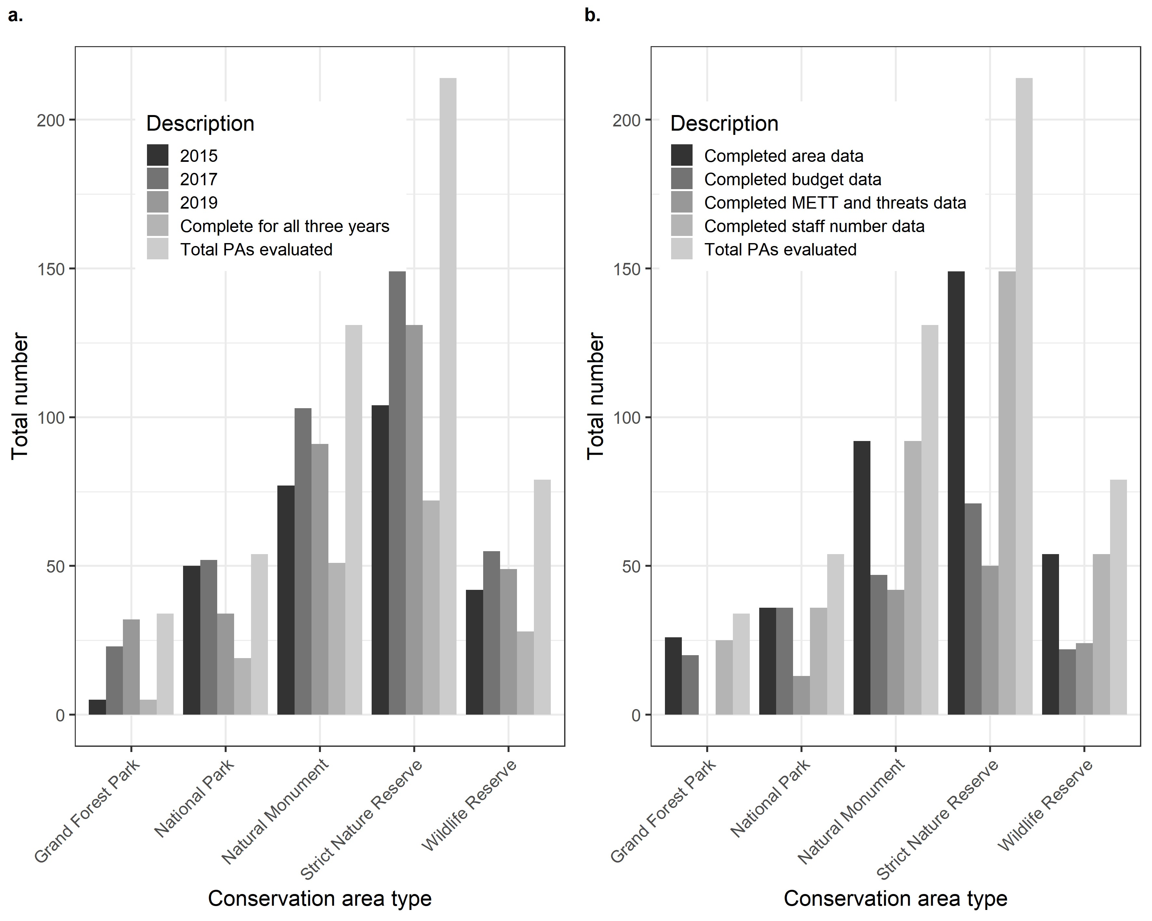
(a) (b)

Supplementary Fig. 2 Types of protected area (PA) in Indonesia that are involved in the management evaluation process, as differentiated by (a) year and (b) completeness of data on protected area size, budget, Management Effectiveness Tracking Tool (METT) and threats, and staff.
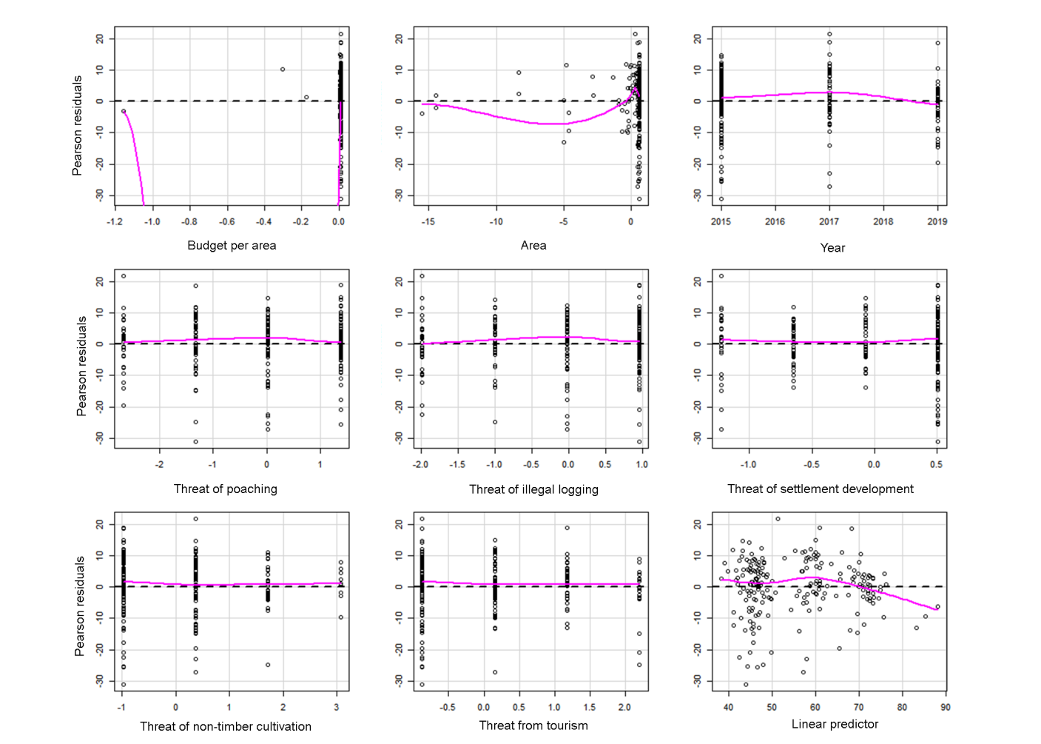

Supplementary Fig. 3 Residual plot of linear regression model between METT score and each of the explanatory variables. There was no extreme temporal pattern when the year of evaluation (top right) was plotted; therefore, no temporal correction was added in the subsequent model.

Supplementary Fig. 4 Residual plot of linear regression model between METT score and the explanatory variables when plotted against their spatial coordinates. Black dots are negative residuals, and grey dots are positive residuals. Several points are clustered indicating spatial autocorrelation, which was later included as a correction factor in the generalized least square model.

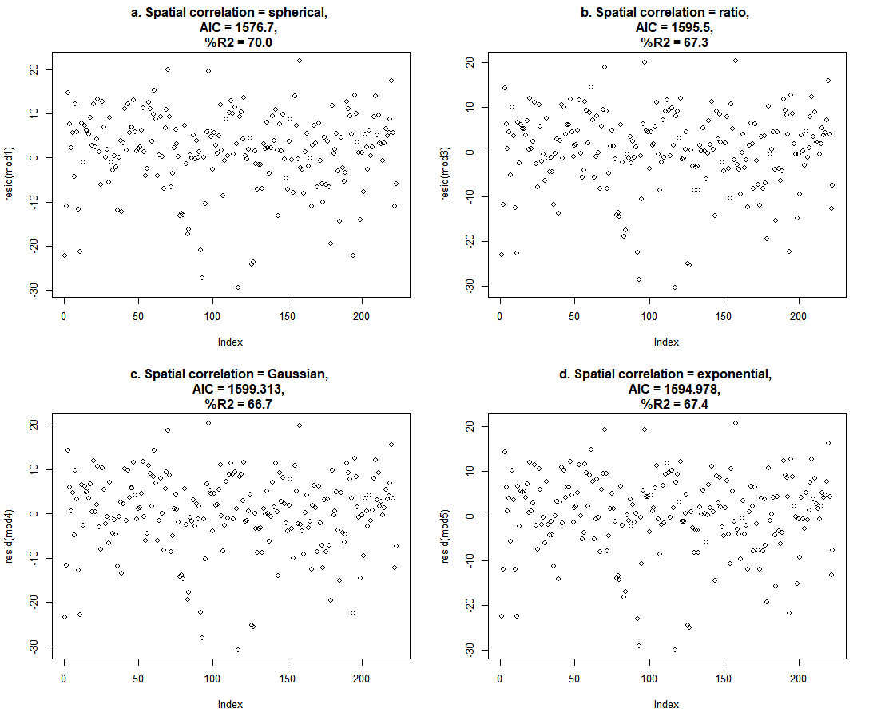
Supplementary Fig. 5 Residual distributions of each model distribution along with their Akaike information criterion (AIC) and %R² values, modeled using different correlation structures: (a) spherical, (b) ratio, (c) Gaussian, and (d) exponential. Adding a spatial correlation structure improved the model, as shown by an improvement of the AIC value compared to the null model (AIC = 1607.9, residual plot not shown).

Supplementary Table 1 Threats observed in protected areas in Indonesia.
Threat category | Threat | Abbreviation used in Supplementary Fig. 7
Development of settlement & commercial building | 1.1 Development of settlement | NA
 | 1.2 Commercial & industrial area | NA
 | 1.3 Tourism infrastructure | NA
Agriculture & fisheries | 2.1a Medicine farming | NA
 | 2.2 Timber & pulp plantations | NA
 | 2.3 Livestock & grazing | NA
 | 2.4 Marine & freshwater aquaculture | Aquaculture
Energy production & mining | 3.1 Oil & gas drilling | NA
 | 3.2 Mining & excavation | NA
 | 3.3 Energy generation, including dams for hydropower | Energy generation
Transportation & service corridors | 4.1 Roads & railroads | NA
 | 4.2 Service lines & services | Service lines
 | 4.3 Shipping lanes & canals | NA
 | 4.4 Flight pathway | NA
Use of, & threats to, biological resources | 5.1 Poaching | NA
 | 5.2 Collection of land plants or plant products (non-timber) (non-timber collection) | NA
 | 5.3 Illegal logging | NA
 | 5.4 Fishing, killing, & harvesting water resources | Water resources harvesting
Human interference | 6.1 Tourism activities | NA
 | 6.2 War, civil unrest, & military exercises | Armed activities/conflict
 | 6.3 Research, education, & other related work | Research/education
 | 6.4 PA management activities | NA
 | 6.5 Vandalism, destructive activities/threats to employees/visitors | Vandalism/destructive activities
Modification of natural systems | 7.1 Fire | NA
 | 7.2 Dams, hydrological modifications, & water management/use | Hydrological modifications/use
 | 7.3a Increased fragmentation | NA
 | 7.3b Habitat isolation | NA
 | 7.3c Edge effect on PA values | NA
 | 7.3d Loss of keystone species | NA
Invasive species/genes | 8.1 Invasive/non-native vegetation | NA
 | 8.1a Invasive/non-native animal | NA
 | 8.1b Pathogen | NA
 | 8.2 Introduction of genetic material | NA
Pollution | 9.1 Domestic/municipal sewage | NA
 | 9.1a Manufacture lines or wastewater | Manufacture lines
 | 9.2 Industrial, mining, & military wastes | Industrial & other waste
 | 9.3 Disposal from agriculture & forestry | Agriculture disposal
 | 9.4 Garbage & solid waste | NA
 | 9.5 Air pollution | NA
 | 9.6 Excess energy | NA
Geological events | 10.1 Volcanic eruption | NA
 | 10.2 Earthquake/tsunami | NA
 | 10.3 Snow/landslide | NA
 | 10.4 Erosion & deposition of salt | NA
Climate change and weather | 11.1 Habitat change & destruction | NA
 | 11.2 Drought | NA
 | 11.3 Extreme temperature | NA
 | 11.4 Storm & flood | NA
Specific cultural & social threats | 12.1 Loss of cultural linkage, local knowledge, and/or management practices | Cultural/knowledge loss
 | 12.2 Natural decline of important cultural site values | Cultural site natural decline
 | 12.3 Destruction of cultural heritage buildings, parks, sites, etc. | Cultural heritage destruction

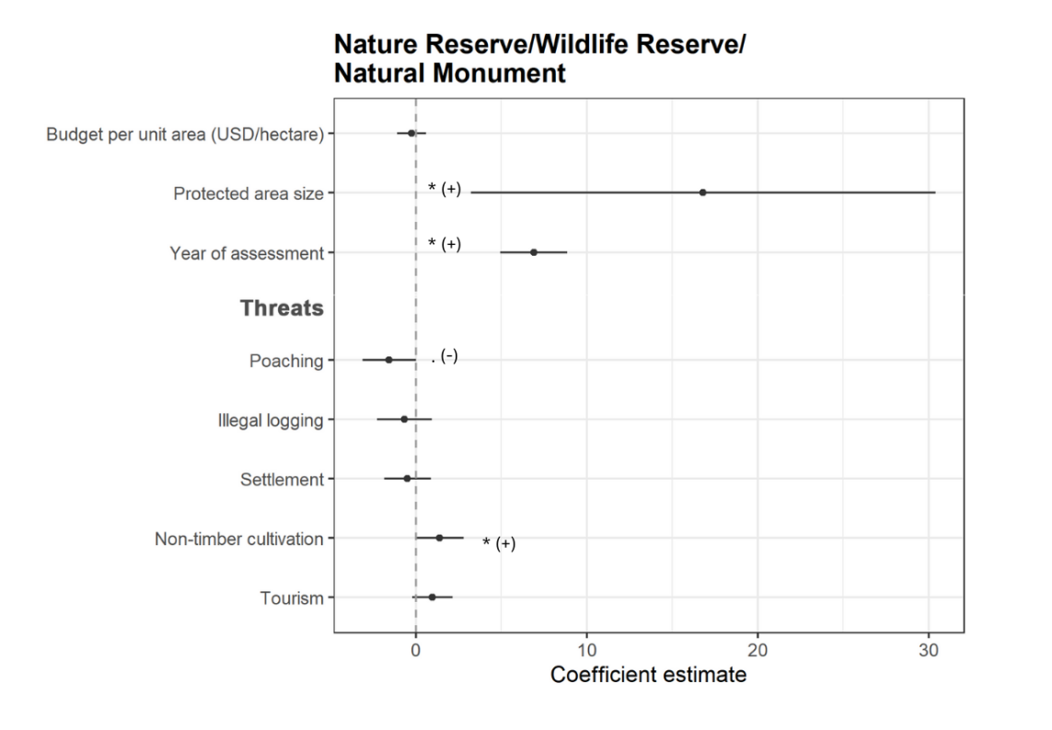

Supplementary Fig. 6 Coefficient estimates (with 95% confidence intervals) for all variables that may influence the management effectiveness of protected areas in Indonesia, separated by site type (top: Nature Reserve/Wildlife Reserve/Natural Monument, bottom: National Park), which were tested based on the following equation: METT score ~ Budget per unit area of protected area size + protected area size + year of assessment + threat 1 + threat 2 + threat 3 + threat 4 + threat 5. The asterisk (*) shows significant correlation at P-value < 0.05, and dot (.) shows P-value = 0.051. The plus (+) and minus (-) show the direction of correlation (positive or negative, respectively). Ratio correlation structure was added to both models.

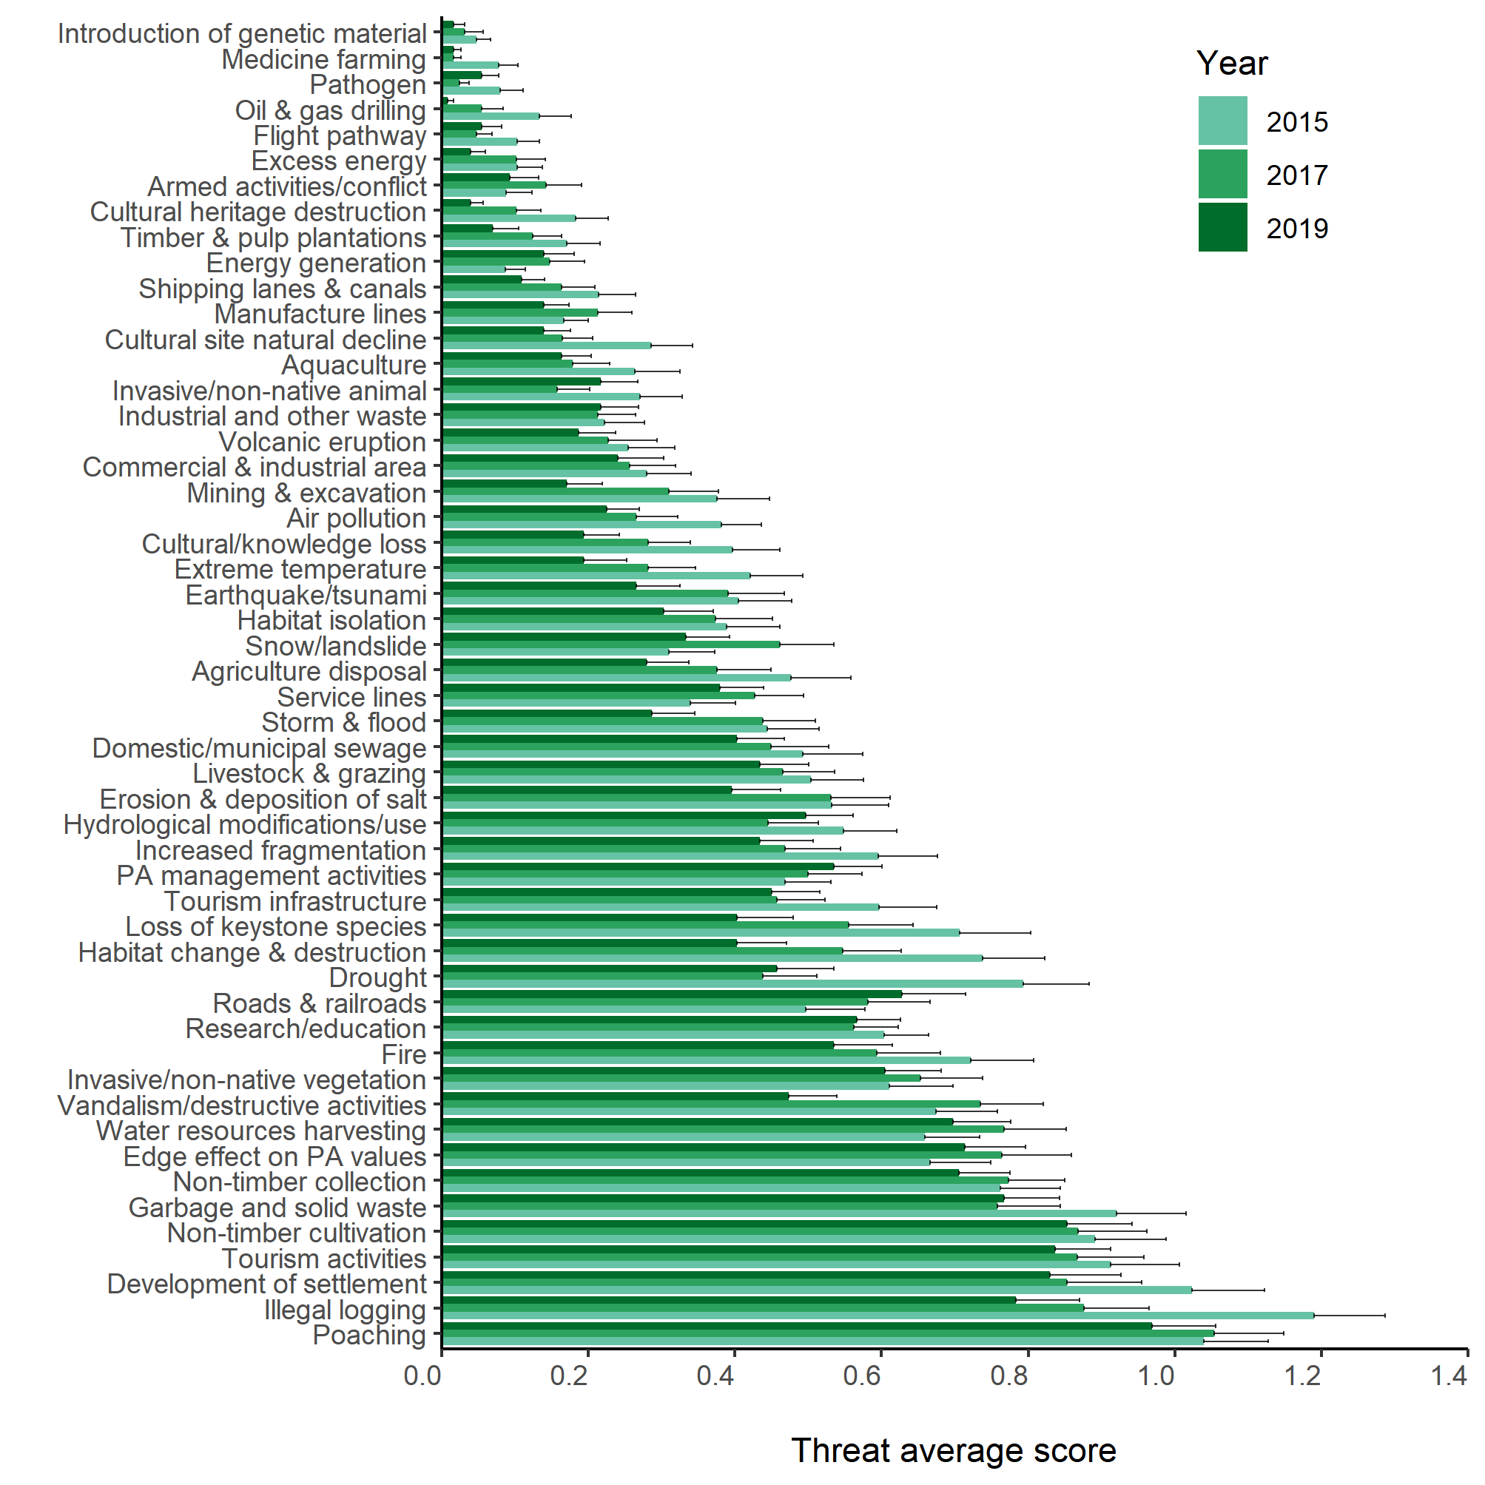
Supplementary Fig. 7 List of threats faced by protected areas in Indonesia during 2015–2018. The treat scores (shown as mean ± SE) were calculated as the average value of each threat from all protected area per year, with scores ranging from 0 (low threat) to 3 (high threat).
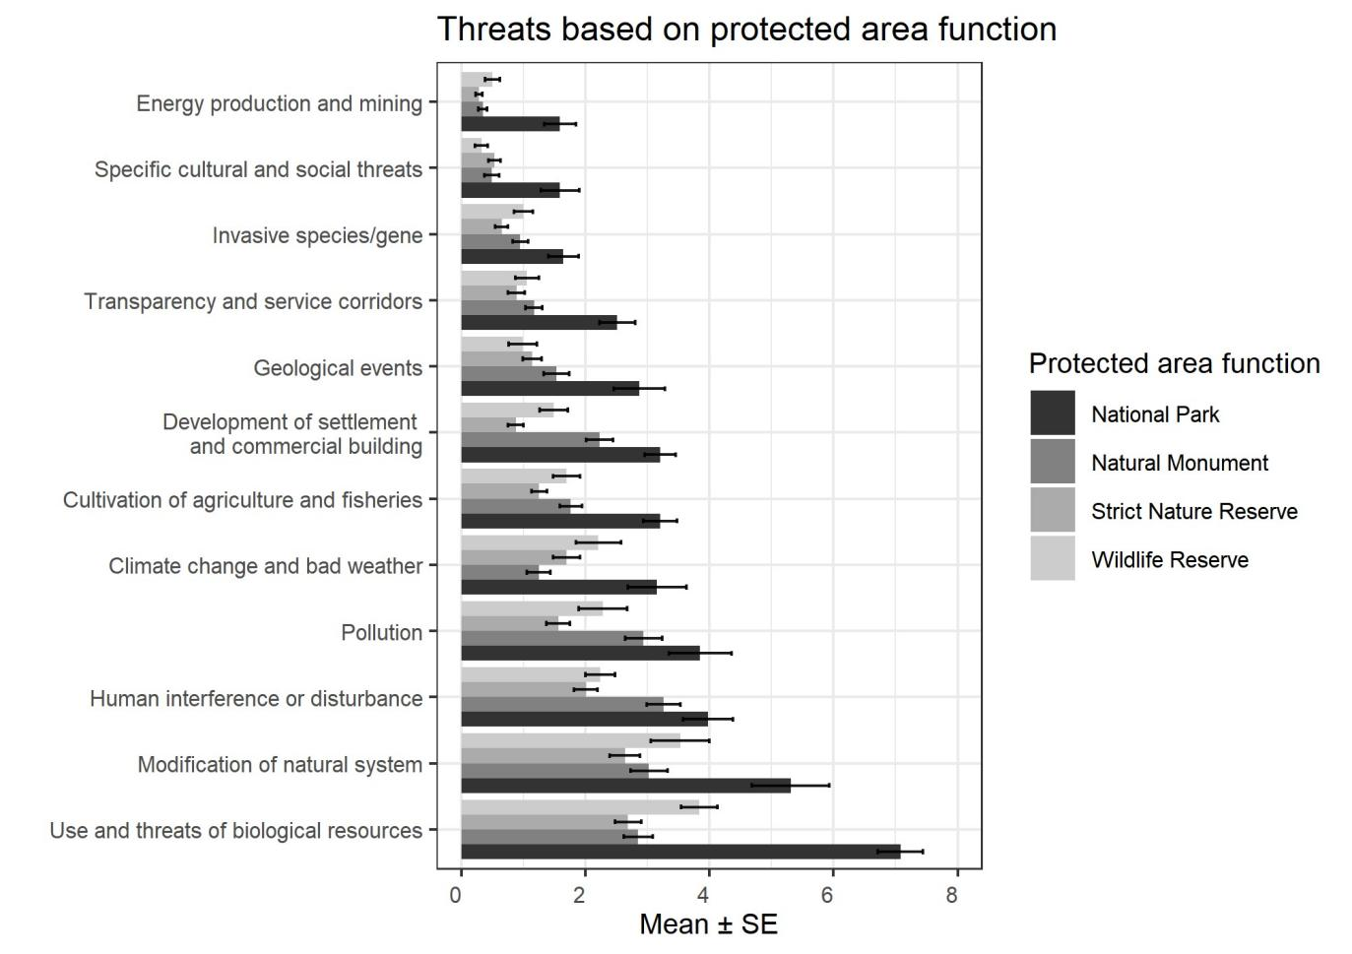
Supplementary Fig. 8 Threats facing different types of protected area in Indonesia: Cagar Alam (Strict Nature Reserve), Suaka Margasatwa (Wildlife Reserve), Taman Nasional (National Park), and Taman Wisata Alam (Natural Monument).

Supplementary Table 2 Summary of budget per unit area (USD/ha), staff per unit area (number/ha) and protected area size (ha) for protected areas of different management authority types.

 |  | Management authority type
 |  | National Park |  | Grand Forest Park |  | Nature Reserve/Wildlife Reserve/  Natural Monument
Resources | Year | Mean ± SD | Median | Mean ± SD | Median | Mean ± SD | Median
Budget per unit area (USD/ha)* | 2015 | 8.6 ± 16.3 | 3.1 | 455.5 ± 675.5 | 0.6 | 525.4 ± 5,641.9 | 0.0
 | 2019 | 21.2 ± 44.3 | 0.7 | 703.2 ± 1087.4 | 257.2 | 9,737.7 ± 63,856.6 | 36.8
 | 2015-2019 | 197.3 ± 1411.4 | 4.4 | 340.4 ± 639.4 | 21.6 | 4,032.2 ± 4,9036.4 | 0.5
Staff per unit area (number/ha) | 2015 | 0.002 ± 0.003 | 0.0004 | 0.05 ± 0.05 | 0.6 | 0.6 ± 3.3 | 0.007
 | 2019 | 0.003 ± 0.005 | 0.0007 | 0.0 ± 0.09 | 257.2 | 2.7 ± 24.7 | 0.017
 | 2015-2019 | 0.02 ± 0.16 | 0.0007 | 0.08 ± 0.18 | 21.6 | 7.5 ± 117.9 | 0.007
Protected area size (ha) | NA | 447,851 ± 626,518 | 141,261.9 | 2,051 ± 32,049 | 1,373.5 | 12,010 ± 32,337 | 574.3
*USD 1 = IDR 14,000 (February 2021).

