Using power analysis and spatial prioritisation to evaluate design of a forest bird monitoring programme
Darren M. Southwell, Adam Smart, Samuel D. Merson,
Katherine Selwood and Nicholas A. Macgregor

Supplementary material is published as supplied by the authors. It is not checked for accuracy, copyedited, typeset or proofread. The responsibility for accuracy and file functionality remains with the authors.

All data used by Selwood et al (2019) to build species distribution models came from the Island Wide Survey (IWS) programme (2001–2015), which has been conducted biennially since 2001 and consists of a regular survey grid of approximately 1,000 points across Christmas Island (excluding inaccessible areas such as active mine leases and the detention centre). Using this data, Selwood et al. (2019) built species distribution models for species with > 20 records. They fitted boosted regression trees (BRTs) for species with presence-absence data using the dismo package in R. BRTs are a flexible regression modelling technique for selecting relevant variables, fitting accurate functions and automatically identifying and modelling interactions. All BRT models used 10-fold cross validation, with bag fraction = 0.75, tree complexity = 5 and learning rate = 0.005. BRTs were fitted using the gbm.step function to select the optimal number of trees for inclusion in each model and were modelled with a Bernoulli error distribution. Environmental predictors used in the modelling were vegetation structure (canopy height, variation in canopy height), geology, topography (slope, elevation, aspect, topographic wetness index) and landscape context (distance to nearest valley, distance to nearest coast, distance to cleared areas). Elevation and distance to coast were highly correlated (r > 0.7), and so elevation was used for all species models. The plots below show the importance of each predictor variable in the BRT for each of the four forest birds.

Supplementary Fig. 1 The effect of environmental predictors for the Christmas Island thrush Turdus poliocephalus erythropleurus (AUC = 0.622).

Supplementary Fig. 2 The effect of environmental predictors for the Christmas Island emerald dove Chalcophaps indica natalis (AUC = 0.627).

Supplementary Fig. 3 The effect of environmental predictors for the Christmas Island imperial pigeon Ducula whartoni (AUC = 0.638).

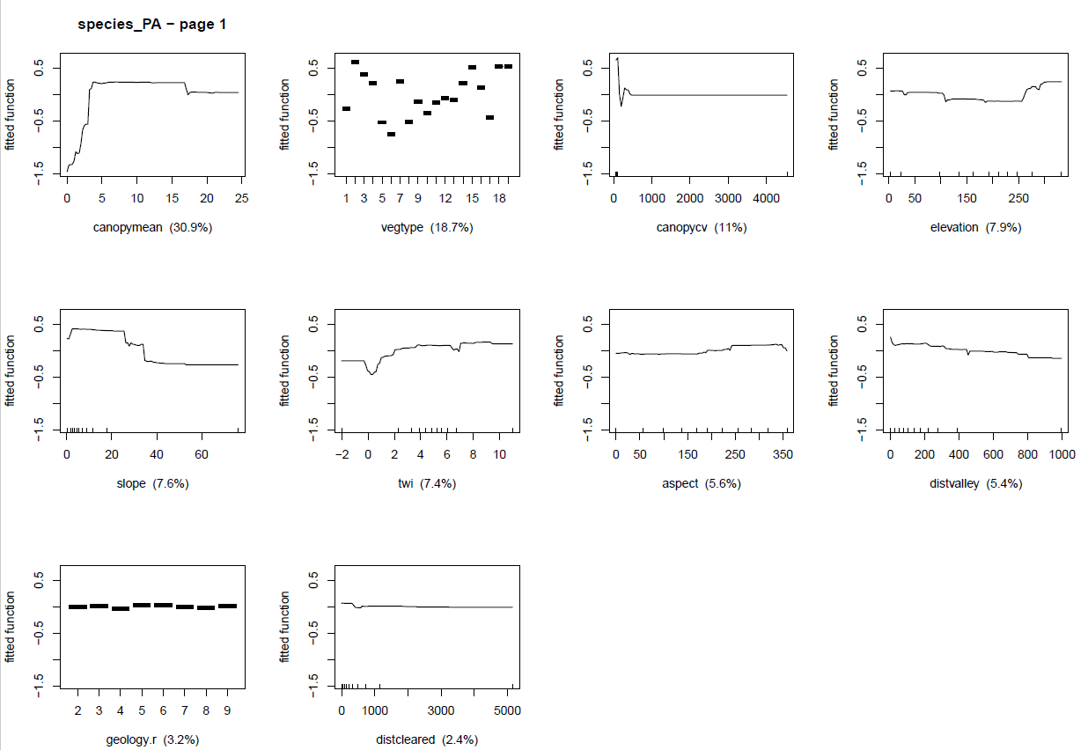

Supplementary Fig. 4 The effect of environmental predictors for the Christmas Island white-eye Zosterops natalis (AUC = 0.638).

